Chemical linguistics | DOI: 10.1002/anie.200((will be filled in by the editorial staff))
Organic chemistry as a language and the implications of chemical lingustics for structural and reactivity analyses. **
Andrea Cadeddu, Matthew Wampler-Doty, Bartosz A. Grzybowski*

Informally, there is a clear analogy between a chemist's understanding of a compound and an English speaker's understanding of a sentence. In either case, the trained mind effortlessly identifies part-whole relationships, often despite a lack of demarcations. The intuitive analogy between the spoken language and the language of chemistry has been suggested in Jean-Marie Lehn’s famous quote stating that „Atoms are letters, molecules are the words, supramolecular entities are the sentences and the chapters“ [LEHN1]. No matter how imaginative such analogies are, however, they lack a formal proof – that is, they become valid only when the structures of the language and of chemistry are both quantified and then compared with one another. With natural languages, such structural analyses has been largely enabled by the development of modern computers and today Natural Language Processing ([MANNING1, SPARK1, SAGGION1] REFS AS 2a,b,c) is perhaps the most vibrant sub-field of linguistics research. NLP has proven already capable of useful applications such as internet search engines, automatic translators, automatic summarization, natural language generation and understanding, parsing, segmentation, information retrieval and extraction. In chemistry, however, the linguistic terms of corpus, formal grammar, or n-grams are largely unknown and not even considered as relevant to the practice of our discipline. As we show in this work, this is a rather premature omission. First, we show that organic molecules contain fragments whose rank-distribution is essentially identical to that of sentence fragments in English – that is, the „dictionary“ of organic chemistry and English follow very similar laws. What is chemically surprising is that the „words“ of chemistry and not the functional groups we are accustomed to (methyyl, ethyl, hydroxyl, etc.) – instead, they are the common sub-fragments of diverse set of molecules. Second, extendign the concepts of automatic translators to organic chemistry, we show how the dictionary composed of these sub-fragments/“words“ can be used to identify in organic molecules high-information-content bonds defining molecular symmetry and locations most suitable for retrosynthetic cuts. While we have a clear perception that the current work is only an opening chapter, we suggest that application of computational linguistics to chemistry can have immense impact on the use of computers to analyze organic molecules and reactions to find structural and reactivity regularities that are hidden in the big-data ouvre of chemistry.
[∗]

XXX, Prof. Dr. B.A. Grzybowski
Department of Chemical and Biological Engineering Department of Chemistry
Northwestern University
2145 Sheridan Rd., Evanston, IL 60208 (USA)
Tel: (+1) 847-491-3024
E-mail: grzybor@northwestern.edu
Homepage: http://dysa.northwestern.edu

[∗∗] This work was supported by the Non-equilibrium Energy Research Center which is an Energy Frontier Research Center funded by the U.S. Department of Energy, Office of Science, Office of Basic Energy Sciences under Award Number DE-SC0000989.
Supporting information for this article is available on the WWW under http://www.angewandte.org or from the author.
As early as 1935, George Zipf noted that in a corpus [ZIPF1] (i.e., large and structured set of texts) of a natural languages, the frequncies of words are inversely proportional to their ranks in the frequency table – that is, the most frequent word occurs twice as often as the second most frequent one, three times more often as the third most frequent word, etc. This regularity is nowadays known as the Zipf’s law [GABAIX1] and it basic premise – that is, that language can be described and analyzed by statistical measures – is one of the cornerstones of modern corpus linguistics [THORNDIKE1, NATION1]. One of the algorithms popular in quantifying the structure of natural language corpora is as follows [SHANNON1]. A text comprising n sentences is selected for analysis. All possible pairs of sentences within this corpus are then analyzed to find maximum common substrings, MCS – for instance, if one sentence is „George Whitesides is a famous chemist“ and another is „Versailles is a famous place,“ then the MCS of these two sentences is „is a famous“. All of such maximum common substrings identified are saved in the dictionary. The numbers of times each MCS is repeated in the dictionary is calculated and the MCS are then ranked accordign to the frequency of their occurence and plotted in the form of rank vs. occurence distribution. For instance, blue cross markers in Figure 1a correspond to the distribution of MCS derived from the analysis of 100 sentences chosen at random from English Wikipedia. Perhaps not surprisingly, the most common fragment of the sentences is „e“, followed by „a“ and „o“. In corpus lingistics, it is customary to normalize such distributions and plot them on doubly logarithmic scales to give characteristic truncated power laws such as those given by the solid markers in Figure 1b; here, different distributions correspond to different numbers of sentences in the texts analyzed, n = 30, 60, 100, 200, 400.
We now apply similar concepts to the analysis of organic chemistry. Without much ambiguity, our corpus here is a collection of molecules, and each molecule corresponds to a „sentence“ – the question is whether there are „words“ or fragments in this chemical corpus that would make it akin to English. An approach that probably every chemist would consider first is to look at functional groups (OH, NH₂, COOH, COOR, ete.) as potential „words“ of chemistry. This, howver is a poor choice – when molecules composing the corpus are divided into functional groups (314 of them, listed in [SOH1]), and when these groups are ranked according to their frequencies of occurence, one obtains a distribution that deviates strongly from that of English (red triangular markers in Figure 1a). Emphatically, the functional groups are not the buildign blocks of a chemical language. Upon reflection, this is perhaps not that surprising since when we inspect organic molecules we recognize in them patterns that are often more complex that individual groups. Indeed, we often categorize molecules by larger common repeat patterns – as in the common substrings in English sentences. Therefore, buildign on this analogy, we consider analysis in which for a set of n molecules we inspect all molecule-molecule pairs and extract from each pair the largest common structural fragment (see Figure 1c for an example). We then count the repetitions of identical fragments, rank them accordign to the frequency of their occurence and plot the frequency distribution. The cyan circle markers in Figure 1a demonstrate that the distribution of such common molecular fragments follows closely the distribution of maximal common substrings in sentences. Moreover, as shown in Figure 1b, this correspondence holds for different sizes of the chemical and English corpora (i.e., n molecules vs. n sentences, where n‘s shown are 30, 60, 100, 200, 400). Within these distributions we discover fragments correspondign to functional groups (Figure 1d) but also those that are not intuitive at all (Figure 1e). Together, these are the common „utternaces“ from which chemical „language“ is made of.
We have just shown that there exists a set of molecular fragments with which organic molecules can be described as a language. This finding suggests that it should be possible to apply the tools of computational linguistics to the analysis of molecules. Of particular interest to us are the linguistic methods that examine the information content of the documents and could, potentially, be extended to identify the information-rich bonds of organic molecules – as we will see shortly, these information-rich bonds define molecular symmetry and are also likely candidates for making retrosynthetic disconnections.
The linguistic aproach we consider is aking to the computation of the so-called Shannon information entropy, and is based on the so-called tf-idf scoring (term frequency – inverse document frequency). In short, tf-idf is a numerical statistic used by computer search engines and other information retrieval schemes to determine STOP FOR NOW, PLS UPDATE TEXT UP TO HERE< PUT IN FIG 1, REFERENCE DOCUMENT ETC> I NEED TO TALK TO YOU AFTER GROUP MTG ABOOUT THE REST
STOP FOR NOW, PLS UPDATE TEXT UP TO HERE< PUT IN FIG 1, REFERENCE DOCUMENT ETC> I NEED TO TALK TO YOU AFTER GROUP MTG ABOOUT THE REST

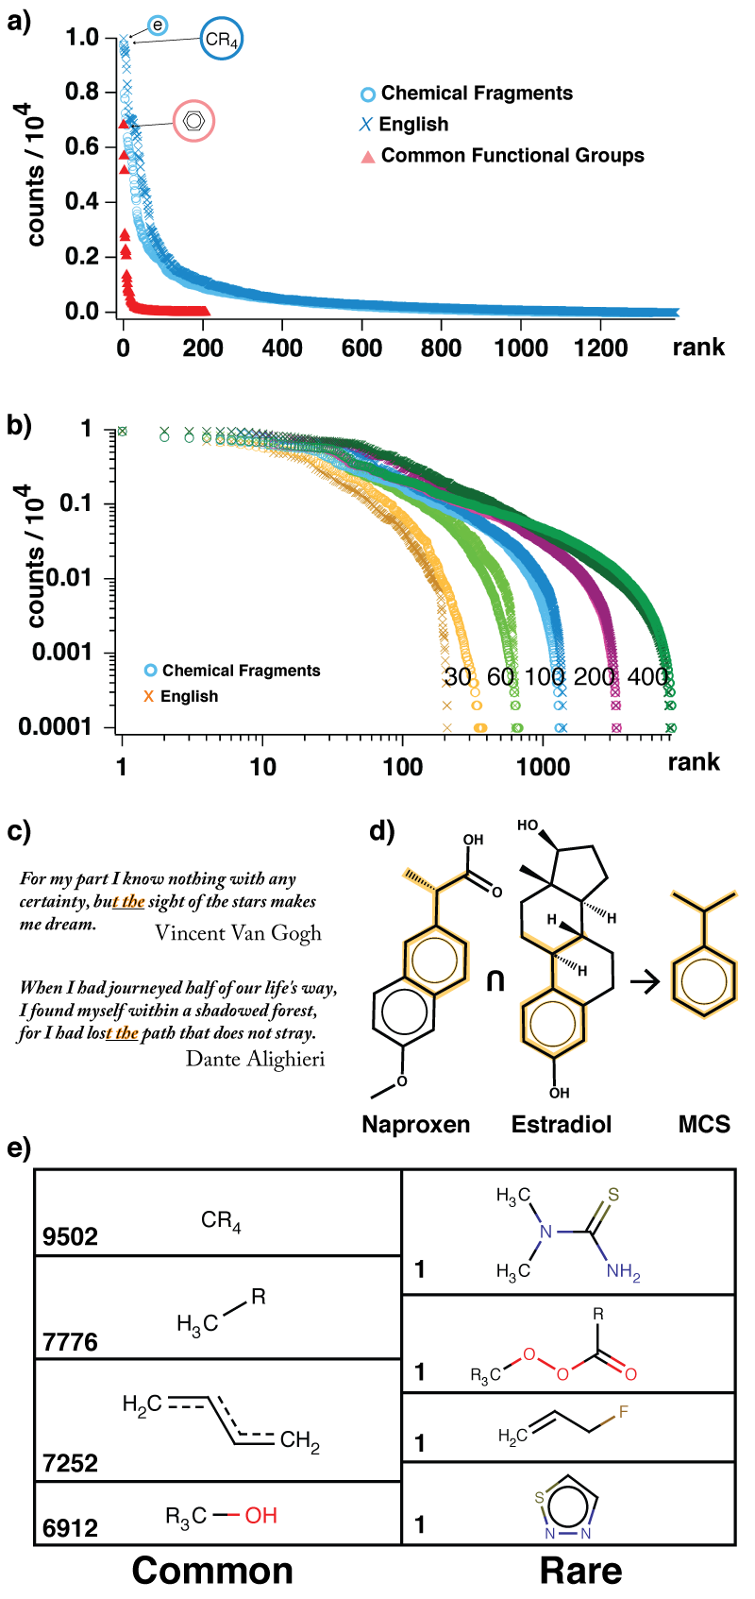
Figure 1. a) blue X markers have the rank-frequency distribution of maximum common substrings in English sentences (here, based on the analysis of n =100 sentences). Distribution of common molecular subfragments follows a similar dependence (blue O markers). In contrast, rank-distribution of common functional groups is markedly different. Note: rank = 1 means the most frequent substring/fragmet/group; rank = 2 means second most frequent substring/fragment/group, etc. Frequency = normalized frequency of occurence of substrings/fragments/groups in a given set of sentences or molecules.analyzed. b) The rank vs. frequency distributions ploteted on doubly-logarithmic scales and derived from corpora of n = 30, 60, 100, 200, 400 sentences (X markers) or molecules (O markers). c) Example of a maximal substring of two English sentences and d) a maximal sub-fragment of two organic molecules. e) Most common and less common sub-fragments constitutign the dictionary of organic chemistry.

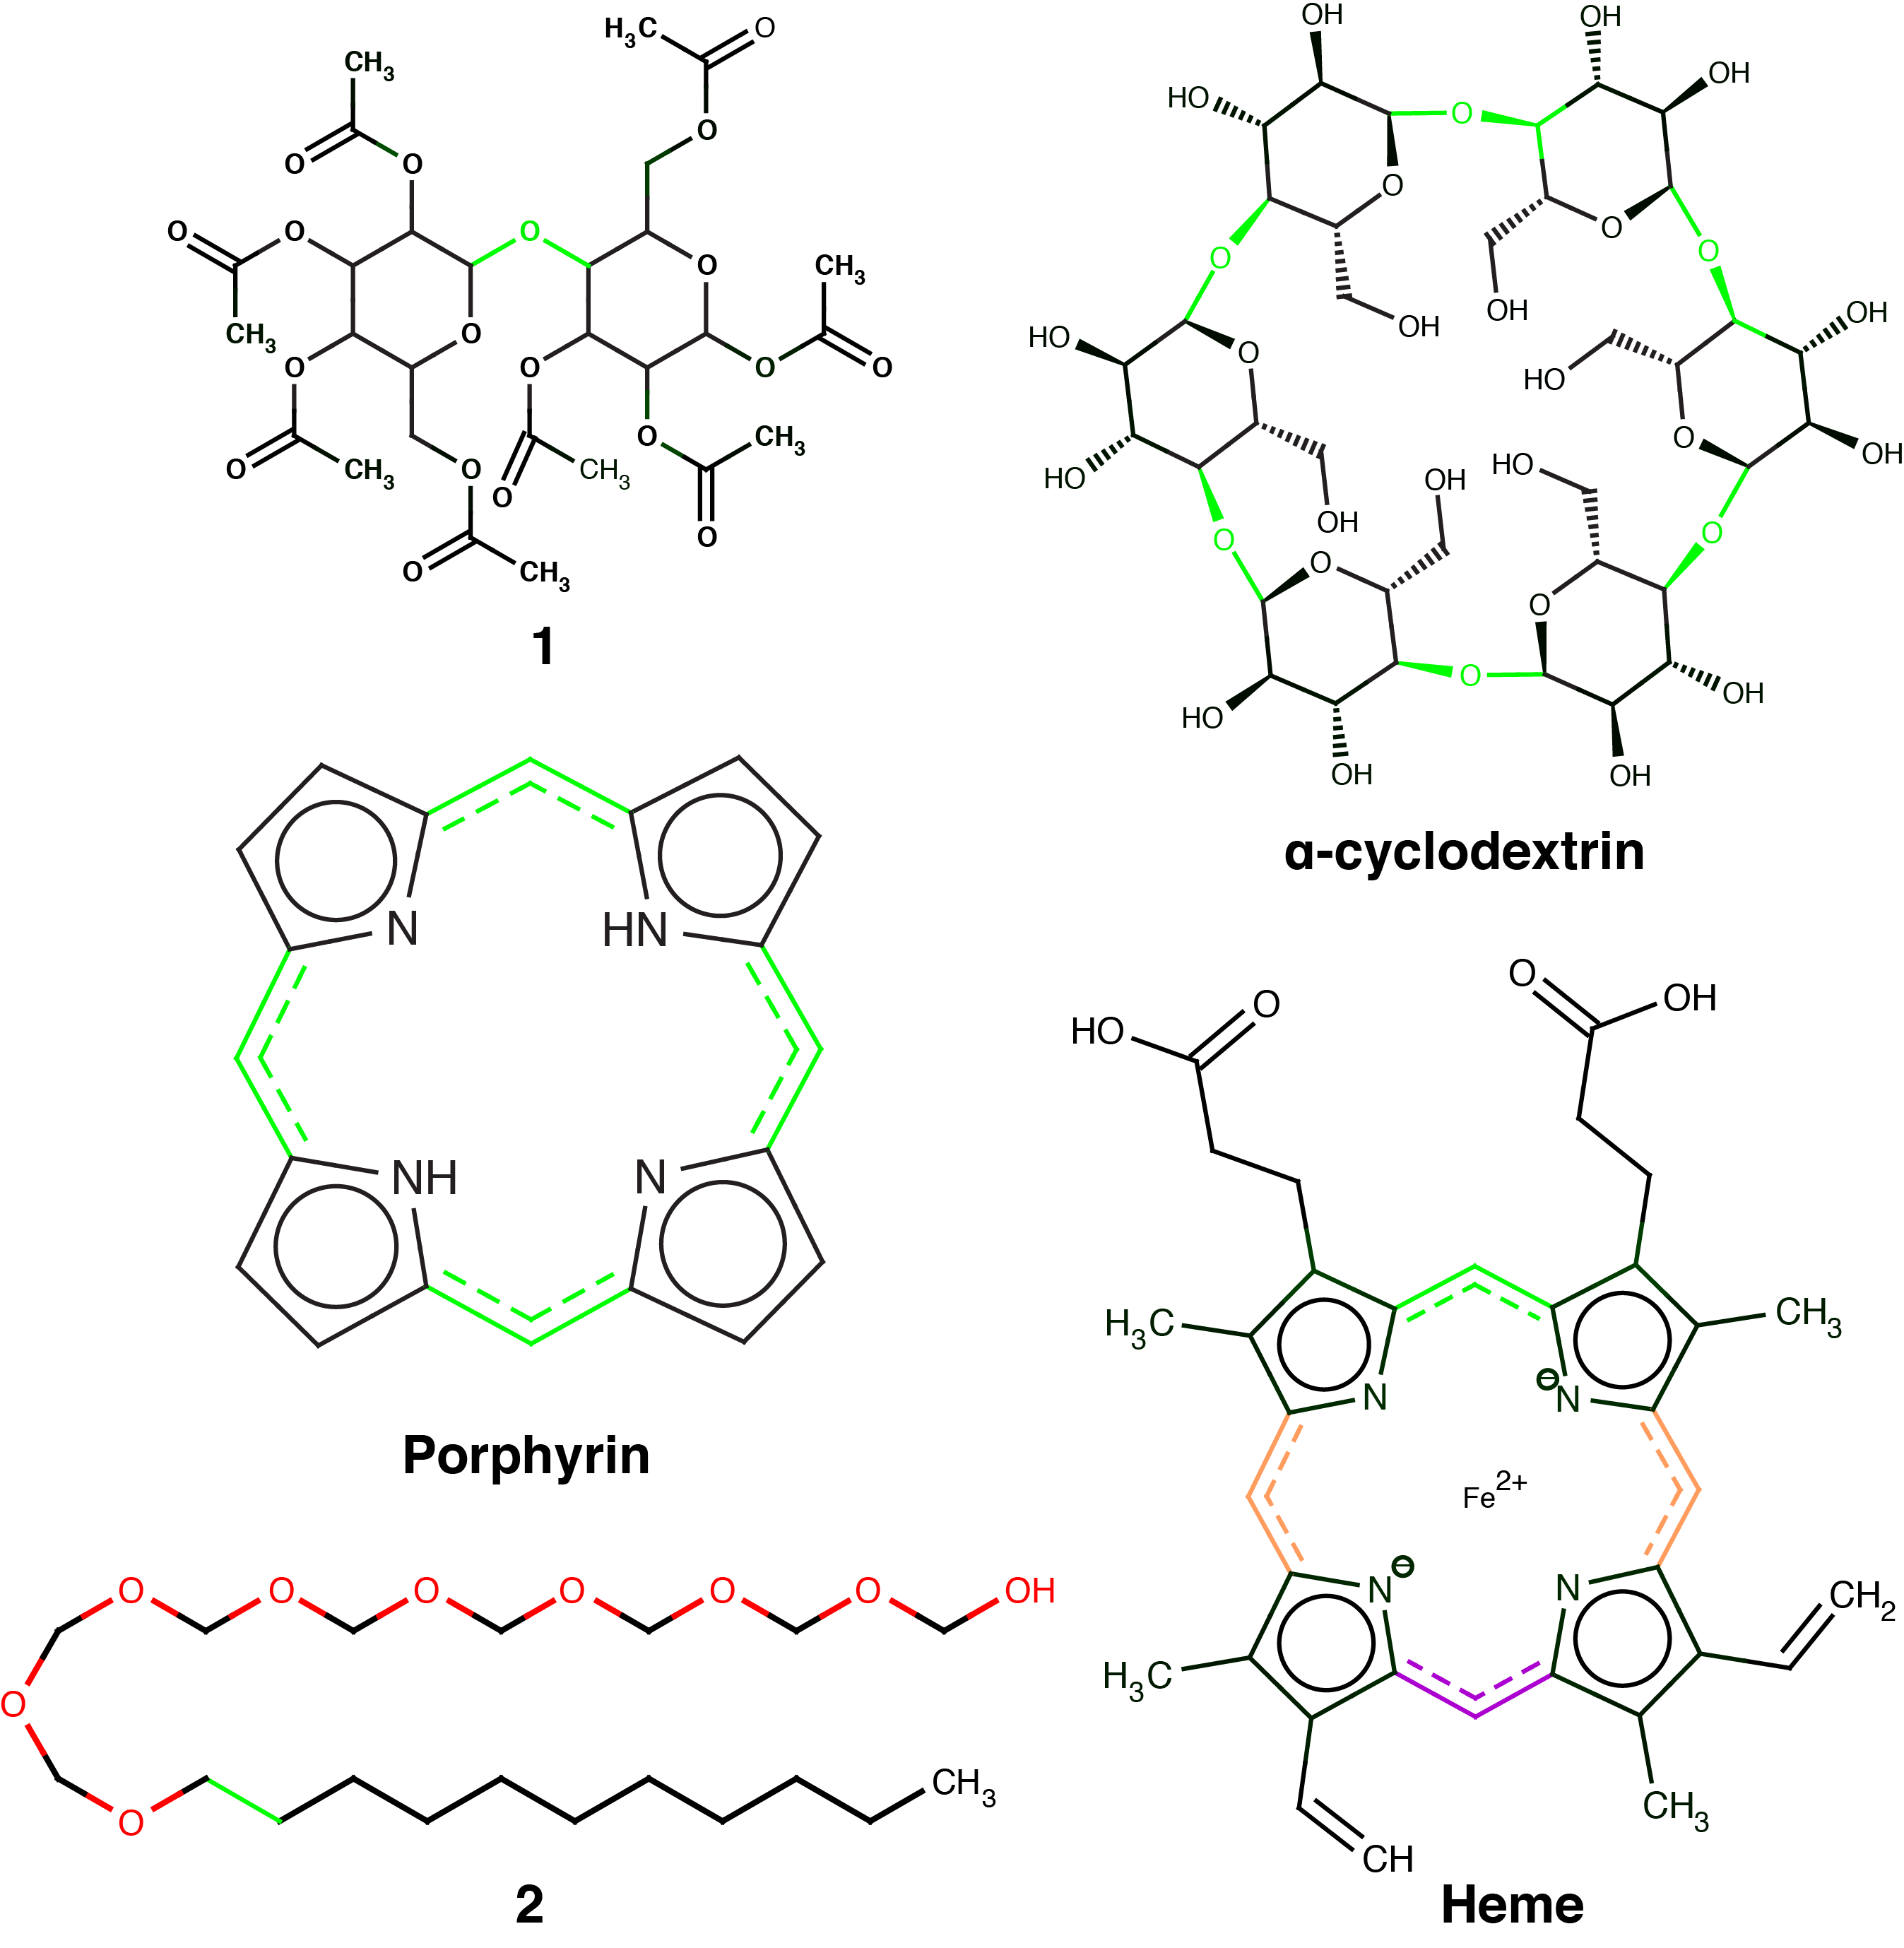
Figure 2. a)possible disconnection candidates are highlighted in green.

Received: ((will be filled in by the editorial staff))
Published online on ((will be filled in by the editorial staff))
Keywords: Chemical linguistics, chemical corpus, graphs, information, symmetry, retrosynthesis.

[LEHN1] Lehn, J.M. Supramolecular Chemistry: Concepts and Perspectives; Wiley VCH: D-69451 Weinheim, 1ed.; 1995.
[MANNING1] Manning C.D., Schuetze H. Foundations of statistical language processing, Cambridge MA: MIT Press 1999.
[SPARK1] Spark Jones K., Thesaurus, Encyclopedia of artificial intelligence. (ed. Shapiro) 2nd Ed, New York: Wiley, 1992, 1605-1613
[SAGGION1] Saggion, H. Poibeau T., Piskorski, P. Theory and Applications of Natural Language Processing, Multi-source, Multilingual Information Extraction and Summarization Springer Berlin 2013
[ZIPF1] a) Zipf, G. The Psychobiology of Language: An Introduction to Dynamic Philology. 1935 Cambridge, Mass.: M.I.T. Press. b) Zipf, G. Human Behavior and the Principle of Last Effort (Cambridge, MA: 1949 Addison-Wesley)
[GABAIX1] Gabaix, X. The Quarterly Journal of Economics, Vol. 114, No. 3 (Aug., 1999), pp. 739-767
[CHIANG1] Chiang, D. Theory and applications of natural language processing Grammars for language and genes : theoretical and empirical investigations Springer 2012
[THORNDIKE1] Thorndike, E.L. and I. Lorge. The Teacher's Word Book of 30,000 Words. l944. Teachers College, Columbia University.
[NATION1] Nation, I.S.P. (1997), "Vocabulary size, text coverage, and word lists", in Schmitt; McCarthy, Vocabulary: Description, Acquisition and Pedagogy, Cambridge: Cambridge University Press, pp. 6–19, ISBN 978-0-521-58551-4
[SHANNON1] We use a modification of a Bag Of Words algorithm, based on the Longest Common Substring. BOW were probably developed among 15th century cryptographers. For a modern mathematical treatment see Shannon, C.E. The Bell System Technical Journal, Vol. 27, pp. 379–423, 623–656, 1948. B(For the LCS see Gusfield, D. 1999 Algorithms on Strings, Trees and Sequences: Computer Science and Computational Biology. USA: Cambridge University Press.
[SOH1] Soh,S. Wey,Y. Kowalczyk, B., Gothard, C. M., Baytekin, B. Gothard,N. Grzybowski, B. Chem. Sci., 2012, 3, 1497
[5] M. Kowalik, C.M. Gothard, A.M. Drews, N.A. Gothard, A. Wieckiewicz, P.E. Fuller, B.A. Grzybowski, K.J.M. Bishop, Angew. Chem. Int. Ed. 2012, 51, 7928-7932.
[6] P.E. Fuller, C.M. Gothard, N.A. Gothard, A. Wieckiewicz, B.A. Grzybowski, Angew. Chem. Int. Ed. 2012, 51, 7933-7937.

Entry for the Table of Contents
Layout 1:
Synthetic Networks |  | Freezing time: A microfluidic device was developed to study chemical oscillators. The device allows for rapid screening of the chemical phase space, with the accuracy of a vigorously stirred batch reactor, but the speed of a continuous stirred tank reactor.
XXX, Janusz Jurczak*, Bartosz A. Grzybowski *
Quantifying the kinetics of a pH oscillator using a microfluidic device.

Supporting Information for manuscript entitled “Organic pH-oscillator frozen in time”

Thomas M. Hermans, Peter S. Stewart, Bartosz A. Grzybowski*

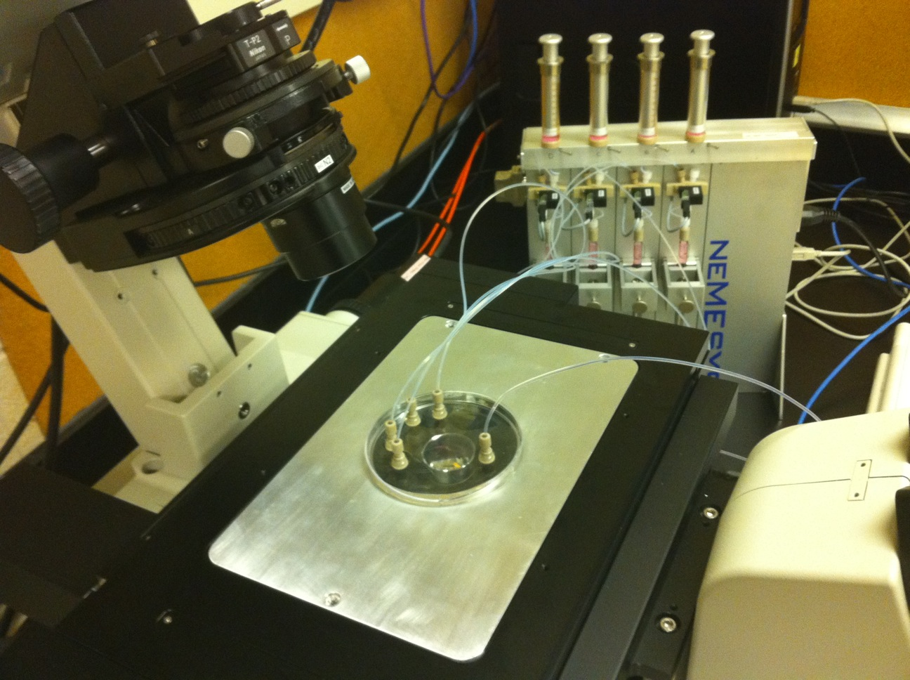
Fig. S1: Digital micrograph of microfluidic device mounted onto the stage of the confocal microscope (Nikon A1) with in the background the four syringe pumps.

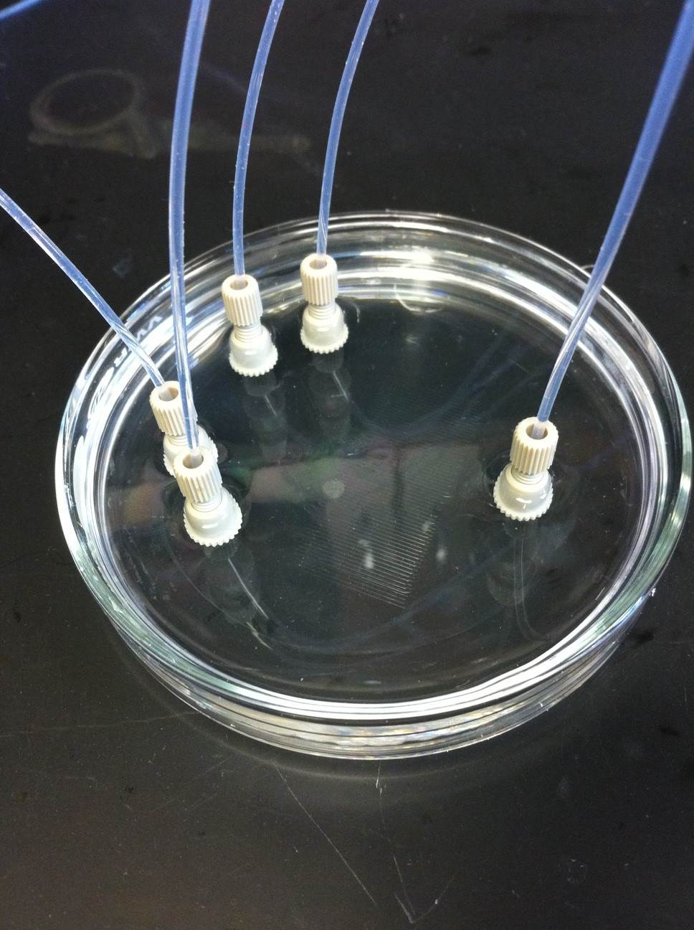
Fig. S2: Digital micrograph of the microfluidic device showing the four inlets (left side) and outlet (right side) connected using nanoports.

