Chemical linguistics | DOI: 10.1002/anie.200((will be filled in by the editorial staff))
Organic chemistry as a language and the implications of chemical linguistics for structural and retrosynthetic analyses. **
Andrea Cadeddu, Matthew Wampler-Doty, Bartosz A. Grzybowski*

Abstract: Methods of computational linguistics are adapted to the analysis of organic molecules. It is shown that a natural language such as English and organic chemistry have the same structure in terms of the frequency of, respectively, text fragments and molecular fragments. This analogy allows the use of tools from computational corpus linguistic to the analysis of organic molecules. It is shown that within organic molecules bonds that have highest information content are the ones that define repeat/symmetry subunits and can identify the loci of potential retrosynthetic disconnections. Linguistics-based analysis is well suited to the analysis of complex structural and reactivity patterns within organic molecules.

Informally, there is a clear analogy between a chemist's understanding of a compound and an English speaker's understanding of a sentence. In either case, the trained mind effortlessly identifies part-whole relationships, often despite a lack of demarcations. The intuitive analogy between the spoken language and the language of chemistry has been suggested in Jean-Marie Lehn’s famous quote stating that „Atoms are letters, molecules are the words, supramolecular entities are the sentences and the chapters“ ^{[1]}. No matter how imaginative such analogies are, however, they lack a formal proof – that is, they become valid only when the structures of the language and of chemistry are both quantified and then compared with one another. With natural languages, such structural analyses has been largely enabled by the development of modern computers and today Natural Language Processing^{[2]} is perhaps the most vibrant sub-field of linguistics research. NLP has proven already capable of useful applications such as internet search engines, automatic translators, automatic summarization, natural language generation and understanding, parsing, segmentation, information retrieval and extraction. In chemistry, however, the linguistic terms of corpus, formal grammar, or n-grams are largely unknown and not even considered as relevant to the practice of our discipline. As we show in this work, this is a rather premature omission. First, we show that organic molecules contain fragments whose rank-distribution is essentially identical to that of sentence fragments in English – that is, the „dictionary“ of organic chemistry and English follow very similar laws. What is chemically surprising is that the „words“ of chemistry and not the functional groups we are accustomed to (methyl, ethyl, hydroxyl, etc.) – instead, they are the common sub-fragments of diverse set of molecules. Second, extendign the concepts of automatic translators to organic chemistry, we show how the dictionary composed of these sub-fragments/“words“ can be used to identify in organic molecules high-information-content bonds defining molecular symmetry and locations most suitable for retrosynthetic cuts. While we have a clear perception that the current work is only an opening chapter, we suggest that application of computational linguistics to chemistry can have immense impact on the use of computers to analyze organic molecules and reactions to find structural and reactivity regularities that are hidden in the big-data ouvre of chemistry.
As early as 1935, George Zipf noted^{[3]} that in a corpus (i.e., large and structured set of texts) of a natural languages, the frequncies of words are inversely proportional to their ranks in the frequency table – that is, the most frequent word occurs twice as often as the second most frequent one, three times more often as the third most frequent word, etc. This regularity is nowadays known as the Zipf’s law^{[4]} and it basic premise – that is, that language can be described and analyzed by statistical measures – is one of the cornerstones of modern corpus linguistics ^{[5,6]}. One of the algorithms popular in quantifying the structure of natural language corpora is as follows ^{[7]}. A text comprising n sentences is selected for analysis. All possible pairs of sentences within this corpus are then analyzed to find maximum common substrings, MCS – for instance, if one sentence is „George Whitesides is a famous chemist“ and another is „Versailles is a famous place,“ then the MCS of these two sentences is „is a famous“. All of such maximum common substrings identified are saved in the dictionary. The numbers of times each MCS is repeated in the dictionary is calculated and the MCS are then ranked accordign to the frequency of their occurence and plotted in the form of rank vs. occurence distribution. For instance, blue cross markers in Figure 1a correspond to the distribution of MCS derived from the analysis of 100 sentences chosen at random from English Wikipedia. Perhaps not surprisingly, the most common fragment of the sentences is „e“, followed by „a“ and „o“. In corpus lingistics, it is customary to normalize such distributions and plot them on doubly logarithmic scales to give characteristic truncated power laws such as those given by the solid markers in Figure 1b; here, different distributions correspond to different numbers of sentences in the texts analyzed, n = 30, 60, 100, 200, 400.
[∗] Dr. Andrea Cadeddu, Mr.Matthew Wampler-Doty , Prof. Dr. B.A. Grzybowski
Department of Chemical and Biological Engineering Department of Chemistry
Northwestern University
2145 Sheridan Rd., Evanston, IL 60208 (USA)
Tel: (+1) 847-491-3024
E-mail: grzybor@northwestern.edu
Homepage: http://dysa.northwestern.edu

[∗∗] This work was supported by the Non-equilibrium Energy Research Center which is an Energy Frontier Research Center funded by the U.S. Department of Energy, Office of Science, Office of Basic Energy Sciences under Award Number DE-SC0000989.
Supporting information for this article is available on the WWW under http://www.angewandte.org or from the author.
Figure 1. a) Dark blue, cross markers have the rank-frequency distribution of maximum common substrings in English sentences (here, based on the analysis of n =100 sentences). Distribution of common molecular subfragments follows a similar dependence (light blue, open-circle markers). In contrast, rank-distribution of common functional groups (red markers) is markedly different. Note: rank = 1 means the most frequent substring/fragmet/group; rank = 2 means second most frequent substring/fragment/group, etc. Frequency = normalized frequency of occurence of substrings/fragments/groups in a given set of sentences or molecules.analyzed. b) The rank vs. frequency distributions ploteted on doubly-logarithmic scales and derived from corpora of n = 30, 60, 100, 200, 400 sentences or the same number of molecules Within each pair of nearly overlapping curves, one (darker color) is for English and one (lighter color) is for chemistry. . c) Example of a maximal substring of two English sentences and d) a maximal sub-fragment of two organic molecules. e) Some most common and less common sub-fragments constituting the dictionary of organic chemistry.
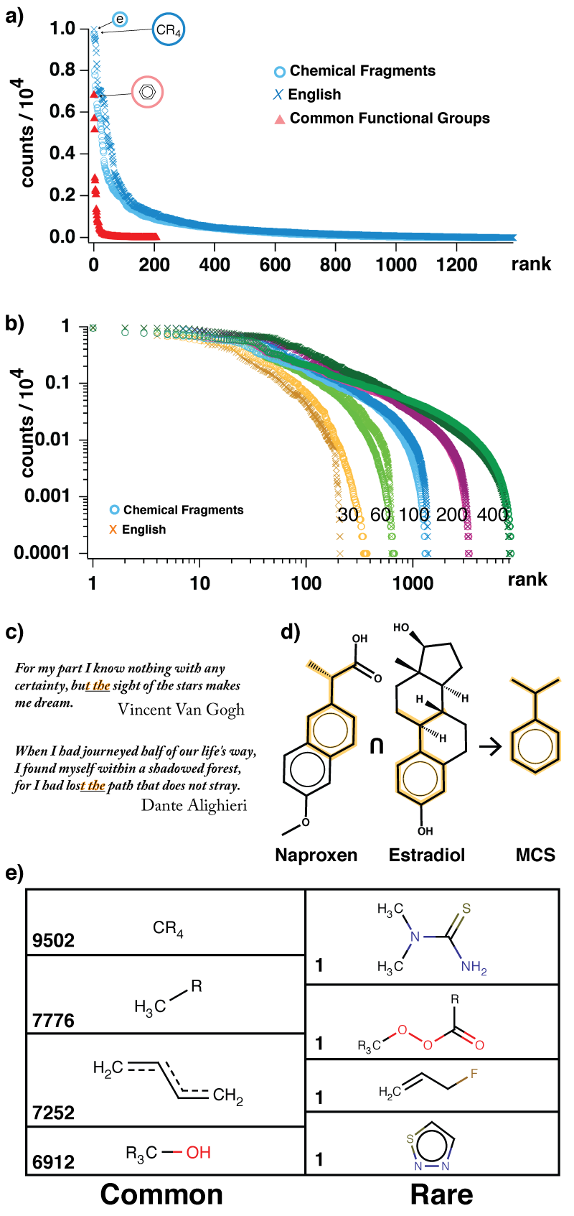
We now apply similar concepts to the analysis of organic chemistry. Our corpus here is a collection of molecules, and each molecule corresponds to a „sentence“ – the question is whether there are „words“ or fragments in this chemical corpus that would make it akin to English. An approach that probably every chemist would consider first is to look at functional groups (OH, NH₂, COOH, COOR, ete.) as potential „words“ of chemistry. This, however is a poor choice – when molecules composing the corpus are divided into functional groups (314 of them, listed in ^{[8]}), and when these groups are ranked according to their frequencies of occurence, one obtains a distribution that deviates strongly from that of English (red triangular markers in Figure 1a). Emphatically, the functional groups are not the buildign blocks of a chemical language. Upon reflection, this is perhaps not that surprising since when we inspect organic molecules we recognize in them patterns that are often more complex that individual groups. Indeed, we often categorize molecules by larger common repeat patterns – as in the common substrings in English sentences. Therefore, buildign on this analogy, we consider analysis in which for a set of n molecules we inspect all molecule-molecule pairs and extract from each pair the largest common structural fragment (see Figure 1c for an example). We then count the repetitions of identical fragments, rank them according to the frequency of their occurence and plot the frequency distribution. The cyan circle markers in Figure 1a demonstrate that the distribution of such common molecular fragments follows closely the distribution of maximal common substrings in sentences. Moreover, as shown in Figure 1b, this correspondence holds for different sizes of the chemical and English corpora (i.e., n molecules vs. n sentences, where n‘s shown are 30, 60, 100, 200, 400). Within these distributions we discover fragments correspondign to functional groups (Figure 1d) but also those that are not intuitive at all (Figure 1e). Together, these are the common „utternaces“ from which chemical „language“ is made of.
We have just shown that there exists a set of molecular fragments with which organic molecules can be described as a language. This finding suggests that it should be possible to apply the tools of computational linguistics to the analysis of molecules. Of particular interest to us are the linguistic methods that examine the information content of the documents and could, potentially, be extended to identify the information-rich bonds of organic molecules – as we will see shortly, these information-rich bonds define molecular symmetry and are also likely candidates for making retrosynthetic disconnections.
The linguistic aproach we consider is based on the so-called tf-idf scoring (term frequency – inverse document frequency) which is a numerical statistic used by computer search engines and other information retrieval schemes to determine how relevant certain keywords are to a given text. The tf part of the score is simply the frequency of how often a given keyword occurrs in a document one is interested in, tf = word frequency in a document. This measure, however, is rather misleadign because certain words (e.g., „the“, „this,“ etc.) generally occur in a language/corpus more often than others. To correct for this bias, tf is multiplied by an idf which xpresses the frequeny with which which a given word occurs in the entire corpus – it is typically given as a logarigtm, idf = -log(documents in which a word is found/total number of documents). Note that if a word like „the“ occurs in all documents under study, idf = log (1) = 0 and this word is not a good, specific keyword. In general, tf-idf scores are highest for the most characteristic words in documents – another another way of putting it is that the tf-idf scores identify the most information-rich content of documents (note that the product tf·idf has a form of -probability*log(probability) which is reminiscent – thought not fully equivalent – of the familiar Shannon information theory).
We extended the above analysis to organic molecules in which we sought the most information-rich bonds. Our hypothesis has been that these bonds would be chemically most meaningful in, for instance, definign molecular symmetry and also defining loci of potential retrosynthetic disconnections. Our algorithm (with the source code included in the SI) used as dictionary the set of N_{dict} = 8305 largest common structural fragments discussed earlier (see Figure 1c). First, for any molecule of interest, it was established which structural fragments from the dictionary this molecule contained – we denote the total number of fragments identified in a molecule as N_{mol}. Next, the term frequency was calculated by dividing the number of times a given fragment of type i was found in the molecule by the total number of fragments in this molecule, 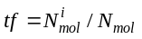. For example, if a molecule contains, say, 20 different fragments from the dictionary and two of these fragments are phenyls, then the term frequency of phenyls in this molecule is 2/20. Then, an idf score was calculated for each fragment in the molecule vs, the entire dictionary, 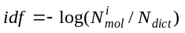. As in the case of linguistics, the 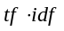product weighted the relevance of fragments from our dictionary to the molecule under analysis – at the same time, it did not yet provide information at the level of individual bonds within the molecule. To achieve this, we considered each bond in the molecule and established to which m structural fragments it belonged (note: since disctionary fragments are not necessarily „orthogonal,“ each bond can belong to more than one fragment). We then summed up and averaged the tf-idf scores of all j = 1,....,m fragments incorporating the particular bond:
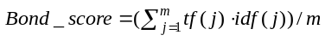. All bonds in the molecule were assigned such scores.
Figure 2 shows examples of molecules in which the highest scoring bonds are colored in green – as we see by the examples of dimer 1, the α-cyclodextrin, and the porphyrin, the linguistic approach identifies the symmetry/repeat units of all these molecules and bonds along which they can be cut into smaller substrates. We emphasize that this is not a small feat given we have not even considered any (x,y,z) coordinates of the atoms makign up these molecules and performed no linear-algebra analysis to find symmetries which, incidentally, can be a computationally intensive protocol involving manipulation of matrices. Second, the speed of our algorithms (usually less than 800msec per molecule*) makes this linguistics-based protocol very suitable for computational retrosynthetic planning where, to date, identification of repeat sub-units and symmetries is one of the major obstacles (both in terms of effectiveness of existing algorithms and also of the long computational times required). In fact, the approach we developed is being incorporated into the retrosynthesis portion of our Chematica software^{[9,10]}.
Another important point is that by matching into molecules entire chemical „words“/patterns – typically spannign several atoms – the tf-idf scoring is capable of distinguishing bonds based on their environments. This is illustrated by the Heme example in Figure 2 whereby the locally equivalent bonds joining the imidazole rings are given different scores based on the presence of different side chains – the higheest-information-content bonds are in green followed by the violet-colored ones and the orange ones.
Naturally, no method is without its limitations. One simple example of such a limitation is given by molecule 2 in which two proximal bonds have similar tf-idf scores. Of course, the C-O bond is a synthetically much more meaningful locus of a retrosynthetic disconnection than the nearby C-C bond. The reason for the high score of the latter is likely that our dictionary of 8305 chemical fragments we are currently operating with has been developed on an insufficient number of n-alkane molecules translating into poor representation of such strctural motifs in the dictionary. This points towards an obvious improvement of building a larger disctionary comprising tens to hundreds of thousands of common molecular fragments. While such a work is under way in our laboratory, it has to be pointed out that increasign dictionary size will translate into longer matching/computation times (albeit scaling only linearly in dictionary size). Identification of the most-compact yet most-complete dictionary of the chemical language is therefore one of the tasks for future research. In the meantime, the current work aims to (i) document that organic chemistry has a structure of a natural language and (ii) introduce the basic concepts and potential impact of linguistics-based analyses to a general chemical audience. We believe that the tools of computational corpus linguistics are indeed the proper set of tools with which to analyze organic chemistry. These statistical methods have been designed and tested to recognize and process characteristic and most information-rich patterns within large and diverse sets of texts – this activity is familiar to chemists whose brains are constantly trained to recognize structural and reactivity patterns in diverse sets of organic molecules. We therefore suggest that the linguistic approach that can help us codify and perhaps one day automate the analysis of organic molecules and „the art of organic synthesis“.

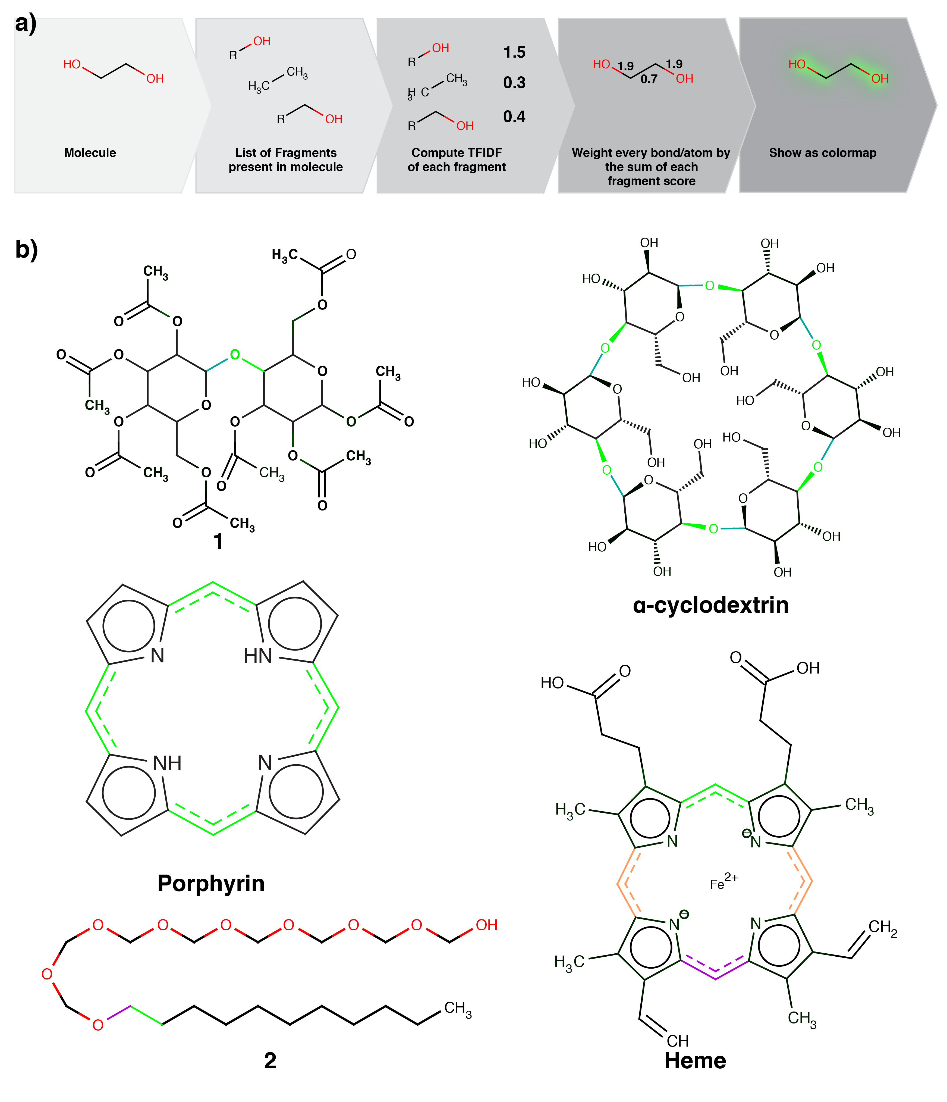
Figure 2. a) scheme illustrating the process to score bonds b) few examples of resulting segmentations, generated with a dictionary of 8305 fragments. The highest scoring bond is presented in bright green. The second highest is dark green, if present. The colorscale has been extended in Heme to show the top three scores.
Received: ((will be filled in by the editorial staff))
Published online on ((will be filled in by the editorial staff))
Keywords: Chemical linguistics, chemical corpus, graphs, information, symmetry, retrosynthesis.

[1] Lehn, J.M. Supramolecular Chemistry: Concepts and Perspectives; Wiley VCH: Weinheim, 1ed.; 1995.
[2] a) Manning C.D., Schuetze H. Foundations of statistical language processing, MIT Press: Cambridge MA, 1999; b) Spark Jones K., Thesaurus, Encyclopedia of artificial intelligence. (ed. Shapiro) 2nd ed, Wiley: New York, 1992, 1605-1613; c) Saggion, H. Poibeau T., Piskorski, P. Theory and Applications of Natural Language Processing, Multi-source, Multilingual Information Extraction and Summarization Springer: Berlin, 2013.
[3] a) Zipf, G. The Psychobiology of Language: An Introduction to Dynamic Philology. M.I.T. Press: Cambridge, MA, 1935; b) Zipf, G. Human Behavior and the Principle of Last Effort Addison-Wesley: Cambridge, MA, 1949.
[4] Gabaix, X. The Quarterly Journal of Economics, 1999, 3, 739-767.
[5] Thorndike, E.L. and I. Lorge. The Teacher's Word Book of 30,000 Words. Teachers’ College, Columbia University, l944.
[6] Nation, I.S.P. Vocabulary size, text coverage, and word lists, in Schmitt; McCarthy, Vocabulary: Description, Acquisition and Pedagogy, Cambridge University Press: Cambridge, UK, 1997.
[7] We use a modification of a Bag Of Words algorithm, based on the Longest Common Substring. BOW algorithms were probably developed by 15th century cryptographers. For a modern mathematical treatment see Shannon, C.E. The Bell System Technical Journal, 1948, 27, 379–423, 623–656; For the discussion of largest common substrings, see Gusfield, D. Algorithms on Strings, Trees and Sequences: Computer Science and Computational Biology. Cambridge University Press: Cambridge UK, 1999.
[8] Soh,S. Wey,Y. Kowalczyk, B., Gothard, C. M., Baytekin, B. Gothard,N. Grzybowski, B. Chem. Sci., 2012, 3, 1497-1502
[9] a) M. Kowalik, C.M. Gothard, A.M. Drews, N.A. Gothard, A. Wieckiewicz, P.E. Fuller, B.A. Grzybowski, K.J.M. Bishop, Angew. Chem. Int. Ed. 2012, 51, 7928-7932. b) P.E. Fuller, C.M. Gothard, N.A. Gothard, A. Wieckiewicz, B.A. Grzybowski, Angew. Chem. Int. Ed. 2012, 51, 7933-7937.

Chemical linguistics |  | Chemistry is a language: A formal analysis reveals that Jean-Marie Lehn’s famous analogy between chemistry to a natural language is indeed substantiated. The patterns of the English language and the structural motifs of organic mlecules follow the same statistics. This enables the use of the methods of computational linguistics to the analysis of organic molecules to identify in them characteristic, information-rich patterns defining symmetry/repeat sub-units and also bonds amenable to retrosynthetic disconnections.
Andrea Cadeddu, Matthew Wampler-Doty, Bartosz A. Grzybowski *
Organic chemistry as a language and the implications of chemical linguistics for structural and retrosynthetic analyses.

Supporting Information for manuscript entitled “Organic chemistry as a language and the implications of chemical linguistics for structural and retrosynthetic analyses.”

Andrea Cadeddu, Matthew Wampler-Doty, Bartosz A. Grzybowski *

# tfidf_to_heatmaps.py - computes the tf idf score for each molecule and returns the heatmap representation.
# author: Matthew Wampler-Doty
# author: Andrea Cadeddu
#

import sys, json
from collections import defaultdict
from math import log
from rdkit import Chem

def label_mol(mol):
for a in mol.GetAtoms():
a.SetProp('molAtomMapNumber', str(a.GetIdx() + 1))

def weight_bonds(words, idfs, mol):
# Compute the word matches for bonds in the molecule
bond_words = defaultdict(set)
# Keep track of counts for use in TF-IDF later
doc_word_counts = defaultdict(float)
for i, w in enumerate(words):
mol_matches = mol.GetSubstructMatches(w, uniquify=False)
if mol_matches:
doc_word_counts[i] += len(mol_matches)
for m in mol_matches:
cmap = dict(enumerate(m))
for b in w.GetBonds():
start = b.GetBeginAtomIdx()
end = b.GetEndAtomIdx()
bond_words[frozenset([cmap[start], cmap[end]])].add(i)

# Compute the maximal words
words_to_use = doc_word_counts.keys()

# Compute the TF-IDF scores for each word
maxtf = float(max(doc_word_counts[t] for t in words_to_use))
score = defaultdict(float, ((t, doc_word_counts[t] / maxtf * idfs[t])
for t in words_to_use))

# Get the combined TF-IDF scores for each bond
bond_weights = dict((k, sum(score[t] for t in v))
for k, v in bond_words.items())
# Return the bond values
return bond_weights

def get_idfs(counts, docs):
"""Computes the IDF scores given a table of counts"""
return [log(float(docs) / float(c)) for c in counts]

def get_color_pairs(mol, bw, maxes, mins):
cp = []
palette = {
mins[0]: "FF0000",
mins[1]: "C76939",
mins[2]: "FFDA45",
maxes[0]: "00FF00",
maxes[1]: "00AA00",
maxes[2]: "005500"
}
for x in mol.GetBonds():
start = x.GetBeginAtomIdx()
end = x.GetEndAtomIdx()
score = bw.get(frozenset([start, end]), 0.0)
cp.append(
{'a': start + 1, 'b': end + 1, 'color': palette.get(score, "000000")})

return cp

if __name__ == "__main__":
# arguments:
# 1) fragment dictionary
# 2) number of documents
# 3) input file (list of smiles)
# 4) output file.json

smart_stats_fn = sys.argv[1]
numdocs = float(sys.argv[2])

# Get all the mols with counts from smarts file
words = []
counts = []
smarts = []
with open(smart_stats_fn) as smart_stats:
for line in smart_stats:
c, s = line.strip().split('\t')
words.append(Chem.MolFromSmarts(s, mergeHs=True))
counts.append(float(c))
smarts.append(s)

# Compute the idf scores
idfs = get_idfs(counts, numdocs)
data = []

with open(sys.argv[3], 'r') as inp:
i = 0
for line in inp.readlines():
i += 1
try:
mol = Chem.MolFromSmiles(line)
bweights = weight_bonds(words, idfs, mol)

# needs at least 6 diff kind of bonds!!
allweights = sorted(list(set(bweights.values())))
maxweights = allweights[-3:] # top3
minweights = allweights[:3] # bottom 3

# Label the atoms
label_mol(mol)
smiles = Chem.MolToSmiles(mol, isomericSmiles=True)

data.append({
"format": {
'width': 500,
'height': 500,
'fname': str(i) + ".svg"
},
"data": {
'smiles': smiles,
'pairs': get_color_pairs(mol, bweights, maxweights, minweights),
}
})
except Exception as e:
print "line", i, line, "failed."

with open(sys.argv[4], 'w') as outfile:
json.dump({'entries': data}, outfile, sort_keys=True,
indent=4, separators=(',', ': '))

Fig. S1: Code used to generate the tf-idf scores and the heatmaps.

