Results from supervised learning (long + short term)
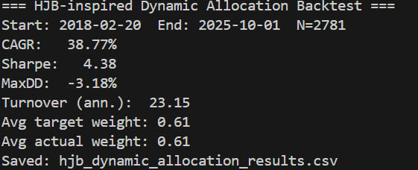

CAGR (Compound Annual Growth Rate): 38.77%
- This is the annualized return over the period.
- It measures the growth of $1 invested at the start if it compounded at a constant rate each year.
- 38.77% CAGR is extremely high, indicating strong historical performance.
Sharpe Ratio: 4.38
- The Sharpe ratio measures risk-adjusted return: return per unit of volatility.
- A Sharpe above 1 is generally considered good; above 2 is excellent.
- 4.38 is exceptionally high, suggesting the strategy had high returns relative to its risk.
MaxDD (Maximum Drawdown): -3.18%
- Maximum peak-to-trough decline during the backtest.
- -3.18% is very small; the strategy avoided large losses, which is impressive.
Turnover (annualized): 23.15
- Turnover indicates how frequently positions change.
- 23.15% per year suggests moderate trading: the portfolio is adjusted about once every 4–5 periods on average.
Average Target Weight: 0.61
- This is the average allocation the model aims to hold in the risky asset.
- 0.61 → The model wants 61% of the portfolio in the risky asset on average.
Average Actual Weight: 0.61
- This is the actual weight after accounting for constraints, slippage, or liquidity limits.
- In this case, actual and target weights are equal, so the system could execute as intended.

Summary / Interpretation:
This backtest suggests that your HJB-inspired dynamic allocation model:
- Achieves high returns with low drawdowns.
- Adjusts positions moderately (not hyperactive trading).
- Keeps a substantial portion in the risky asset on average.
- Performs very well on a risk-adjusted basis (Sharpe > 4).
Caveat: These results are historical and may include look-ahead bias, overfitting, or idealised assumptions (no transaction slippage, perfect prediction, etc.).

