# /Views/Students/Index.cshtml

Pre Edit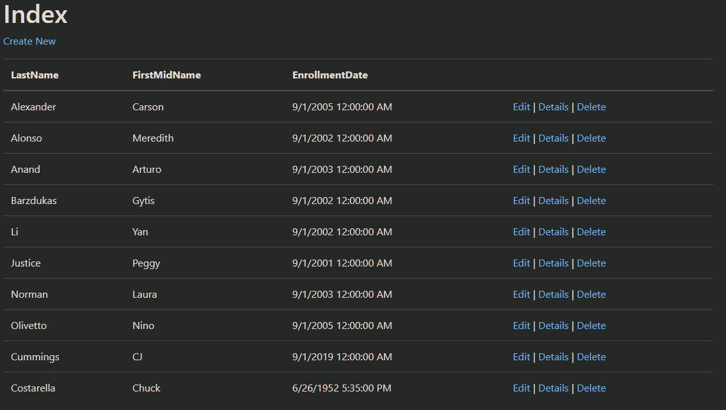

Post Edit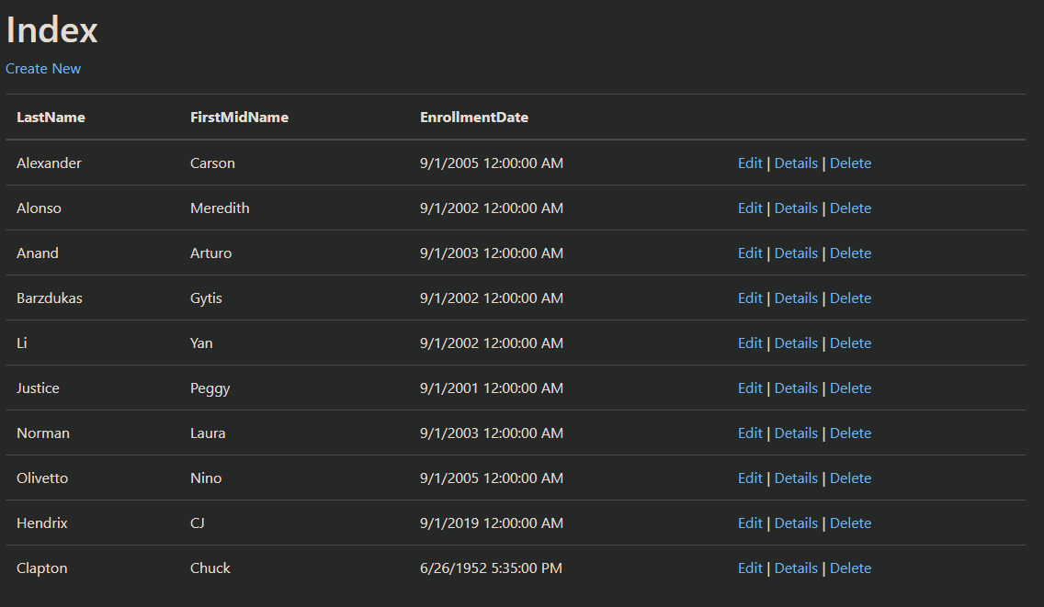

# /Views/Students/Edit.cshtml

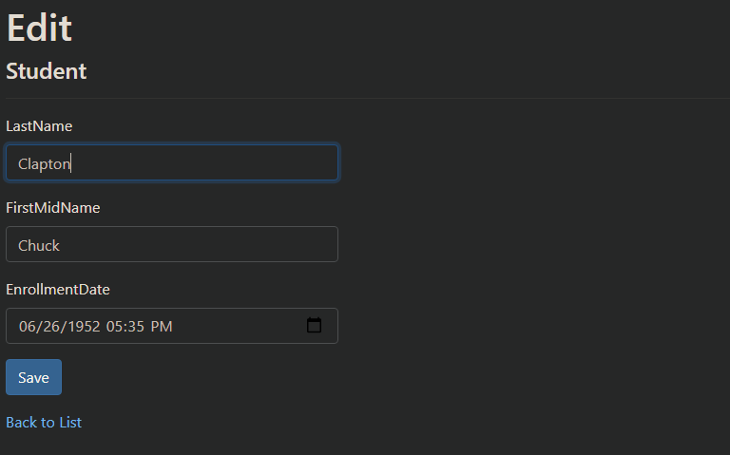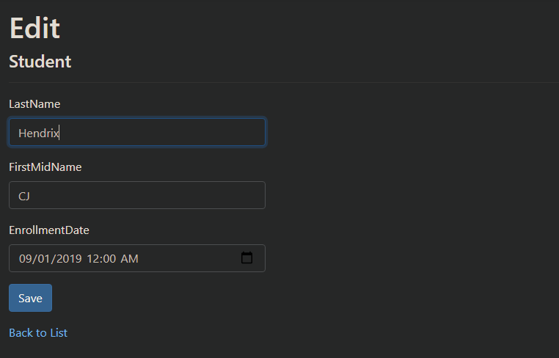

# SQL Server Object Explorer (Students.dbo)