Customer Retention & Churn Analysis
Task 2 — Data Science & Analytics Internship, Future Interns
Prepared by: Jatin | Subscription business, cohorts Jan 2023 - Dec 2024

1. Objective
This analysis studies customer churn patterns, retention drivers, and customer lifetime for a subscription-based business, in order to identify why customers leave and where retention efforts should be focused.

2. Data Overview & Cleaning
The raw dataset contained 2,510 customer records with signup date, subscription plan, region, acquisition channel, current status (Active/Churned), tenure in months, and — for churned customers — churn date and reason.
Data quality steps performed before analysis:
- Removed 10 duplicate customer records (same Customer_ID appearing more than once).
- Filled 15 missing Acquisition_Channel values with 'Organic', the most common channel, to avoid dropping records.
- Standardized inconsistent region-name casing (e.g. 'NORTH' → 'North').
- Derived a Signup_Cohort field (year-month of signup) to support cohort-based retention analysis.
Final clean dataset: 2,500 customer records, 0 missing values, 0 duplicates.

3. Key Performance Indicators
Metric | Value
Total Customers | 2,500
Active Customers | 1,379
Churned Customers | 1,121
Overall Churn Rate | 44.8%
Avg Tenure of Churned Customers | 6.8 months
Current Monthly Recurring Revenue (MRR) | ₹8,28,121

A 44.8% churn rate is high for a subscription business — as a benchmark, healthy SaaS/subscription businesses typically target well under 20% annual churn. This is the single most important number in this analysis and should be leadership's top priority.

4. Overall Retention Curve
Tracking all customers from signup, retention drops sharply in the first few months and continues declining through month 12, with just over half of customers (55.5%) still active a year after signing up.
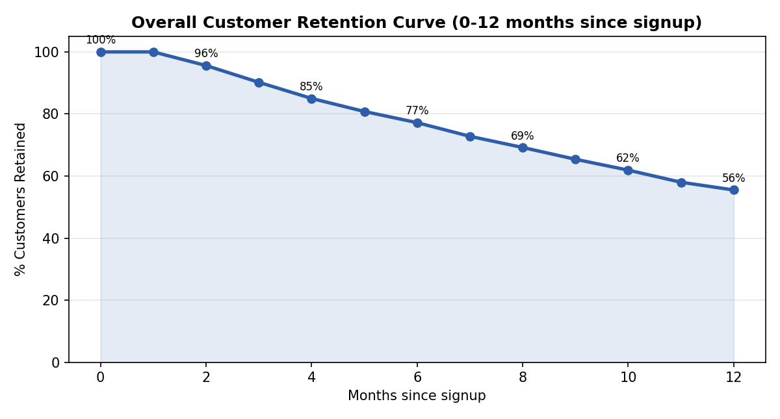
The steepest drop-off is between months 2 and 7 — this is the critical window where retention interventions (onboarding, engagement nudges, proactive support) would have the highest impact.

5. Cohort Retention Pattern
Viewing retention by monthly signup cohort (see companion Excel workbook, 'Cohort Retention' sheet, color-coded from red/low to green/high retention) shows the same pattern holds consistently across almost every cohort — this is a structural churn problem, not a one-off issue tied to a specific signup period or campaign.

6. Churn by Plan
Plan | Total | Churn Rate | Avg Tenure (months) | MRR (₹)
Basic | 1,098 | 55.5% | 7.4 | 1,46,211
Standard | 895 | 42.1% | 9.0 | 3,10,282
Premium | 507 | 26.6% | 10.4 | 3,71,628

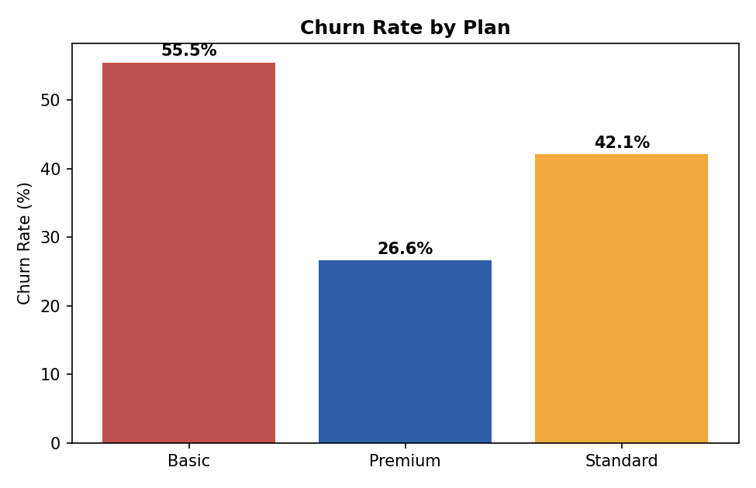
There is a clear, consistent pattern: higher-tier plans churn less and retain longer. Basic-plan customers churn more than twice as often as Premium customers, despite Basic being the largest plan by customer count.

7. Churn by Acquisition Channel
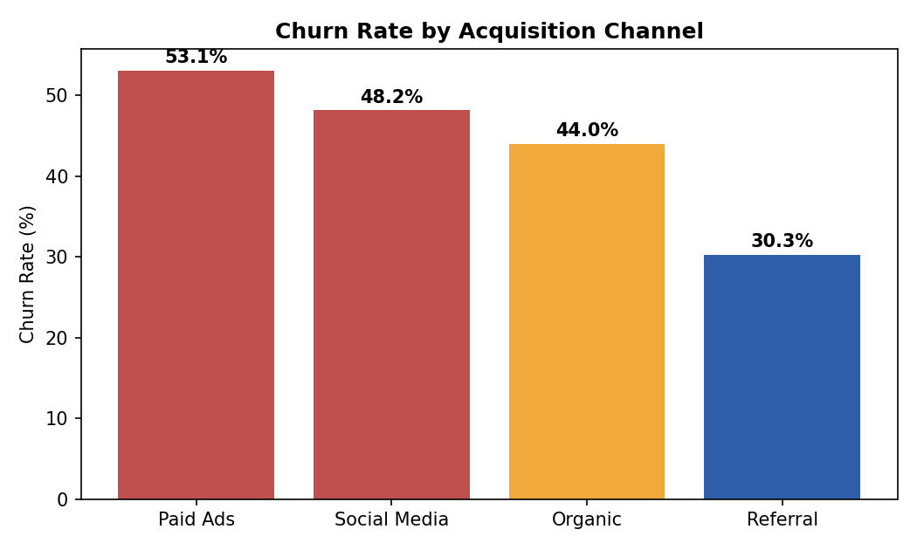
Paid Ads brings in the highest-churning customers (53.1%), while Referral customers churn far less (30.3%) — referred customers arrive with better expectations and tend to stick around, whereas paid-ad customers may be more price-sensitive or less qualified at signup.

8. Churn by Region
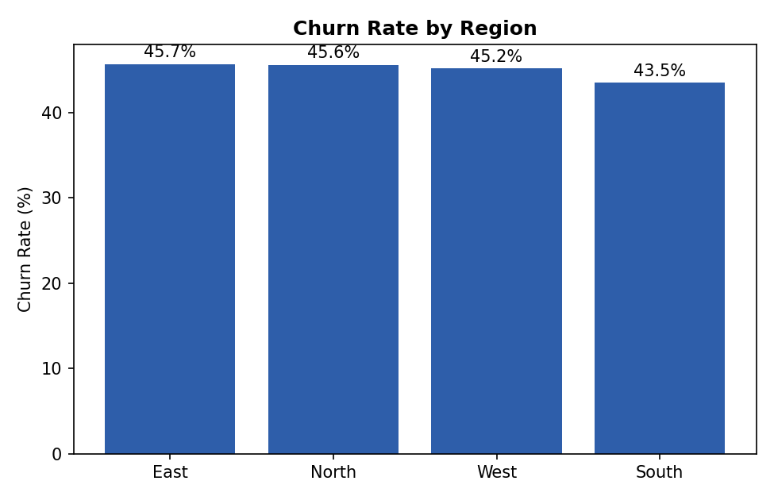
Unlike plan and channel, churn rate is fairly uniform across regions (43.5%-45.7%), indicating region is not a meaningful driver of churn for this business — the plan tier and acquisition channel matter far more.

9. Reasons for Churn
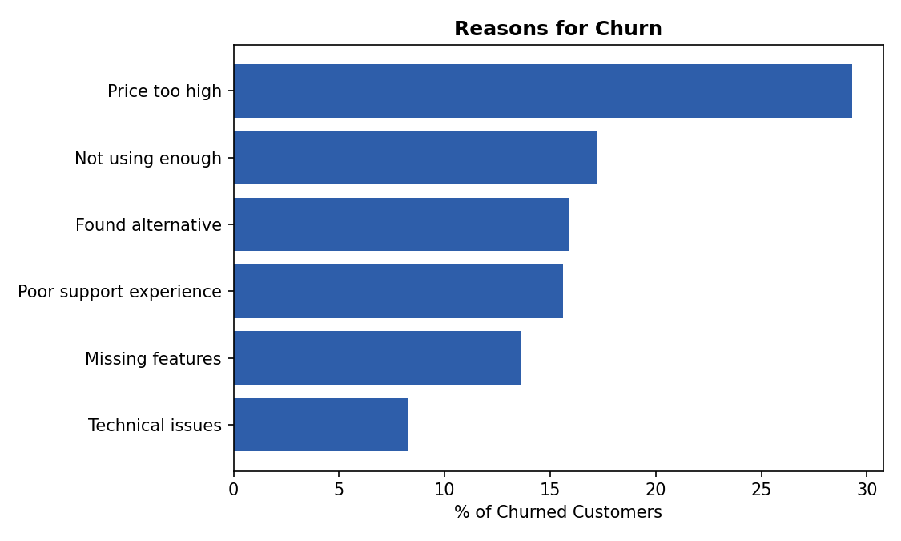
Price sensitivity is the single biggest stated reason for leaving (29.3%), followed by customers simply not using the product enough (17.2%) and finding an alternative (15.9%). Together, price and low engagement account for nearly half of all churn.

10. Key Insights
- Overall churn (44.8%) is high enough to be an urgent business problem, not a background metric.
- Plan tier is the strongest predictor of retention: Basic churns 2x more than Premium, and churns fastest (7.4 vs 10.4 months average tenure).
- Acquisition channel matters almost as much: Paid Ads churn (53.1%) is nearly double Referral churn (30.3%).
- Region has little to no effect on churn — it is not a useful lever here.
- Price and low engagement are the top two stated churn reasons, together explaining ~46% of churn.
- Retention drops fastest between months 2-7 of the customer lifecycle — this is the highest-leverage window for intervention.

11. Recommendations
- Launch a structured onboarding/engagement program targeting months 2-7 of the customer lifecycle, where the steepest retention drop happens.
- Re-evaluate Basic plan pricing and value — consider a mid-tier nudge (upsell path to Standard) since Basic customers churn 2x faster than Premium.
- Shift acquisition spend gradually from Paid Ads toward Referral programs — referred customers churn 23 points less than paid-ad customers.
- Address price sensitivity directly: test flexible/annual pricing or a loyalty discount for at-risk Basic-plan customers around month 4-5 of tenure.
- Since region is not a driver, retention initiatives can be rolled out uniformly nationwide rather than region-specific.

12. Deliverable Notes
A companion Excel workbook (Customer_Retention_Churn_Dashboard.xlsx) accompanies this report with: a one-page visual dashboard, retention curve, a color-coded cohort retention heatmap, churn breakdowns by plan/channel/region, churn reasons, and the full cleaned customer dataset.

