**[A4] Clustering and Feature Engineering**

**2021313075 백경인**

1. 선택한 데이터셋의 data point 개수 및 feature 개수

This dataset is about Abalone which is 전복. Following picture tells about our dataset and our task.

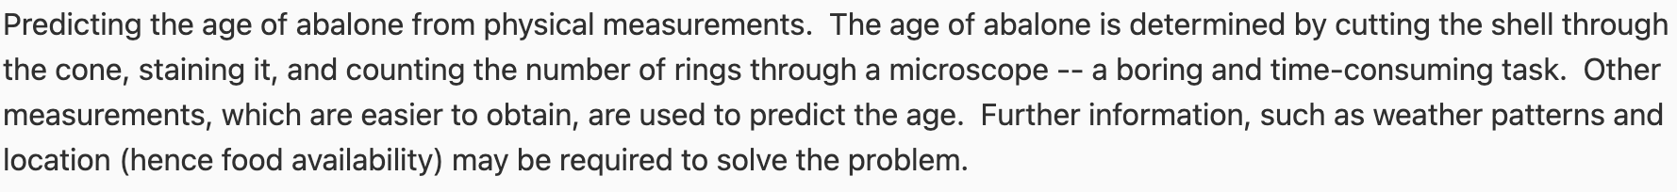

One thing I saw interesting is that the sex. Not only M, F there was I, which refered to infant.