
Blog Post Template

Internal Writing Resources
- Exact Market Blog post guidelines
- Best-Practices for Write a Blog Post Optimized for AI-Searches

Title (TC)
Key Takeaways (2-3 bullets)
Body Copy

CTA
FAQs To optimize AI searches (Generative Engine Optimization),  focus on direct, conversational answers (35-55 words) that address real user questions that can be found in "People Also Ask" or support logs.  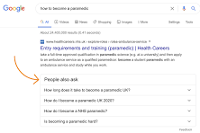 | 1.  2.  3.

Social Media Copy

