
Exact Market Blog Overview and Guidelines
Table of Contents
Why We Blog 1
File Tracker on Box 1
Publishing Cycle 1
Topics 1
POV 2
Lend Credibility 2
CTAs 2
Formatting 2
Include an Exact Market LinkedIn Post 3
Embrace storytelling 4

Why We Blog
At Exact Market, our blog is a dynamic platform to showcase our extensive B2B marketing expertise and skills in product marketing management, advisory roles, and creative content creation and design.

Our primary aim is to demonstrate the depth and breadth of our knowledge in product marketing management, technology, alliance building, channel partner relationships, and content marketing management. While we actively share our insights on social media, our current focus extends beyond generating leads. Client services frequently leverages our blog posts as a valuable resource when engaging with clients and prospects, illustrating our commitment to adding value through expertise and thought leadership.

File Tracker on Box
- Find posts we are planning and what we’ve published
- Create a folder and add your documents when you write a new post
- Use this naming convention: em-blog-title-v1.0

Publishing Cycle
Weekly blogs go live on Thursdays, topic sent to design the Thursday before for graphics.

Topics
- B2B technology news: Review what’s been done and create variety across posts
- Technology marketing, the channel, marketing to channel partners, alliances – but don’t give away any EM secret sauce 😉—a great place to ideate on industry sites and the news.

POV
Third person for technology subjects: not “your business can…” but “businesses can…”; written more journalistic, “this is what we observe” with proof points to back it up, vs. “we are the experts or an authority.”

First/second person for marketing and channel topics: Can be more direct (we/you) when delivering content around marketing and channel where we have expertise and are often providing thought leadership.

Lend Credibility
- Add stats and quotes to back up the storyline, particularly for tech topics
- Cite original reports, not referring articles
- Keep stats to within a year and ideally within six months, especially for AI topics, as blogs should be topical and relevant now. See statistics guidelines in the writing tips training.

CTAs
Unless we are promoting our own services, we typically do not include any kind of call to action. Simply give the blog a closing that makes sense or refers back to the intro to close the loop—doesn't have to be elaborate.

Formatting
Sections: Title, Key Takeaways, Body (with Subtitles), FAQs
Style: Chicago Manual of Style | EM Cheat Sheet
Title casing:
- Title: Title Case (e.g., Is AI Your New BFF—Or Your Biggest Privacy Risk?)
- Section Headers: Title Case (e.g., Sadly, Not All AI Friends Can Be Trusted)
- Sub-headers: Sentence case (e.g., Trustworthy AI doesn’t just show up—it’s built.)
Example: https://exactmarket.com/2025/06/is-ai-your-new-bff-or-your-biggest-privacy-risk/
Social hashtag casing:
- Use upper camel case: Capitalize the first letter of each word in multi-word hashtags (e.g., #CloudSecurity #ZeroTrust #WinnersCircle)
- Check out the EM LinkedIn page for post examples: Exact Market LinkedIn
Citation casing:
- Use the original capitalization style of the title as it appears in the source—do not convert it to title case if it was written in sentence case.
Sources: Footnotes and citations
- Format: #. Source, article/report title with link, month year
- Example: 1. Legal Dive, Companies lean on AI in push to curb cyber insurance costs, Sept 2024
- Per Chicago style, footnotes are placed after periods, not before.
- Duplicate citations: If a source is cited more than once in the same blog post, list each instance separately and number it sequentially. Use ibid. when citing the same source consecutively in the citation list.
Length:
- Typical length range (on average 700 words, but this can be flexible)
Links:
- Citation links: Use for Exact Market blog posts to credit sources, build authority with association to industry experts, and validate your blog’s information.
- Deep links: Use to cross-link to other EM blog posts only.
Misc.:
Do not include a TOC; do not include a placeholder [LINK] in the social—these things just have to be deleted before going live

Title: Should be short, sweet, and compelling. EM blogs support a main title as well as a subtitle that will show up under the hero image. The subtitle is optional.
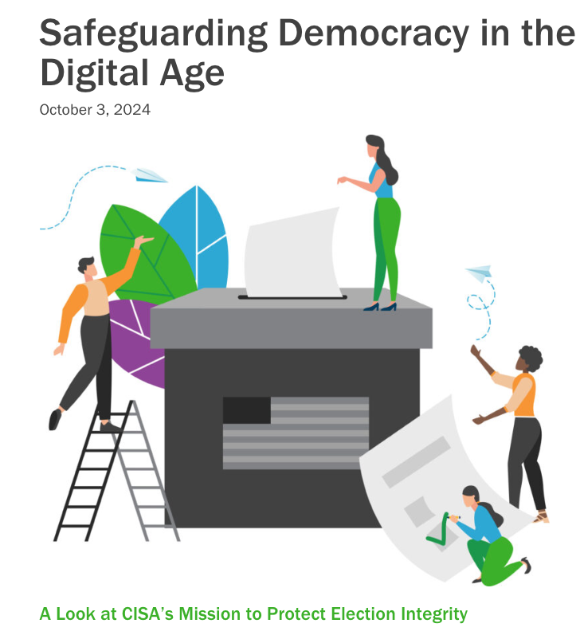
Design: Simple graphics are ok but not required; these will go through the design team
Misc: Avoid floating boxes and use tables instead
***Always Proofread***
Use the EM proofing checklist and seek a second pair of eyes on the team for review.

Include an Exact Market LinkedIn Post
- Carry through the same tone and POV
- Use social best practices
- Include relevant #hastages
- Watch for typos in the hashtags

Embrace storytelling
Product Marketing Alliance: What is storytelling in marketing?

Storytelling frameworks: https://blog.hubspot.com/marketing/two-simple-frameworks-thatll-make-you-a-better-storyteller-in-business-and-in-life

Headers and sub-headers: These are opportunities to tell a story. Keep them concise and meaningful. Use headers and sub-headers to:
- Facilitate the narrative
- Grab/keep attention
- Convey a key point
- Hint at what’s next
- Carry a theme throughout.
- A test for storytelling: If you only read the headers and sub-headers, do they tell a story? Can you make changes so they do?

More Writing Resources: EM Writing Training

