**WDD 330 Web Frontend Development II BYU-Idaho Fall 2022**

**Marc Williamson November 11, 2022**

**Final Project Proposal**

**Purpose:** Design and built a mobile web app for JW Farm, an organic vegetable grower, to assist in keeping up with current weather conditions, important upcoming farm dates, and tracking daily work log activities. App will ideally be used on mobile device to enter work log activities on the go while working on the farm.

**Audience:** Built specifically for use by JW Farm operators at JW Farm in Northern Alabama (growing zone 7A) but could easily be modified to accommodate other purposes.

**Data Sources:**

Current weather conditions will be pulled from api.weather.com from a particular personal weather station (ID: KALHARTS33) located at JW Farm in Hartselle, AL.

Important farm dates will be pulled from a local JSON file containing important annual farm events, like planting dates, frost dates, etc. The data pull will include the next 10 events from current date.

Work log entries will persist in local storage.

Images will come from selected images at JW Farm.

**File List**:

Index.html – main web page

Styles.css – css styling

Jwfarm.js – connected to index.html

Model.js – for getting the data

Controller.js – manipulating the data from model and communicating to view and vice versa

View.js – for generating/updating the user interface

**Wireframes:**

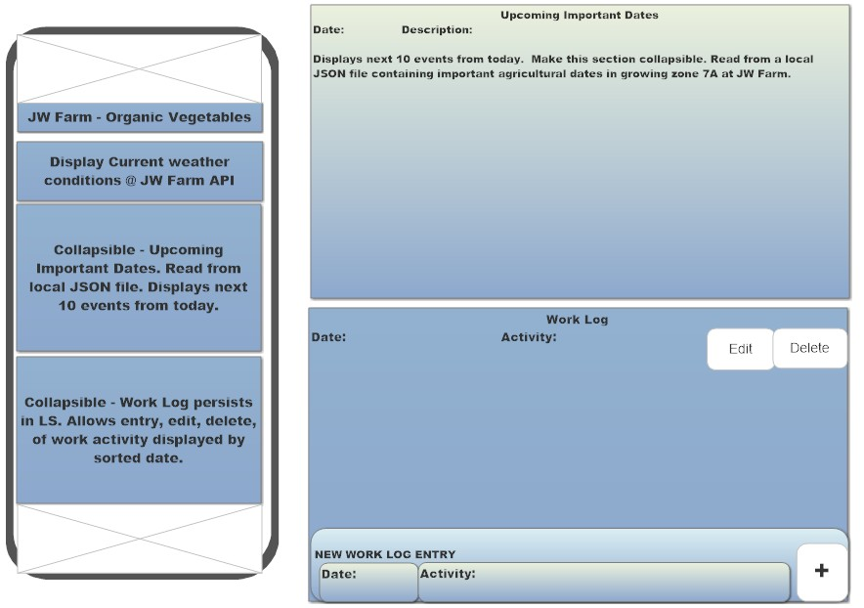

**Colors/Typography/Styling:**

Will use colors similar to wireframe above. Mainly light blues, light greens, and earth tones. Images will show dark greens and browns. Styling will be simple and clean. Typography will utilize a serif font for headings and a sans serif font for body text.

**Schedule:**

By 11/11/22 submit proposal

By 11/18//22 complete JSON data file, get API fetch working and displaying current weather conditions on page

By 11/25/22 complete display of upcoming events (Local JSON)

By 12/2/22 complete work log submission form and display work log entries on page (Local Storage)

By 12/9/22 complete functionality and styling of app.

By 12/15/22 complete testing and debugging and submit completed project