Question | 1
Type | NAT
Body | Light from free space is incident at an angle $\scriptstyle \theta_i$ to the normal of the facet of a step-index large core optical fibre. The core and cladding refractive indices are $\scriptstyle n_1=1.5$ and $\scriptstyle n_2=1.4$, respectively.  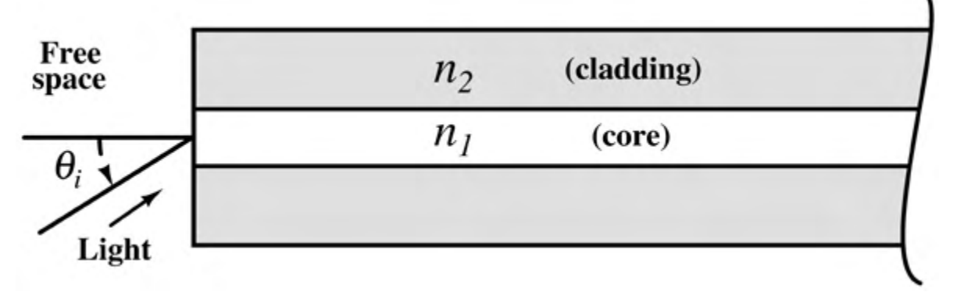  The maximum value of $\scriptstyle \theta_i$ (in degrees) for which the incident light will be guided in the core of the fibre is ________
Correct | 32.5 to 32.7
Explanation | Given: free-space index $\scriptstyle n_0=1$, core index $\scriptstyle n_1=1.5$, cladding index $\scriptstyle n_2=1.4$.  Concept: light stays guided only when it undergoes total internal reflection at the core-cladding boundary. Let $\scriptstyle \theta_r$ be the refraction angle inside the core at the fibre facet. The ray then meets the core-cladding boundary at an angle of incidence $\scriptstyle 90^{\circ}-\theta_r$.  Refraction at the facet (Snell's law): $\scriptstyle \sin\theta_i=n_1\sin\theta_r$.  Limiting case of total internal reflection: $\scriptstyle \sin(90^{\circ}-\theta_r)=\cos\theta_r=\tfrac{n_2}{n_1}$.  Then $\scriptstyle \sin\theta_r=\sqrt{1-\left(\tfrac{n_2}{n_1}\right)^2}=\tfrac{\sqrt{n_1^2-n_2^2}}{n_1}$.  Substituting in Snell's law: $\scriptstyle \sin\theta_{i,max}=n_1\sin\theta_r=\sqrt{n_1^2-n_2^2}=\sqrt{1.5^2-1.4^2}=\sqrt{0.29}=0.5385$.  So $\scriptstyle \theta_{i,max}=\sin^{-1}(0.5385)\approx 32.6^{\circ}$.  Hence the maximum angle of incidence is about $\scriptstyle 32.6^{\circ}$.  Tip: For a ray coming from free space, the core index cancels out and only $\scriptstyle \sqrt{n_1^2-n_2^2}=\sqrt{0.29}$ matters (the numerical aperture of this fibre), so any larger angle than this lets the ray hit the cladding below the critical angle and leak out.
Subject | EMFT - ECE
Topic | Plane Waves (Normal and Oblique incidence of Plane Waves)
Correct Marks | 1
Incorrect Marks | 0
PYQ | GATE ECE 2016 - 2
OTS ID

