2. (Use software such as Python, R, Matlab, etc ..) Suppose X1, · · · ,Xn are from N(0,1). The
distribution of the maximum X(n) does not have a closed form pdf. However, we can consider
two ways to approximate the pdf. Let n = 30.

(a) Approximate the distribution of X(n) by simulation, that is, repeat the data generation many
times and draw a histogram of X(n).
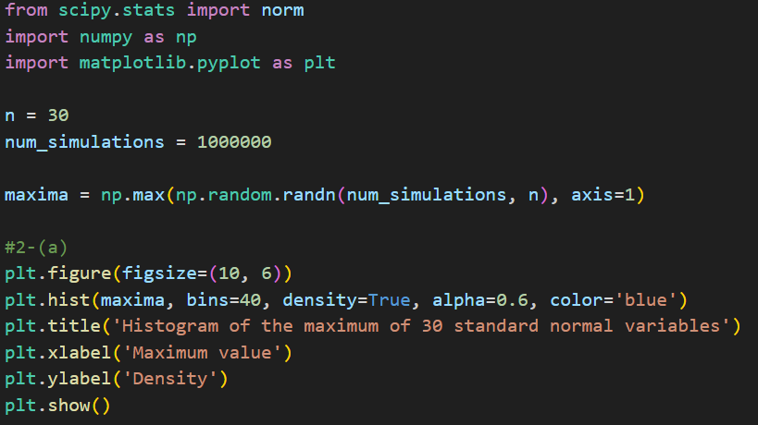
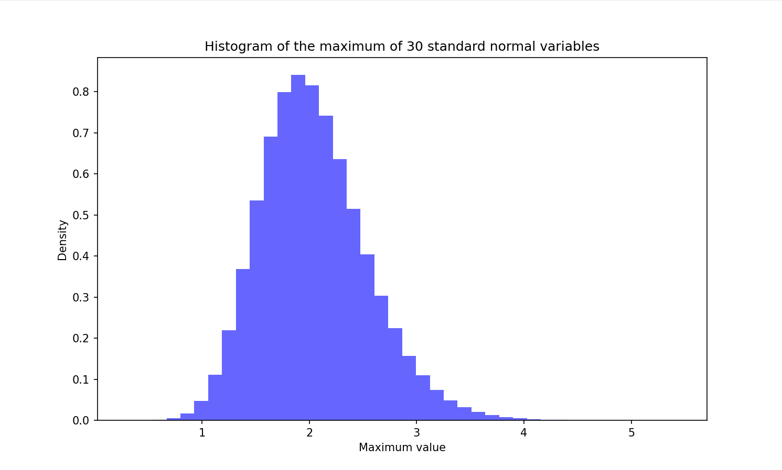
(b) Write the pdf of X(n), as learned from the class. Draw the pdf by numerically evaluating
the function over a grid. Compare this with the histogram in the above.
- Pdf of X(n) is $f_{X(n)}=n×ϕ\left(x\right)×{\left[Φ\left(x\right)\right]}^{n-1}$
- $ϕ\left(x\right)$is the PDF of the standard normal distribution and $Φ\left(x\right)$ is its CDF.
- Both plots demonstrate that the theoretical PDF is consistent with the simulated data, validating the use of the given mathematical model to describe the behavior of the maximum of standard normal variables for n=30.
