TouchStone© 2003  System Design & Programming  Dr Simon Wilkinson  Educational Design & Quality  Dr Reg Dennick  Dr John Whittle  Statistics  Mr Paddy Riley  Usability/Functionality Testing  Mr Ash Self (Sheffield)  Question & Test Interoperability (QTI)  Dr David Davies (Birmingham)  Backend Server Configuration  Dr Ian Vincent  Mr Roy McPartland  Mr Andy Barker  Mr Matt Hamilton (www.netsight.co.uk)  TouchStone  University of Nottingham Medical Education Unit  Copyright 2003 – All rights reserved  Licensed exclusively to  University of Sheffield Medical School |  |     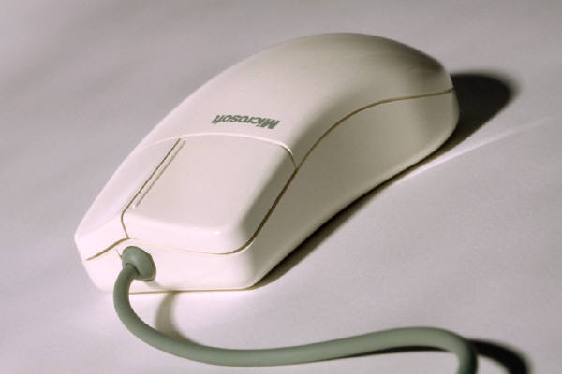  TouchStone  Medical Education Unit - © 2003    Licensed exclusively to  University of Sheffield Medical School  

