

System Documentation
Copyright © 2003 - University of Nottingham, Medical Education Unit

Table of Contents
1.0 Introduction 3
1.1 Types of Assessment 3
2.0 Question Types 4
2.1 Dichotomous 4
2.2 Multiple Choice 6
2.3 Multiple Response 8
2.4 Extended Matching 10
2.5 Likert Scale 12
2.6 Ranking 13
2.7 Fill-in-the-Blank 14
3.0 Creating Assessments 17
3.1 Creating new Questions 17
3.2 Creating new Papers 20
4.0 Outcome Explorer 21
5.0 Marking and Statistics 24
6.0 Searching 27
7.0 Importing/Exporting Questions 29
8.0 Uploading into the NLE 30
Appendix A - Technical Specification 32
System Architecture 32
General System Specification 32
Question Types 32
Appendix B – Database Architechure 34
Properties Table 34
Papers Table 34
Questions Table 35
Options Table 35
Appendix C – System Code 36
Paper Display 36
Add Scripts 36
Edit Scripts 36
Delete Scripts 36
Other Scripts 37
Statistics 37
GD Library scripts 37
Outcomes Explorer 37
Interoperability 38

1.0 Introduction

TouchStone is a purpose-built Assessment/Survey system designed to integrate with the Networked Learning Environment VLE. It is entirely web-based to allow easy access by staff and students at any site and any computer platform. Running over secure SSL protocols the system supports four distinct types of paper: 1) formative assessment, 2) progress test, 3) summative assessment and 4) surveys.

1.1 Types of Assessment

TouchStone supports the following four types of assessments/surveys.
- Formative Assessment
Assessment paper is presented to the examinee on a screen by screen basis. When the final screen in completed a final single screen is displayed showing all the questions marked by the system and any pre-entered textual feedback from the exam writer.
- Progress Test
Assessment paper is presented to the examinee on a screen by screen basis but unlike formative assessments the final screen only confirms with the examinee that all selections and marks have been recorded by the system. This allows a number of different students to complete the test over a period of time and not to be able to determine the correct answers until some predefined time. All students who have completed a particular progress test can be emailed their marks individually by using the ‘Class Totals’ part of the ‘Statistics’ menu.
- Summative Assessment
Summative assessments for all intents and purposes can be thought of as Progress Tests, certainly in how they are handled by the system. The two types are separately provided for to allow staff to diferentially code up assessments of both types and then to list them separately.
- Surveys
Surveys, like assessments, are presented screen by screen. At the end the user is told that their responses have been sucessfully recorded by the system. The main difference between surveys and summative assessments is that the responses to a survey are not marked. The data remains in the database so that staff may perform an item analysis and determine the number of reponses per question option.

2.0 Question Types

2.1 Dichotomous

Presentation
Dichotomous type questions present a clinical scenario, lead-in and a variable number of options (or stems) to which the examinee must answer either ‘True’ or ‘False’, or ‘Yes’ or ‘No’. Depending upon the configuration of a particular question the system will support positive or negative marking and the addition of an ‘Abstain’ answer.

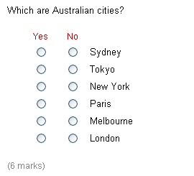
Figure 1: Six option textual dichotomous question using ‘Yes’ / ‘No’ labels.

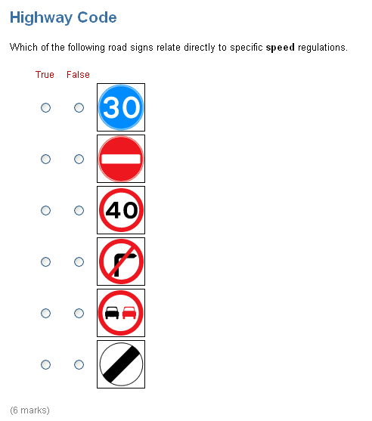
Figure 2: Six option graphical dichotomous question using ‘True’ / ‘False’ labels.

Marking

Dichotomous questions can be marked in positive or negative mode. Positive mode assigns one point to each correct option and zero to incorrect options. Negative mode, however, assigns one point to each correct option but negative one to each incorrect option.

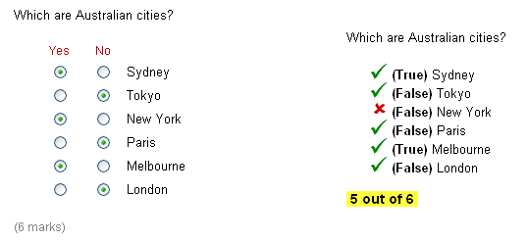
Figure 3: Dichotomous question selections (left) and marked (right).

Figure 3 shows on the left hand side the various choices a user made to the available options. On the right of this figure shows the interface presenting this question marked. New York is not an Australian city and so a red cross is displayed next to it. The embolded text within the brackets shows the correct answers. So in the case of New York it is meant to be False. Positive marking in employed in Figure 3 so the user receives 5 out of 6.

2.2 Multiple Choice

Presentation

Multiple choice questions allow the examinee to select one answer from a range of options. Between 2 and 12 different options can be included per question and these can be made up of text or other media (graphics, Chime, audio, video). As Figure 4, Figure 5 and Figure 6 show, the system can support a variety of different interface presentation styles. In Figure 4 the options are short and so to save space the examiner has opted to choose horizontal alignment. Figure 5 shows graphical options, in this case safety symbols, that are vertically oriented. Finally, in Figure 6 a dropdown list is used to present the options. In this last case only text can be used as the options – no media formats can be supported.

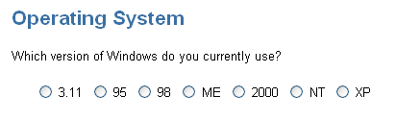
Figure 4: Seven option textual multiple choice question layed out horizontally.

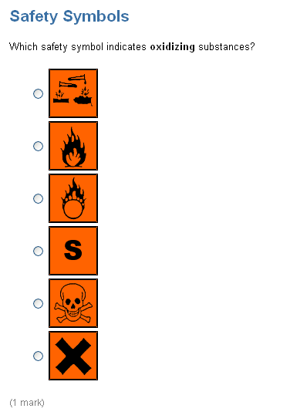
Figure 5: Six option graphical multiple choice question.

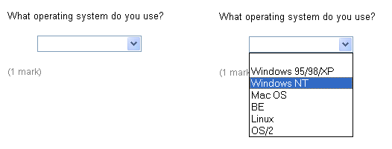
Figure 6: Six option dropdown list multiple choice question.

Marking

One mark is assigned to a correct answer, zero to incorrect answers. Figure 7 shows a graphical multiple choice question that has been marked. In this example the user has selected incorrectly the ‘S’ symbol. A red cross is placed next to this to show that it is wrong. The text ‘Is correct’ is placed next to the burning circle symbol to indicate that it is the correct answer.

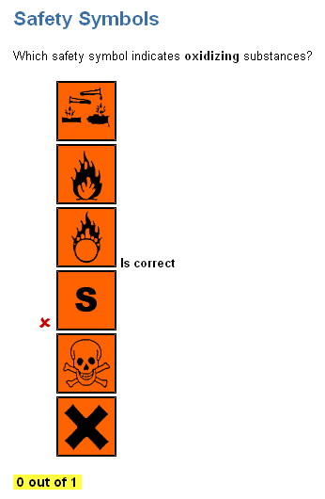
Figure 7: Graphical multiple choice question marked.

2.3 Multiple Response

Presentation

Multiple response questions, like multiple choice questions, contain between 3 and 12 options. However, they differ in that the examinee is asked to select multiple options as part of their answer. In the example shown in Figure 8 the examinee is asked to select 2 of the options displayed. If they try to cheat and simply select all options, after clicking a third a popup warning similar to the one shown in Figure 9 will be displayed. When the user selects ‘OK’ the system will automatically unselect the last option.

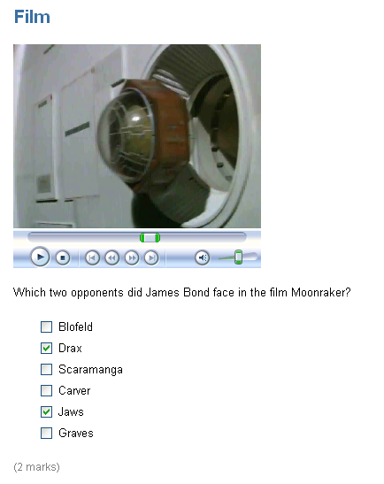
Figure 8: Six option multiple response question using video to augment the textual lead-in.

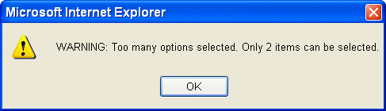
Figure 9: Popup warning if the examinee selects more options than they should.

If an image (GIF, JPEG or PNG) is wider than 550 pixels or higher than 550 pixels then a magnifying glass icon will be displayed beneth it. In such circumstances the image is initially shown at half size with the plus magnifying glass shown. When the user click on this JavaScript automatically resizes the image to the original larger size (i.e. zooms in). At this stage the magnifying glass will change to a minus sign and if clicked again will zoom out by altering the image to half its size again. This method is used so that high resolution X-Ray and other images can be loaded and zoomed without becoming pixelated. Images smaller than 550 pixels width or 550 pixels height will simply be displayed at their normal size and the magnifying glass icon will not be displayed.

Marking

Since there is the risk of an examinee selecting all the checkboxes of a multiple response question, as highlighted above, TouchStone employs two different marking schemes for this type of question:
- One mark is awared per correct answer. So, for example, in Figure 8 the question is marked out of 2. However, in this mode the question writer must specify how many options are expected in the answer. The system will, as seen in Figure 9, display a warning if more options are selected.

- In situations where the question writer does not want to specify how many options should be specified the system will support the marking of all stems. In such circumstances 1 mark is given for each stem if correct. So, for example, if an option should be selected and the examinee has then 1 mark is awarded, but also if an option should be left blank (i.e. inappropriate) and the examinee has left it unchecked then again 1 mark is awarded. If the examinee selects an option that should not or does not select an option which should then the system will take off 1 mark for that stem. Assuming a roughly 50:50 split in the number of correct to incorrect options an examinee checking all options will receive zero marks.

2.4 Extended Matching

Presentation

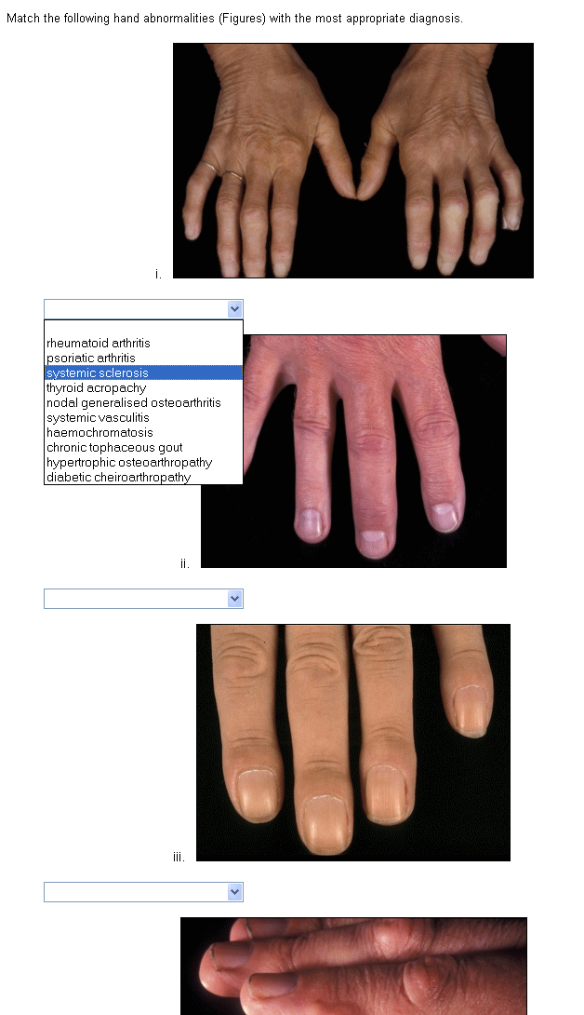
Figure 10: Extended Matching (single response) using graphical instead of the more traditional textual scenarios.

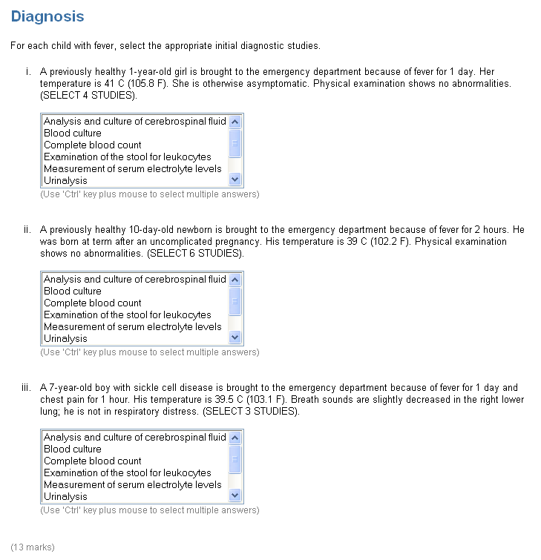
Figure 11: Extended Matching example allowing the examinee to select multiple studies for each of the three clinical scenarios.

2.5 Likert Scale

Presentation

Likert scales will normally be used with surveys, however they can be marked if so desired for assessments. Any number of points on the scale are available from 3 to 10 and the labels at each end, in the case of Figure 12 ‘Disagree’ and ‘Agree’ can be edited by the examiner.

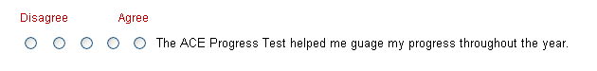
Figure 12: Five point likert scale labelled ‘Disagree’ to ‘Agree’.

Marking

As stated above likert scales would normally be used unmarked in surveys, however in situations where they are included in assessments 1 mark is given for a correct position on the scale and 0.5 marks awarded for neighbouring positions. Zero marks awarded for any other position on the scale.

2.6 Ranking

Presentation

Ranking questions allow the examinee to assign various positions to the range of options presented. In the example shown below in Figure 13 student is being asked to put the planets in the solar system in order starting with the one nearest the sun.

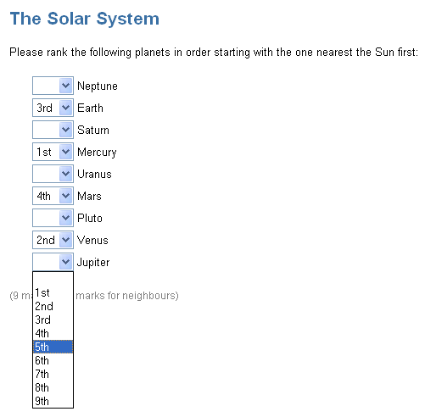
Figure 13: Ranking example using 1 mark per correct option with half marks if the examinee got to within one position of the true order.

Marking

Ranking questions can be marked in three different ways:
- One mark is assigned to each option correctly placed (e.g. Earth = 3rd). No marks are awared or subtracted for incorrectly ranked options.
- The example in Figure 11 has half marks for correct neighbouring positions. In this mode the system will award 0.5 marks if the examinee put Earth as 2nd or 4th. This allows an examiner to award marks if the overall pattern of a student’s reponses roughly correct.
- Ranking only selected options with a bonus mark for correct order. This mode is useful in medicine when it is useful to present the student with a range of different options but only ask them to rank the top three most important (see Figure 14). In this mode the system will assign 1 mark for each correctly selected option (independent or correct rank). This marking scheme is the same as multiple response. However, if the examinee got all the correct responses in the correct order as well then they are assign an extra bonus mark worth one point.

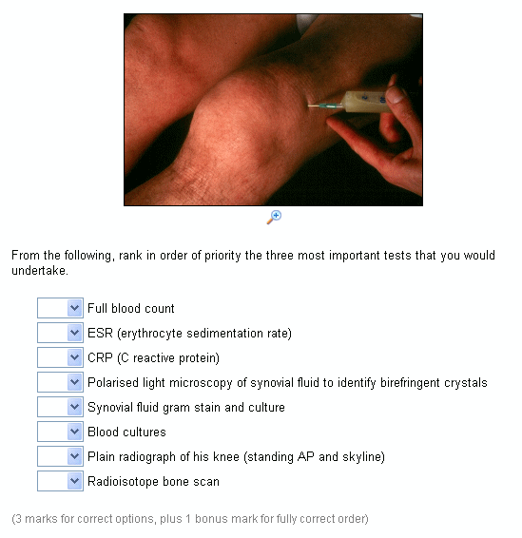
Figure 14: Ranking example using the bonus mark method with a number of distractors which are not to be ranked.

2.7 Fill-in-the-Blank

Presentation

Fill-in-the-blank questions require the examinee to select a correct option for each blank within a paragraph(s) of text (see Figure 15). Because of the difficulty associated with computers marking free-text input boxes (spelling mistakes, synonyms, etc), TouchStone has a dropdown list version of this question type. The examiner writes the question and included the correct answer for each blank (e.g. Cretaceous) together with a number of distractors (e.g. Triassic and Jurassic). The order of all options is randomised within each dropdown list each time the question is displayed.

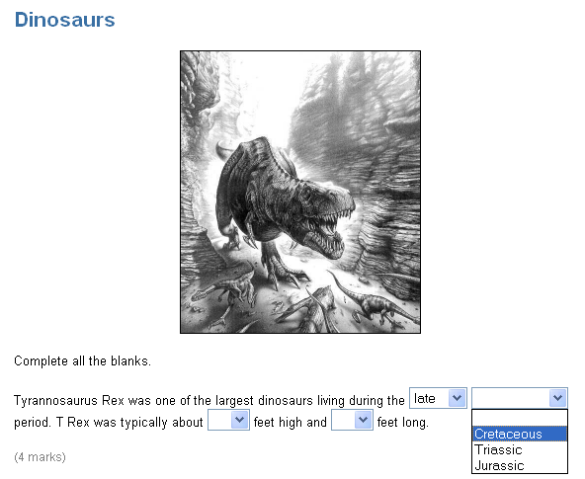
Figure 15: Fill-in-the-Blank question using dropdown lists for each blank.

Marking

One mark is awared for each blank correctly answered. As Figure 16 shows, a tick or a cross is inserted next to each blank to indicate if the examinee got it right or wrong. If they got it wrong the correct answer is displayed in bracked emboldened (e.g. ‘Late’ Cretaceous).

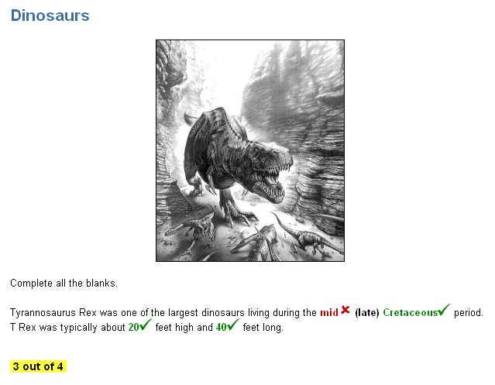
Figure 16: Fill-in-the-Blank marked.

3.0 Creating Assessments

3.1 Creating new Questions

New questions can be created by any member of staff by selecting ‘Create new Question’ from the ‘Question Bank Tasks’ menu. A popup menu will be displayed, as shown in Figure 17 listing all the available types of questions that the system supports. Clicking on a specific type of question takes the question writer to an add interface specific to that question type.

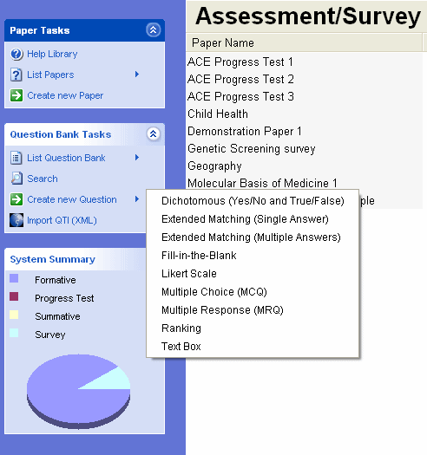
Figure 17: Popup menu showing all the different types of questions that can be created.

Although the add interface differs slightly according to the type of question being added, there is nevertheless many common features. For example, all question types can have a theme, supporting media, clinical scenario, lead-in, notes, keywords and learning outcomes. The add interface for a multiple choice question can be seen in Figure 18.

When all the necessary fields are complete and the question writer click on the ‘Add Questions’ button at the bottom of the screen the system will create a new set of records in the question database and upload any specified media. This question is now in the Question Bank but as yet unassigned to a specific assessment or survey paper.
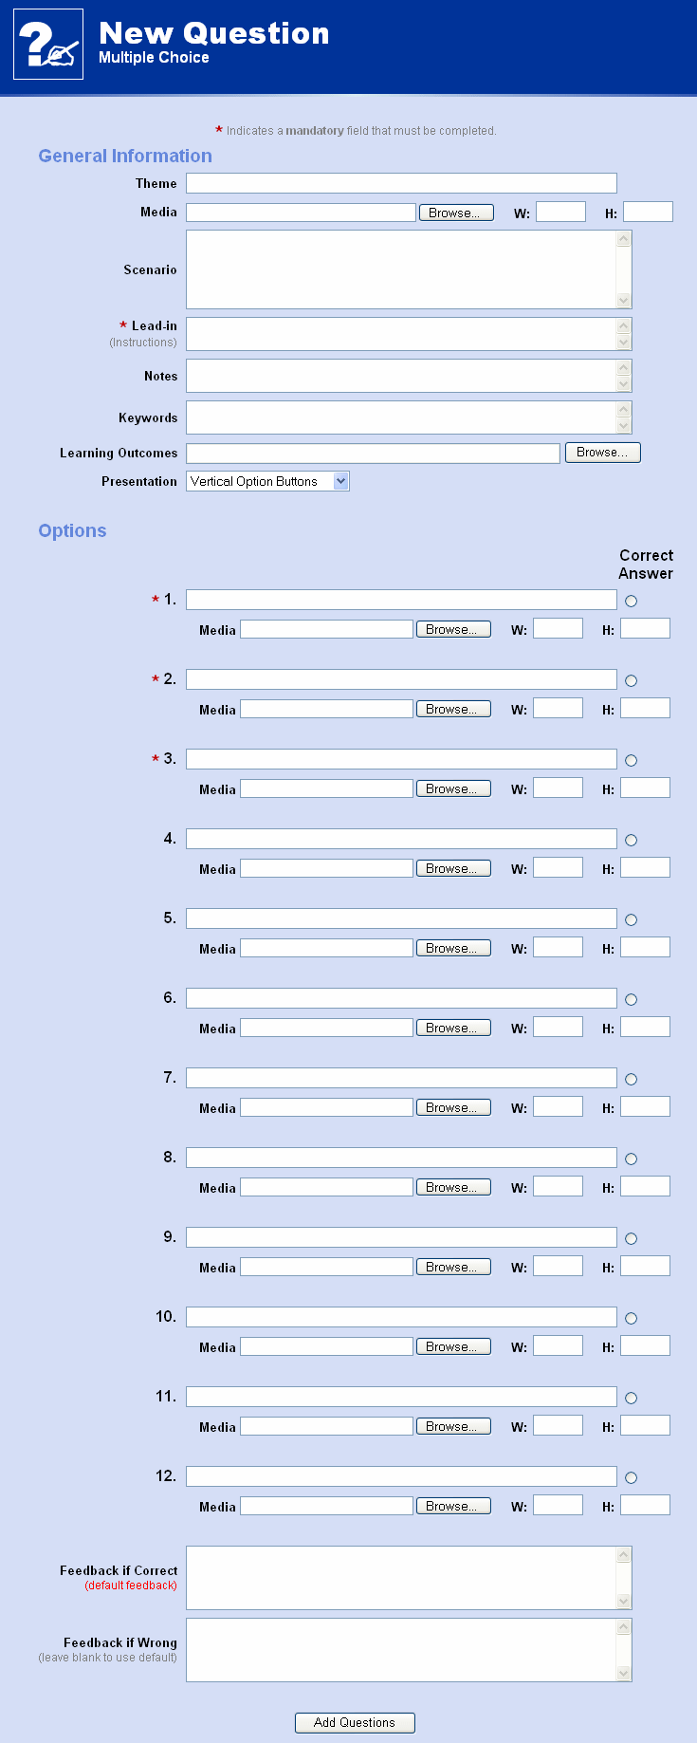 | Figure 18: Add interface for a multiple choice question.
To add a newley created question to an existing paper the examiner should first select a relevant paper to work on. To display a list of the papers the ‘List Papers’ option in the ‘Paper Tasks’ menu should be selected. Once a paper is selected the menu will change to include a ‘Current Paper Tasks’ menu. From here the ‘Add questions to Paper’ link can be selected and a list of questions, similar to those in Figure 19, will be displayed. By default screen shows all questions in the Question Bank that are currently unassigned to any paper.

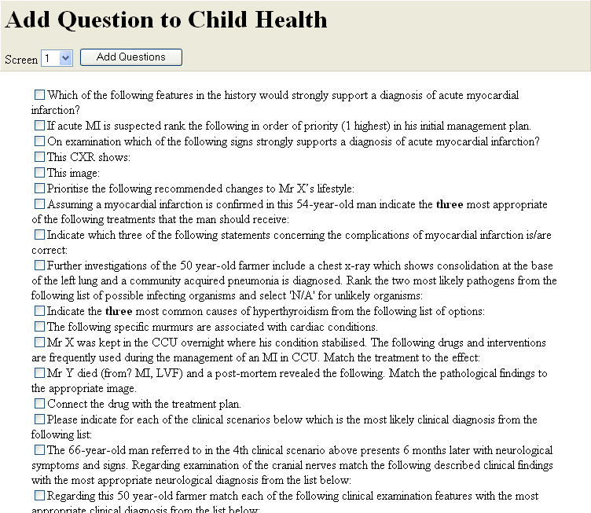
Figure 19: List of questions which can be added to the ‘Child Health’ paper.

3.2 Creating new Papers

To create a new paper (assessment or survey) there must first be at least one available question in the question bank. If there is not a new question must be added (see Section 3.1 above). To start adding a new paper select ‘Create new Paper’ from the ‘Paper Tasks’ menu. A form similar to the one in Figure 20 will be displayed which will allow the examiner to set a paper title (must be unique), the type of the assessment (formative, progress test, summative or survey), which candidates are allowed to sit the paper (i.e which degree programmes), which year of study and finally the time and date when this new paper will be available from and to. When all the relevant details have been set the paper writer should click the ‘Next >’ button.

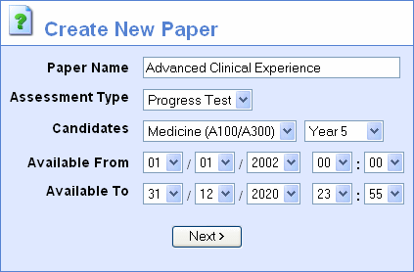
Figure 20: Setting the properties of a new paper.

Having sucessfully set the properties of the paper a list of available questions from the Question Bank will be displayed which is the same as adding questions to an existing paper (see Figure 19). Select (check) the relevant questions, set the screen number they will appear on and then click ‘Add Questions’.

4.0 Outcome Explorer

In a similar way to the HTML file input type with its ‘Browse…’ button for selecting various files, the ‘Outcome Explorer’ seeks to do a similar thing but instead selecting outcomes from the curriculum map. When adding a new question the examiner cannot write in the learning outcome as free-text but must instead select the ‘Browse…’ button to display the Outcome Explorer as shown in Figure 21.

The interface defaults initially to Tree view where a collapsable heirarchy of outcomes is displayed for the whole curriculum. At the top are broad programme outcomes. Clicking on these reveals more detailed subordinate outcomes related to specific modules. Expanding these further reveal more detailed outcomes which may be specific to individual sessions (e.g. lecture, seminar, ward round, etc.). At this level the examiner writing the question is selected with all the session outcomes together with checkboxes next to each item. As many as required can be selected and then the ‘Add Outcomes’ button clicked. Outcome Explorer will be closed and the selected outcomes linked in with the question being added.

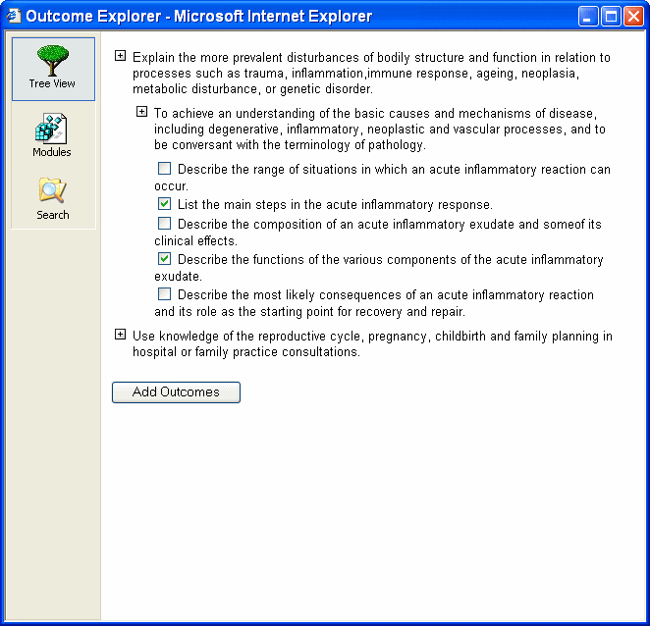
Figure 21: Outcome Explorer showing all curriculum outcomes in tree view.

Figure 22 shows Outcome Explorer in ‘Module View’ whereby all module and session outcomes are grouped together and categorised by which module they apply to.

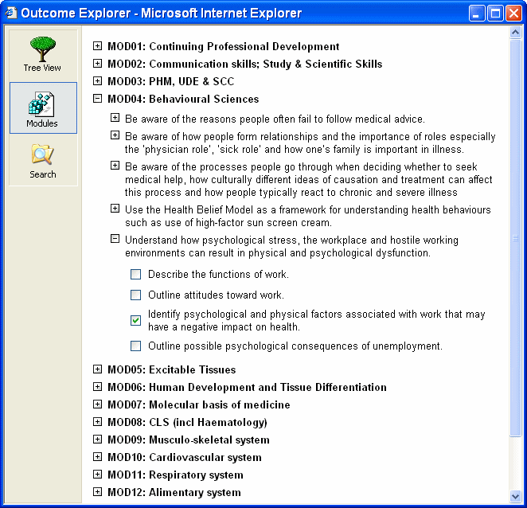
Figure 22: Outcome Explorer showing outcomes categorised by module.

The final tab ‘Search’ presents various options and facilities for find outcomes anywhere in the entire curriculum map (see Figure 23). A keyword may be entered and various parameters set such as the type of outcome (e.g. knowledge, practical skill, transferable skill, etc.), what year of study and session it applies to.

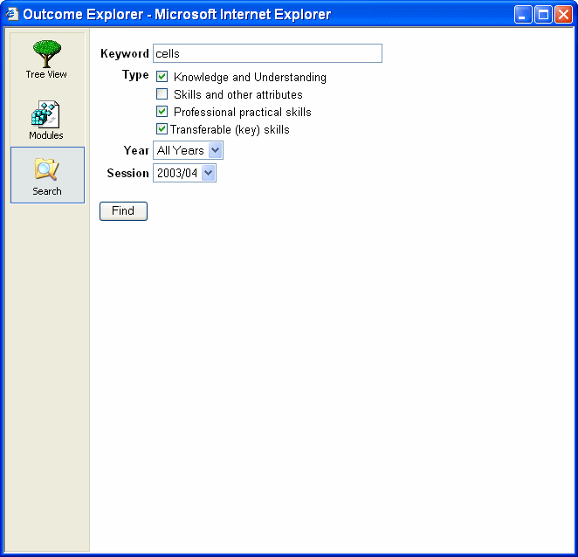
Figure 23: Outcome Explorer showing the search interface.

5.0 Marking and Statistics

5.1 Introduction

Currently two reports are available regarding a cohorts’ responses to a paper: 1) class totals and 2) item analysis. As Figure 24 shows, the examiner must selct a start date/time and an end date/time to define the time boundaries of the investigation. Having set the date/times one of the two links below may be selected.

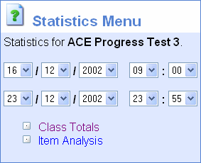
Figure 24: Statistics menu options.

5.2 Class Totals

The ‘class totals’ report displays, as shown in Figure 25, one line per examinee (ordered by examinee’s last name) listing the following information: Examinee last name followed by initials, NLE username, raw mark, adjusted percentage, start time, total duration. In the case of the ‘ACE Progress Test 3’ paper shown in Figure 25 the raw mark is an unadjusted total number of marks awared to the examinee for this paper. In this case the paper was marked out of a total of 200 marks. The ‘adjusted percentage’ column takes this raw mark and subtracts the ‘expected mark’ from the examinee’s mark and displays this as a percentage out of the total number of marks possible on the paper minus the expected mark. This adjusting is particularly important in the absence of negative marking where there is a statistical probability of selecting the correct answer purely by chance. For example, a True/False question worth 1 mark would have an expected mark of 0.5 marks. A four option MCQ question worth 1 mark would have an expected mark of 0.25 and so on. These probabilities are all calculated automatically by the system.

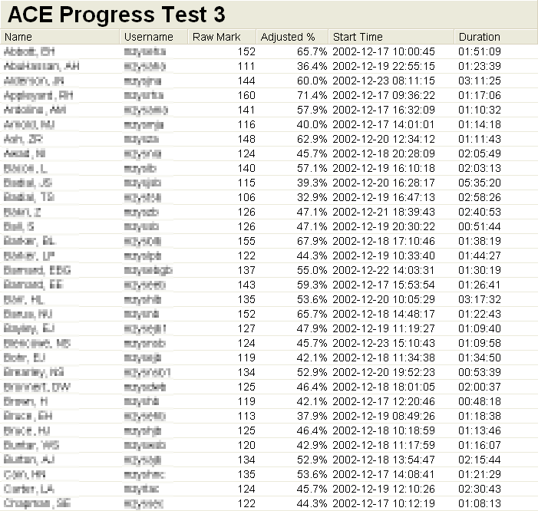
Figure 25: Class totals for assessment ‘ACE Progress Test 3’.

At the bottom of the ‘class totals’ report a number of summary charts are displayed. As shown in Figure 26 a distribution bar chart shows adjusted percentage mark against occurrence. Percentages below 40% are displayed in red to indicate failures. Below this bar chart is a scatter plot showing adjusted percentage mark against time in minutes. Again, marks below 40% are displayed in red. Below the charts some quantitative summaries are presented: number of students submitted, total marks for the paper, the calculated expected mark, average raw mark and average adjusted percentage, standard deviation of the raw mark, maximum raw mark, minimum raw mark and the average time taken to complete the paper.

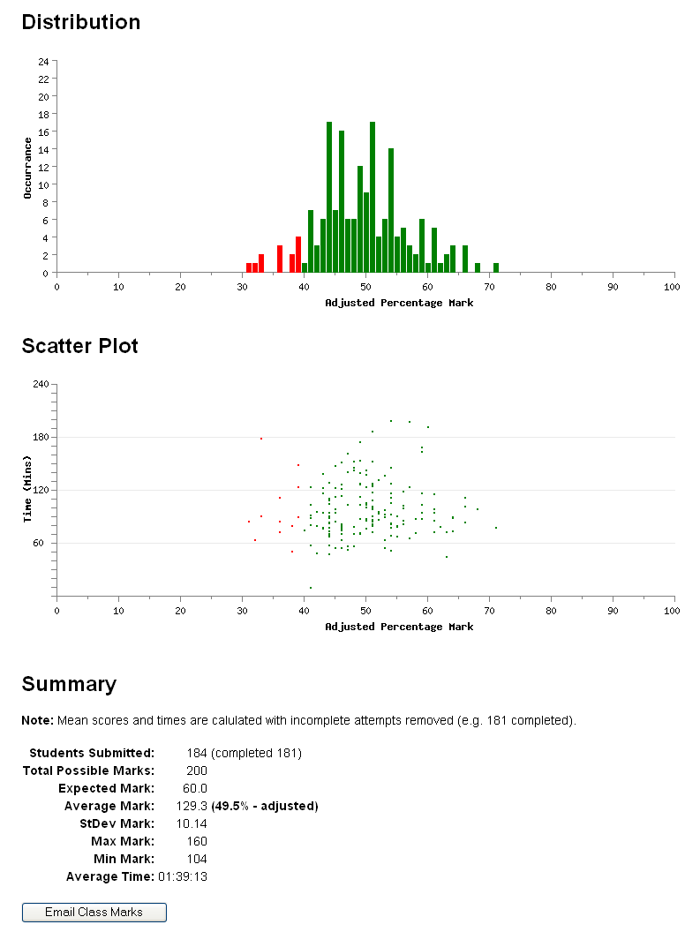
Figure 26: Continuation of Figure 25 (bottom of screen).

5.3 Item Analysis

6.0 Searching

TouchStone provides for the full-text search of an combination of the following fields: theme, scenario, lead-in, options and keywords.

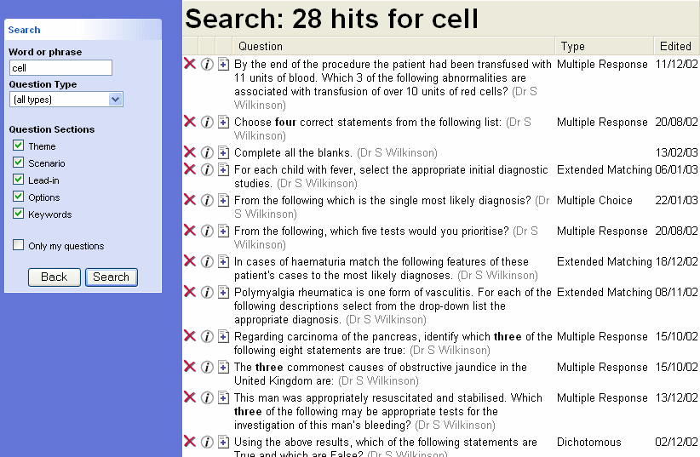
Figure 27: Search options (left) together with results (right).

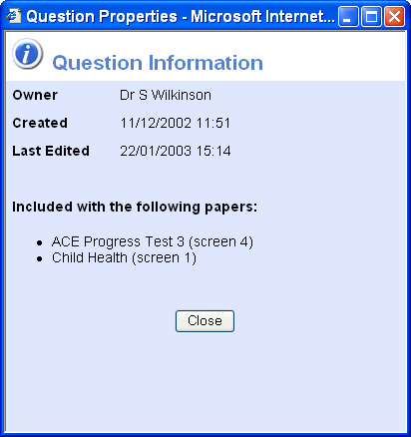
Figure 28: Question details displayed after click on an information icon in Figure 16.

7.0 Importing/Exporting Questions

8.0 Uploading into the NLE

All add, edit and statistics screens within TouchStone are accessible to staff only. However, when an assessment paper or survey is completed it will at some point need to be taken by the students. A link can be inserted into the NLE by first selecting the relevant paper to be linked to and then clicking ‘Upload to the NLE’ from the ‘Current Paper Tasks’ menu. An upload wizard similar to the one shown in Figure 29 will be displayed. The title will automatically be inserted based on the title of the paper in TouchStone. The uploading member of staff is free to alter this title but it is advisable not to. Unlike the standard upload wizard for files and URLs the assessment wizard does not know which course the assessment applies to. A dropdown list of all available courses is provided at the top of the wizard. Uploaded papers will be put in the ‘self-assessment’ section of the selected course.

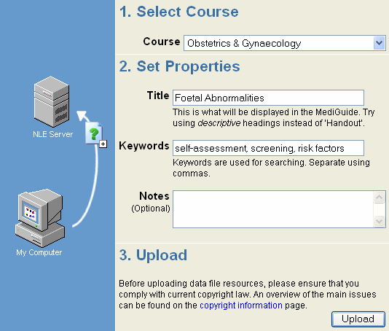
Figure 29: Paper upload wizard.
After clicking on the ‘Upload’ button a ‘Resource Added’ confirmation dialog box will be displayed. Clicking ‘OK’ will take the user back to the relevant course in the NLE, in this case Obstetrics and Gynaecology and the newly uploaded resource will be visible (see Figure 30).

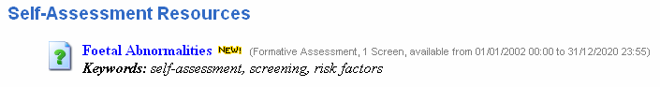
Figure 30: Uploaded paper linked into the NLE and visible to students.

The type of assessment, number of screens and date available from and to are all picked up from the settings of the paper in TouchStone. These may be altered by selecting the paper in TouchStone and then clicking ‘Edit Properties’ from the ‘Current Paper Tasks’ menu. The hyperlink next to the assessment icon is always active even when the current date is not between the specified dates the paper may be taken. However, this link takes the student to a screen similar to the one shown in Figure 31. It is at this point that the ‘Sit Paper’ may be disabled if the current date is outwith the timeframe when the paper is avaible to be completed. The date only applies to students though, staff may still take the paper for testing purposes at any time.

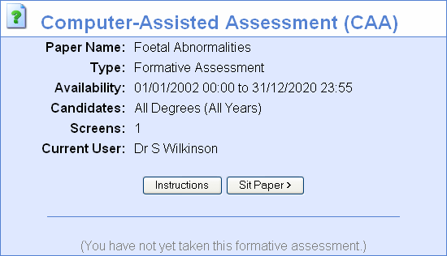
Figure 31: Properties of a selected paper.

Appendix A - Technical Specification

System Architecture
Apache 1.3.27
MySQL 3.23
PHP 4.2.3

General System Specification
Question Bank
Unlimited size
Papers
Types – Formative, Progress Test, Summative and Survey
Unlimited number

Import/Export
currently QTILite (future – full QTI compliance)
Reporting
Class totals with distribution and scatter plots plus bulk emailing of individualised marks.
Item Analysis
Search Facilities
Full-text searching on any combination of the following fields: theme, scenario, lead-in, options and keywords.

Question Types
Dichotomous
True/False
True/False/Abstain
Yes/No
Yes/No/Abstain
Textual or Media based options
Marking – positive or negative
1 to 10 options

Multiple Choice
Vertial, Horizontal or Dropdown List presentation
Textual or Media based (not with dropdown lists) options
3 to 12 options

Multiple Reponse
Textual or Media based options
Marking – positive for correct options, or negative marking all options
3 to 12 options
Auto-checking that the number of correct options is less than or equal to half the total number of displayed options.
Extended Matching (Single Answer)
10 scenarios sharing a bank of 25 options
Extended Matching (Multiple Answers)
10 scenarios sharing a bank of 25 options
Ranking
15 options
Marking – 1) exact positions, 2) half marks for 1 position out, or 3) marking as per multiple response plus one bonus mark for correct order.
TextBox
Sizes from 1 row by 20 columns to 15 rows by 80 columns.
Likert Scale
User-definable labels
Scale sizes from 3 to 10

Fill-in-the-Blank
Unlimited blanks – unlimited distractors

Notes:
Media – support for the following formats:
- Images – GIF, JPEG and PNG
- Audio – WAV, MID and WMA
- 3D – Chime Molecules
- Video – AVI, MOV
- Documents – PDF, Word, PowerPoint, Excel

Any media filenames that conflict with already existing files on the TouchStone server are automatically renamed by appending a number (e.g. image, image1, image2, image3, etc). The system will support 9999 different variants of the same filename using this system.

Appendix B – Database Architechure

Table Relationships

Papers
Questions
Options
Outcomes
Properties
Programme
Modules
Sessions
TouchStone
database
Cur Map
database
o_id
q_id
q_id
question
paper_title
paper
prog_given_id
mod_parent
sess_parent
mod_given_id
q_id
question_id
outcome_id
sess_given_id

Properties Table
Field | Type | Purpose
property_id | int(11) | Primary Key
paper_title | text | Name of the paper
start_date | datetime | Date when student can start completing the paper
end_date | datetime | Date when the paper becomes unavailable again
question_type | int(11) | Tyep of paper (0=Formative, 1=Progress Test, 2=Summative, 3=Survey)
paper_notes | text | Notes section that is displayed to the examinee once at the top of screen 1 when they take the paper.
degreeID | varchar(4) | Identifier which specifies from which degree the examinees come from that can take the paper (e.g. A100=Medicine). ‘%’ is used to signify any degree.
yearID | char(1) | Identifier which specifies which year the examinees from from that can take the paper (‘%’ denotes all years).

Papers Table
Field | Type | Purpose
p_id | int(11) | Primary Key
paper | text | Name of the paper
question | int(11) | ID of question used (links with q_id in Questions table)
screen | int(11) | Screen number question will appear on
display_pos | int(11) | Used to control the physical order of questions on a paper.
owner | varchar(15) | Username of the member of staff who created the paper.

Questions Table
Field | Type | Purpose
q_id | int(11) | Primary Key
ass_type | text | Holds what type a question is (e.g. dichotomous, MCQ, MRQ, etc)
theme | text | Holds the theme of a question.
scenario | text | Holds the clinical scenario of a question.
leadin | text | Holds the lead-in of a question.
correct_fback | text | Holds general feedback for a question if the examinee answered it correctly.
incorrect_fback | text | Holds general feedback for a question if the examinee answered it incorrectly.
score_method | varchar(30) | Scoring methods used for certain questions such as positive or negative.
notes | text | Notes used for presentation purposes to the examinee.
owner | varchar(15) | Username of the member of staff who created the question.
q_media | varchar(255) | Filename of a piece of media (image, sound, Chime, etc).
q_media_width | int(11) | Physical display width in pixels of the media (zero for audio formats).
q_media_height | int(11) | Physical display height in pixels of the media (zero for audio formats).
creation_date | datetime | Time and date when a question was last edited.
last_edited | timestamp(14) | Time and date when the question was first created.
keywords | text | List of keywords associated with a question.

Options Table
Field | Type | Purpose
o_id | int(11) | ID of the options – links with q_id from Questions table.
option_text | text | Text of each option.
o_media | varchar(255) | Media used with/for each option.
o_media_width | int(11) | Width in pixels of the media.
o_media_height | int(11) | Height in pixels of the media.
feedback_right | text | Textual feedback if the examinee got the option correct.
feedback_wrong | text | Textual feedback if the examinee got the option incorrect.
correct | text | Which option is correct.
id_num | int(11) | Primary Key
marks | int(11) | Marks awarded to the option.

Outcomes Table
Field | Type | Purpose
out_auto_id | int(11) | Primary Key
question_id | int(11) | ID (q_id) of the question the outcome relates to.
outcome_id | varchar(10) | ID of the learning outcome record in the curriculum map database.

Appendix C – System Code

Paper Display
user_index.php Displays a summary of a particular paper. Initiall screen called by a VLE and is used to launch start.php.
start.php Display/marking routine for all assessment types.
caa_functions.inc Include file used with start.php.
staff_auth.inc Authentication routine which permits staff only access.
staff_student_auth.inc Authentication routine which permits staff and student access to a page.

Add Scripts
add_blank.php Adds a new Fill-in-the-Blank question to the bank.
add_mcq.php Adds a new Multiple Choice question to the bank.
add_mrq.php Adds a new Multiple Response question to the bank.
add_dichotomous.php Adds a new Dichotomous question to the bank.
add_matching.php Adds a new Extended Matching question to the bank.
add_multimatching.php Adds a new Extended Matching question with multiple responses to the bank.
add_likert.php Adds a new likert scale question to the bank.
add_rank.php Adds a new Ranking question to the bank.
add_textbox.php Adds a new Textbox question to the bank.

Edit Scripts
edit_blank.php Edits an existing Fill-in-the-Blank question.
edit_mcq.php Edits an existing Multiple Choice question.
edit_mrq.php Edits an existing Multiple Response question.
edit_dichotomous.php Edits an existing Dichotomous question.
edit_matching.php Edits an existing Extended Matching question.
edit_multimatching.php Edits an existing Extended Matching question with multiple responses.
edit_likert.php Edits an existing Likert scale question.
edit_rank.php Edits an existing Ranking question.
edit_textbox.php Edits an existing Textbox question.

Delete Scripts
check_delete_q_pointer.php Confirmation dialog for deleting a pointer to a question (i.e. from a assessment paper).
check_delete_q_original.php Confirmation dialog for deleting a question from the question bank.
do_delete_q_pointer.php Removes a question pointer from a paper.
do_delete_q_original.php Removes the actual question from the question bank.

Other Scripts
index.php Main menu frame that loads options_menu.php and paper_list.php.
options_menu.php Displays tasks for the main menu frame (menu.php).
paper_list.php Displays a list of papers.
paper_frame.php Papers frame which loads papers_menu.php and paper_list.php.
papers_menu.php Task menu for papers.
paper_details.php Displays tasks for the papers frame (papers_menu.php).
paper_properties.php Allows the properties of a paper to be edited.
question_properties.php Displays properties of a question (not editable).
question_list_frame.php Frame for listing questions.
question_list_menu.php Task menu for question list.
question_list.php List of questions from the question bank.
search_frame.php Frame that loads search_options.php and find.php.
search_options.php Search string and parameters that are passed to find.php.
find.php Performs a search of the question bank.
new_paper.php Creates a new paper (see Figure 20).
add_questions.php Adds question(s) to a new or existing paper (see Figure 19).
add_question_to_paper.php Adds a question to an existing paper. Called from find.php.

Statistics
stats_menu.php Displays the statistics/marking menu (see Figure 24)
class_totals.php Class total report (see 5.2 Class Totals)
item_analysis.php Item analysis report (see 5.3 Item Analysis)

GD Library scripts
draw_distribution_chart Draws the distribution bar chart used with class_totals.php.
draw_scatter_plot.php Draws the scatter plot used with class_totals.php.
pie_chart Draws the pie chart used on options_menu.php.

Outcomes Explorer
module_frame.php Loads module_tab.php and module_view.php.
module_tab.php Displays tabs with module view highlighted.
module_view.php Displays a collapsible hierarchy of learning outcomes categorised by modules.
search_frame.php Loads search_tab.php and search_view.php.
search_tab.php Displays tabs with search view highlighted.
search_view.php Displays the results of a search for outcomes.
tree_frame.php Loads tree_tab.php and tree_view.php.
tree_tab.php Displays tabs with tree view highlighted.
tree_view.php Displays a collapsible hierarchy of learning outcomes starting at the root with the programme specification, referencing module outcomes and session outcomes beneath.

Interoperability
caa_catalogue.php RSS output from a URL query string.
export_qti.php Exports the current paper in XML format (currently only works with MCQs).
import_qti.php Imports an XML file and loads it into the question bank (currently under construction).

Questions may only be added to a paper by the current owner of the paper. Also, no questions may be added to a paper by anyone, including the owner, while that paper is available to be sat by examinees.

