Задание 1.

Код запроса/создания функции:

USE [stack]

GO

--задание 1

IF OBJECT_ID ('select_orders_by_item_name') IS NOT NULL

DROP FUNCTION select_orders_by_item_name;

GO

CREATE FUNCTION select_orders_by_item_name(@ItemName nvarchar(max))

RETURNS Table AS RETURN

(

SELECT Orders.row_id as order_id, Customers.name as customer, COUNT(Orders.row_id) as items_count

FROM Orders, OrderItems, Customers

WHERE Orders.customer_id = Customers.row_id AND OrderItems.order_id = Orders.row_id AND OrderItems.name = @ItemName

GROUP BY Orders.row_id, Customers.name, OrderItems.name

);

GO

-- примеры задания 1

-- select * from select_orders_by_item_name(N'Факс')

-- select * from select_orders_by_item_name(N'Кассовый аппарат')

-- select * from stack.dbo.select_orders_by_item_name(N'Стулья')

Отчёт о работе функции:

select * from select_orders_by_item_name(N'Факс')

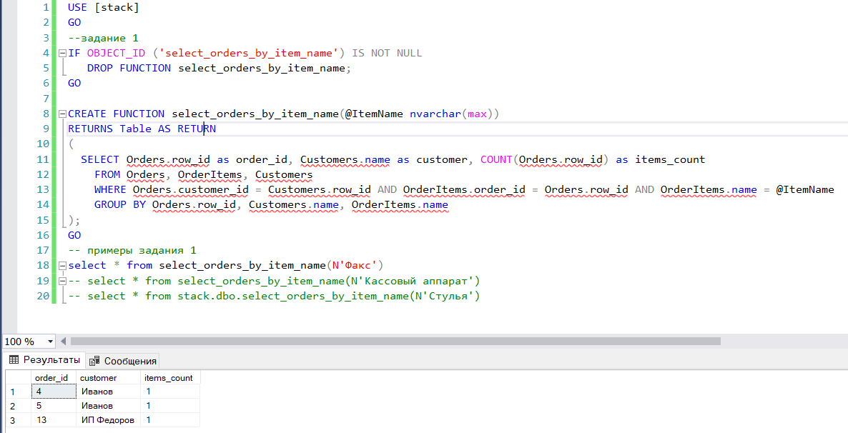

select * from select_orders_by_item_name(N'Кассовый аппарат')

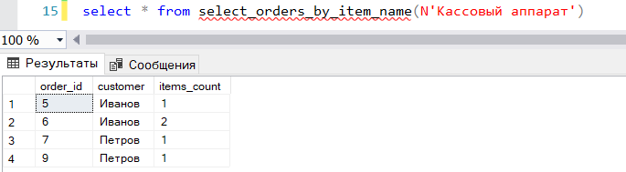

select * from stack.dbo.select_orders_by_item_name(N'Стулья')

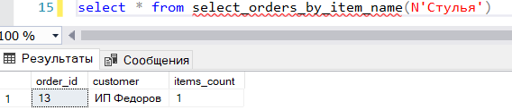

Задание 2.

Код запроса/создания функции:

IF OBJECT_ID ('is_root') IS NOT NULL

DROP FUNCTION is_root;

GO

CREATE FUNCTION is_root(@RowId int)

RETURNS BIT AS BEGIN

IF (SELECT TOP 1 group_name

FROM Orders

WHERE row_id = @RowId) IS NOT NULL

RETURN 1

RETURN 0

END;

GO

IF OBJECT_ID ('calculate_total_price_for_orders_group') IS NOT NULL

DROP FUNCTION calculate_total_price_for_orders_group;

GO

CREATE FUNCTION calculate_total_price_for_orders_group(@RowId int)

RETURNS INT AS BEGIN

DECLARE @total_sum INT;

SET @total_sum = 0;

IF dbo.is_root(@RowId) = 1

SELECT @total_sum = @total_sum + dbo.calculate_total_price_for_orders_group(o.row_id)

FROM Orders AS o

WHERE o.parent_id = @RowId

ELSE

SELECT @total_sum = sum(i.price)

FROM Orders AS o inner join OrderItems AS i ON o.row_id = i.order_id

WHERE o.row_id = @RowId

RETURN @total_sum

END;

GO

-- примеры задания 2

--select dbo.calculate_total_price_for_orders_group(1) as total_price1 -- 703, все заказы

--select dbo.calculate_total_price_for_orders_group(2) as total_price2 -- 513, группа 'Частные лица'

--select dbo.calculate_total_price_for_orders_group(3) as total_price3 -- 510, группа 'Оргтехника'

--select dbo.calculate_total_price_for_orders_group(12) as total_price12 -- 190, группа 'Юридические лица'

--select dbo.calculate_total_price_for_orders_group(13) as total_price13 -- 190, заказ 'ИП Федоров'

Отчёт о работе функции:

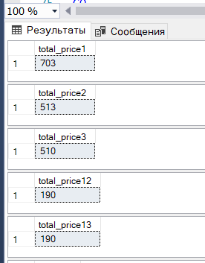

Задание 3.

Код запроса:

SELECT Customers.name

FROM

Orders, OrderItems, Customers

WHERE

Orders.customer_id = Customers.row_id

AND OrderItems.order_id = Orders.row_id

AND Orders.registered_at > '2019-12-31'

AND Orders.registered_at < '2021-01-01'

GROUP BY Customers.name

HAVING COUNT(DISTINCT OrderItems.order_id)

=

COUNT(DISTINCT

CASE WHEN OrderItems.name = N'Кассовый аппарат'

THEN OrderItems.order_id END)

;

Отчёт о работе функции:

