# A Project Report on

**DINO RUSH**

**GAME**

Submitted by

**Niraj Ratnawat (18IT1015)**

**Rudresh Paradkar (18IT2020)**

**Saujanya Pandey (18IT1046)**

Under the guidance of

**Mr. Madhav Vyas Assistant Professor**

**Department of Information Technology Ramrao Adik Institute of Technology**

**Nerul, Navi Mumbai**

**Certificate**

This is to certify that the project entitled **Dino Rush Game** is being submitted to the Department of Information Technology, Ramrao Adik Institute of Technology,Navi Mumbai.

Project Guide External

Examiner (Mr. Madhav Vyas) ( )

# Acknowledgement

We owe our gratitude to many people who have supported us throughout this journey.

We would, firstly like to express our heartfelt gratitude towards our respected Principal Dr. M.D. Patil and our Head of Department Dr. Ashish Jadhav for providing us immense facilities, guidance and never-ending support.

The completion of any inter-disciplinary project depends upon cooperation and combined efforts of several sources of knowledge. We take this opportunity to express our profound gratitude and deep regards to our guide Mr. Madhav Vyas for his exemplary guidance, monitoring and constant encouragement throughout the course of this project.

Lastly, we thank our parents, family, friends and well-wishers who always looked for the chance to help us in whatever means came forth and for their constant encouragement without which the project would not be a distant reality.

# Introduction

While browsing the internet, we may sometimes abruptly go offline either due to disconnection or some network failure.

In the Google Chrome browser when a user is, a “No internet” text appears on the screen. So, Google integrated a simple yet interesting dino game in the Chrome browser, also called the ‘No internet game’ or the ‘T-rex runner’ which can only be played when the user is offline.

In this game, the player is a dinosaur and has to avoid all incoming obstacles (cacti or a pterodactyl) by either jumping over them or ducking.

Our project, the ‘Dino Rush game’ is also based on the same google chrome game and we have implemented a colorful and lively version of the game using the python language and its pygame module.

The aim of our project was to implement the working of the game in a similar way in the form of an executable file to be able to play it on any platform.

# Proposed System

The objective is to create a simple yet interesting game which has optimal accessibility and cost in terms of memory and execution. The game will be based on cognitive response. It will be made using Object Oriented Style of programming.

The game will have 3 main parts, namely, the graphics rendering logic, the collision logic and game control logic.

This version of the game will be a more lively and vivid version of the original chrome t-rex game but at the same time will be efficient in terms of memory and speed.

# System Components

**Language:** Python 3

**Modules:** Pygame 1.9.6, Random, Sys, OS.

* 1. **Pygame:**

**Pygame** is a cross-platform set of Python modules designed for writing video games. It includes computer graphics and sound libraries designed to be used with the Python programming language. Pygame was officially written by **Pete Shinners** to replace PySDL. Pygame is suitable to create client-side applications that can be potentially wrapped in a standalone executable. Applications using Pygame can run on Android phones and tablets with the use of Pygame Subset for Android (pgs4a). Sound, vibration, keyboard, and accelerometer are supported on Android.

* 1. **Random:**

Python offers random module that can generate random numbers.

These are pseudo-random number as the sequence of number generated depends on the seed. If the seeding value is same, the sequence will be the same. For example, if you use 2 as the seeding value, you will always see the following sequence. It is used **cryptographically as secure** random generator using a **secrets module to** generate secure **tokens**, security **keys**, and **URLs.**

* 1. **Sys:**

The sys module provides information about constants, functions and methods of the Python interpreter.

The python sys module provides functions and variables which are used to manipulate different parts of the Python Runtime Environment. It lets us access system-specific parameters and functions.

* 1. **OS:**

The OS module in Python provides a way of using operating system dependent functionality. The functions that the OS module provides allows you to interface with the underlying operating system that Python is running on – be that Windows, Mac or Linux.

# Architecture

# 

## Pygame working sequence diagram

**WORKING OF SYSTEM**

The Dino Rush game system consists of three parts: -

1. **Graphics Rendering Logic:**

The intro screen is the first screen or the introduction screen that first pops up as soon as the file is executed. It consists of:

* A 600x150 console window.
* The title of the game “Dino Rush”

The various sprites of the game are stored in a sprite sheet and are drawn on the screen by partial image blitting method using pygame. The pygame rect & surface module have been extensively used for this purpose.

1. **Collision Logic:**

The collision logic of this game utilizes masking method of pygame by using colorkey to make the background of the sprite transparent and create a mask out of it. The collision is taken into account when the mask of dino collides with the mask of any other sprite and the player is dead. The score of the player is counted according to the amount of time dino is alive. The game also consists of a high score variable which displays the high score of players whenever the game is run.

1. **Game control logic:**

# The game loop is divided into two parts: the introscreen and the gameplay loop. The introscreen loop is initiated as soon as the game is run and when the spacebar is pressed, the gameplay loop starts.

# Once the game is over, it gives us the option to initialize the gameplay loop again or exit the game altogether.

# Advantages of Dino Rush Game

1. Based on cognitive responses, hence improves mind-body coordination.
2. Triggers positive emotional responses.
3. Uses OOPS style of programming, therefore easy to modify.
4. Optimal accessibility and cost in terms of memory and speed.
5. Contains over 10 different sprites.

SOURCE CODE:

import os

import sys

import pygame

import random

from pygame import *

pygame.mixer.pre_init(44100, -16, 2, 2048) # fix audio delay

pygame.init()

scr_size = (width,height) = (600,150)

FPS = 60

gravity = 0.6

black = (0,0,0)

white = (255,255,255)

background_col = (235,235,235)

high_score = 0

screen = pygame.display.set_mode(scr_size)

clock = pygame.time.Clock()

pygame.display.set_caption("Dino Rush!")

jump_sound = pygame.mixer.Sound('sprites/jump.wav')

die_sound = pygame.mixer.Sound('sprites/die.wav')

checkPoint_sound = pygame.mixer.Sound('sprites/checkPoint.wav')

def load_image(name,sizex=-1,sizey=-1,colorkey=None,):

    fullname = os.path.join('sprites', name)

    image = pygame.image.load(fullname)

    image = image.convert()

    if colorkey is not None:

        if colorkey is -1:

            colorkey = image.get_at((0, 0))

        image.set_colorkey(colorkey, RLEACCEL)

    if sizex != -1 or sizey != -1:

        image = pygame.transform.scale(image, (sizex, sizey))

    return (image, image.get_rect())

def load_sprite_sheet(sheetname,nx,ny,scalex = -1,scaley = -1,colorkey = None,):

    fullname = os.path.join('sprites',sheetname)

    sheet = pygame.image.load(fullname)

    sheet = sheet.convert()

    sheet_rect = sheet.get_rect()

    sprites = []

    sizex = sheet_rect.width/nx

    sizey = sheet_rect.height/ny

    for i in range(0,ny):

        for j in range(0,nx):

            rect = pygame.Rect((j*sizex,i*sizey,sizex,sizey))

            image = pygame.Surface(rect.size)

            image = image.convert()

            image.blit(sheet,(0,0),rect)

            if colorkey is not None:

                if colorkey is -1:

                    colorkey = image.get_at((0,0))

                image.set_colorkey(colorkey,RLEACCEL)

            if scalex != -1 or scaley != -1:

                image = pygame.transform.scale(image,(scalex,scaley))

            sprites.append(image)

    sprite_rect = sprites[0].get_rect()

    return sprites,sprite_rect

def disp_gameOver_msg(retbutton_image,gameover_image):

    retbutton_rect = retbutton_image.get_rect()

    retbutton_rect.centerx = width / 2

    retbutton_rect.top = height*0.52

    gameover_rect = gameover_image.get_rect()

    gameover_rect.centerx = width / 2

    gameover_rect.centery = height*0.35

    screen.blit(retbutton_image, retbutton_rect)

    screen.blit(gameover_image, gameover_rect)

def extractDigits(number):

    if number > -1:

        digits = []

        i = 0

        while(number/10 != 0):

            digits.append(number%10)

            number = int(number/10)

        digits.append(number%10)

        for i in range(len(digits),5):

            digits.append(0)

        digits.reverse()

        return digits

class Dino():

    def __init__(self,sizex=-1,sizey=-1):

        self.images,self.rect = load_sprite_sheet('dino.png',5,1,sizex,sizey,-1)

        self.images1,self.rect1 = load_sprite_sheet('dino_ducking.png',2,1,59,sizey,-1)

        self.rect.bottom = int(0.98*height)

        self.rect.left = width/15

        self.image = self.images[0]

        self.index = 0

        self.counter = 0

        self.score = 0

        self.isJumping = False

        self.isDead = False

        self.isDucking = False

        self.isBlinking = False

        self.movement = [0,0]

        self.jumpSpeed = 11.5

        self.stand_pos_width = self.rect.width

        self.duck_pos_width = self.rect1.width

    def draw(self):

        screen.blit(self.image,self.rect)

    def checkbounds(self):

        if self.rect.bottom > int(0.98*height):

            self.rect.bottom = int(0.98*height)

            self.isJumping = False

    def update(self):

        if self.isJumping:

            self.movement[1] = self.movement[1] + gravity

        if self.isJumping:

            self.index = 0

        elif self.isBlinking:

            if self.index == 0:

                if self.counter % 400 == 399:

                    self.index = (self.index + 1)%2

            else:

                if self.counter % 20 == 19:

                    self.index = (self.index + 1)%2

        elif self.isDucking:

            if self.counter % 5 == 0:

                self.index = (self.index + 1)%2

        else:

            if self.counter % 5 == 0:

                self.index = (self.index + 1)%2 + 2

        if self.isDead:

           self.index = 4

        if not self.isDucking:

            self.image = self.images[self.index]

            self.rect.width = self.stand_pos_width

        else:

            self.image = self.images1[(self.index)%2]

            self.rect.width = self.duck_pos_width

        self.rect = self.rect.move(self.movement)

        self.checkbounds()

        if not self.isDead and self.counter % 7 == 6 and self.isBlinking == False:

            self.score += 1

            if self.score % 100 == 0 and self.score != 0:

                if pygame.mixer.get_init() != None:

                    checkPoint_sound.play()

        self.counter = (self.counter + 1)

class Cactus(pygame.sprite.Sprite):

    def __init__(self,speed=5,sizex=-1,sizey=-1):

        pygame.sprite.Sprite.__init__(self,self.containers)

        self.images,self.rect = load_sprite_sheet('cacti-small.png',3,1,sizex,sizey,-1)

        self.rect.bottom = int(0.98*height)

        self.rect.left = width + self.rect.width

        self.image = self.images[random.randrange(0,3)]

        self.movement = [-1*speed,0]

    def draw(self):

        screen.blit(self.image,self.rect)

    def update(self):

        self.rect = self.rect.move(self.movement)

        if self.rect.right < 0:

            self.kill()

class Ptera(pygame.sprite.Sprite):

    def __init__(self,speed=5,sizex=-1,sizey=-1):

        pygame.sprite.Sprite.__init__(self,self.containers)

        self.images,self.rect = load_sprite_sheet('ptera.png',2,1,sizex,sizey,-1)

        self.ptera_height = [height*0.82,height*0.75,height*0.60]

        self.rect.centery = self.ptera_height[random.randrange(0,3)]

        self.rect.left = width + self.rect.width

        self.image = self.images[0]

        self.movement = [-1*speed,0]

        self.index = 0

        self.counter = 0

    def draw(self):

        screen.blit(self.image,self.rect)

    def update(self):

        if self.counter % 10 == 0:

            self.index = (self.index+1)%2

        self.image = self.images[self.index]

        self.rect = self.rect.move(self.movement)

        self.counter = (self.counter + 1)

        if self.rect.right < 0:

            self.kill()

class Ground():

    def __init__(self,speed=-5):

        self.image,self.rect = load_image('ground.png',-1,-1,-1)

        self.image1,self.rect1 = load_image('ground.png',-1,-1,-1)

        self.rect.bottom = height

        self.rect1.bottom = height

        self.rect1.left = self.rect.right

        self.speed = speed

    def draw(self):

        screen.blit(self.image,self.rect)

        screen.blit(self.image1,self.rect1)

    def update(self):

        self.rect.left += self.speed

        self.rect1.left += self.speed

        if self.rect.right < 0:

            self.rect.left = self.rect1.right

        if self.rect1.right < 0:

            self.rect1.left = self.rect.right

class Cloud(pygame.sprite.Sprite):

    def __init__(self,x,y):

        pygame.sprite.Sprite.__init__(self,self.containers)

        self.image,self.rect = load_image('cloud.png',int(90*30/42),30,-1)

        self.speed = 1

        self.rect.left = x

        self.rect.top = y

        self.movement = [-1*self.speed,0]

    def draw(self):

        screen.blit(self.image,self.rect)

    def update(self):

        self.rect = self.rect.move(self.movement)

        if self.rect.right < 0:

            self.kill()

class Scoreboard():

    def __init__(self,x=-1,y=-1):

        self.score = 0

        self.tempimages,self.temprect = load_sprite_sheet('numbers.png',12,1,11,int(11*6/5),-1)

        self.image = pygame.Surface((55,int(11*6/5)))

        self.rect = self.image.get_rect()

        if x == -1:

            self.rect.left = width*0.89

        else:

            self.rect.left = x

        if y == -1:

            self.rect.top = height*0.1

        else:

            self.rect.top = y

    def draw(self):

        screen.blit(self.image,self.rect)

    def update(self,score):

        score_digits = extractDigits(score)

        self.image.fill(background_col)

        for s in score_digits:

            self.image.blit(self.tempimages[s],self.temprect)

            self.temprect.left += self.temprect.width

        self.temprect.left = 0

def introscreen():

    temp_dino = Dino(44,47)

    temp_dino.isBlinking = True

    gameStart = False

    temp_ground,temp_ground_rect = load_sprite_sheet('ground.png',15,1,-1,-1,-1)

    temp_ground_rect.left = width/20

    temp_ground_rect.bottom = height

    logo,logo_rect = load_image('logo.png',280,60,-1)

    logo_rect.centerx = width*0.65

    logo_rect.centery = height*0.5

    ptera1,ptera1_rect = load_image('ptera.png',92,40,-1)

    ptera1_rect.centerx = width*0.26

    ptera1_rect.centery = height*0.6

    while not gameStart:

        if pygame.display.get_surface() == None:

            print("Couldn't load display surface")

            return True

        else:

            for event in pygame.event.get():

                if event.type == pygame.QUIT:

                    return True

                if event.type == pygame.KEYDOWN:

                    if event.key == pygame.K_SPACE or event.key == pygame.K_UP:

                        temp_dino.isJumping = True

                        temp_dino.isBlinking = False

                        temp_dino.movement[1] = -1*temp_dino.jumpSpeed

        temp_dino.update()

        if pygame.display.get_surface() != None:

            screen.fill(background_col)

            screen.blit(temp_ground[0],temp_ground_rect)

            if temp_dino.isBlinking:

                screen.blit(logo,logo_rect)

                screen.blit(ptera1,ptera1_rect)

            temp_dino.draw()

            pygame.display.update()

        clock.tick(FPS)

        if temp_dino.isJumping == False and temp_dino.isBlinking == False:

            gameStart = True

def gameplay():

    global high_score

    gamespeed = 4

    startMenu = False

    gameOver = False

    gameQuit = False

    playerDino = Dino(44,47)

    new_ground = Ground(-1*gamespeed)

    scb = Scoreboard()

    highsc = Scoreboard(width*0.78)

    counter = 0

    cacti = pygame.sprite.Group()

    pteras = pygame.sprite.Group()

    clouds = pygame.sprite.Group()

    last_obstacle = pygame.sprite.Group()

    Cactus.containers = cacti

    Ptera.containers = pteras

    Cloud.containers = clouds

    retbutton_image,retbutton_rect = load_image('replay_button.png',35,31,-1)

    gameover_image,gameover_rect = load_image('game_over.png',190,11,-1)

    temp_images,temp_rect = load_sprite_sheet('numbers.png',12,1,11,int(11*6/5),-1)

    HI_image = pygame.Surface((22,int(11*6/5)))

    HI_rect = HI_image.get_rect()

    HI_image.fill(background_col)

    HI_image.blit(temp_images[10],temp_rect)

    temp_rect.left += temp_rect.width

    HI_image.blit(temp_images[11],temp_rect)

    HI_rect.top = height*0.1

    HI_rect.left = width*0.73

    while not gameQuit:

        while startMenu:

            pass

        while not gameOver:

            if pygame.display.get_surface() == None:

                print("Couldn't load display surface")

                gameQuit = True

                gameOver = True

            else:

                for event in pygame.event.get():

                    if event.type == pygame.QUIT:

                        gameQuit = True

                        gameOver = True

                    if event.type == pygame.KEYDOWN:

                        if event.key == pygame.K_SPACE:

                            if playerDino.rect.bottom == int(0.98*height):

                                playerDino.isJumping = True

                                if pygame.mixer.get_init() != None:

                                    jump_sound.play()

                                playerDino.movement[1] = -1*playerDino.jumpSpeed

                        if event.key == pygame.K_DOWN:

                            if not (playerDino.isJumping and playerDino.isDead):

                                playerDino.isDucking = True

                    if event.type == pygame.KEYUP:

                        if event.key == pygame.K_DOWN:

                            playerDino.isDucking = False

            for c in cacti:

                c.movement[0] = -1*gamespeed

                if pygame.sprite.collide_mask(playerDino,c):

                    playerDino.isDead = True

                    if pygame.mixer.get_init() != None:

                        die_sound.play()

            for p in pteras:

                p.movement[0] = -1*gamespeed

                if pygame.sprite.collide_mask(playerDino,p):

                    playerDino.isDead = True

                    if pygame.mixer.get_init() != None:

                        die_sound.play()

            if len(cacti) < 2:

                if len(cacti) == 0:

                    last_obstacle.empty()

                    last_obstacle.add(Cactus(gamespeed,40,40))

                else:

                    for l in last_obstacle:

                        if l.rect.right < width*0.7 and random.randrange(0,50) == 10:

                            last_obstacle.empty()

                            last_obstacle.add(Cactus(gamespeed, 40, 40))

            if len(pteras) == 0 and random.randrange(0,200) == 10 and counter > 500:

                for l in last_obstacle:

                    if l.rect.right < width*0.8:

                        last_obstacle.empty()

                        last_obstacle.add(Ptera(gamespeed, 46, 40))

            if len(clouds) < 5 and random.randrange(0,300) == 10:

                Cloud(width,random.randrange(height/5,height/2))

            playerDino.update()

            cacti.update()

            pteras.update()

            clouds.update()

            new_ground.update()

            scb.update(playerDino.score)

            highsc.update(high_score)

            if pygame.display.get_surface() != None:

                screen.fill(background_col)

                new_ground.draw()

                clouds.draw(screen)

                scb.draw()

                if high_score != 0:

                    highsc.draw()

                    screen.blit(HI_image,HI_rect)

                cacti.draw(screen)

                pteras.draw(screen)

                playerDino.draw()

                pygame.display.update()

            clock.tick(FPS)

            if playerDino.isDead:

                gameOver = True

                if playerDino.score > high_score:

                    high_score = playerDino.score

            if counter%700 == 699:

                new_ground.speed -= 1

                gamespeed += 1

            counter = (counter + 1)

        if gameQuit:

            break

        while gameOver:

            if pygame.display.get_surface() == None:

                print("Couldn't load display surface")

                gameQuit = True

                gameOver = False

            else:

                for event in pygame.event.get():

                    if event.type == pygame.QUIT:

                        gameQuit = True

                        gameOver = False

                    if event.type == pygame.KEYDOWN:

                        if event.key == pygame.K_ESCAPE:

                            gameQuit = True

                            gameOver = False

                        if event.key == pygame.K_RETURN or event.key == pygame.K_SPACE:

                            gameOver = False

                            gameplay()

            highsc.update(high_score)

            if pygame.display.get_surface() != None:

                disp_gameOver_msg(retbutton_image,gameover_image)

                if high_score != 0:

                    highsc.draw()

                    screen.blit(HI_image,HI_rect)

                pygame.display.update()

            clock.tick(FPS)

    pygame.quit()

    quit()

def main():

    isGameQuit = introscreen()

    if not isGameQuit:

        gameplay()

main()

IMPLEMENTATION OF GAME APPLICATION:

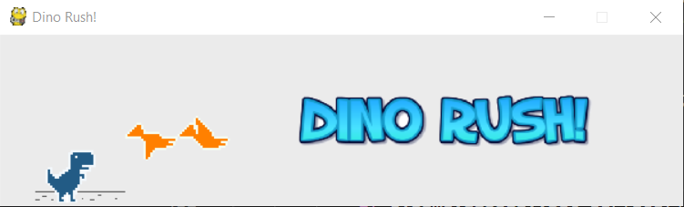

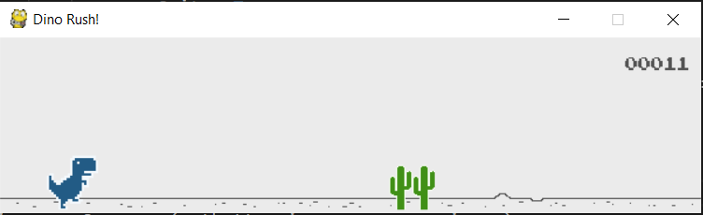

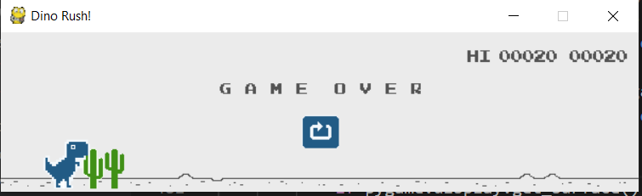

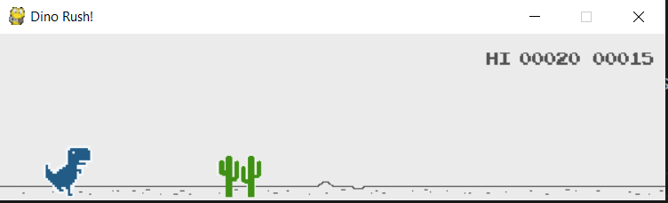

**Conclusion**

The Dino Rush game was successfully made using Pygame, OS, Sys, and Random modules of the Python language. This game was made from an entertainment point of view.

This game was also made to enhance our knowledge of the python language and learn the new pygame module.

# References

* <https://www.pygame.org/docs/>
* <https://pygame2.readthedocs.io/en/latest/pygame2.rect.html>
* Sentdex Youtube
* Thenewboston Youtube
* Pylet Youtube
* <http://inventwithpython.com/makinggames.pdf>
* Stackoverflow.com