

ITA_System Configuration / Environment Construction Guide

Terraform-driver

*－*Version 1.9*－*

Copyright © NEC Corporation 2020. All rights reserved.

Disclaimer

All the contents of this document are protected by copyright owned by NEC Corporation

Unauthorized reproduction or copying of all or part of the contents of this document is prohibited

The contents of this document are subject to change without prior notice in the future.

NEC Corporation is not responsible for any technical or editorial errors or omissions in this document.

NEC Corporation do not guarantee accuracy, usability, certainty of the content in this document.

Trademark

* Linux is registered trademark or trademark of Linux Torvalds, registered in the U.S. and other countries.
* Red Hat is registered trademark or trademark of Red Hat, Inc., registered in the U.S. and other countries.
* Apache、Apache Tomcat and Tomcat are registered trademarks or trademarks of the Apache Software Foundation.
* Oracle and MySQL are registered trademarks of Oracle Corporation and its subsidiaries and affiliates in the U.S. and other countries.
* MariaDB is a registered trademark or trademark of the MariaDB Foundation.
* Terraform is a registered trademark or trademark of HarshCorp, Inc..

The names of other systems, company name and products mentioned in this document are registered trademarks or trademarks of their respective companies.

The® mark and TM mark are not specified in this document.

※「Exastro IT Automation 」 is written as「ITA」in this document.

Table of Contents

Introduction 3

1 Function 4

2 System configuration 5

3 System requirements 6

4 Terraform initial setting 7

4.1 Prepare required resource 7

# Introduction

This document explains the system configuration and environment construction for operating Terraform optional function (referred to as Terraform driver hereafter) in ITA.

To use the ITA Terraform driver, it is assumed that the basic ITA functions have been built. Please refer to "System Configuration/Environment Construction Guide - Basics" for constructing ITA basic function.

# Function

Terraform driver provides the following functions.

Table 1-1-1. Function name

|  |  |  |  |  |
| --- | --- | --- | --- | --- |
| No | Function name | User | WEB  Content | BackYard  Content |
| 1 | Terraform driver | Generate an execution plan and execute the construction bases on the coded infrastructure configuration in ITA via Terraform.  In addition, it is possible manage coded access policies based on Policy as Code. | ◎ | ◎ |

# System configuration

The system configuration of Terraform driver is same as the ITA system.

For the Terraform driver, there are two configurations. One that uses Terraform cloud or one where there Terraform has its own server separately from ITA.

This figure shows a configuration in which a Terraform server is added to the balanced HA type, the recommended configuration for the ITA system.

※The figure here is a omitted version. Please refer to "System Configuration/Environment Construction Guide - Basics" for details.

ITA system/Terraform driver

Web/AP server [ACT]

Web/AP server [ACT]

Web

function

Web/AP server [ACT]

DB connection

information

**Terraform**

**driver**

Load balancer

Backyard server [SBY]

Terraform



b

Backyard server [ACT]

Session management

**Terraform API Function**

BackYard

Function

Uploaded

file

Terraform

DB

DBMS

DB connection

Information

**Terraform**

**driver**

Configuration target device

Network  
device

Server

Storage

External installed server

# System requirements

Since Terraform driver (ITA side) is based on system requirements of ITA system, please refer to "System Configuration/Environment Construction Guide - Basics". This section describes the requirements for BackYard.

●Version

Table 3‑1. Terraform Enterprise system requirements

|  |  |  |
| --- | --- | --- |
| **Package** | **Version** | **Remarks** |
| Terraform Enterprise | 202110-1 (576)以上 |  |

Table 3‑2.Terraform Cloud system requirements

|  |  |  |
| --- | --- | --- |
| **Package** | **Version** | **注意事項** |
| Terraform Cloud | - | Terraform Cloud must be running the latest version. |

●BackYard

**Table 3-1. Linux commands required for Terraform backyard**

|  |  |
| --- | --- |
| **Command** | **Note** |
| tar |  |
| zip |  |

# Terraform initial setting

## Prepare required resource

In order to link Terraform from Terraform driver, you need to create an user token.

Log in to Terraform from a browser, then click [User Setting] → [Tokens] → [Create an API token] to create API token.

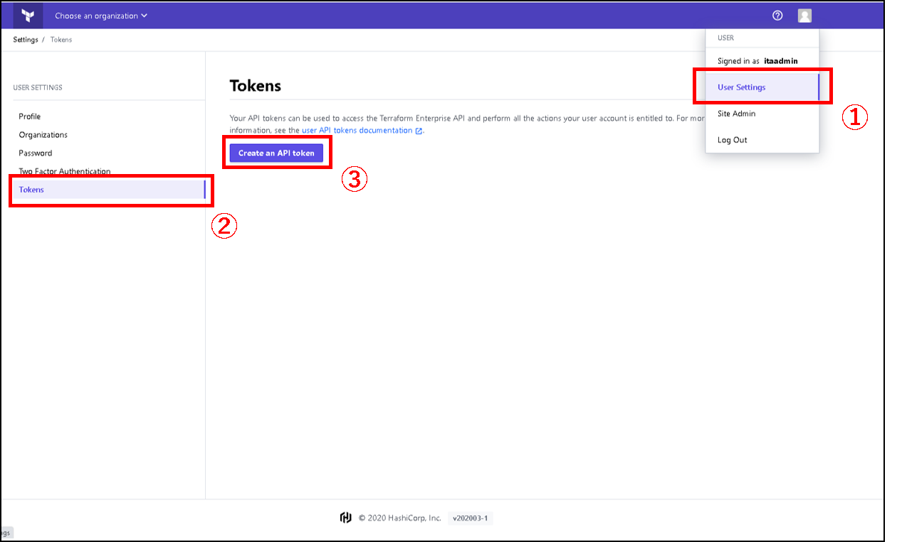

The created user token should be set to “Interface information” of Terraform console in ITA.  
Please refer to “User Instruction manual Terraform-driver” for details.