

ITA_User instruction Manual

Basic Console

*－*Version 1.9*－*

Copyright © NEC Corporation 2019. All rights reserved.

Disclaimer

All the contents of this document are protected by copyright owned by NEC Corporation.

Unauthorized reproduction or copying of all or part of the contents of this document is prohibited.

The contents of this document are subject to change without prior notice in the future.

NEC Corporation is not responsible for any technical or editorial errors or omissions in this document.

NEC Corporation do not guarantee accuracy, usability, certainty of the content in this document.

Trademark

* Linux is registered trademark or trademark of Linux Torvalds, registered in the U.S. and other countries.
* Red Hat is registered trademark or trademark of Red Hat,Inc. Registered in the U.S. and other countries.
* Apache, Apache Tomcat, and Tomcat are registered trademarks or trademarks of the Apache Software Foundation.
* Ansible is registered trademark or trademark of Red Hat,Inc.
* AnsibleTower is registered trademark or trademark of Red Hat,Inc.

The names of other systems, company name and products mentioned in this document are registered trademarks or trademarks of their respective companies.

The® mark and TM mark are not specified in this document.

※ “Exastro IT Automation” is written as “ITA” in this document.

**Table of contents**

Introduction 3

1 Overview of ITA basic console 4

2 ITA basic console menu screen configuration 5

2.1 ITA basic console menu list 5

3 ITA basic console user instruction procedure 6

3.1 Work flow 6

4 Function and operation method description 7

4.1 ITA basic console 7

4.1.1 Device list 7

4.1.2 Associated menu 10

4.1.3 Input operation list 11

4.1.4 Movement list 12

4.1.5 ER Diagram 13

4.1.6 ER Diagram menu list. 15

4.1.7 ER Diagram Item list 16

5 Operation notes 19

5.1 Routine deletion of operation work history 19

Introduction

This document explains the functions and operation methods of the ITA basic console.

# Overview of ITA basic console

This chapter explains the functions and operation methods of the basic console menu.  
The basic console provides the following functions that are commonly required to perform work using ITA.

# ITA basic console menu screen configuration

This chapter explains the menu and screen configuration of the ITA basic console.



## ITA basic console menu list

The ITA common / basic console menu is shown below.

**Table 2.1-1 ITA screen list**

|  |  |  |  |
| --- | --- | --- | --- |
| **No** | **Menu**  **Group** | **Menu / Screen** | **Description** |
| 1 | ITA basic  console | Device list | Users can maintain the list of managed systems (view / register / update / discard). |
| 2 | Input operation list | Users can maintain the operation list (view / register / update / discard). |
| 3 | Movement list | Users can view the list of registered movements. |
| 4 | ER Diagram | Displays the links between all menus and their referred data in an ER Diagram. |

# ITA basic console user instruction procedure

## Work flow

The standard workflow in the ITA basic console is as follows.

Details of each operation are described in next section.

Please refer to the details on how to register a Movement in the user instruction manual of each driver.

1. **Confirm/ Check device information**

**② Confirm / Check Operation**

**④ Check Movement**

**③ Registering Movement in each driver of ITA**

**Figure 3.1-1 Work flow**

# Function and operation method description

## ITA basic console

Device list

1. In the [Device List] screen, information on the target host is managed.

Please register the required information according to the server type before running the orchestrators.

If the server information has been changed when re-executing, change the server information in advance.

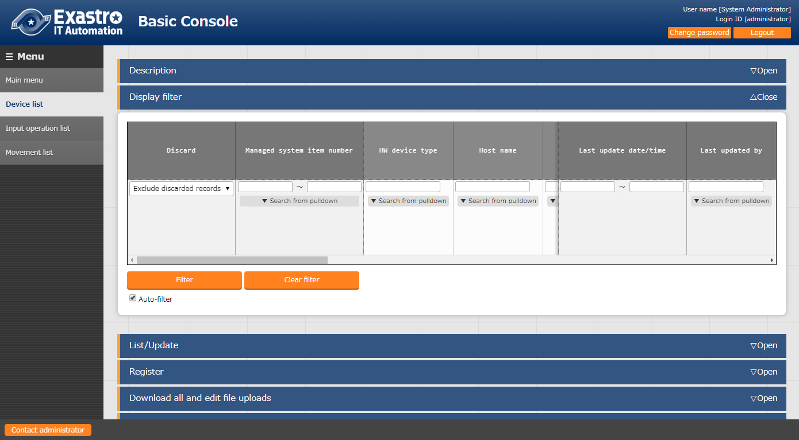

Figure 4.1-1 Submenu screen (device list)

1. Click [Registration] - [Start Registration] button to register device information.

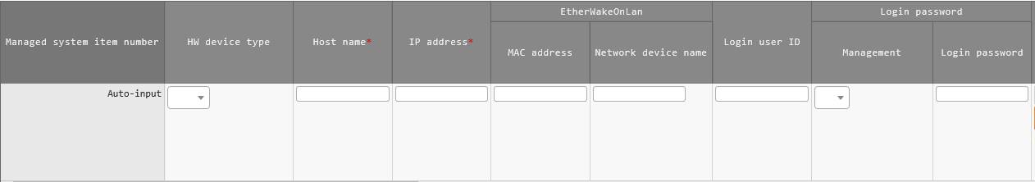

Figure 4.1-2 Registration screen (device list-common items)

1. The list of common items on the registration screen is as follows.

Please make sure to enter the target [Host name] and [IP address].

※Registration is required if “Login password” is "●" for “Management”.

**Table 4.1-1 List of Registration Screen Items (Device List-Common Items)**

|  |  |  |  |  |  |
| --- | --- | --- | --- | --- | --- |
| **Item** | | **Description** | **Input**  **Required** | **Input** **type** | **Restrictions** |
| Managed system item number | | A unique ID that identifies the registration information is automatically entered. | - | Autofill | If the managed system item number exceeds 10,000,000, the host group function will not function properly.  If you want to use the host group function, make sure that the managed system item number is lower than 10,000,000. |
| HW device type | | Select the type of HW device | - | Manual input | Maximum length 128 bytes |
| Host name | | Enter the host name | ○ | Manual input | - |
| IP address | | Enter the IP address (xxx.xxx.xxx.xxx format). | ○ | Manual input | Maximum length 15 bytes |
| EtherWakeOnLan | MAC  address | Enter MAC address | - | Manual input | Maximum length 17 bytes |
| Network device name | Enter the network device name | - | Manual input | Maximum length 256 bytes |
| Login user ID | | Enter the user ID to log in. | - | Manual input | Maximum length 30 bytes |
| Login password | Management | Select “●”to manage the password in ITA | - | List selection | - |
| Login passwords | Specify a password | ※ | Manual input | Maximum size 128 bytes |
| ssh key credentials | SSH private key file | Enter the key file when performing key authentication by specifying the ssh authentication key file. Provide a key file that can be authenticated by the root user. | - | File selection |  |
| Passphrase | If there is a passphrase set to the ssh key file, make sure to input it here. |  |  | Maximum size 256 bytes |
| Remarks | | Free description field | - | Manual input | - |

1. In addition to the common items, information is registered when using each Driver/orchestrator. For details on each Driver, Please refer to the usage instruction for each driver.
2. Ansible Dedicated information

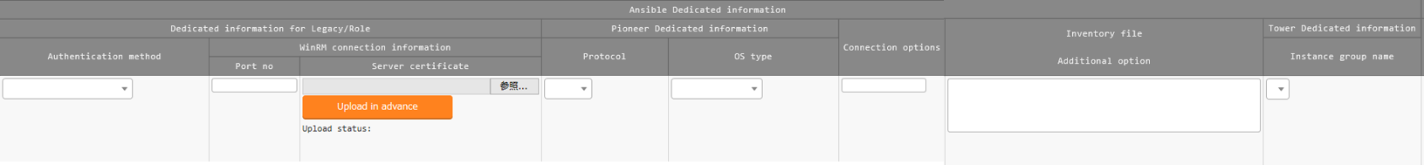

Figure 4.1-3 Registration Screen (Device List-Ansible)

* Ansible Dedicated information is a required parameter for Ansible driver.
* For more details, please refer to “Usage Instruction_Manual_Ansible-driver”.

### Associated menu

In the “Associated menu” menu, users can register/update/discard CMDB menus that are linked using substitute value auto-registration settings.

While the most is done in BackYard if you want to change anything manually, please use this menu.

This menu is hidden by default.  
You can change this by restoring it in the "Role/Menu link list" menu in the Management Console.

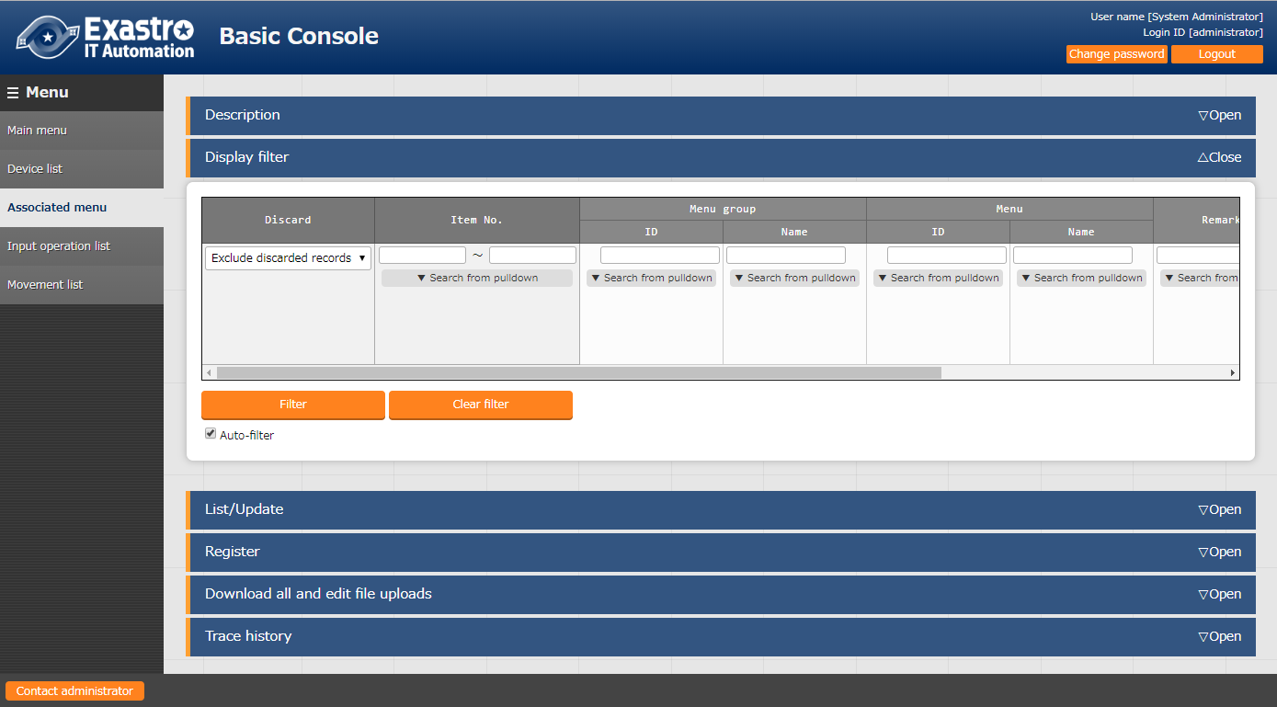

**Figure 4.1-4 Submenu screen (Associated menu)**

1. Click [Registration]-[Registration start] button to link/associate the menu.

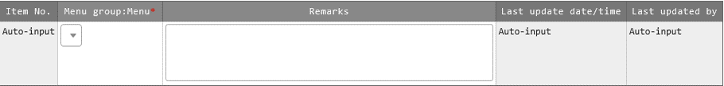

Figure 4.1-5 Registration screen (linking/Associated menu)

1. The list of items in the registration screen is as follows.

**Table 4.1-2 List of registration screen items (associated menu)**

|  |  |  |  |  |
| --- | --- | --- | --- | --- |
| **item** | **Description** | **Input**  **Required** | **Input Type** | **Restrictions** |
| Menu group:Menu※2 | The CMDB menu is displayed. Select the menu of CMDB to be associate with the substitution value automatic registration setting. | ○ | List selection | - |
| Remarks | Free description field | - | Manual input | Maximum length 4000 bytes |

※2 Registration of CMDB menu group and menu is required

Please refer to [User Instruction Manual_Management Console] for the registration of menu group and menu of CMDB.

Input operation list

1. In the [Input operation list] screen, the operations for the target host to be executed by the orchestrator are managed.

(Example) [Additional service construction work] etc.

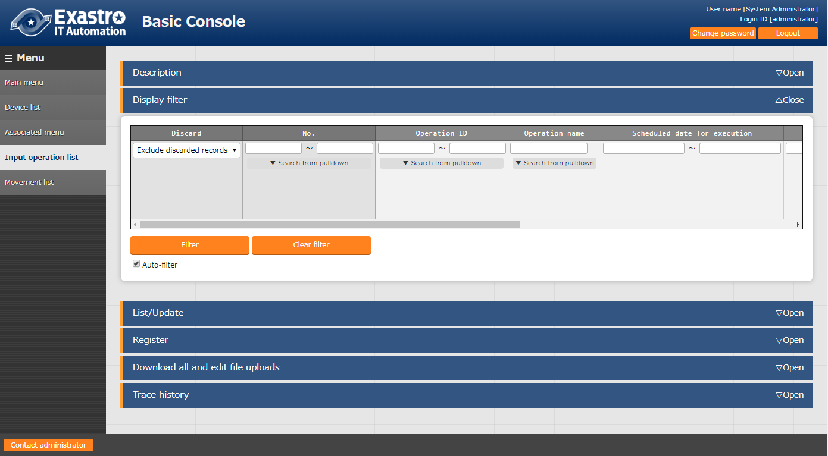

**Figure 4.1-6 Submenu screen (list of input operations)**

1. Click [Registration]-[Registration start] button to register the operation information.



Figure 4.1-7 Registration Screen (List of Input Operations)

1. The list of items on the registration screen is as follows.

**Table 4.1-3 List of registration screen items (input operation list)**

|  |  |  |  |  |
| --- | --- | --- | --- | --- |
| **item** | **Description** | **Input**  **required** | **Input type** | **Restrictions** |
| Operation name | Register desired operation name | ○ | Manual input | Maximum length 256 bytes |
| Scheduled date for executions | Enter the scheduled date and time of the operation.  ※The process is not actually executed on the date specified here.  ※The work history associated with the operation for which the scheduled execution date and time is set is automatically deleted after the specified reservation period. | ○ | Manual input | - |
| Operation ID | The system automatically inputs a unique ID that identifies the operation. | - | Autofill | - |
| Last execution date | Displays the actual date and time when the operation is selected for Symphony execution or each driver's work execution. | - | Display item | Blank is displayed for unexecuted operations. |
| Remarks | Free description field | - | Manual input | - |

Movement list

1. In the [Movement list] screen, you can see the association of the Movement with the orchestrator when using the orchestrator (for reference only).

For the actual registration of Movement, please refer to the instruction manual of each Driver and go to the console menu of the ITA driver of each orchestrator.

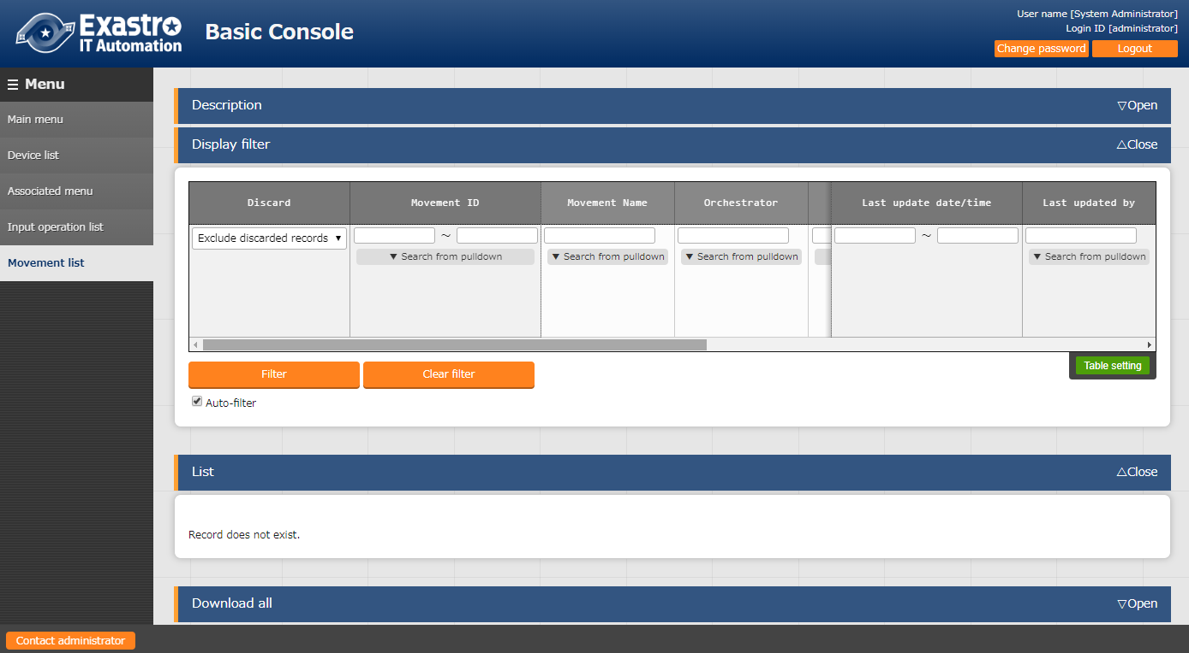

**Figure 4.1-8 Submenu screen (Movement list)**

ER Diagram

1. In the “ER Diagram” screen, the link between all the menus and their referred data is displayed in an ER Diagram.

Only the menus that the user has permission to will be displayed.

1. Print

Prints the ER Diagram.

1. Menu group select

Select what menus to display.

※The Management console is not selected when the menus are displayed.

1. Relation

Display or hide ER Diagram relations.

1. The entire display

Shows the whole display.

1. Display reset

Resets the display.

1. Menu item list

The filtered items of each menu.

* The “Remarks”, “Last updated by” and “Last updated date” will not be displayed.

1. Relation

A one-way arrow is drawn between items with relation.

**Relation destination**

**Relation start**

※The following relations are not linked due to their large number and complexity

・Operation list ->Operation ID

・Operation list ->Operation name

・Device list -> Host name

①

⑥

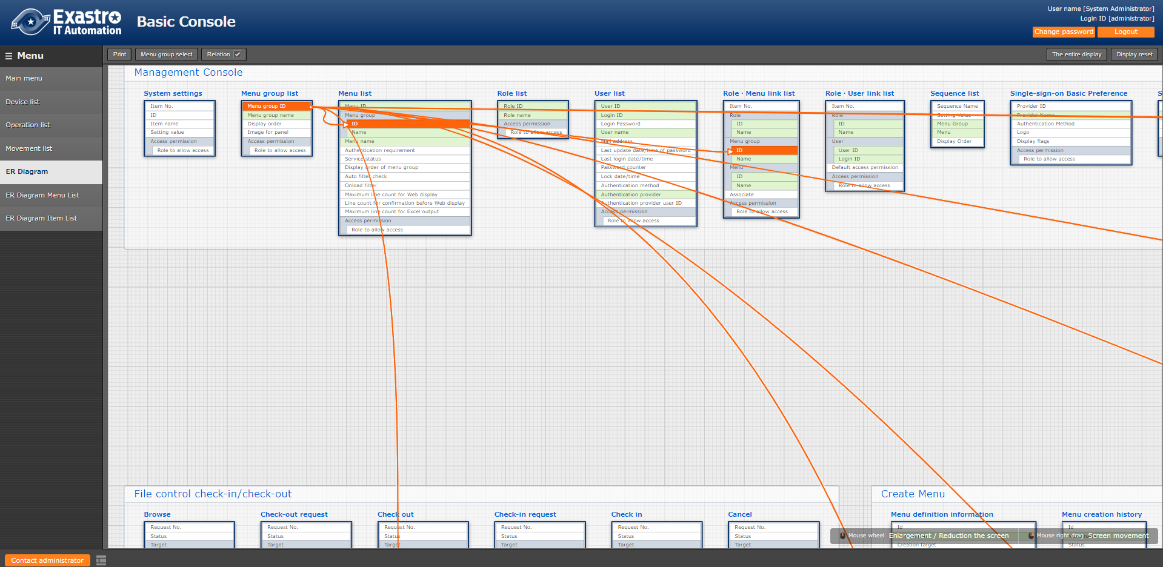Figure 4‑1 ER Diagram Display screen.

**②**

**⑤**

**④**

**⑦**

**③**

1. Operation explanation

|  |  |
| --- | --- |
| **Operation** | **Action** |
| Zoom in and out | Scroll with the mouse wheel to zoom in and out. |
| Move | Right-click and move the mouse to move the screen |
| Highlight/Un-highlight relation | Click an item with a relation |
| Highlight relation (temporary) | Hover the cursor over an item with a relation. |

1. ER Diagram creation

The ER Diagram is created when the following happens.

1. When ITA is installed.
2. When a Menu is created with the Menu creation function.
3. When an kym file is imported with the “Menu import” menu.

ER Diagram menu list.

1. In the “ER Diagram Menu list” menu, users can manage the menus and tables displayed in the ER Diagram, as well as their links.

By inputting Item data into the “ER Diagram Item list” after inputting data into this menus will display the respective table information in the ER Diagram.

While the most is done in BackYard if you want to change anything manually, please use this menu.

The data in the ER Diagram menu list has no history.

The data will be deleted when it gets regenerated, but only if it was not last updated by a user.

This menu is hidden by default.

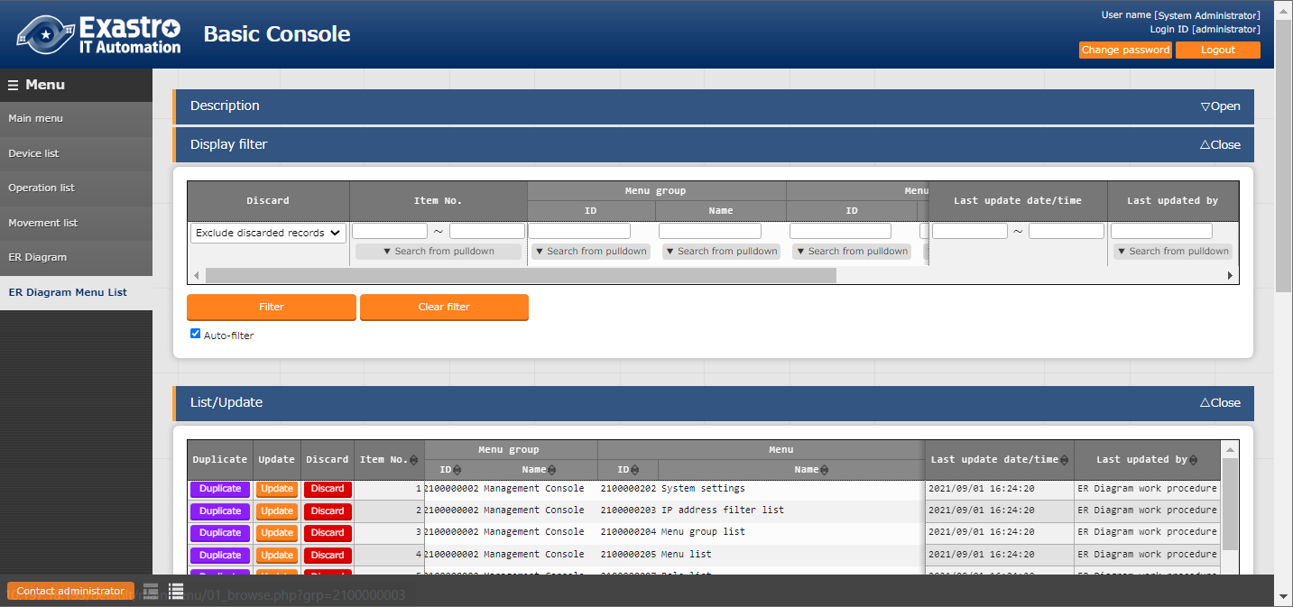You can change this by restoring it in the "Role/Menu link list" menu in the Management Console.

**Figure 4‑ 10 Submenu screen（ER Diagram Menu List）**

1. Press "Start Registration" in the "Register" submenu to register menu information that is going to be displayed in the ER Diagram.



Figure 4‑11 ER Diagram Menu list

1. The items in the Registration screen is as following

Table 4.1‑4 Registration screen item list（ER Diagram menu list）

|  |  |  |  |  |
| --- | --- | --- | --- | --- |
| **Item** | **Description** | **Input required** | **Input format** | **Restrictions** |
| Menu group:Menu | All the menus are displayed.  Select the menu you want the ER Diagram to display. | ○ | List selection | - |
| Table name | Register the table name that is going to be linked to the Menugroup:Menu | ○ | Manual input | Maximum length 256 bytes |
| View name | Register the view name that is going to be linked to the Menugroup:Menu | - | Manual input | Maximum length 256 bytes |
| Remarks | Free description field | - | Manual input | - |

ER Diagram Item list

1. In the "ER Diagram item list" screen, users can configure ER Diagram settings and the Menu items.

While the most is done in BackYard if you want to change anything manually, please use this menu.

The data in the ER Diagram menu list has no history.

The data will be deleted when it gets regenerated, but only if it was not last updated by a user.

After installation, the "ER Diagram Item List" is set to be hidden.

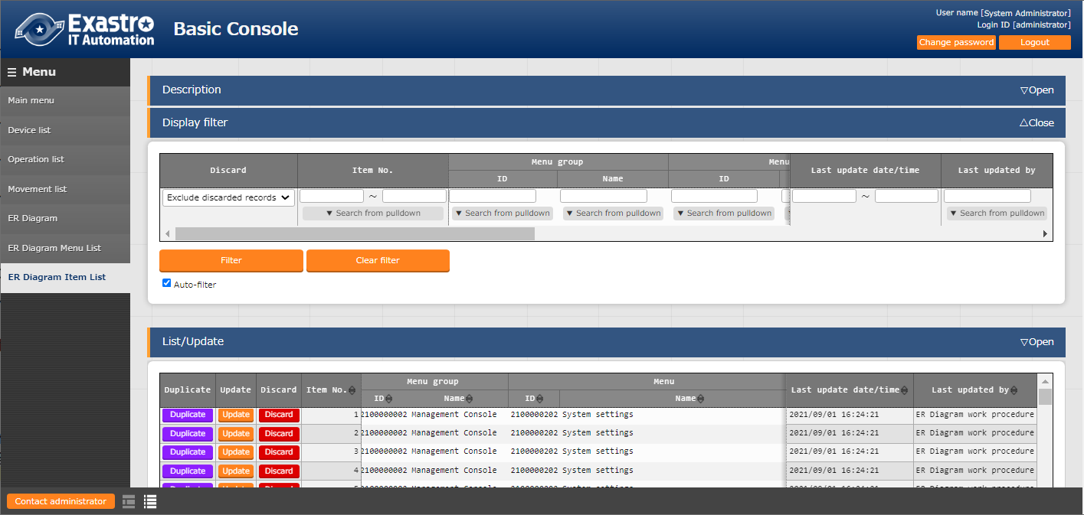 You can change this by regenerating it in the "Role/Menu link list" menu in the Management Console.

Figure 4‑12 Submenu screen（ER Diagram Item list）

1.  Press "Start Registration" in the "Register" submenu to register menu information that is going to be displayed in the ER Diagram.

Figure 4‑13 ER Diagram Item list

(3) The items in the Registration screen is as following

Table 4.1‑5 Registration screen item list（ER Diagram Item list）

|  |  |  |  |  |
| --- | --- | --- | --- | --- |
| **Items** | **Description** | **Input required** | **Input format** | **Restrictions** |
| Menu group:Menu | The menus configured in the "ER Diagram Menu list" is displayed.  Select the menu you want the ER Diagram to display. | ○ | List Selection | - |
| Display order | Enter the display order of the menus in the ER Diagram. | - | Manual input | Numeric Value |
| Item | Input a name for the Item.  Make sure that the name is unique for its menu. | ○ | Manual input | Maximum length 256 bytes |
| Item type | Select either Group or Item. | ○ | List selection | - |
| Parent Item | Input the group where the selected item belongs to.  If it doesn’t belong to any group, leave it blank. | - | Manual input | Maximum length 256 bytes |
| Physical name | Input the physical name of the item.  This name is used when configuring related items. | - | Manual input | Maximum length 256 bytes |
| Logical name | Input the logical name of the item.  This is the name that will be displayed in the ER Diagram. | ○ | Manual input | Maximum length 256 bytes |
| Related Table name | Input the name of the table that the linked item is going to belong to. | - | Manual input | Maximum length 256 bytes |
| Related Item | Input the physical name of the item that is going to be linked.  It’s not possible to link a relation if there is no physical name set. | - | Manual input | Maximum length 256 bytes |
| Remarks | Free description field | - | Manual input | - |

# Operation notes



## Routine deletion of operation work history

The function to delete the data associated with the scheduled date and time of the operation that is registered in the “input operation list” menu is available.

Please refer to “User Instruction Manual_Management Console” for details.