

ITA_User Instruction Manual

Compare function

*－*Ver 1.7*－*

Copyright © NEC Corporation 2021. All rights reserved.

Disclaimer

All the contents of this document are protected by copyright owned by NEC Corporation.

Unauthorized reproduction or copying of all or part of the contents of this document is prohibited.

The contents of this document are subject to change without prior notice in the future.

NEC Corporation is not responsible for any technical or editorial errors or omissions in this document.

NEC Corporation do not guarantee accuracy, usability, certainty of the content in this document.

Trademark

* Linux is registered trademark or trademark of　Linus Torvalds, registered in the U.S. and other countries.
* Red Hat is registered trademark or trademark of Red Hat, Inc. registered in the U.S. and other countries.
* Apache, Apache Tomcat, and Tomcat are registered trademarks or trademarks of the Apache Software Foundation.
* Ansible is registered trademark or trademark of Red Hat, Inc.

The names of other systems, company name and products mentioned in this document are registered trademarks or trademarks of their respective companies.

The ® mark and TM mark are not specified in this document.

※「Exastro IT Automation」 is written as 「ITA」 in this document.

Table of contents

Table of contents 2

Introduction 3

1 Compare function overview 4

1.1 Compare function 4

1.1.1 Compare function overview figure. 4

1.1.2 Compare function process overview 5

1.1.3 Comparison definition overview 6

1.2 Comparing Parameter sheets 8

1.2.1 Compare function requirements 8

1.2.2 Comparison parameters 8

2 Comparing items 9

2.1 Comparing items 9

2.1.1 Items that can be compared. 9

2.1.2 Item combinations that can be compared. 9

3 Comparison menu configuration 10

3.1 Menu/Screen list 10

4 Using the Compare function 11

4.1 Operation flow 11

4.1.1 Compare function operation flow. 11

5 Compare function operation 13

5.1 Compare 13

5.1.1 Compare list 13

5.1.2 Comparison definition details. 14

5.1.3 Comparison execution 15

6 Appendix 18

6.1 References 18

6.1.1 Example comparing parameter sheets with pulldown selections. 18

Introduction

This document explains ITA’s Functions and how to operate them.

# Compare function overview

This chapter explains the Compare function

## Compare function

The Compare function can be used to compare Parameter sheets created with the ITA Menu create function and output the differences.

This function only supports Parameter sheets (with host/operation).

For more details regarding Parameter sheets, please refer to  
“Exastro-ITA_User_Instruction_Manual_Menu_creation_function.”

For more information regarding Access rights/ Access permission roles, please refer to  
“Exastro-ITA_User_Instruction_Manual_Role-based_access_control_for_data_records”

### Compare function overview figure.

The following figure illustrates the workflow of using the Compare function,。

ITA

3.Symphony

実行

※Link settings for the menu getting compared.

Run Comparison

Define Comparison

Define Comparison details

Parameters when compared

Comparison definition

Comparison definition details

Outputs comparison results

※Outputs as Web or File（Excel,Csv）

Parameter sheet

(With host/operation)

Create menu

Register data

※Link settings for every item in the Menu.

### Compare function process overview

The following figure illustrate the process of the Compare function.

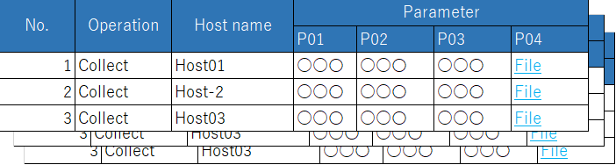

3.Symphony

実行

Define Comparison

Define Comparison details

Parameter sheet 1



Parameter sheet 2

Run comparison

Parameter sheet

※Outputs comparison results according to the definition and the detailed definition, as well as the parameters compared.

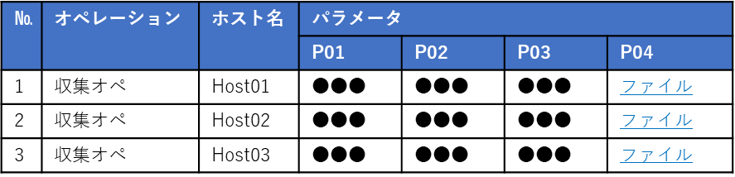

Run Comparison

Comparison definition

Base date 1/2

Target host

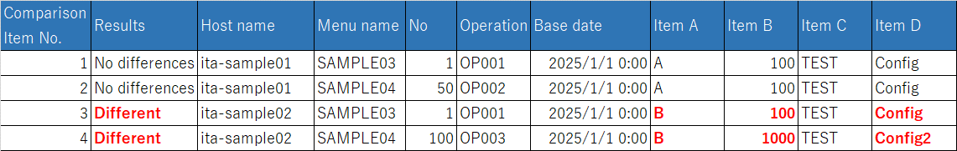

### Comparison definition overview

The following figure illustrates the link between the parameter sheets as well as the comparison results. For information regarding Comparison definition, Comparison details definition and the different configurations, please refer to Chapter 5, Compare function operation.

・Parameter sheet link(When the items of the parameter sheets are identical to each other)

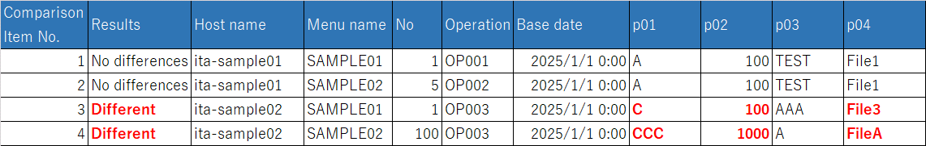

Run Comparison

・

**※Link the parameter sheets in the Comparison definition.**



**Paraneter sheet 1**

**Parameter sheet 2**

**Comparison result**

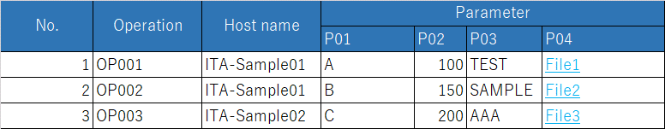

・Parameter sheet link (When the items of the parameter sheets dont match each other).



Run Comparison

・

**Link the parameter sheet in the Comparison definition. Link the items in the detailed comparison definition.**

Parameter sheet 1

Parameter sheet 2

**Comparison results**

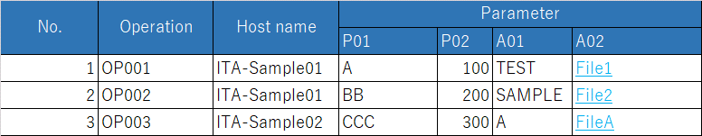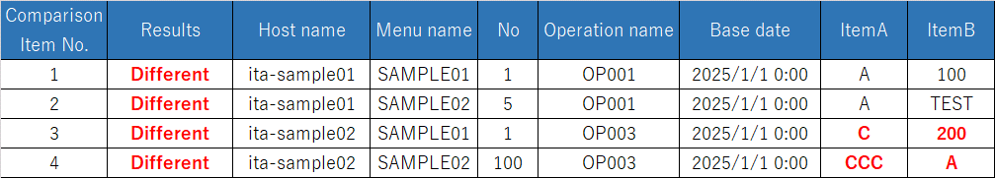

## Comparing Parameter sheets

The compare function allows users to do comparisons between parameter sheets linked in the Comparison definition and the Comparison definition details.

### Compare function requirements

Make sure that the ITA Settings fill the following requirements.

* ITA is installed with “createparam” selected in the ITA installer.
* Parameter sheets (with host/operation) is created using the Menu create function.
* A link is created between the parameter sheets you want to compare in the Comparison definition.
* A link is created between the parameter sheet’s items in the Comparison definition details (unnecessary depending on the Comparison definition settings).

### Comparison parameters

Configure the following parameters in order to run comparison.

For more information regarding Comparison definition, please see 5.1.1 later in this document.

**Table 1.2‑1　Comparison parameters**

| **Parameter** | **Description** | **Input necessary** | **Input format** | **Restrictions** |
| --- | --- | --- | --- | --- |
| Comparison definition | Select Comparison definition. | 〇 | List selection |  |
| Base date 1 | Input the base date of Menu 1 in the Comparison definition. |  | Manual input |  |
| Base date 2 | Input the base date of Menu 2 in the Comparison definition. |  | Manual input |  |
| Target host | Select the target host.  Default: No host(Shows the whole comparison). |  | List selection |  |

# Comparing items

## Comparing items

### Items that can be compared.

The parameter sheet items that can be compared with the Compare function are as following.。

**Table 2.1‑1　Comparable parameter sheet items**

| **Item type** | **Restrictions** |
| --- | --- |
| String |  |
| Multi string |  |
| Integer |  |
| Decimal number |  |
| Pulldown selection | The ID of the selected list will be compared.  If you dont have access permission, ID Conversion failure(X) will be displayed. |
| File upload | If both items are file upload type items, the file name and the file contents will be compared. |
| Link |  |

※For more information regarding access rights, please refer to   
“Exastro-ITA_User_Instruction_Manual_Role-based_access_control_for_data_records”

### Item combinations that can be compared.

The different combinations of parameter sheet items that can be used with the compare function are as following.

Table 2-1 Comparable Parameter sheet item combinations

|  |  |  |  |  |  |  |  |
| --- | --- | --- | --- | --- | --- | --- | --- |
|  | **String** | **Multi string** | **Integer** | **Decimal number** | **Pulldown selection** | **File upload** | **Link** |
| **String** | 〇 | 〇 | 〇 | 〇 | 〇※1 | 〇※2 | 〇 |
| **Multi string** | 〇 | 〇 | 〇 | 〇 | 〇※1 | 〇※2 | 〇 |
| **Integer** | 〇 | 〇 | 〇 | 〇 | 〇※1 | 〇※2 | 〇 |
| **Decimal number** | 〇 | 〇 | 〇 | 〇 | 〇※1 | 〇※2 | 〇 |
| **Pulldown selection** | 〇※1 | 〇※1 | 〇※1 | 〇※1 | 〇※1 | 〇※1※2 | 〇※1 |
| **File upload** | 〇※2 | 〇※2 | 〇※2 | 〇※2 | 〇※1※2 | 〇※3 | 〇※2 |
| **Link** | 〇 | 〇 | 〇 | 〇 | 〇※1 | 〇※2 | 〇 |

※1 he pulldown menu will have it's selected list's ID compared.

Please see the Comparison example in Chapter 6.1.1 Example comparing parameter sheets with pulldown selections.

※2 The target value and file name will be compared.

※3If either the name or contents of the file are different, they will be displayed as "Different".。

# Comparison menu configuration

This chapter explains the menu configuration of the comparison function.

For information regarding loggin into the Web console or the ITA screen configuration and it's operations, please refer to the First step guide.

## Menu/Screen list

The Compare function's menu list is as following.

Table 3-1 Compare screen list

|  |  |  |  |
| --- | --- | --- | --- |
| No | Menu group | Menu/Screen | Description |
| 1 | Compare | Contrast list | Create Compare Definition name and link parameter sheets. |
| 2 | Contrast details | Link Parameter sheet items. |
| 3 | Contrast execution | Run the comparison using the settings configured in the Contrast list and Contrast details. |

# Using the Compare function

This chapter explains how to use the Compare function.

## Operation flow

The standard Compare function operation flow is as following.

### Compare function operation flow.

The following figure illustrates a standard Compare function operation flow.

1. **Create Parameter sheet**
2. **Create Compare definition**

**Required**

**Legend**

1. **Register data to Parameter sheet**
2. **Configure detailed settings for Compare Def.**
3. **Run comparison**

**※If the Comparison definition contains items that dont completely match up with each other, you will need to configure Detailed comparison definition.**

* **Detailed workflow and references.**

1. **Create Parameter sheet**Create a Parameter sheet in the "Create/Define menu" menu in the "Menu create" menu group.

For more information, please refer to   
“Exastro-ITA_User_Instruction_Manual_Menu_creation_function”

1. **Register data data to Parameter sheet**

Register data to the Parameter sheet creted in the previous step.

For more information, please refer to   
“Exastro-ITA_User_Instruction_Manual_Menu_creation_function”

1. **Create Comparison definition**

Use the "Compare definition" menu to define/create a comparison

For more information, please refer to Chapter 5.1.1 Comparison definition.

1. **Configure Detailed comparison definition**

[Use the "Comparison details" menu to configure details for the previously created comparison.

For more information, please refer to Chapter 5.1.2 Comparison definition details

1. **Run comparison**

Use the Comparison execution menu to run compare the set parameter sheets.

For more information, please refer to Chapter 5.1.3 Comparison execution.

# Compare function operation

This chapter describes the different menus in the Comparison function.

## Compare

### Compare list

1. In the "Compare list", users can register and update/change Comparison definitions (Links between parameter sheets)。

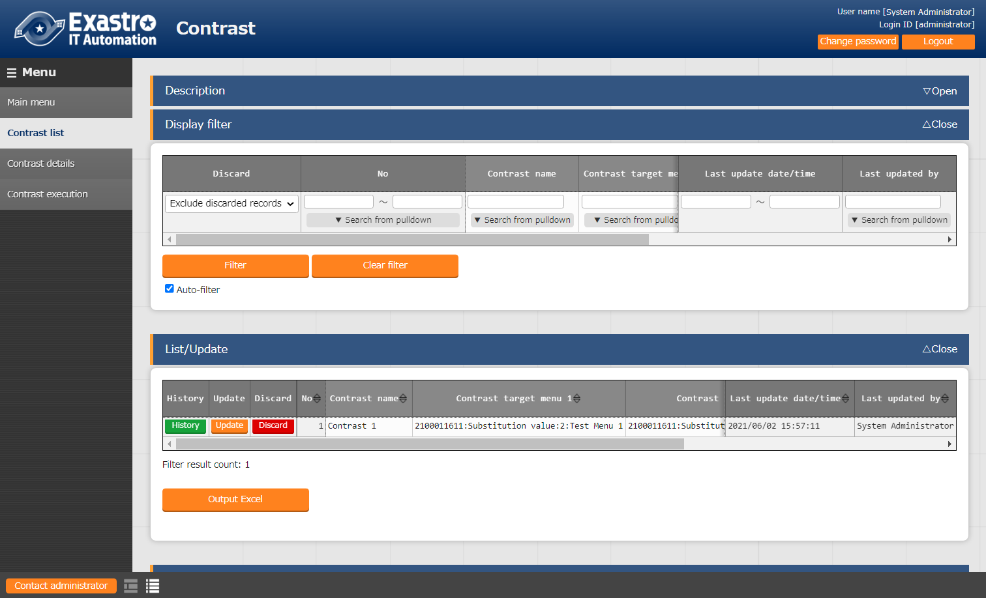

**Figure 5.1‑1 Submenu screen（Compare list）**

1. Users can register Comparison definitions by clicking the “List/Update” button and then the “Start registering” button.

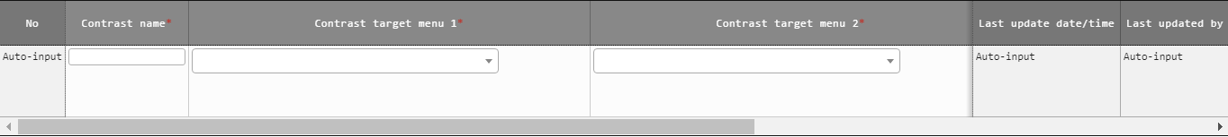

Figure 5.1‑2 Register screen（Compare list）

1. The item list found in the Comparison definition menu is as following.

**Table 5.1‑1　Registration screen items （Comparison list）**

| **Item** | **Description** | **Input required** | **Input format** | **Constraints** |
| --- | --- | --- | --- | --- |
| Comparison name | Input name of the comparison | 〇 | Manual input |  |
| Comparison target menu 1 | Select target menu | 〇 | List selection |  |
| Comparison target menu 2 | Select target menu | 〇 | List selection |  |
| Match all cases | Select if Menu 1 and Menu 2’s item match up. | - | Select | ※1 |
| Remarks | Free description field | - | Manual input |  |

※1 The user does not need to configure comparison definition details if “Match all cases” is selected.

In order to select this, all items of the selected parameter sheets needs to match up.

### Comparison definition details.

1. In the “Comparison definition details” menu, users can link the different items of the parameter sheets linked in the “Comparison definition” menu.

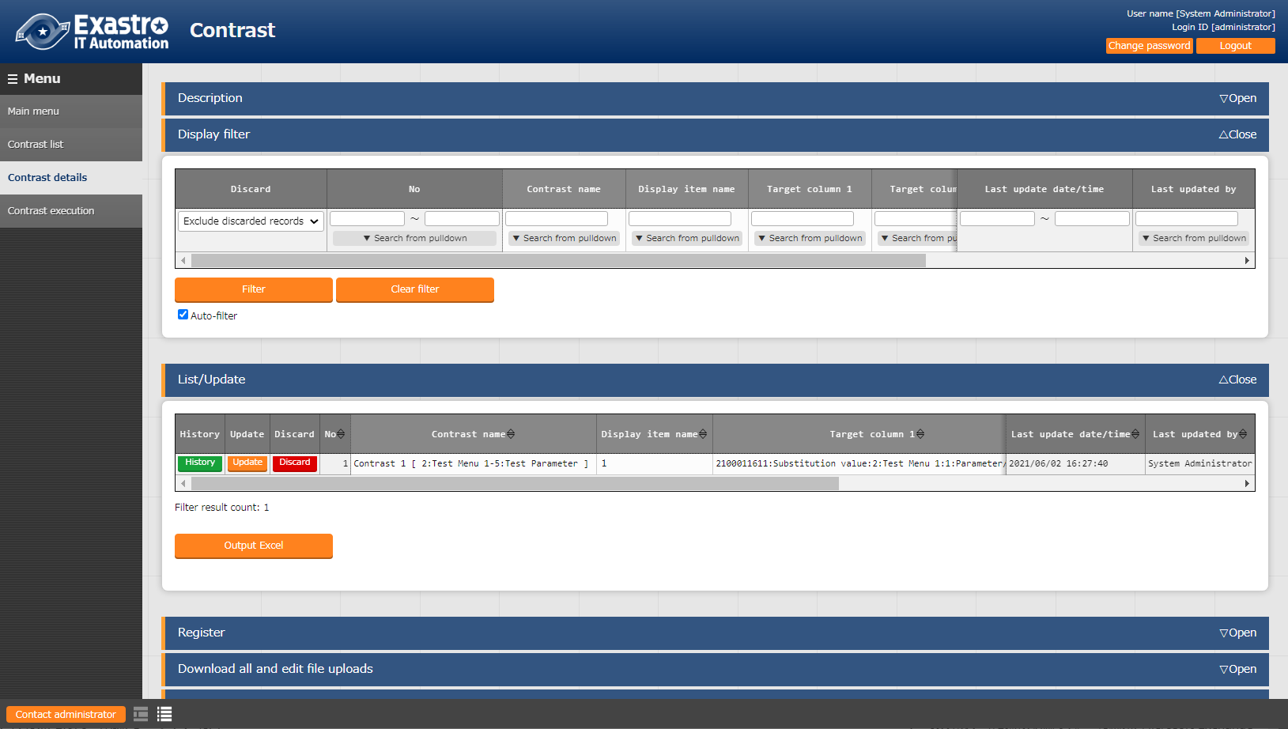

**Figure 5.1‑3 Submenu screen（Comparison definition details）**

1. 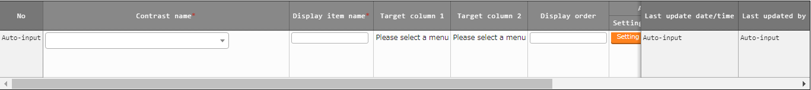Press the “List” and then “Start registration” to register link between items.

Figure 5.1‑4 Registration screen（Comparison definition details）

1. The following table lists the items in the Compare item value list screen.

**Table 5.1‑1　Registration screen item list（Comparison definition details）**

| **Item** | **Description** | **Input required** | **Input method** | **Restrictions** |
| --- | --- | --- | --- | --- |
| Comparison name | Select a comparison | 〇 | List selection | ※1 |
| Display item name | Input the name of the display items.  This is the item name that will be used in the output comparison results. | 〇 | Manual input |  |
| Target column 1 | Select Target column | 〇 | List selection | ※2 |
| Target column 2 | Select Target column | 〇 | List selection | ※3 |
| Display order | Select display order | - |  | ※4 |
| Remarks | Free description field | - |  |  |

※1 Only items for parameter sheets that has “Match all cases” unchecked in the “Comparison definition” menu.

※2 Items that are registered in Target Menu 1 in the Comparison definition can be selected.

※3 Items that are registered in Target Menu 2 in the Comparison definition can be selected.

※4 If nothing is input, the comparison results will be output in the order of Comparison Definition details ID, left to right.

### Comparison execution

1. The “Comparison execution” compares parameter sheets based on the information set in the Comparison definition and Comparison definition details menu.

* 「The list of Comparison definition registered in “5.1.1 Comparison definition” is displayed.
* Clicking the “Compare” button executes the comparison and compares the target menus and items based on the input parameters.

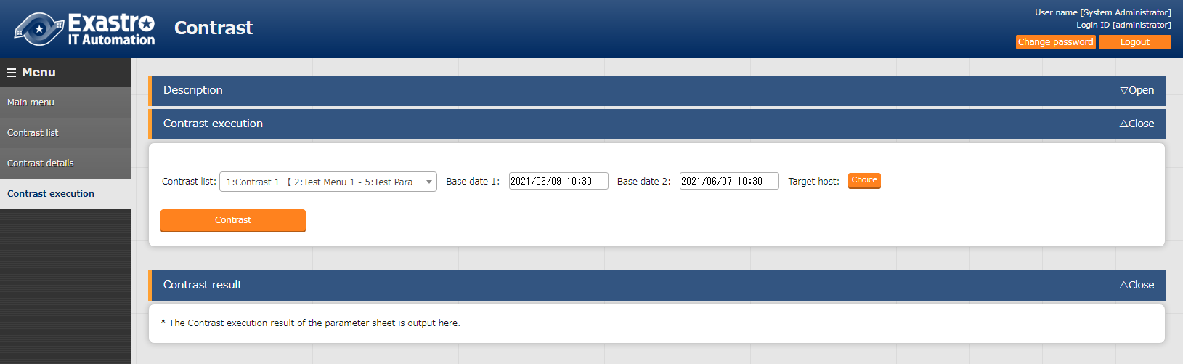

**Figure 5.1‑5 Comparison execution screen（Input Parameter）**

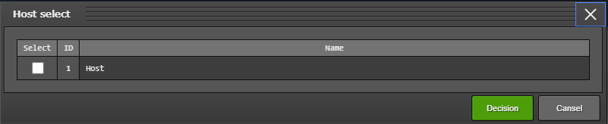

**Figure 5.1‑6 Host list menu（Comparison execution：Target host）**

**Table 5.1‑1　Comparison execution item list**

| **Item** | **Description** | **Input required** | **Input method** | **Constraints** |
| --- | --- | --- | --- | --- |
| Comparison list | Select Comparison definition. | 〇 | List selection |  |
| Base date 1 | Specify the base date for Menu 1 | - | Manual input | ※1 |
| Base date 2 | Specify the base date for Menu 2 | - | Manual input | ※1 |
| Host | Pressing the “Host” button will open up a list of target hosts. Please select a host and press the “Decision” button. | - | Select | ※2 |
| Compare | Press this button to run the comparison between the selected parameters and outputs the results. | - | - | - |

※1 If a base date is input, the data compared will be the latest version at the time of the input date.

If nothing is input, the latest version will be used,  
※2 No host is selected by default.

Will output the comparison for all host linked to the menu.

* After pressing the “Compare” button, a file output button (excel, CSV) button will be displayed.
* The results will be displayed in the order of Menu 1 and Menu 2 for each host.

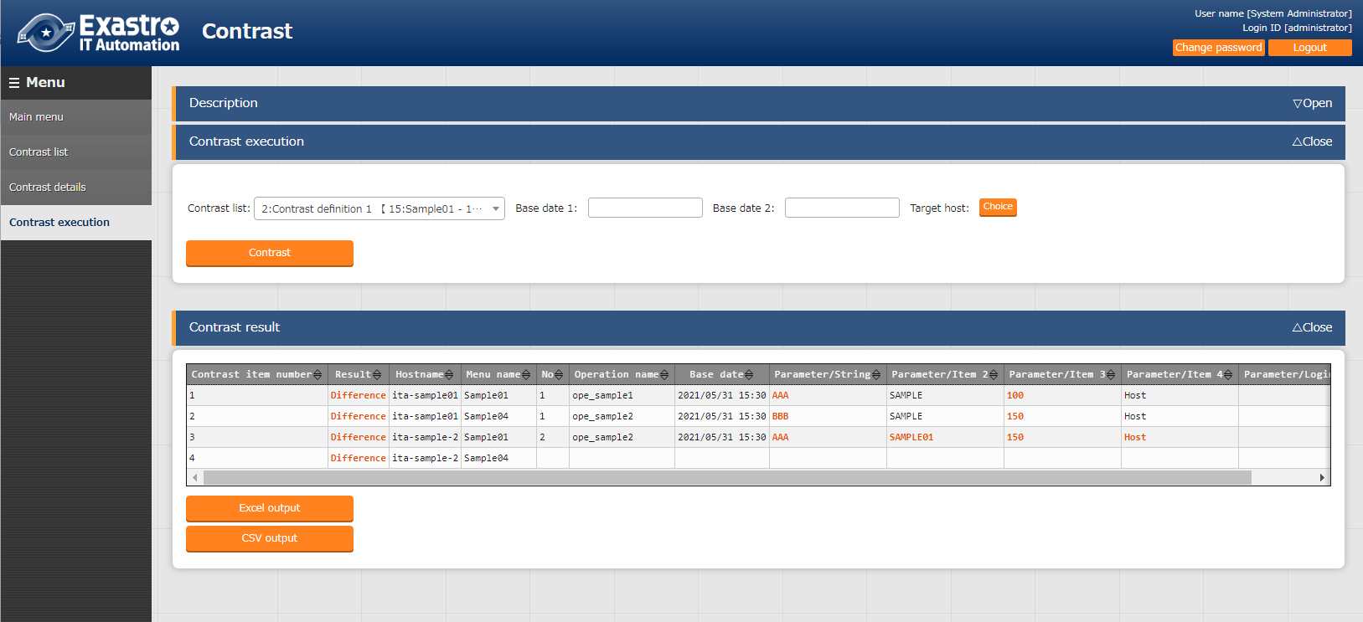

**Figure 5.1‑7 Comparison execution screen (Comparison results)**

**Table 5.1‑1　Comparison execution output list**

| **Item** | **Description** | **Constraints** |
| --- | --- | --- |
| Comparison item number | Number of the items output from the Comparison results. |  |
| Result | Displays the comparison results.  Either with “Difference” or “no difference”. | ※1 |
| Host name | Displays the target host name |  |
| Menu name | Displays the target menu name |  |
| No | Displays the compared menu number. |  |
| Operation name | Displays the operation name |  |
| Base date | Displays the Base date |  |
| Comparison item | Displays the target item. | ※1 |
| Excel output | Outputs the results in excel format. |  |
| CSV output | Outputs the results in CSV format. |  |

※1 If there were any differences, it will be highlighted in red text.

# Appendix

## References

### Example comparing parameter sheets with pulldown selections.

The following illustrates an example using the compare function to compare parameter sheets with pulldown selection items.

* 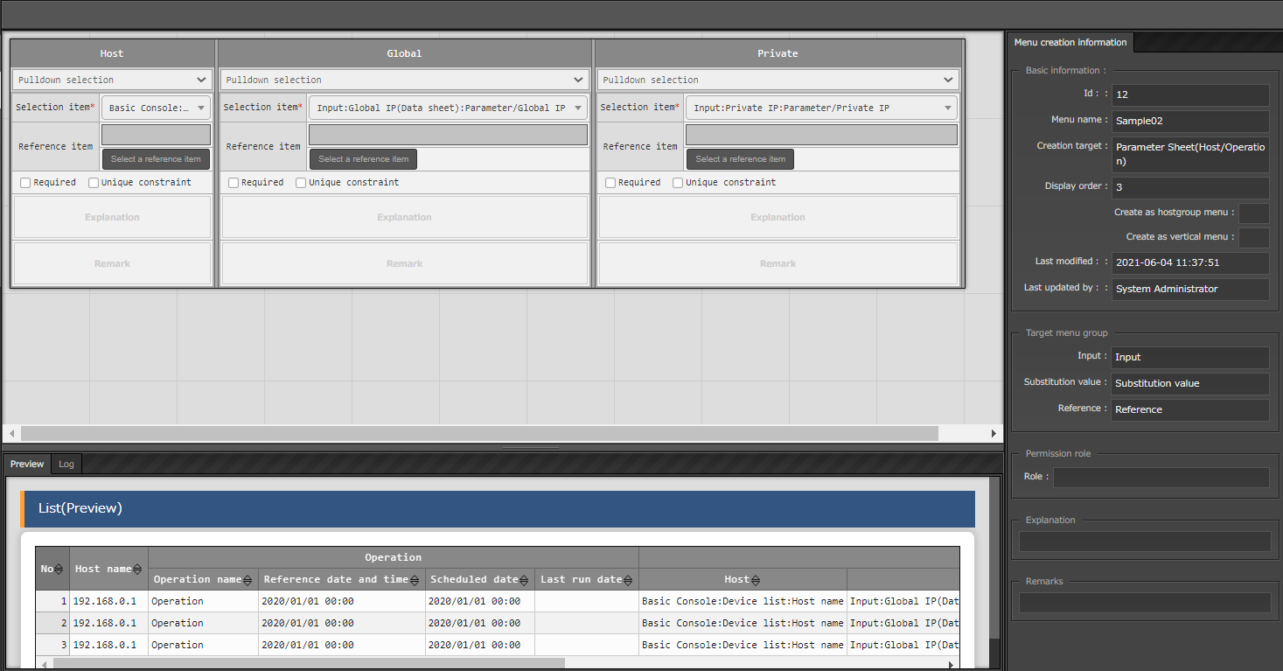Comparing Pulldown selection items in Parameter sheets and their configurations.

**Figure 6.1‑1 Parameter sheet（Create/Define menu）**

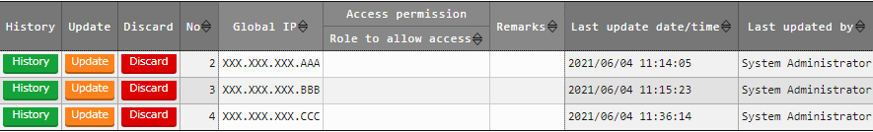

**Figure 6.1‑2 Pulldown reference definition [Data sheet:Global IP]**

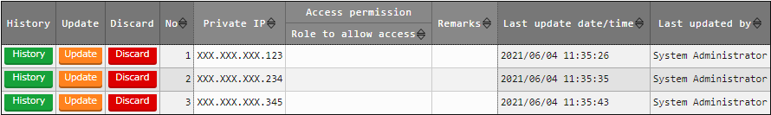

**Figure 6.1‑3 Pulldown reference destination [Data sheet :Private IP]**

* Comparisons and Comparison definitions

In the following illustration, the items marked with red-blue are going to be compared.

Gllobal：References Global IP (Datasheet)

Private：References Private IP (Datasheet)

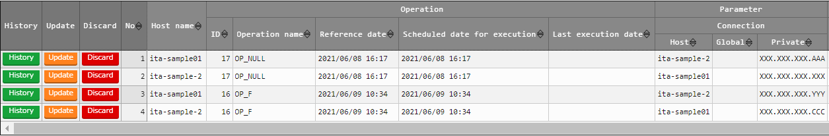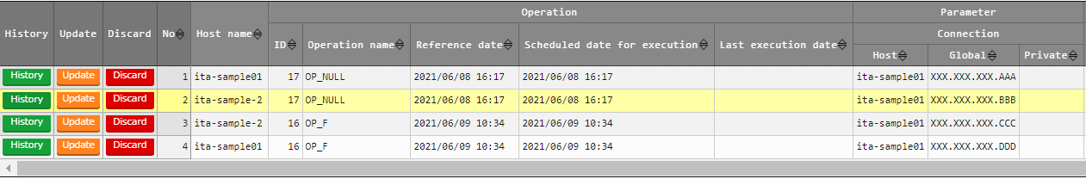

SAMPLE07

SAMPLE08

**Figure 6.1‑4 Comparable parameter sheets**



**Figure 6.1‑5 Comparison definition setting example**



**Figure 6.1‑6 Comparison definition details setting example**

* Comparison execution

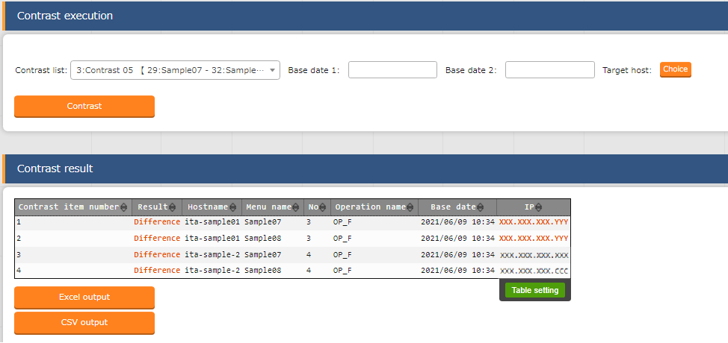

※1

※2

**Figure 6.1‑7Comparison execution results**

Since the pulldown reference destination is different from each other, patterns like ※1 and ※2 might occur.

※1 If the displayed contents are the same, but the reference destinaton’s no. is the same, it will be considered as being different.

※2 If the reference destination’s no. is different, but the contents are the same, it will not be considered as being different.