

ITA_User Instruction Manual

Contrast function

*－*Ver 1.7*－*

Copyright © NEC Corporation 2021. All rights reserved.

Disclaimer

All the contents of this document are protected by copyright owned by NEC Corporation.

Unauthorized reproduction or copying of all or part of the contents of this document is prohibited.

The contents of this document are subject to change without prior notice in the future.

NEC Corporation is not responsible for any technical or editorial errors or omissions in this document.

NEC Corporation do not guarantee accuracy, usability, certainty of the content in this document.

Trademark

* Linux is registered trademark or trademark of　Linus Torvalds, registered in the U.S. and other countries.
* Red Hat is registered trademark or trademark of Red Hat, Inc. registered in the U.S. and other countries.
* Apache, Apache Tomcat, and Tomcat are registered trademarks or trademarks of the Apache Software Foundation.
* Ansible is registered trademark or trademark of Red Hat, Inc.

The names of other systems, company name and products mentioned in this document are registered trademarks or trademarks of their respective companies.

The ® mark and TM mark are not specified in this document.

※「Exastro IT Automation」 is written as 「ITA」 in this document.

Table of contents

Table of contents 2

Introduction 3

1 Contrast function overview 4

1.1 Contrast function **エラー! ブックマークが定義されていません。**

1.1.1 Contrast function overview figure. 4

1.1.2 Contrast function process overview 5

1.1.3 Contrast list overview 6

1.2 Comparing Parameter sheets 8

1.2.1 Contrast function requirements 8

1.2.2 Contrast parameters 8

2 Comparing items 9

2.1 Comparing items 9

2.1.1 Items that can be compared. 9

2.1.2 Item combinations that can be compared. 9

3 Contrast menu configuration 10

3.1 Menu/Screen list 10

4 Using the Contrast function 11

4.1 Operation flow 11

4.1.1 Contrast function operation flow. 11

5 Contrast function operation 13

5.1 Compare **エラー! ブックマークが定義されていません。**

5.1.1 Compare list 13

5.1.2 Contrast details. 14

5.1.3 Contrast execution **エラー! ブックマークが定義されていません。**

6 Appendix 18

6.1 References 18

6.1.1 Example comparing parameter sheets with pulldown selections. 18

Introduction

This document explains ITA’s Functions and how to operate them.

# Contrast function overview

This chapter explains the Contrast function

## Contrast function

The Contrast function can be used to compare Parameter sheets created with the ITA Menu create function and output the differences.

This function only supports Parameter sheets (with host/operation).

For more details regarding Parameter sheets, please refer to  
“Exastro-ITA_User_Instruction_Manual_Menu_creation_function.”

For more information regarding Access rights/ Access permission roles, please refer to  
“Exastro-ITA_User_Instruction_Manual_Role-based_access_control_for_data_records”

### Contrast function overview figure.

The following figure illustrates the workflow of using the Contrast function,。

ITA

3.Symphony

実行

※Link settings for the menu getting compared.

Run Contrast

Define Contrast

Define Contrast details

Parameters when compared

Contrast definition

Contrast details

Outputs Contrast results

※Outputs as Web or File（Excel,Csv）

Parameter sheet

(With host/operation)

Create menu

Register data

※Link settings for every item in the Menu.

### Contrast function process overview

The following figure illustrate the process of the Contrast function.

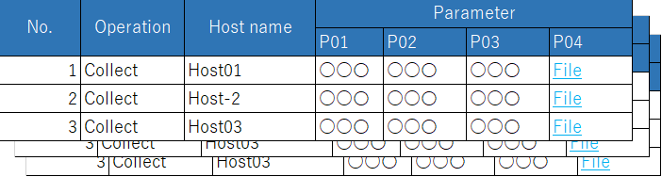

3.Symphony

実行

Define Contrast

Define Contrast details

Parameter sheet 1



Parameter sheet 2

Execute Contrast

Parameter sheet

※Outputs Contrast results according to the definition and the detailed definition, as well as the parameters compared.

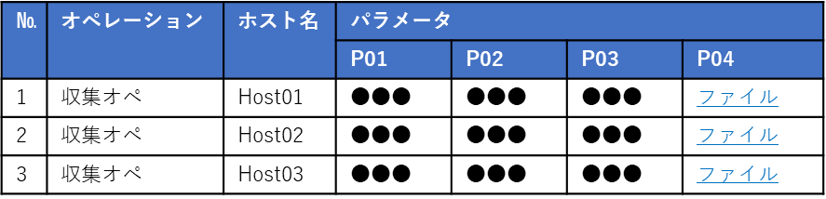

Run Contrast

Contrast list

Base date 1/2

Target host

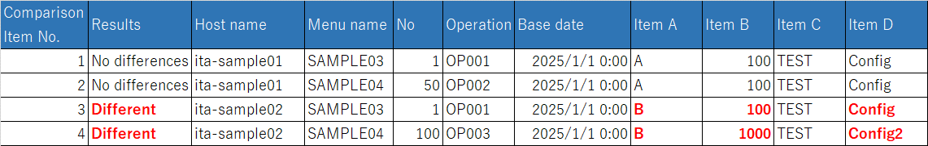

### Contrast list overview

The following figure illustrates the link between the parameter sheets as well as the Contrast results. For information regarding Contrast list, Contrast details definition and the different configurations, please refer to Chapter 5, Contrast function operation.

・Parameter sheet link(When the items of the parameter sheets are identical to each other)

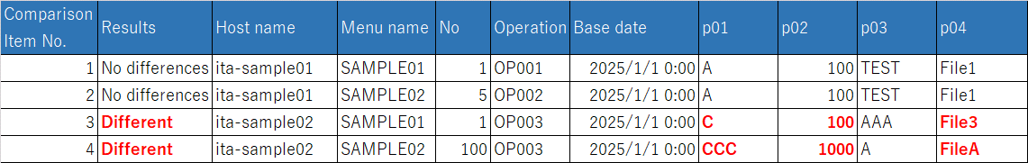

Execute Contrast

・

**※Link the parameter sheets in the Contrast list.**



**Paraneter sheet 1**

**Parameter sheet 2**

**Contrast result**

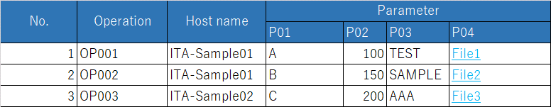

・Parameter sheet link (When the items of the parameter sheets dont match each other).



Run Contrast

・

**Link the parameter sheet in the Contrast list. Link the items in the detailed Contrast list.**

Parameter sheet 1

Parameter sheet 2

**Contrast  
results**

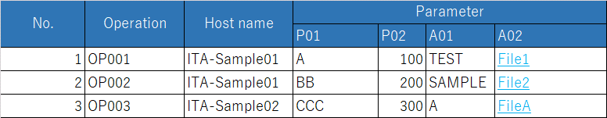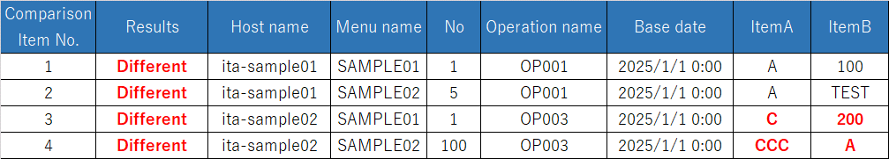

## Comparing Parameter sheets

The Contrast function allows users to do Contrasts between parameter sheets linked in the Contrast list and the Contrast details.

### Contrast function requirements

Make sure that the ITA Settings fill the following requirements.

* ITA is installed with “createparam” selected in the ITA installer.
* Parameter sheets (with host/operation) is created using the Menu create function.
* A link is created between the parameter sheets you want to compare in the Contrast list.
* A link is created between the parameter sheet’s items in the Contrast details (unnecessary depending on the Contrast list settings).

### Contrast parameters

Configure the following parameters in order to run Contrast.

For more information regarding Contrast list, please see 5.1.1 later in this document.

**Table 1.2‑1　Contrast parameters**

| **Parameter** | **Description** | **Input necessary** | **Input format** | **Restrictions** |
| --- | --- | --- | --- | --- |
| Contrast list | Select Contrast list. | 〇 | List selection |  |
| Base date 1 | Input the base date of Menu 1 in the Contrast list. |  | Manual input |  |
| Base date 2 | Input the base date of Menu 2 in the Contrast list. |  | Manual input |  |
| Target host | Select the target host.  Default: No host(Shows the whole Contrast). |  | List selection |  |

# Comparing items

## Comparing items

### Items that can be compared.

The parameter sheet items that can be compared with the Contrast function are as following.。

**Table 2.1‑1　Comparable parameter sheet items**

| **Item type** | **Restrictions** |
| --- | --- |
| String |  |
| Multi string |  |
| Integer |  |
| Decimal number |  |
| Pulldown selection | The ID of the selected list will be compared.  If you dont have access permission, ID Conversion failure(X) will be displayed. |
| File upload | If both items are file upload type items, the file name and the file contents will be compared. |
| Link |  |

※For more information regarding access rights, please refer to   
“Exastro-ITA_User_Instruction_Manual_Role-based_access_control_for_data_records”

### Item combinations that can be compared.

The different combinations of parameter sheet items that can be used with the Contrast function are as following.

Table 2-1 Comparable Parameter sheet item combinations

|  |  |  |  |  |  |  |  |
| --- | --- | --- | --- | --- | --- | --- | --- |
|  | **String** | **Multi string** | **Integer** | **Decimal number** | **Pulldown selection** | **File upload** | **Link** |
| **String** | 〇 | 〇 | 〇 | 〇 | 〇※1 | 〇※2 | 〇 |
| **Multi string** | 〇 | 〇 | 〇 | 〇 | 〇※1 | 〇※2 | 〇 |
| **Integer** | 〇 | 〇 | 〇 | 〇 | 〇※1 | 〇※2 | 〇 |
| **Decimal number** | 〇 | 〇 | 〇 | 〇 | 〇※1 | 〇※2 | 〇 |
| **Pulldown selection** | 〇※1 | 〇※1 | 〇※1 | 〇※1 | 〇※1 | 〇※1※2 | 〇※1 |
| **File upload** | 〇※2 | 〇※2 | 〇※2 | 〇※2 | 〇※1※2 | 〇※3 | 〇※2 |
| **Link** | 〇 | 〇 | 〇 | 〇 | 〇※1 | 〇※2 | 〇 |

※1 he pulldown menu will have it's selected list's ID compared.

Please see the Contrast example in Chapter 6.1.1 Example comparing parameter sheets with pulldown selections.

※2 The target value and file name will be compared.

※3If either the name or contents of the file are different, they will be displayed as "Different".。

# Contrast menu configuration

This chapter explains the menu configuration of the Contrast function.

For information regarding loggin into the Web console or the ITA screen configuration and it's operations, please refer to the First step guide.

## Menu/Screen list

The Contrast function's menu list is as following.

Table 3-1 Compare screen list

|  |  |  |  |
| --- | --- | --- | --- |
| No | Menu group | Menu/Screen | Description |
| 1 | Compare | Contrast list | Create Compare Definition name and link parameter sheets. |
| 2 | Contrast details | Link Parameter sheet items. |
| 3 | Contrast execution | Run the contrast using the settings configured in the Contrast list and Contrast details. |

# Using the Contrast function

This chapter explains how to use the Contrast function.

## Operation flow

The standard Contrast function operation flow is as following.

### Contrast function operation flow.

The following figure illustrates a standard Contrast function operation flow.

1. **Create Parameter sheet**
2. **Create Contrast definition**

**Required**

**Legend**

1. **Register data to Parameter sheet**
2. **Configure detailed settings for Contrast Def.**
3. **Run Contrast**

**※If the Contrast list contains items that dont completely match up with each other, you will need to configure Detailed Contrast list.**

* **Detailed workflow and references.**

1. **Create Parameter sheet**Create a Parameter sheet in the "Create/Define menu" menu in the "Menu create" menu group.

For more information, please refer to   
“Exastro-ITA_User_Instruction_Manual_Menu_creation_function”

1. **Register data data to Parameter sheet**

Register data to the Parameter sheet creted in the previous step.

For more information, please refer to   
“Exastro-ITA_User_Instruction_Manual_Menu_creation_function”

1. **Create Contrast list**

Use the "Compare definition" menu to define/create a Contrast

For more information, please refer to Chapter 5.1.1 Contrast list.

1. **Configure Detailed Contrast list**

[Use the "Contrast details" menu to configure details for the previously created Contrast.

For more information, please refer to Chapter 5.1.2 Contrast details

1. **Run Contrast**

Use the Contrast execution menu to run compare the set parameter sheets.

For more information, please refer to Chapter 5.1.3 Contrast execution.

# Contrast function operation

This chapter describes the different menus in the Contrast function.

## Contrast

### Contrast list

1. In the "Contrast list", users can register and update/change Contrast lists (Links between parameter sheets)。

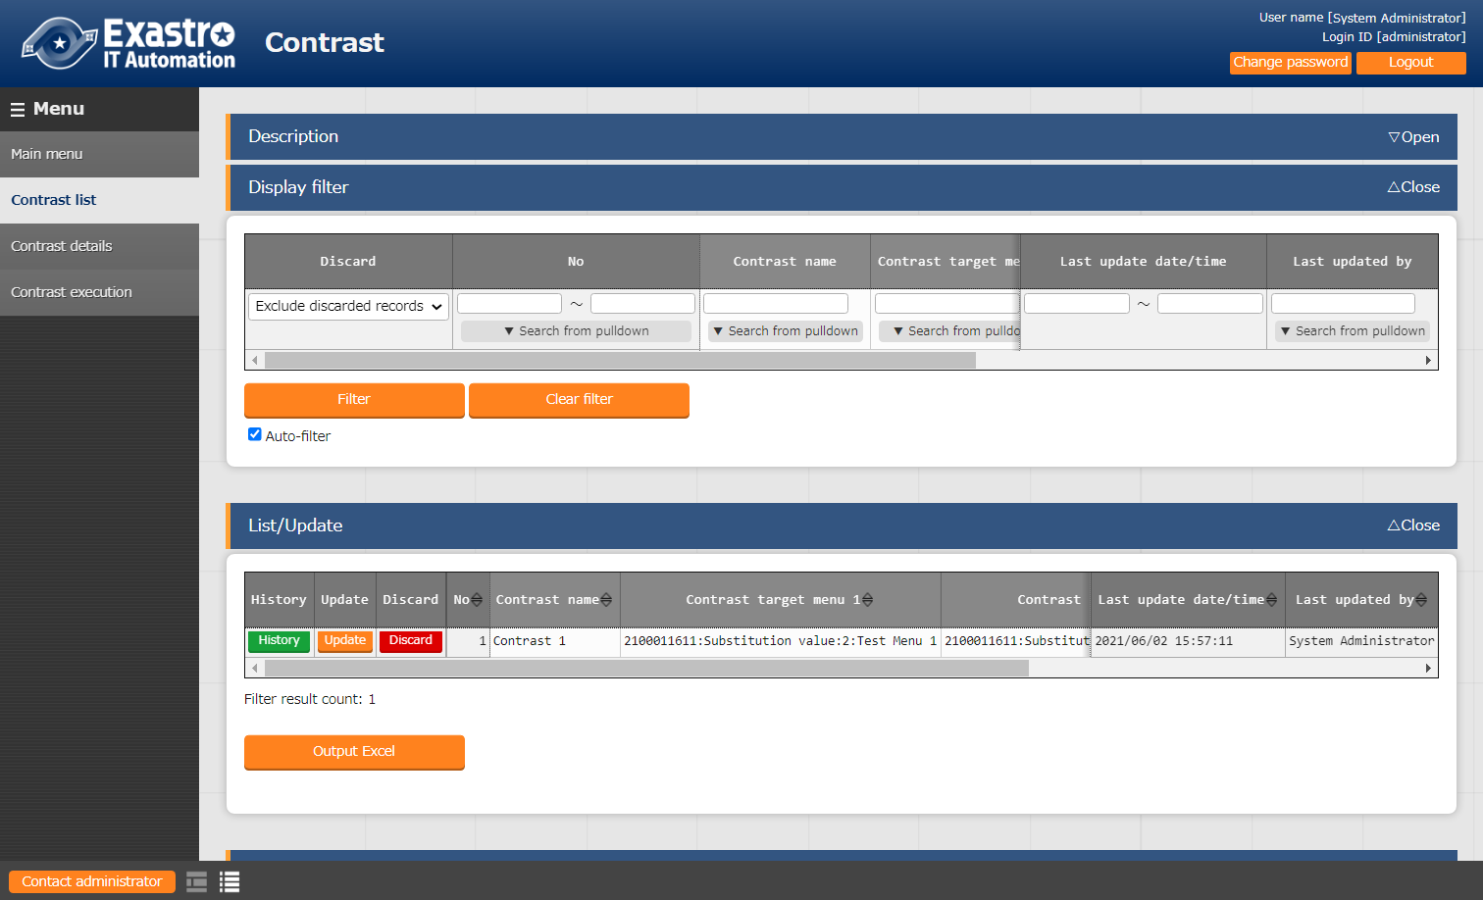

**Figure 5.1‑1 Submenu screen（Contrast list）**

1. Users can register Contrast lists by clicking the “List/Update” button and then the “Start registering” button.

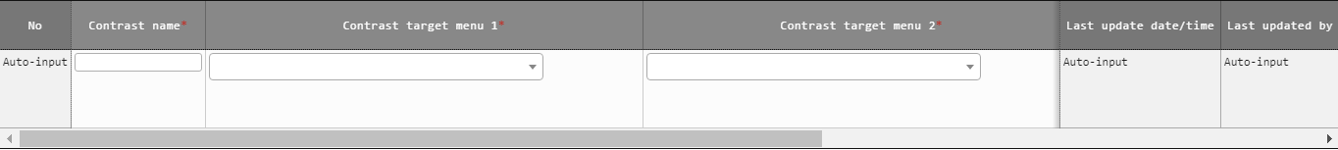

Figure 5.1‑2 Register screen（Contrast list）

1. The item list found in the Contrast list menu is as following.

**Table 5.1‑1　Registration screen items （Contrast list）**

| **Item** | **Description** | **Input required** | **Input format** | **Constraints** |
| --- | --- | --- | --- | --- |
| Contrast name | Input name of the Contrast | 〇 | Manual input |  |
| Contrast target menu 1 | Select target menu | 〇 | List selection |  |
| Contrast target menu 2 | Select target menu | 〇 | List selection |  |
| Match all cases | Select if Menu 1 and Menu 2’s item match up. | - | Select | ※1 |
| Remarks | Free description field | - | Manual input |  |

※1 The user does not need to configure Contrast details if “Match all cases” is selected.

In order to select this, all items of the selected parameter sheets needs to match up.

### Contrast details.

1. In the “Contrast details” menu, users can link the different items of the parameter sheets linked in the “Contrast list” menu.

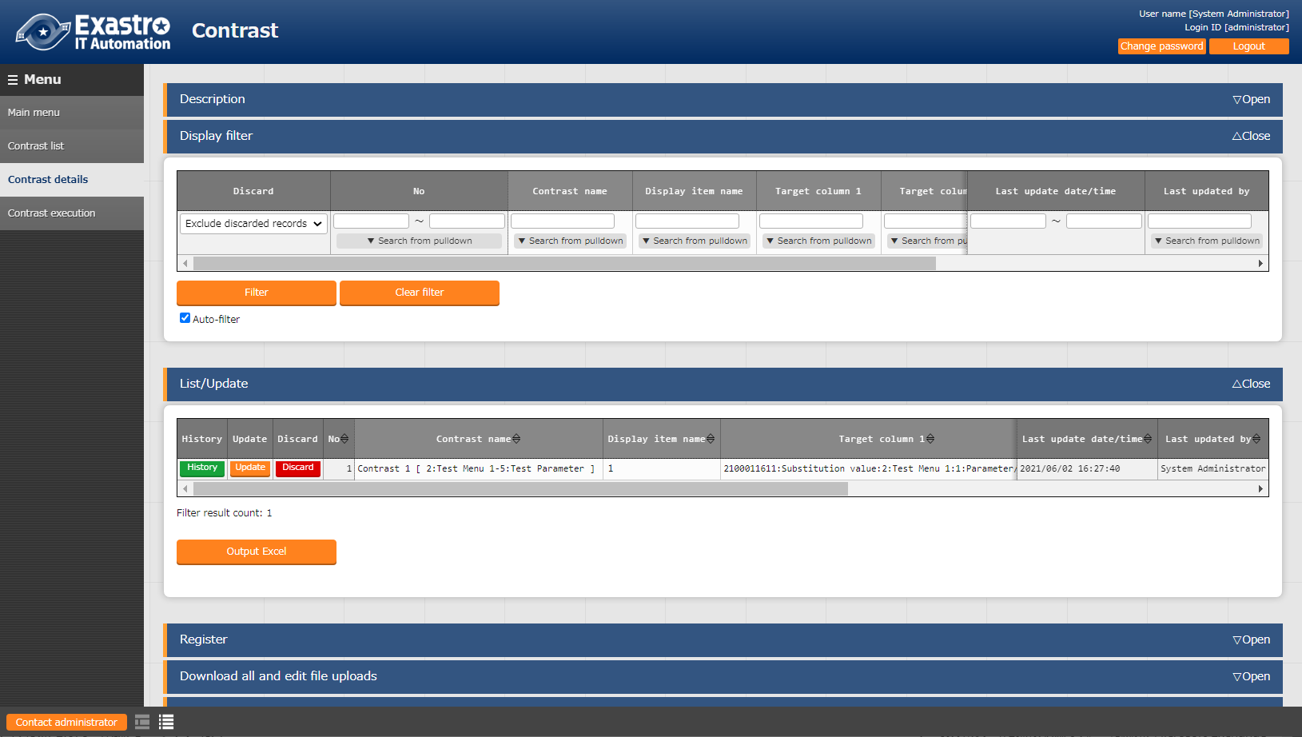

**Figure 5.1‑3 Submenu screen（Contrast details）**

1. 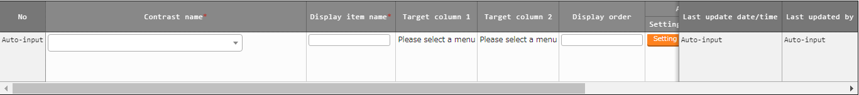Press the “List” and then “Start registration” to register link between items.

Figure 5.1‑4 Registration screen（Contrast details）

1. The following table lists the items in the Compare item value list screen.

**Table 5.1‑1　Registration screen item list（Contrast details）**

| **Item** | **Description** | **Input required** | **Input method** | **Restrictions** |
| --- | --- | --- | --- | --- |
| Contrast name | Select a Contrast | 〇 | List selection | ※1 |
| Display item name | Input the name of the display items.  This is the item name that will be used in the output Contrast results. | 〇 | Manual input |  |
| Target column 1 | Select Target column | 〇 | List selection | ※2 |
| Target column 2 | Select Target column | 〇 | List selection | ※3 |
| Display order | Select display order | - |  | ※4 |
| Remarks | Free description field | - |  |  |

※1 Only items for parameter sheets that has “Match all cases” unchecked in the “Contrast list” menu.

※2 Items that are registered in Target Menu 1 in the Contrast list can be selected.

※3 Items that are registered in Target Menu 2 in the Contrast list can be selected.

※4 If nothing is input, the Contrast results will be output in the order of Contrast details ID, left to right.

### Contrast execution

1. The “Contrast execution” compares parameter sheets based on the information set in the Contrast list and Contrast details menu.

* 「The list of Contrast list registered in “5.1.1 Contrast list” is displayed.
* Clicking the “Compare” button executes the Contrast and compares the target menus and items based on the input parameters.

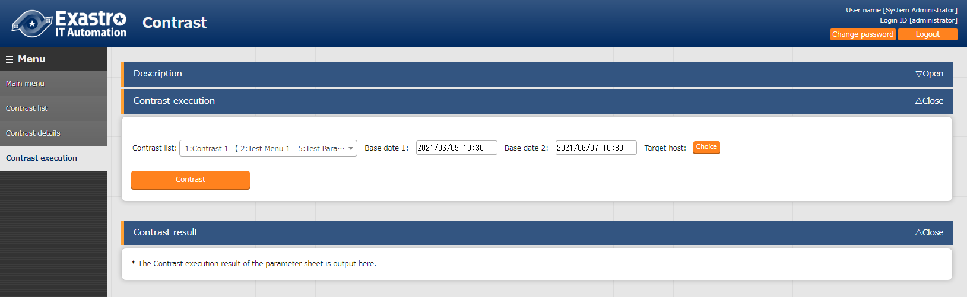

**Figure 5.1‑5 Contrast execution screen（Input Parameter）**

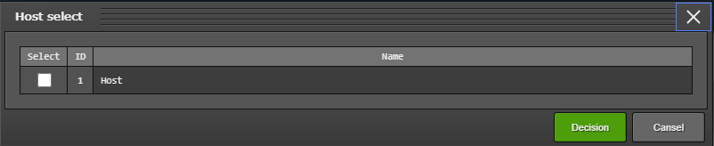

**Figure 5.1‑6 Host list menu（Contrast execution：Target host）**

**Table 5.1‑1　Contrast execution item list**

| **Item** | **Description** | **Input required** | **Input method** | **Constraints** |
| --- | --- | --- | --- | --- |
| Contrast list | Select Contrast list. | 〇 | List selection |  |
| Base date 1 | Specify the base date for Menu 1 | - | Manual input | ※1 |
| Base date 2 | Specify the base date for Menu 2 | - | Manual input | ※1 |
| Host | Pressing the “Host” button will open up a list of target hosts. Please select a host and press the “Decision” button. | - | Select | ※2 |
| Compare | Press this button to run the Contrast between the selected parameters and outputs the results. | - | - | - |

※1 If a base date is input, the data compared will be the latest version at the time of the input date.

If nothing is input, the latest version will be used,  
※2 No host is selected by default.

Will output the Contrast for all host linked to the menu.

* After pressing the “Contrast” button, a file output button (excel, CSV) button will be displayed.
* The results will be displayed in the order of Menu 1 and Menu 2 for each host.

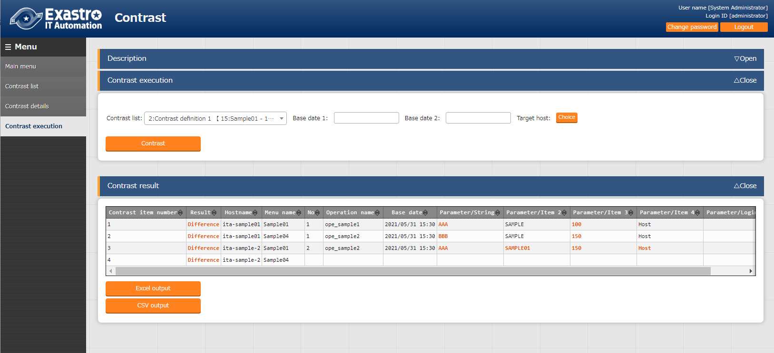

**Figure 5.1‑7 Contrast execution screen (Contrast results)**

**Table 5.1‑1　Contrast execution output list**

| **Item** | **Description** | **Constraints** |
| --- | --- | --- |
| Contrast item number | Number of the items output from the Contrast results. |  |
| Result | Displays the Contrast results.  Either with “Difference” or “no difference”. | ※1 |
| Host name | Displays the target host name |  |
| Menu name | Displays the target menu name |  |
| No | Displays the compared menu number. |  |
| Operation name | Displays the operation name |  |
| Base date | Displays the Base date |  |
| Contrast item | Displays the target item. | ※1 |
| Excel output | Outputs the results in excel format. |  |
| CSV output | Outputs the results in CSV format. |  |

※1 If there were any differences, it will be highlighted in red text.

# Appendix

## References

### Example comparing parameter sheets with pulldown selections.

The following illustrates an example using the Contrast function to compare parameter sheets with pulldown selection items.

* 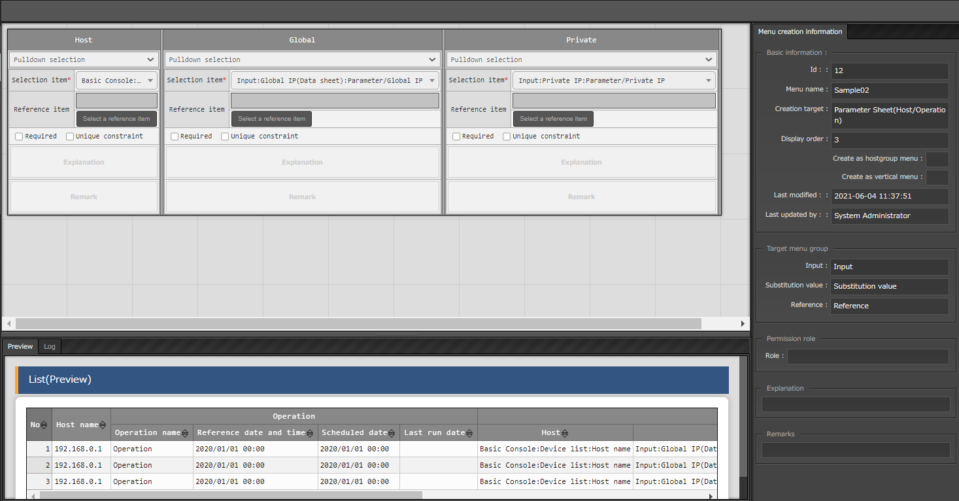Comparing Pulldown selection items in Parameter sheets and their configurations.

**Figure 6.1‑1 Parameter sheet（Create/Define menu）**

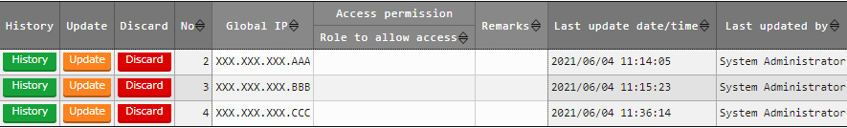

**Figure 6.1‑2 Pulldown reference definition [Data sheet:Global IP]**

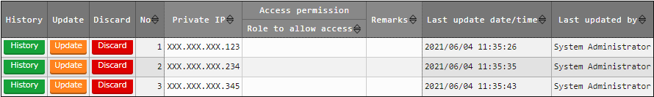

**Figure 6.1‑3 Pulldown reference destination [Data sheet :Private IP]**

* Contrasts and Contrast lists

In the following illustration, the items marked with red-blue are going to be compared.

Gllobal：References Global IP (Datasheet)

Private：References Private IP (Datasheet)

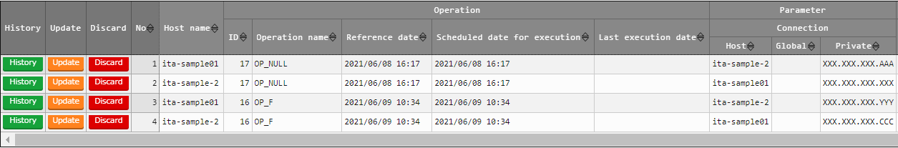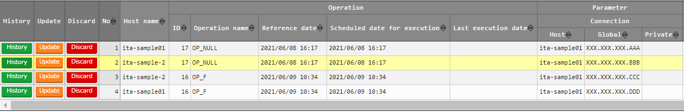

SAMPLE07

SAMPLE08

**Figure 6.1‑4 Comparable parameter sheets**



**Figure 6.1‑5 Contrast list setting example**



**Figure 6.1‑6 Contrast details setting example**

* Contrast execution

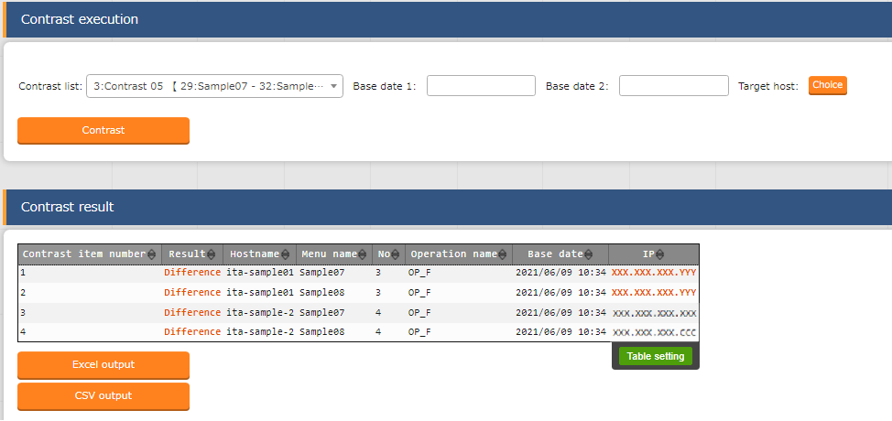

※1

※2

**Figure 6.1‑7Contrast execution results**

Since the pulldown reference destination is different from each other, patterns like ※1 and ※2 might occur.

※1 If the displayed contents are the same, but the reference destinaton’s no. is the same, it will be considered as being different.

※2 If the reference destination’s no. is different, but the contents are the same, it will not be considered as being different.