

ITA_User Instruction Manual

Terraform-driver

*－* Version 1.9*－*

Copyright © NEC Corporation 2020. All rights reserved.

Disclaimer

All the contents of this document are protected by copyright owned by NEC Corporation.

Unauthorized reproduction or copying of all or part of the contents of this document is prohibited.

The contents of this manual are subject to change without notice.

NEC Corporation is not responsible for any technical or editorial errors or Shorteneds in this document.

NEC Corporation do not guarantee accuracy, usability, certainty of the content in this document.

Trademark

* Linux is registered trademark or trademark of Linus Torvalds, registered in the U.S. and other countries.
* Red Hat is registered trademark or trademark of Red Hat, Inc. registered in the U.S. and other countries.
* Apache, Apache Tomcat, and Tomcat are registered trademarks or trademarks of the Apache Software Foundation.
* Terraform is a registered trademark or trademark of HashiCorp.

The names of other systems, company name and products mentioned in this document are registered trademarks or trademarks of their respective companies.

The ® mark and TM mark are not specified in this document.

※「Exastro IT Automation」 is written as 「ITA」 in this document.

Table of contents

Table of contents 3

Introduction 4

1 Terraform driver overview 5

1.1 About Terraform 5

1.2 About Terrform driver 5

2 Variable handling in Terraform driver 6

2.1 Variable type 6

2.2 Extraction of variables and registration of concrete values 6

3 Terraform driver console menu structure 7

3.1 Manu/Screen list 7

4 Terraform driver user instruction 8

4.1 Terraform workflow 8

5 Policy operation in Terraform Driver 11

5.1 About link Policy/PolicySet/Workspace 11

6 Terraform driver function and operation method explanation 12

6.1 Basic console 12

6.1.1 Operation list 12

6.2 Terraform driver console 13

6.2.1 Interface information 13

6.2.2 Organizations list 15

6.2.3 Workspaces list 17

6.2.4 Movement list 20

6.2.5 Module files 21

6.2.6 Policies list 24

6.2.7 Policy Sets list 26

6.2.8 PolicySet-Policy link list 28

6.2.9 PolicySet-Workspace link list 29

6.2.10 Movement module link 31

6.2.11 Substitution value automatic registration 32

6.2.12 Substitution value list 36

6.2.13 Execution 38

6.2.14 Check operation status 40

6.2.15 Execution list 43

6.2.16 Terraform registration list 44

7 How to write construction code 46

7.1 Module description 46

7.2 Policy description 46

7.3 BackYard Content 46

8 Application operation 48

8.1 Maintenance 48

8.2 About Maintenance and Maintaining 49

Introduction

This document explains the function and the operation method of ITA.

# Terraform driver overview

This chapter describes Terraform and Terraform driver.

## About Terraform

Terraform is an Orchestration tool that streamlines the infrastructure provided by HashiCorp.

For the infrastructure configuration coded in the language called HCL (HashiCorp Configuration Language), generate an execution plan and then execute the construction.

Additionally, you can code and manage access policies with Policy as Code.

For more information about Terraform, please refer to the Terraform product manual.

## About Terrform driver

Terraform driver functions as an option for ITA systems, allowing Terraform registered with ITA systems to create organizations, Workspaces and execute operations (Plan/PolicyCheck/Apply) and acquire operation logs.

Module files used to perform operations (Plan/Apply) and Polycy files for PolicyCheck can be managed so that they can be made in to components and reused on the ITA system.

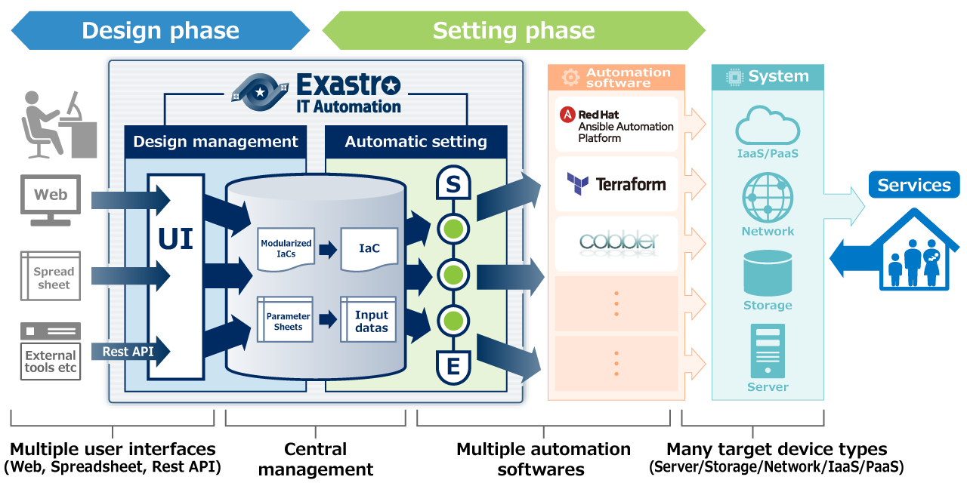

**Figure 1.2-1 ITA System Overview**

In addition, Terraform driver can set variables in Module from the screen.For details, please refer to "Variable handling in Terraform driver" in this document.

# Variable handling in Terraform driver

## Variable type

In Terraform driver, user can set the specific value of the variable in module from the ITA configuring screen.

**※For more information on the configuring method, please refer to "6.2.12 Substitution value list" in this document.**

There is one type of variable in module that can be handled as an ITA variable:

|  |  |
| --- | --- |
| Type | Content |
| Normal variable | A variable that allows you to define one specific value for the variable name.  The variables in the Module should be written in the following format according to the variable rules of the HCL (HashiCorp Configuration Language). In this case, "xxx" is extracted from Module as a variable.   |  | | --- | | variable “xxx” {  ~Shortened~  } | |

## Extraction of variables and registration of concrete values

User can register specific values by extrating variables out of module files uploaded to ITA.

For the specific value of the extracted variable, register the specific value in "6.2.11 substitution value automatic registration" and "6.2.12 Substitution value list".

The registered variables and concrete values are registered as "Key" for "Variable name" and "Value" for "Specific value" for Variables managed in Workspace on the Terraform side when the work is executed.

# Terraform driver console menu structure

This chapter describes the menu configuration of the ITA console.

Please refer to the "First Step Guide" for information on how to log in to the web console and the components/basic operations of the menu screen.

## Manu/Screen list

1. ITA basic console menu

The menu list of ITA basic console used in Terraform driver is described below.

Table 3.1‑1 Basic console menu/screen list

|  |  |  |  |
| --- | --- | --- | --- |
| No | Menu Group | Menu Screen | Description |
| 1 | ITA Basic console | Operation list | The Operation list can be maintained (browsing/register/update/abolish). |

1. **Console menu of Terraform driver**

The menu list for the Terraform driver console is described below.

Table 3.1‑2Terraform driver console menu/screen list

|  |  |  |  |
| --- | --- | --- | --- |
| No | Menu Group | Menu Screen | Description |
| 1 | Terraform | Interface information | Manage Terraform information that links with ITA. |
| 2 | Organizations list | Manage the Organization information used in Terraform. |
| 3 | Workspaces list | Manage the Workspace information used in Terraform. |
| 4 | Movement list | Manages the list of Movements that you want to register with Symphony. |
| 5 | Module files | Manage Module files. |
| 6 | Policies list | Manage policy files. |
| 7 | Policy Sets list | Manage Policy Set.Policy Set is linked with Polycy and Workspace to enable Polycy for the workspace of target when you execute work. |
| 8 | PolicySet-Policy link list | Manages the linking between PolicySet and Polycy. |
| 9 | PolicySet-Workspace link list | Manages the linking between PolicySet and Workspace. |
| 10 | Movement module link | Manages the linking between Movement and Module files. |
| 11 | Substitution value automatic registration | Manage movements and variables that link items and values for each operation registered in the parameter sheet menu. |
| 12 | Substitution value list | Manages the subsituted value of a variable. |
| 13 | Operation execution | Select the Movement and Operation to execute and indicate the execution. |
| 14 | Check operation status | Displays the operation status. |
| 15 | Work list | Manage execution history. |
| 16 | Terraform registration list | Users can list and delete Organizations, Workspaces, Policies and PolicySets that are registered in Terraform. |

# Terraform driver user instruction

Description about user instruction of each Terraform console.

## Terraform workflow

The standard work flow for each Terraform console is as follows.

Details of each operations are described in the next section.

For information on how to use the ITA Basic Console, please refer to "User Instruction Manual_Basic Console".

The flow to operation in Terraform are as follows.

1. **Register Operation name**

**⑤ Register work pattern (Movement)**

**⑥ Register module files**

**Required task**

**Optional task task**

**【**Legend**】**

**⑪　Set module files in movement**

**②　Register interface information**

**③ Organization registration and cooperation**

**④ Workspace registration and cooperation**

**⑦ Register Policy**

**⑧** Register **PolicySet**

**⑨ Link Policy to PolicySet**

**⑩ Link Workspace to PolicySet**

**⑬ 作業実行**

**⑭ 実行状態確認**

**⑮ 作業履歴確認**

**必須タスク**

**任意タスク**

**【凡例】**

**⑫ 変数値の設定**

**⑬ Execution**

**⑭ Check operation status**

**⑮ Check operation history**

**Required task**

**Optional task**

**【**Legend**】**

**⑫** Set variable value

* **Work flow details and references**

1. **Register Operation name**

Register the Operation name for work from the Operation list screen of the ITA basic console.

For details, refer to "6.1.1 Operation list".

1. **Register interface information**

Register the information of Terraform that links with the ITA system.

For details, refer to "6.2.1 Interface Information".

1. **Organization registration and cooperation**

Register Organization information and link with Terraform.

For details, refer to "6.2.2 Organizations list".

1. **Workspace Registration and cooperation**

Register Workspace information and link with Terraform.

For details, refer to "6.2.3 Workspace list"

1. **Register work pattern (Movement)**Register a movement for operation.  
   For details, refer to "6.2.4 Movement list".
2. **Register module files**

Register the Module file to be executed in the operation.

For details, refer to "6.2.5 Module files".

1. **Register policy (Execute if needed)**Register the Polycy file to run with PolyCheck before you execute the work.

For details, refer to “6.2.6 Policies list”.

1. **Register PolicySet (Execute if needed)**Register a PolyCySet to link to Workspace to which you want to apply Policy.

For details, refer to "6.2.7 Policy Sets list".

1. **Link Policy to PolicySet**Register the linking between PolicySet and Policy.  
   For details, refer to "6.2.8 PolicySet-Policy link list".
2. **Link Workspace to PolicySet**

Register the linking between PolicySet and Workspace.

For details, refer to "6.2.9 PolicySet-Workspace link list".

1. **Set module files in Movement**

Specify the Module files in the registered Movement.

For details, refer to "6.2.10 Movement module link".

1. **Set variable value (Execute if needed)**Set the value of the variable defined in the Module files registered in Movement. If you are not using variables, user do not need to set them.  
   For details, refer to "6.2.12 Substitution value list".
2. **Execution**Select and set the execution date and time, and the Operation to indicate the execution of the operation.

For details, refer to "6.2.13 Execution".

1. **Check operation status**

The status of the work executed is displayed in real time.

User can also monitor work emergency stops, execution logs and error logs.  
For details, refer to "6.2.14 Check operation status".

1. **Check operation history**

A list of the work executed is displayed and the history can be checked.

For details, refer to "6.2.15 Execution list".

# Policy operation in Terraform Driver

## About link Policy/PolicySet/Workspace

In order to apply Policy, it is necessary to make a linking setting after each setting registration for Policy is made.

The first Polycy registered in "6.2.6 Policies list" and the PolyCySet registered with "6.2.7 Policy Sets list" will be linked with "6.2.8 PolicySet-Policy link list".

Next, workspace registered in "6.2.3 Workspaces list" and PolycySet registered with "6.2.7 Policy Sets list" will be linked with "6.2.9 PolicySet-Workspace link list".

PolicySet and its associated Polycy are applied to Workspace tied to Movement when you execute operation.

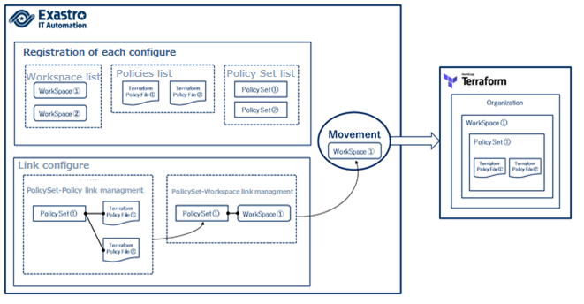

**Figure 5.1-1 about linking Policy/PolicySet/Workspace**

# Terraform driver function and operation method explanation

This document explains each console function used in Terraform driver.

## Basic console

This section describes the operation in the ITA Basic Console.

Please refer to the ITA basic console manual for this operation and perform the operation in the ITA basic console screen.

### Operation list

1. The "Operation list" screen manages the operations on the target host that the Orchestrator executes. Select the work from the menu in the ITA basic console.

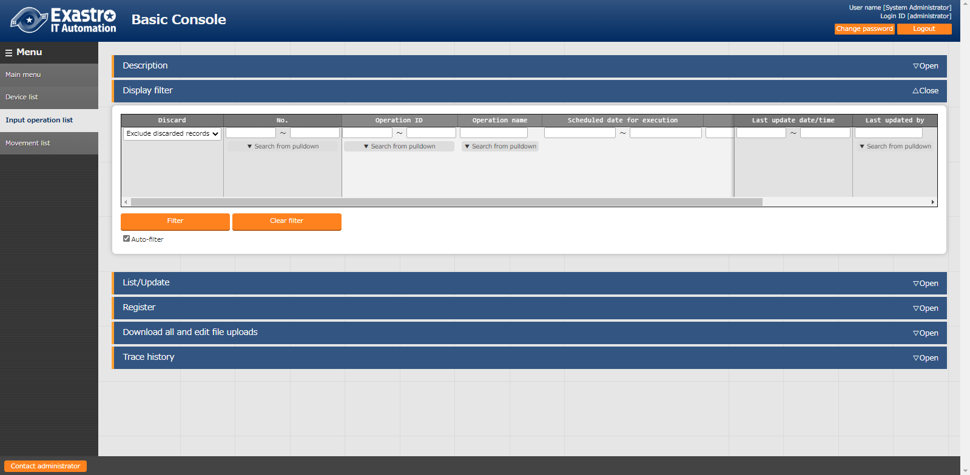

**Figure 6.1.1-1 Submenu screen (list of Operations)**

For details on the registration method, please refer to "User Instruction Manual_Basic Consol" in the related manual.

## Terraform driver console

This section describes the operation on the Terraform console.

### Interface information

1. In [Interface Information], user can maintain (browsing/update) the information of Terraform that is associated with the ITA system. User will need a User Token issued by Hostname of Terraform and User of Terraform to be targeted with.

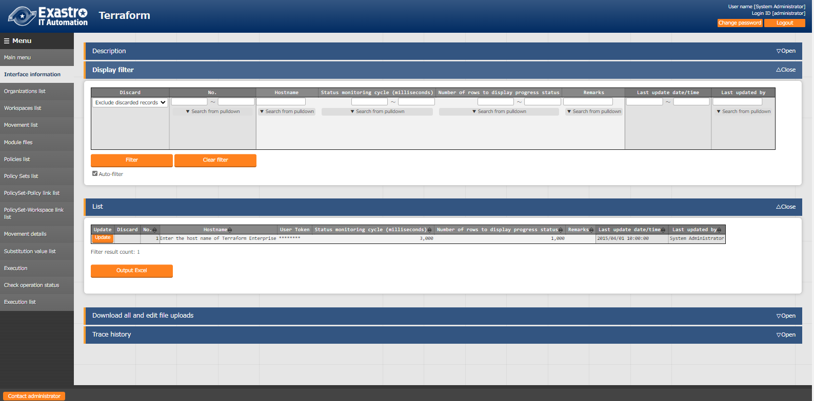

**Figure 6.2.1‒1 Submenu screen (Interface Information)**

1. Clicking the "List" button and then "Update" button will manage the registration of interface infornations.

If you execute with interface information unregistered or multiple records registered, the work execution will be an unexpected error.

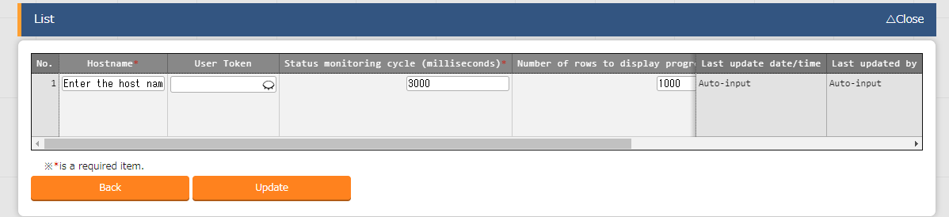

Figure 6.2.1-2 Registration screen (Interface Information)

1. The list of items on the interface information screen is as follows.

**Table 6.2.1-1 Item list（interface information）**

| **Item** | | **Description** | **Input**  **required** | **Input type** | **Restriction** |
| --- | --- | --- | --- | --- | --- |
| Hostname | | Enter hostname for Terraporrm Enterprise, which the target for link with the ITA system. | ○ | Manual　input | Maximum length 256 bytes |
| User Token | | Enter the User Token issued by User Settings in Terraform. | ○ | Manual input | Maximum length 256 bytes |
| Proxy | Address | Input the Proxy server address.  If ITA is under a Proxy environment, you might need to configure it to connect to Terraform. |  | Manual input |  |
| Port | Input the Proxy server port.  If ITA is under a Proxy environment, you might need to configure it to connect to Terraform. |  | Manual input |  |
| Condition observation period (Unit milli second) | | Enter the refresh space for the log displayed in "6.2.14 Check operation status". Usally, about 3000 milliseconds is the recommended value. | ○ | Manual input | Minimum value 1000 ms |
| Number of lines progress status displayed | | Enter the maximum number of lines to be displayed in the progress log and error log in "6.2.14 Check operation status ". Usally, about 1000 lines is the recommended value. | ○ | Manual input | - |
| NULL link | | If the specific value of the parameter sheet in the " Substitution value auto-registration setting" is NULL(blank), users can set registrations to the list to have the value NULL(blank) or not.  This value is applied when "NULL Link" (In the Substitution value auto-registration setting menu) is blank.  ・　If "Enable", any value in the parameter sheet is registered in the substitution value list.  ・　If "Disable", the value is registered in the value list only if the parameter sheet contains a value. | ○ | List selection |  |
| Remarks | | Free description field. | - | Manual input | Maximum length 4000 bytes |

### Organizations list

1. In “Organizations list”, performs maintenance (browsing/registration/update/abolition) of the Organizations used in Terraform is performed. In addition, the Organization registered with the ITA system can be linked (register/update/delete) to Terraform.

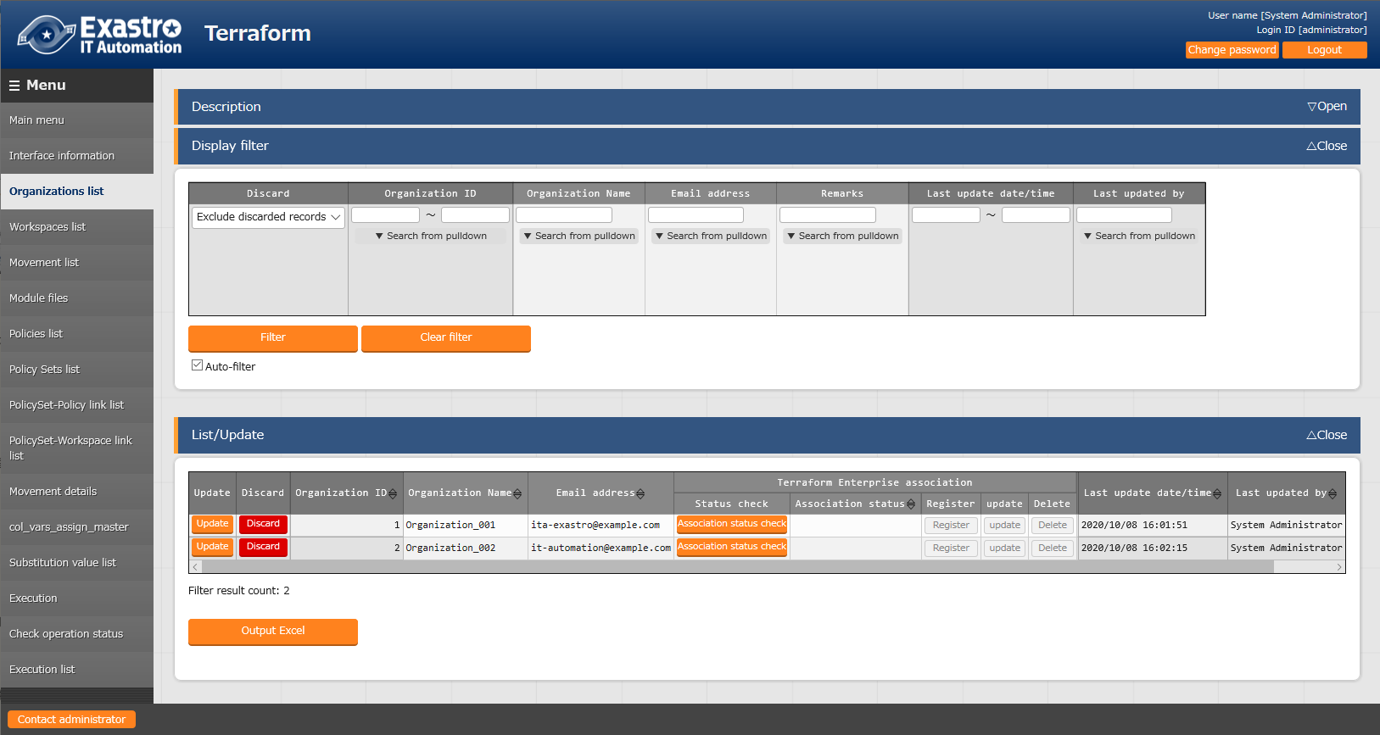

**Figure 6.2.2-1 Submenu screen (Organizations list)**

1. Clicking the "Register" button and then "Start registration" button will register the Organization infornations.

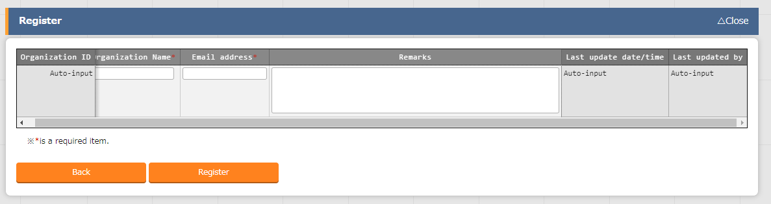

**Figure 6.2.2-2 Registration screen（Organizations list）**

1. After registering your Organization, user can check the link status with Terraform by clicking the "Check link status" button from "List/Update".

Depending on the link status, the Link to Terraform (Register/ Update / Delete) button changes to active and you can perform the integration with Terraform by clicking.

If the work is executed without the Organization being linked (registered) with Terraform, the work execution will be an unexpected error.

If hostname and User Token registered in "6.2.1 Interface Information" are incorrect, the link with Terraform will fail, and the following message will be displayed in the link status.

"Failed to connect to Terraform. Check the interface information”.

Clicking the Workspaces button will move the user to the target Organization "6.2.3 Workspaces list"

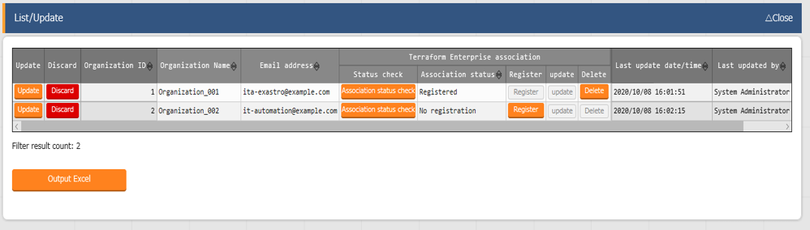

**Figure 6.2.2-3 Terraform link (Organizations list)**

1. The list of items on the organizations list screen is as follows.

**Table 6.2.2‑1　Item list （Organizations list）**

|  |  |  |  |  |  |
| --- | --- | --- | --- | --- | --- |
| **Item** | | **Description** | **Input**  **required** | **Input type** | **Restriction** |
| Organization Name | | Enter the name of the Organization.  Alphanumeric characters and symbols (_ ,-) only (underbars and hyphens) are available. | ○ | Manual input | Maximum length 40 bytes |
| Email address | | Enter the Email address of the Organization. | ○ | Manual input | Maximum length 128 bytes |
| Terraform Link | Link status check | Button to execute the link status check. | - | - |  |
| Link status | For the target Organization, the status of link with Terraform is displayed.  If you are not registered with Terraform, "No registration". If you are registered the difference email address, "Updated".  If it is registered, it will be displayed as "Registered". | - | - |  |
| Registration | Button to execute registration. It is activated in the case of "No registration". Click to register the target organization in Terraform. | - | - |  |
| Update | Update button. It is activated in the case of "update". Click to update the email address of the target organization registered in Terraform. | - | - |  |
| Delete | Delete button. It is activated in the case of “registered”,"update". Click to delete the target organization registered in Terraform.  ※Deleted Organization cannot be restored. Workspace under the organization will also be deleted. | - | - |  |
| Workspace list | | Moves the user to “6.2.3 Workspaces list” |  |  |  |
| Remarks | | Free description field. | - | Manual input | Maximum length  4000 bytes |

### Workspaces list

1. In “Workspaces list”, performs maintenance (browsing/registration/update/abolition) of Workspace used in Terraform.

Also, Workspace registered in the ITA system can be linked (register/update/delete) to Terraform.

Workspace is linked to Organization, first it is necessary to register the target in "6.2.2 Organizations List".

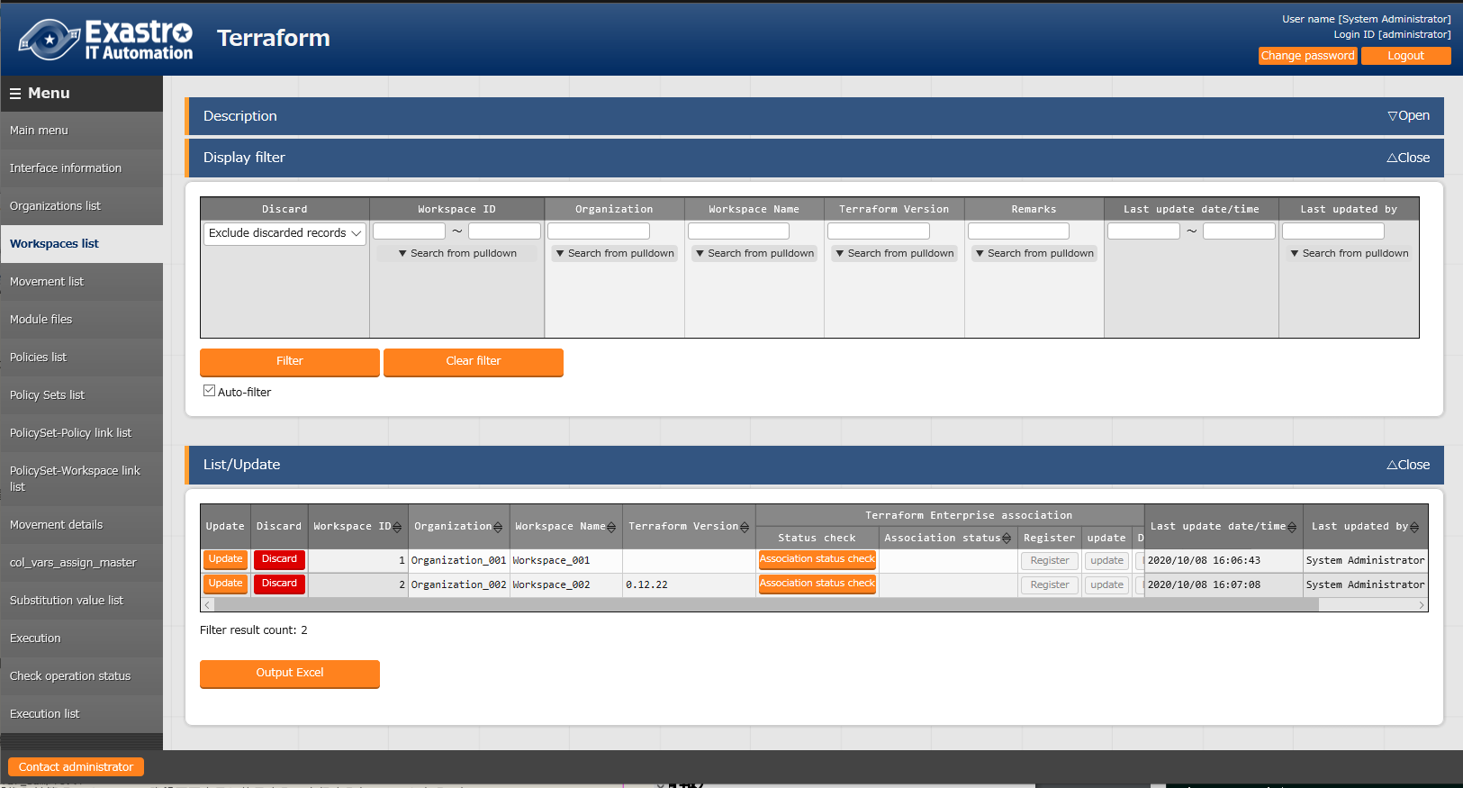

**Figure 6.2.3-1 Submenu screen（Workspaces list）**

1. Clicking the "Register" button and then "Start registration" button will register the Workspace infornations.

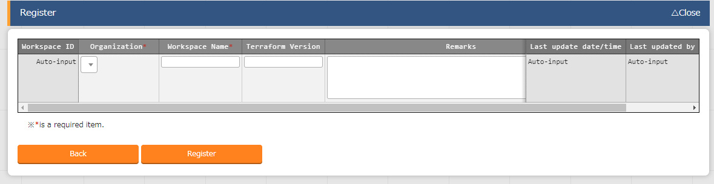

Figure 6.2.3-2 Registration screen（Workspaces list）

1. After registering your Workspace, user can check the link status with Terraform by clicking the "Check link status" button from "List/Update".

Depending on the link status, the Link to Terraform (Register/ Update / Delete) button changes to active and you can perform the integration with Terraform by clicking.

If the work is executed without the Organization being linked (registered) with Terraform, the work execution will be an unexpected error.

If hostname and User Token registered in "6.2.1 Interface Information" are incorrect, the link with Terraform will fail, and the following message will be displayed in the link status.

"Failed to connect to Terraform. Check the interface information”.

If the selected Organization is not connected (registered) to Terraform, a similar message is displayed.

Clicking the "Organization" link will move the user to the target "6.2.2 Organizations list".

Clicking the Movement list will move the user to the target Organization:Workspace "6.2.4 Movement list".

Clicking the PolicySet-Workspace Link List button will move the user the the target Organization:Workspace "6.2.8 PolicySet-Policy link list".

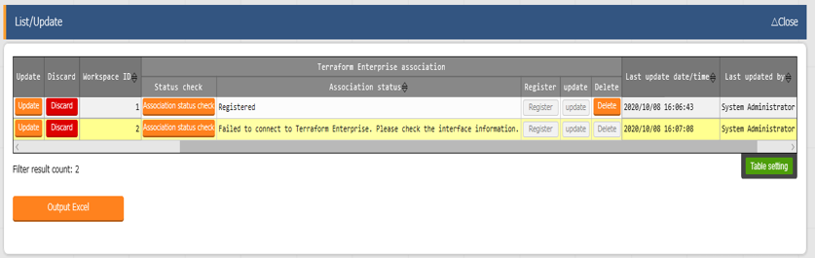

Figure 6.2.3-3 Terraform link (Workspaces List)

1. The list of items on the Workspaces list screen is as follows.

**Table 6.2.3-1 item list（Workspaces list）**

|  |  |  |  |  |  |
| --- | --- | --- | --- | --- | --- |
| **Item** | | **Description** | **Input required** | **Input type** | **Restriction** |
| Organization Name | | Select the Organization Name registered in "6.2.2 Organizations list". | ○ | List selection |  |
| Workspace Name | | Enter the name of the Workspace name.  Alphanumeric characters and symbols (_ ,-) only (underbars and hyphens) are available. | ○ | Manual input | Maximum length 90 bytes |
| Terraform Version | | Enter the version of Terraform. If it is blank, the new version will be automatically applied at the time of link (registration). |  | Manual input |  |
| Terraform  Link | Check link status | Button to execute the integration check link status. | - | - |  |
| Link status | For the target Workspace, the status of link with Terraform is displayed.  If you are not registered with Terraform, "No registration". If you are registered the difference Terraform version, "Updated".  If it is registered, it will be displayed as "Registered". | - | - |  |
| Registration | Button to execute registration. It is activated in the case of "No registration". Click to register the target Workspace in Terraform. | - | - |  |
| Update | Button to execute update. It is activated in the case of "update". Click to update the Terraform driver of the target Workspace registered in Terraform. | - | - |  |
| Delete | Button to execute deletion. It is activated in the case of “registered”,"update". Click to delete the target Workspace registered in Terraform.  ※Deleted Workspace cannot be restored. | - | - |  |
| Movement list | | This button moves the user to “6.2.4 Movement list” |  |  |  |
| PolicySet-Workspace Link list | | This button moves the user to “6.2.8 PolicySet-Policy link list” |  |  |  |
| Remarks | | Free description field. | - | Manual input | Maximum length 4000 bytes |

### Movement list

1. In “Movement list”, performs maintenance (browsing/registration/update/abolition) for Movement names.

Movement needs to be linked with Organization: Workspace as Terraform usage information, first it is necessary to register the target in "6.2.2 Organizations list" and "6.2.3 Workspaces list".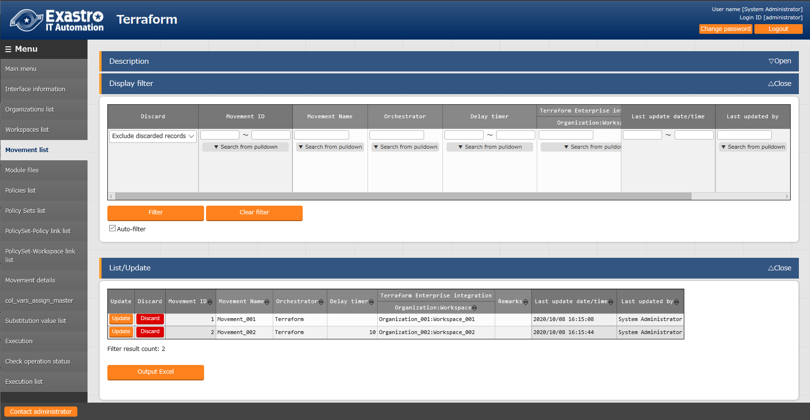

**Figure 6.2.4-1 Submenu screen (Movement list)**

1. Clicking the "Register" button and then "Start registration" button will register the Movement infornations.

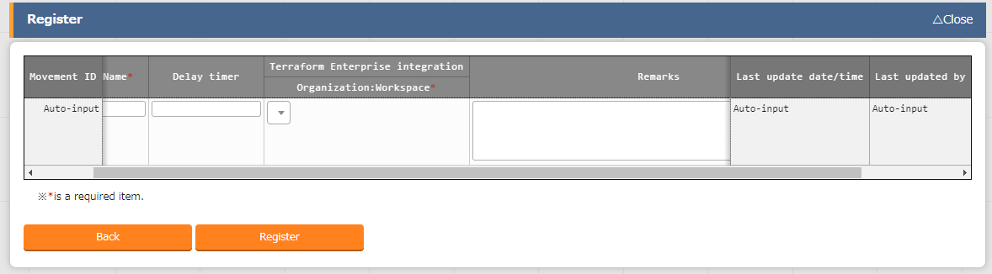

Figure 6.2.4-2 Registration screen (Movement list)

1. 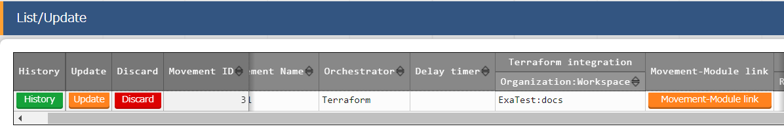Clicking the Movement-Module link button will move the user to the target Movement's "6.2.10 Movement-Module link"

**Figure 6.2.4-3 Submenu screen (Movement list)**

**(4)** The items on the Movement list screen are as follows.

**Table 6.2.4-1 Item list（Movement list）**

|  |  |  |  |  |  |
| --- | --- | --- | --- | --- | --- |
| **Item** | | **Description** | **Input required** | **Input type** | **Restriction** |
| Movement Name | | Enter the name of the Movement. | ○ | Manual input | Maximum length 256 bytes |
| Orchestrator | | "Terraform" is automatically entered. | - | - | - |
| Delay timer | | Enter the specified period (1~) if you want the status to be displayed as a warning when the movement is delayed for the specified period. (Unit: minutes)  If it is not entered, no warning will be displayed. | - | Manual input | - |
| Terraform use information | Organization: Workspace | Select the Workspace registered (linked to Organization) in "6.2.3 Workspaces list". | ○ | List selection |  |
| Movement-Module link | | Moves the user to “6.2.10 Movement-Module link”. | - | - |  |
| Remarks | | Free description field. | - | Manual input | Maximum length 4000 bytes |

### Module files

1. In “Module files”, performs maintenance (browsing/registration/update/abolition) of the module created by the user.

For more information about Module description, refer to "7.1 Module description".

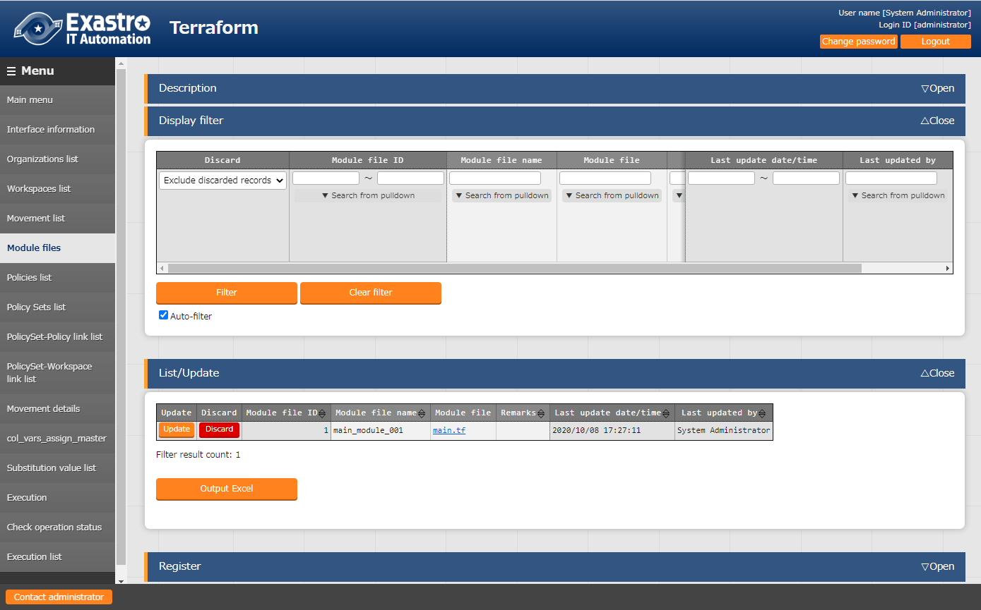

Figure 6.2.5-1 Submenu screen (Module files)

1. Clicking the "Register" button and then "Start registration" button will register the Movement infornations.

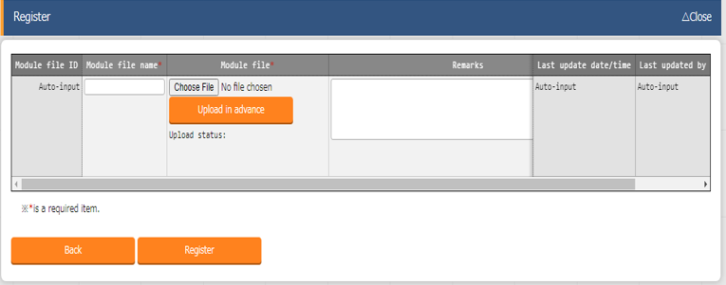

Figure 6.2.5-2 Registration screen (Module files)

Please "Upload in advance (①)" the "Module files" before "register". Please click the "Register" button after checking the Module file name displayed in the "Upload status(②)".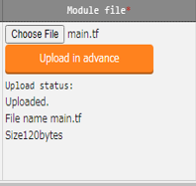

1. 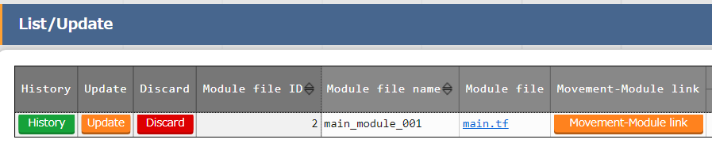Clicking the Movement-Module link button will move the user to the target Movement’s “6.2.10 Movement-Module Link”.

**Figure 6.2.5-3 Submenu screen (Module files)**

1. The list of items in the Module files is as follows.

**Table 6.2.5-1 Item list (Module files)**

| **Item** | **Description** | **Input required** | **Input type** | **restriction** |
| --- | --- | --- | --- | --- |
| Module files name | Enter the module file name that you want to list in ITA. | ○ | Manual input | Maximum length 256 bytes |
| Module files | Upload the created Module files. | ○ | File selection | Maximum size 4G bytes |
| Movement-Module link | Moves the user to “6.2.10 Movement-Module link” |  |  |  |
| Remarks | Free description field. | - | Manual input | Maximum length 4000 bytes |

1. The "BackYard" process extracts the variables defined in the Module file. The variables extracted can then have specific values registered to them in "6.2.11 Substitution value automatic registration" and "6.2.12 Subsitution value list".

The extraction is not happening in realtime, so it might take some time before users can handle the variables in "6.2.11 Substitution value automatic registration" and "6.2.12 Subsitution value list".

※**Please refer to the timing of extraction is described in "(3) Change of starting period" of "8.2 About the maintenance method".**

### Policies list

1. In “Policies list”, performs maintenance (browsing/registers/updates/abolition) of Policy created by the users.

For more information about Policy description, refer to "7.2 Policy description".

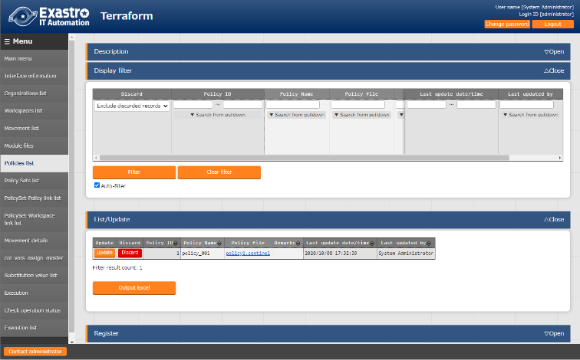

**Figure 6.2.6-1 Submenu screen（Policies list）**

1. Clicking the "Register" button and then "Start registration" button will register the Policy.

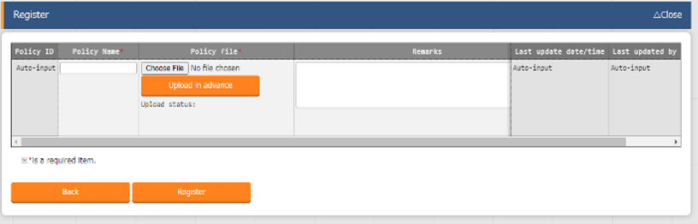

Figure 6.2.6-2 Regristration screen（Policies list）

Please "Upload in advance (①)" the "Policy list" before "register". Please click the "Register" button after checking the Playbook file name displayed in the "Upload status(②)".

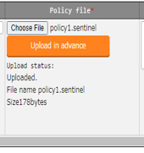

1. Clinking the PolicySet-Policy link list button will move the user to “6.2.8 PolicySet-Policy link list”.

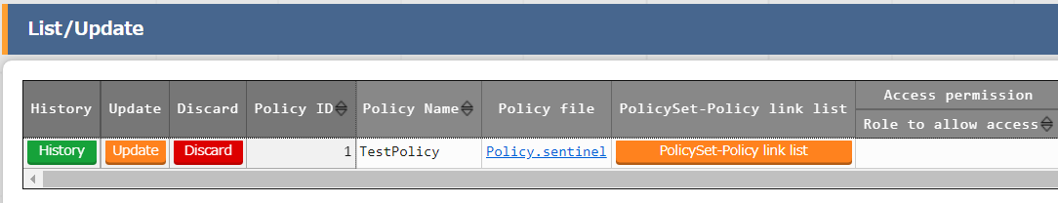

**Figure 6.2.6-3 Submenu screen (Policies list)**

1. The list of items managed by Policies is as follows.

**Table 6.2.6-1 Item list（Policies list）**

|  |  |  |  |  |
| --- | --- | --- | --- | --- |
| **Item** | **Description** | **Input required** | **Input type** | **Restriction** |
| Policy name | Enter the Polycy name that you want to list in the ITA. | ○ | Manual input | Maximum length 256 bytes |
| Policy file | Upload the created Module files. | ○ | File selection | Maximum size 4G bytes |
| PolicySet-Policy link list | Moves the user to “6.2.8 PolicySet-Policy Link list” |  |  |  |
| Remarks | Free description field. | - | Manual input | Maximum length 4000 bytes |

### Policy Sets list

1. In “Policy Sets list”, performs maintenance (browsing/register/update/abolish) of the Policy Sets.

Policy Set is linked with Polycy and Workspace in "6.2.8 PolicySet-Policy link list" and "6.2.9 PolicySet-Workspace link list" to apply Polycy to Workspace at the time of operation executing.

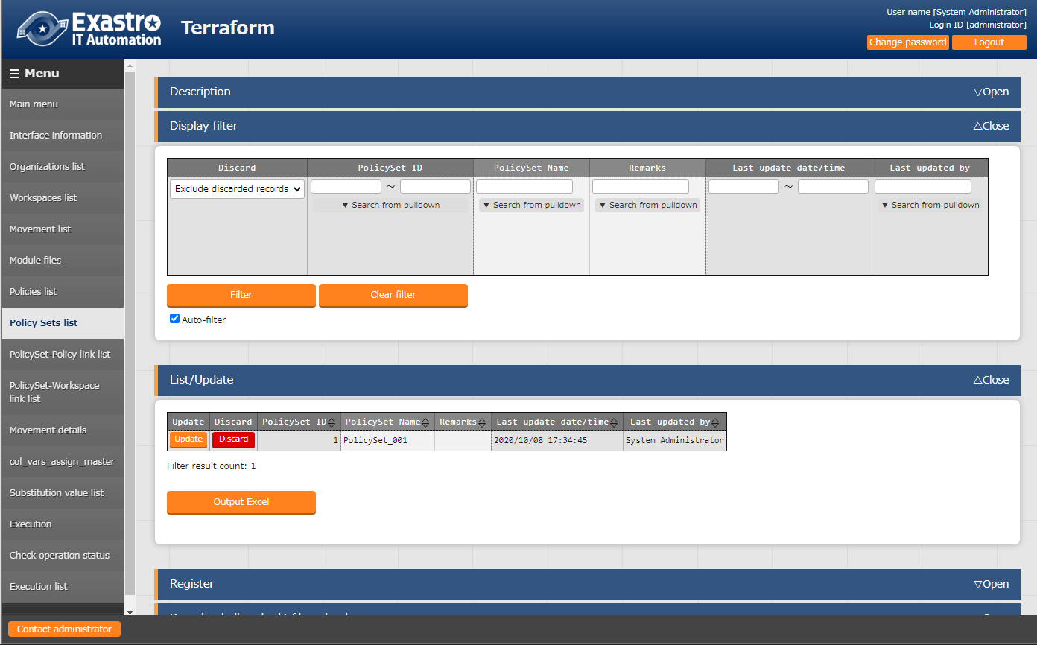

**Figure 6.2.7-1 Submenu screen（Policy Sets list）**

**(2)** Clicking the "Register" button and then "Start registration" button will register the PolicySet.

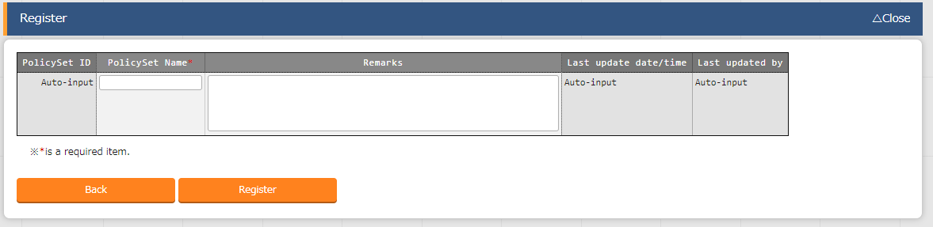

**Figure 6.2.7-2 Registration（Policy Sets list）**

**(3)** Clicking the PolicySet-Policy link list button will move the user to “6.2.8 PolicySet-Policy link list”.

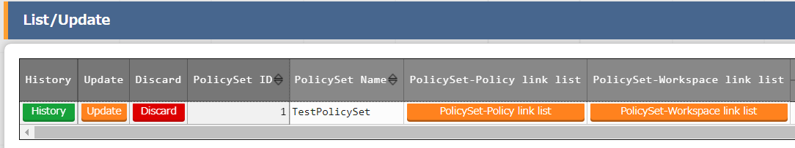Clicking the user to PolicySet-Workspaces link list button will move the user to “6.2.9 PolicySet-Workspace link list”.

**Figure 6.2.7-3 Submenu screen (Policy Sets list)**

**(4)** The list of items on the registration screen is as follows.

**Table 6.2.7-1 Item list（PolicySets list）**

|  |  |  |  |  |
| --- | --- | --- | --- | --- |
| **Item** | **Description** | **Input required** | **Input type** | **Restriction** |
| PolicySet name | Enter the PolycySet name that you want to list in the ITA. | ○ | Manual input | Maximum length 256 bytes |
| PolicySet-Policy link list | Moves the user to “6.2.8 PolicySet-Policy link list”. |  |  |  |
| PolicySet-Workspaces link list | Moves the user to “6.2.9 PolicySet-Workspace link list”. |  |  |  |
| Remarks | Free description field. | - | Manual input | Maximum length 4000 bytes |

### PolicySet-Policy link list

1. In “PolicySet-Policy link list”, performs maintenance (browsing/registration/update/abolition) for the linking of Policy created in "6.2.6 Policies list" and PolicySet created in "6.2.7 Policy Sets list".

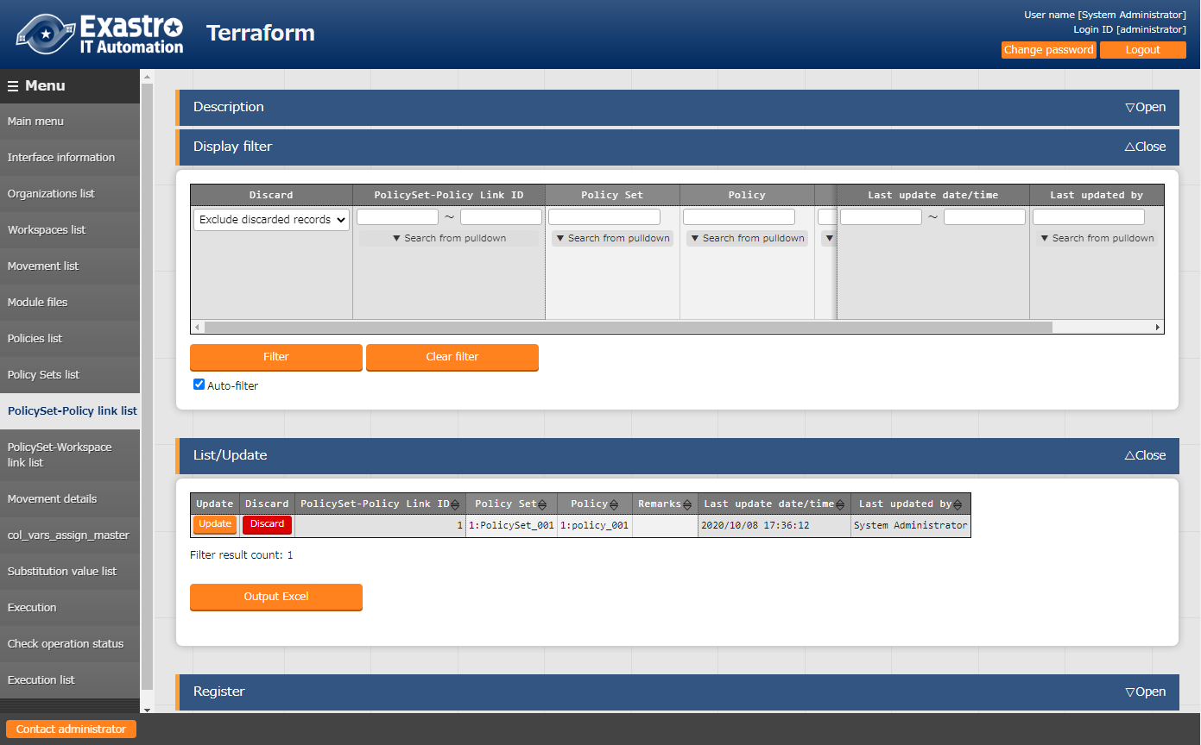

**Figure 6.2.8-1 Submenu screen（PolicySet-Policy link list）**

1. Clicking the "Register" button and then "Start Registration" button will register the PolicySet-Policy link.

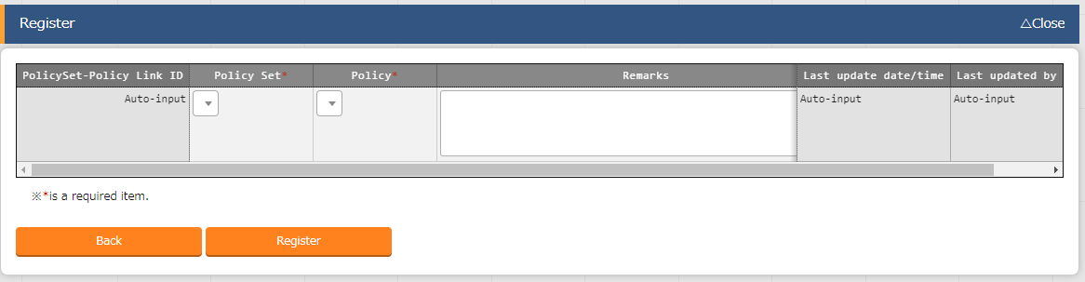

**Figure 6.2.8-2 Registration screen（PolicySet-Policy link list）**

1. 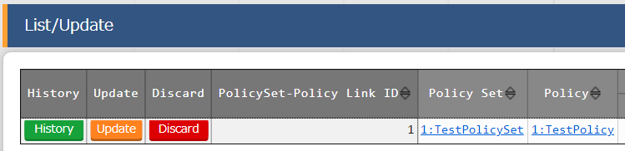Clicking the Policy Set link will move the user to “6.2.7 Policy sets list”  
   Clicking the Policy link will move the user to “6.2.6 Policies list”.

**Figure 6.2.8-3 Submenu screen (PolicySet-Policy Link list)**

1. The list of items on the PolicySet-Policy link list is as follows.

**Table 6.2.8-1 Item list (PolicySet-Policy link list)**

|  |  |  |  |  |
| --- | --- | --- | --- | --- |
| **Item** | **Description** | **Input required** | **Input type** | **Restriction** |
| Policy Set | Select the Policy Set name registered in "6.2.7 Policy Sets list". | ○ | List selection |  |
| Policy | Select the Policy name registered in "6.2.6 Policies list". | ○ | List selection |  |
| Remarks | Free description field. | - | Manual input | Maximum length 4000 bytes. |

### PolicySet-Workspace link list

1. In “PolicySet-Workspace link list”,performs maintenance (browsing/registration/update/abolition) for the linking of Workspace created in "6.2.3 Workspaces list" and PolicySet created in "6.2.7 Policy Sets list".

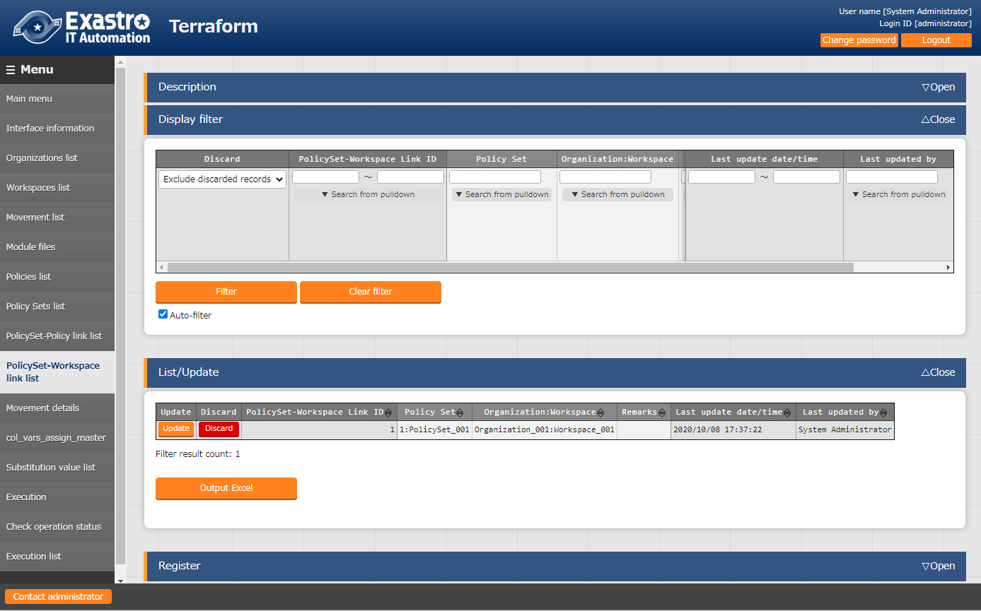

**Figure 6.2.9-1 Submenu screen （PolicySet-Workspace link list）**

1. Clicking the "Register" button and then "Start Registration" button will manage register of PolicySet-Workspace link.

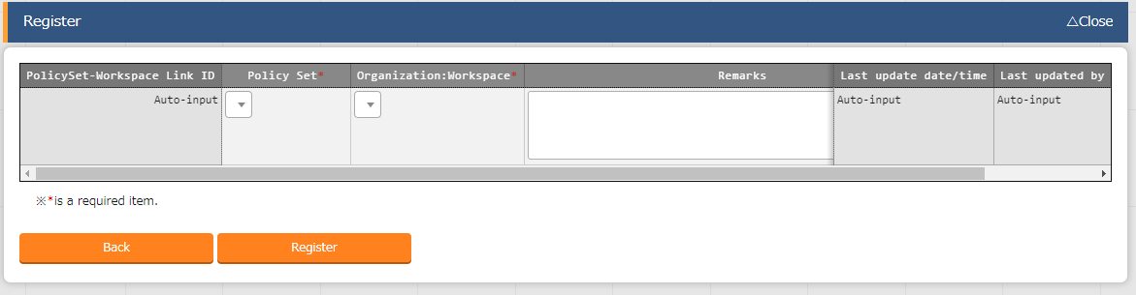

Figure 6.2.9-2 Registration screen （PolicySet-Workspace link list）

1. Clicking the Policy Sets link moves the user to the target “6.2.7 Policy Sets list”  
   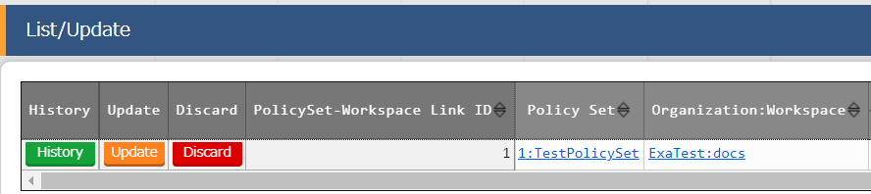Clicking the Organization:Workspace link moves the user to the target “6.2.3 Workspaces list”.

**Figure 6.2.8-3 Submenu screen (PolicySet-Workspace Link list)**

1. The list of items for PolicySet-Workspace association list is as follows.

**Table 6.2.9-1Item list (PolicySet-Policy link list)**

|  |  |  |  |  |
| --- | --- | --- | --- | --- |
| **Item** | **Description** | **Input required** | **Input type** | **Restriction** |
| Policy Set | Select the PolicySet name registered in "6.2.7 Policy Sets list”. | ○ | List selection |  |
| Organization:Work space | Select the Workspace registered (link to Organization) in "6.2.3 Workspaces list". | ○ | List selection |  |
| Remarks | Free description field. | - | Manual input | Maximum length 4000 bytes |

### Movement module link

1. In　“Movement module link”, performs maintence (browsing/register/update/ abolition) of the module files executed in the Movement.

Multiple Module files can be linked to the Movement.

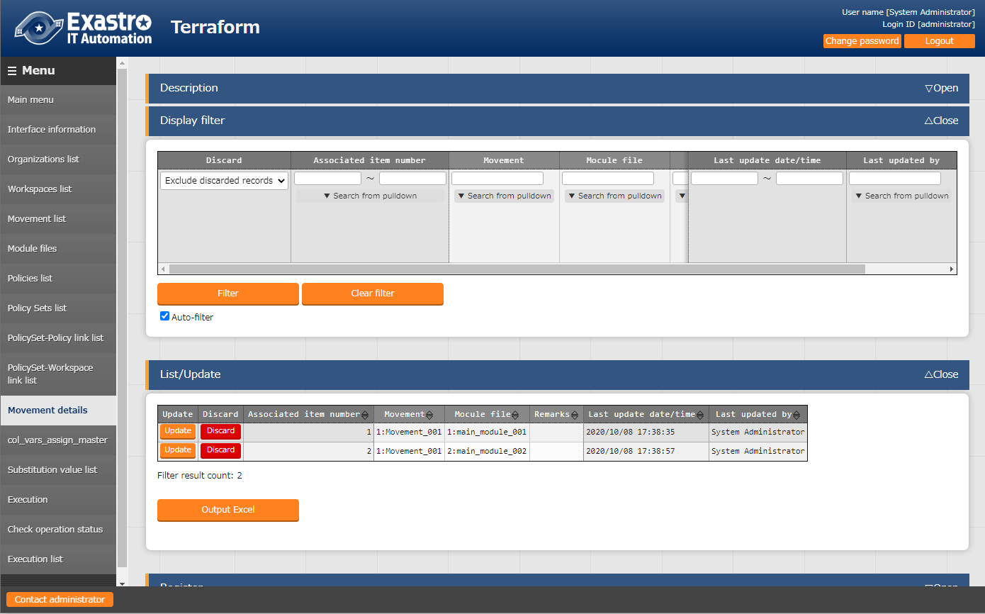

**Figure 6.2.10-1 Submenu screen（Movement module link）**

1. Clicking the "Register" button and then "Start Registration" button will manage the Movement module link.

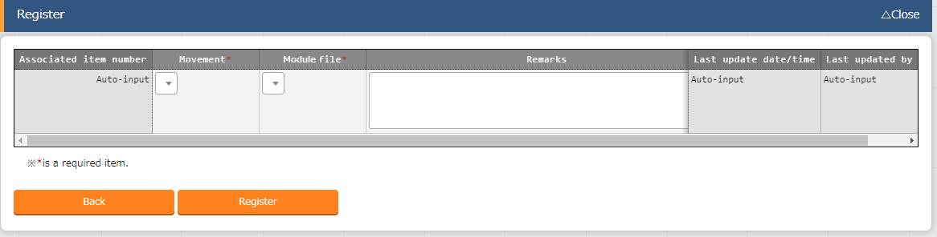

Figure エラー! 参照元が見つかりません。-2 Registration screen （Movement module link）

1. 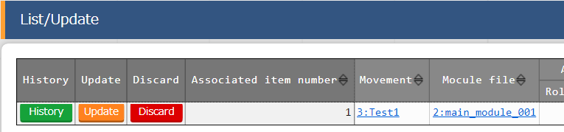Clicking the Movement URL will move the user to “6.2.4 Movement list”.  
   Clicking the Module file URL will move the user to “6.2.5 Module files”
2. The item list of Movement module link is as follows

**Tab**le エラー! 参照元が見つかりません。**-1 Item list（Movement module link）**

|  |  |  |  |  |
| --- | --- | --- | --- | --- |
| **Item** | **Description** | **Input required** | **Input type** | **Restriction** |
| Movement | Select the Movement registered in "6.2.4 Movement list". | ○ | List selection | - |
| Module files | Select the Module file registered in "6.2.5 Module files". | ○ | List selection | - |
| Remarks | Free description field. | - | Manual | Maximum length 4000 bytes |

### Substitution value automatic registration

* 1. In "Substitution value automatic registration", users can link Parameter sheets created with the Menu creation tool (With Operation) and Movement variables.

The registered information will be reflected to the Substitution value list by the BackYard Process.

The reflection rules is mentioned in 7.3 BackYard Content (2) substitution value automatic registration configuratio. 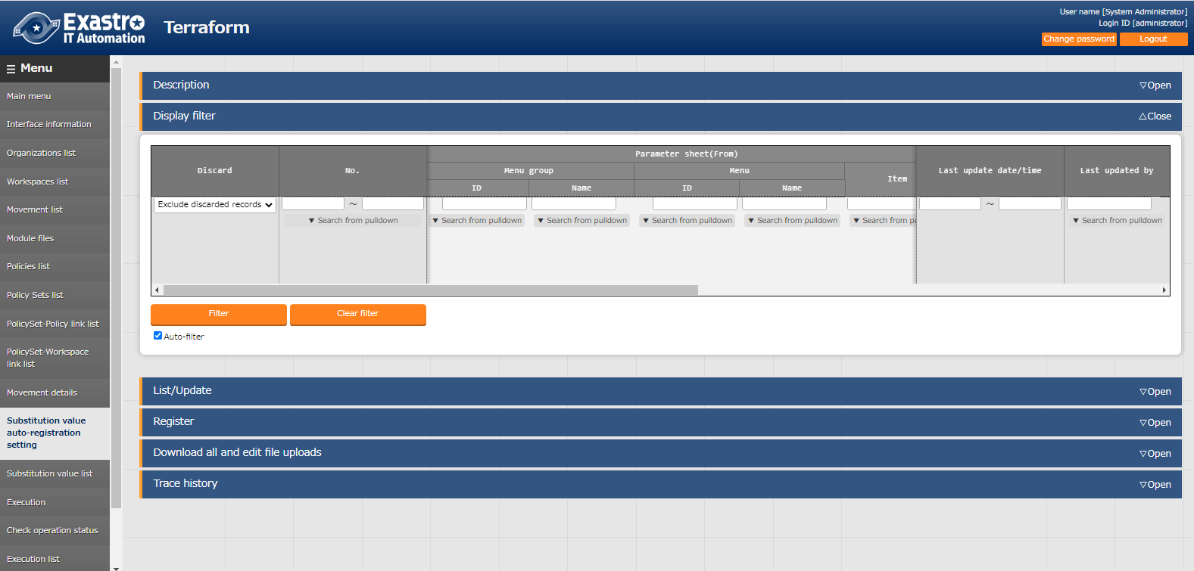

**Figure 6.2.11-1 Sub-menu screen (Substitution value automatic registration)**

* 1. Clicking the "Register" button and then "Start Registration" button will manage the substitute values. 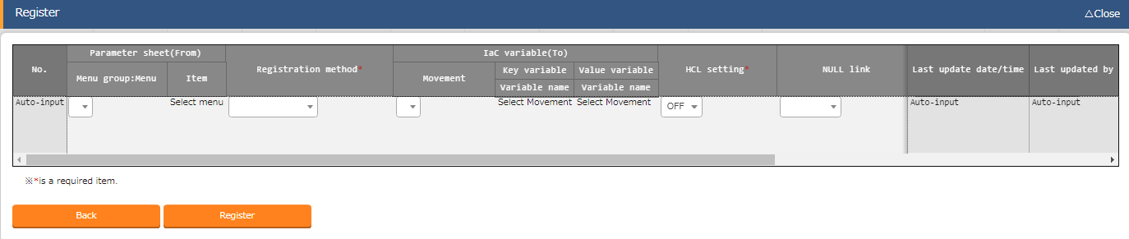

**Figure 6.2.11-2 Registration Screen (Substitution value automatic registration)**

* 1. 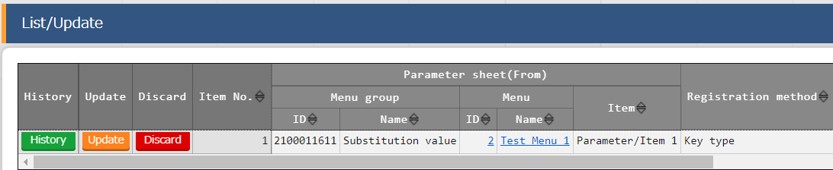Clicking the Menu ID or the Menu name link will move the user to the target menu.

**Figure 6.2.11-3 Submenu screen (Substitution value auto-registration settings)**

* 1. The list of items on the registration screen is as follows.

**Figure 6.2.11-1 Item list (Substitution value automatic registration)**

| **Column** | | **Description** | **Input**  **required** | **Input type** | **Restriction** |
| --- | --- | --- | --- | --- | --- |
| Menu group ：menu | | The parameter sheet (with operation) created by the menu creation function is displayed.  Select the appropriate parameter sheet. | ○ | List selection |  |
| Item | | The items in the selected parameter sheet are displayed.Select the target item. | ○ | List selection |  |
| Registration method | | Value Type: Select when you want the set value of the item to be the specified value of the linked variable.  Key Type: Select when you want the name of the item to be the specified value of the linked variable.  If the set value of an item is blank, it will not be linkable.  Key-Value Type: Select when you want the name of the item (Key) and the set value (Value) to be used as the specified value of a linked variable. | ○ | List selection |  |
| Movement | | The movement registered in the Movement list is displayed.Select Movement. | ○ | List selection |  |
| Key  information | Variable name | The variables used in the materials registered in the Movement module link are displayed.  Select the variable you want to link to the specific value in the Key type. | ○  OR  ／ | List selection | Required if the registration method is Key or Key-Value type. |
| Value  information | Variable name | The variables used in the materials registered in the Movement module link are displayed.  Select the variable you want to link to the specific value in the Value type. | ○  OR  ／ | List selection | Required if the registration method is Key or Key-Value type. |
| HCL setting | | Select "OFF" or "ON".  BackYard processing takes over the selected value when it is reflected in the subsititution value list. | ○ | List selection |  |

| NULL link | If the specific value of the parameter sheet in the "Substitution value auto-registration setting" is NULL(blank), users can set registrations to the list to have the value NULL(blank) or not.  This value is applied when "NULL Link"(In the Substitution value auto-registration setting menu) is blank.  ・If "Enable", any value in the parameter sheet is registered in the substitution value list.  ・If "Disable", the value is registered in the value list only if the parameter sheet contains a value.  ・If it is blank, the "NULL link" value of the interface information is applied. | - | List selection | - |
| --- | --- | --- | --- | --- |
| Remarks | Free description field. | - | Manual input | Maxumum length 4000 byte |

### Substitution value list

1. In “Substitution value list”, substitute variables in Module used in the target Movement for each operation. Specific values can be maintained (browsing/register/update/abolition).

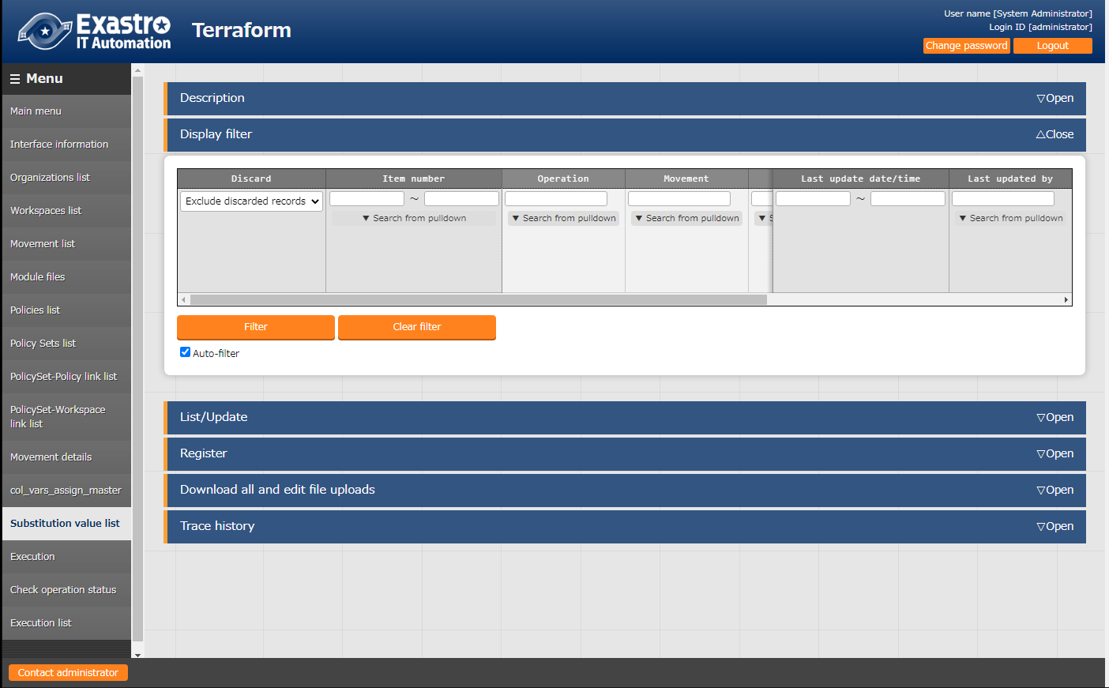

**Figure 6.2.12-1 Submenu screen （Substitution value list）**

1. Clicking the "Register" button and then "Start Registration" button will manage the substitute values.

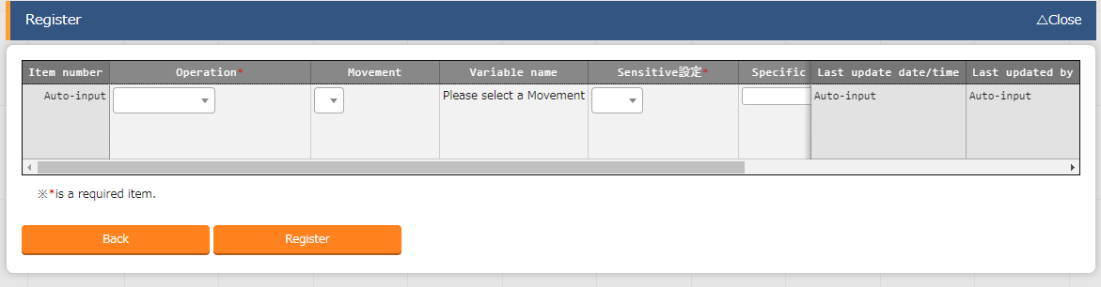

Figure 6.2.12-2 Registration screen（Substitution value list）

The variables in substitution value list are reflected from the file information registered in "6.2.5 Module files".

**※Please refer to the timing of reflection is described in "(3) Change of starting period" of "8.2 About the maintenance method".**

1. For the variables registered in the substitution value list, the "variable name" is registered as "Key" and "Specific value" is registered as "Value" for the Variables managed in the Workspace on the Terraform side when the operation is executed.

If "HCL settings" is set to "ON", it will be registered with "HCL" checked.

If "Sentive settings" is set to "ON", it will be registered with "Sentive" checked.

1. The list of items for assignment value list is as follows.

**Table 6.2.12-1　Item list（Substitution value list）**

|  |  |  |  |  |
| --- | --- | --- | --- | --- |
| **Item** | **Description** | **Input required** | **Input type** | **Restriction** |
| Operation | Select the target Operation. | ○ | List selection | - |
| Movement | Select the target Movement. | ○ | List selection | - |
| Variable name | From the Module files registered in the Movement module link, the name of the variable attached to the selected Movement is displayed. Select a variable. | ○ | List selection | - |
| HCL settings | Select "OFF" or "ON".  If "ON" is selected, "HCL" will be enabled for Variables when they are registered in the Workspace on the Terraform side.  Use this setting when configuring a variable to a value that is not a character string. | ○ | List selection |  |
| Sensitive settings | Select “OFF” or “ON”.  If "ON" is elected, the specific value will be encrypted won't be displayed on ITA.  Also keep in mind that when registering any variables to the workspace on the Terraform side, "Sensitive" for that variable will be enabled and specific values will not be displayed. | ○ | List selection |  |
| Specific value | Enter the specific value of the variable to use in Operations/Movements. | ○ | Manual input | Maximum length 8192 bytes |
| Remarks | Free description field. | - | Manual input | Maximum length 4000 bytes |

1. Updating ITA from Version 1.5 to 1.6 or later will make the "Variable name" of records registered in the substitution list display "ID conversion failed (ID).

This happens due to how variables are extracted (2. Variable handling in Terraform driver).

If this happens, the user will have to update the record and set a new variable name.

### Execution

1. Instructs to execute the operation. Select with the radio button from the Movement list and Operation list respectively, and when you press the execute button, it will move to "6.2.14 Check operation statu" and execute it.

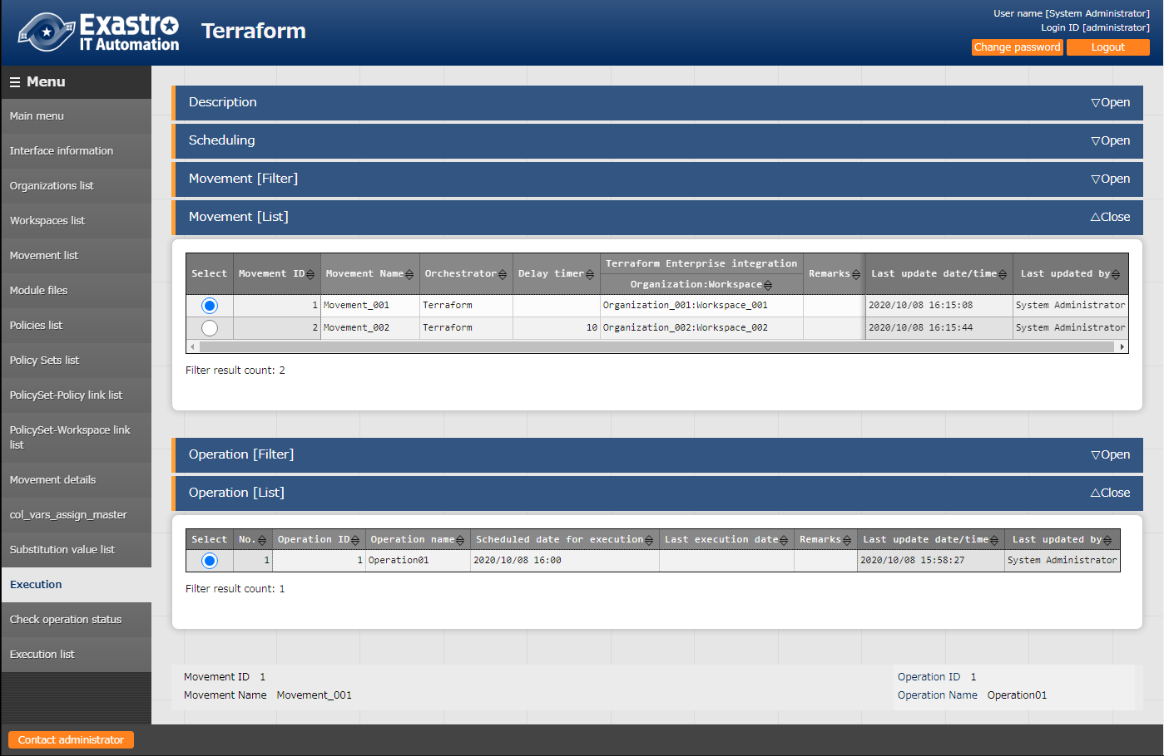

**Figure 6.2.13-1 Submenu screen（Execution）**

1. **Specify scheduled date/time**

Users can reserve Execution and Plan confirmations by entering the "Scheduled date/time".

Only date/time can be registered for "Schedule date/time"

1. **Specify Movement**

Select the Movement registered in the "6.2.4 Movement list".

1. **Specify Operation**

Select the Operation registered in the "6.1.1 Operations list".

1. **Execution**

Clicking the "Execute" button will move the user to ""6.2.14 Check Operation status"" and execute the operation.

"Apply" will automatically be executed after the Plan and/or the PolicyCheck are completed.

1. **Plan confirmation**

Clicking the "Plan Confirmation" button will similarly to clicking the "Execute" button, start the execution. However, "Discard Run" will be applied to RUN after the Plan and PolicyCheck are completed, and "Apply" will not be executed.

If a module with an output block is run with Conductor,

the contents of the output block will be saved to the deta relay storage path(shared movement directory) as a json file.

This file allows users to use a value output by Terraform from a different Movement (in the same conductor).

File path:

[Data relay storage path]/[Conductor instance ID]/terraform_output_[Operation No].json

Example：/exastro/data_relay_storage/conductor/0000000001/terraform_output_0000000001.json

Data relay storage path -[Conductor]-[Conductor interface information ] - [Data relay storage path]

Conductor instance ID・・・[Conductor]-[Conductor list] - [Conductor instance ID]（The 10 numbers from the left.）

Operation No.・・・ [Terraform]-[Execution list] - [Operation No.]（The 10 numbers from the left.）

Description

|  |
| --- |
| variable "VAR_sample" {  type = string  default = "sample_string"  }  output "output_sample" {  value = "${var.VAR_sample}"  } |

Output

|  |
| --- |
| {  "output_sample": "sample_string"  } |

### Check operation status

1. Monitor the execution status of operation.

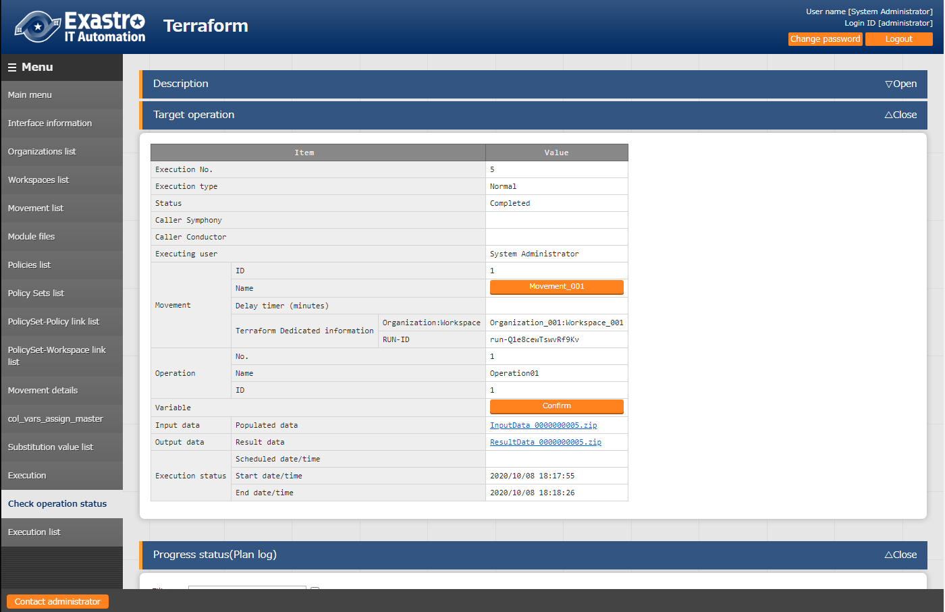

**Figure 6.2.14-1 Submenu screen （Check operation status）**

1. **Display of execution status**

"Status" will be displayed to match the Execution status.

The "Execution Type" will contain "Plan Confirmation" for plan confirmations, and "Normal" for other cases.

Execution log for Progress (Plan Log), Progress (PolicyCheck Log) and Progress (Apply Log) executed in Terraform are displayed in Plan/ PolicyCheck / Apply.

If the status ends with an unexpected error, there is no registration of "6.2.1 Interface information", "6.2.2 Organizations list" and "6.2.3 Workspaces list" with Terraform.

Or if it is due to unregistration of other web content, a message will be displayed in "Progress (error log)".

For other errors, the progress (error log) does not display a message. Check the process logs as needed.

※Please refer to "④ Log file name" in "8.2 About maintenance method" for the process log.

“Call Symphony”, displays which Symphony was executed. It will be blank if you execute it directly from the Terraform driver or from Conductor.

In “Call Conductor”, displays which Conductor was executed. It is blank if you execute it directly from the Terraform driver or from Symphony.

"Execution user" displays the login user when the "Execute" button is pressed from the execution menu.

The "RUN-ID" displayed in "Terraform User Information" is an execution list ID managed by Terraform and is used for linking with Terraform with Backyard content.

1. **Substitution value confirmation**

By clicking the "confirmation" button, "6.2.12 Substitution value list" will display and the substitution value filtered by the operation and Movement of operation target will be displayed.

1. **Emergency stop/Schedule cancellation**

It is possible to stop the construction operation by clicking the "Emergency stop" button.

In addition, for the "scheduled execution" operation before execution, the "schedule cancellation" button will display. Cancel the scheduled execution by clicking the "schedule cancellation" button.

1. **Log filter**Execution log and error log can be filtered. By entering the string that the user wants to search in the filter box of each log and checking the "Display only corresponding lines" checkbox, only the corresponding line will be displayed. The display refresh cycle and the maximum display line count of exeuction and error log can be set in "Status monitoring cycle (milliseconds)" and "Number of rows to display progress status" of "6.2.1 Interface information" menu.
2. **Input data**Users can download executed module files and a zip file containing a list of policy materials and the configured substitute values in Json format. The files are as following:

**Table** エラー! 参照元が見つかりません。**-1 Input data files**

|  |  |  |
| --- | --- | --- |
| **Directory name** | **File name** | **Description** |
| - | (Name of the input Module file) | Contains all the input module files. Stored directly under the zip file. |
| - | (Name of the input Policy file) | Contains all the policy files. Stored directly under the zip file. |
| variables | variables.json | Contains "Variable name (key)", "Specific value (value)", "HCL settings" and "Sensitive settings" configured to the substitute value.  The Specific value will not be included if the sensitive settings is active. |

1. **Result data**

User can download execution logs, error logs, and state files generated by Terraform.  
  
**Table** エラー! 参照元が見つかりません。**-2 Result data files**

|  |  |  |
| --- | --- | --- |
| **Directory name** | **File name** | **Description** |
| - | plan.log | Log file that contains the contents output to the progress (plan) log. |
| - | policyCheck.log | Log files that contains the contents output to the progress (policy check) log. |
|  | apply.log | Log files that contains the contents output to the progress (apply) log. |
|  | error.log | Log files that contains the contents output to the progress (error) log. |
| - | sv-XXXXXX.tfstate | State file generated by Terraform. The file name is generated by Terraform and will therefore be different every time.  The file is encrypted. |

### Execution list

1. The history of operation can be viewed here.

The operation list table and graph will display by specifying criteria and clicking the "filter" button.

By clicking the "Check execution status" button, the screen will transit to "6.2.14 Check operation status" and the details of execution status can be viewed.

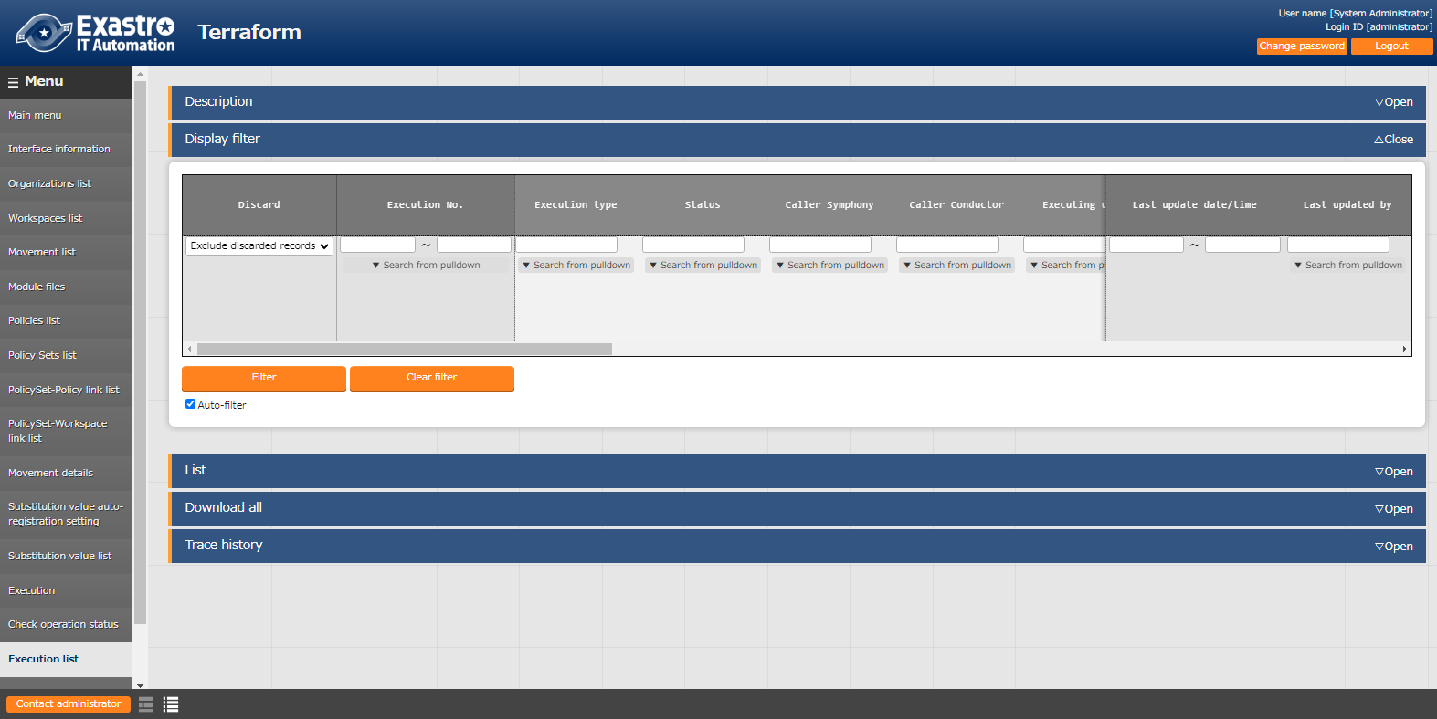

**Figure 6.2.15-1 Submenu screen（Execution list）**

### Terraform registration list

1. Connect to Terraform based on the information registered in "6.2.1 Interface Information" and register with Terraform.

You can display a list of Organization/Workspace/ Policy/PolicySets respectively.

You can remove Targets from the display list from Terraform.

It is also possible to unlink Workspaces and Policies that are linked to PolicySet.

※Operations performed on this page will not affect the registered targets on the ITA side. 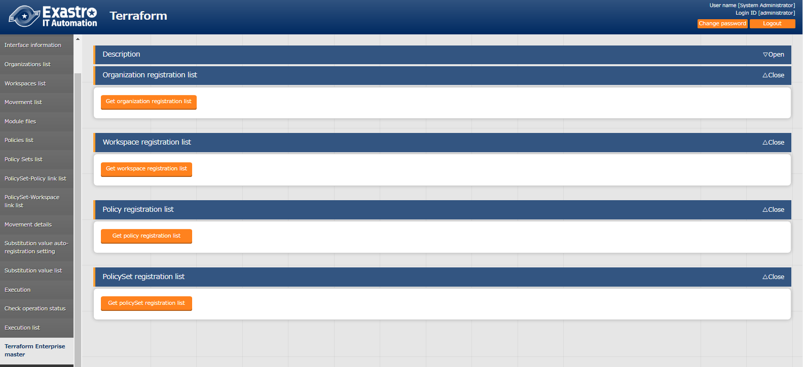

**Figure 6.2.16-1 Sub-menu screen (Terraform registration list)**

1. The list of items displayed by each list acquisition is as follows.

**Table 6.2.16-1 Items list (Organization registration list)**

|  |  |
| --- | --- |
| **Item** | **Description** |
| Organization Name | Name of the Organization registered with Terraform. |
| Email address | Email address registered in the Organization. |
| ITA registration status | If the target Organization Name is registered in "6.2.2 Organizations list", it will be displayed as "Registered".  If it is not registered, it will be displayed as "Unregistered". |
| Deletion | Clicking this button will display a confirmation dialog box. Pressing OK will remove the target Organization from Terraform.  ※Deleted Organizations cannot be restored. |

**Table 6.2.16-2 Items list (Workspace registration list)**

|  |  |
| --- | --- |
| **Item** | **Description** |
| Organization Name | The name of the Organization linked with the target Workspace. |
| Workspace Name | Name of Workspace registered with Terraform. |
| Terraform Version | Terraform version set to the target Workspace. |
| ITA　 registration status | If the target Workspace Name is registered in "6.2.3 Workspaces list", it will be displayed as "Registered".  If it is not registered, it will be displayed as "Unregistered". |
| Deletion | Clicking this button will display a confirmation dialog box. Pressing OK will remove the target Workspace from Terraform.  ※Deleted Workspace cannot be restored. |

**Table 6.2.16-3 Items list (Policy registration list)**

|  |  |
| --- | --- |
| **Item** | **Description** |
| Organization Name | The name of the Organization linked with the target Policy. |
| Policy Name | Name of Policy registered with Terraform. |
| ITA　 registration status | If the target Policy Name is registered in "6.2.6 Policies list", it will be displayed as "Registered".  If it is not registered, it will be displayed as "Unregistered". |
| Download Policy Code | Click this link to download the Policy Code file of the target Policy. |
| Deletion | Clicking this button will display a confirmation dialog box. Pressing OK will remove the target Policy from Terraform.  ※Deleted Policy cannot be restored. |

**Table 6.2.16-4 Items list (PolicySet registration list)**

|  |  |
| --- | --- |
| **Item** | **Description** |
| Organization Name | The name of the Organization linked with the target PolicySet. |
| PolicySet Name | Name of the target PolycySet. |
| Link Workspace | The name of the Workspace linked with the target PolicySet. |
| Link Policy | The name of the Policy linked with the target PolicySet. |
| ITA registration status | If the target PolicySet Name is registered in "6.2.7 PolicySet list", it will be displayed as "Registered".  If it is not registered, it will be displayed as "Unregistered". |
| Delete/Unlink | The "Delete" button is displayed for PolicySet Name and the "Un-link" button is displayed for linked Workspace and Policy.  Clicking the "Delete" button will display a confirmation dialog box. Pressing OK will remove the target PolicySet from Terraform.  Clicking the "Un-link" button will display a confirmation dialog box. Pressing OK will remove the link to the target Workspace/Policy's PolicySet.  ※Deleted PolicySets cannot be restored. |

# How to write construction code

Describes the description of Module and Policy in Terraform driver.

## Module description

Module files are written in HashiCorp's own language called HCL (HashiCorp Configuration Language).

For more information on HCL, see the Terraform product documentation.

## Policy description

The Policy file is written in HashiCorp's own language called Sentinelese language.

For more information on the Sentinel language, see the Terraform product documentation.

## BackYard Content

1. **Automatic variable registration**

This function extracts variables from the Module files registered in "6.2.5 Module files".

Please refer to "2.1 Variable types" for more information regarding "Variable extraction rules".

Additionally, the timing of the extraction depends on the startup cycle of the "Automatic Terraform Variables Registration" process.

1. **Automatic Substitute Value Registration Settings**

The Information from the movement and variables linked to the set values of Operation itens in the target parameter sheets is reflected in the Substitute Value list.

The timing of the extraction depends on the startup cycle of the "Terraform Auto Registration Settings" process.

The Substitute value list can be updated by multiple operators. If the last update was performed by another operator, it will not be reflected.

If you want to reflect the data of the Automatic Substitute value registration settings, please delete the corresponding record in the Substitute Value list.

The rules for reflecting the substitution value list are written below.

1. **When the information registered in the Substitution value automatic registration is reflected in the Substitution value list**

|  |  |  |  |  |  |
| --- | --- | --- | --- | --- | --- |
| **Substitution value list status** | **Without applicable record** | **With applicable record** | | | **Record abolishing** |
| **= Specific value** | **≠ Specific value** | |
| **Last update** | |
| **BackYard process** | **Other operators** |
| Reflected to substitution value list | Add new record | - | Update specific values for the applicable record | - | Abolition record revival |

※Applicable record: Operation + Movement + Variable name + HCL configuration + Records with the same access permission.

1. **Information not registered in substitution value automatic registration (registered only for the substitution value list) is reflected in the subsitution value list.**

|  |  |  |
| --- | --- | --- |
| **Substitution**  **value list status** | **With applicable record** | |
| **Last update** | |
| **BackYard process** | **Other operators** |
| Reflected to  substitution value list | Record abolishing | - |

1. **About HCL settings**

The value of the "HCL setting" configured for substitution value automatic registration is set to the same value when reflected in the substitution value list.

1. **About Sensitive settings**

If the item in the Link-target parameter sheet is set to "Password", the "Sensitive settings" will be set to "ON" when reflected in the Substitution value list.

1. **About access permission roles**

The access permission role of the operation set in the record of the link-target parameter sheet and the access permission role of the Movement set in the record of automatic assignment value registration are referred to, and all matching access permission roles are set when reflected in the Substitute value list.

If no permission role is set for either of them (blank), the blank space will also be set when reflected in the Substitute Value list.

Additionally, if there are no single matching permission roles, no record will be created in the Substitute Value list.

# Application operation

The operation to utilize ITA system contains not only inputs by user from the browser screen of client PC but also operations according to system operation and maintenance. The available operation and maintenance are as follows.

## Maintenance

The files required to start/stop/restart Terraform driver processes are as follows.

|  |  |
| --- | --- |
| **Description** | **Target file name** |
| Terraform operation execution monitoring  Execute the unexecuted Operation. | ky_terraform_execute-workflow.service |
| Terraform operation execution monitoring  Check the status of executing work and acquire logs. | ky_terraform_checkcondition-workflow.service |
| Terraform variable automatic registration  Remove variables from uploaded Module files. | ky_terraform_varsautolistup-workflow.service |
| Terraform auto registration settings  The information configured for substitution value automatic registration is reflected in the substitution value list. | ky_terraform_valautosetup-workflow.service |

The target file is stored in “/usr/ lib/ystemd/system”.

The method of Starting/Stopping/Restarting a process is as follows. Please execute the command with root permission.

1. Start process

# systemctl start ky_terraform_execute-workflow.service

1. Stop process

# systemctl stop ky_terraform_execute-workflow.service

1. Restart Process

# systemctl restart ky_terraform_execute-workflow.service

Please replace each target file name with a start/stop/restart.

## About Maintenance and Maintaining

1. Change to NORMAL level

Rewrite line 8 of the following file with "DEBUG" to NORMAL.

　Log level configuration file: <installation directory> /ita-root/confs/backyardconfs/ita_env

1. Change to DEBUG level

　Rewrite line 8 of the following file with "DEBUG" to NORMAL.

　 Log level configuration file: <installation directory>/ita-root/confs/backyardconfs/ita_env

1. Change the startup period

　Change the 5th parameter of ExecStart of each target file. (Unit: seconds)

　With exceptions, use the default value for the startup period.

ExecStart=/bin/sh ${ITA_ROOT_DIR}/backyards/common/ky_loopcall-php-procedure.sh /bin/php /bin/php ${ITA_ROOT_DIR}/backyards/terraform_driver/ky_terraform_execute-workflow.php ${ITA_ROOT_DIR}/logs/backyardlogs **5** ${ITA_LOG_LEVEL} > /dev/null 2>&1

After rewriting the file, **it enables after the process is restarted.**

1. Log file name

|  |  |
| --- | --- |
| **Process name** | **Log file name** |
| ky_terraform_execute-workflow | ky_terraform_execute-workflow_YYYYMMDD.log |
| ky_terraform_checkcondition-workflow | ky_terraform_checkcondition-workflow_YYYYMMDD.log |
| ky_terraform_varsautolistup-workflow | ky_terraform_varsautolistup-workflow_YYYYMMDD.log |
| ky_terraform_valautosetup-workflow | ky_terraform_valautosetup-workflow_YYYYMMDD.log |

Log file output directory: <installation directory> /ita-root/logs/backyardlogs