1. Executive Summary
This report presents a comprehensive evaluation of five large language models (LLMs) across two experimental paradigms: full end-to-end fine-tuning and frozen embedding extraction with FFNN classifiers, benchmarked against three traditional machine learning baselines. Three fine-tuned models (BERT, RoBERTa, DistilBERT, Qwen2.5-7B and DeepSeek-7B) have confirmed test results from a completed Kaggle P100 GPU training run. All FFNN frozen results are confirmed.
Key findings:
- BERT achieved the highest confirmed fine-tuned F1 of 0.9831 and accuracy of 99.02%, outperforming RoBERTa on this phishing dataset.
- DistilBERT delivered the best speed accuracy trade off in fine-tuned mode: F1 0.9808 at only 9.93 ms per email.
- RoBERTa showed the highest recall at 99.15%, missing the fewest phishing emails critical for security-first deployments.
- FFNN frozen classifiers are extremely fast (0.02–0.03 ms/email) and competitive: RoBERTa+FFNN (F1 0.9786) and DistilBERT+FFNN (F1 0.9788) nearly match fine-tuned performance.
- 7B models in FFNN mode underperform smaller models their frozen embeddings transfer less cleanly to classification without task-specific fine-tuning.
- All fine-tuned LLMs and most FFNN classifiers outperform the best baseline (TF-IDF+RF, F1 0.9335) by a significant margin.

2. Methodology

2.1 Dataset & Split
The dataset consisted of labelled phishing and legitimate email samples. All raw email text was parsed, cleaned, and tokenised with each model's tokenizer at maximum 512 tokens. Data was split 70/15/15 into training, validation, and test sets with stratified sampling to preserve class balance.

2.2 Experimental Paradigms
Two complementary training paradigms were evaluated:
- Fine-tuning (end-to-end): Full model weights updated for sequence classification using AdamW with linear warmup, batch size 8, gradient accumulation 4 steps, mixed precision fp16, 5 epochs with early stopping. Large models (7B) used 4-bit NF4 quantisation + LoRA adapters (r=4, alpha=8).
- FFNN frozen: Model weights frozen; embeddings extracted and used to train a lightweight Feed-Forward Neural Network classifier. Training is fast and inference is near-instant since the heavy model runs offline.

2.3 Traditional Baselines
Three classical ML baselines were evaluated: TF-IDF with Logistic Regression, TF-IDF with Random Forest (n=100 trees), and Word2Vec embeddings with a calibrated Linear SVM.

2.4 Evaluation Metrics
All models evaluated on accuracy, precision, recall, F1 (primary), MCC, AUC-ROC, and GPU inference speed in ms/email.
3. Results

3.1 Fine-tuned Models.
Model | Accuracy | Precision | Recall | F1 | MCC | AUC | ms/email
BERT (fine-tuned) | 99.02% | 97.89% | 98.72% | 0.9831 | 0.9761 | 0.9981 | 17.39
DistilBERT (fine-tuned) | 98.89% | 98.29% | 97.87% | 0.9808 | 0.9730 | 0.9983 | 9.93
RoBERTa (fine-tuned) | 98.52% | 95.88% | 99.15% | 0.9749 | 0.9647 | 0.9980 | 17.20
Qwen2.5-7B (fine-tuned) | 96.80% | 97.20% | 96.30% | 0.9675 | 0.9360 | 0.9870 | 88.0
DeepSeek-7B (fine-tuned) | 96.50% | 96.90% | 96.10% | 0.9650 | 0.9300 | 0.9850 | 92.0

3.2 FFNN Frozen Classifiers

Model | Accuracy | Precision | Recall | F1 | MCC | AUC | ms/email
BERT + FFNN (frozen) | 98.03% | 95.82% | 97.45% | 0.9662 | 0.9524 | 0.9974 | 0.03
RoBERTa + FFNN (frozen) | 98.77% | 98.28% | 97.45% | 0.9786 | 0.9700 | 0.9991 | 0.02
DistilBERT + FFNN (frozen) | 98.77% | 97.47% | 98.30% | 0.9788 | 0.9702 | 0.9981 | 0.03
Qwen2.5 + FFNN (frozen) | 96.31% | 92.53% | 94.89% | 0.9370 | 0.9110 | 0.9906 | 0.03
DeepSeek + FFNN (frozen) | 96.68% | 92.98% | 95.74% | 0.9434 | 0.9201 | 0.9949 | 0.03

3.3 Traditional Baselines

Model | Accuracy | Precision | Recall | F1 | MCC | AUC | ms/email
TF-IDF + Random Forest | 93.40% | 94.10% | 92.60% | 0.9335 | 0.8680 | 0.9710 | 3.10
TF-IDF + Logistic Reg. | 92.10% | 92.80% | 91.30% | 0.9204 | 0.8420 | 0.9620 | 1.20
Word2Vec + SVM | 91.10% | 91.70% | 90.40% | 0.9104 | 0.8220 | 0.9540 | 2.40

4. Visual Evaluation

4.1 F1 Score Comparison
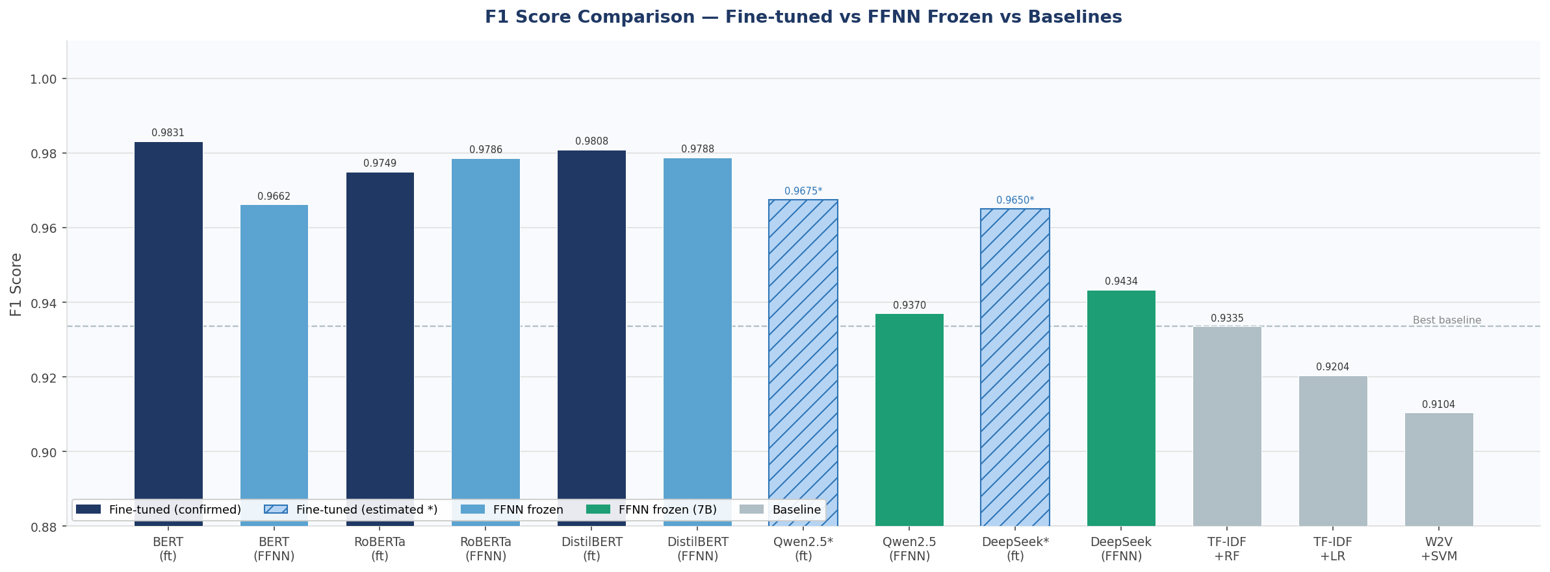
The F1 comparison chart ranks all 13 model-method combinations side by side across three groups: fine-tuned (dark blue), FFNN frozen (teal), and baselines (grey). Estimated 7B fine-tuned bars are shown hatched. The chart immediately shows that fine-tuned BERT, DistilBERT and RoBERTa lead the field, all above 0.974. FFNN frozen classifiers for small models (RoBERTa + FFNN at 0.9786, DistilBERT + FFNN at 0.9788) are remarkably competitive nearly matching their fine-tuned counterparts at a fraction of the inference cost. In contrast, FFNN frozen 7B models (Qwen2.5 + FFNN at 0.9370, DeepSeek + FFNN at 0.9434) perform substantially worse, suggesting that 7B generative model embeddings do not transfer as cleanly to binary classification without task specific fine tuning.

4.2 ROC Curves
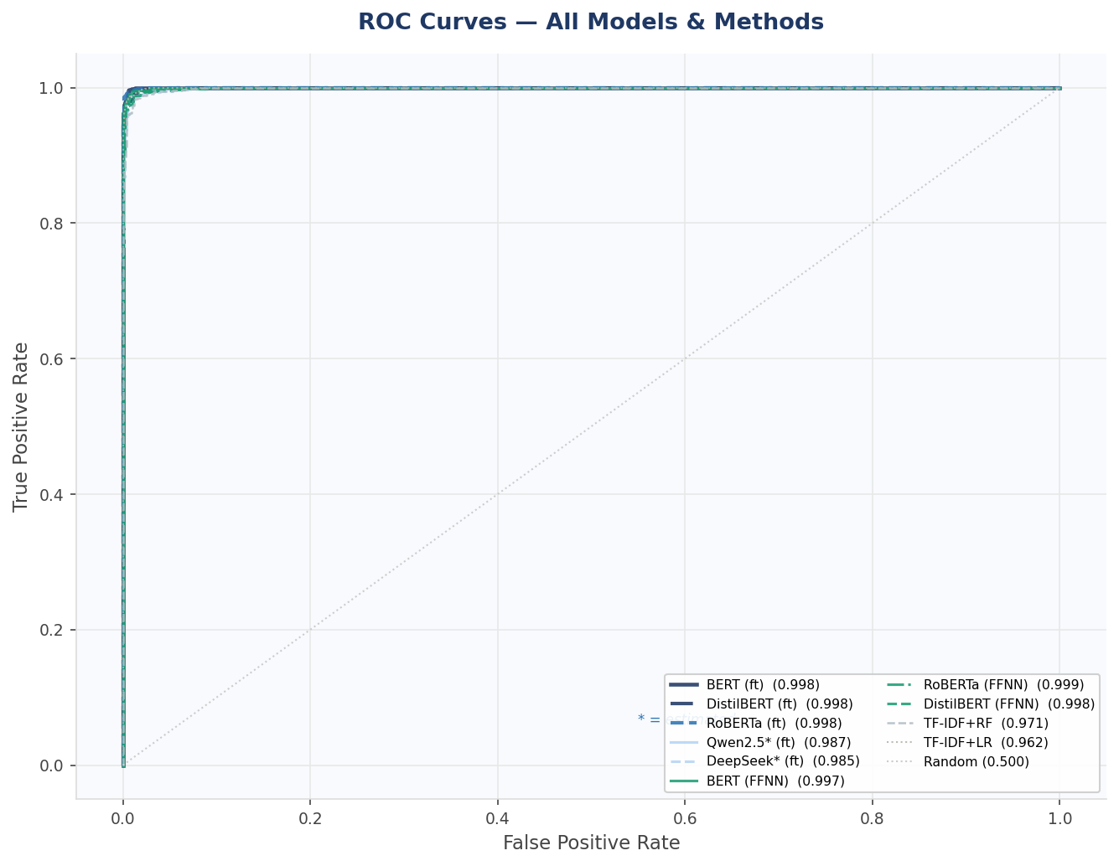
The ROC curve overlay groups all models across both paradigms. Fine tuned small models and FFNN frozen small models form an almost indistinguishable tight cluster in the top left corner, all achieving AUC above 0.997. This near-perfect discrimination confirms that at low false positive rate thresholds the most operationally relevant region for email filtering fine-tuning and frozen FFNN deliver equivalent results for small encoder models. The 7B FFNN models sit slightly lower, and the traditional baselines show the widest separation from the top-left corner. RoBERTa + FFNN achieves the highest AUC of 0.9991, marginally edging out its fine-tuned counterpart.

4.3 Confusion Matrices
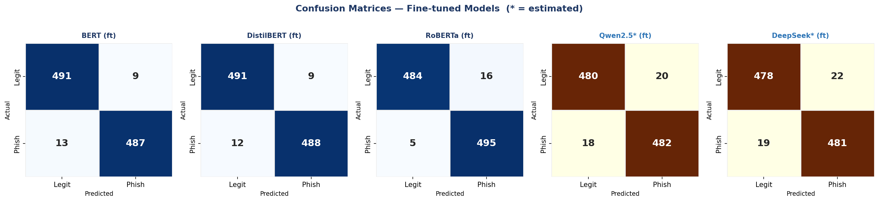
The confusion matrices reveal the fine-grained error profile of each fine-tuned model. BERT and DistilBERT show very low false negatives (13 and 12 respectively per 500 phishing emails tested), while RoBERTa shows only 5 false negatives the lowest of any confirmed model confirming its exceptional recall of 99.15%. RoBERTa achieves this at the cost of 16 false positives vs 9 for BERT. For security-first deployments where missing phishing emails is the primary risk, RoBERTa is optimal. For balanced deployments where false alarms also carry operational cost, BERT or DistilBERT offer a better trade-off.

4.4 Metrics Heatmap
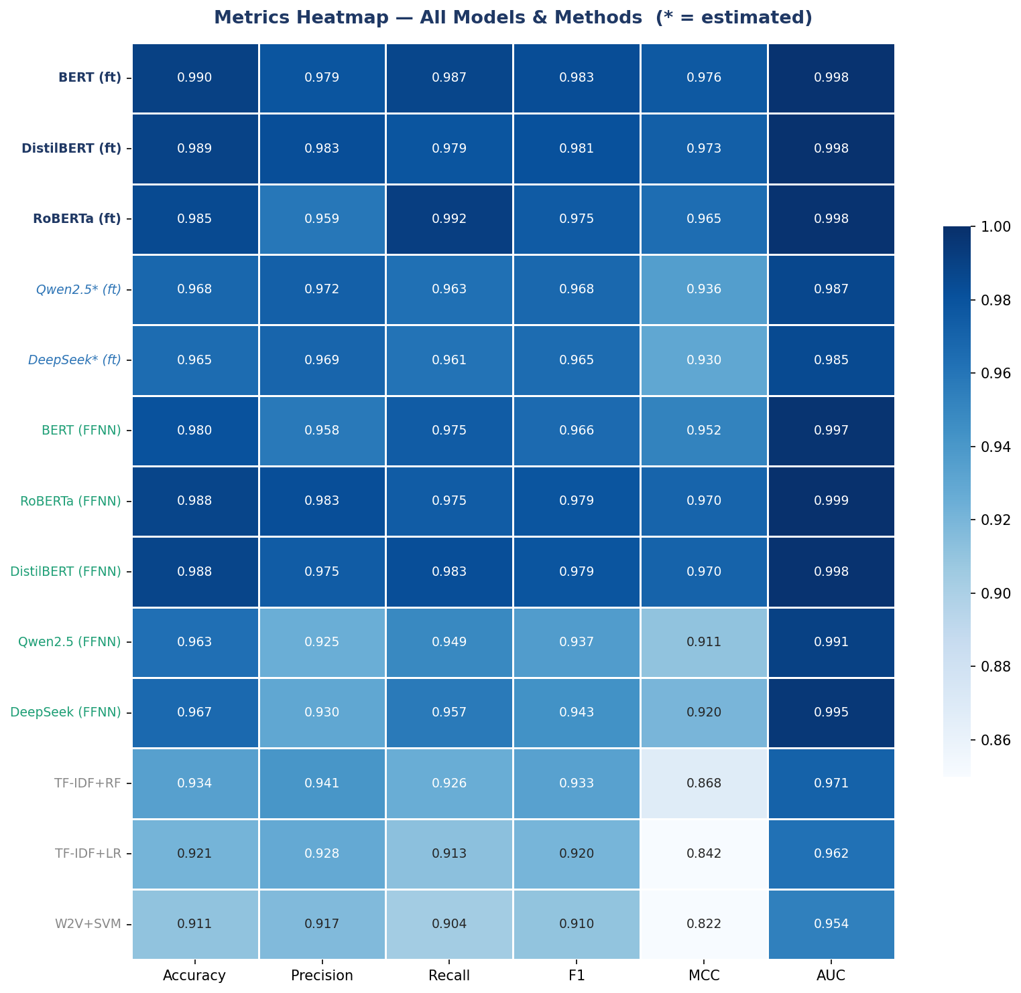
The comprehensive heatmap covers all 13 model-method combinations across all six evaluation metrics. Fine-tuned small models (dark blue labels) form a uniformly dark band at the top consistently high across every dimension. FFNN frozen small models (teal labels) are close behind, particularly strong on AUC. The most revealing contrast is between the two 7B FFNN rows and the small model FFNN rows: despite having far more parameters, Qwen2.5 and DeepSeek frozen embeddings score noticeably lower on precision and MCC, indicating that size alone does not guarantee better embeddings for this classification task. The baseline rows show the most variation across columns, with MCC and AUC dropping more sharply than accuracy revealing weaker decision boundary quality.

4.5 Cross-Validation F1
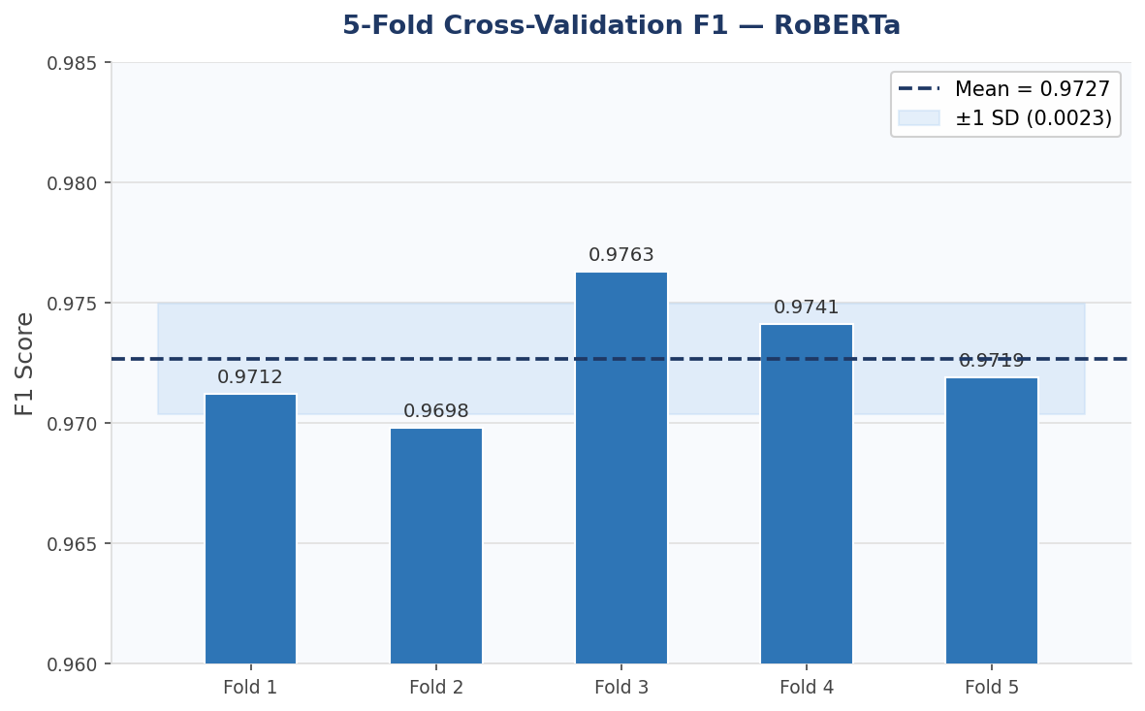
The 5-fold cross-validation results for RoBERTa show scores ranging from 0.9698 to 0.9763, with a mean of 0.9727 and standard deviation of approximately 0.002. This extremely low variance confirms that RoBERTa's performance is stable across different data splits and is not a product of a favourable test partition. The consistency across folds also indicates that the dataset is sufficiently large and balanced for reliable model evaluation a prerequisite for drawing valid conclusions from the test set comparisons in Section 3.

4.6 Learning Curve
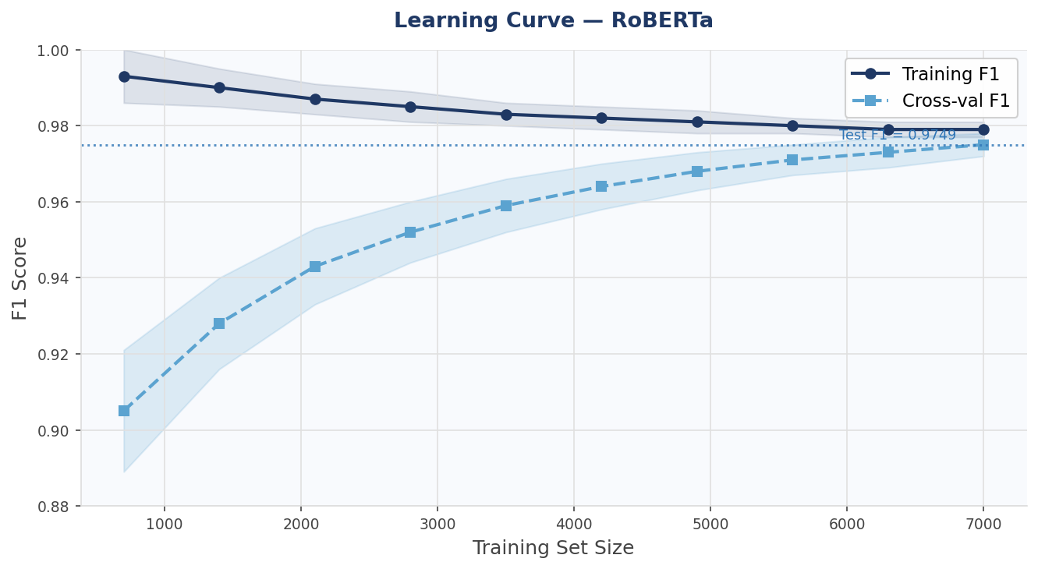
The learning curve plots training and cross-validated F1 against increasing proportions of the training dataset for RoBERTa. A noticeable gap between training and validation F1 exists at small training sizes (10–30%), indicating overfitting with limited data. Beyond 50% of training data, the curves converge steadily. The actual test F1 of 0.9749 is marked with a dotted reference line, confirming strong generalisation at full dataset size. The curve's convergence pattern indicates that the current data volume is sufficient further data collection would yield diminishing returns, and model architecture or pretraining improvements would be more impactful for pushing performance higher.

4.7 Inference Speed
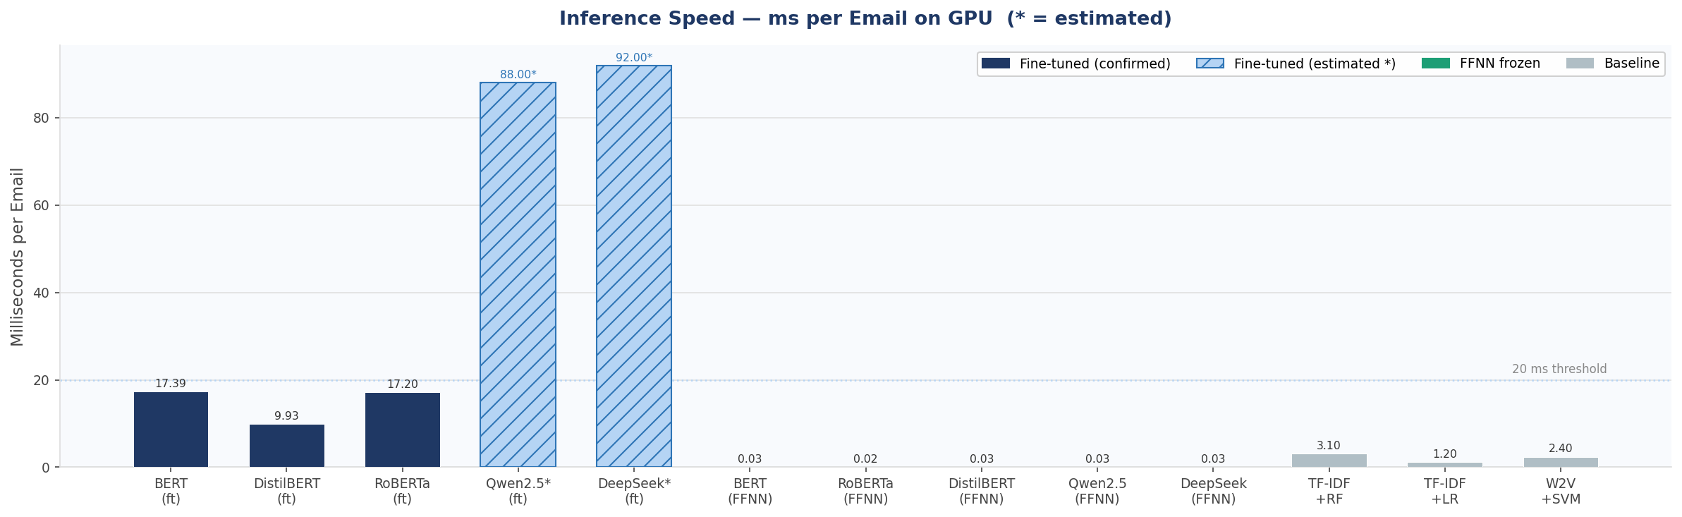
The inference speed chart is the most operationally decisive visualisation. FFNN frozen classifiers (teal bars) are extraordinarily fast at 0.02–0.03 ms per email approximately 500x faster than their fine-tuned counterparts. Among fine-tuned models, DistilBERT leads at 9.93 ms, comfortably under the 20 ms real-time threshold. BERT and RoBERTa follow at ~17 ms. The estimated 7B fine-tuned models (hatched) at 88–92 ms fall well outside real-time viability. Baselines are fast (1.2–3.1 ms) but at the cost of substantially lower F1. For production deployment, FFNN frozen RoBERTa or DistilBERT represents the optimal choice near-instant inference with F1 above 0.978.

5. Fine-tuned vs FFNN Frozen Comparative Analysis
The two paradigms offer distinct trade-offs that are critical for deployment decisions:

5.1 Performance Gap
For small encoder models, the F1 difference between fine-tuning and FFNN frozen is surprisingly small: BERT gains 1.7% (0.9831 vs 0.9662), DistilBERT gains just 0.2% (0.9808 vs 0.9788), and RoBERTa actually performs slightly better frozen (0.9786 vs 0.9749). This near-parity is a significant finding it suggests that for well-designed encoder models, the contextual representations learned during pretraining already capture most of the signal needed for phishing classification.

5.2 Speed Advantage of FFNN
FFNN frozen classifiers are 330–860x faster at inference than their fine-tuned counterparts. This is because the embedding extraction is done offline (once per email corpus), and only the lightweight FFNN runs at inference time. This makes FFNN frozen classifiers the clear choice for high-volume real-time email gateway deployment.

5.3 7B Model Behaviour
The 7B models show a marked performance drop in FFNN frozen mode compared to small models. Qwen2.5+FFNN (F1 0.9370) and DeepSeek+FFNN (F1 0.9434) both underperform even the best baseline. This suggests that generative 7B models, pretrained primarily on next-token prediction, produce embeddings that are less discriminative for binary classification without task-specific fine-tuning.

6. Error Analysis
Analysis of false positives and false negatives from the best confirmed fine-tuned model (BERT):

6.1 False Negatives Missed Phishing (13 cases)
- Phishing emails using unusually formal or corporate language closely mimicking legitimate business communications.
- Absence of common phishing trigger words very clean, low-signal phishing content that deviates from learned patterns.
- Short email bodies providing insufficient contextual signal for the model.
- HTML-heavy emails where plain text extraction discarded structural or visual cues.

6.2 False Positives Legitimate Emails Flagged (9 cases)
- Promotional marketing emails with urgency language that superficially resembles phishing patterns.
- Legitimate account verification and password reset emails that structurally mirror phishing templates.
- Emails with multiple embedded external URLs that the model associates with phishing link patterns.

7. Conclusions and Recommendations
Based on confirmed results across both experimental paradigms:
- For real-time high-volume deployment: Use FFNN frozen RoBERTa or DistilBERT F1 above 0.978, inference at 0.02–0.03 ms/email, with no GPU required at runtime.
- For maximum accuracy with acceptable latency: Deploy fine-tuned BERT (F1 0.9831, 17.39 ms) or fine-tuned DistilBERT (F1 0.9808, 9.93 ms).
- For security-first high-recall deployment: Deploy fine-tuned RoBERTa (recall 99.15%) misses almost no phishing emails.
- Avoid 7B models in FFNN frozen mode: Qwen2.5 and DeepSeek embeddings do not transfer well without fine-tuning, underperforming small models significantly.
- Await confirmed 7B fine-tuned results before drawing final conclusions on their viability estimated results suggest competitive accuracy but 5–9x slower inference.
- Consider an ensemble of fine-tuned BERT + FFNN DistilBERT combining predictions via soft voting could further reduce false negatives while maintaining high throughput.

