**Title**: Procedural Challenges: Machine Learning tasks for OCR of historical CJK newspapers

**Authors:** Matthias Arnold*, Duncan Paterson**, XIE Jia*  
*Heidelberg Centre of Transcultural Studies, University of Heidelberg; **Institute of Chinese Studies, University of Freiburg

**Abstract** *(343+11)*

The use of convolutional neural networks in digitizing historical documents has drastically expanded the quality and scope of available sources for digital analysis.[1] The ability to reuse or to refine pre-trained models means that DH practitioners are now tackling sources previously deemed impossible to process automatically. In light of these developments, we wish to present our own work on adapting tools developed for use with Western materials to the complex layouts of republican Chinese newspapers from the Early Chinese Periodicals Online (ECPO) project.[2] Our results demonstrate how digital monolinguism negatively affects models and algorithms through cultural biases towards Latinized scripts, and layouts. To overcome these shortcomings, we conducted experiments with crowd-sourcing, pattern recognition, and machine-learning. We aim to provide a development workflow from image scan to machine-readable full-text, and published our ground truths for reuse with other neural networks.[3]

It stands to reason, that similar developments happen in China, and that models trained on CJK sources would be better suited for our task. Yet, we continue to encounter procedural difficulties when following this approach. The first difficulty consists of our ability to locate and identify relevant research. Beginning with the lack of uniformity in search results, for example in China National Knowledge Infrastructure 中国知网 (CNKI)[4] when accessed from China, or from different providers in Europe, including CrossAsia.[5] We are then providing a systematic literature review concerning the use of machine learning methods to process historical CJK documents for either layout-analysis or OCR. Our review includes a discussion of the related problems of a) data-access to ground-truths, and training data, which are preconditions for b) reproducibility and ultimately c) reusability.

In conclusion, we contrast the impressions that our review generates of common research practices in this area in China with the demands placed on publicly funded research in the EU.[6] When it comes to adherence with data management plans,[7] and to the creation of sustainable and FAIR[8] research results the main challenges for collaboration with China are indeed procedural, and less the result of the specifics of the Chinese writing system.

**Figures**

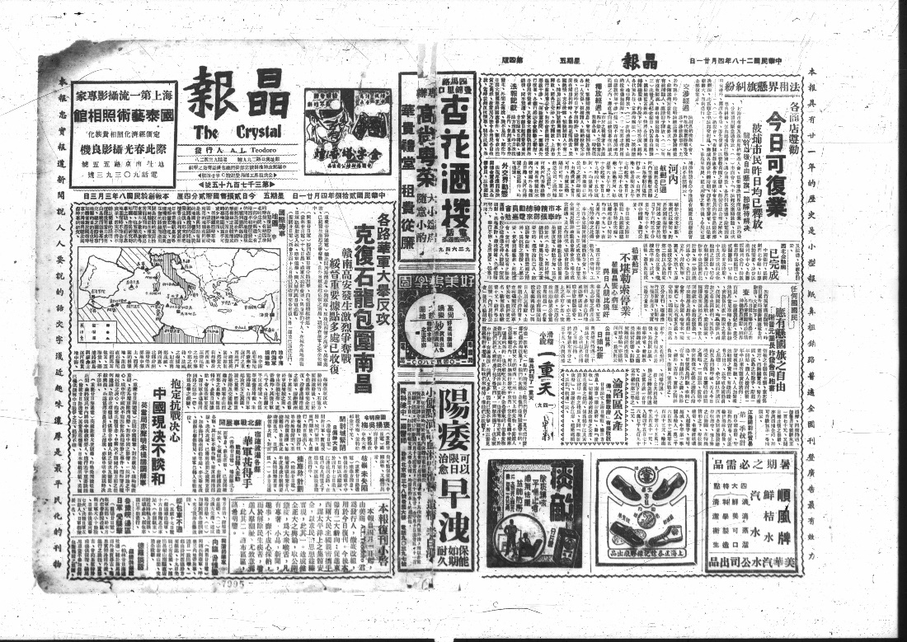

Fig. 1: A typical complex newspaper page layout. *Jing bao* 晶報 (The Crystal), April 21, 1939, pages 1+4. In ECPO: https://kjc-sv034.kjc.uni-heidelberg.de/ecpo/publications.php?magid=1&isid=20&ispage=1.

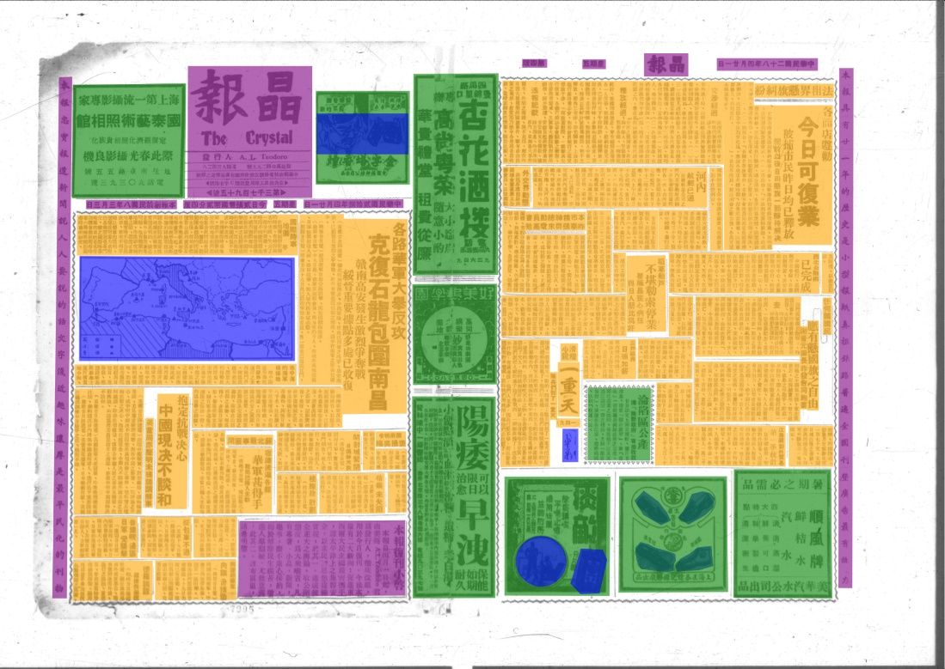

Fig. 2: The page fully manually annotated from our ground truth set (orange = article, blue = image, green = advertisement, purple = header and marginalia). *Jing bao* 晶報 (The Crystal), April 21, 1939, pages 1+4.

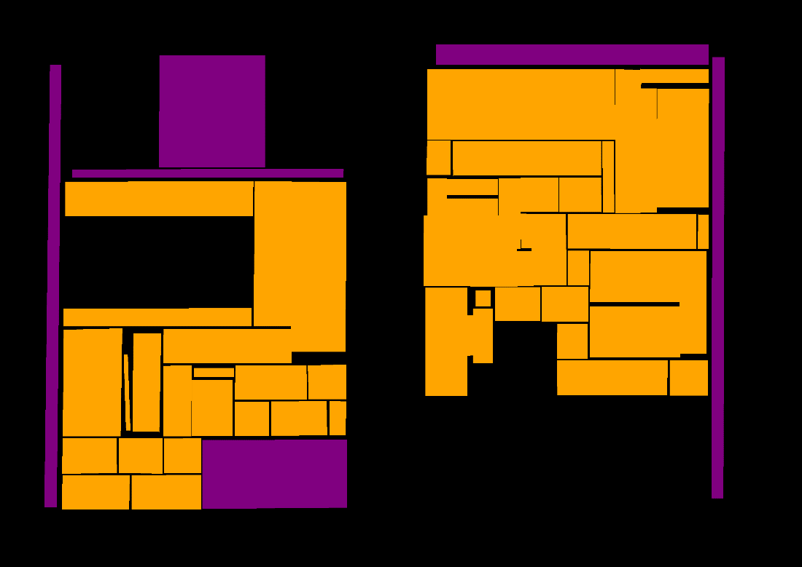

Fig. 3: Detection of content types using dhSegment: advertisements and images ignored, orange = text (i. e. “articles”), purple = header and marginalia. *Jing bao* 晶報 (The Crystal), April 21, 1939, pages 1+4.

**References** (selection of Chinese research articles):

张玮. “民国报纸数字化验收常见问题研究——以国家图书馆为例.” 图书情报研究, no. 3 (2019): 72–79.

方自金. “民国报纸影印出版的现状、问题与建议.” 出版参考 2019, no. 6 (2019). [www.sohu.com/a/330753909_488898](https://doi.org/www.sohu.com/a/330753909_488898).

郭薇, and 任思琪. “报纸数字对象模型设计与应用——以上海图书馆《全国报刊索引》平台为例.” 图书馆杂志 2018, no. 7 (2018): 41–52.

杨海林. “基于深度学习的古籍文字识别和检测.” 硕士. 华南理工大学. 2019.

郭利敏, 葛亮, and 刘悦如. “卷积神经网络在古籍汉字识别中的应用实践.” 图书馆论坛 39, no. 10 (2019): 142–48.

**Bibliography**

Ares Oliveira, Sofia, Benoit Seguin, and Frederic Kaplan. “DhSegment: A Generic Deep-Learning Approach for Document Segmentation.” In *2018 16th International Conference on Frontiers in Handwriting Recognition (ICFHR)*, 7–12. IEEE, 2018. https://doi.org/10.1109/ICFHR-2018.2018.00011.

Arnold, Matthias. “Multilingual Research Projects: Challenges for Making Use of Standards, Authority Files, and Character Recognition.” *Digital Studies / Le Champ Numérique* 11 (forthcoming).

Arnold, Matthias, and Lena Hessel. “Transforming Data Silos into Knowledge: Early Chinese Periodicals Online (ECPO).” In *Heuveline, Vincent, Gebhart, Fabian and Mohammadianbisheh, Nina (Hrsg.): E-Science-Tage 2019: Data to Knowledge*, 95–109. Heidelberg: heiBOOKS, 2020. https://doi.org/10.11588/heibooks.598.c8420.

European Research Council (ERC). “Guidelines on Implementation of Open Access to Scientific Publications and Research Data,” April 21, 2017. https://ec.europa.eu/research/participants/data/ref/h2020/other/hi/oa-pilot/h2020-hi-erc-oa-guide_en.pdf.

Liebl, Bernhard, and Manuel Burghardt. “An Evaluation of DNN Architectures for Page Segmentation of Historical Newspapers,” April 15, 2020. https://arxiv.org/abs/2004.07317v1.

Wilkinson, Mark D., Michel Dumontier, IJsbrand Jan Aalbersberg, Gabrielle Appleton, Myles Axton, Arie Baak, Niklas Blomberg, et al. “The FAIR Guiding Principles for Scientific Data Management and Stewardship.” *Scientific Data* 3, no. 1 (March 15, 2016): 160018. https://doi.org/10.1038/sdata.2016.18.

1. Bernhard Liebl and Manuel Burghardt, “An Evaluation of DNN Architectures for Page Segmentation of Historical Newspapers,” April 15, 2020, <https://arxiv.org>.   
   Sofia Ares Oliveira, Benoit Seguin, and Frederic Kaplan, “DhSegment: A Generic Deep-Learning Approach for Document Segmentation,” in *2018 16th International Conference on Frontiers in Handwriting Recognition (ICFHR)* (IEEE, 2018), 7–12.
2. Early Chinese Periodicals Online (ECPO), <https://uni-heidelberg.de/ecpo>.
3. Matthias Arnold and Lena Hessel, “Transforming Data Silos into Knowledge: Early Chinese Periodicals Online (ECPO),” in *Heuveline, Vincent , Gebhart, Fabian Und Mohammadianbisheh, Nina (Hrsg.): E-Science-Tage 2019: Data to Knowledge* (Heidelberg: heiBOOKS, 2020), 95–109, https://doi.org/10.11588/heibooks.598.c8420; Matthias Arnold, “Multilingual Research Projects: Challenges for Making Use of Standards, Authority Files, and Character Recognition,” *Digital Studies / Le Champ Numérique* 11 (2021).
4. Chinese version: <https://cnki.net/> ; overseas version: <https://oversea.cnki.net/index/>
5. CrossAsia <https://blog.crossasia.org/about/?lang=en> is one of the portals of the Specialized Information Service Asia (FID Asia), funded by the German Research Foundation (DFG), cf. <https://idw-online.de/en/news646187> (in German).
6. European Research Council (ERC), “Guidelines on Implementation of Open Access to Scientific Publications and Research Data,” April 21, 2017, https://ec.europa.eu/research/participants/data/ref/h2020/other/hi/oa-pilot/h2020-hi-erc-oa-guide_en.pdf.
7. Many institutions provide examples and guides, for a basic introduction see https://en.wikipedia.org/wiki/Data_management_plan. In Germany, two initiatives provide more information: https://forschungsdaten.org - co-funded by the German Research Foundation (DFG), and https://forschungsdaten.info - funded by the State of Baden-Württemberg
8. Mark D. Wilkinson et al., “The FAIR Guiding Principles for Scientific Data Management and Stewardship,” *Scientific Data* 3, no. 1 (March 15, 2016): 160018, https://doi.org/10.1038/sdata.2016.18.