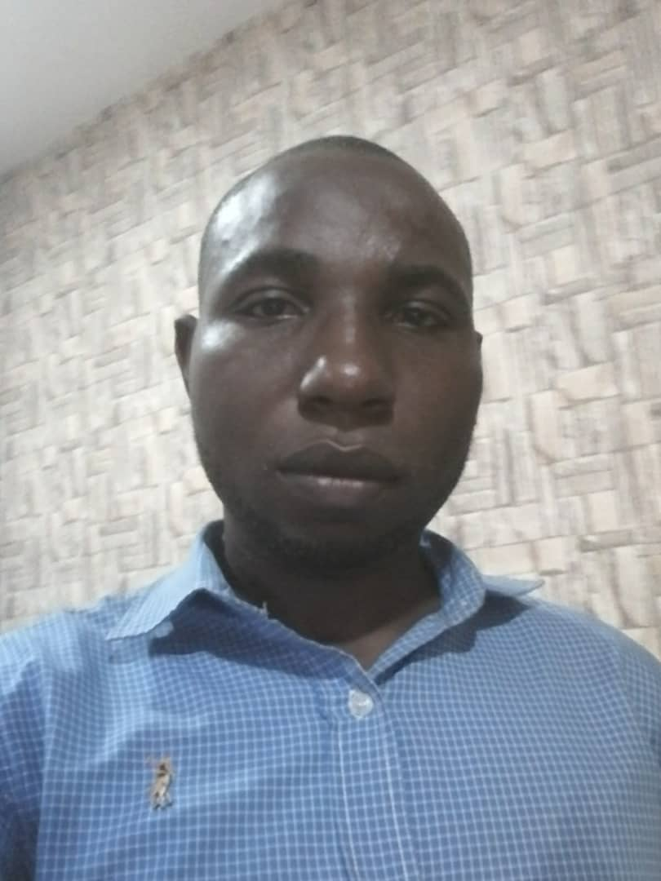

**PHP DEVELOPER**

SKILLS

* PHP
* Laravel
* CodeIgniter
* Java
* HTML5
* CSS3
* JavaScript
* JQuery
* AJAX
* SQL
* C#
* C++(Beginner)
* WordPress
* Node JS
* Git

**GODSON IHEMERE**

Enthusiastic PHP Developer with 8+ years’ experience participating in the complete product development lifecycle of successfully launched applications. Worked extensively with Laravel to create clean code base that solves business needs of clients.

**EXPERIENCE**

**Senior PHP Developer**

*XceedHub, Alapere, Lagos*

September 2019 – November 2020

* Worked extensively with PHP versions 5x – 7x. Currently experimenting and exploring PHP version 8 new features.
* Built highly scalable Web Applications with Laravel and CodeIgniter 4 Frameworks, JQuery and MYSQL database.
* Implemented AJAX technique in situations where it is not user-friendly to refresh a webpage.
* Developed RESTful Web Services to create API for client applications.
* Converted PSD sketches into Laravel blade template engine.
* Designed Webpage templates using HTML5, CSS3 and JavaScript
* Made use of AGILE software development methodology with daily SCRUM calls with my team members.
* Worked with cross-browser compatibility issues

**CONTACT**

[godson.ihemere@gmail.com](mailto:godson.ihemere@gmail.com)

+2347030595988

2 Ajibowu Lane, Ajah, Lagos.

* Managed user feedback and perform system checkups to improve user experience of all developed webpages.
* Supervised and trained 2 interns on PHP OOP best practices.

**Software Development Lead**

*Xown Solutions, Ikeja, Lagos.*

December 2018 – August 2019

* Lead a team of software engineers in the creation of high quality software within agreed project deadlines.
* Oversaw the technologies, tools and techniques used within the team.
* Ensured that development standards, policies and procedures are adhered to.
* Drove change to implement efficient and effective strategies as advised by management.
* Actively contributed to the process of continual improvement, with regard to self, team and systems.
* Trained and integrated new team members and proactively support the continued development of existing team members.
* Worked closely with other team leaders and development teams when necessary to create software that is cohesive.
* Ensured that projects are accurately estimated and delivered to schedule.
* Effectively managed team members in line with company policy and procedures, including performance, development, disciplinary and conflict resolution with effective feedback.
* Implementation SCRUM or other Agile methodologies for team members.

**PHP Developer**

Adivosoft Technologies**,** Lekki, Lagos

April 2013 – November 2018

* Meet up with clients to determine application requirements.
* Designing, coding and modifying websites/web application, from layout to function and testing using standard HTML/CSS best practices.
* . Solving client-side and server-side code problems.
* UI and UX optimization, cross-browser compatibility, user-friendly and clear navigation.
* Integrating of data from various back-end services and databases.
* Writing clean, fast PHP to a high standard, in a timely and scalable way.
* Troubleshoot, test and maintain the core product software and databases to ensure strong optimization and functionality

**EDUCATION**

**HND, Computer Science**

Lagos State Polytechnic

July 2007 – November 2014

* Completed my course load in computer science through six advanced classes.