FOOTWORK CHAMPS

OUR SERVICES

**The loss of a leg changes how you move through life. At Footwork, we can help restore your mobility by providing a selection of lower limb prosthetics and wheelchairs. Our mission is to maintain a level of excellence with everything we provide. Our goal is to ease your mobility and restore freedom of movement in your day-to-day life.**

**Hip and Ankle Disarticulation**

Lower limb amputations at the hip or ankle level are called disarticulations. Footwork offers customized prosthetic solutions for disarticulations.

**Below-Knee Limb Loss**

A below-knee (BK) leg prosthesis typically consists of a custom-made socket, a pylon and a foot. Sometimes a suspension sleeve or harness may also be necessary.

FOOTWORK, INC

* [HOME](https://126925824-746676644548589026.preview.editmysite.com/editor/main.php)

* [ABOUT](https://126925824-746676644548589026.preview.editmysite.com/editor/main.php)

* [CONTACT](https://126925824-746676644548589026.preview.editmysite.com/editor/main.php)

|  |  |
| --- | --- |
| * + **SPACER** | * + **SPACER** |

* **CONTACT US**

## ****O U R   S E R V I C E S****

## ****The loss of a leg changes how you move through life. At Footwork, we can help restore your mobility by providing a selection of lower limb prosthetics and wheelchairs. Our mission is to maintain a level of excellence with everything we provide. Our goal is to ease your mobility and restore freedom of movement in your day-to-day life.****

* **SPACER**

|  |  |  |
| --- | --- | --- |
| * + Picture   + **SPACER**   + **Hip and Ankle Disarticulation**   + Lower limb amputations at the hip or ankle level are called disarticulations. Footwork offers customized prosthetic solutions for disarticulations. | * + **SPACER**   + Picture   + **Below-Knee Limb Loss**   + A below-knee (BK) leg prosthesis typically consists of a custom-made socket, a pylon and a foot. Sometimes a suspension sleeve or harness may also be necessary. | * + Picture  Prosthetic feet  * + There are multiple types of prosthetic feet available, including hydraulic and microprocessor feet. |

* **SPACER**

## ****Sports Wheelchair****

* 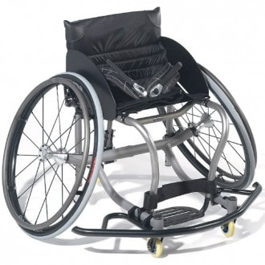

## Foldable Manual Wheelchair

* 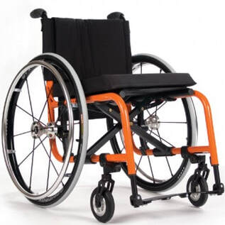
* **CONTACT US**

## ASK US ABOUT OUR SELECTION OF PROSTHETICS AND WHEELCHAIRS

* **SPACER**
* **SPACER**

## ****T E S T I M O N I A L S****

## Happy People

|  |  |  |
| --- | --- | --- |
| * + **SPACER** | * + My leg stays on for the entirety of my bike riding and I am able to adjust the fit of my socket throughout my workout. Their product enable me to perform significantly better than my previous experience.   + Picture | * + **SPACER** |

* **SPACER**
* Sherry Miller
* **SPACER**

FOOTWORK, INC

* [HOME](https://126925824-746676644548589026.preview.editmysite.com/editor/main.php)

* [ABOUT](https://126925824-746676644548589026.preview.editmysite.com/editor/main.php)

* [CONTACT](https://126925824-746676644548589026.preview.editmysite.com/editor/main.php)
* About us
* **SPACER**
* **SPACER**
* **We strive to improve the lives of people with mobility products that enable them to actively participate in everyday life. We provide manual, powered wheelchairs and prosthetics that serve unique medical and functional needs.**
* **SPACER**
* 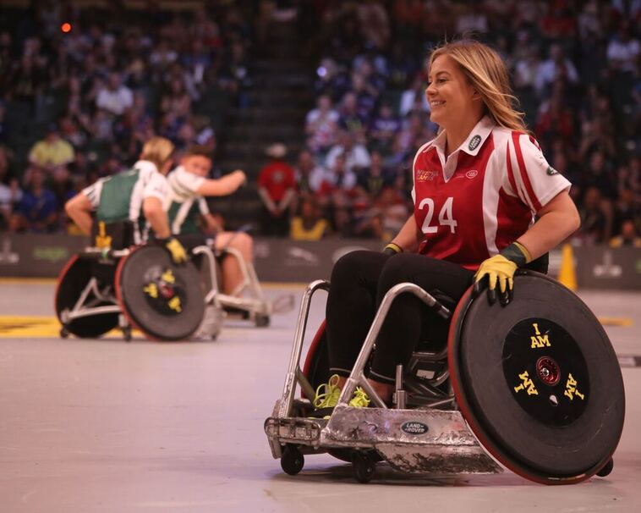
* **SPACER**
* **SPACER**

FOOTWORK, INC

* [HOME](https://126925824-746676644548589026.preview.editmysite.com/editor/main.php)

* [ABOUT](https://126925824-746676644548589026.preview.editmysite.com/editor/main.php)

* [CONTACT](https://126925824-746676644548589026.preview.editmysite.com/editor/main.php)
* Contact Us
* **SPACER**
* **Phone (954) 282-9402**
* **SPACER**
* 