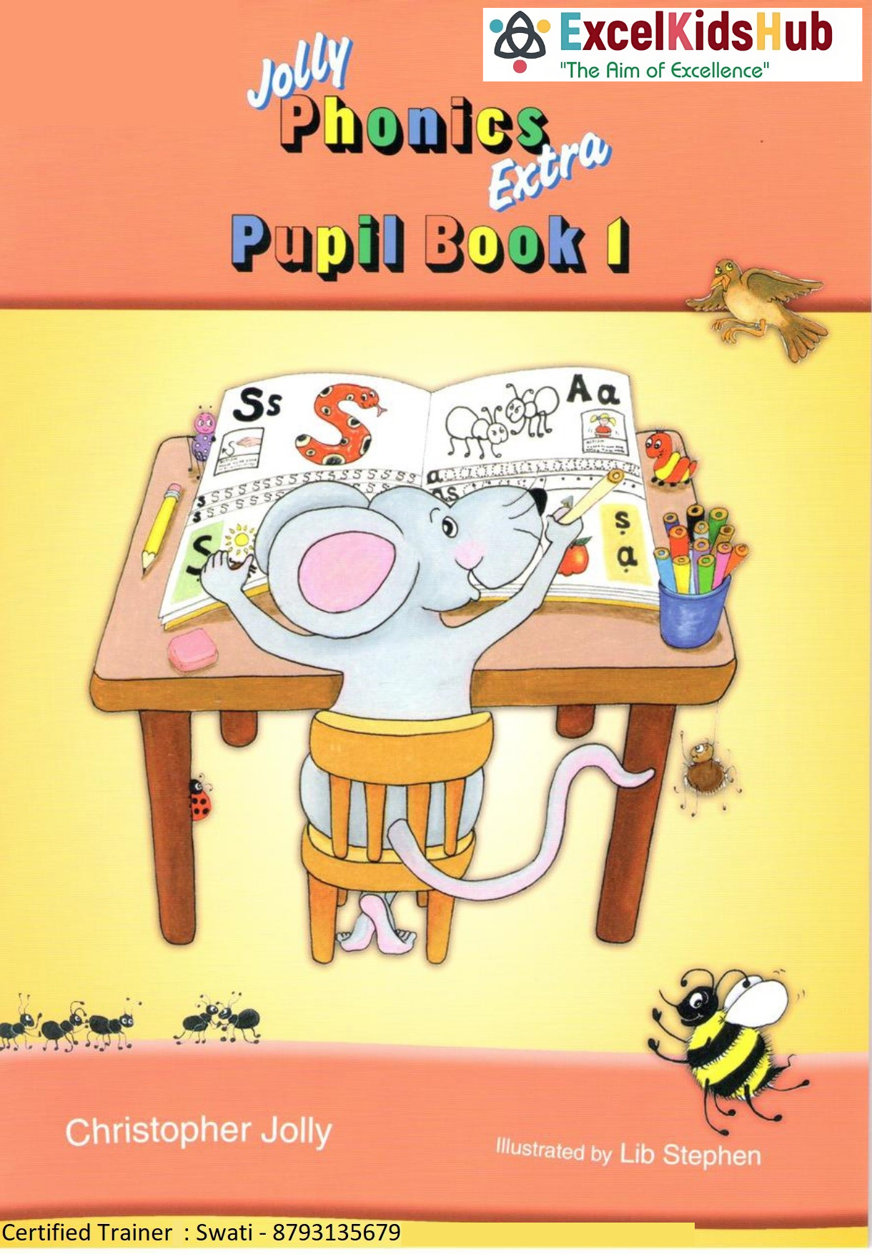
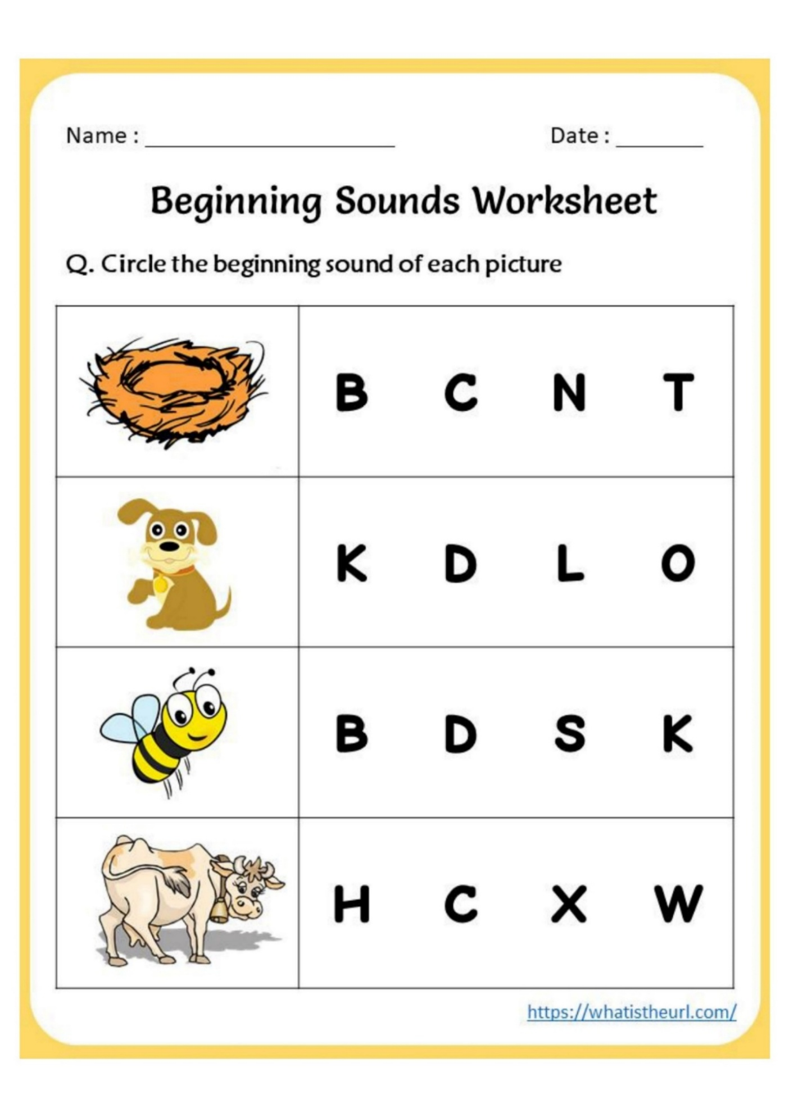
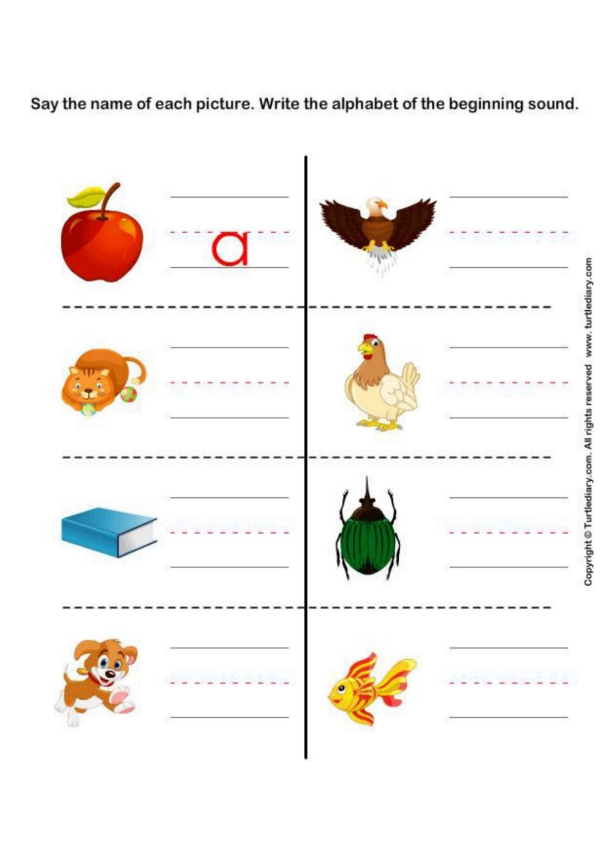
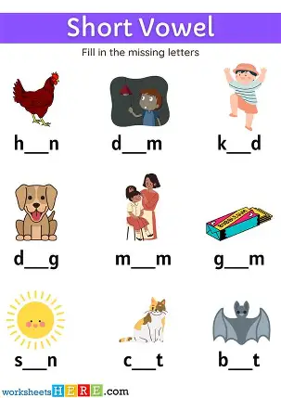
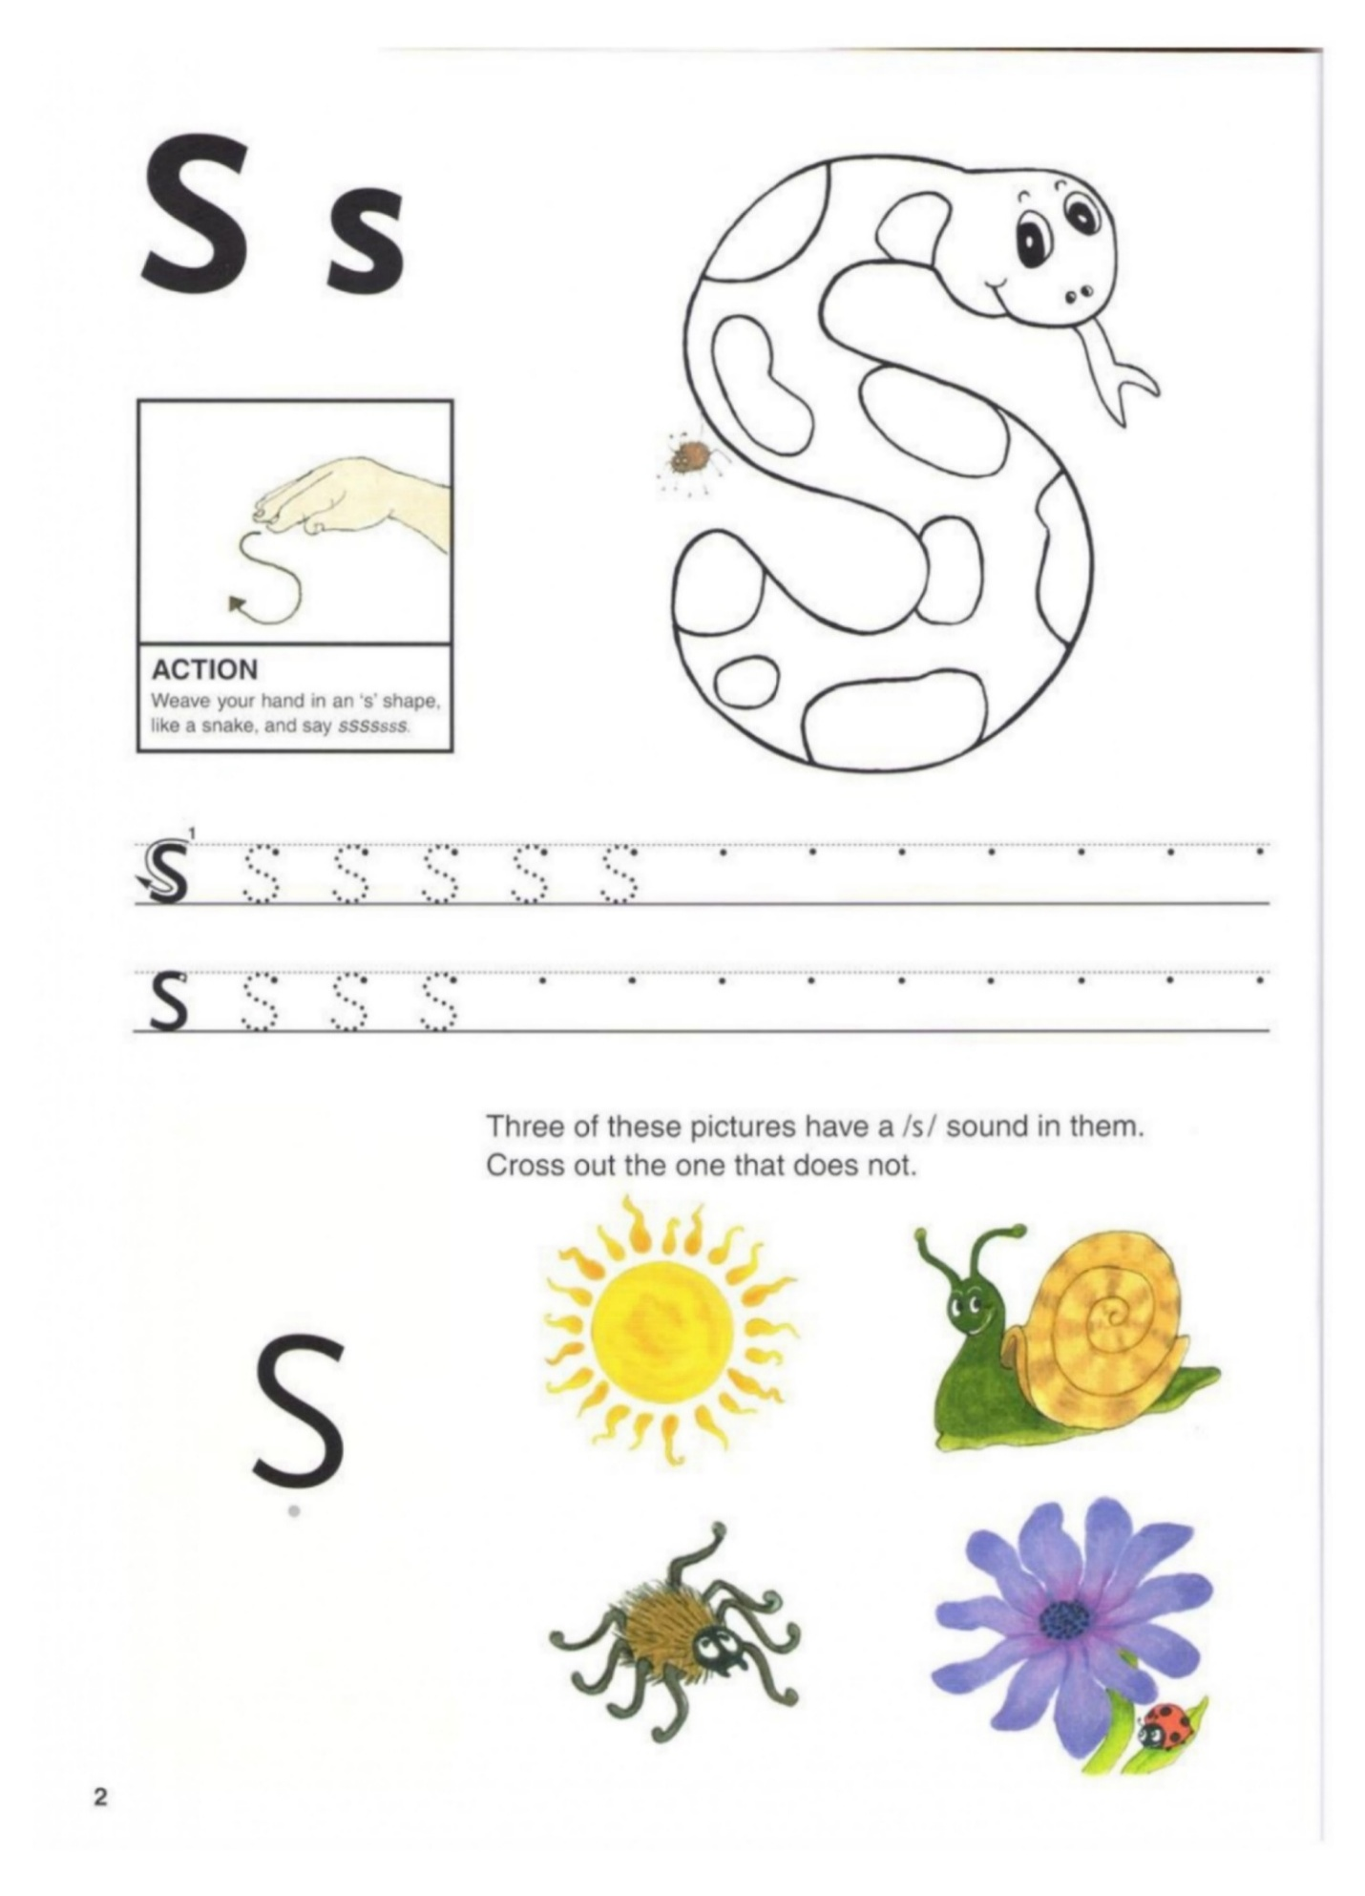
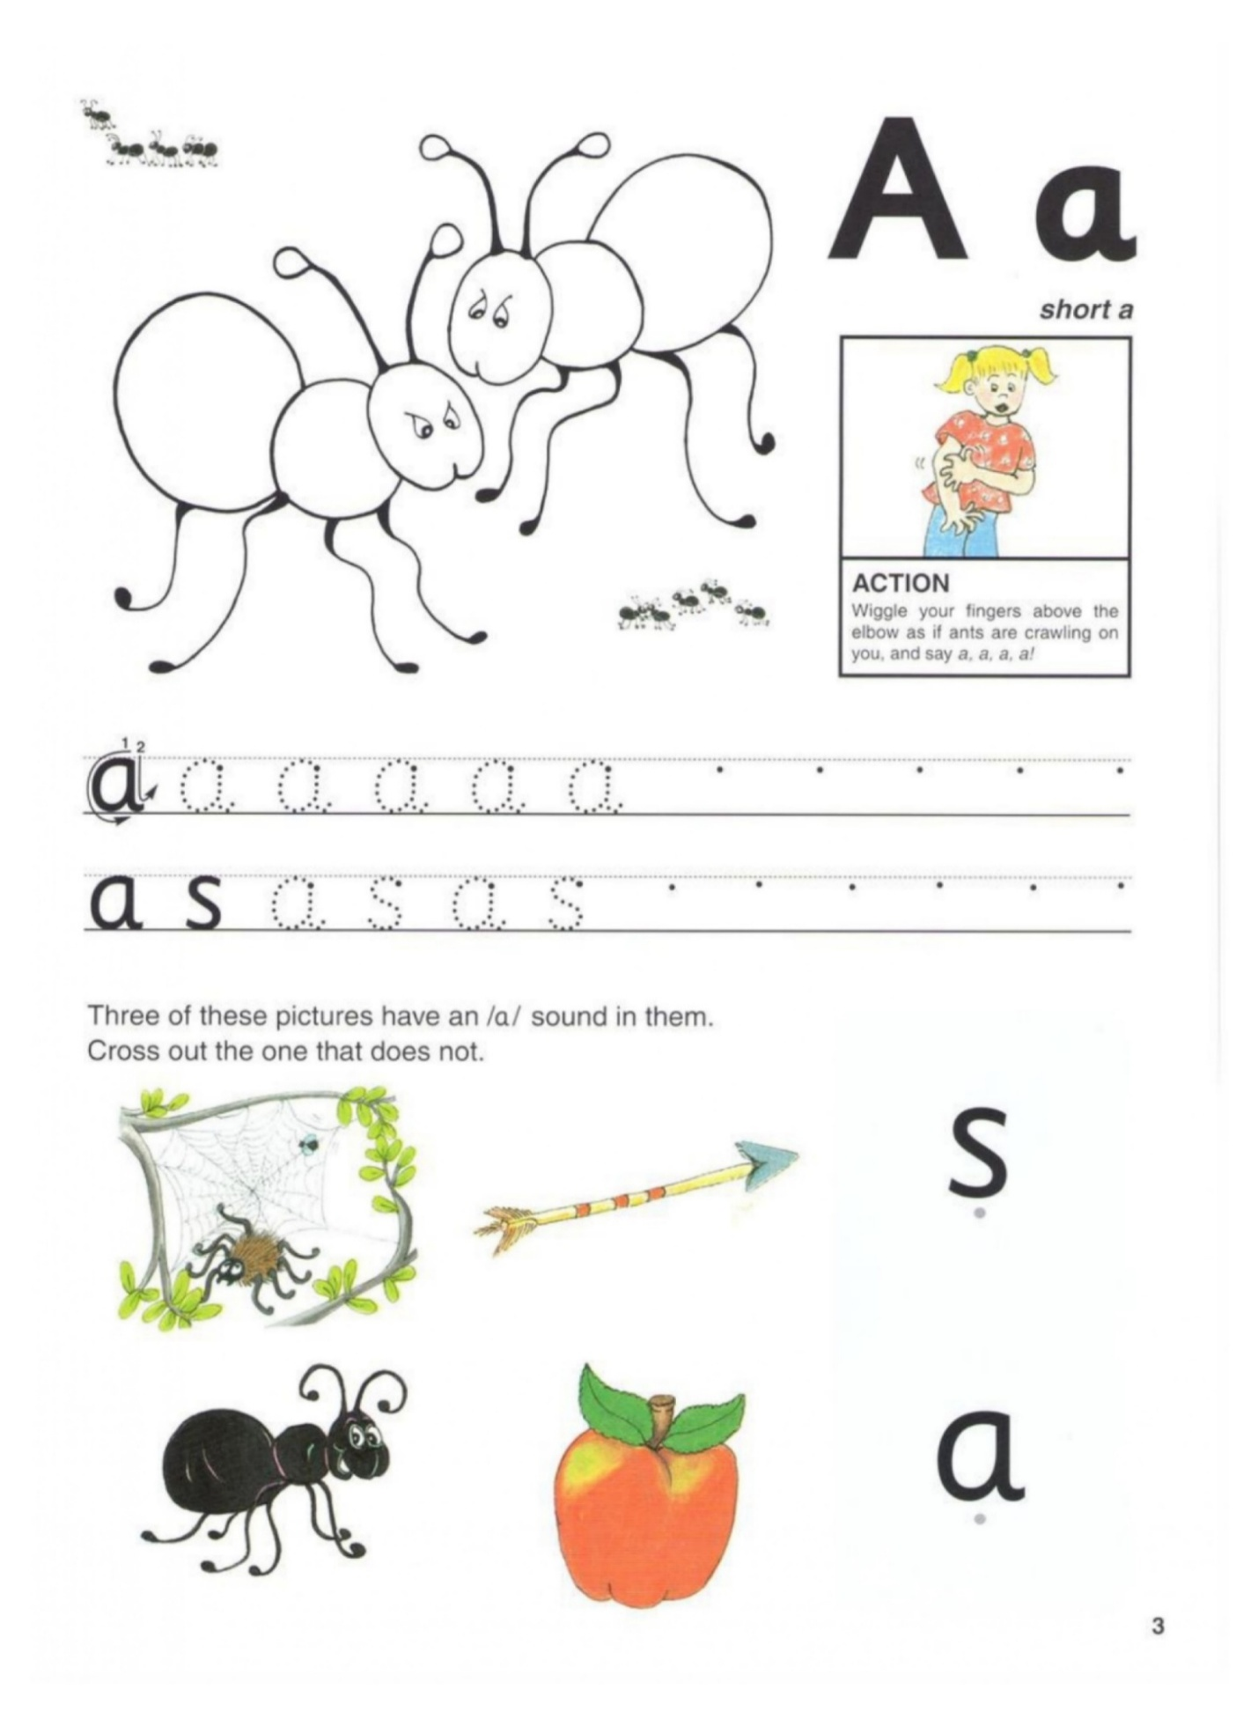
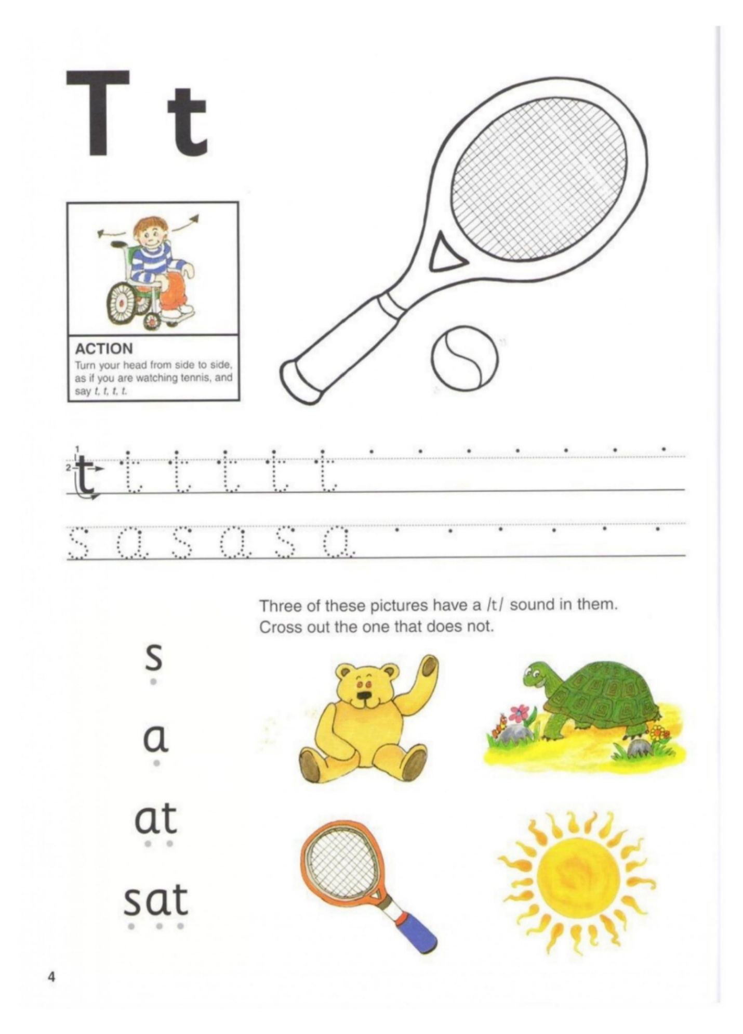
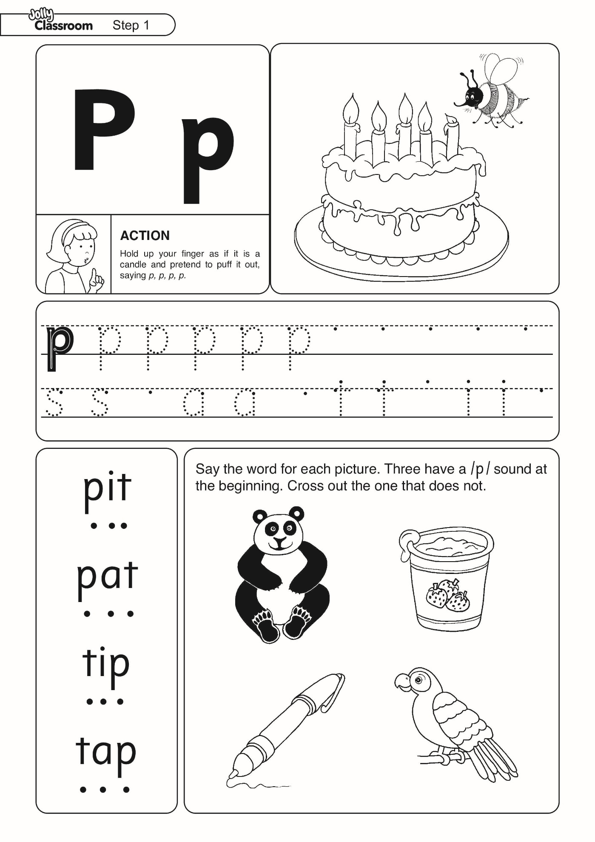
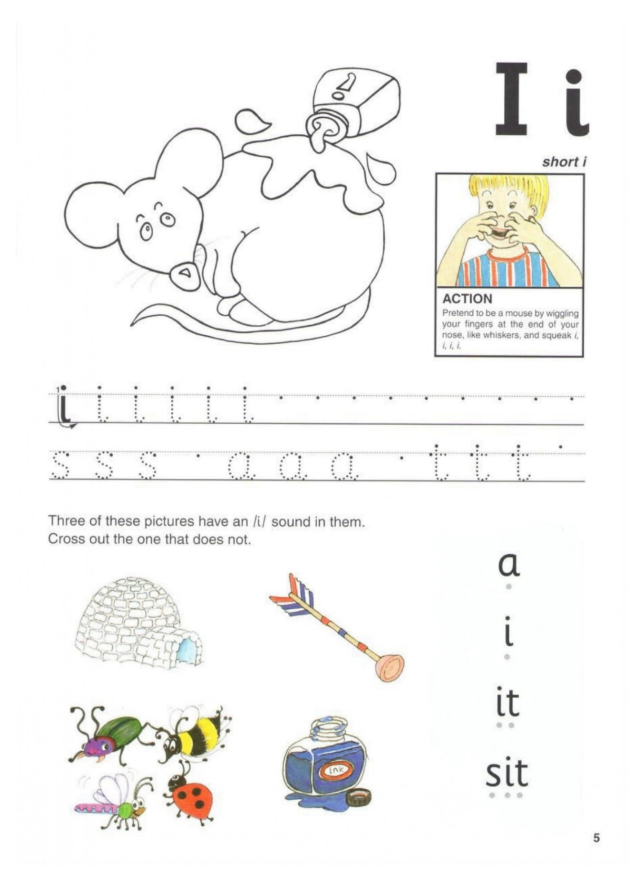
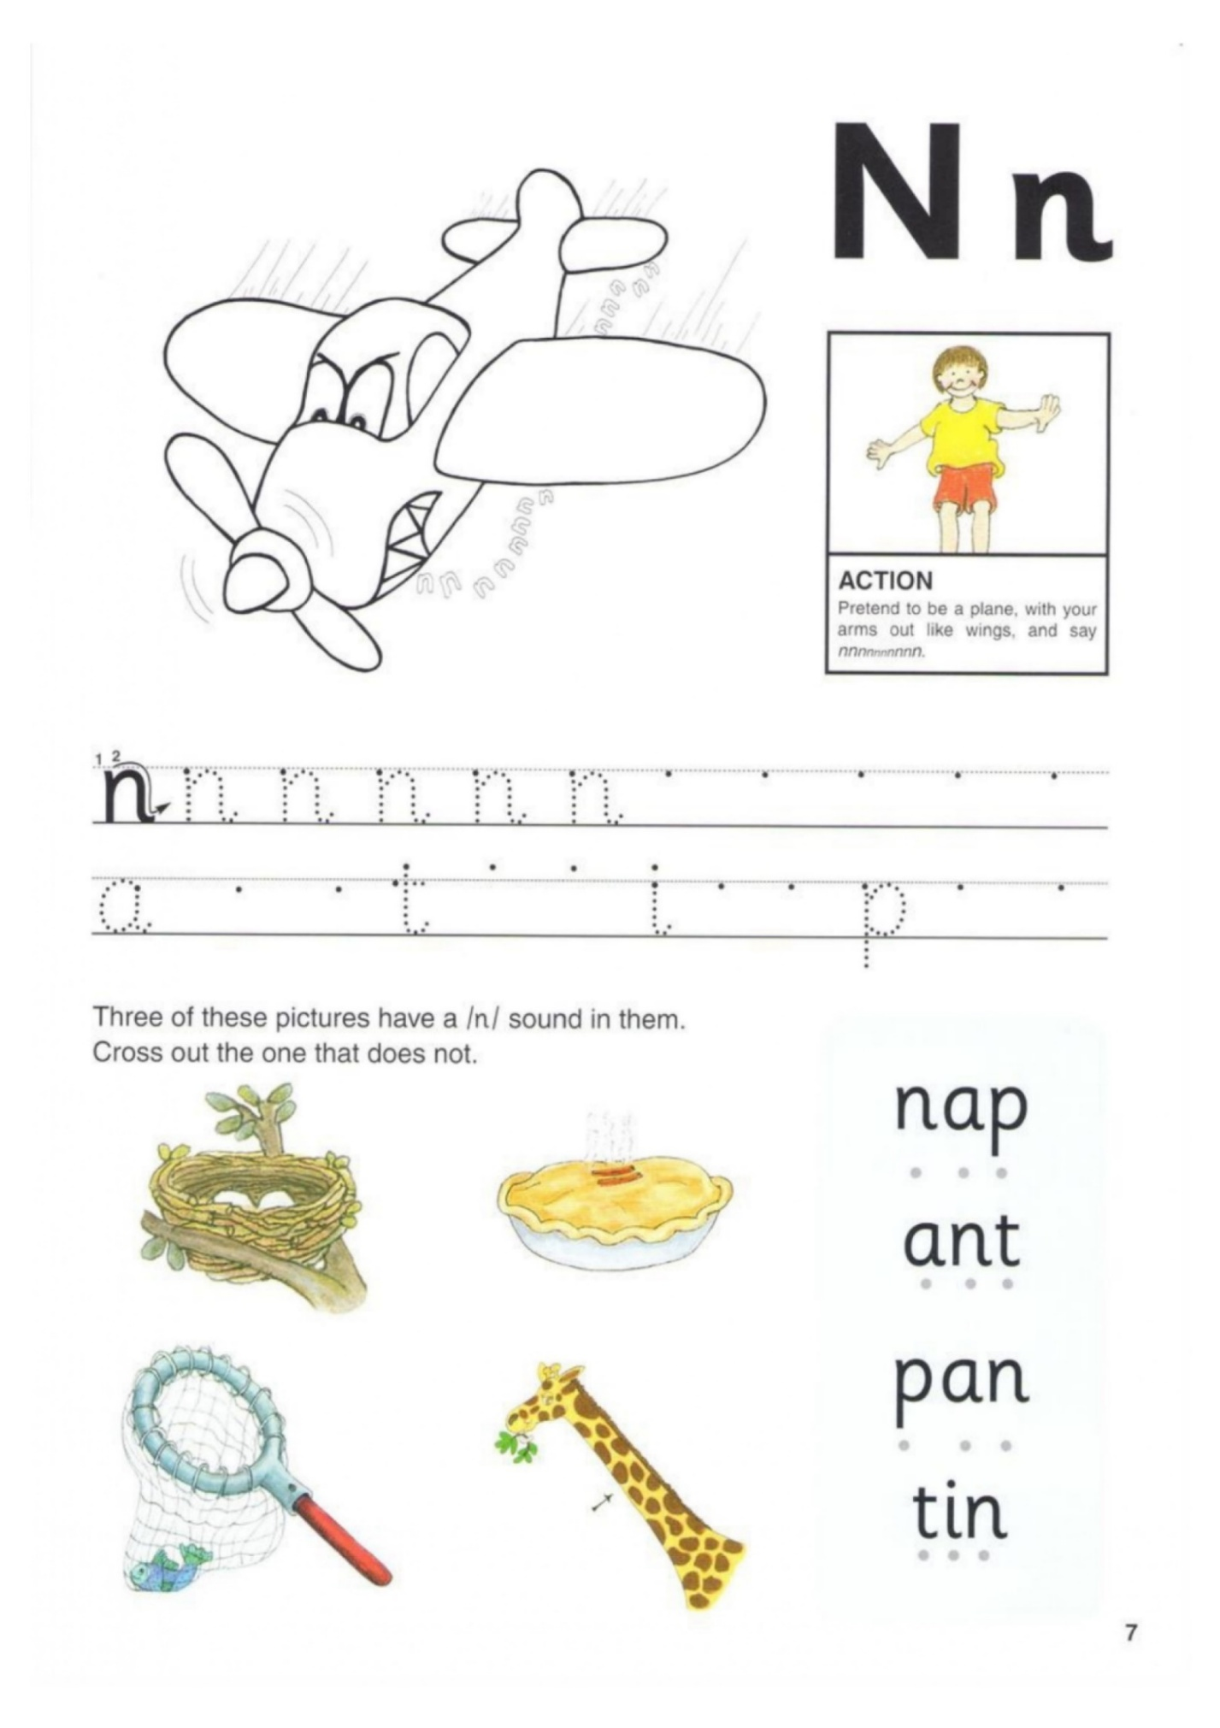
a | e | i | o | u

s a = sa | s a =sa | sa

t a = ta | t a = ta | ta
n a = na | n a = na | na

------ ------ ------
s a sa

t a ta

p a pa

n a na

s a sa p sap

t a ta p tap
s a p _______

t a p _______

n a p _______

i t it it

s i si t sit

p i pi t pit

n i ni t nit
a n i n a s

n a p | _ a p | n _ p | n a _
p i n | p _ n | _ i n | p _ _
s i p | s _ p | _ i p | _ i _
n a p p a n t i n

n i t t a n n i p
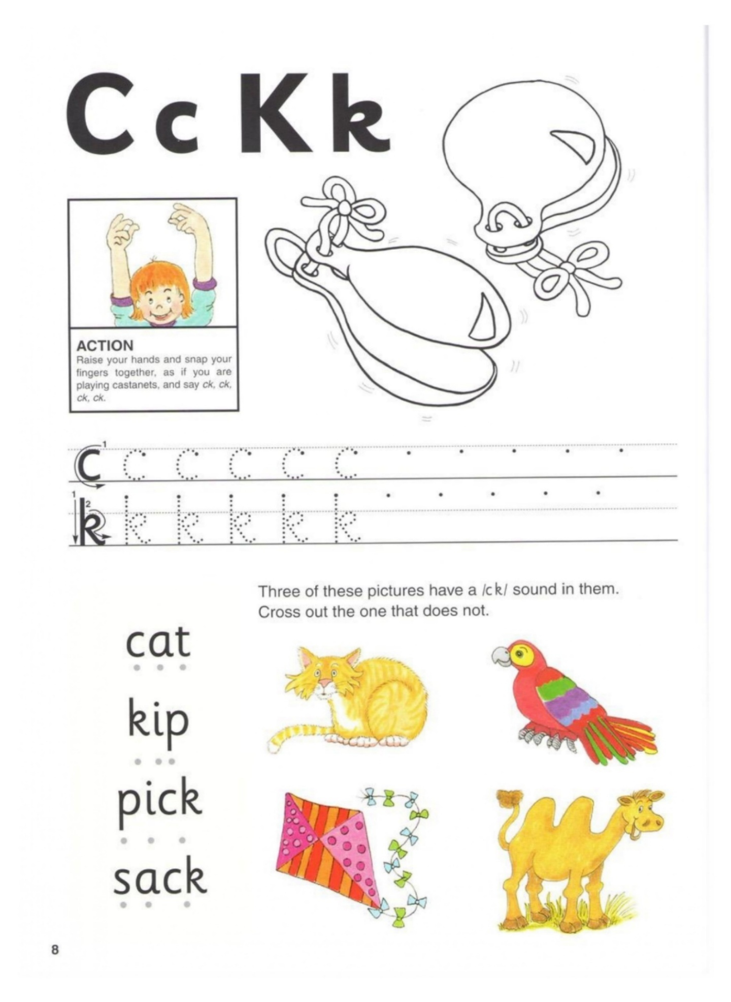
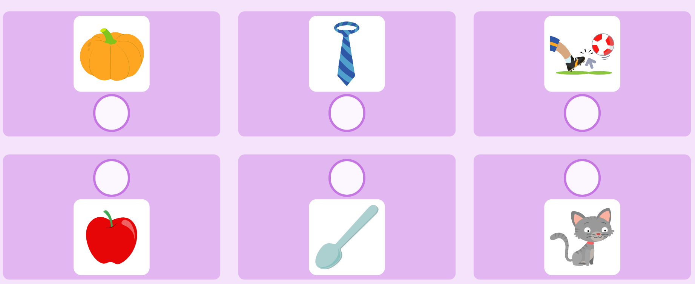
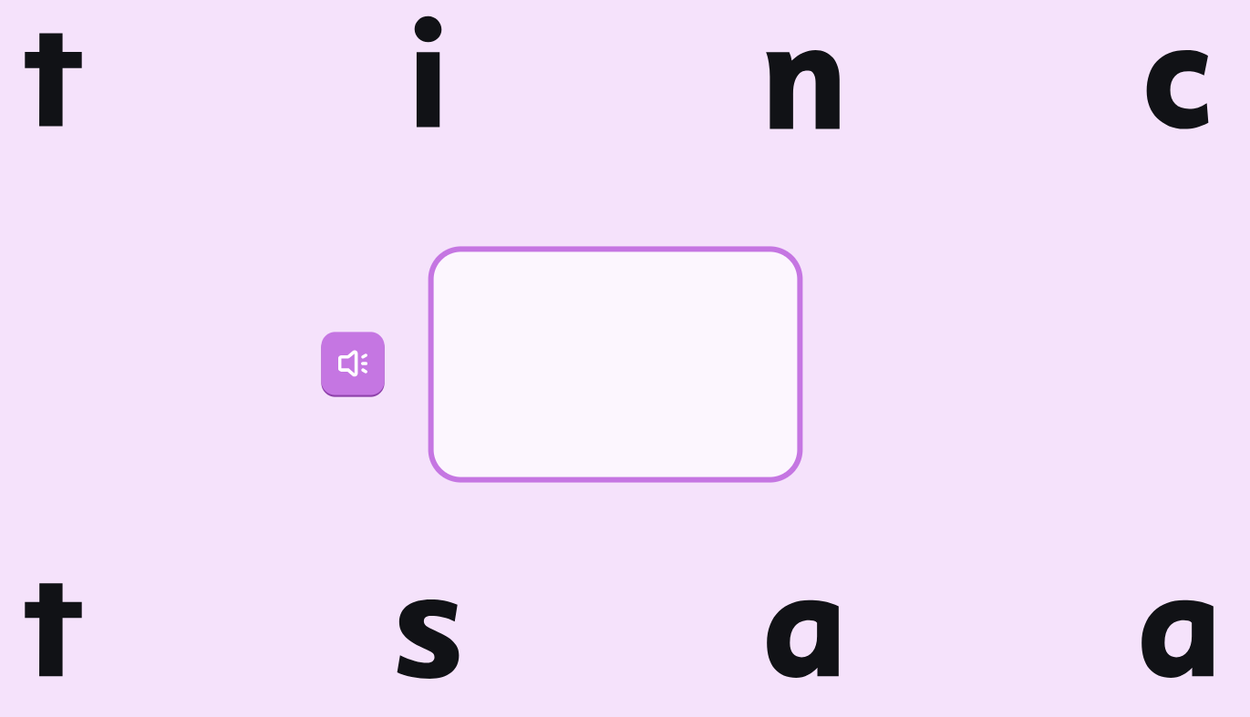

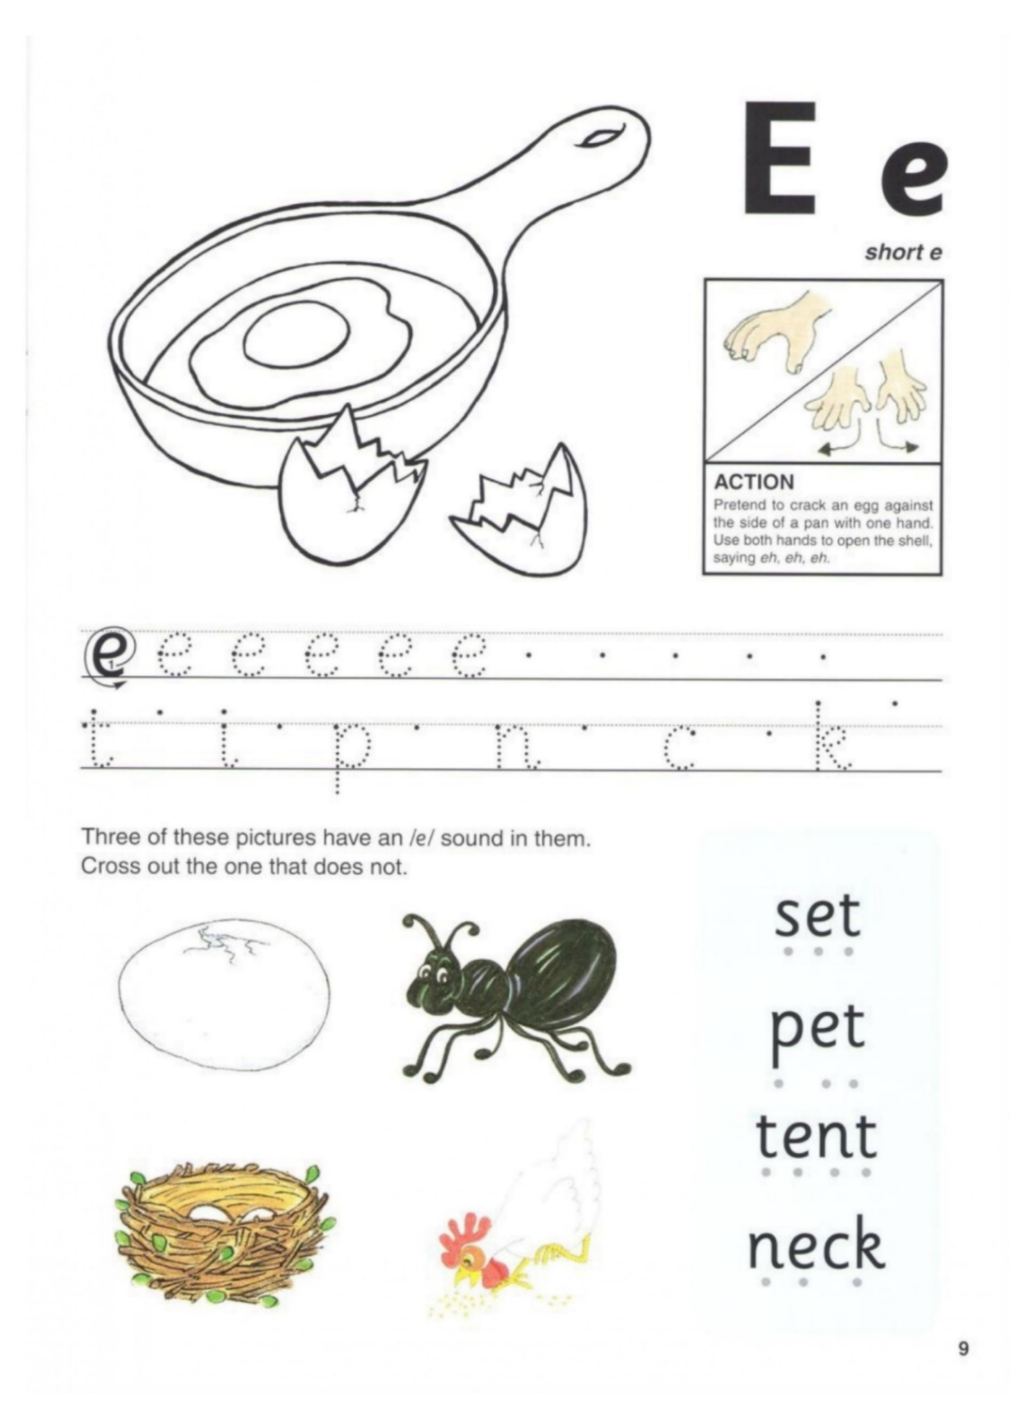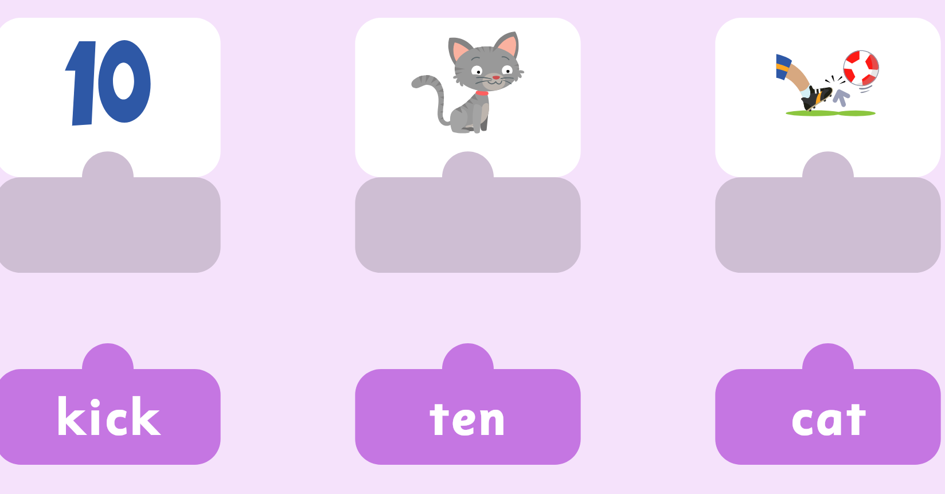
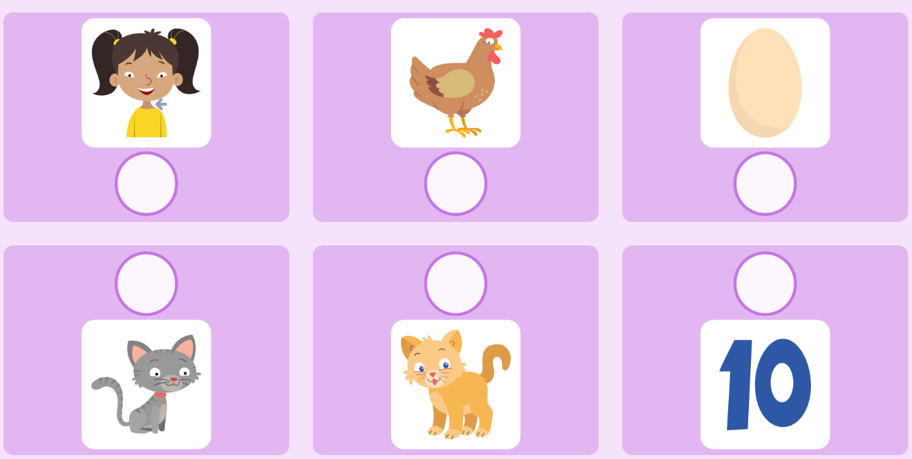

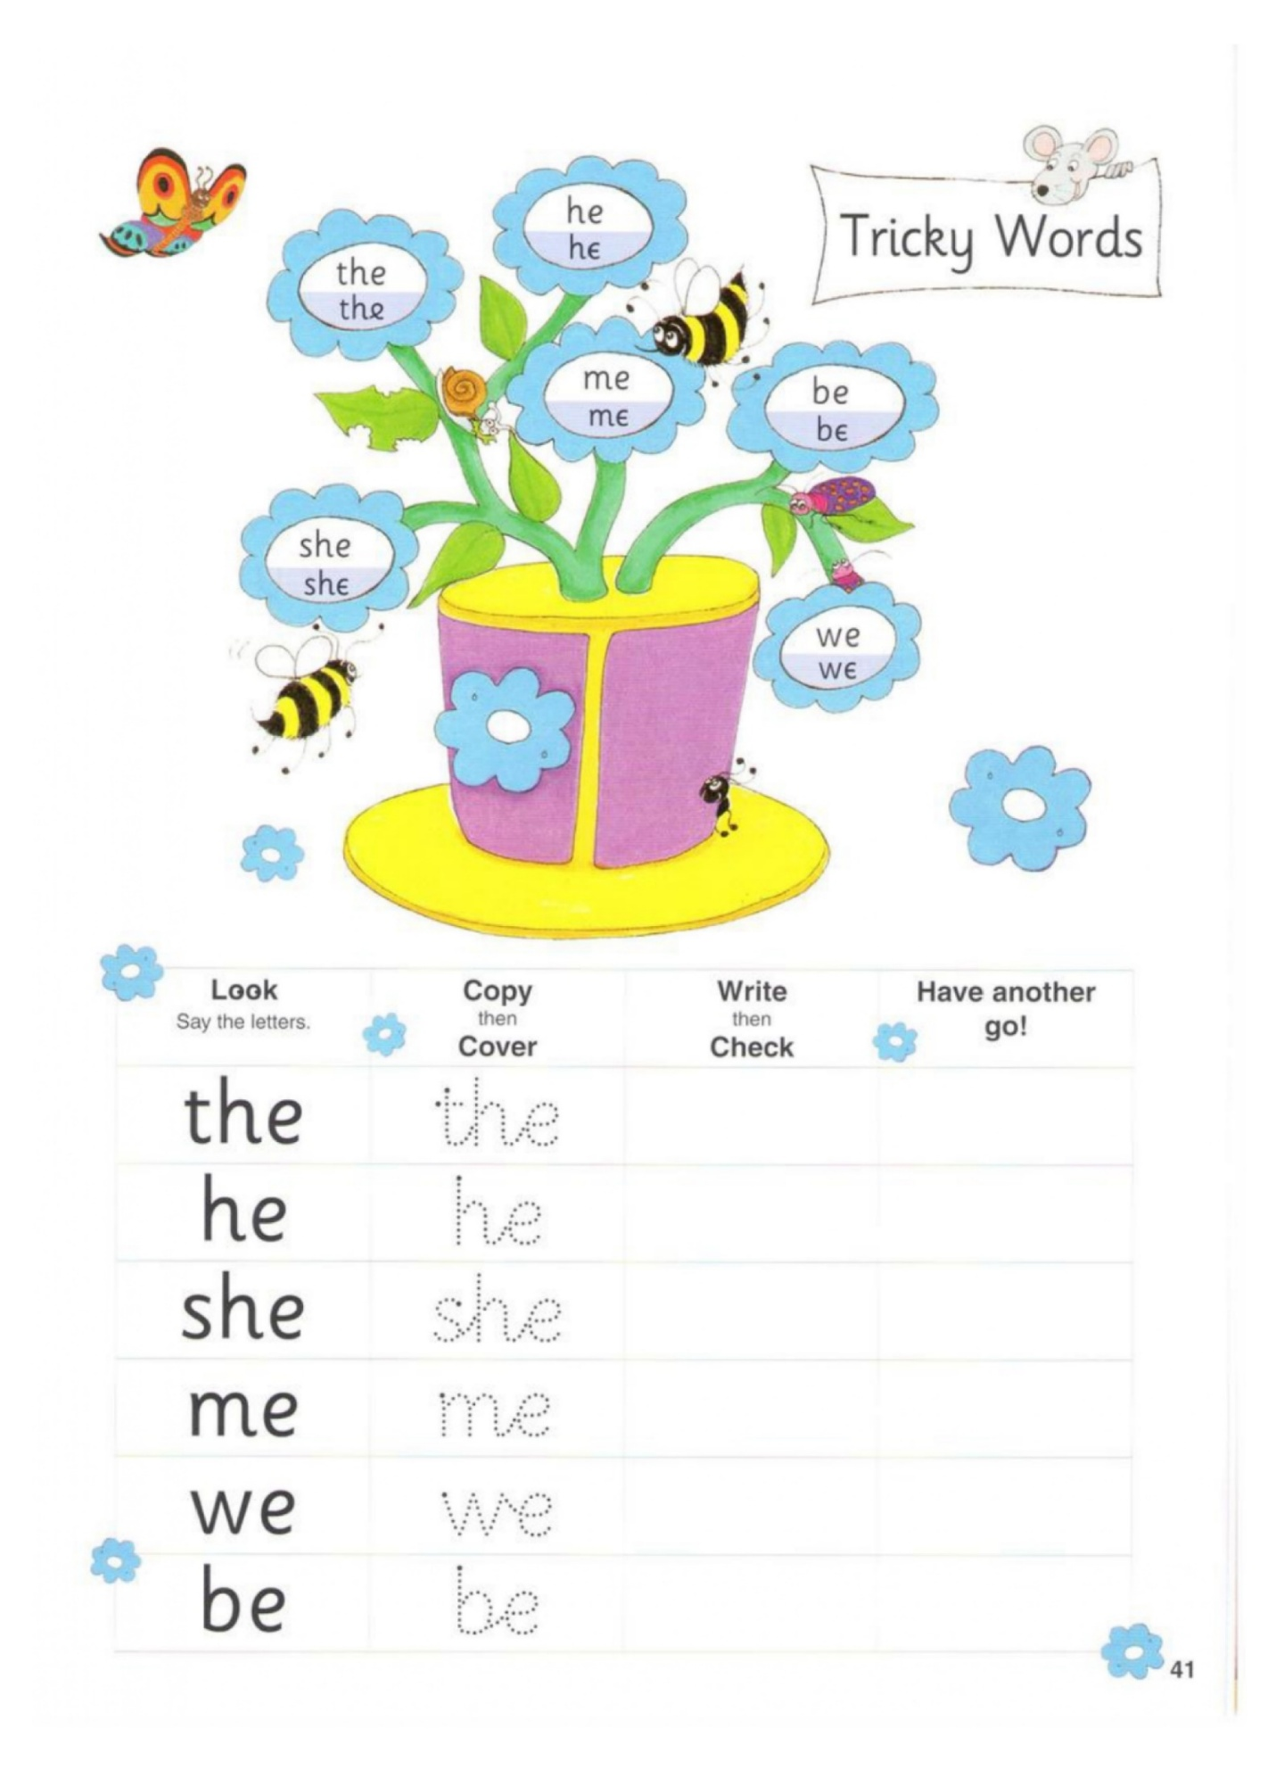
- The cat sat on a mat.
- The cat set a pit.
- The cat had a nap.
- I sat on a mat.
- I like the cat.
Dictation:
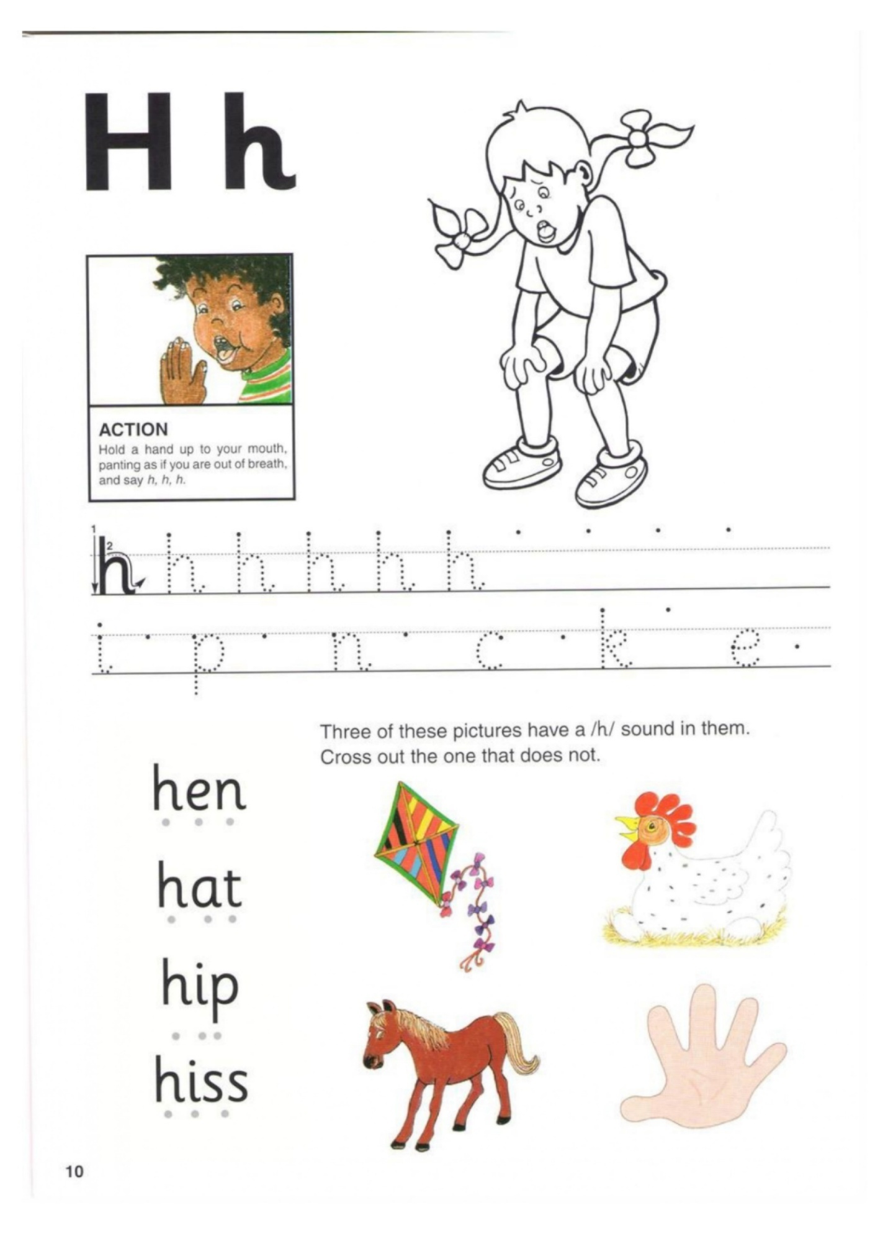
h e n _______
h a t _______
h i p _______
h i ss _______
h i n t _______

pack | tent | sick | neck
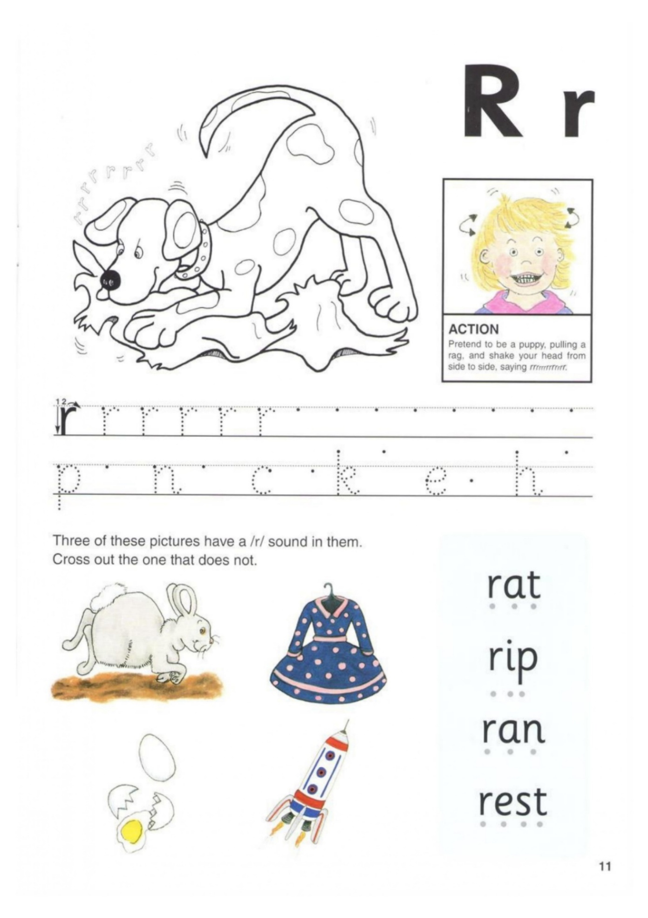
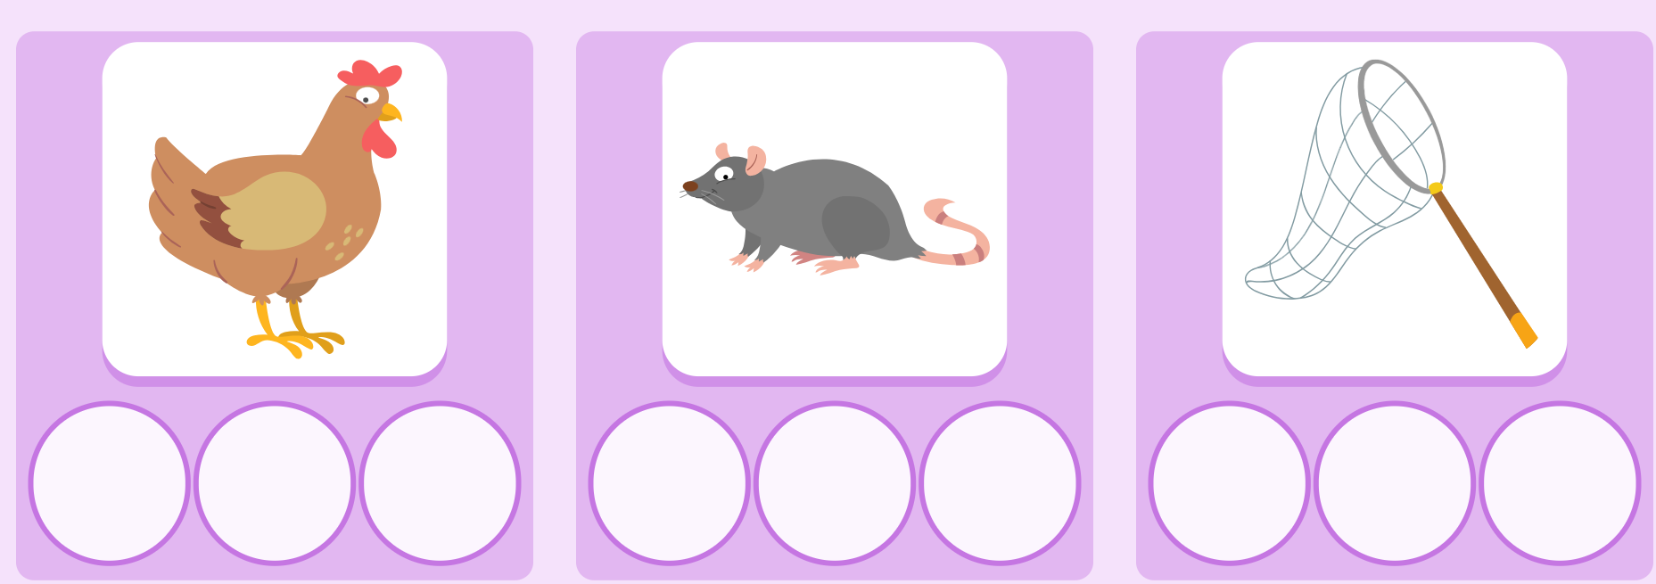
e n h t r a n t e
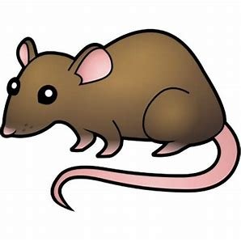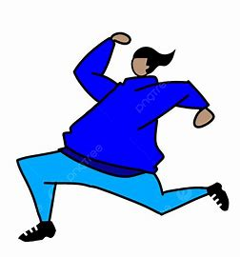

Tr__ck r__t r__n

- A rat ran on a track.
- A rat ran fast.
- A rat is my pet.
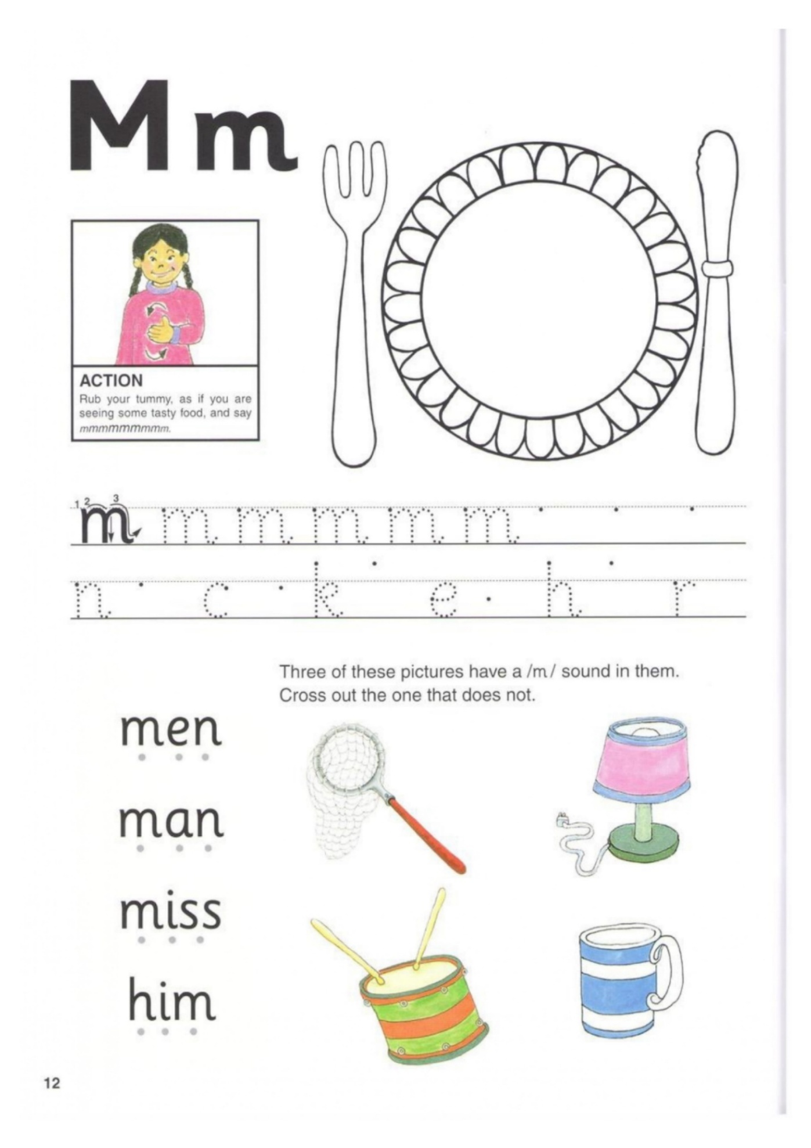
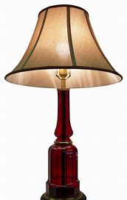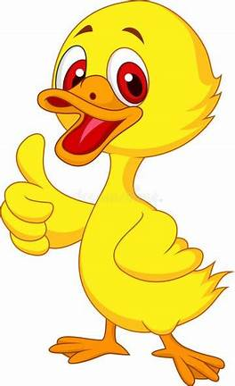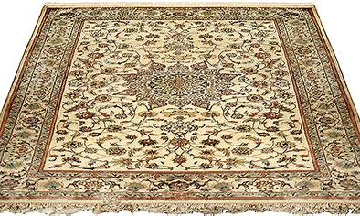

Lam__ __uck m__t

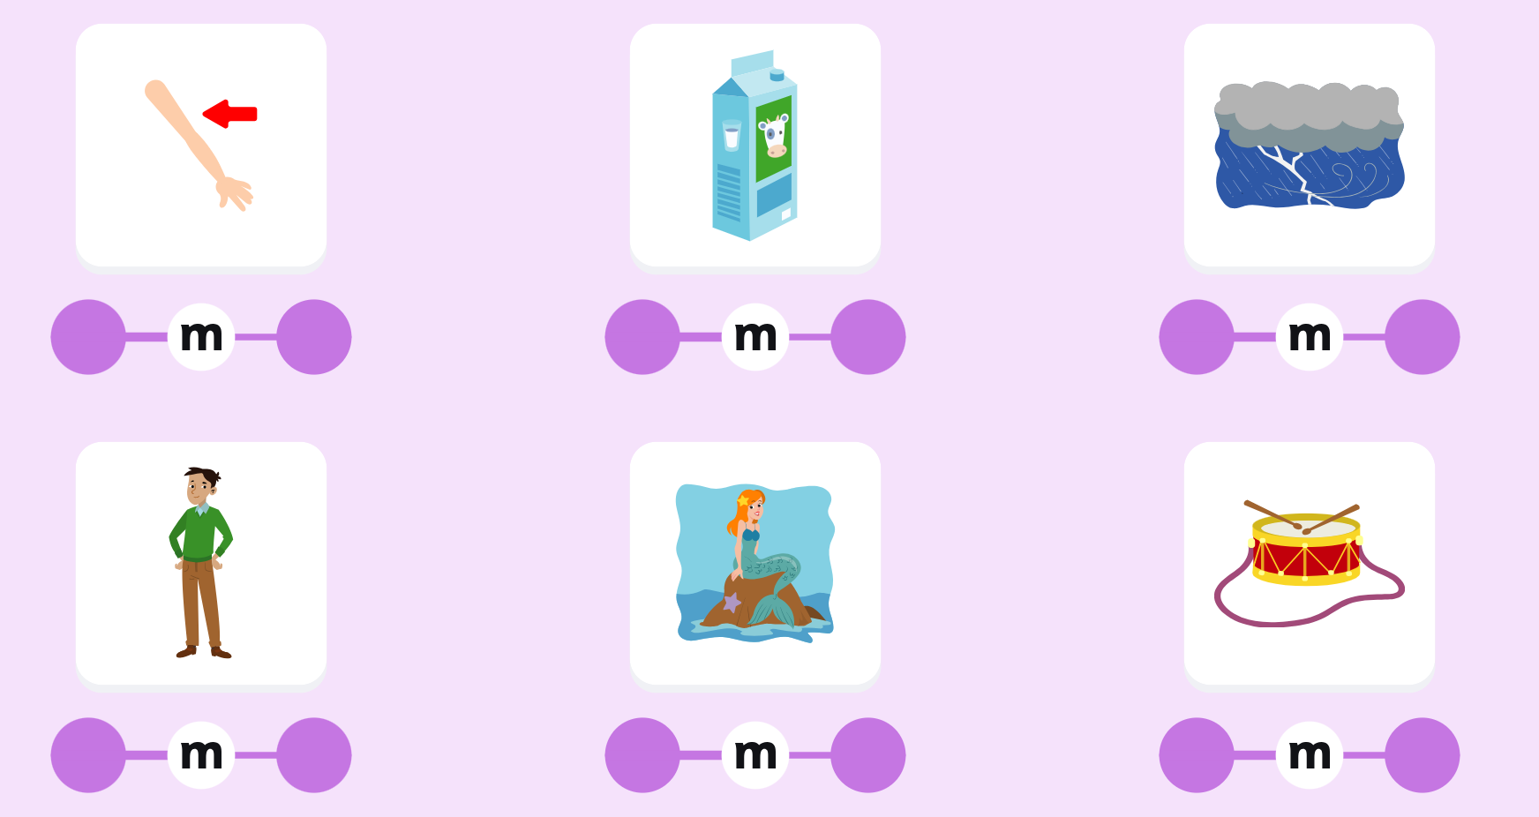
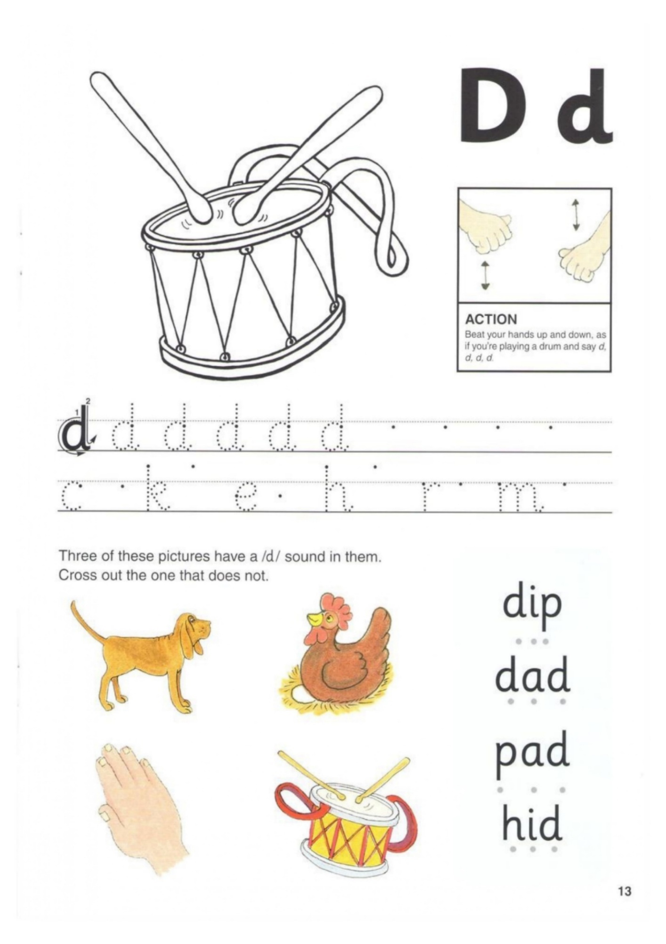
a d d _______
d i p _______
d e n _______
d a m _______
m i d _______
h a n d _______

s a n d _______

b+I | bl
c+I | cl
s+I | sl
g+I | gl
f+I | fl
p+I | pl
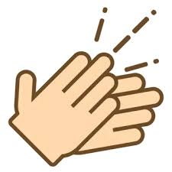___ap
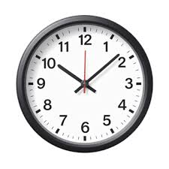 ___ock
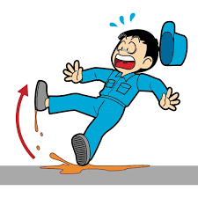 __ip
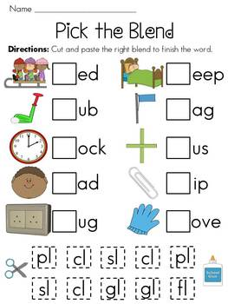
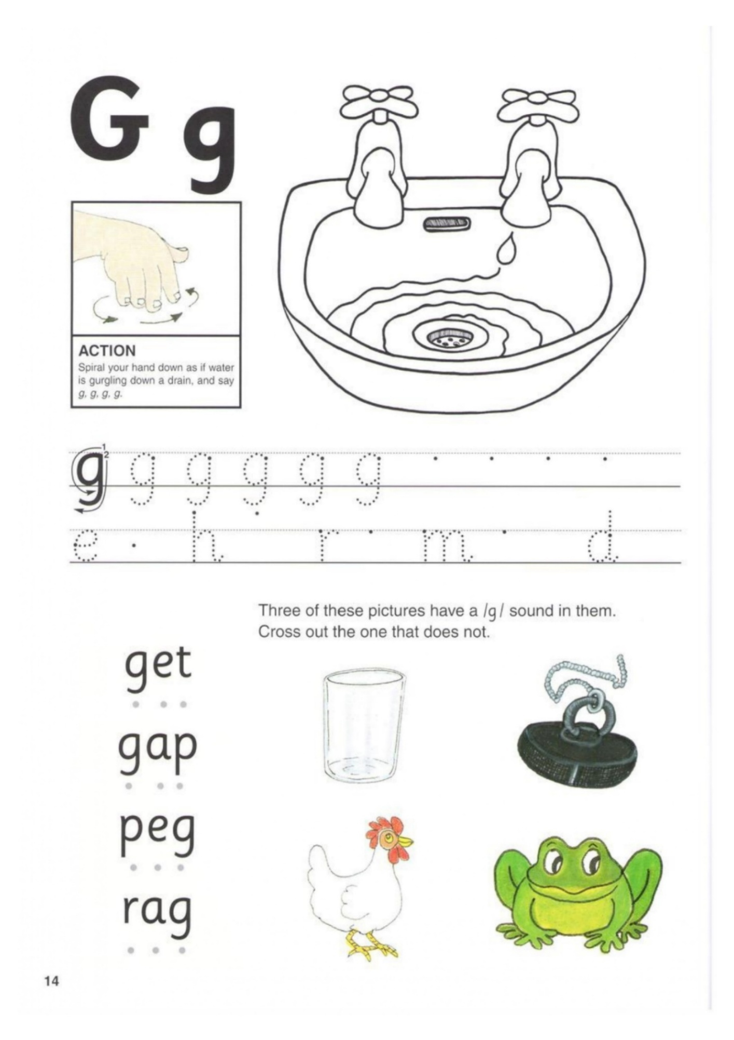
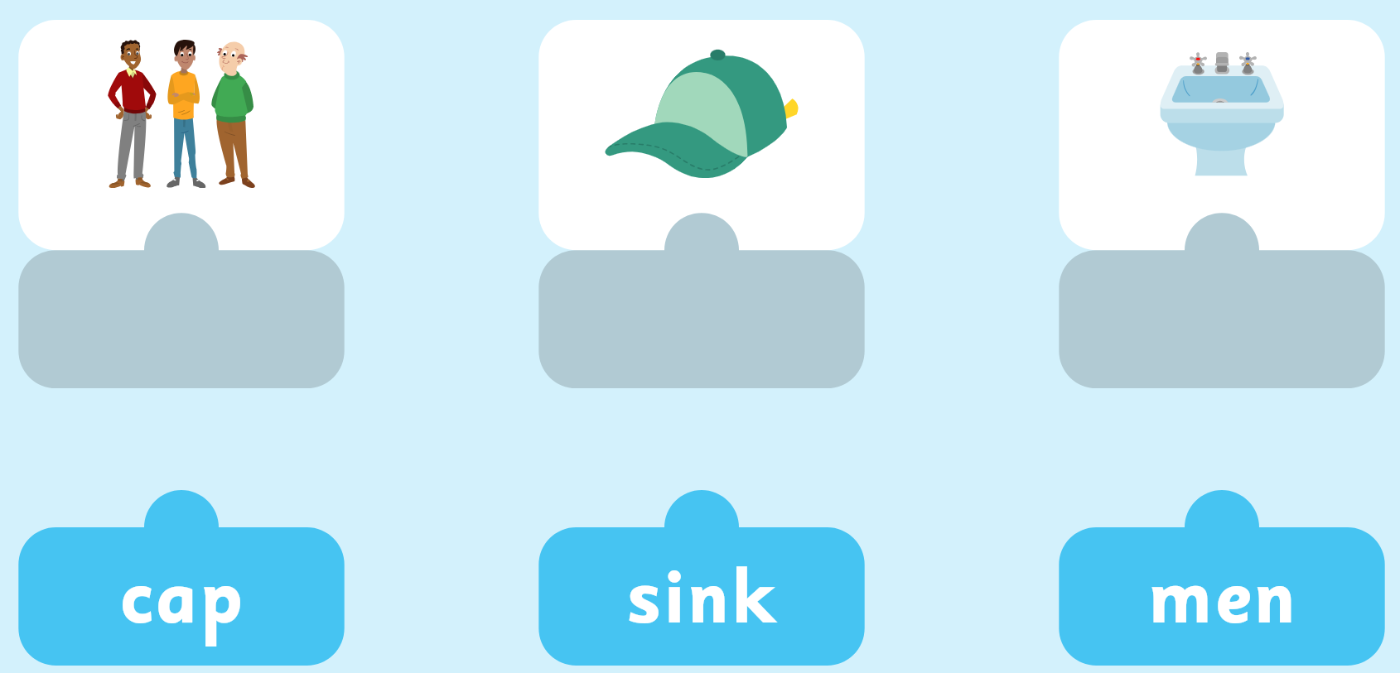
egg | dig | gap | gas | Get
peg | rag | sag | tag | pig
tag | sag | pig | grip | snag
Dictation:
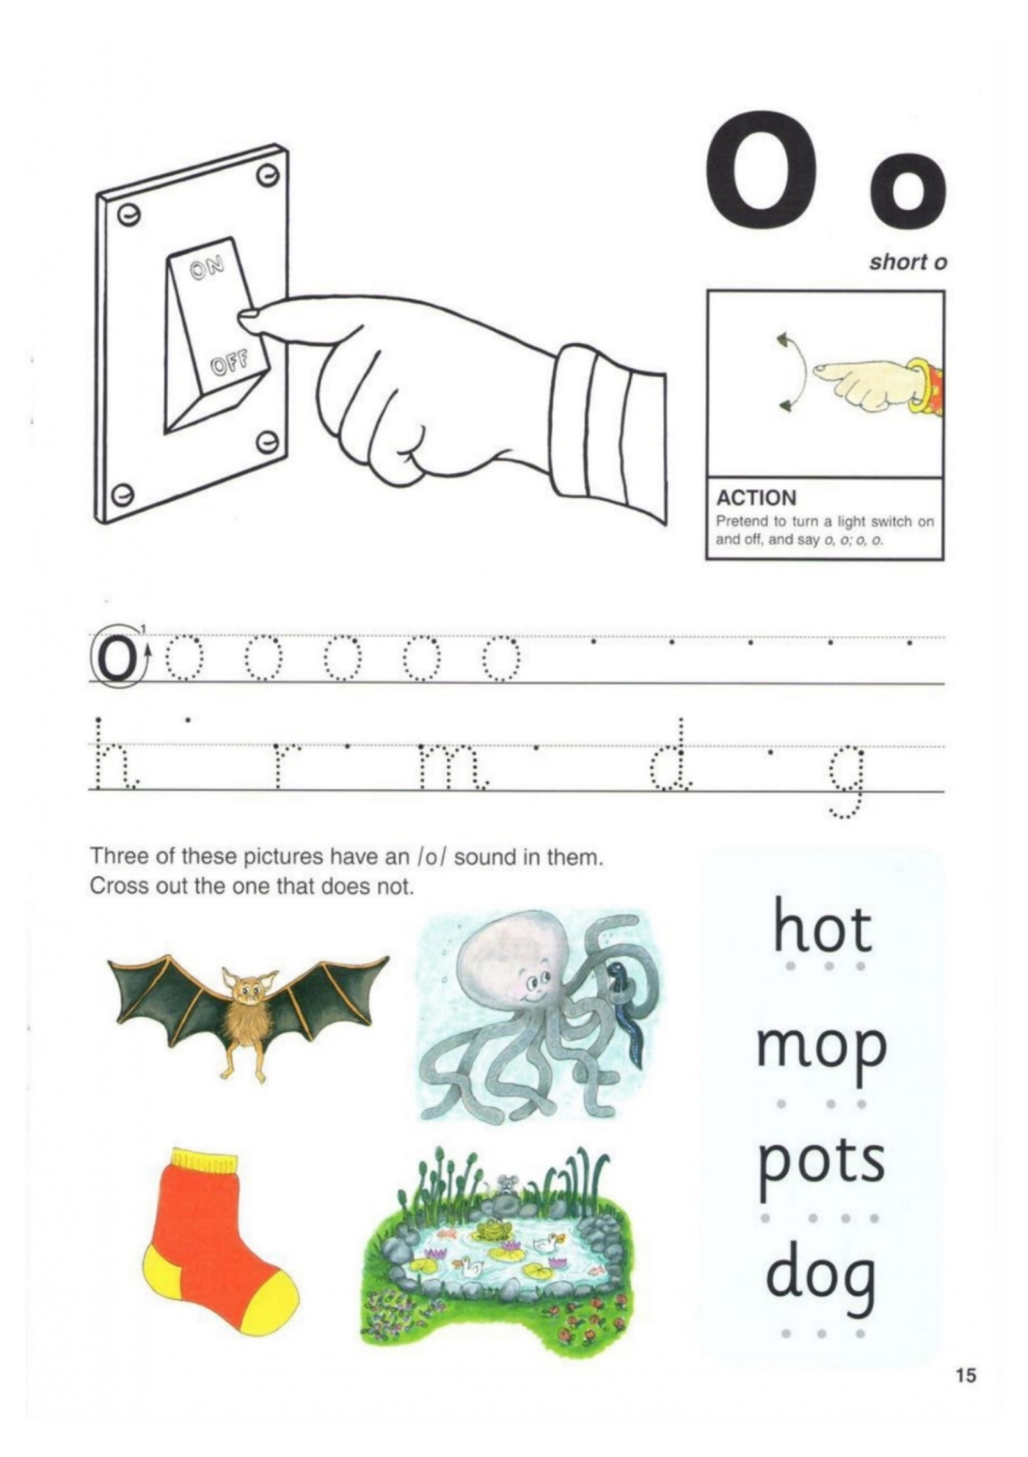
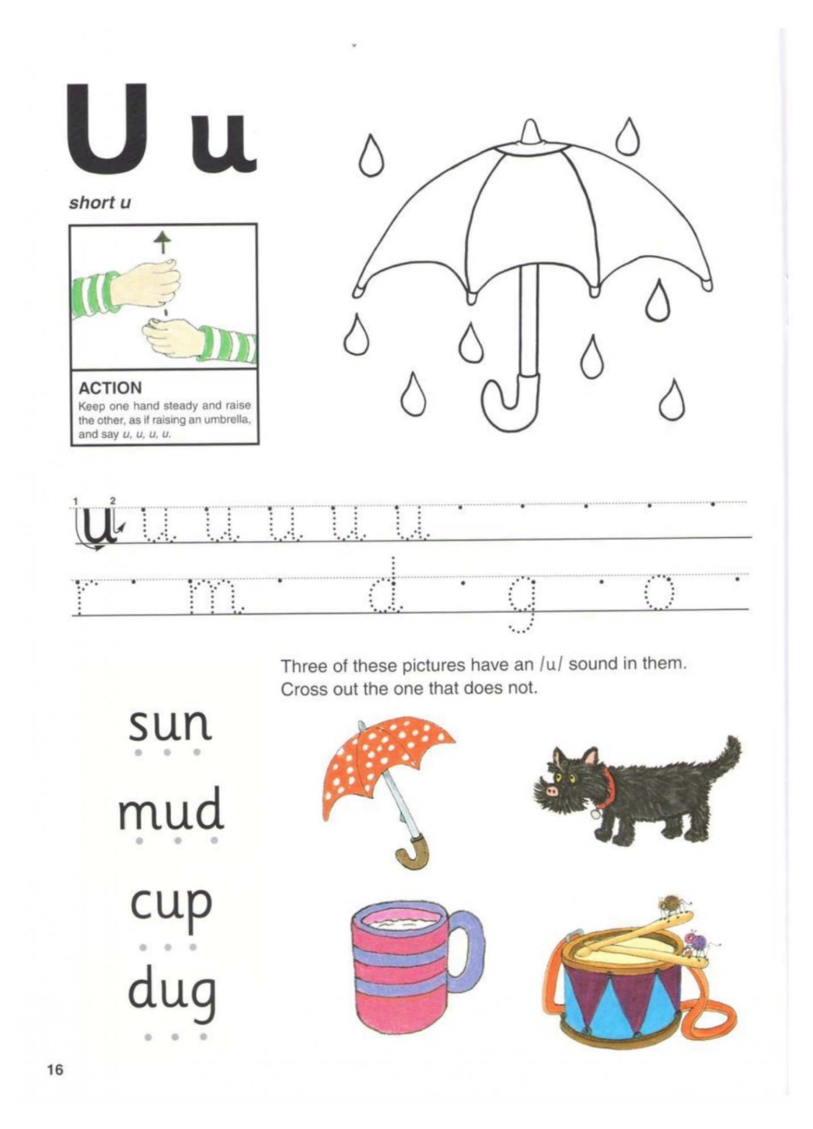
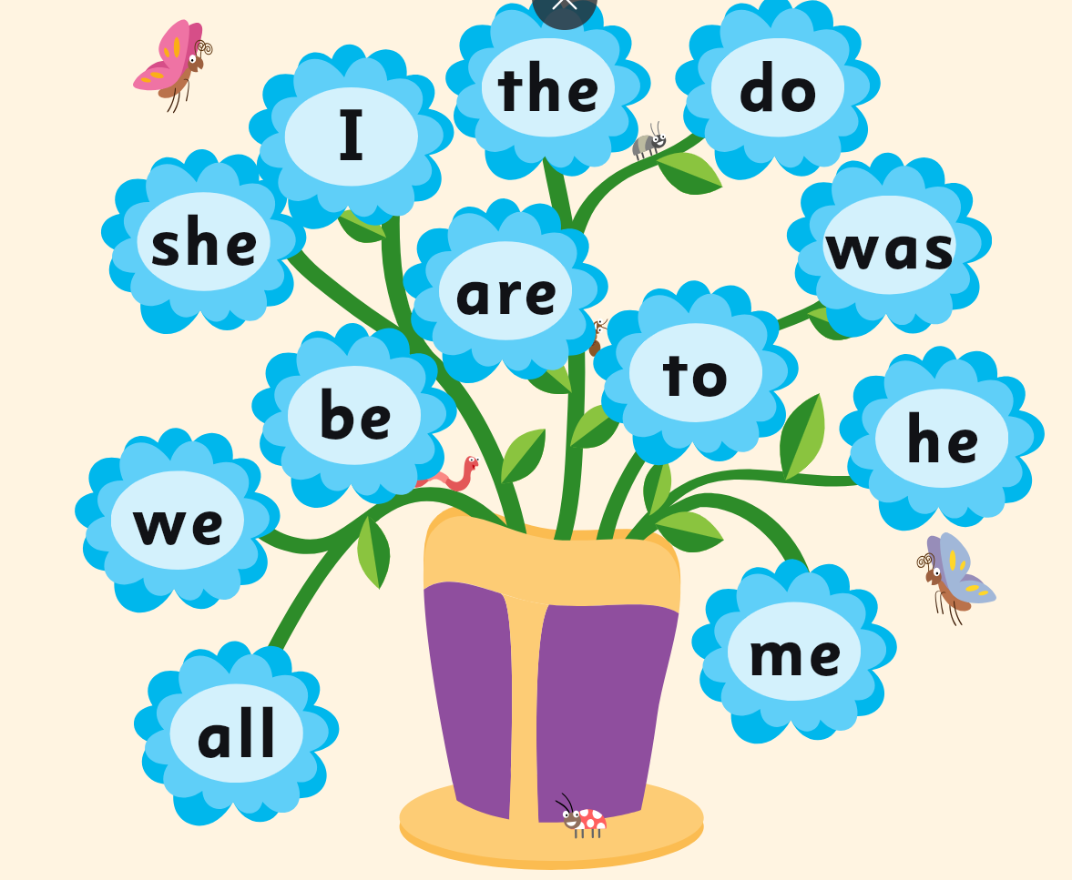
- We had fun in the sun.
- Bud got a hug from Gus.
- Is it a cup or a mug?
- A cub can play in the mud.
- Do not cut the bun.
- The pup is a pug.
R-Blends
t+r | tr
c+r | cr
b+r | br
g+r | gr
f+r | fr | -
p+r | pr  •.
d+r | dr
s+p | \  sp
s+n | sn
s+m | sm
s+w | sw
swam | swip | swim | spot | spin

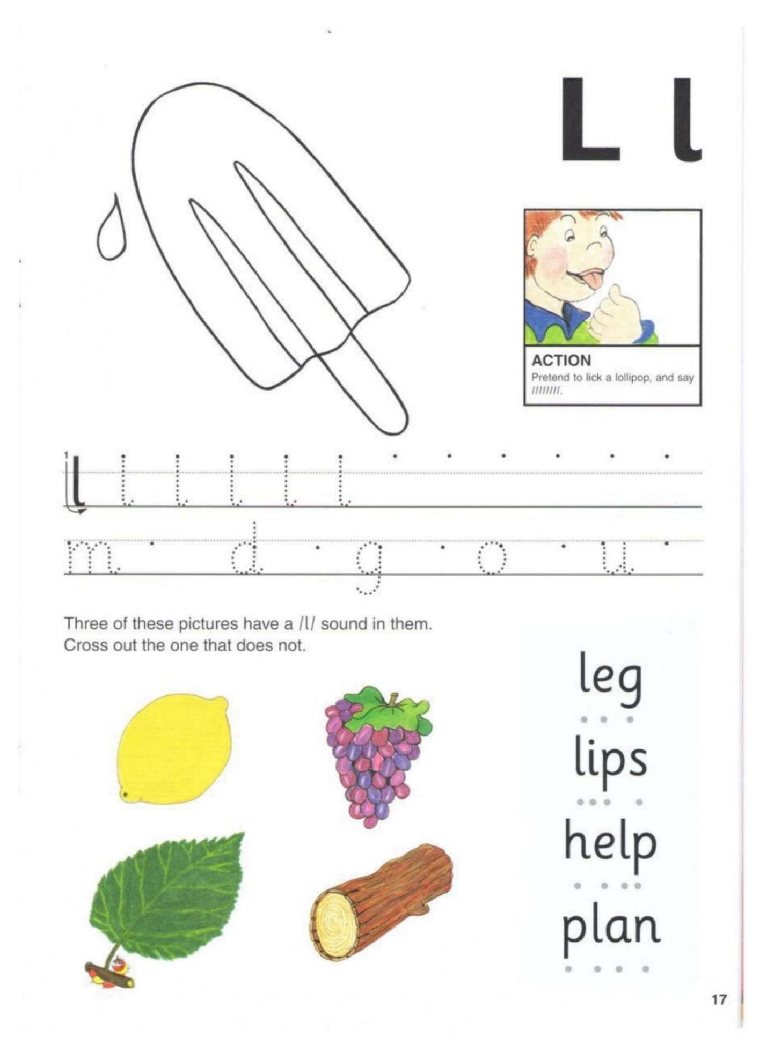
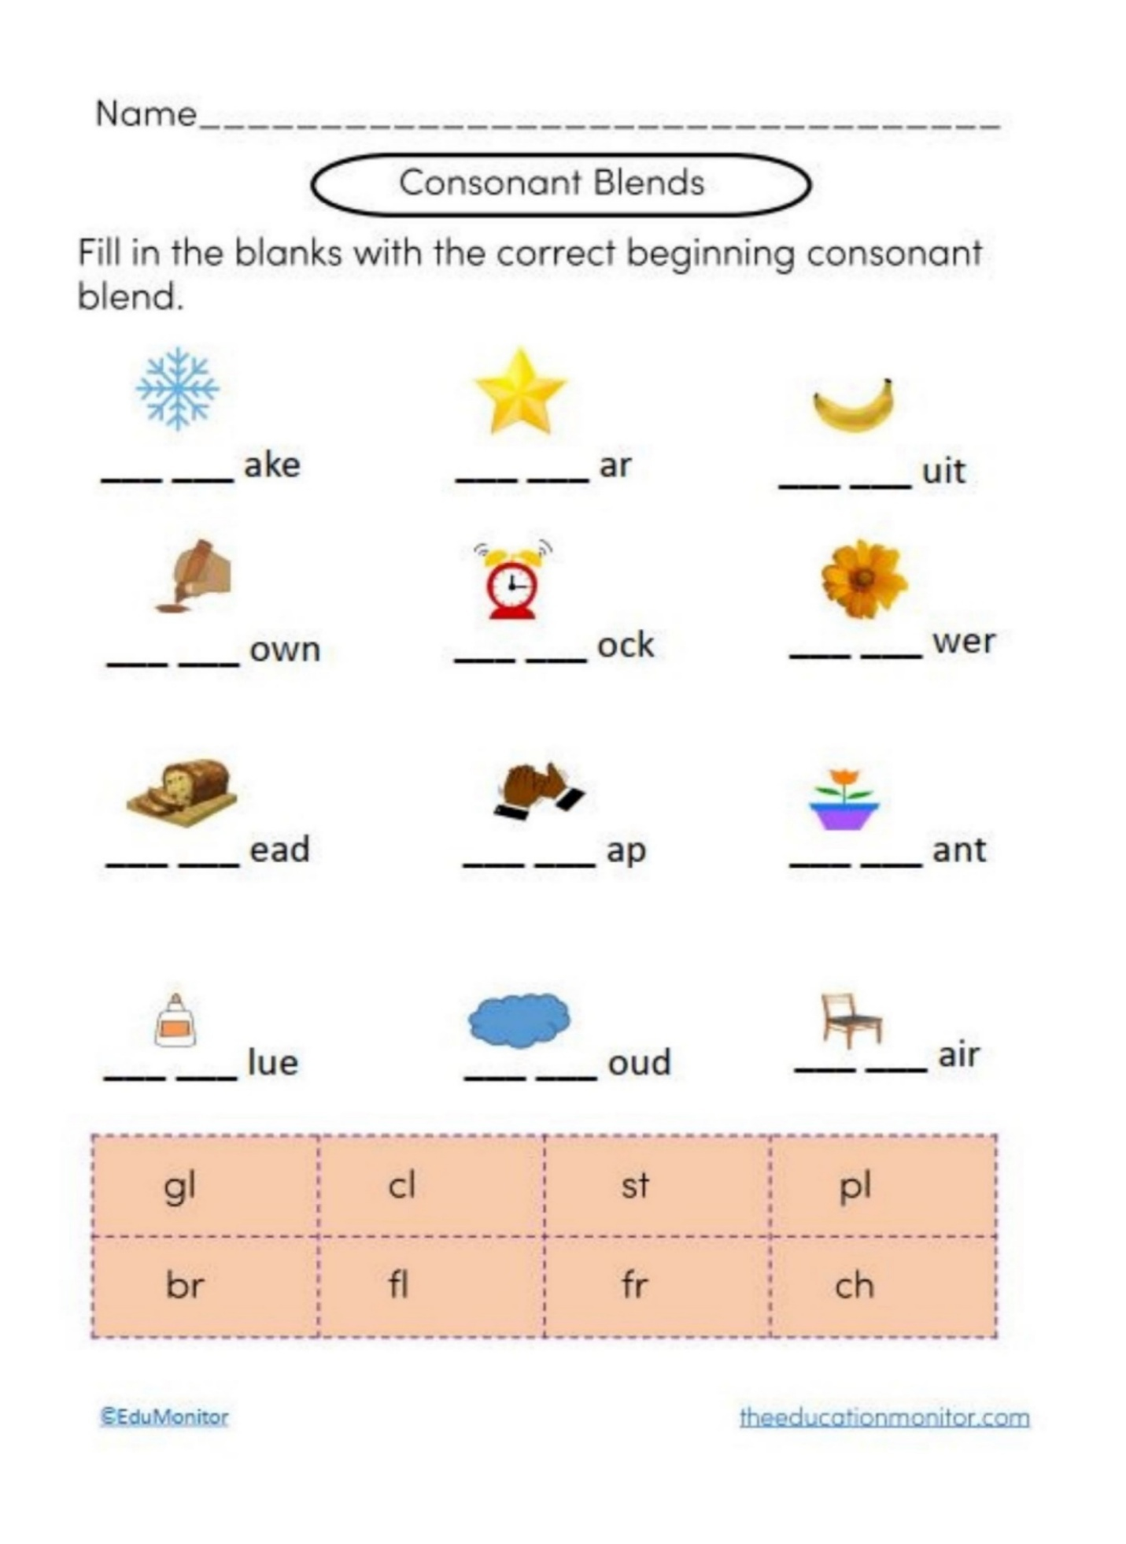
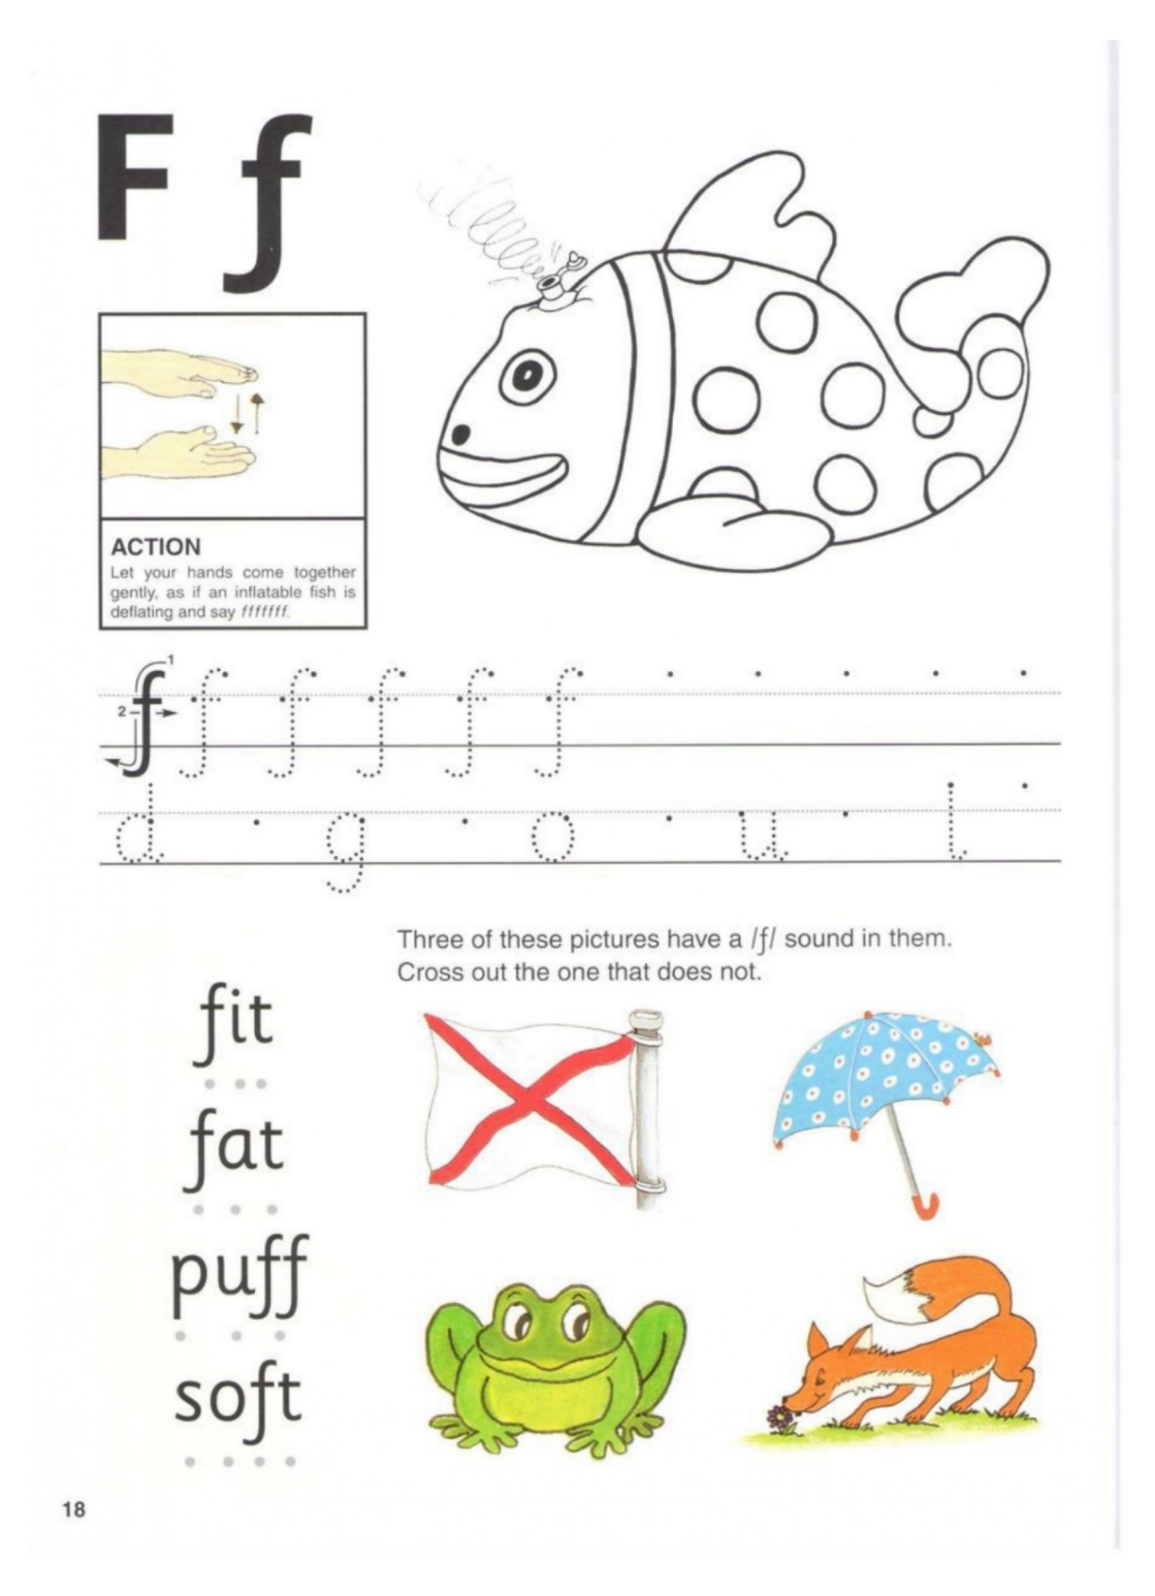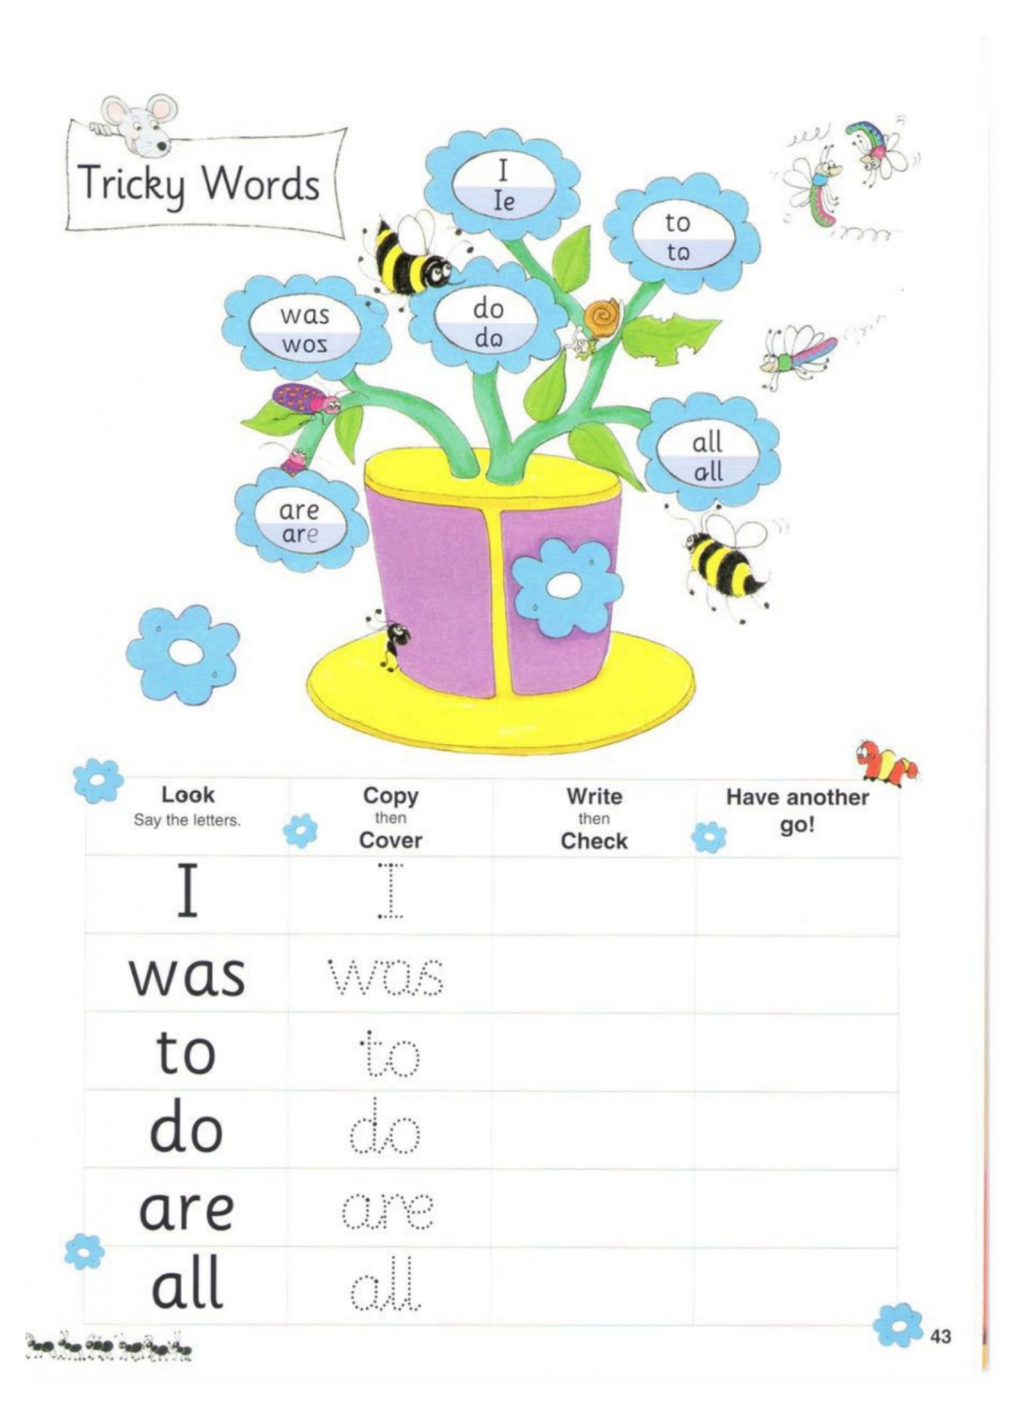
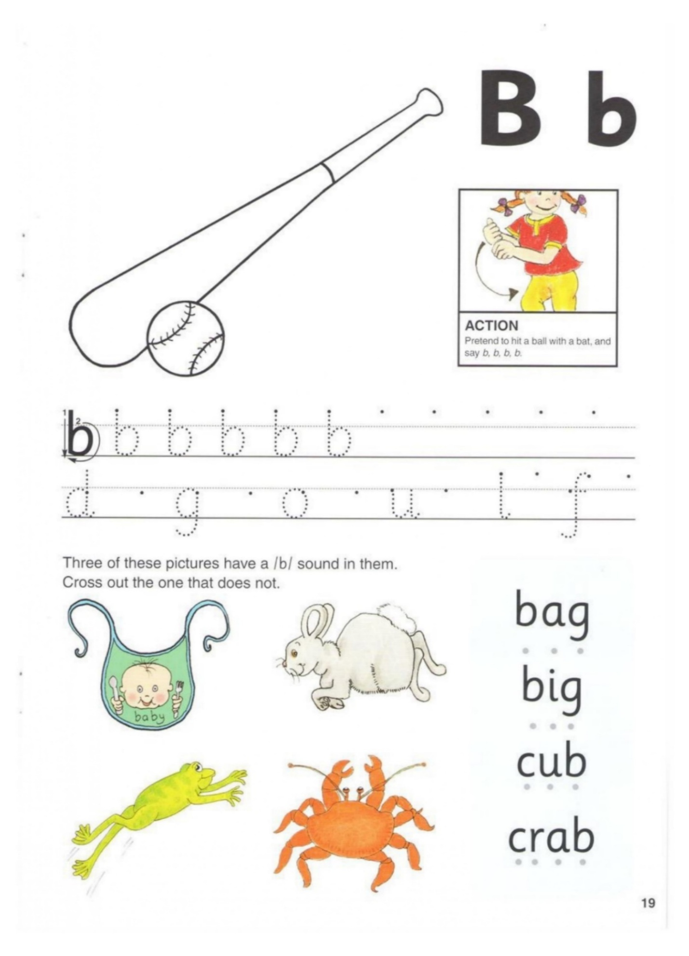
club | crab | crib | grab | scab
black | block | brick | blend | I  Brass
brim | blunt | web | tablet | cob
bend | bent | best | bulb | bump

Brush, Brush
Brit will get up. Then, Brit
will brush her teeth. Brush,
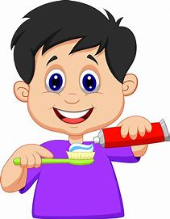
brush! Next, Brit will brush
her hair.
Brit's hair is
brown. Brush, brush!
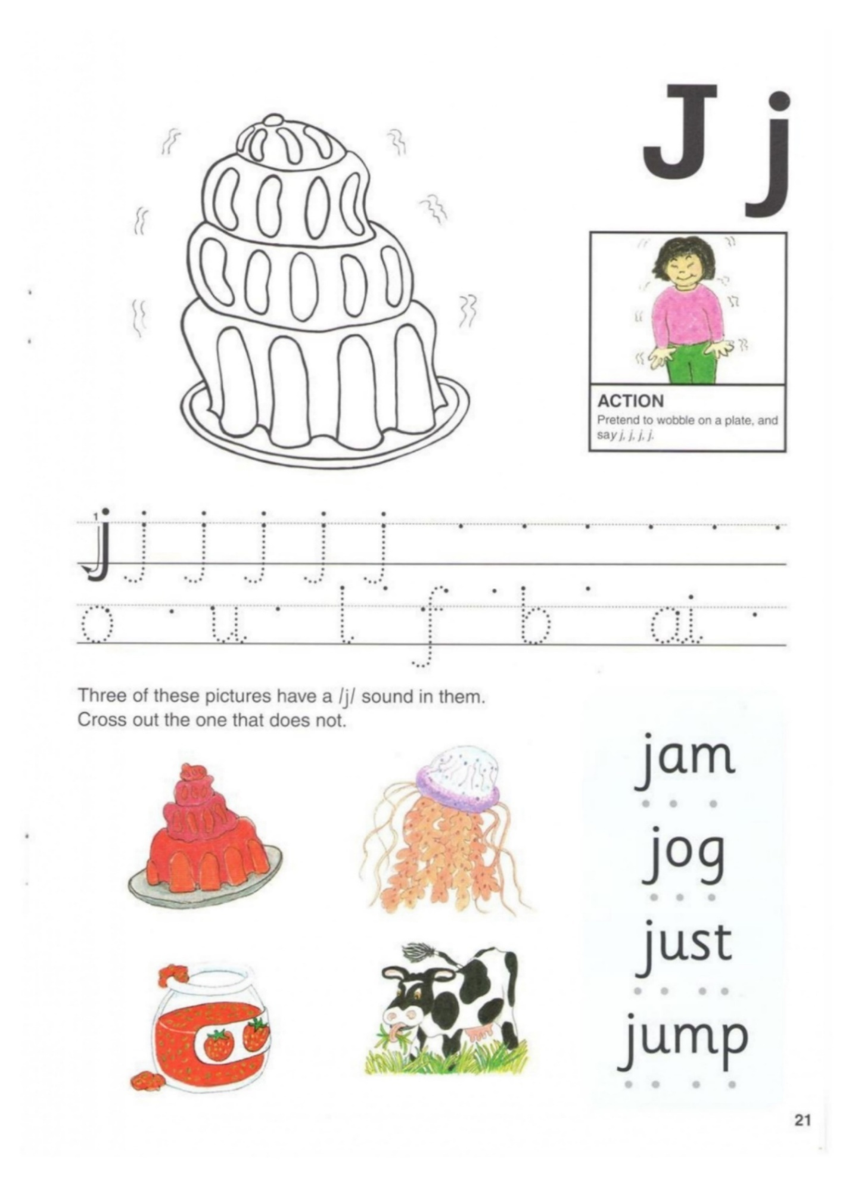
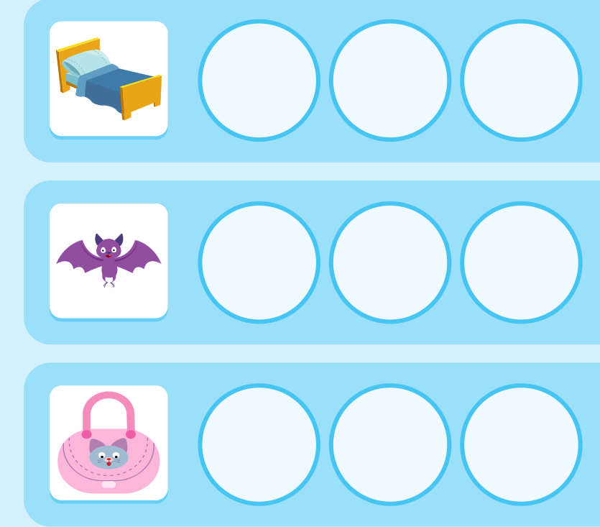
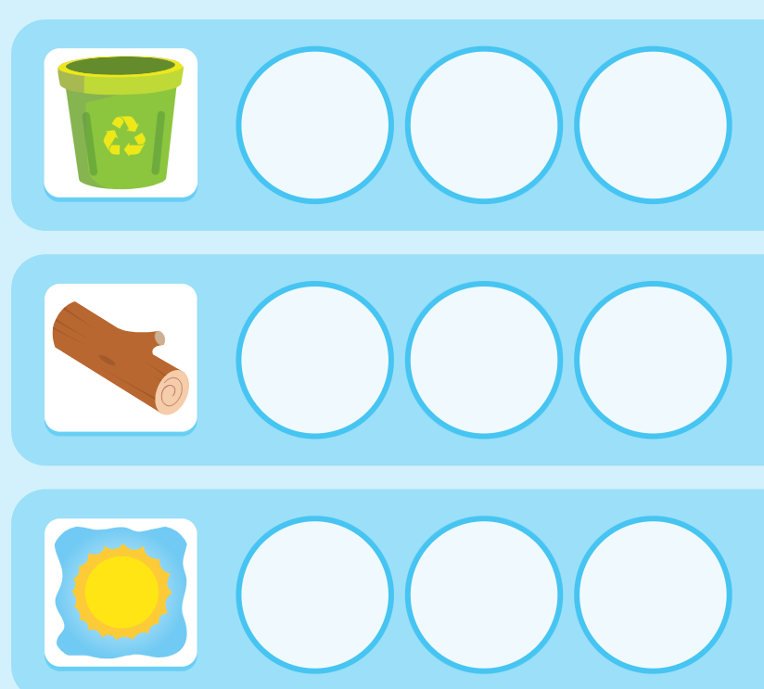
Jam | jet | Jog | jab | Jig
job | jot | Jug | Jump | I  just

The ten men are wet.
Go get the red pen.
He led the vet to the den.
My leg is in the net.
He has a hot dot.
Do not jot on the cot.
The mob has a cob.
Do not rob the pot.
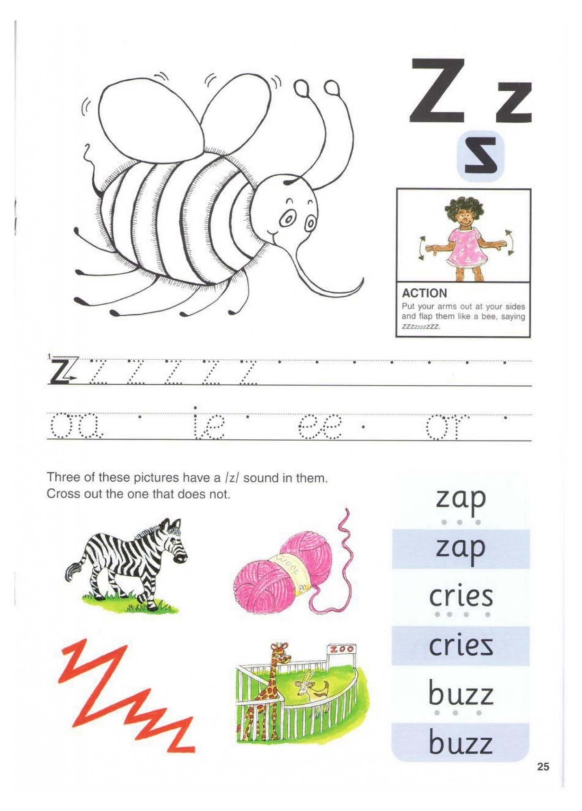
zap | zit | Zip | buzz | fizz
 |  |  | - | -
Jazz | zest | Un-zip | '  Zig zag

She bit the pit.
He has a kit in the pit.
Can you sit in the pit?
The kit can fit in the pit.
She hit the kit and the pit.
Can you hit the kit?
Look at the hog.
Look at the fog
I have a dog.
I have a cot.
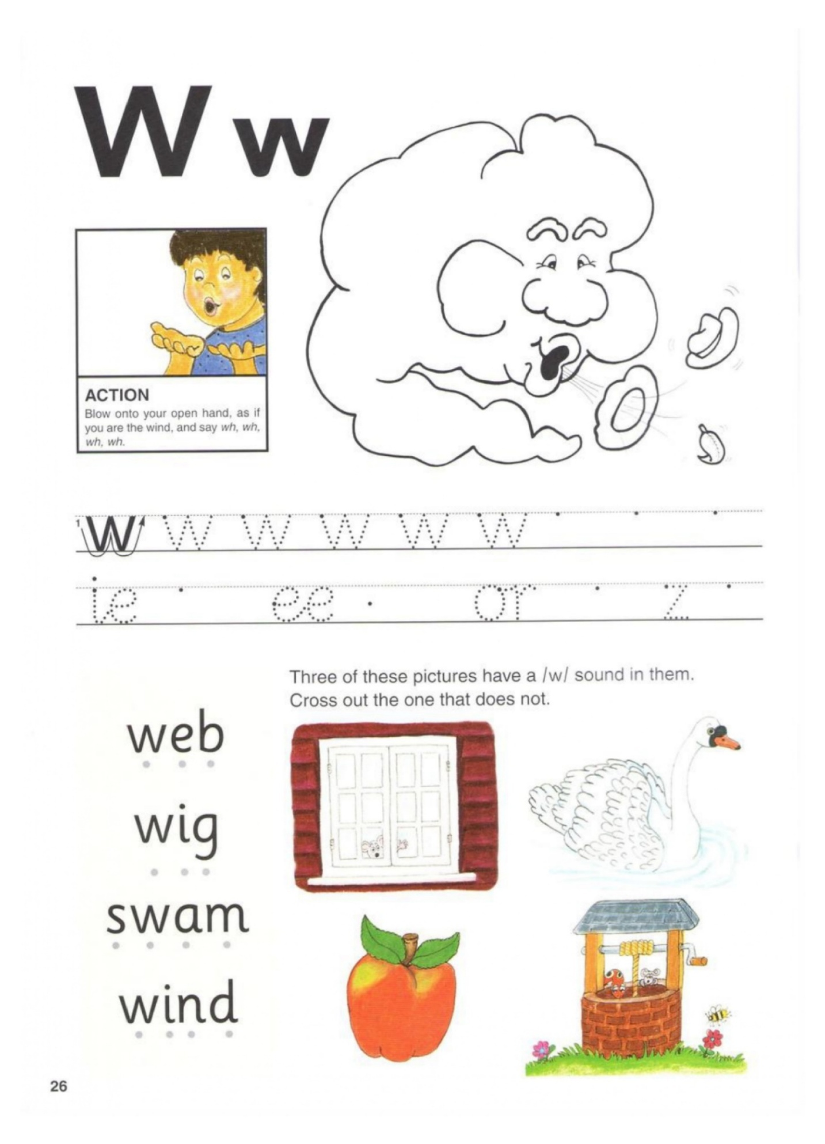
wag | Web | Well | Wet | wig
 |  |  | - | -
Wag | Web | Well | Wet | Wig
This is a frog.
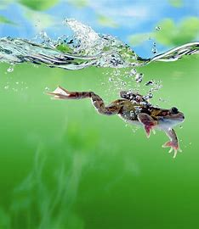
A frog has 4 legs.
It has wet skin.
This frog is red.
It has spots.
What is red on this frog?
This frog is flat.
It is a water frog.
What Can Frogs Do?
Frogs can do a lot.
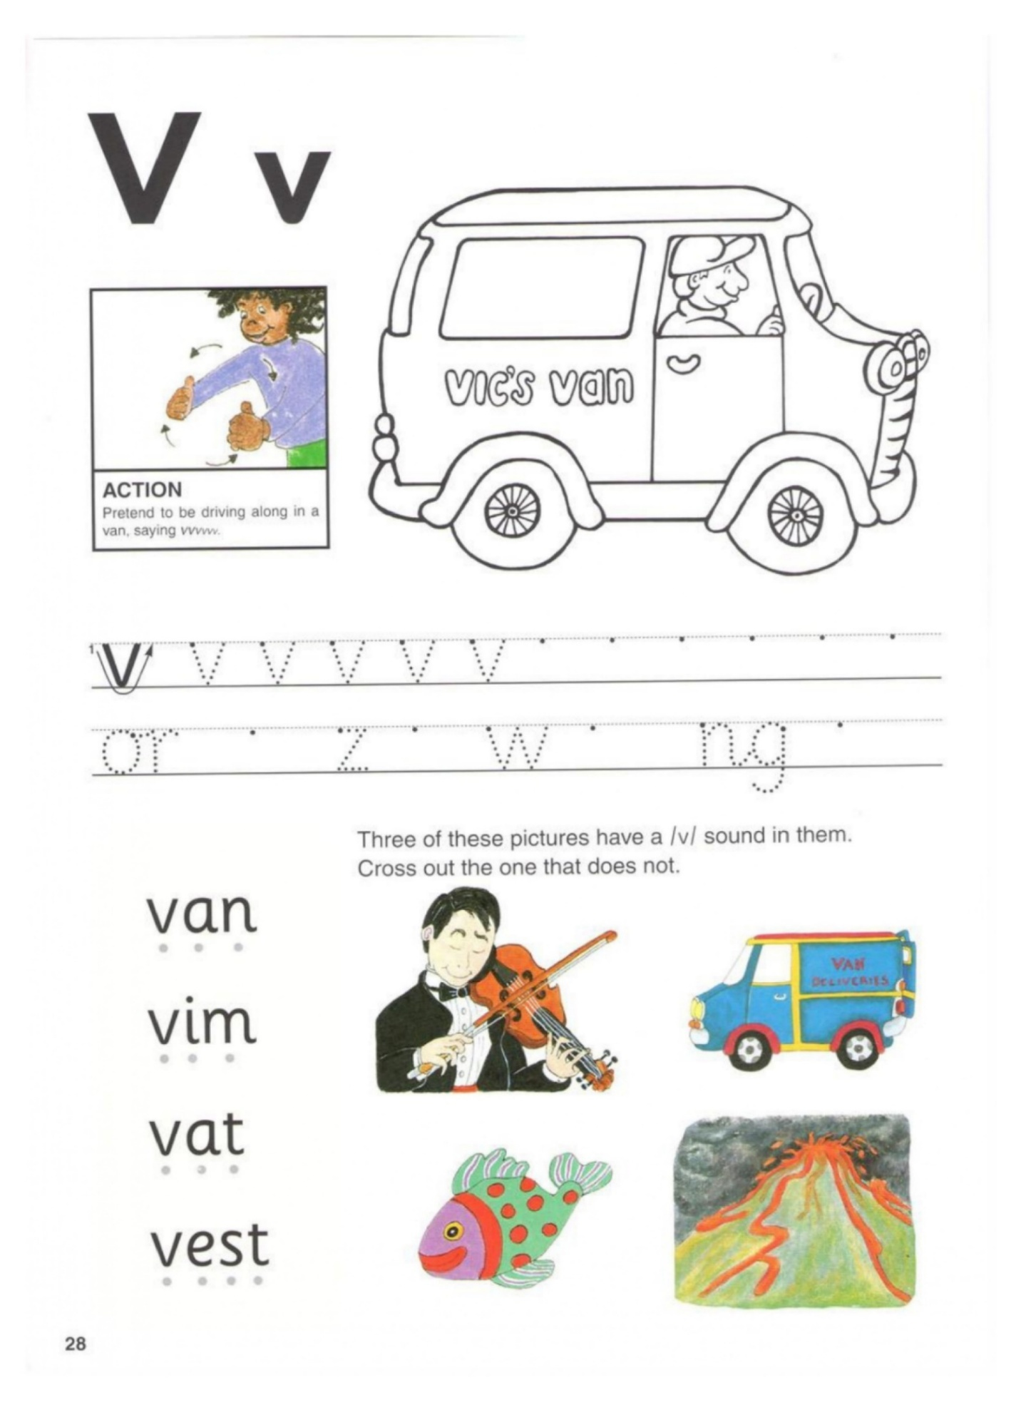
🚐 van 🐾 vet
1️⃣ __an 1️⃣ __et
2️⃣ v__n 2️⃣ v__t
3️⃣ va__ 3️⃣ ve__
🦺 vest 🌬️ vent
1️⃣ __est 1️⃣ __ent
2️⃣ v__st 2️⃣ v__nt
3️⃣ ve__t 3️⃣ ve__t
4️⃣ ves__ 4️⃣ ven__

Vivid invent vomit vision
Visit vista vezir vim
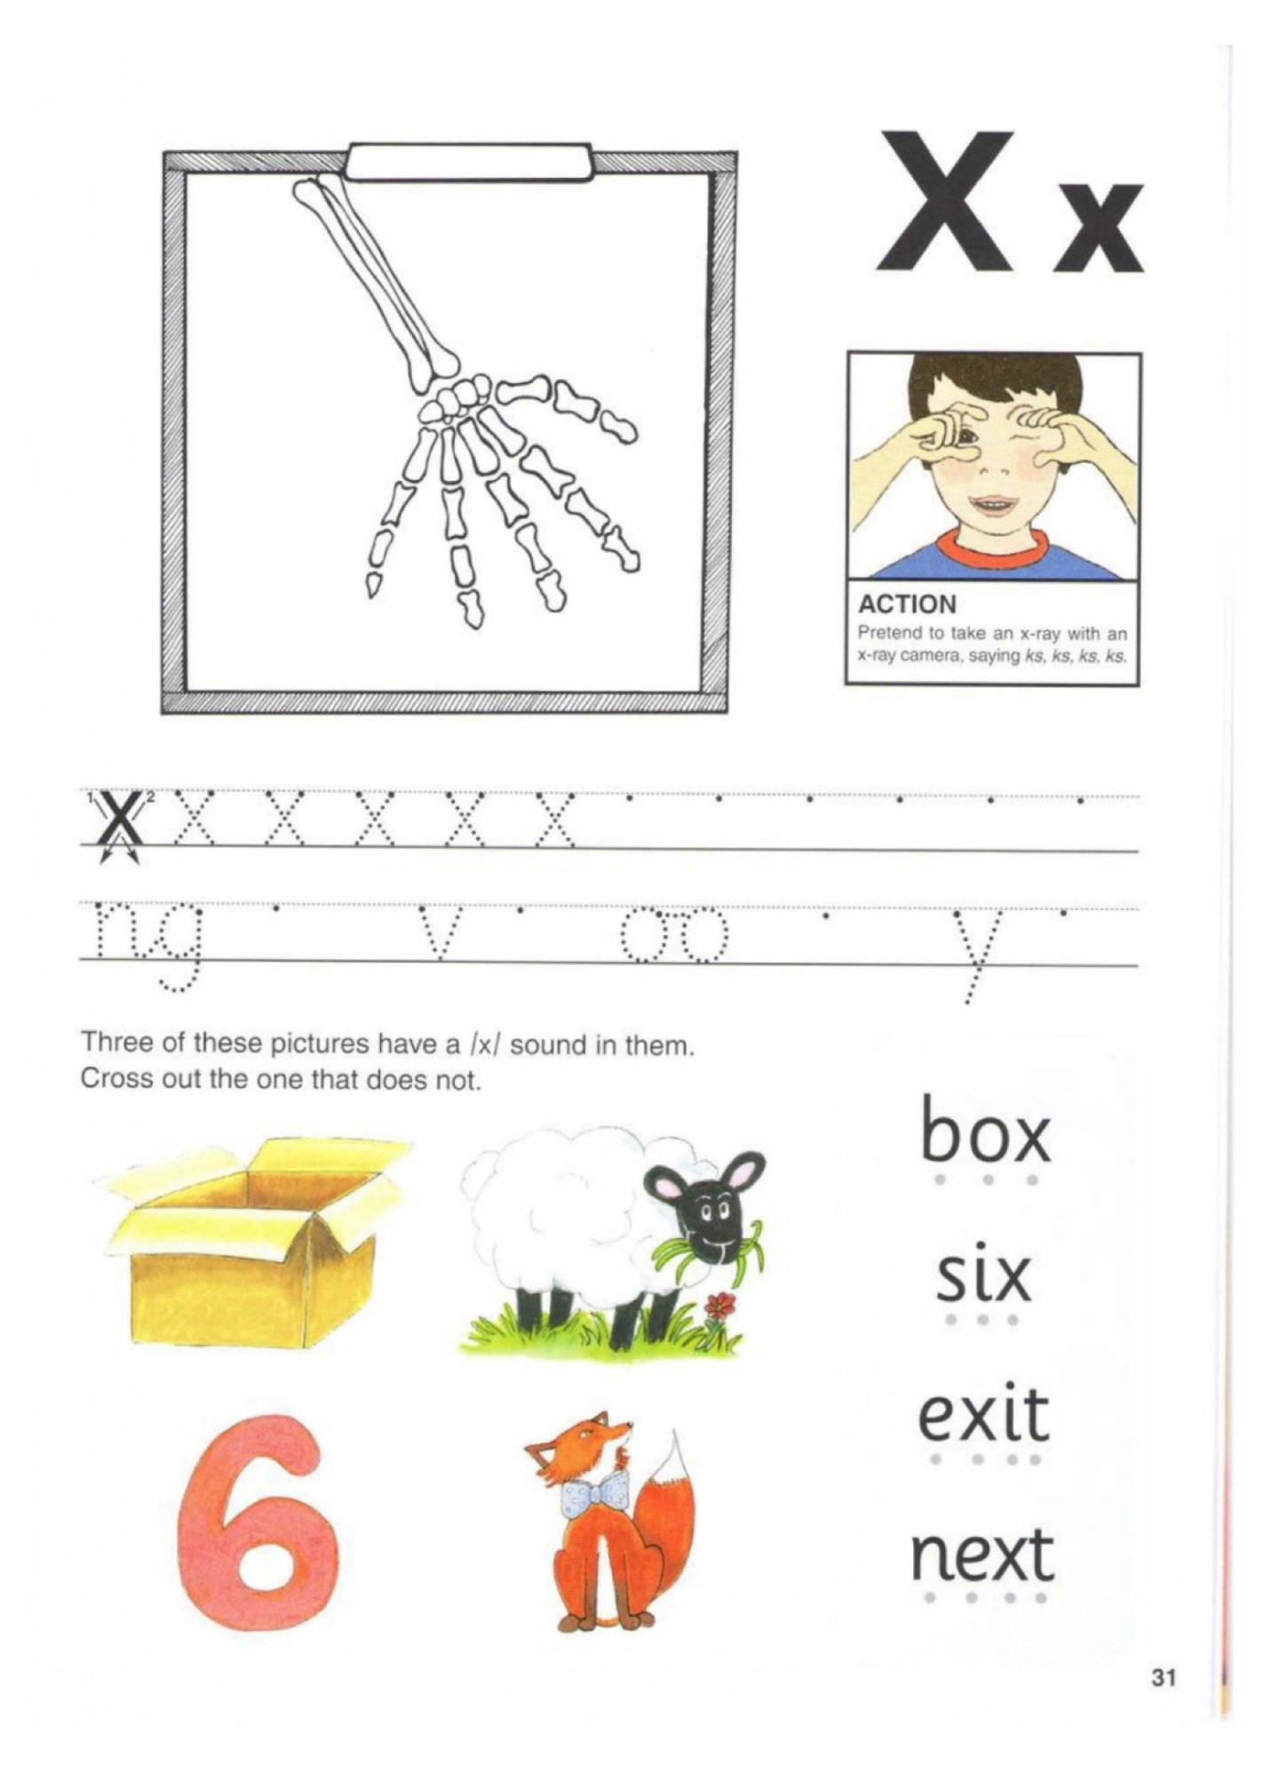
1️⃣ Read the Words
🦊 fox 📦 box 🐂 ox 📠 fax 🧩 fix
🎨 mix 6️⃣ six 💰 tax 🕯️ wax 🚪 exit
💪 flex ➡️ next 📝 text 🐈 tux ✨ nix
2️⃣ Fill in the Missing Letters
f _ x b _ x f _ e _
e _ i t w _ x n e _ t
t _ x m _ x
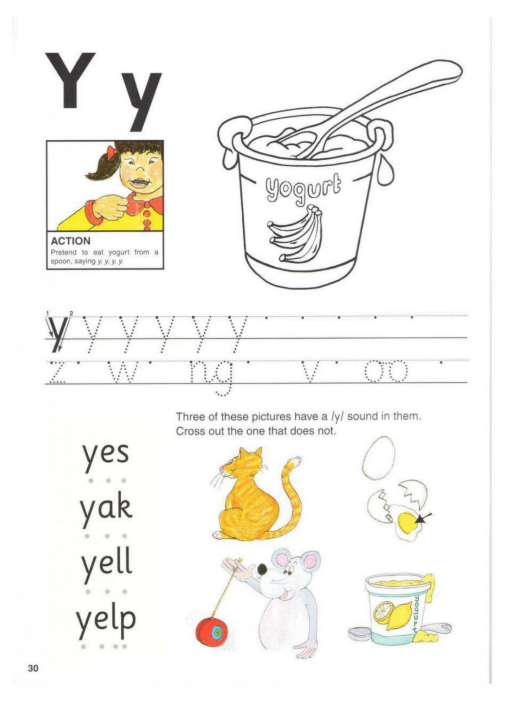
🐂 → yak y _ k
🍠 → yam y _ m
🐶 → yelp y _ _ p
😊 → yes y _ s
🤢 → yuck y _ ck
Dictation:
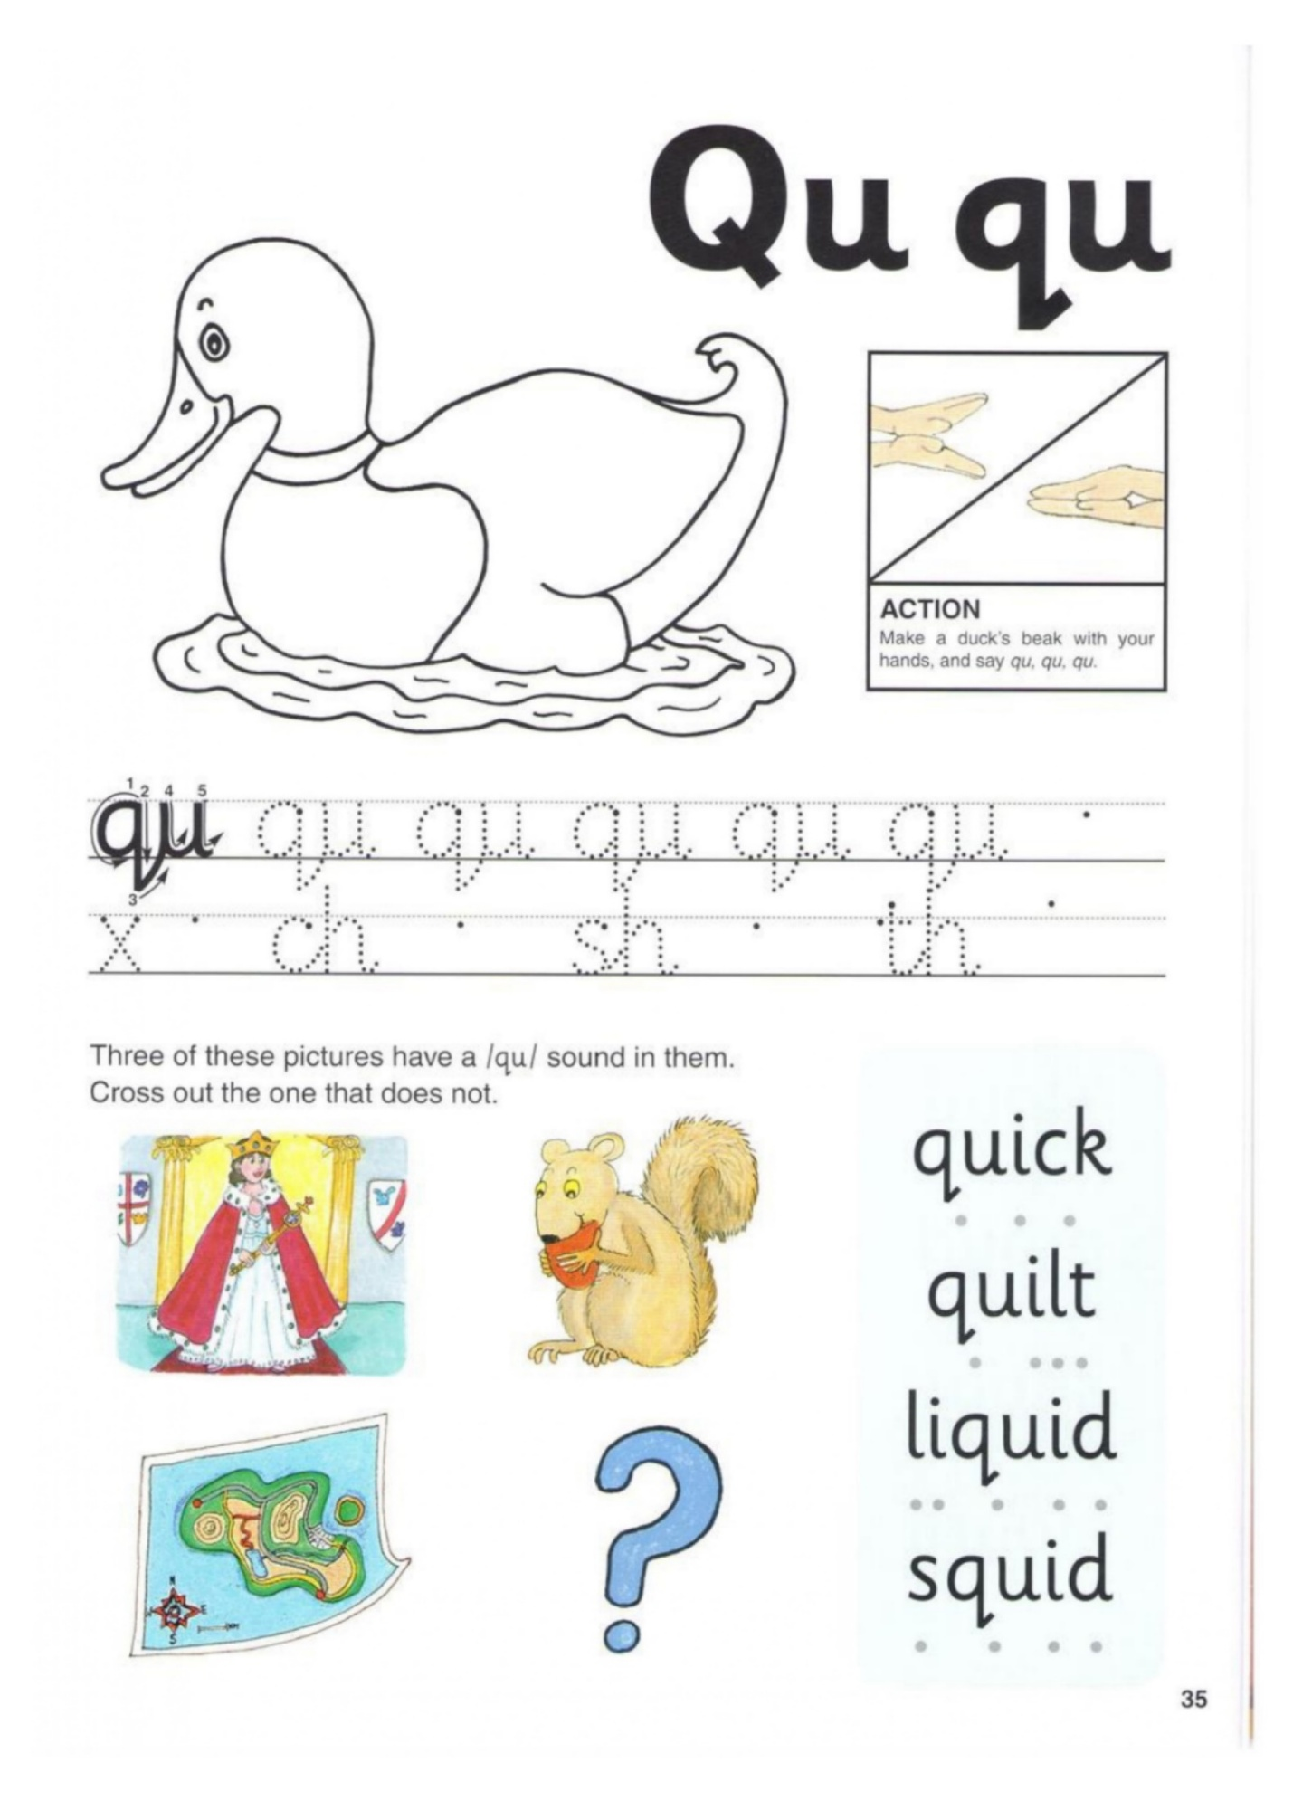
🦆 → quack q _ a c k
🛏️ → quilt q _ i l t
🐙 → squid s q u _ d
🖊️ → quill q _ i ll
🛡️ → squad _ q u _ d
Choose the Correct Word
- The duck says quack / quit.
- I took a short quiz / squid in class.
- A soft blanket is a quilt / quack.
- The team of helpers is a squad / squid.
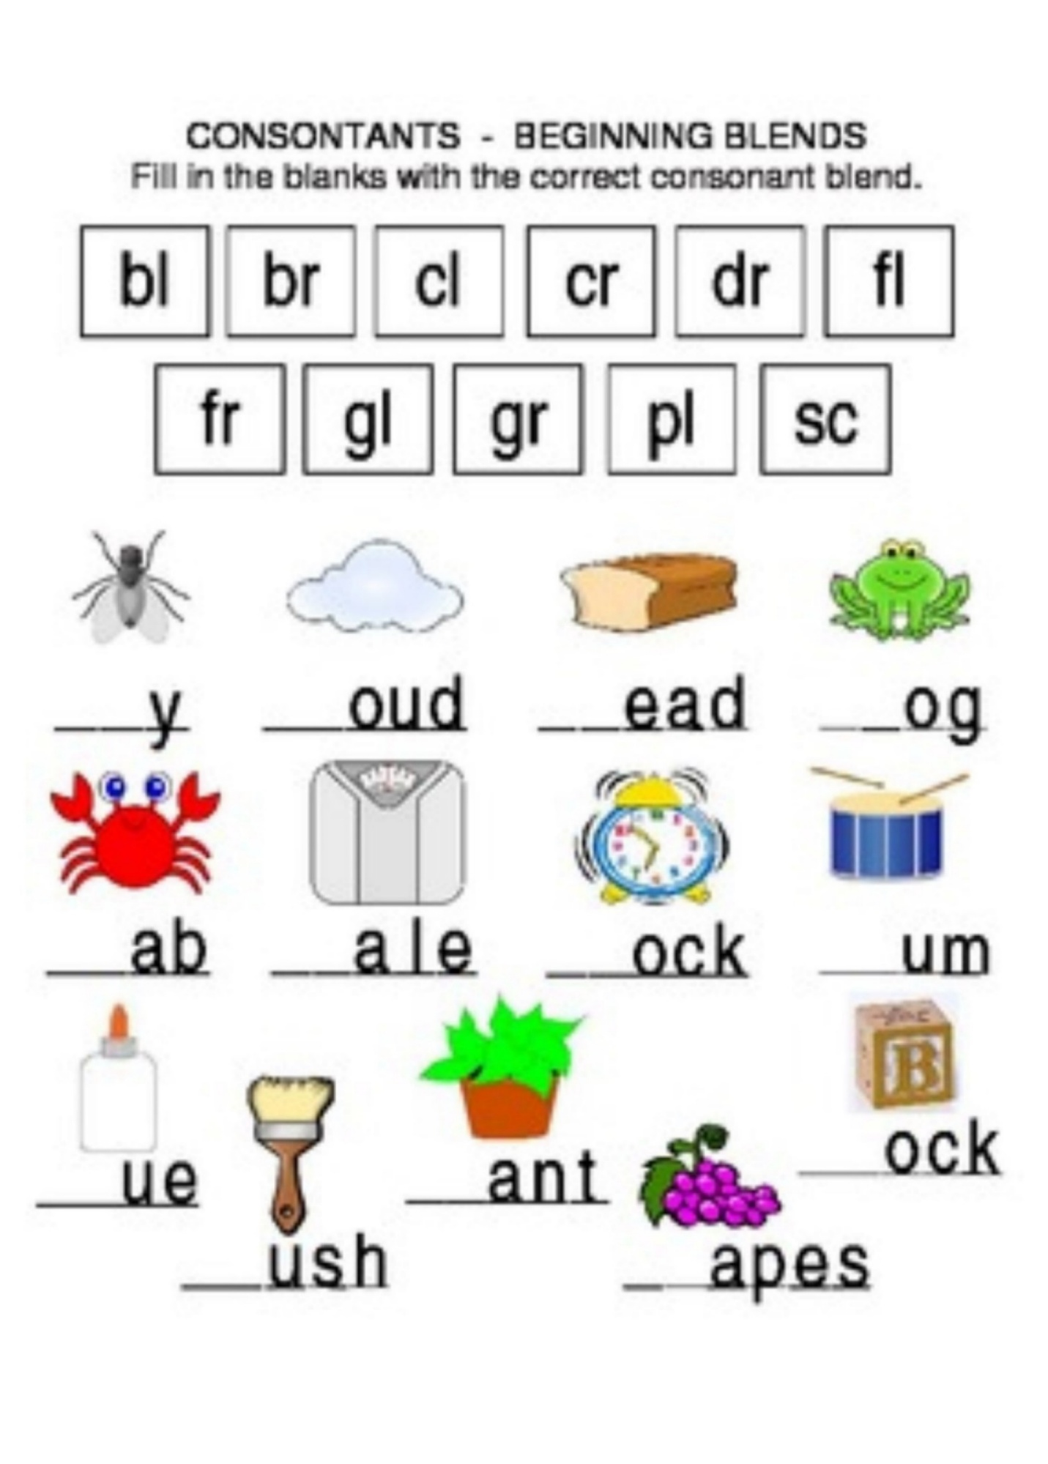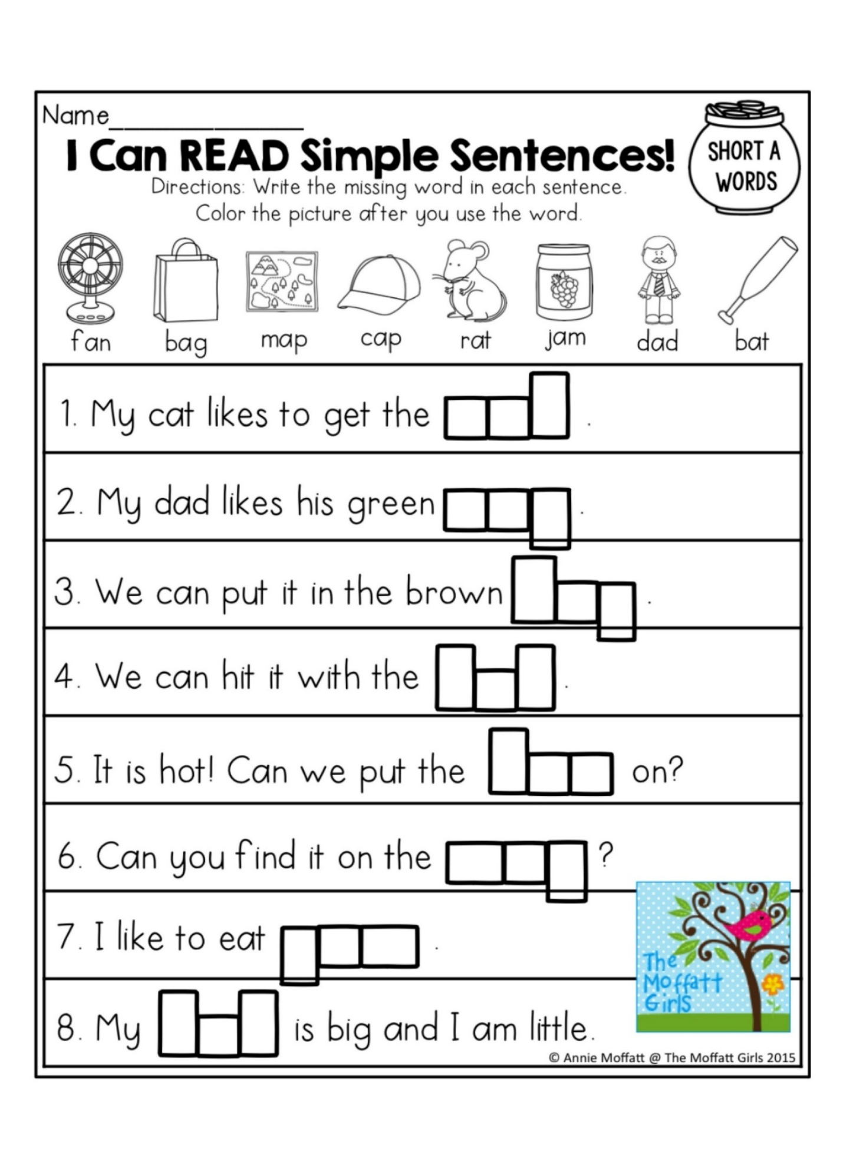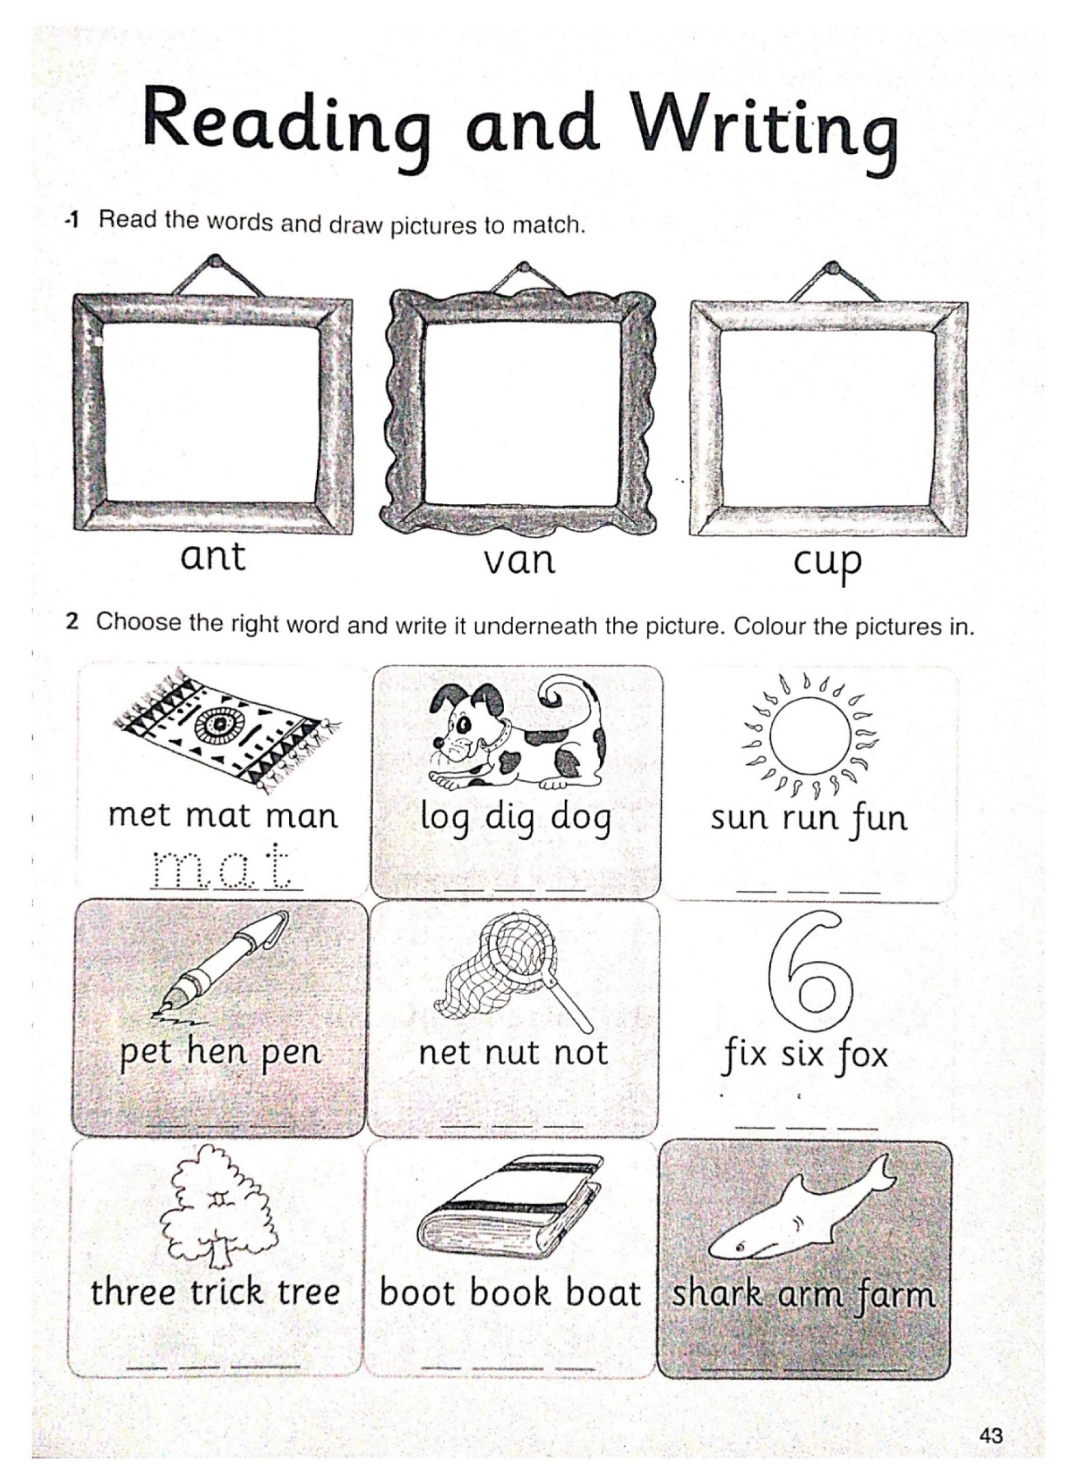 🌟 Short /a/
(Using blends: bl, cl, fl, sl, sn, sp, st, sw…)
- a black cat a glad clam
- clap on the mat a flag on the van
- a sled and a bag snap the clip
- a flat pan swim with the crab🌟 Short /e/
(Using blends: bl, br, cr, dr, fl, fr, sm, sp…)
- a red sled Fred can smell
- the crab had a leg blend the egg
- a wet dress smell the nest
- Brett can spell step on the deck
🌟 Short /i/
(Using blends: bl, cl, fl, gr, pl, pr, sl, sp…)
- a slim pig flip the lid
- a big grin slip on the clip
- split the twig a drip on the grill
- pick the brick slid into the crib🌟 Short /o/
(Using blends: bl, br, cl, dr, fl, fr, gl, pl…)
- a frog on the block a clock on the box
- drop the cloth the blond dog hops
- plop on the log a flock of crows
- the rock is soft clap for the fox
🌟 Short /u/
(Using blends: bl, cl, dr, fl, gl, pl, sl, sp, st…)
- a slug in the mud plug the jug
- drum on the rug clap for the cub
- the skunk had fun scrub the tub
- a blunt club stuck in the dust
S blends words
sw | sm | st | sn | sp
swap | small | stop | snack | Spot
swim | smart | step | snip | spark
swept | smell | still | snake | sport

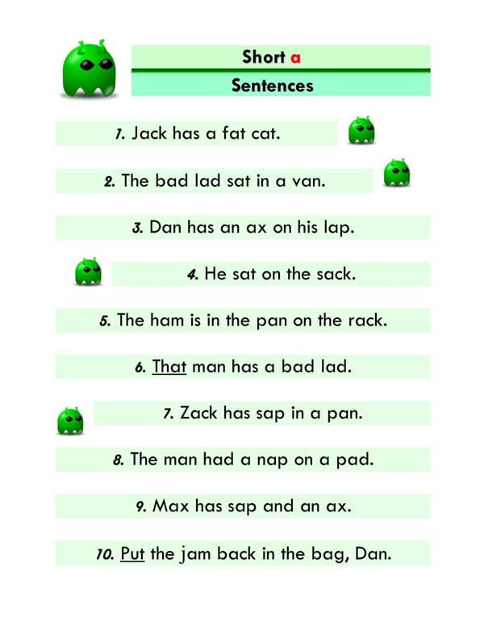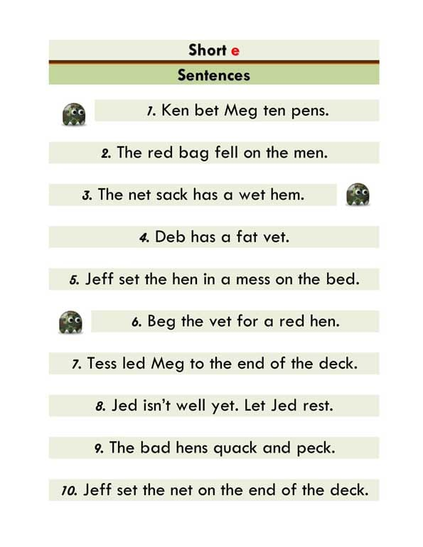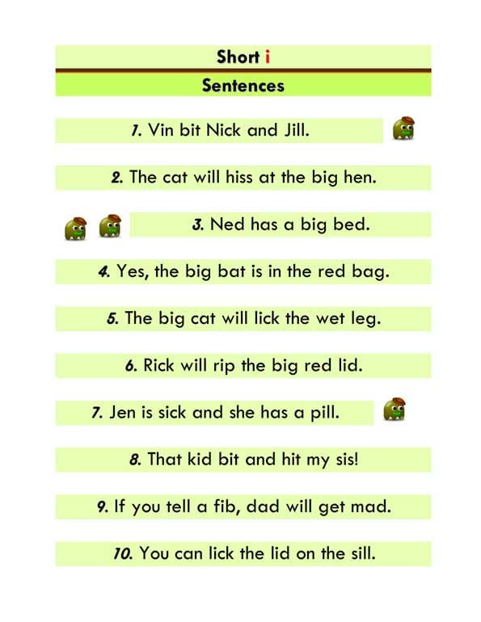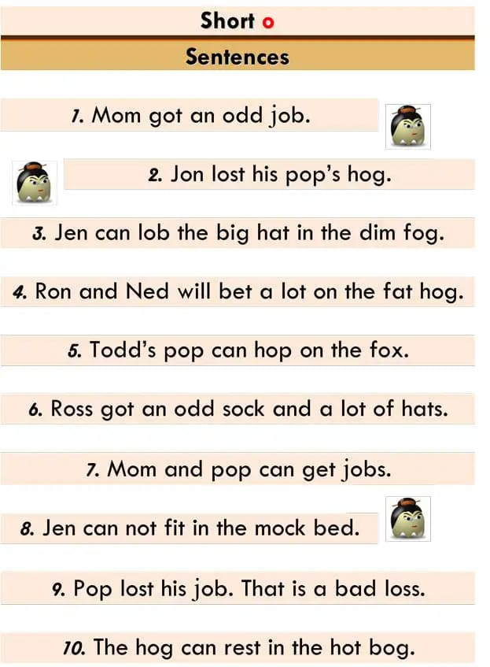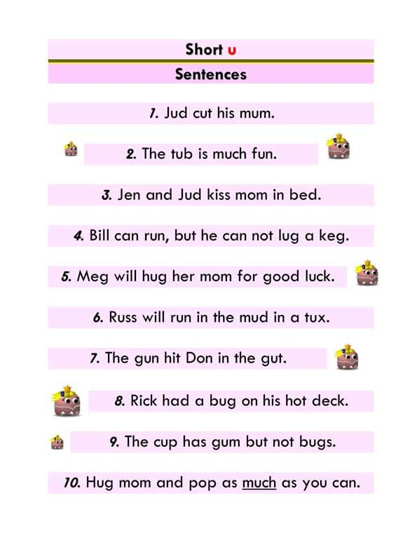

Glen likes to run in class. Glen ran and
did slip on a black block. Glen slid and did
a flip. In a flash, Glen fell flat on his
back. Slam! A glass clock fell on Glen.
The glass did clip Glen's lip. Plop! A plant
did flop on Glen. The pot did club Glen's
leg. Glen's leg is plump and plum. Now
Glen will be a sloth in class.
