Page 1 • Lesson Preview
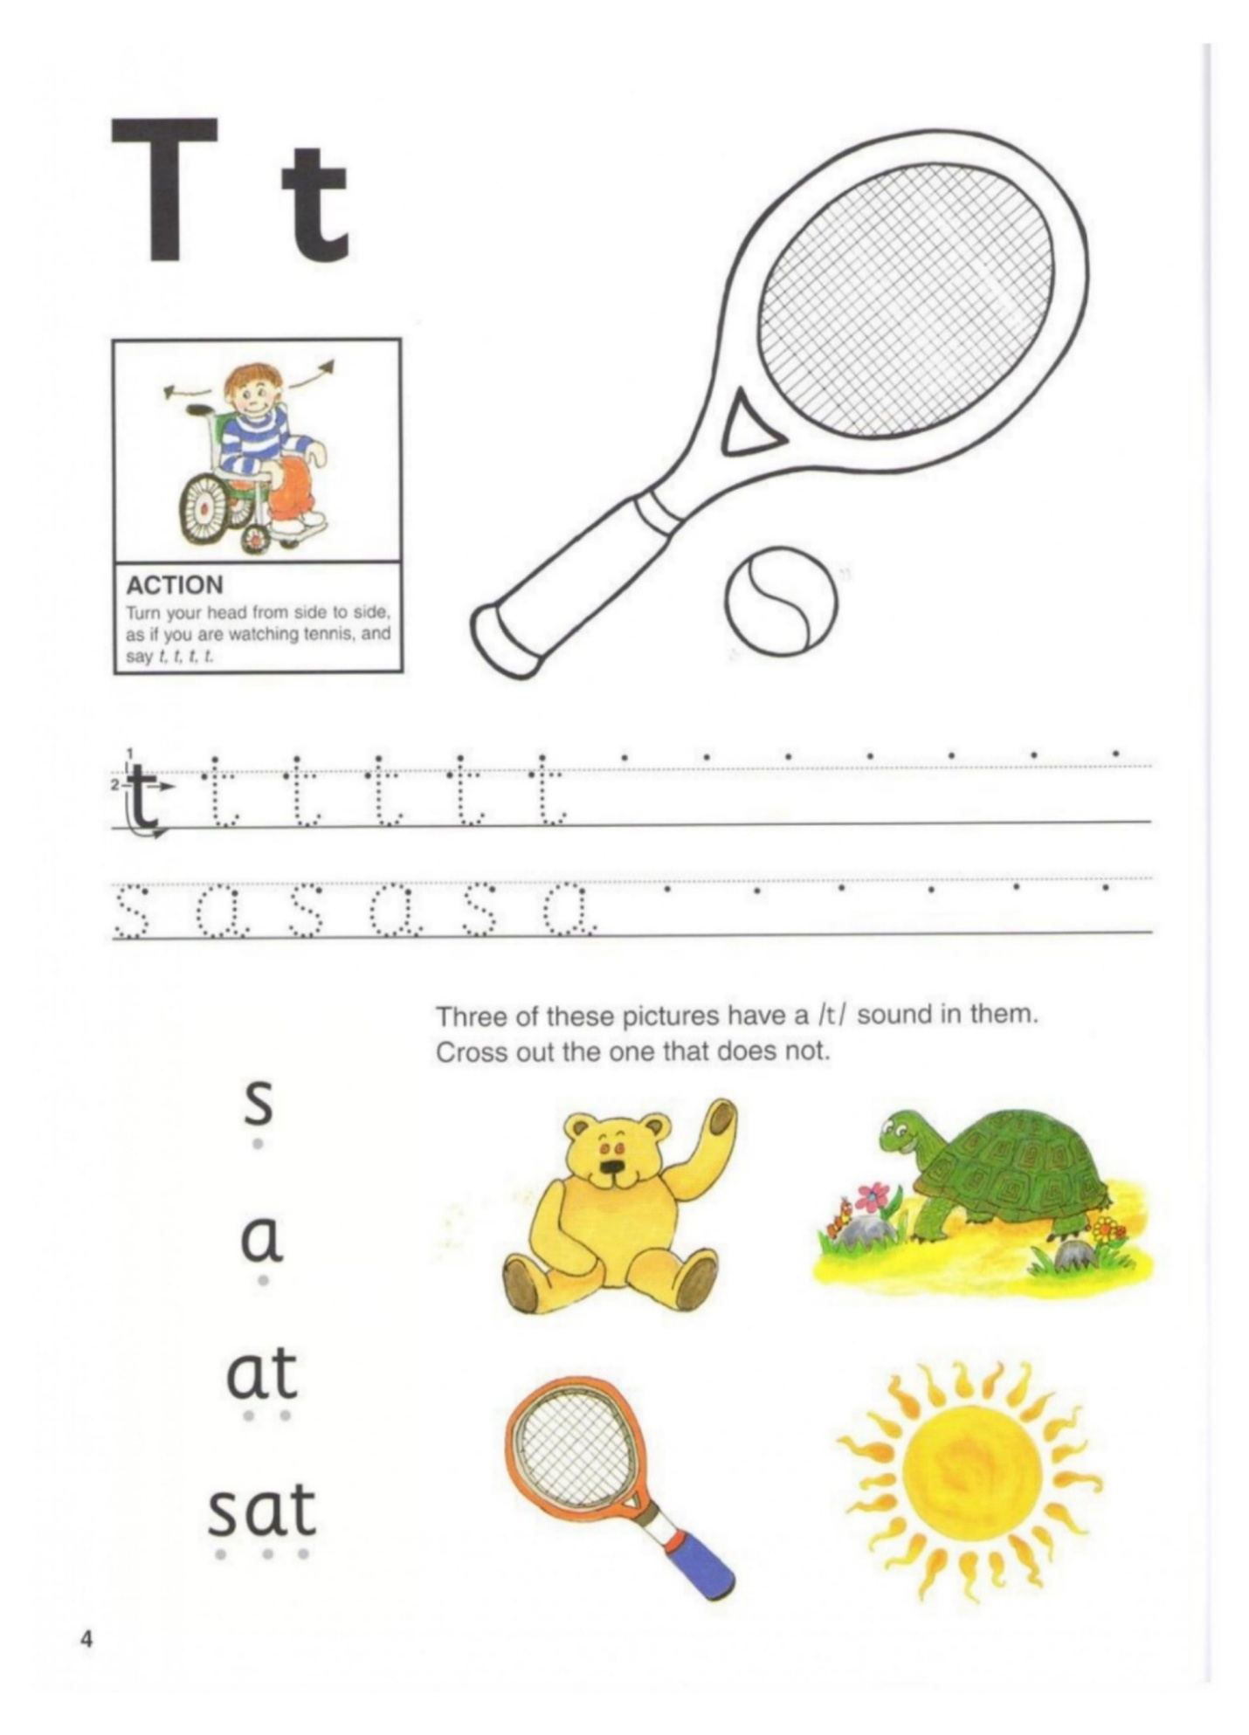
Image + Text Layout | ------ ------ ------  Keep the same lesson order and page sequence.  Use the image as the hero and place the directions in a clean text box.

Page 2 • Lesson Preview
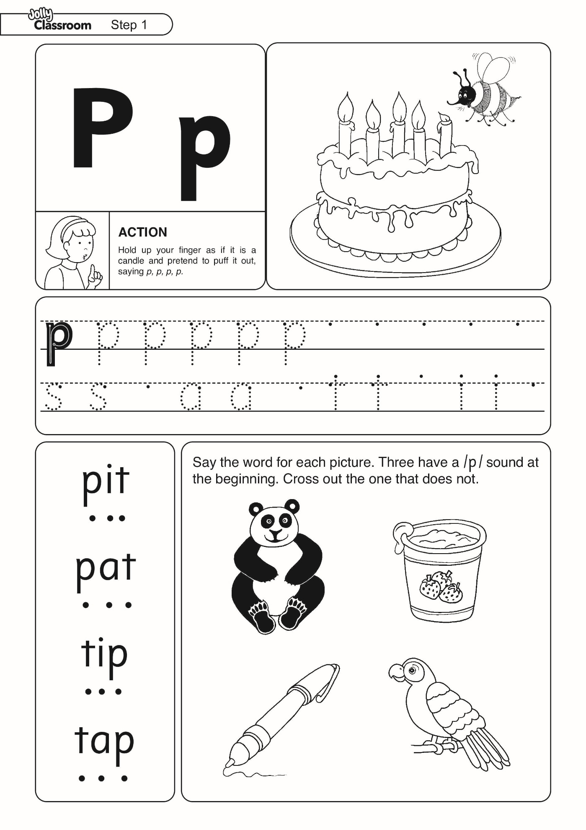
Image + Text Layout | s a sa  Keep the same lesson order and page sequence.  Use the image as the hero and place the directions in a clean text box.

Page 3 • Lesson Preview
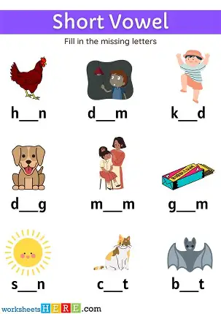
Image + Text Layout | t a ta  Keep the same lesson order and page sequence.  Use the image as the hero and place the directions in a clean text box.

Page 4 • Lesson Preview
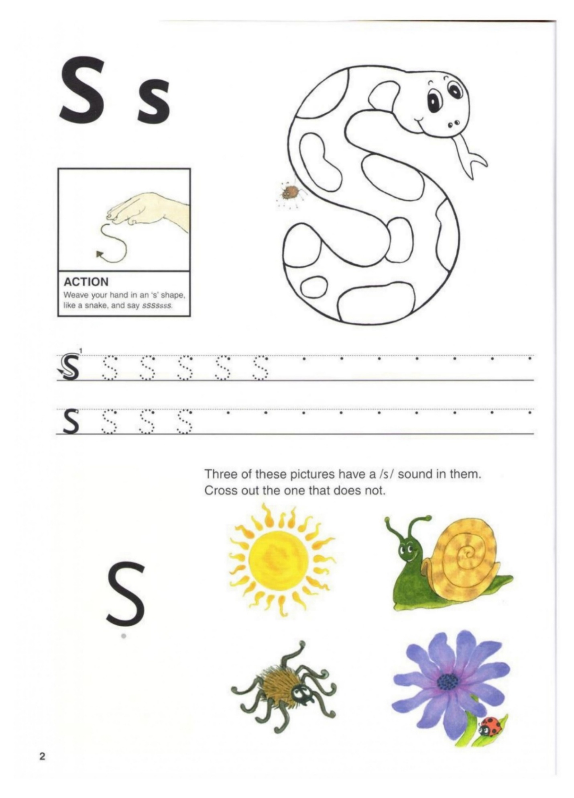
Image + Text Layout | p a pa  Keep the same lesson order and page sequence.  Use the image as the hero and place the directions in a clean text box.

Page 5 • Lesson Preview
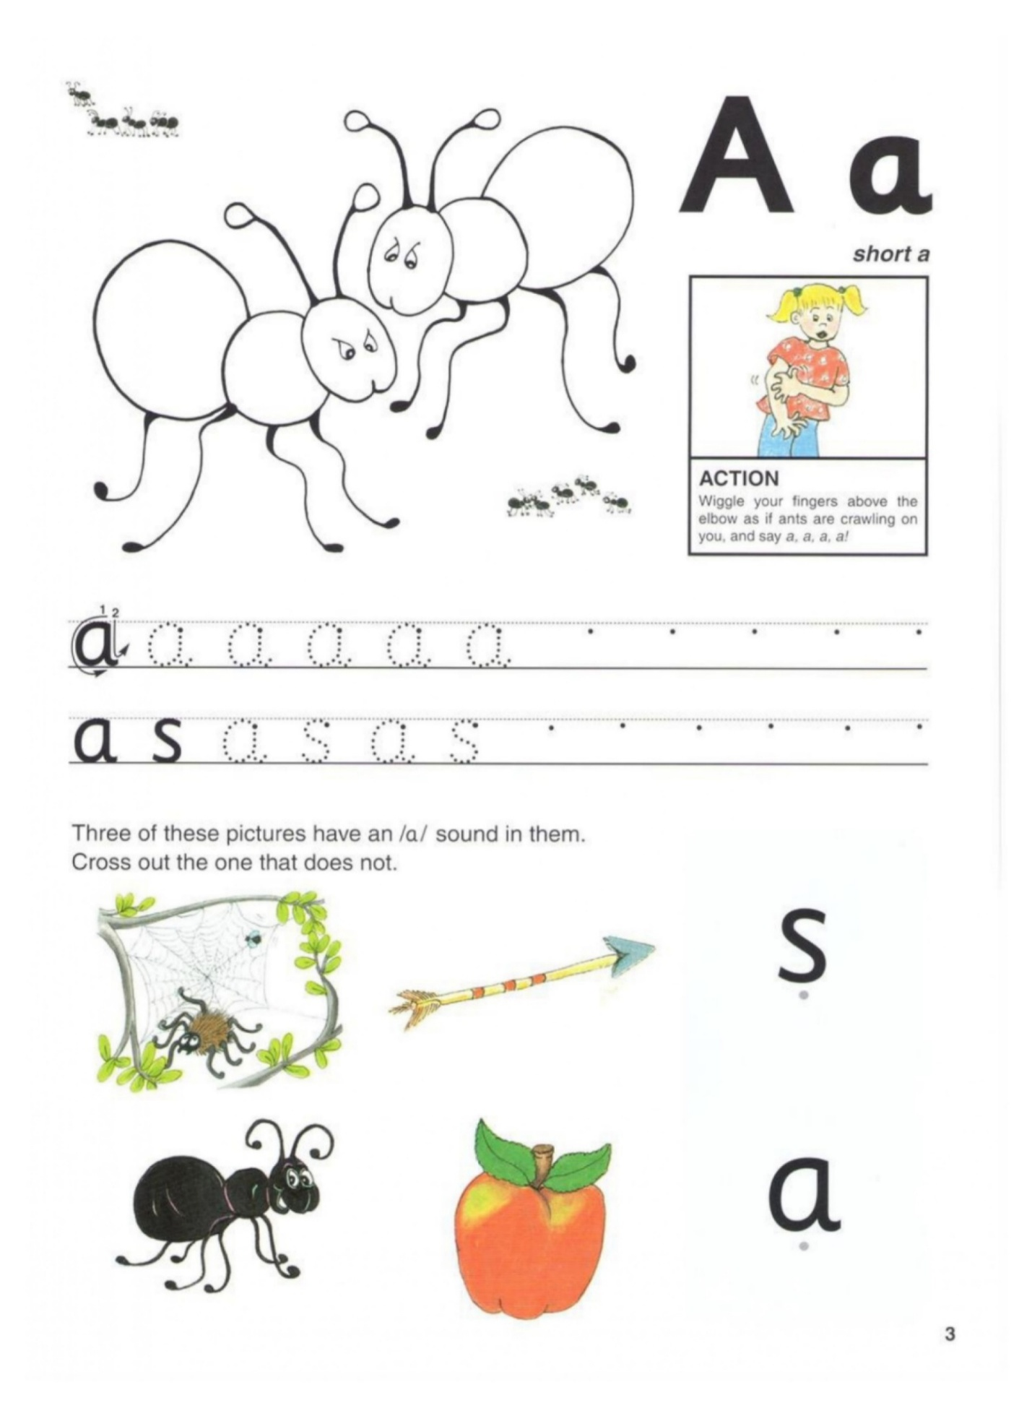
Image + Text Layout | n a na  Keep the same lesson order and page sequence.  Use the image as the hero and place the directions in a clean text box.

