Ex1
//Students(StudentID, FirstName,
//LastName, Address, Phone,
//Course1, Grade1, Course2,
//Grade2, Course3, Grade3)
Table Student{
id SERIAL [primary key]
FirstName varchar(20)
LastName varchar(30)
Address varchar(20)
Phone varchar(12)
}
Table Course{
id SERIAL [primary key]
studentId int
course varchar(10)

}

Table Grade {
id SERIAL [primary key]
studentId int
courseId int
grade int

}

Ref: Course.studentId > Student.id
Ref: Grade.studentId > Student.id
Ref: Grade.courseId > Course.id

table student{
FirstName varchar(20)
LastName varchar(30)
Address varchar(20)
Phone varchar(12)
course varchar(10)
grade varchar(5)
}

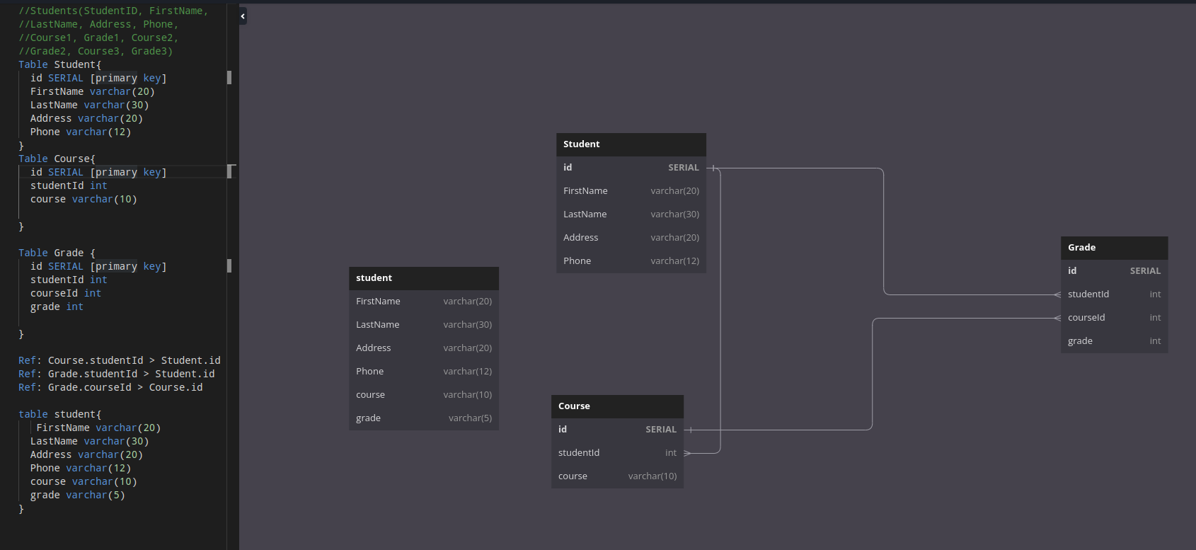
\

Ex2
//Orders(OrderID, OrderDate,
//CustomerName, CustomerAddress,
// ProductName, ProductPrice,
// Quantity)
Table Orders{
OrderId integer
OrderDate date
CustomerName varvhar
CustomerAddress varchar
ProductName varchar
ProductPrice varchar
Quantity varchar
}

Table Customer {
id SERIAL [primary key]
CustomerName varchar(20)
CustomerAddress varchar(20)
}

Table Product {
id SERIAL [primary key]
ProductName varchar(20)
ProductPrice varchar(10)

}

Table Order{
id SERIAL [primary key]
OrderDate date
customerId integer
productId integer
Quantity integer
}

Ref: Order.customerId > Customer.id
Ref: Order.productId > Product.id

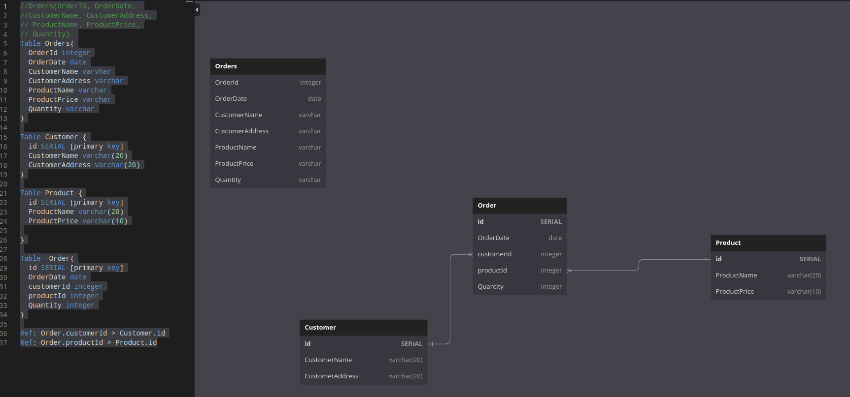

Ex3
//Movies(MovieID, Title, Director,
// Actor1, Actor2, Genre, Rating,
//Reviewer1, Reviewer2, Reviewer3)

Table Movies{
MovieId integer
Title varchar
DirectorName varchar
ActorName varchar
Genre varchar
Rating integer
Reviewer varchar

}

Table Movie {
id SERIAL [primary key]
DirectorName varchar(20)
ActorName varchar(20)
Genre integer
Rating varchar
Reviewer varchar
}

Table Actore {
id SERIAL [primary key]
ActoreName varchar(20)
movie_id integer
}

Table Reviewer{
id SERIAL [primary key]
Reviewer varchar(20)
movie_id integer
}

Ref: Actore.movie_id > Movie.id
Ref: Reviewer.movie_id > Movie.id

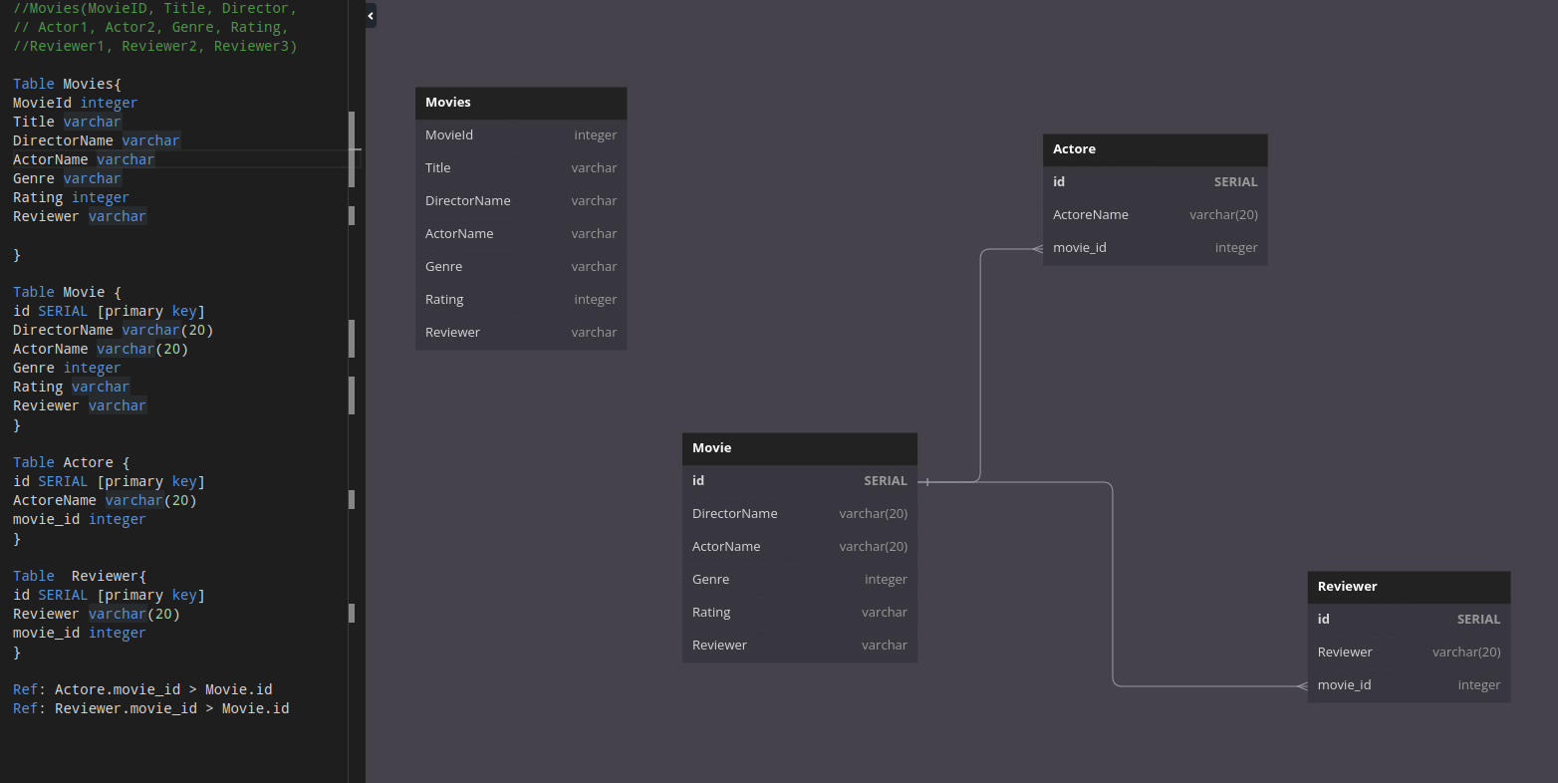
Ex4
//Courses(CourseID, CourseName,
//Instructor, Student1, Student2,
// Student3, Student4)

Table Courses{
CourseId integer
CourseName varchar
Instructor varchar
StudentName varchar
}

Table Course {
id SERIAL [primary key]
CourseName varchar(20)
Student_id integer
Instructor_id integer
}

Table Student {
id SERIAL [primary key]
StudentName varchar(20)
}

Table Instructor{
id SERIAL [primary key]
InstructorName varchar(20)
}

Ref: Course.Student_id > Student.id
Ref: Course.Instructor_id > Instructor.id

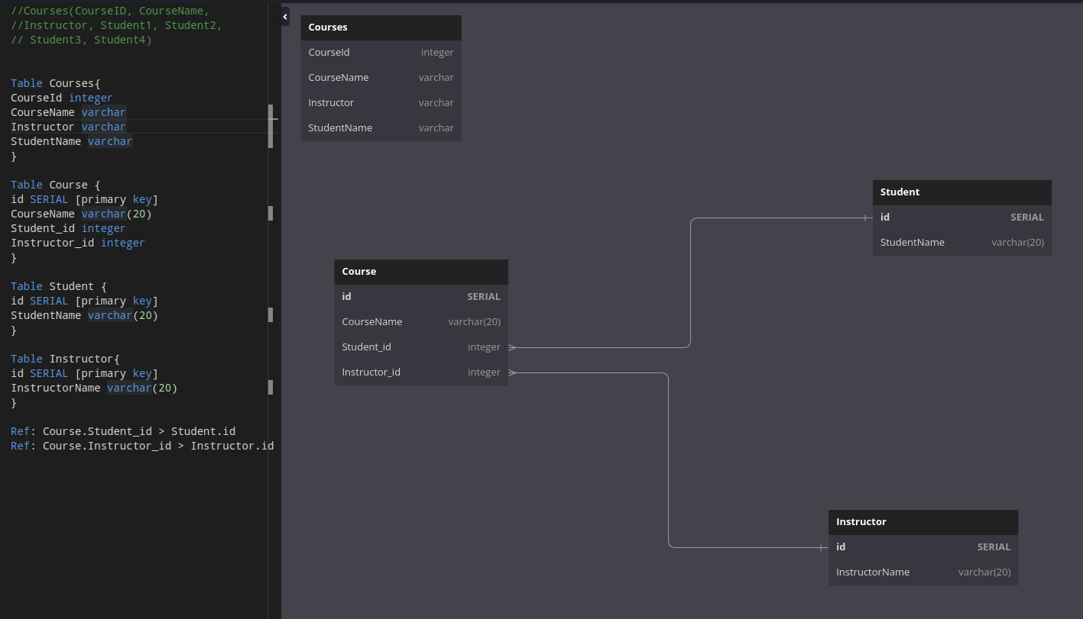

Ex5
//Books(ISBN, Title, Author,
//Publisher, YearPublished, Category,
// Quantity, Price, CustomerName,
// CustomerAddress, OrderDate)

Table Books{
ISBN integer
Title varchar
Author varchar
Publisher varchar
YearPublished date
Category varchar
Quantity integer
Price integer
CustomerName varchar
CustomerAddress varchar
OrderDate date
}

Table Author {
id SERIAL [primary key]
Author varchar
}

Table Book {
ISBN SERIAL [primary key]
Title varchar(20)
Author_id integer
Publisher varchar(20)
YearPublished date
Category varchar(10)
Price varchar(10)
}

Table Customer {
id SERIAL [primary key]
CustomerName varchar(20)
CustomerAddress varchar(20)
}

Table Order{
id SERIAL [primary key]
book_id integer
Price integer
OrderDate date
Customer_id integer
Quantity integer
}

Ref: Book.Author_id > Author.id
Ref: Order.Customer_id > Customer.id
Ref: Order.book_id > Book.ISBN

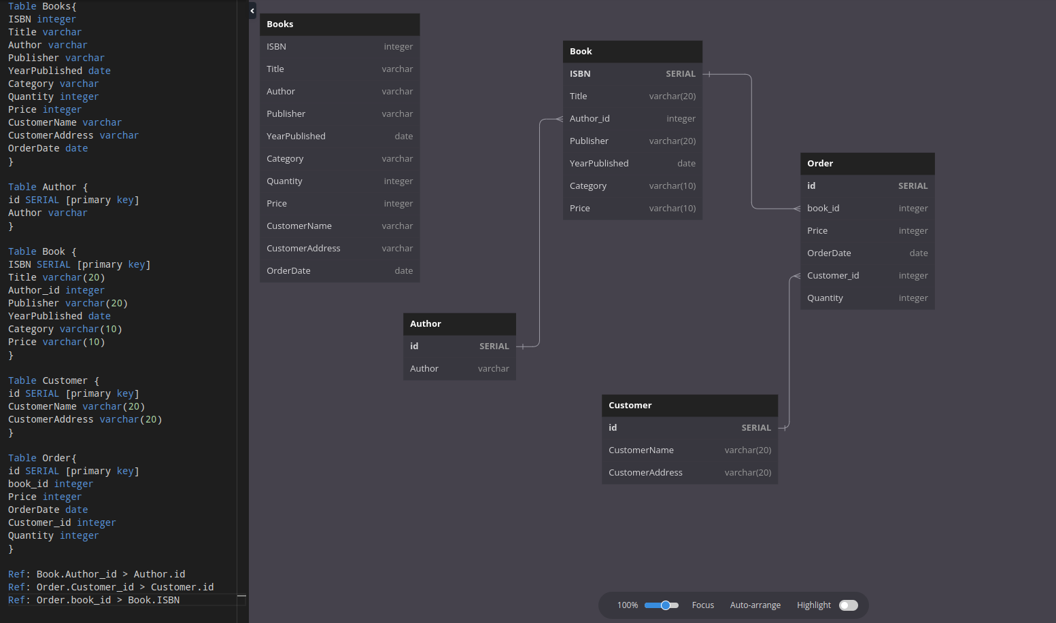

Ex6
//Employees(EmployeeID, FirstName,
// LastName, DepartmentName,
// ManagerFirstName,
//ManagerLastName, Salary)

Table Employees{
EmployeeId integer
FirstName varchar
LastName varchar
DepartmentName varchar
ManagerFirstName varchar
ManagerLastName varchar
Salary varchar
}

Table Employee {
id SERIAL [primary key]
FirstName varchar(20)
LastName varchar(20)
ManagerFirstName varchar(20)
ManagerLastName varchar(20)
Salary integer
Department_id integer
}

Table Department {
id SERIAL [primary key]
DepartmentName varchar(20)
}

Ref: Employee.Department_id > Department.id

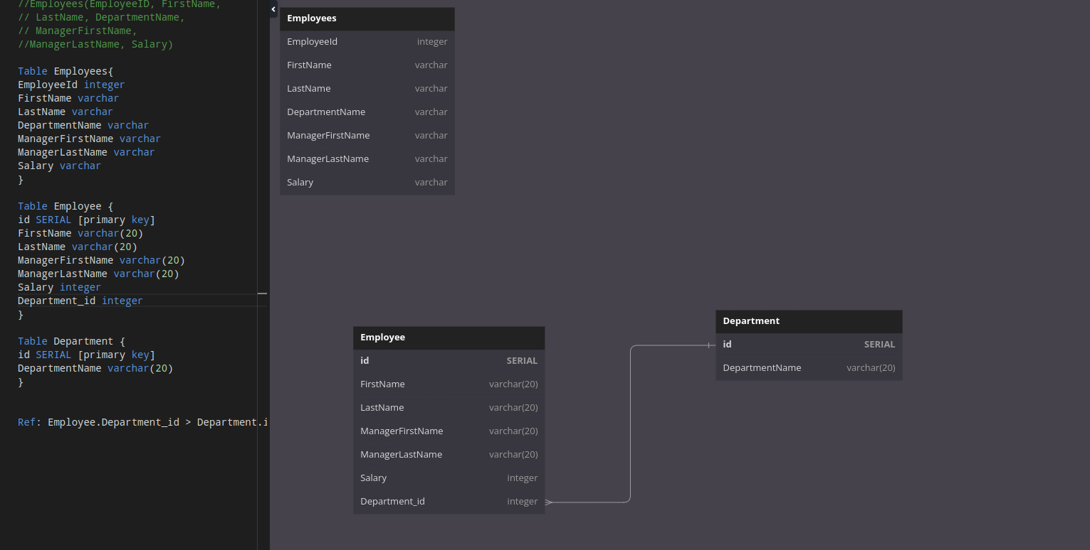

Ex7
//Invoices(InvoiceID, CustomerName,
//CustomerAddress, Product1Name,
//Product1Price, Product1Quantity,
//Product2Name, Product2Price,
//Product2Quantity, Product3Name,
// Product3Price, Product3Quantity)

Table Invoices{
InvoiceId integer
CustomerName varchar
CustomerAddress varchar
ProductName varchar
ProductQuantity varchar
ProductPrice varchar
}

Table Invoice {
id SERIAL [primary key]
ProductQuantity varchar(10)
ProductPrice varchar(10)
CustomerId integer
ProductId integer
}

Table Customer{
id SERIAL [primary key]
CustomerName varchar(20)
CustomerAddress varchar(20)
}
Table Product{
id serial [primary key]
ProductName varchar(20)
}

Ref: Invoice.CustomerId > Customer.id
Ref: Invoice.ProductId > Product.id

