CREATE DATABASE db;

\c db;

CREATE TABLE store(store_name VARCHAR(20) UNIQUE NOT NULL,store_budget CHAR(15) UNIQUE NOT NULL);
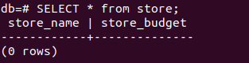

INSERT INTO store VALUES('store1','10000');
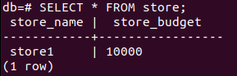

INSERT INTO store VALUES('store2','20000');

CREATE TABLE product(product_name CHAR(15),supply_prise CHAR(5),sale_price CHAR(5),provider_name CHAR(15));

\d product
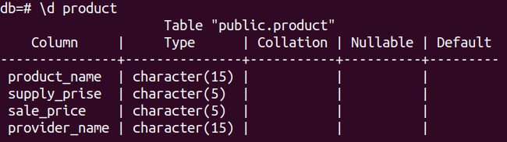

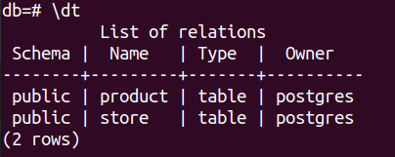
\dt

Տվյալների տիպի փոփոխություն
ALTER TABLE store
ALTER COLUMN store_budget TYPE FLOAT
USING store_budget::INTEGER;

Փոփոխություններից հետո՝

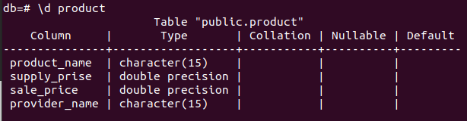

CREATE TABLE customer
(customer_name VARCHAR(20),
customer_budget FLOAT(10),
customer_email VARCHAR(20),
customer_phone INT UNIQUE NOT NULL);

\d customer
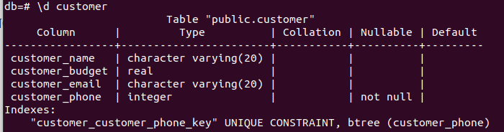

CREATE TABLE vendor
(vendor_name VARCHAR(20),
vendor_surname VARCHAR(20),
vendor_phone INT UNIQUE NOT NULL);

INSERT INTO store (store_name,store_budget) VALUES ('shop1','100000');
INSERT INTO store (store_name,store_budget) VALUES ('shop2','200000');

INSERT INTO product(product_name,supply_prise,sale_price,provider_name) VALUES ('apple','200','250','name1'),
('milk','300','500','name2'),
('juice','350','500','name3');

INSERT INTO customer(customer_name,customer_budget,customer_email,customer_phone) VALUES
('customer1','35000','customer1@mail.ru','045689861'),
('customer2','5000','customer2@mail.ru','045689862'),
('customer3','50000','customer3@mail.ru','045689863');

INSERT INTO vendor(vendor_name,vendor_surname,vendor_phone) VALUES ('vendor1','Vendor','045689811'),
('vendor2','Vendor2','045689822'),
('vendor3','Vendor3','045689833');

