Lion Roaring Automation Framework Implementation Report
Prepared For: Lion Roaring
Developed By: Excellis IT Pvt. Ltd.

1 Executive Summary
The Lion Roaring Automation Framework was developed to automate repetitive administrative workflows within the Lion Roaring web application. The automation suite was implemented using Python and Selenium WebDriver with a reusable framework architecture to improve regression testing efficiency, reduce manual effort, and ensure consistent execution across critical business modules.
The framework automates business-critical operations such as authentication, member management, role management, membership configuration, promotional code management, messaging, reporting, and audit log validation. Each automation follows a standardized execution process that includes browser initialization, authentication, business workflow execution, validation, logging, screenshot capture, and browser cleanup.

2 Project Objective
The objective of this automation implementation was to:
- Reduce repetitive manual testing.
- Improve regression testing efficiency.
- Increase consistency of test execution.
- Provide reusable automation scripts.
- Reduce release validation time.
- Improve software quality before deployment.

3 Technology Stack
Technology | Purpose
Python | Automation Programming Language
Selenium WebDriver | Browser Automation
ChromeDriver | Browser Driver
dotenv | Environment Configuration
Logging | Execution Tracking
Screenshot Utility | Evidence Collection

4 Framework Architecture
Insert architecture diagram here.
Automation Script

↓

Reusable Login Framework

↓

Browser Initialization

↓

Business Module

↓

Validation

↓

Logs + Screenshots

↓

Execution Complete

5 Automation Modules

5.1 Login & Logout Automation

Objective
Automate the user authentication and logout workflow.

Automation Flow
- Launch Chrome Browser
- Open Lion Roaring
- Accept Disclaimer
- Enter Credentials
- Submit OTP
- Validate Dashboard
- Logout Successfully

Features
✔ Automated Login
✔ OTP Submission
✔ Dashboard Validation
✔ Automated Logout
✔ Screenshot Capture
✔ Execution Logging

Terminal Execution
Insert Login_Logout terminal screenshot
Caption:
Figure 5.1 – Successful execution of Login & Logout automation.

Application Screenshot
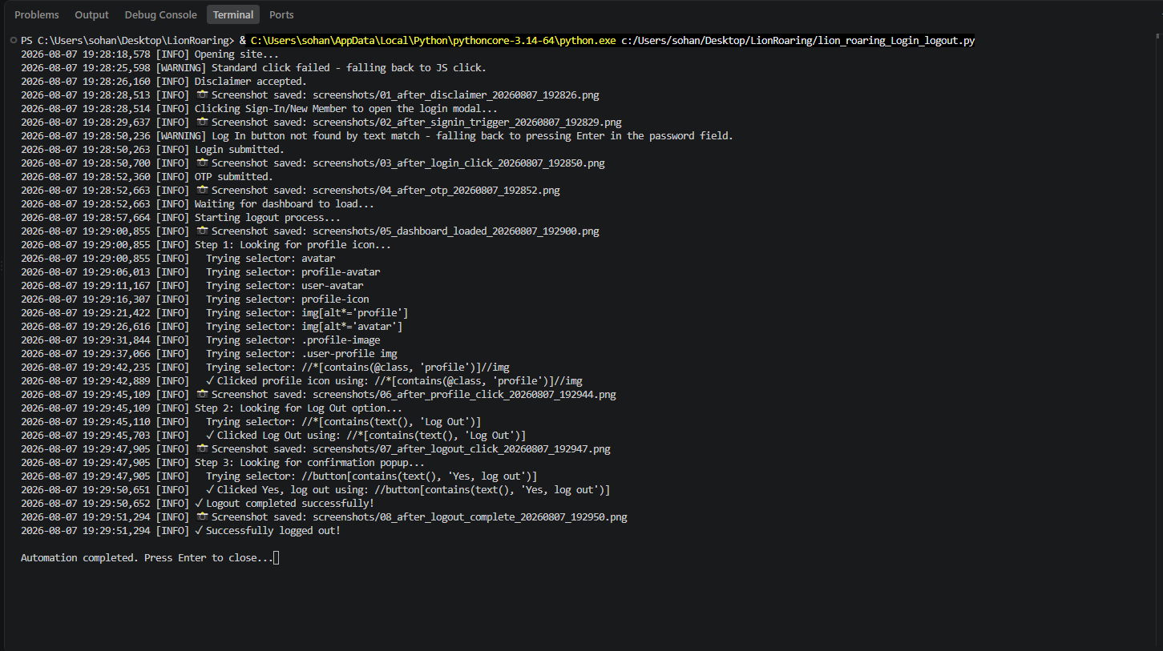

Figure 5.2 – Successful login and logout to the application.

5.2 Forgot Password Automation

Objective
Validate the Forgot Password workflow.

Steps Performed
- Open Login Window
- Click Forgot Password
- Enter Registered Email
- Submit Password Reset Request
- Validate Success Message

Terminal Execution
Insert Forgot_Password terminal screenshot.

Result
Password reset request submitted successfully.
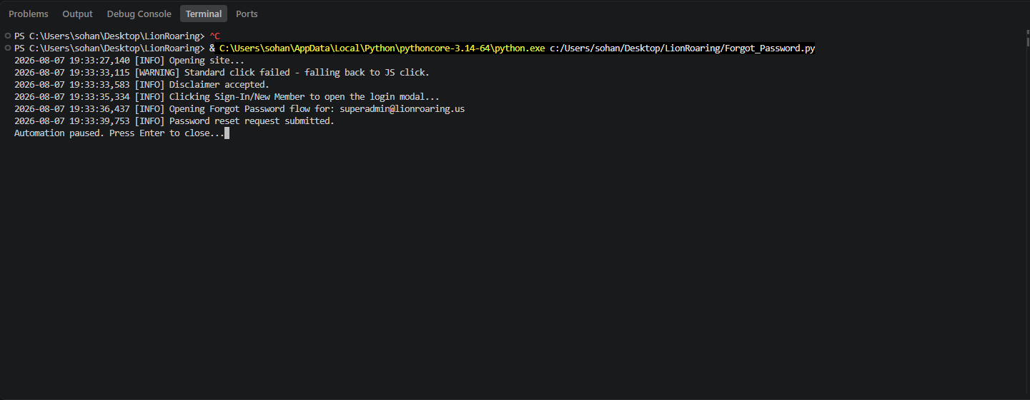

5.3 Add Member Automation

Objective
Automate member creation.

Steps Performed
- Login
- Navigate to Add Member
- Populate User Information
- Populate Personal Information
- Select Administrator Role
- Assign Permissions
- Save Member
- Validate Success

Validation
- Member created successfully.
- Success message displayed.
- Screenshot captured.

Terminal Execution

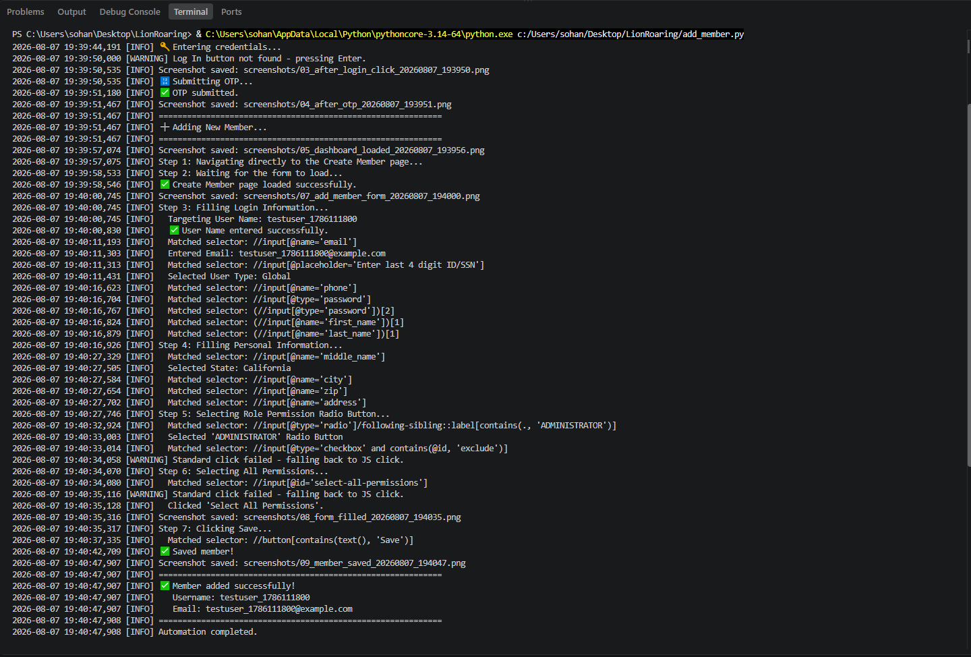

Application Screenshot
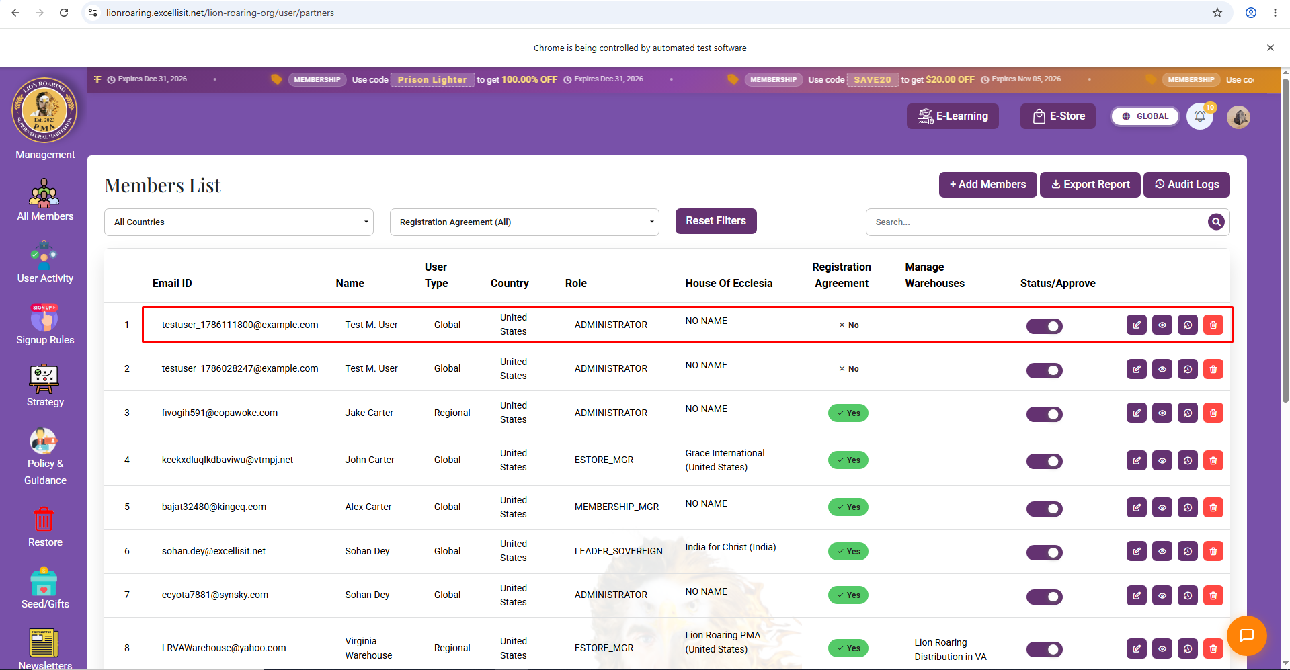

5.4 Role Permission Automation

Objective
Automate role creation.

Steps Performed
- Navigate to Role Permission
- Create New Role
- Assign Permissions
- Save Role
- Validate Success

Terminal Execution
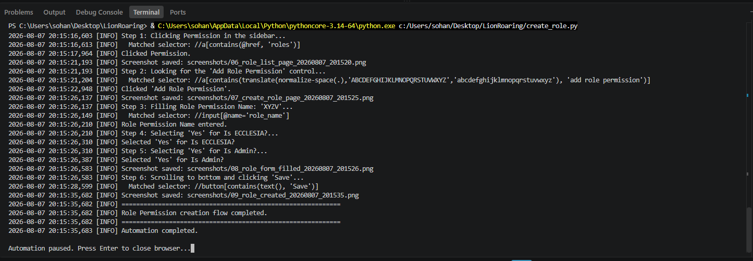

Result
Role Permission created successfully.

5.5 Membership Plan Automation

Objective
Automate creation of Membership Plans.

Steps
- Navigate to Membership Plans
- Enter Tier Name
- Configure Pricing
- Configure Benefits
- Save Membership

Terminal Execution
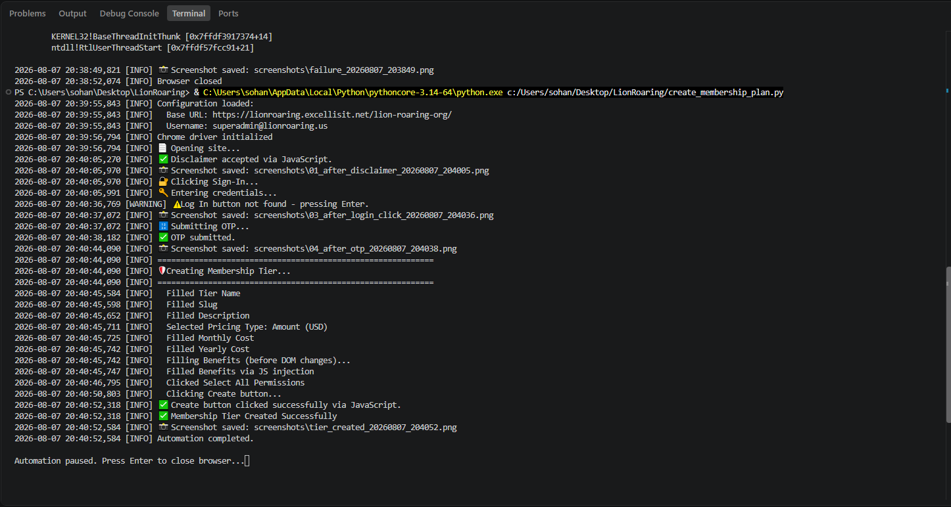

Result
Membership Tier created successfully.

5.6 Membership Promo Code Automation

Objective
Automate Membership Promotional Code creation.

Workflow
- Open Promo Code Page
- Populate Details
- Configure Dates
- Configure Discount
- Create Promo Code

Terminal Screenshot
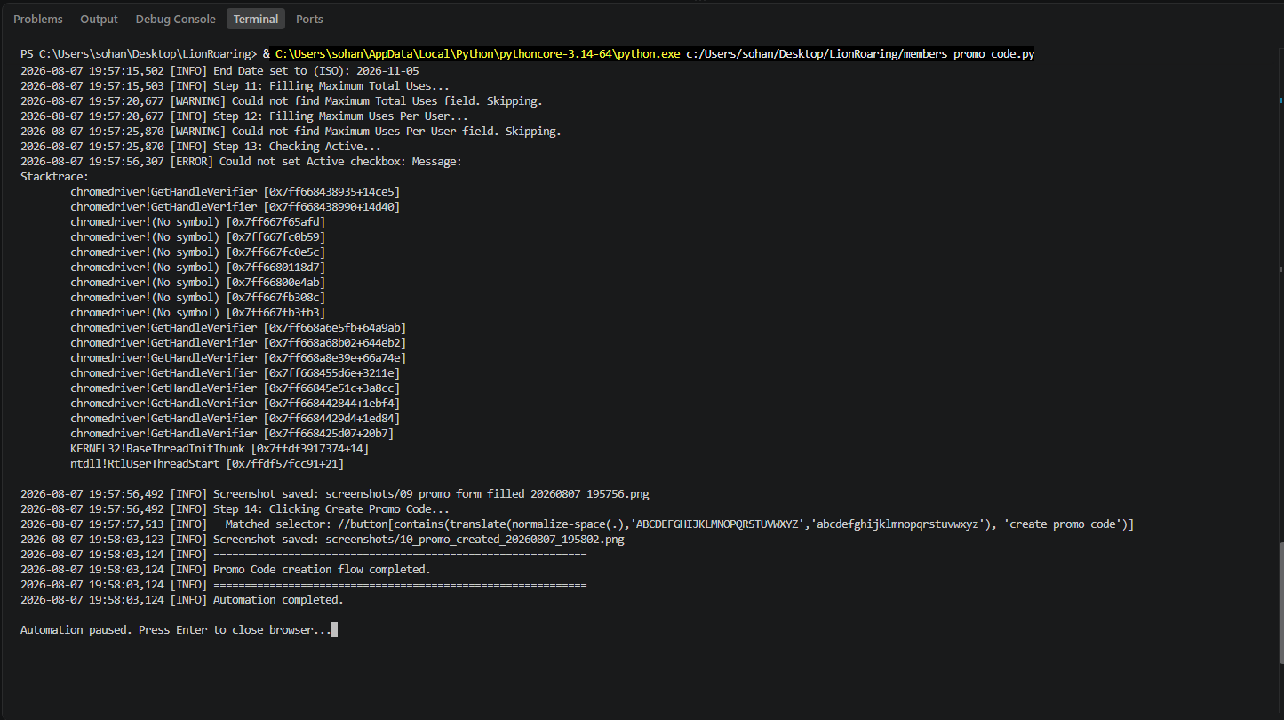
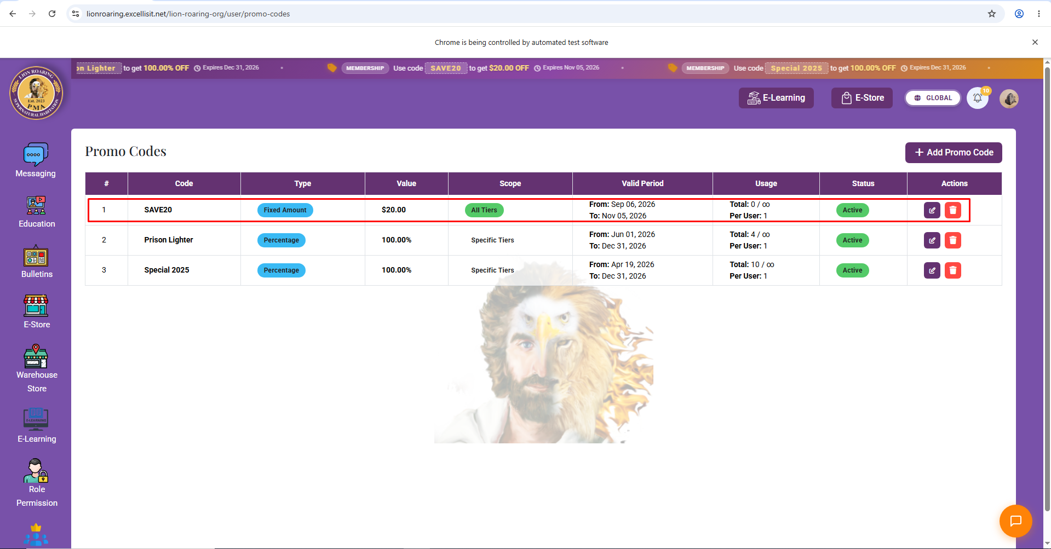

Result
Promo Code created successfully.

5.7 E-Store Promo Code Automation

Objective
Automate promotional code management for the E-Store.

Workflow
- Open E-Store Promotion
- Enter Code Details
- Configure Discount
- Save

Terminal Screenshot
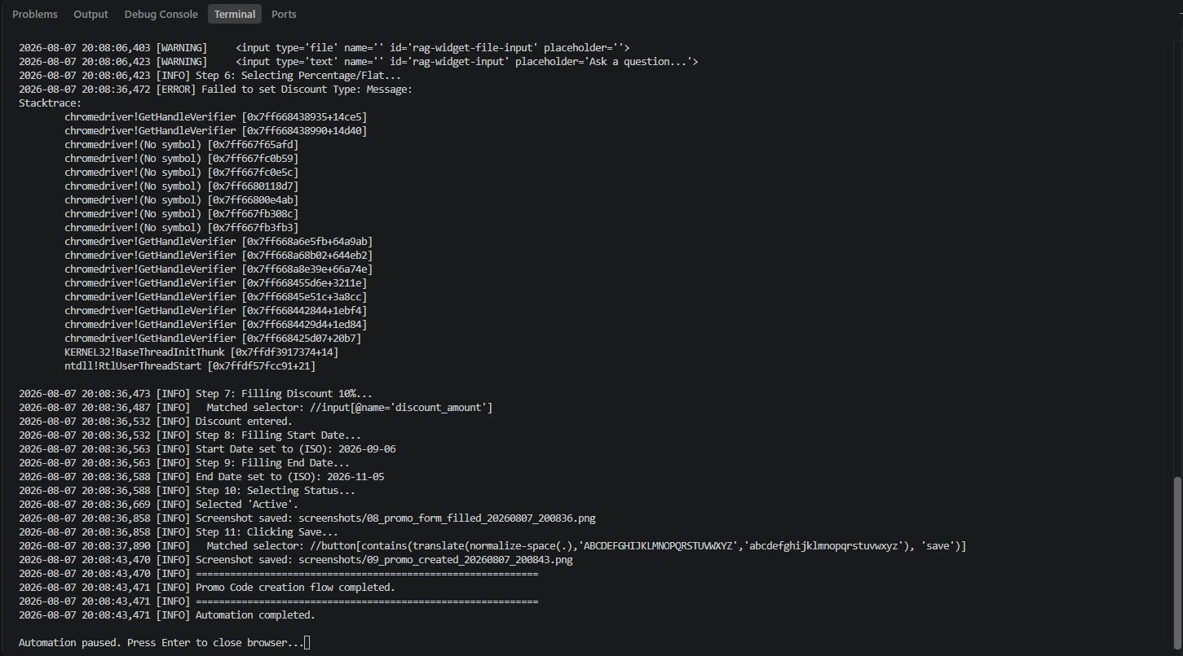

Application Screenshot
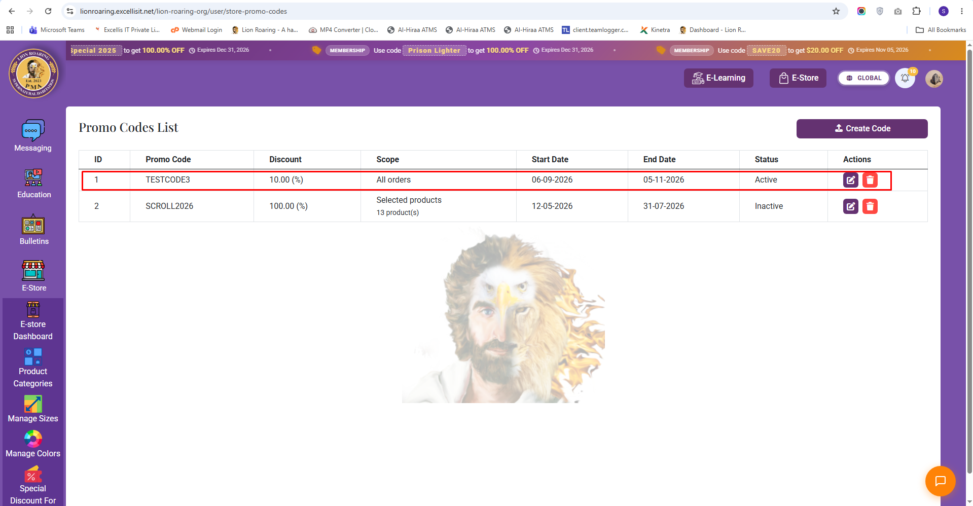

5.8 E-Store Purchase Automation

Objective
Validate the end-to-end E-Store purchase workflow by automating product selection, checkout navigation, and payment initiation.

Workflow
- Login to the application
- Navigate to the E-Store
- Search and select the desired product
- Open the product details page
- Proceed to checkout
- Validate checkout page navigation
- Attempt payment initiation

Execution Summary
The automation successfully completed the following activities:
- Successfully navigated to the E-Store.
- Selected the target product.
- Opened the product details page.
- Added the product to the checkout flow.
- Successfully navigated to the payment page.
During the payment stage, the automation intentionally stopped before completing the transaction.

Payment Gateway Limitation
The Lion Roaring application uses a secure third-party payment gateway for processing transactions. For security and financial compliance reasons, the payment gateway requires real payment credentials and additional validations that are not suitable for execution within an automated regression test.
As a result, the automation framework validates the checkout navigation and payment initiation only. The final payment confirmation is intentionally excluded from the automation scope to prevent unintended financial transactions during test execution.
The error shown in the execution log occurred while attempting to interact with the protected payment card input field. This behavior is expected and does not indicate a defect in the automation framework or the application under test.

Result
Validation Item | Status
Login | ✅ Passed
Product Search | ✅ Passed
Product Selection | ✅ Passed
Checkout Navigation | ✅ Passed
Checkout Page Validation | ✅ Passed
Payment Initiation | ✅ Passed
Final Payment Transaction | ⚠️ Not Executed (Intentionally Excluded)

Evidence
Terminal Execution of E-Store Purchase Automation
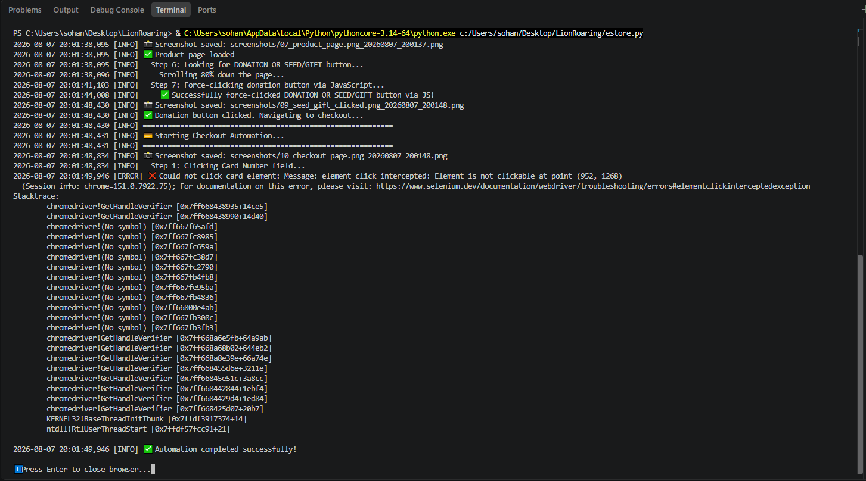

5.9 Chat Automation

Objective
Validate automated chat messaging.

Workflow
- Navigate to Chats
- Select Contact
- Enter Message
- Send Message
- Validate Delivery

Terminal Screenshot
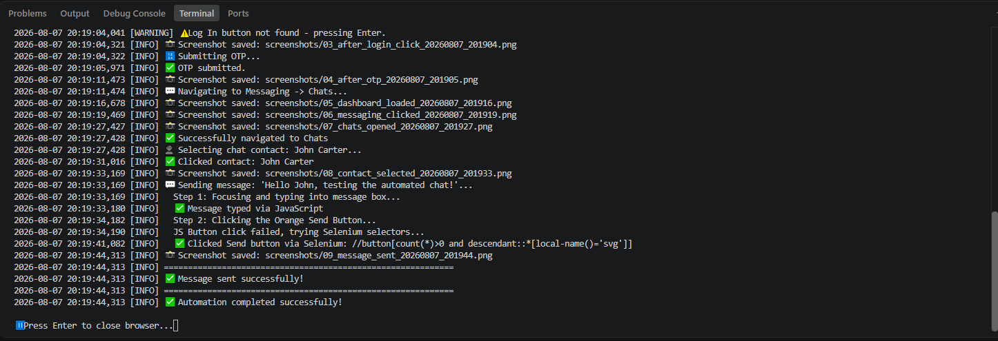

Result
Message delivered successfully.

5.10 Member Search & Filter Automation

Objective
Validate search functionality.

Features Tested
- Name Search
- Email Search
- Dynamic Search
- Reset Filters

Terminal Screenshot
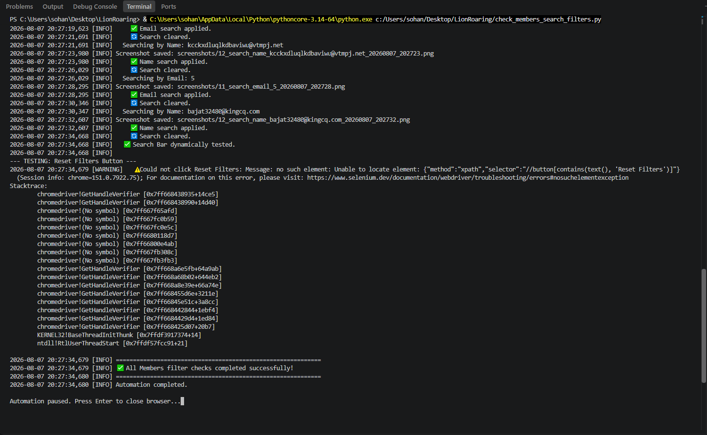

5.11 Export Members Report

Objective
Validate member export functionality.

Workflow
- Navigate to Members
- Click Export
- Download Report
- Validate Download

Terminal Screenshot
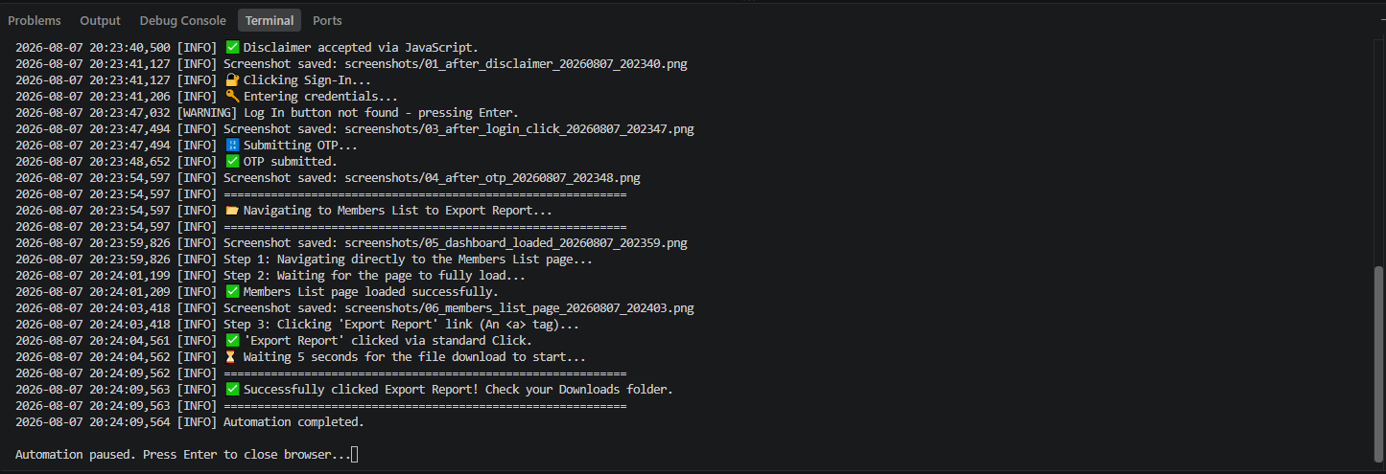

5.12 Audit Log Export Automation

Objective
Validate Audit Log export.

Workflow
- Navigate Audit Logs
- Export Report
- Verify Download

Terminal Screenshot
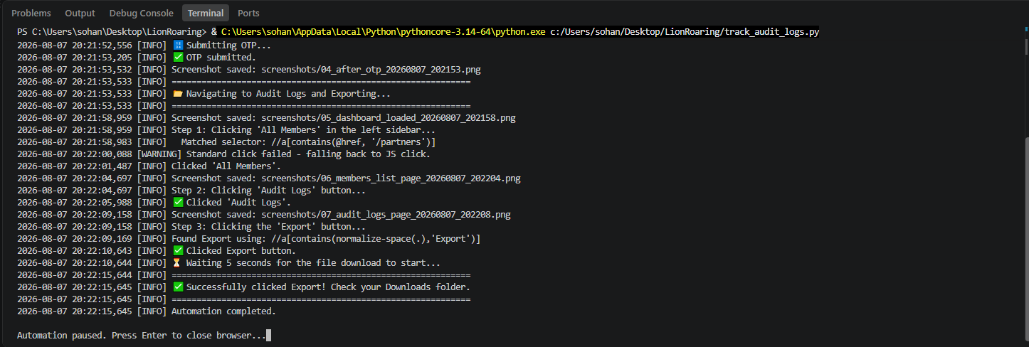

5.13 Activity List Automation

Objective
Validate user activity listing.

Workflow
- Open Activity List
- Read Activity Records
- Validate Data

Terminal Screenshot
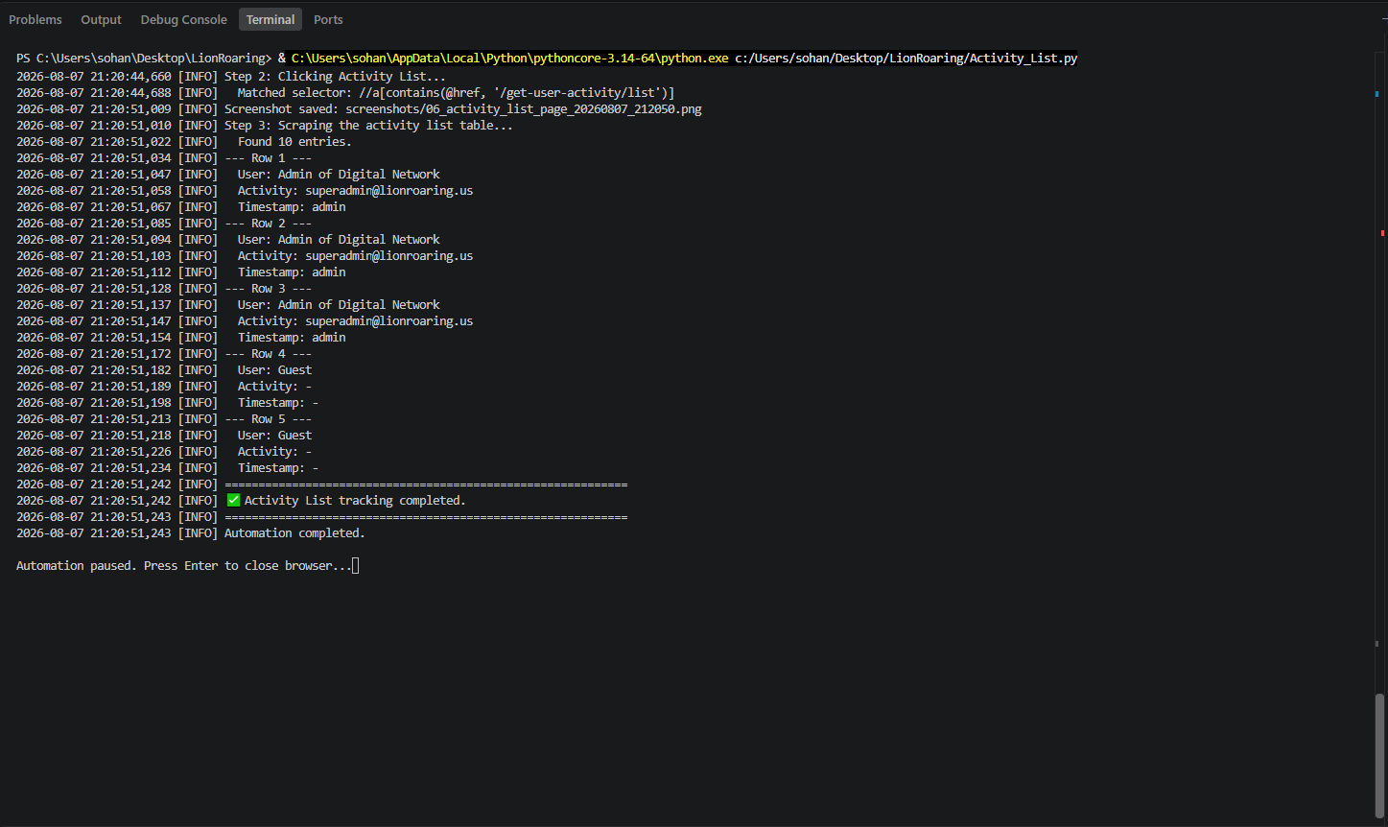

6 Logging & Evidence Collection
During execution, every automation module generates detailed logs that record each significant action, including page navigation, data entry, element interaction, validation results, warnings, and exceptions. Screenshots are captured automatically at important checkpoints and upon failures, providing execution evidence and supporting troubleshooting activities.

7 Error Handling
The framework incorporates robust error-handling mechanisms to improve execution stability.
Implemented strategies include:
- JavaScript click fallback when standard Selenium clicks are intercepted.
- Explicit wait conditions for dynamic page elements.
- Screenshot capture upon unexpected exceptions.
- Structured logging for error diagnosis.
- Graceful browser cleanup after execution.

8 Benefits
The automation framework provides the following benefits:
- Reduced manual regression effort.
- Faster validation of business-critical workflows.
- Improved execution consistency.
- Reusable automation components.
- Detailed execution logs and screenshots.
- Easier maintenance and scalability.

9 Future Enhancements
Potential enhancements include:
- Pytest integration.
- Allure reporting.
- Jenkins / GitHub Actions CI/CD integration.
- Parallel execution.
- Cross-browser automation.
- Email execution reports.

10 Conclusion
The Lion Roaring Automation Framework has successfully automated key administrative workflows within the application using a reusable Selenium-based architecture. The framework improves regression testing efficiency, reduces manual effort, and provides reliable execution evidence through structured logging and automated screenshots. Its modular design allows future business workflows to be incorporated with minimal changes, supporting the long-term scalability and maintainability of the automation solution.

