# File permissions in Linux

## Project description

I am a security professional at a large organization. I mainly work with the research team. Part of my job is to ensure users on this team are authorized with the appropriate permissions. This helps keep the system secure.

My task is to examine existing permissions on the file system. I will need to determine if the permissions match the authorization that should be given. If they do not match, I will need to modify the permissions to authorize the appropriate users and remove any unauthorized access.

## Check file and directory details

Please, refer to the "**Current_file_permissions**" file for the current permissions of the files and directory. Those permissions are also presented in the screenshot below.

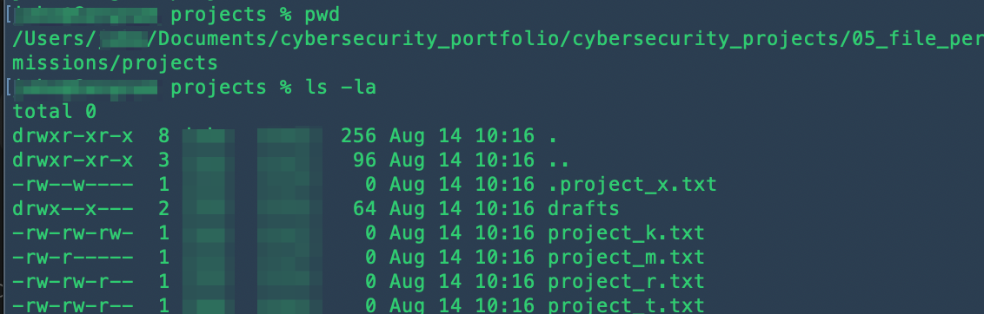

I used pwd to print a working directory.

Then I used ls -la to list the contents of a directory. The option -l is to display file permissions which I will describe in the next section. The option -a is to list all files including hidden files that start with a dot .

## Describe the permissions string

Linux has a 10-character string to show permissions. An example is drwx--x--- in the screenshot above for the drafts folder.

1. d for directory. - for file.
2. r for User's read permissions. - for User's no read permissions.
3. w for User's write permissions. - for User's no write permissions.
4. x for User's execute permissions. - for User's no execute permissions.
5. r for Group's read permissions. - for Group's no read permissions.
6. w for Group's write permissions. - for Group's no write permissions.
7. x for Group's execute permissions. - for Group's no execute permissions.
8. r for Other's read permissions. - for Other's no read permissions.
9. w for Other's write permissions. - for Other's no write permissions.
10. x for Other's execute permissions. - for Other's no execute permissions.

User is the owner of the file. Group is a set that the owner is a part of. Other is all other users on the system.

## Change file permissions

The organization does not allow others to have write access to any files. Based on the permissions established in Step 3, identify which file needs to have its permissions modified. Use a Linux command to modify these permissions.

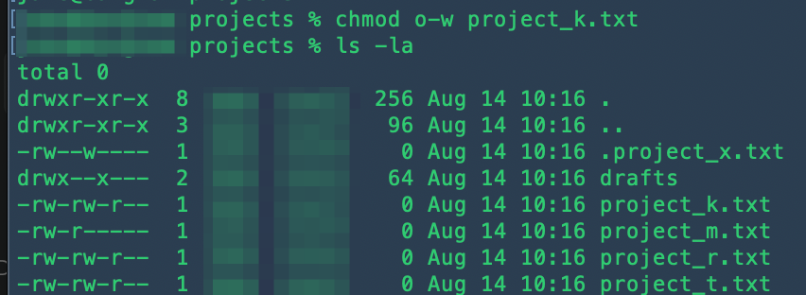

I used chmod to change the permission of project_k.txt to remove write permissions from others by specifying o-w between chmod and the file name.

I used ls -la to check whether the right permissions are granted.

## Change file permissions on a hidden file

The research team has archived **.project_x.txt**, which is why it’s a hidden file. This file should not have write permissions for anyone, but the user and group should be able to read the file. Use a Linux command to assign **.project_x.txt** the appropriate authorization.

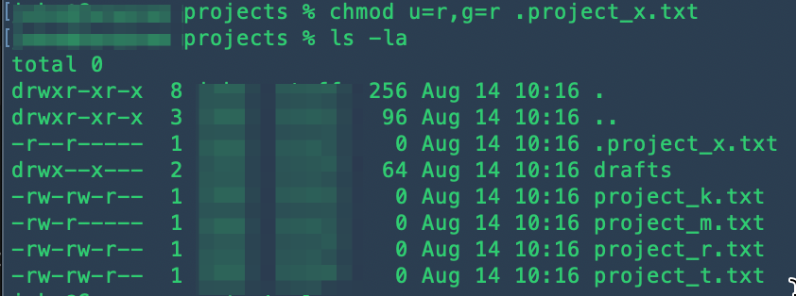

I used chmod to change the permission of .project_x.txt to assign only read permissions to both user and group by specifying u=r,g=r between chmod and the file name.

I used ls -la to check whether the right permissions are granted. The -a option enables us to see hidden files and directories.

## Change directory permissions

The files and directories in the projects directory belong to the ⬛ user. Only ⬛ should be allowed to access the **drafts** directory and its contents. Use a Linux command to modify the permissions accordingly.

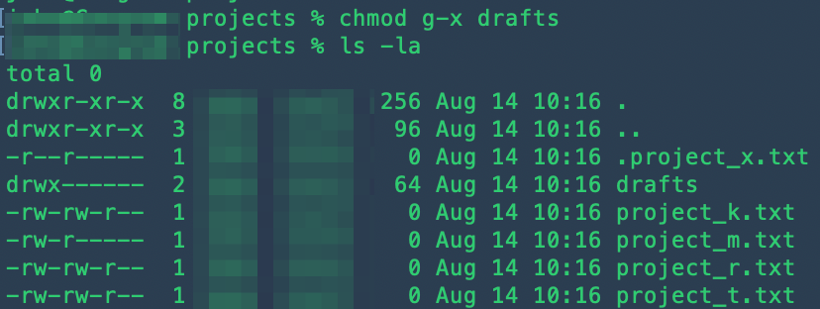

I used chmod to change the permission of the drafts directory to remove any existing (execute) permission from the group by specifying g-x between chmod and the directory name.

I used ls -la to check whether the right permissions are granted.

## Summary

As a cybersecurity professional in the research team in this scenario, I am required to change the permissions of files and directories in accordance with the regulations of the company.

Linux is a go-to tool for a permission change. Linux has a 10-character permissions string to show permissions of User, Group, and Other. It consists of the first character for a file vs a directory. The next three characters are User's read, write, and execute permission. The next three characters are Group's read, write, and execute permission. The last three characters are Other's read, write, and execute permission.

The chmod and ls in Linux are to change the permissions and list files, respectively. The syntax for chmod is like chmod [new permission] [file or directory name] . The ls command has -la options: -l and -a combined here. The -l option is to show a detailed list of permissions, whereas the -a option is to show hidden files and directories.