

By Pranit Dalvi

Introduction

This document provides a detailed overview of the core architectural patterns and deployment tools critical for modern software engineering and DevOps practices.

1. ***Monolithic vs. Microservices Architecture***

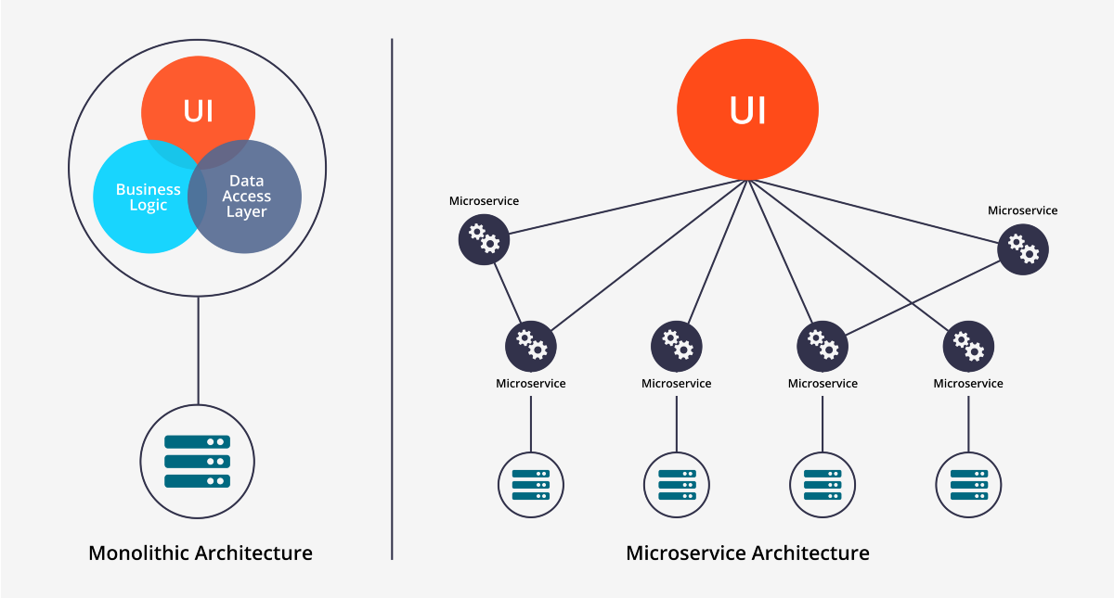

These two patterns dictate the fundamental structure and organization of an application's components.9

**1.1. Monolithic Architecture**

A monolithic application is built as a **single, unified, and tightly integrated unit**. All components—such as the user interface, business logic, and data access layers—are combined into one large codebase and deployed together as a single executable.

**Characteristics of Monoliths:**

* **Tight Coupling:** Components are deeply intertwined. A small change in one module often necessitates rebuilding and redeploying the entire application.
* **Shared Resources:** The entire application typically shares a single, large database, making any schema changes highly risky.
* **Scaling Inefficiency:** Scaling requires replicating the entire application instance, even if only one small function is experiencing heavy load. This is wasteful of resources.
* **Technology Lock-in:** The entire system must generally use the same programming language and framework, limiting the ability to adopt newer, specialized technologies.
* **Slow Development:** As the codebase grows, it becomes harder for large teams to manage and maintain, slowing down the development cycle.

**1.2. Microservices Architecture**

The microservices architectural style structures an application as a **collection of small, independent services**, where each service is built around a specific business capability (e.g., "Payment Processing," "User Authentication").

**Characteristics of Microservices:**

* **Loose Coupling:** Services are independent. They communicate via well-defined APIs, typically using lightweight protocols like HTTP/REST or asynchronous messaging.
* **Decentralized Data:** Each service manages its own dedicated database, ensuring data autonomy and preventing services from directly accessing another's data stores.
* **Efficient Scaling:** Scaling is surgical and efficient. Only the specific service under high demand needs to be replicated, optimizing resource usage.
* **Polyglot Persistence/Programming:** Teams can choose the best-suited programming language, framework, and database for *each* service, enhancing performance and developer productivity.
* **Resilience and Isolation:** If one service fails (e.g., the Recommendation service crashes), the failure is isolated, and the rest of the application remains functional.
* **Faster Deployment:** Services can be deployed, updated, or rolled back individually without impacting the availability of the rest of the system.

***2. Blue-Green Deployment Environment***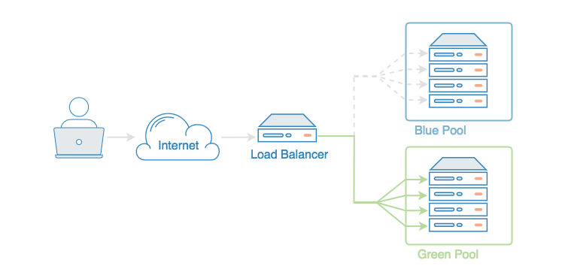

Blue-Green Deployment is a technique that minimizes downtime and risk during application updates by running two identical production environments.

**The Phases of Blue-Green Deployment**

1. **The Blue Environment (Live):** This is the current version of the application actively serving all production traffic. It is the known stable state.
2. **The Green Environment (Staging):** This is an exact clone of the Blue environment. The **new version** of the application, including any code changes and database migrations, is deployed here. It remains isolated from live traffic.
3. **Validation:** Extensive automated and manual tests are executed against the Green environment to ensure the new version functions correctly in a production-like setting.
4. **The Switch (Traffic Routing):** Once validation is complete, the network load balancer or router is instantly reconfigured to send all incoming user traffic from the Blue environment to the Green environment. This switch is seamless and results in **near-zero downtime**.
5. **Rollback and Standby:** The old Blue environment is kept live but idle as a **hot standby**. If any critical issues are discovered in the Green environment after the switch, traffic can be instantly rolled back to the stable Blue environment simply by flipping the router setting.

**Key Benefits**

* **Zero Downtime:** Users experience no service interruption during the deployment process.
* **Reduced Risk:** Provides a guaranteed and immediate rollback path, making deployments much safer.
* **Production Testing:** Allows the new version to be tested in a production-ready infrastructure environment before exposure to live traffic.

***3. Basic Docker Commands***

Docker is the essential tool for packaging applications into containers, which is necessary for adopting both Microservices and Blue-Green deployment strategies.

**Docker Image and Lifecycle Commands**

|  |  |  |
| --- | --- | --- |
| Command Syntax | Purpose | Detailed Explanation |
| docker build -t name:tag . | **Build an Image** | Creates a reusable image from the Dockerfile located in the current directory (.). The -t flag tags the image with a name and optional version (e.g., web-app:v2). |
| docker run -d -p 8080:80 image-name | **Run a Container** | Creates a new container instance and starts it. The -d flag runs it in **detached mode** (background). The -p flag maps the host machine's port (8080) to the container's internal port (80). |
| docker ps | **List Running Containers** | Displays a list of all containers currently in the **Running** state, along with their assigned ports, IDs, and image names. |
| docker logs container-id | **View Container Logs** | Retrieves the standard output and standard error logs from a running or stopped container. Essential for troubleshooting and debugging application issues. |
| docker exec -it container-id bash | **Execute Command Inside** | Executes a command inside a running container. The -it flags are typically used to open an **interactive terminal session** (like bash or sh) for inspecting the container's environment. |
| docker stop container-id | **Stop a Container** | Sends a SIGTERM signal to stop a running container gracefully. |
| docker rm container-id | **Remove a Container** | Permanently deletes a container instance from the disk. This can only be done on containers that are stopped. |
| docker rmi image-name | **Remove an Image** | Deletes a local Docker image. You must first remove all containers that were created from that image. |

***4. Kubernetes Overview (K8s)*** 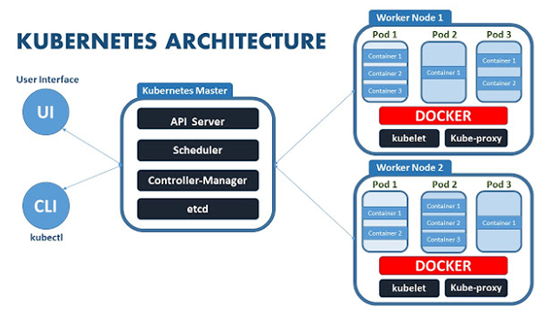

Kubernetes (often abbreviated as K8s) is the industry standard open-source platform for orchestrating, or automatically managing, containerized applications at scale.

**Cluster Architecture**

A Kubernetes cluster is composed of two main types of machines (nodes):

1. **Control Plane (Master Node):** This component manages the worker nodes and the Pods in the cluster. It contains critical elements like the **API Server** (the cluster's central management point), the **Scheduler** (assigns work to nodes), and **etcd** (the cluster's key-value store, holding the desired state).
2. **Worker Nodes:** These are the machines that provide the compute resources (CPU, RAM) and run your applications. Each Worker Node runs the **Kubelet** agent, which communicates with the Control Plane and executes container operations.

**Key Kubernetes Objects**

* **Pod:**
  + **Definition:** The **smallest, most basic deployable unit** in Kubernetes. A Pod typically represents a single instance of a running process (or microservice).
  + **Function:** It often contains one main application container and sometimes secondary "sidecar" containers that share the same network namespace and storage volumes.
* **Deployment:**
  + **Definition:** A controller object that provides a **declarative way** to manage the desired state of your application.
  + **Function:** It automatically handles scaling, self-healing (replacing failed Pods), and performing controlled **rolling updates** of your application to new versions.
* **Service:**
  + **Definition:** An abstraction that provides **stable networking** for a set of Pods.
  + **Function:** Because Pods are ephemeral and their IP addresses change frequently, a Service provides a single, permanent IP address and DNS name. It acts as a load balancer, directing traffic to the correct running Pods.
* **Volume:**
  + **Definition:** A piece of storage attached to a Pod.
  + **Function:** Unlike the container's internal filesystem (which is destroyed when the container stops), Volumes ensure that application data **persists** even if the Pod is restarted, moved, or deleted.

1. ***Docker Implementation: The Dockerfile***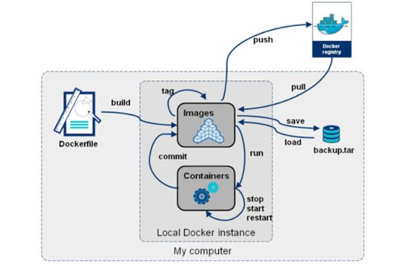

**Installation**

Docker can be installed on different operating systems such as Windows, macOS, and Linux.  
After installation, Docker runs as a background service and allows interaction through the Docker Command Line Interface (CLI) or Docker Desktop GUI.  
Verification of the installation is usually done by running a sample container to confirm the setup is functioning correctly.

**Running Containers**

Once Docker is installed, users can download and run pre-built container images from Docker Hub. Each container runs an isolated instance of an application. Docker allows mapping of ports between the container and the host system, enabling applications running inside containers to be accessed externally.

**Building Custom Images**

Custom Docker images are built using a configuration file called a **Dockerfile**, which defines the environment setup, dependencies, and commands required to run an application.  
Once the image is created, it can be executed as a container, providing a reproducible and portable environment for the application.

**Volumes for Data Storage**

Docker volumes are used for persistent storage. They allow data generated by containers to be stored outside of the container’s file system so that it remains available even when containers are stopped, updated, or deleted.  
This feature is essential for database-driven or stateful applications.

**Networking in Docker**

Docker provides several networking options to enable communication between containers.  
Containers can be connected to the same network to communicate internally, or they can expose ports for external access.  
This facilitates the creation of distributed applications where different services interact with each other seamlessly.

**Docker Compose**

Docker Compose is a tool used to define and manage multi-container applications.  
By using a single configuration file, multiple services can be started, stopped, and managed together.  
This is particularly useful for full-stack applications where a backend, frontend, and database service need to run simultaneously.

**Image Distribution via Docker Hub**

Docker Hub acts as a cloud-based registry for storing and sharing container images.  
Once an image is created locally, it can be pushed to Docker Hub, making it accessible for download and reuse by other systems or team members.  
This simplifies deployment and promotes version control of containerized applications.

**Real-World Implementation**

In practical environments, Docker is often used to containerize complex multi-service applications.  
For example, a web application might include a frontend, backend, and database service, each running in its own container.  
Docker Compose can orchestrate these services, allowing them to start and communicate automatically within a shared network.

**Advantages of Docker Implementation**

* Ensures consistency across environments
* Lightweight and fast compared to virtual machines
* Simplifies scaling and deployment of applications
* Supports continuous integration and continuous delivery (CI/CD)
* Enables better resource utilization and portability