EXCESS: Monitoring Framework

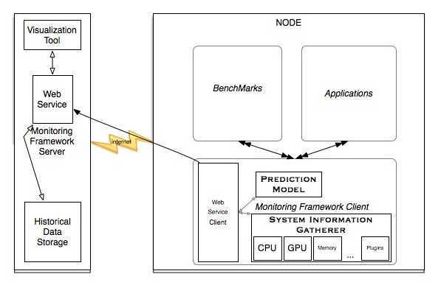

Figure 1: Excess monitoring Framework

This architecture for the Monitoring framework is based on the “producer-consumer” concept, which is widely applied in the monitoring systems. We propose the monitoring framework that consists of two main components. The first one is the Client, which will run on each node of the cluster; the second one is the server, which will run on the front end, as shown in Figure 1. The Client will be able to gather system information of the metrics of interest and send this information to the server at a time interval defined by the user. The Server will collect the information being sent by the nodes and will offer functionalities to query and visulalize the collected data.

“Client” is actually called “Node” in the figure. Many boxes of the figures remain unexplained, including their interconnection/work together