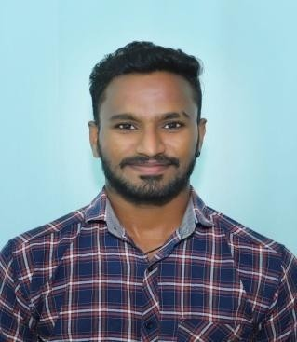
Career Objective :

N VAMSHI KRISHNA
Email : vamshikrish1324@gmail.com
Mobile : 7993644249

My Career option to get join in a reputed organization to increase my skills and knowledge for the growth of the organization through my dedication and hard working and become integral part of it.

Educational Qualification :

MBA- CMR engineering College- 2024.
- Bachelor of Arts- University post graduate college affiliated to Osmania University in 2022.
- Intermediate – Narayana Junior College affiliated to Board of Intermediate in year 2018.
- SSC – Pragna High School, Bodhan in 2016.

Training :
  - Frankfinn Institute ( 2018-2019).
  - Subject - Aviation and Travel Management.

Personnel Competence :

  - Pleasant Personality with good Physique.
  - Remarkable Patience and motivational skills.
  - Cooperate with other team members.
  - Knowledgeable resourceful about the aviation industry.

Language Known :

    - Hindi, English, Telegu, Marathi

Achievements :
- Been a part of "Udaan" project were I have obtained the knowledge about Customer interaction.
- Certified "In Flight" training with Air India.

Declaration :
I hereby declare that the above details furnished are true to the best
of my knowledge.

Place: Hyderabad

Date: N. VAMSHI KRISHNA

