Name of Candidate: Nikita Suresh Padule
Email: nikitapadule99@gmail.com
Mobile No.: 9579827399
LinkedIn Profile: Nikita Padule
Date of Birth: 19/02/2002
Address: Kalthan No 1, Indapur, Pune
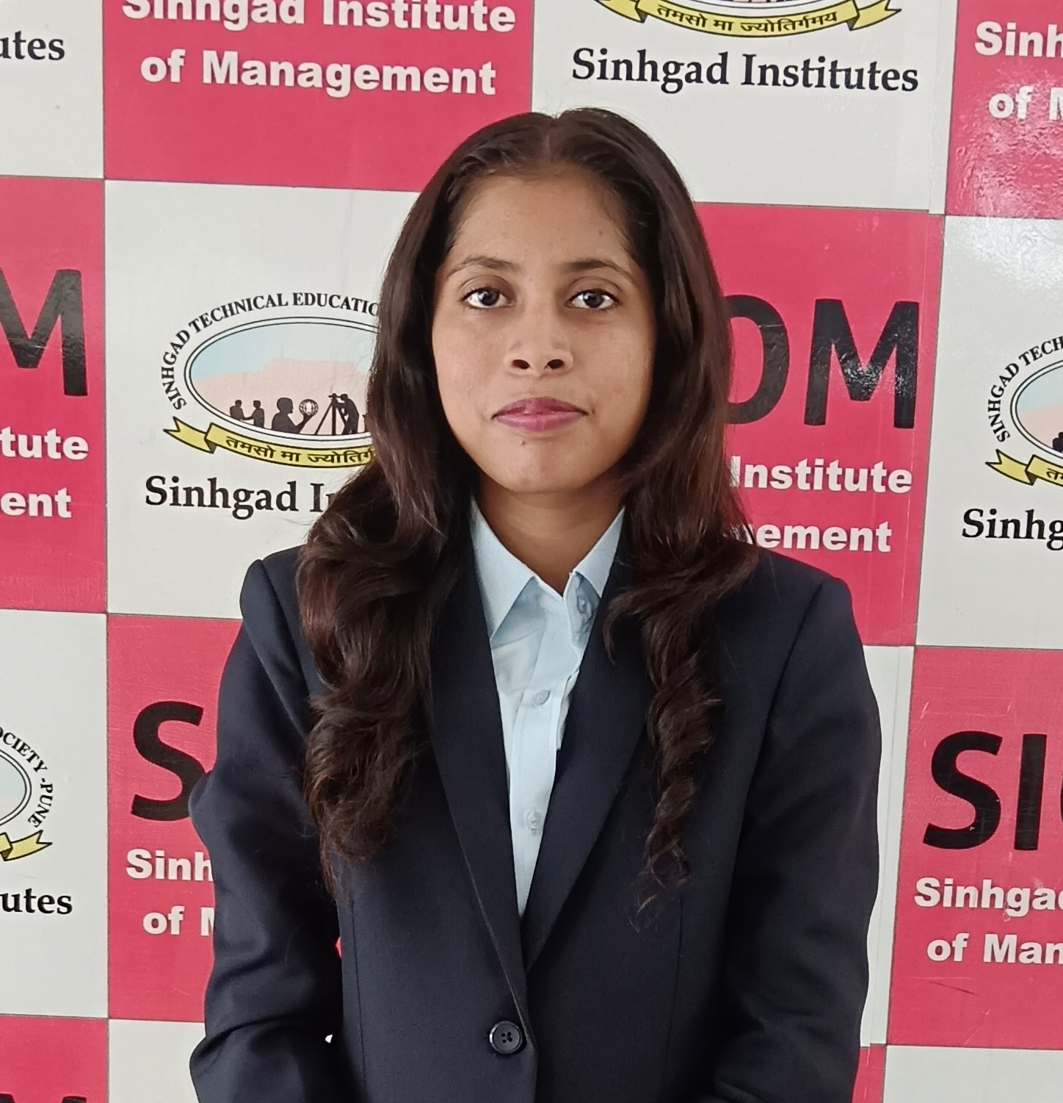

Describe yourself in 2 lines:

Dedicated HRM student pursuing MBA seeking a challenging role to apply academic knowledge in human resource management, employee engagement, talent acquisition, talent management and employee development to contribute effectively to organizational success

EDUCATION

Masters in Business Administration in HR, Aug. 2023 –Aug 2025
Sinhgad Management Institutes, Pune |

Bachelors of Commerce , July 2020- May 2023
Vidya Pratisthan Arts, Science and Commerce College, Baramati | 76.60%

Higher Secondary School Certificate in commerce, June 2018- April 2020
Vidya Pratisthan Arts, Science and Commerce College, Baramati | 84%

Secondary School Certificate, April 2016– April 2018
Shardabai Pawar Vidya Niketan Shardanagar , Baramati | 89%

SUMMER INTERNSHIP

HR Intern , Reinova Biz Consultant Duration: 11th June 24 – 11th Aug 24

- Responsibilities
- Assist in sourcing, screening resumes, scheduling interviews and maintaining candidate databases.
- Help with onbording processes, preparing materials and maintaining employee records during hiring and exit.
- Assist with gathering and updating employee records, attendance and maintaining database.
- Help in planning of engagement activities and gathering employee feedback.

SKILLS (TECHNOLOGY & FUNCTIONAL)

Analytical Thinking
Team work
Leadership
Adaptability

PROFESSIONAL ENHANCEMENTS
CERTIFICATIONS –

HR Analytics
Tally ERP - 9
Rubicon soft Skill Training
TCS ION Career Edge – Young professional cource

EXTRACURRICULAR ACTIVITIES

Position of responsibility

Volunteering
Participated in E - Waste Rally
Cultural Activities
Placement Committee Member

LANGUAGES

English| Hindi | Marathi

