Ein Bild, das Text enthält.
Autonomous Systems – Path Planning and Control

Lab Project Documentation (2.5 ECTS)

|  |  |
| --- | --- |
| Students: | Semyon Kondratev (207612)  Daniel Vetter (190238) |
| Professor: | Prof. Dr.-Ing. Frank Tränkle |
| Term: | Winter term 2021/22 |

Inhalt

1 Exercise 5 - Vehicle Dynamics 3

1.1 Exercise 5.1 Longitudinal dynamic model 3

1.1.1 Exercise 5.1 b) Calculation of the parameters 3

1.1.2 Exercise 5.1 c) Calculation of the transfer function 3

1.1.3 Exercise 5.1 d) Bode plot and step response 4

1.2 Exercise 5.2 vehicle simulation 5

1.2.1 Exercise 5.2 b) Simulink model of the vehicle 5

1.2.2 Exercise 5.2 c) Test 5

1.3 Exercise 6.1 vehicle simulation 10

1.3.1 Exercise 6.1 a) Parameter calculation 10

1.3.2 Exercise 6.1 b) Bode plot of G0(s) 12

1.3.3 Exercise 6.1 c) Step Response of Gw(s) 13

1.3.4 Exercise 6.1 d) discretization 13

1.4 Exercise 6.2 Speed Control simulation 14

1.5 Exercise 8.1 Path definition of straight lines 15

1.5.1 Exercise 8.1 a) Derivation of parameterized curve definition 15

1.5.2 Exercise 8.1 b) Calculation of curvature, tangent vector and normal vector 15

1.6 Exercise 8.2 MODBAS CAR Function for Clothoids (not required for 2.5 ECTS) 16

1.6.1 See the following matlab-files: 16

1.7 Exercise 9.1 Path Following Controller 17

1.7.1 Yaw-angle diagram 17

# Exercise 5 - Vehicle Dynamics

## Exercise 5.1 Longitudinal dynamic model

### Exercise 5.1 b) Calculation of the parameters

The following formula was given as a solution to exercise 5) a):

with the starting condition:

calculation of

### Exercise 5.1 c) Calculation of the transfer function

With the parameters calculated in 5) b) the transfer function can be calculated as follows.

### Exercise 5.1 d) Bode plot and step response

See the following files:

* ex5_1.m

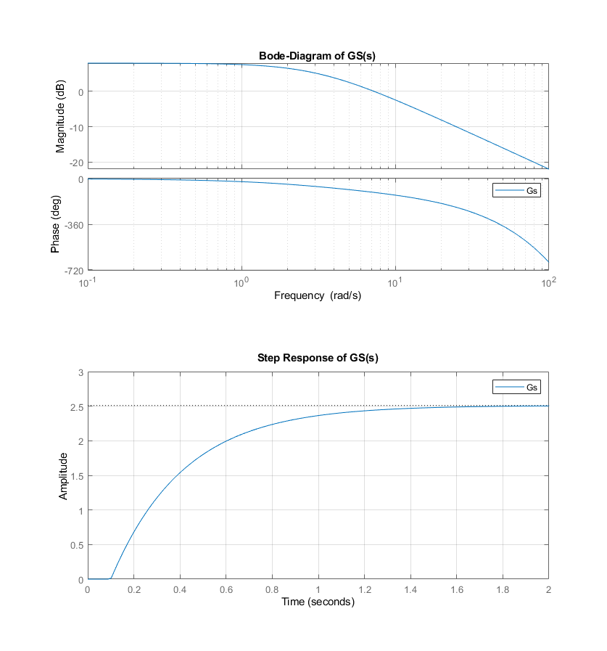

## Exercise 5.2 vehicle simulation

### Exercise 5.2 b) Simulink model of the vehicle

See the following files:

* s6_template.slx (created with version R2020b)
* s6_template_2019a.slx (converted to version R2019a)

### Exercise 5.2 c) Test

Below we inserted a few diagrams with different parameters for the pedals, steering and command

1. CarInputsCommandForward, pedals = 1, δ = 0

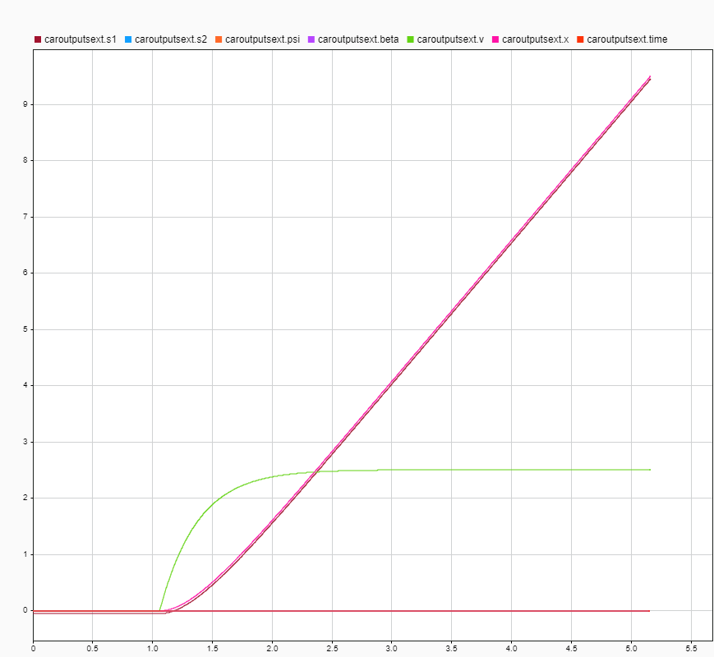

t [s]

speed [m/s]

yaw angle [rad]

1. CarInputsCommandSlow, pedals = 1, δ = 0

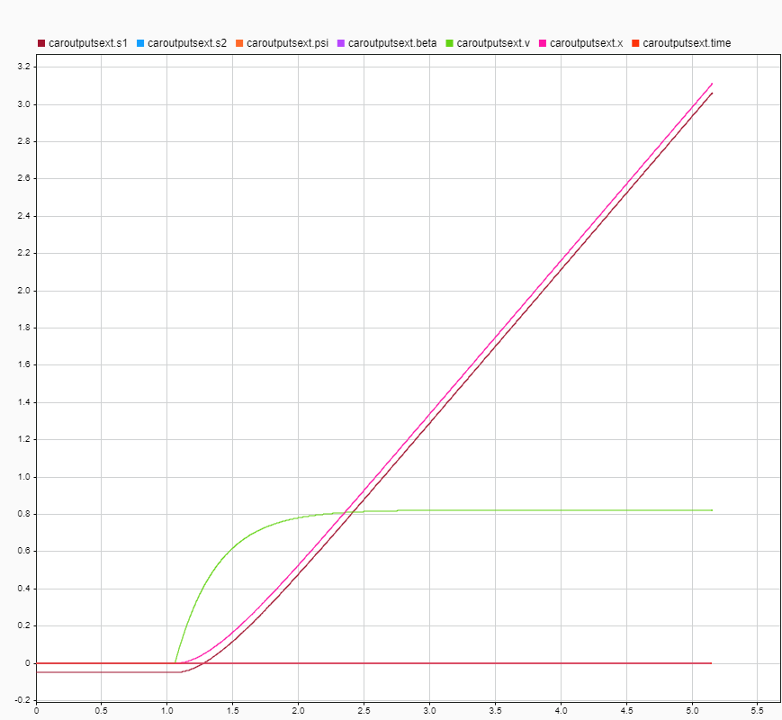

t [s]

speed [m/s]

yaw angle [rad]

1. CarInputsCommandReverse, pedals = -1, δ = 0

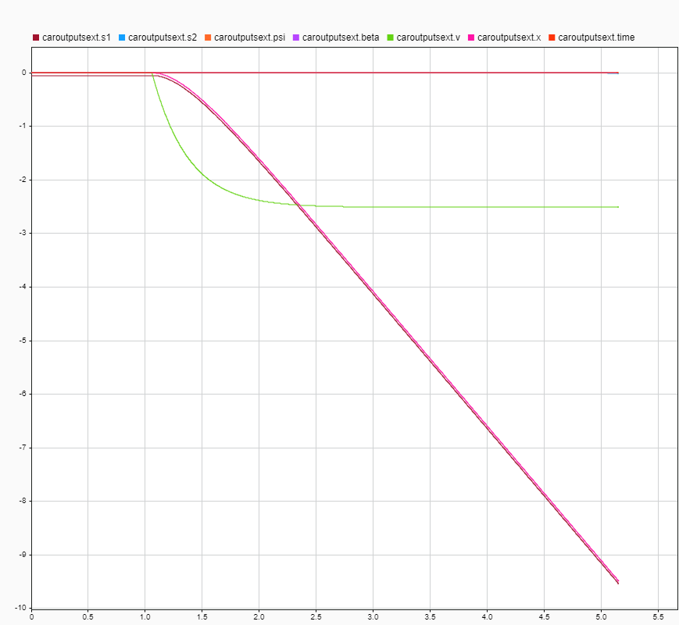

t [s]

speed [m/s]

yaw angle [rad]

1. CarInputsCommandForward, pedals = 1, δ = -0.5

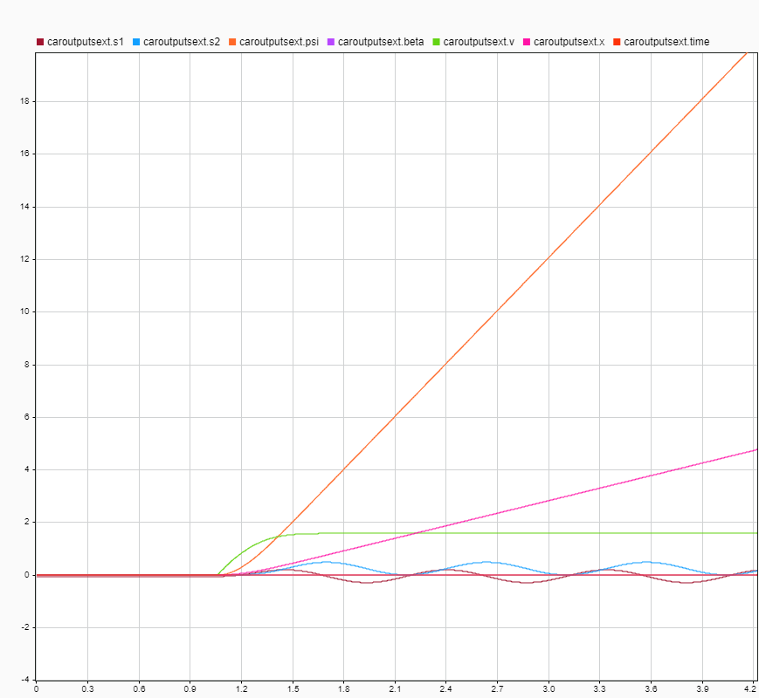

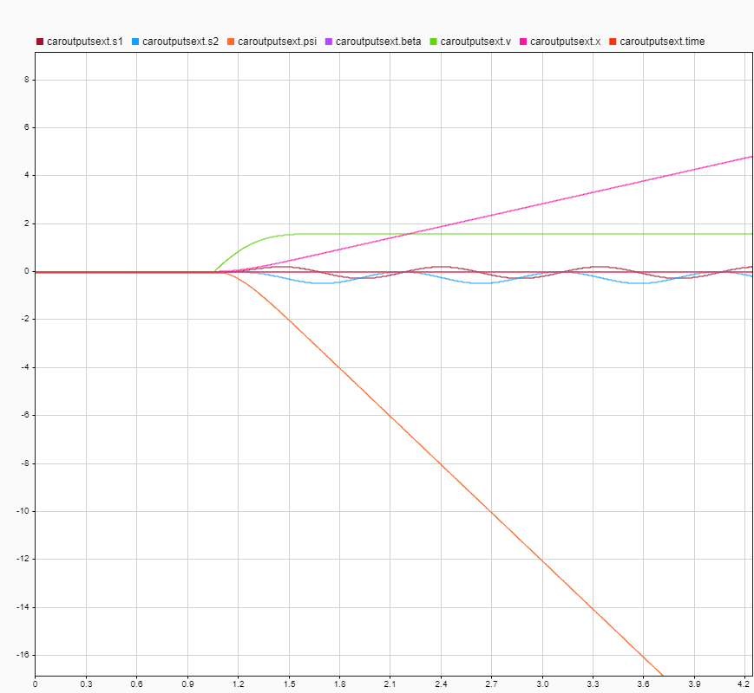

t [s]

speed [m/s]

yaw angle [rad]

1. CarInputsCommandForward, pedals = 1, δ = 0.5



t [s]

speed [m/s]

yaw angle [rad]

## Exercise 6.1 vehicle simulation

### Exercise 6.1 a) Parameter calculation

plant transfer function:

Controller transfer function:

Open-loop transfer function:

Phase of plant:

Phase of controller:

Open-loop phase:

Phase margin:

Open-loop frequency response:

Open-loop magnitude response:

### Exercise 6.1 b) Bode plot of G0(s)

See the following files:

* ex6_1.m

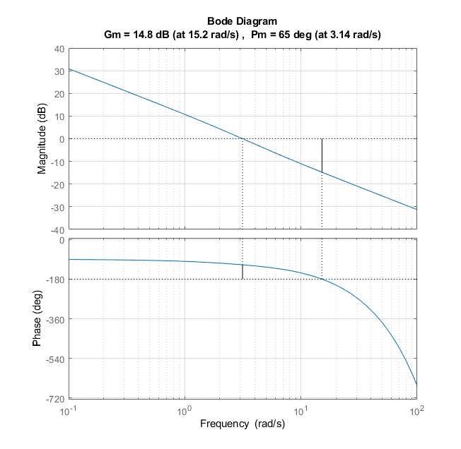

### Exercise 6.1 c) Step Response of Gw(s)

Ein Bild, das Text enthält.

### Exercise 6.1 d) discretization

, with

## Exercise 6.2 Speed Control simulation

Step responses of different vehicle speeds

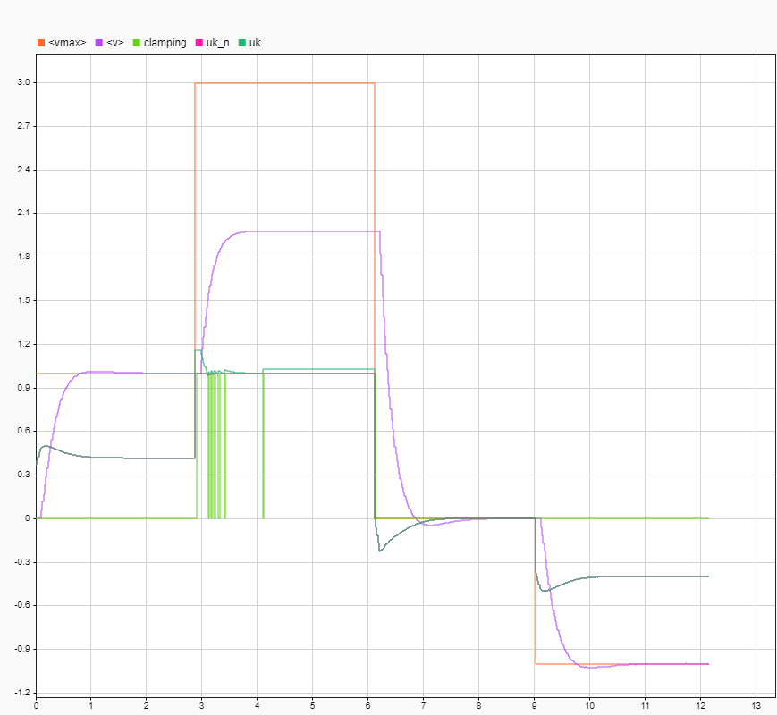

speed [m/s]

t [s]

See also the following files:

* s6_data.m
* s7_template.slx (created with version R2020b)
* s7_template.slx (converted to version R2019a)

## Exercise 8.1 Path definition of straight lines

### Exercise 8.1 a) Derivation of parameterized curve definition

### Exercise 8.1 b) Calculation of curvature, tangent vector and normal vector

Tangent vector:

Normal vector:

Curvature:

## Exercise 8.2 MODBAS CAR Function for Clothoids (not required for 2.5 ECTS)

### See the following matlab-files:

* mbc_clothoid_create.m
* mbc_clothoid_get_points.m
* s6_data.m

## Exercise 9.1 Path Following Controller

### Yaw-angle diagram

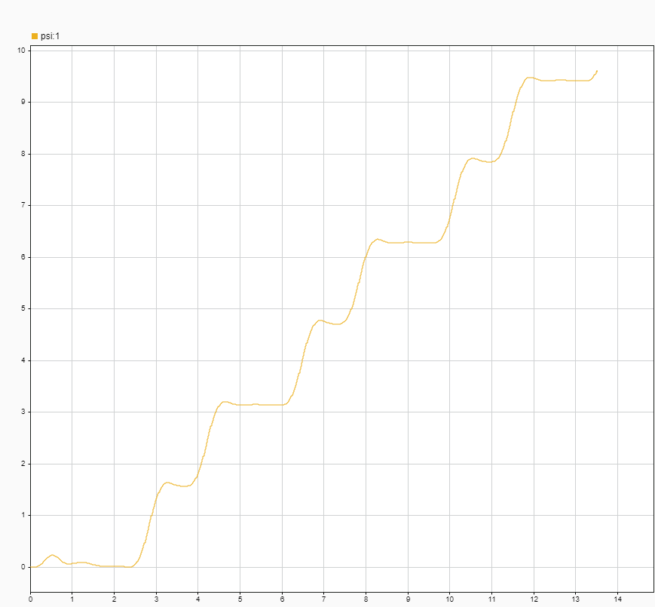

yaw angle [rad]

t [s]

See the following files:

* s9_template.slx (created with version R2020b)
* s9_template.slx (converted to version R2019a)
* s6_data.m