Contents

2 Overview 3

3 What you have to know – read this 4

4 Login details 4

5 Backup of Older physical servers 4

6 Server monitoring 5

6.1 Emails to send to and alert thresholds 5

6.2 Servers to monitor 5

6.3 Frequency of check 5

6.4 Controlling what is monitored 6

6.5 Example Email for one server 7

7 Virtual server backups 9

7.1 SQL Server 9

7.1.1 Backup 9

7.1.2 Restore 9

7.1.3 SQL 2008 Backup performance testing 10

7.1.4 SQL differential restore 11

7.2 File level backup 12

7.2.1 Using Cobian to backup to IBackup 14

7.2.2 Using Cobian to Backup locally (to the other core server) 17

7.2.3 Setting up email notification in Cobian 19

7.3 Hyper V virtual machines 20

7.3.1 Backup 20

7.3.2 Restore 20

7.3.3 An example 23

7.3.4 Restoring an individual VHD 24

7.4 Restoring files 25

8 Older Phyiscal Web Servers 25

8.1 Setting up websites 25

8.1.1 Application pools 26

8.2 Backups from older servers 28

8.2.1 Onsite backups 28

8.2.2 Offsite backups 28

8.2.3 Disk snapshots 29

# Overview

We currently have 7 physical web servers + a SQL 2000 server. We have just added two new HyperV servers to allow us to move at least some of this to a virtualised environment.

This document describes backup procedures for the old physical servers and the new VM servers. Note this is quite different in the two scenarios.

This also starts to give some guidelines as to how servers should be setup (to be extended …)

Also note that Both IBackup and BackupChain have pretty good online chat support (I’ve tested both!)

# What you have to know – read this

If you don’t read anything else – read this if you are setting up a new website / server.

* SQL databases on ESDM-CORE1-SQL are backed up automatically – provided the database is online. These will automatically be backed up off site and on ESDM-CORE2 disks.
* Anything on a VM is backed up as the whole VM is backed up (currently a full backup every 5 days with differential on days between with a retention of 10 days) – this may change – so if exact details are important to you check. If you add a new VM you need to check in BackupChain that it is being backed up (may need machine ticked to make sure its included) See section 7.3.1). These are not backed up off site.
* File based backup – you can backup to the “Other” CORE server (so its physically on a different RAID5 disk) – Files can be moved using scripting or Cobian backup – (see Section 7.2) – files can goto either:
  + Two shared folders have been created (with permission for Administrator to write)
    - \\esdm-core1\BackupOnCore1 (for files if your VM is on Core 2)
    - \\esdm-core2\BackupOnCore2 (for files if your VM is on Core 1)
* If you want the files to go “off site” – copy to somewhere under \\esdm-core1\IBackup in which case they will be backed up offsite every night (need to keep volume and change to a minimum – i.e. do NOT use large zips which change every night)
* To add a new server into the monitoring – simply add the server name into the ServersList.txt (see section 6)

# Login details

All necessary user names and passwords should be held in KeePass

# Backup of Older physical servers

* Most do a snapshot to a USB disk. This should contain at least a months’ worth of history – but as its using USB disks it’s a little prone to failure / disks filling etc. It is intended as a last line of defence
* People setting up servers should script a backup of files that need backing up nightly to the \Backup folder on that server. Files from here are then placed onto the NAS box in telehouse. There is a certain amount of history retained here.
* People setting up servers should script files that need to be archived in case of catastrophic failure (i.e. files that can’t be replaced by any other means) to the folder with the same name as the server. This is then archived offsite to IBAckup every weekend. Note there is no history retained on this its just the last copy.
* Further details are included later in this document

# Server monitoring

There is now some monitoring of servers in place. Core to this functioning (and to reliable backups I believe) is that these all need to be controlled as far as possible from one location.

Everything is run from ESDM-CORE1-SQL and reports on all our servers (Older servers, Core servers and VMs added).

Checks are mainly disk space – and whether the server is pingable – and to a lesser extent memory and cpu use (though as these can change quickly and monitor only looks at moment in time).

Emails can be sent out:

* alerts for low disk – sent once a day – if anything less 10%
* alert – checked every hour for servers up etc
* Info – once a week disk space of all disks
* Info – once a day / week ? – general server status – includes sql 2008 database sizes etc

All these are in D:\SystemMonitor and are powershell scripts

Adding (or removing) a machine from the list to check is just a case of editing D:\SystemMonitor ServerList.txt and adding the server name (make sure there is NOT a carriage return after last server)

If the server uses the same administrator account as ESDM-CORE1-SQL – then that’s all you should have to do. If authentication is different – you may need to create a credentials file (D:\SystemMonitor\Credentials).

All this assumes WMI – so relevant ports etc must be available on firewall and appropriate services running (generally OK on new VMs)

NOTE: SQL 2000 (as its on Server 2000) doesn’t support all the monitors – it does support disk space however.

## Emails to send to and alert thresholds

Are set in:

* D:\SystemMonitor\SystemMonitorConfiguration.ps1
* D:\SystemMonitor\CheckDiskSpace.ps1
* D:\SystemMonitor\CheckDiskSpaceSummary.ps1

## Servers to monitor

D:\SystemMonitor ServerList.txt

### Enable ping response on server 2008

If the VM is on Core2 – then as there is no domain controller – ESDM-CORE1-SQL may need some assistance in finding the machine – so needs an entry in the hosts file ***on ESDM-CORE1-SQL***

C:\Windows\System32\drivers\etc\hosts

Also in order for the system to be able to detect the server is up it needs to be able to respond to a ping. By default Server 2008 has this disabled in the firewall – Enable “File and Printer sharing”

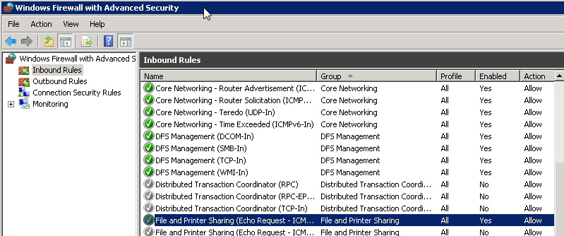

### Allowing WMI through firewall

For the status reports to be generated – WMI service must be running – and available through firewall

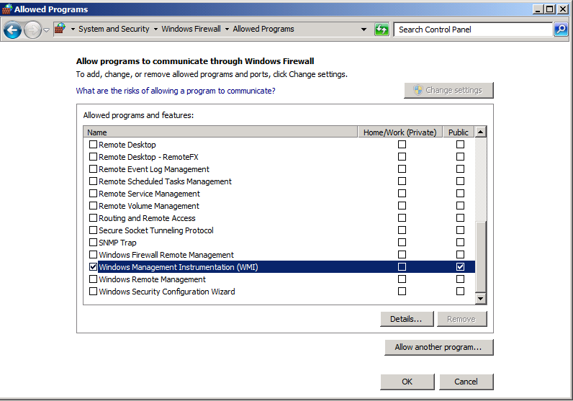

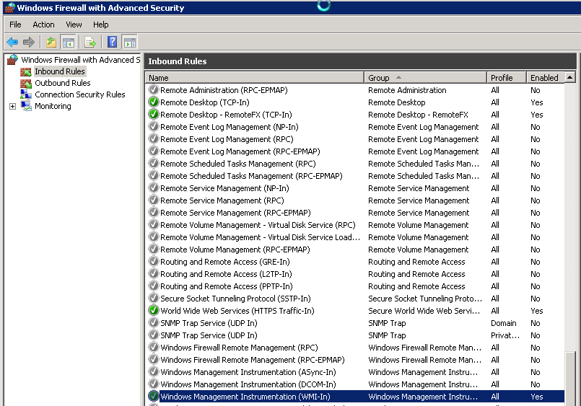

The IP addresses that the WMI service can be locked down further by editing the properties of this firewall rule.

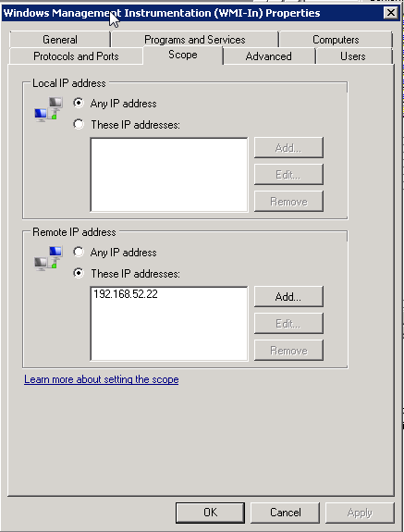

## Frequency of check

Determined by Windows tasks schedule on ESDM-CORE1-SQL

## Controlling what is monitored

Call to D:\SystemMonitor\SystemMonitor.ps1 can take a range of command line parameters:

powershell.exe -command "& 'd:\SystemMonitor\SystemMonitor.ps1' 'cpu' 'memory' 'disk' 'email' 'post' 'sql' 'net' 'os'"

* Disk – disk space
* Cpu – processor use
* Memory – memory use
* Email – if included sends email regardless of whether alert level is reached
* Post – sent data to SQL server
* Sql – include summary of SQL databases (only SQL 2008 on ESDM-CORE1-SQL at the moment)
* Net – network use
* Os – os statistics – including processor queue length

## Example Email for one server

**ESDM-CORE1-SQL**

**ESDM-CORE1-SQL Disk space (GB)**

|  |  |  |  |  |  |  |  |
| --- | --- | --- | --- | --- | --- | --- | --- |
| **Server** | **DriveType** | **DeviceID** | **VolumeName** | **Name** | **FreeSpace** | **Size** | **PercentFree** |
| ESDM-CORE1-SQL | 3 | C: |  | C: | 477 | 499 | 95 |
| ESDM-CORE1-SQL | 3 | D: |  | D: | 248 | 249 | 99 |

**ESDM-CORE1-SQL Memory (Mb)**

|  |  |
| --- | --- |
| **CapacityMB** | **AvailableMB** |
| 8000 | 6353 |

**ESDM-CORE1-SQL Processors**

|  |  |
| --- | --- |
| **ProcessorNumber** | **PercentUsed** |
| 0 | 0 |
| _Total | 0 |

**ESDM-CORE1-SQL Network**

|  |  |  |  |
| --- | --- | --- | --- |
| **Name** | **BytesReceivedPerSec** | **BytesSentPerSec** | **OutputNetworkQueue** |
| Microsoft Virtual Machine Bus Network Adapter | 0 | 423 | 0 |
| isatap.{B06DF532-AF2F-4723-B709-B36CC2F9094F} | 0 | 0 | 0 |
| Teredo Tunneling Pseudo-Interface | 0 | 0 | 0 |

**ESDM-CORE1-SQL OS**

|  |  |  |  |
| --- | --- | --- | --- |
| **ProcessorQueueLength** | **NumProcesses** | **FileWriteOperationsPerSec** | **FileReadOperationsPerSec** |
| 3 | 59 | 4 | 4 |

**ESDM-CORE1-SQL SQL SERVER**

|  |  |  |  |  |  |  |
| --- | --- | --- | --- | --- | --- | --- |
| **Name** | **Collation** | **CompatibilityLevel** | **AutoShrink** | **RecoveryModel** | **Size** | **SpaceAvailable** |
| CMSI-xgDemo | Latin1_General_CI_AS | Version100 | False | Simple | 166.4375 | 832 |
| master | Latin1_General_CI_AS | Version100 | False | Simple | 5.25 | 1624 |
| model | Latin1_General_CI_AS | Version100 | False | Full | 3.5 | 1104 |
| msdb | Latin1_General_CI_AS | Version100 | False | Simple | 18.125 | 3240 |
| ReportServer | Latin1_General_CI_AS_KS_WS | Version100 | False | Full | 10.5 | 1016 |
| ReportServerTempDB | Latin1_General_CI_AS_KS_WS | Version100 | False | Simple | 3.0625 | 912 |
| SystemMonitor | Latin1_General_CI_AS | Version90 | False | Simple | 510 | 509976 |
| tempdb | Latin1_General_CI_AS | Version100 | False | Simple | 9 | 6368 |

# Virtual server backups

## SQL Server

### Backup

* SQL server has a task that backs up all the online databases once a day to D:\ESDM-Core1-SQL2008\Daily and once a week to D:\ESDM-Core1-SQL2008\Weekly
* These are compressed SQL backups.
* Certain databases are only backed up weekly (e.g. HBSMR gateway as daily backup isn’t needed)
* The Weekly backup is a full backup and the daily ones are also full backups ~~differential (all differentials go into the same file).~~
* ~~This seems to give us the best method for backing up offsite (i.e file level differencing works – which it won’t on zip files – or between full compressed backups)~~
* These are then both backed up using IBackup to <http://www.ibackup.com/professional/> - which should give 30 versions (so idea is 30 days daily and 30 weeks weekly). We only get charged for the size of the current version.
* Backup Files are also archived onto \\esdm-core2\BackupOnCore2\SQLDatabases\esdm-core1-sql2008 - with 30 days retention for the daily and 30 weeks for the weekly. Files are named with dates. This should be pretty much a local copy of what is on the IBackup site. Note Core2 is being used so that it’s a different physical disk to where SQL 2008 VM is located.

#### Web 7

* This is the same as SQL2008 server now – except that it only has SQLExpress on it so that the backups aren’t compressed.

#### ESDM-SQL-1

* NOTE: As a stop gap till we move off this server – ESDM-SQL-1 is backing up the full .bak files to IBackup. This is using the uncompressed full backups – so we should get good file differential each day – and 30 days’ worth of backup. This is an extra backup as we have space at the moment.

### Restore

* Restore can be done simply by logging onto the website – downloading the version of the database required and using standard SQL restore tools. Key for decrypting is in Keepass.

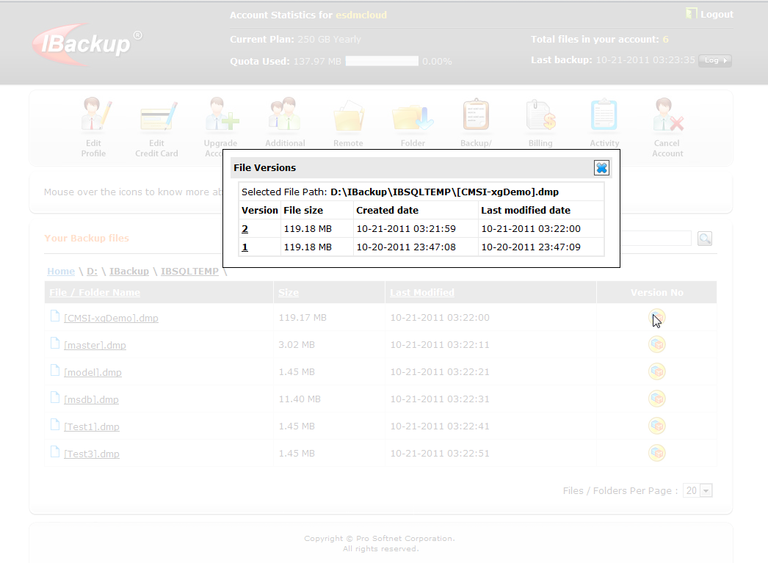

### SQL 2008 Backup performance testing

We currently have c. 40GB uncompressed backups of SQL data.

This is too big to send fully offsite every night. Zipped its about 4GB – which is still too big to send every night. Part of the trouble is that zipping prevents any file differencing to work – so if zipped its effectively got to re transfer the same file.

#### No Compression (123MB)

IBackup will compress data for sending – but we will get charged for full size on their store

Full backup to IBackup 4:29

Next days – minimal changes – 0:08 IBackup

So big speed gains

#### With compression (17MB)

Full Backup – compressed – 1:58 to IBackup

Next days – minimal changes – 2:11 to IBackup

Therefore – not much gain of differential backup on compressed data

#### With compression and sql differential backup to same file (17MB)

Full Backup – compressed – 2:20 to IBackup

Next days – minimal changes – add differential backup to same compressed file – 0:03 to IBackup – so big gains.

So file differencing is still working well if a differential backup is added.

* SQL differential backups can be added to same file – or a secondary file
* Compression appears to keep the original backup unchanged so file differencing works well
* SQL differentials work from the last full backup (i.e they are differential NOT incremental) – so need to have a new full backup taken fairly regularly – especially for database that are actively edited

### SQL differential restore

~~This is pretty simple really – especially if the differentials are in the same file.~~

~~Just restore backup as usual – but make sure you tick the full backup and then the differential backup that you want to add to it (you only need to add the most recent differential)~~

~~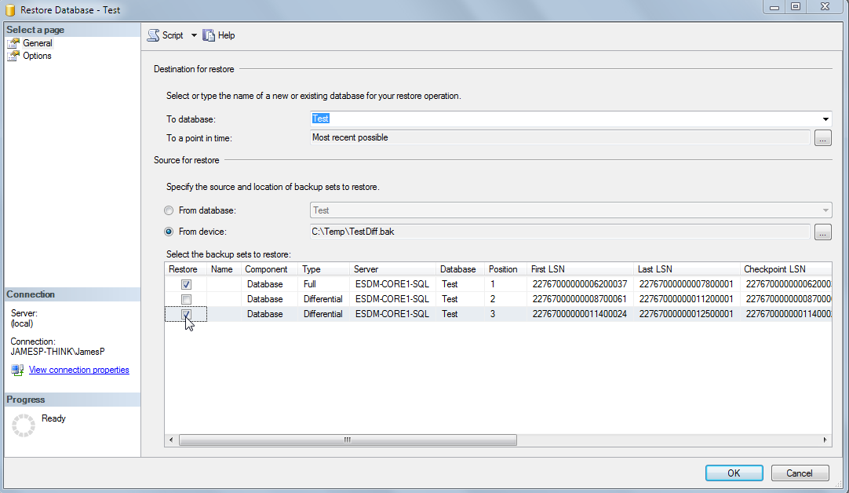~~

~~For a differential restore you must always include the base, and then normally just the version that you want (most current normally). There is no need to add intermediates as it is a~~ *~~differential~~* ~~backup (though ticking them also seems to do no harm).~~

## File level backup

Need to decide what we want to do about this but currently have a reasonable amount of offsite storage.

I suggest a scripted approach like we use on existing folders

We can use Cobian Backup –much easier to setup than scripts which gives lots of options:

* Straight file copy
* Compression of individual files
* Compression of blocks of files
* Differential backups
* Keep x copies
* Email notification
* Etc

The issue we need to work out is that if we upload to IBackup Prof – we get 30 versions – so if we bundle everything into a zip and send it each night that will change each time – so we will get 30 days – and our upload will be bigger because zip files will always be changing – and diffs won’t work well.

So I suggest we zip individual files using Cobian – all into one folder structure – that way with luck it will only push changed / new files up and for most files 30 versions will give us months if not years.

If we are contractually obliged to keep e.g. 3 months’ worth – we might need to also setup a weekly copy of just those files to ensure they don’t get versioned too quickly (but photos we might not to bother with as you can’t really edit photos ?)

For our own backups we might want to juts use versioned zipped differentials copied to core diskspace somewhere.

Also – do we copy backup files off the vhd – e.g. to CORE – or some other disk space to stop us backing up files multiple times (as part of vhd as well …)

e.g. SQL database:

* Live database
* Daily backup on ESDM SQL server vhd - zipped
* Weekly backup on ESDM SQL server vhd - zipped
* Live database & Daily & Weekly zipped copy backed up every day as part of vhd x however many copies of that we keep
* Daily and Weekly (compressed) on IBackup

If we copied those backups to somewhere else (e.g. Direct to a folder on Core) – we would stop the 2 compressed copies being backed up as part of the vhd.

Not too fussed about this with SQL server – but with GB of photos or something this could make quite a difference? Would need to sort out some shares / permissions – but this might be best approach?

* Files that need to be backed up to IBackup should be place in \\esdm-core1\IBackup (regardless of whether they come from core1 or core2 as they are backed up off site every night)
* They should be placed in a subfolder using the VM machine name
* Anything in this IBackup folder is moved to the cloud every night (process controlled from ESDM-Core1-SQL2008 as this machine should always be running – but the process should not need to be edited)

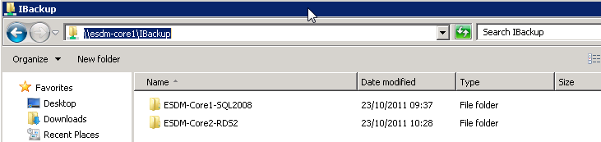

Notes:

* IBackup has 30 version file retention. To maximise the benefit of this you need to make sure that files are not changed when they are not really. Also – if files are compressible it saves our offline storage quota if they are compressed. If you just zip all files, you will normally get a version change each day. Zipping individual files allows you to just have a version incremented when the file has really changed (Cobian backup gives this option), but of course restoring 100s of files would mean they all have to be unzipped again.
* Cobian backup (or hand crafted scripts) can be used to place the files on IBackup. If using Cobian incremental or differential backup it uses the archive bit flag to determine if a file needs to be backed up so:
  + If you have been messing you may need to force a first full backup without this
  + If you have more than one task backing up the same files (to different locations) you have to make sure that only the last one resets the archive bit.

### Using Cobian to backup to IBackup

* Files that need to be backed up to IBackup should be place in \\esdm-core1\IBackup (regardless of whether they come from core1 or core2 as they are backed up off site every night)
* They should be placed in a subfolder using the VM machine name
* They want to be compressed – but individually to maximise use of 30 versions
* We are just making a full backup each time – and not using – or setting – archive flag

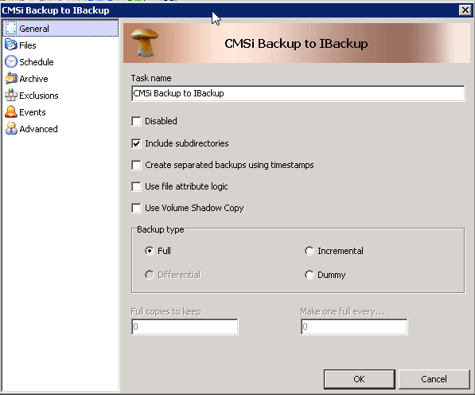

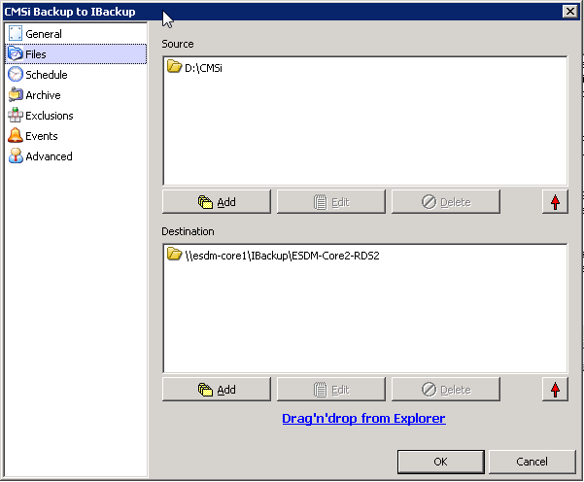

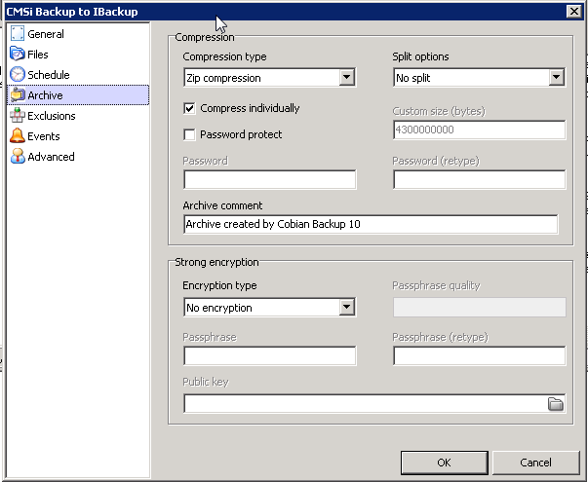

Exclude files that can be easily replace from another source (in this case files that are part of a standard CMSi install)

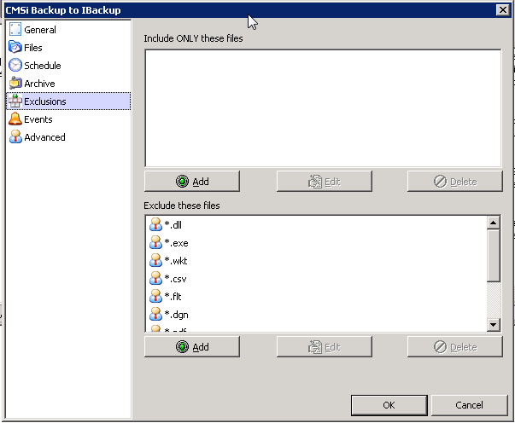

Important to NOT clear the attribute flag if another backup maybe run on this data

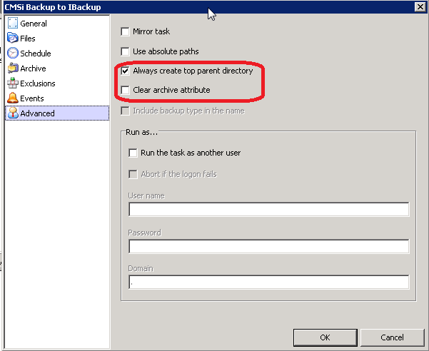

### Using Cobian to Backup locally (to the other core server)

* We don’t want backup files stored on the vhd of a machine as:
  + This isn’t particularly secure as its on the same disk
  + It takes up a lot more space (as the Vhds themselves are then backed up as well)
* So far better to store on native disk on the other core server (RAID5) and physically a different disk
* Two shared folders have been created (with permission for Administrator to write)
  + \\esdm-core1\BackupOnCore1 (for files if your VM is on Core 2)
  + \\esdm-core2\BackupOnCore2 (for files if your VM is on Core 1)

Its upto us to decide quite how best to run this – but obviously we want to minimise duplication.

Cobian backups incremental or differential backups to one overall compressed file per backup is probably sensible here.

* The nice thing about Cobian is it just creates zip files – so no restore process is needed – and you can check exactly what it has backed up for you
* If using Incremental / differential backup you need to make sure you are setting the archive bit – as it uses this for knowing which files have been changed since last backup (as opposed to looking at the files themselves)

Screenshot below shows an example and some of the key values you need to consider.

As always you need to customise this to your exact scenario – and CHECK what is actually being backed up.

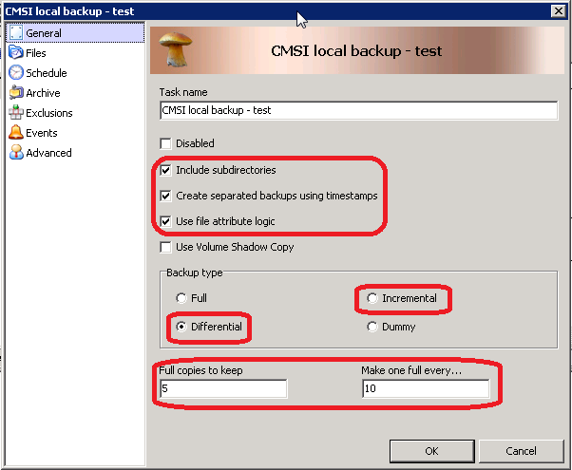

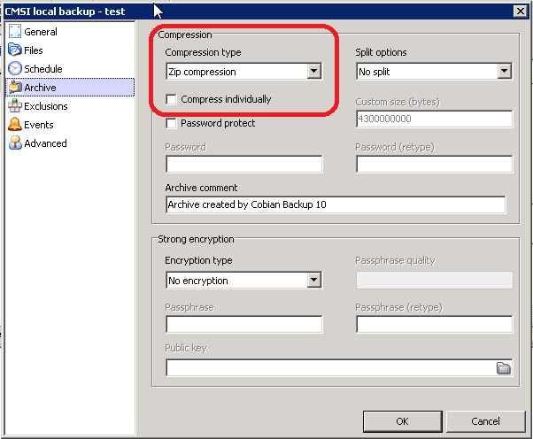

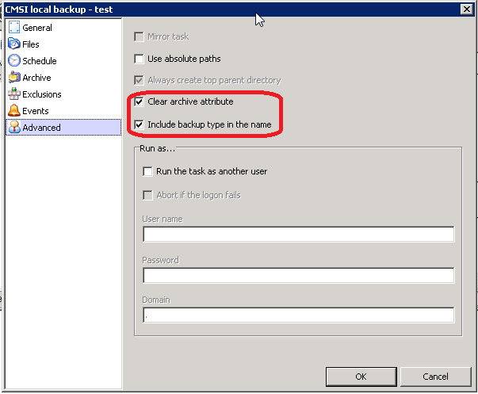

### Setting up email notification in Cobian

You can have log files sent to you every day – or just on failure.

Settings would be similar to below.

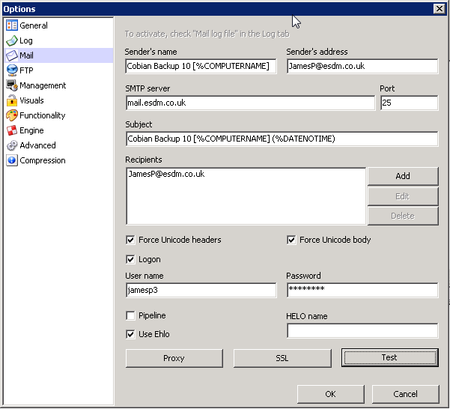

## Hyper V virtual machines

### Backup

* Each CORE server (CORE1 and CORE2) has a copy of backup chain installed on it (<http://backupchain.com/> - manual here <http://backupchain.com/v2help/BackupChainV2Help.html>)
* To access it goto D:\ and type bc
* This backs up the HyperV VMs on each CORE machine to the other. e.g ESDM-CORE1 backs up the HyperV machines to \\ESDM-CORE2\D\Backup (and vice versa)
* It uses VSS so it can backup VMs while running – which is important.
* This happens every night – and currently is set to do a full backup every 5 days and on the other 4 days it does a differential backup. Server backups are currently kept for 10 days.
* ***Frequency etc will need reviewing depending on requirements and disk space. Also option for incremental backup as an alternative to differential.***
* There are also lots of other alternatives for backing up files etc which might be useful

### Restore

* Restoring a HyperV machine is pretty simple – just use the Restore option in BackupChain

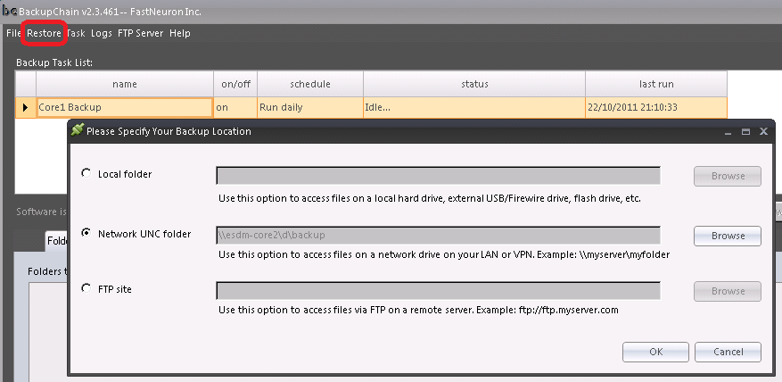

* A VM has to be restored the CORE machine that BackupChain is running on.
* If you are on ESDM-CORE1 and you want to restore a VM to the same machine this VM will have been being backed up to \\ESDM-CORE1\d\Backup - so the paths will not need changing.
* *(If for example CORE1 has failed and you want to restore a VM that was originally running on CORE1 (and hence backed upto CORE2) onto CORE2 then you would run BackupChain on CORE2 and you would need to change the path to* *\\esdm-core2\d\backup**)*
* Note – you need to use the SuperAdmin user to see the shares on the other Core – so set that when you setup the network UNC path

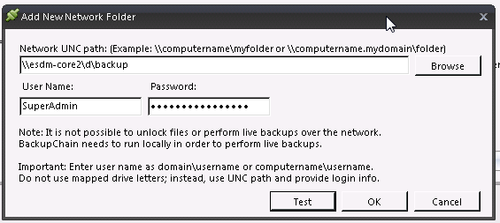

* Select the HyperV backup you want to restore, press restore and give a path for the VMs to be restored. Maybe best to use a new folder so that there is no risk of overwriting any existing files

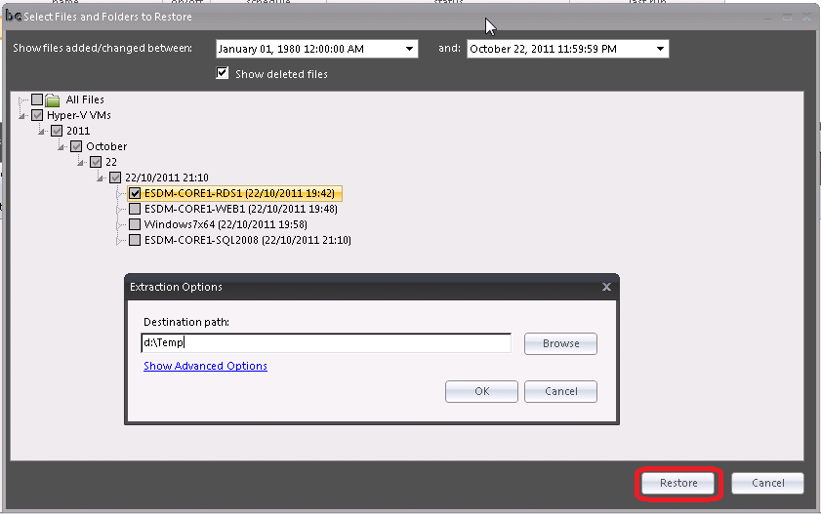

* There are some Advanced Options – but the defaults seem to be OK so long as you are restoring a broken VM or onto another machine.
* When you click OK – the restore starts immediately.

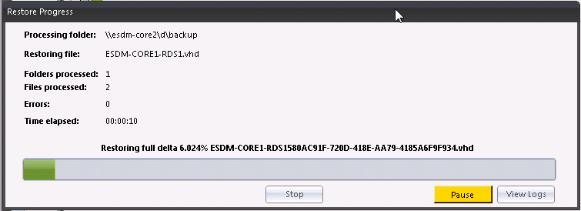

* You will see it progressing with the base VHDs and then applying the deltas. You can view logs on completion.
* On completion you will get a message – and reminder to check the network connection.

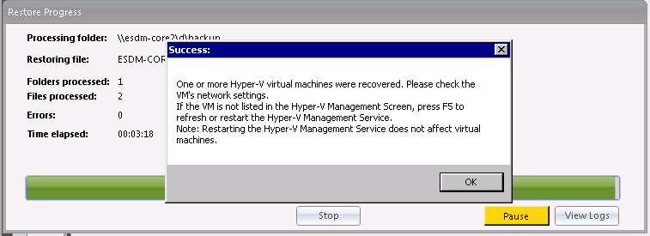

* On completion the VM should automatically appear in HyperV manager and have been started. It will however have had the network connection removed from the VM setup (presumably to avoid the risk of any IP clashes etc).
* Note the name in HyperV manager will distinguish it

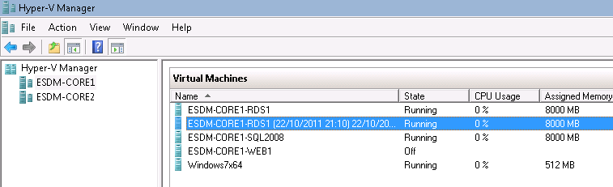

* If the original machine is still running then you must change some IP addresses before enabling the network or you will (obviously) get an IP clash.
* If however the original VM is shut down or destroyed – enabling the network connector should bring it back and have it running exactly as before on the same address.
* The network adapter can be added to the VM in HyperV manager while the machine is still running.

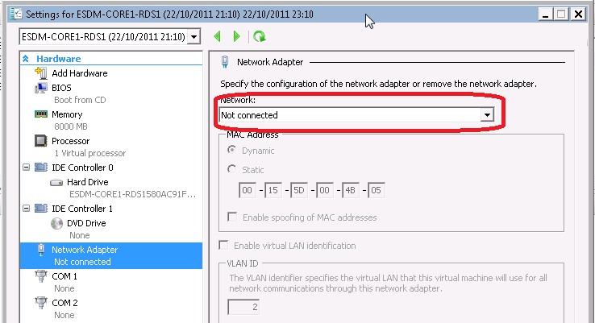

### An example

SQL Server 2008 (Original was on Core1)

Started BC on Core2 – changed the Restore source to \\esdm-core2\backup (where files from Core1 are backed up to)

Restored to D:\Temp

Took c.30 mins to restore both VHDs (C & D) to Core2

Auto started – just had to (stop existing one to avoid IP clash) and assign a network connection to the VM

### Restoring an individual VHD

One of the big advantages of separating our data apps etc onto D I sthat if windows messes up its possible to just restore last night’s C drive VHD.

When restoring – be careful NOT to tick anything in the left tree if you only want an individual file restored as you always get all files restored.

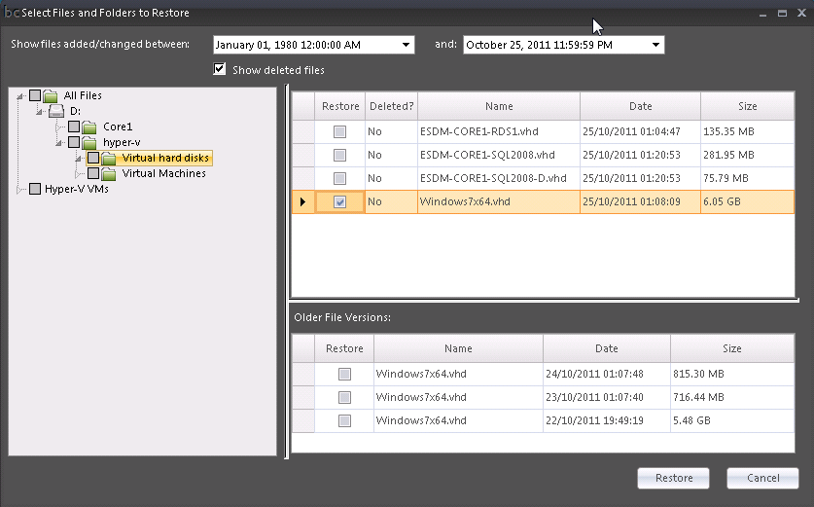

When you copy the file across – and try and restart the VM from HyperV you may get a message about not having sufficient permissions to open the vhd.

I needed to add Network Service with full permissions to the file (actually need Network Service and System apparently – but system is there anyway)

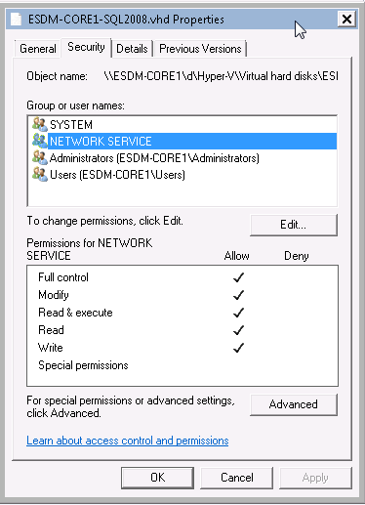

## Restoring files

Obviously a number of ways to do this:

* If it’s a file that has been copied locally to another server (using Cobian or scripting) you can just pick it up from the CORE machine share drive it was copied to
* If it was sent to IBackup – and you just want the most recent copy – then there is probably a local copy from the previous night on the CORE1 (I: drive)
* If it’s a database – or a file that has been backed up off site and you want a version from upto 30 days ago it can be grabbed from our IBackup account
* Also remember that backup chain can be used to restore a VHD which can be temporarily attached to a machine and copy files off that as a local disk

# Older Phyiscal Web Servers

We now have an increasing number of servers up in London (7 + SQL server at the last count)

Some of these will be being retired as we move to the new virtual servers

This document is a first stab at trying to introduce some standards to the way we do things. I appreciate that existing setups don’t always mirror this – and am not suggesting that they be changes – but new sites should follow the guidance below.

## Setting up websites

All new servers will have most of the spare disk space on D: (C: drive will contain OS files etc and should not generally be used for websites / data files etc)

All websites should be setup in D:\Websites

All websites should be self standing and top level websites (not virtual directories within other unrelated sites).

Particularly this means that unrelated websites should NOT share mapserverservices, tmp or scripts directories. This does lead to some duplication – but does mean they are truly independent and so for example, the version of mapserver can be upgraded for one site without worrying as to whether it affects others – which is starting to be an issue for some sites which share.

Also – keeping everything on D:\Websites (and D:\Mapdata) should mean that we can move sites from machine to machine much more easily (this does mean if you are setting up a site on Portal1 that might eventually want to be moved you would be wise to adopt the same protocol).

Below is an example of what I mean for SMFI (both IIS and in file manager)

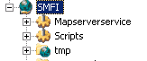

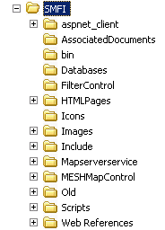

### Application pools

.NET 1.1 & 2.0 can not share the same application pool – therefore it is ESSENTIAL – that you specify the application pool that your website will use – we will aim to have a dotnet 1 and a dotent 2 version on each machine (that needs them). Failure to do this can cause all dotnet 1.1 (or 2.0) sites on the server to fail.

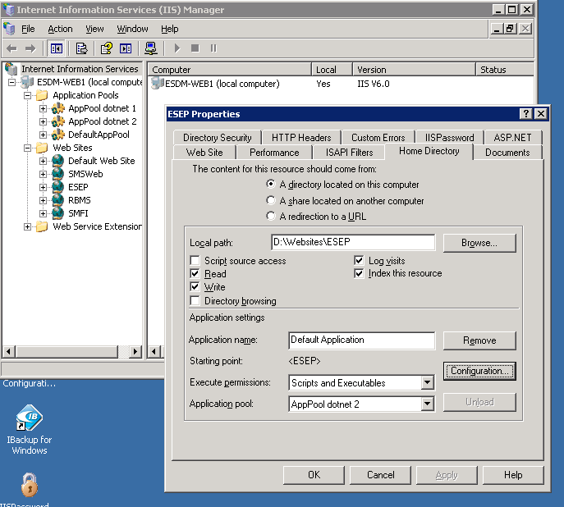

As usual – I’m more than happy to discuss / alter these – but I think we are getting to the point where we need to have a few more standards to avoid us all tripping over each other.

## Backups from older servers

### Onsite backups

<http://backups.nexbyte.net/backups/BackupPC_Admin?action=summary>

There should be a shared folder on usually on D: drive – called backup. This is then backed up onto a NAS box every night. The NAS box is located in TeleHouse – so is in the same location – but a separate disk.

We have a reasonable amount of backup on this (normally about 10GB / server)

Whoever installs / manages the website is responsible to setting up and scheduling batch jobs to move the required data into the Backup folder so that it will be backed up each night. You are also responsible for checking the backup to ensure that it has worked ! Using the link above you can browse the backups and download a couple of files to check its working.

### Offsite backups

We now have a 250GB account on IBackup

Username is exegesis  
Pwd is esdm24

Data can be viewed on line by logging on at:

<https://www.ibackup.com/index.html>

If we exceed the 250GB we get charged $2 / GB / month

There is a desktop element to the software need to be installed on each of the servers (a one off task)

I have created a folder on each server which is what is backed up every Sat to the IBackup server.  Remember this is a backup of backups in case telehouse blows up.

We have local backups going on in telehouse (assuming you have set them up..).  There is only one copy of this backup (i.e. it is overwritten each time it is backed up so there is no history)

 So this backup should only be for irreplaceable client data – i.e. normally that which is uploaded / edited on the server direct – i.e. not any OS data etc that the client could resupply if necessary.

 You should make sure that you have setup a batch job on the server to copy the files that you want to be backed up.  Hopefully this is already running on the servers copying the data into the local Backup folder which is what then gets copied to the NAT box each night, in which case this needs modifying so that the ESSENTIAL data only gets placed into the appropriate folder (see list below)

ESDMWeb1 – D:\ESDMWeb1 -

ESDMWeb2 (HebCon) – C:\ESDMWeb2 -

ESDMWeb3 (NT) – D:\ESDMWeb3 -

ESDMWeb4 – D:\ESDMWeb4 –

 ESDMSQL1 - E:\ESDMSQL1 -

As before – making sure that the correct files are being backed up has to be a task performed by whoever manages the project – as we don’t want to get into complete server backups all the time.

Probably worth making clients aware of the backup system(s) we have in place.  We can backup more data off site – but we should be charging them for it.

Periodically we need to purge the offsite backups to get rid of orphaned files.

#### SQL Server 2000

As a stop gap till we move off this server – ESDM-SQL-1 is backing up the full .bak files to IBackup.

This is using the uncompressed full backups – so we should get good file differential each day – and 30 days worth. This is an extra backup as we have space at the moment.

### Disk snapshots

We are in the process of installing a large USB disk on each server (c. 500GB). The aim is to have some more local storage – but also to setup some disk imaging backups to get a more complete server backup.

This might be an appropriate place to have a copy of Mapdata which can be re-sourced – but is a bit of a pain to upload again – were the disk to fail.

## Backing up from old servers to new core servers

As servers are not on a domain this is a bit of a pain with permissions.

1. Make sure the FastNeuron service is running as the Administrator (not the default of system)
2. Add the network share on the remote server (Create a user ESDMBackup on the remote server with read only permissions on the Share). Note that the Test button can falsely pass the test

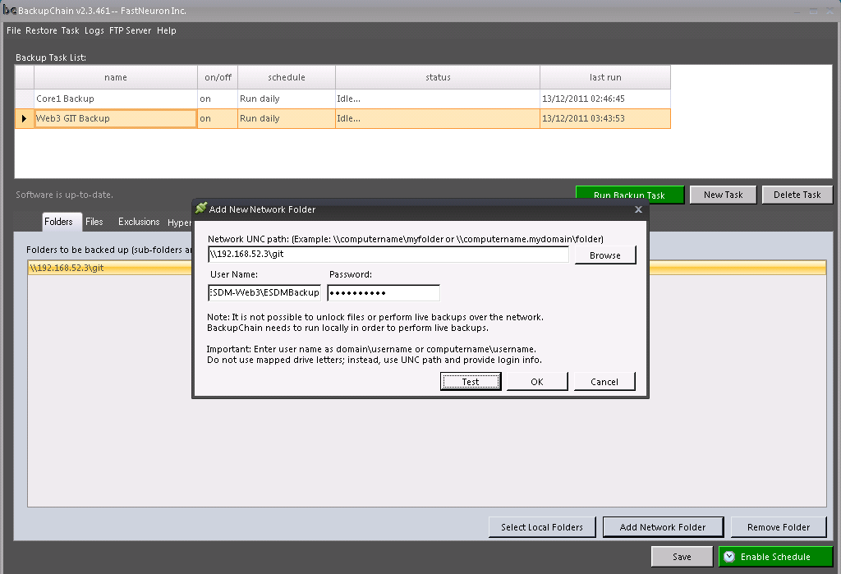

1. You need to run net use external process to setup the share before the task is run

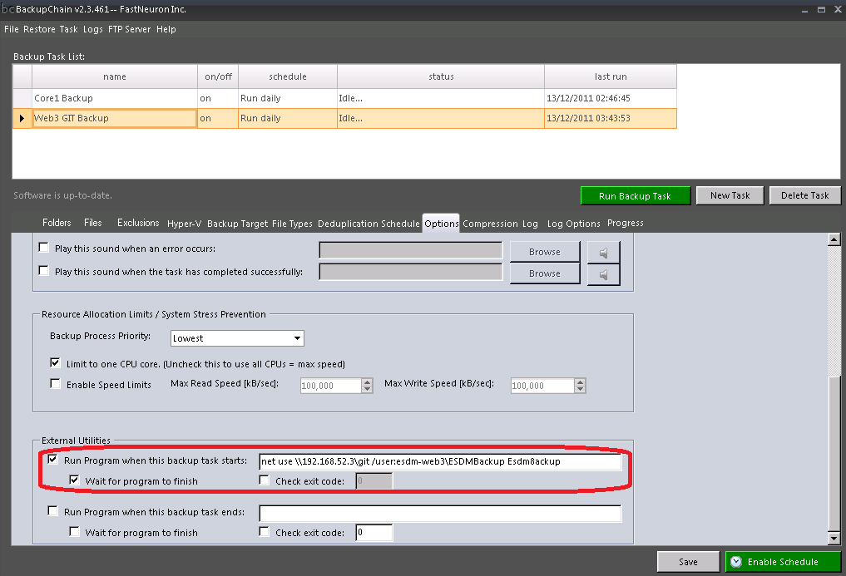

# Permissions on CORE machines

Be VERY careful before messing with these – you can quickly stop all VMs working !

If by any chance something does mess up – below is a screenshot from the default permissions on a core machine on C and D.

ICACLS.EXE will help you set permissions.

<http://technet.microsoft.com/en-us/library/cc753525%28WS.10%29.aspx#BKMK_examples>

Take care / note to set BUILTIN\Administrator etc and not just Administrator (which will default to the machine name – and hence give access to all other machines). Also it doesn’t actually get VMs to work!



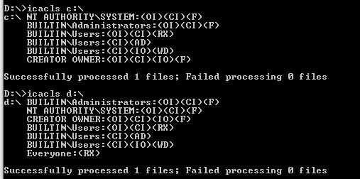

# Managing HyperV machines

## Using HyperV from a VM

Hyper-V manager is installed on Win7Admin VM – and this is probably easiest place to manage VMs from

## Managing VMs from the core

59Manager is a great free tool – similar to HyperV manager that allows you to manage most aspects of VMs from the core (most importantly stopping and starting!)

To run this just got D:\ drive on either Core and type 59

It also has some basic health monitor graphs and measures

## Connecting using HyperV from your local machine

Assumes you are on Win7 and have installed Hyper-V manager

* Setup SuperAdmin user on local machine (with correct password)
* Shift right click starting HyperV and connect as another user. Enter SuperAdmin details
* Then connect using internal IP of core server with VPN running
* BUT – I did have to disable firewall to get initial list of VMs – though once I have them I can restart firewall and it all seems to still work