WEB TECHNOLOGIES / LABORATORY WORK 04
Interactive Web Page with
JavaScript and DOM
STUDENT  Bagin Artem Antonovich | GROUP  IT3-2503 DS
COURSE  Web Technologies | DATE  08 October 2026
Purpose
To create a responsive event registration page that uses JavaScript and DOM manipulation to select events, switch themes, provide live input feedback, validate a form, and display successful registrations without reloading the page.
Screenshots and functionality

Figure 1. One selected event card; its selection state is updated using classList and textContent.

Figure 2. Dark mode is applied by toggling the dark-theme CSS class on the body.

INTERACTION EVIDENCE / VALIDATION & SUCCESS

Figure 3. Invalid form: name, email, student group, and agreement show individual error messages.
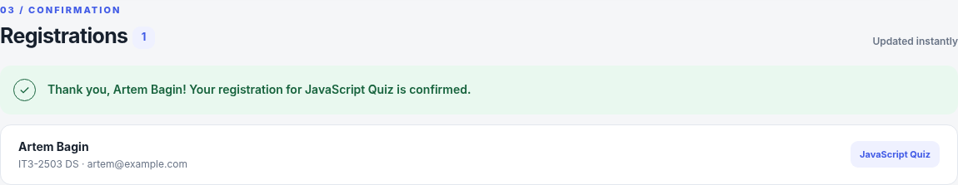
Figure 4. Valid form: personalized success message and a new registration list item appear instantly.
Implementation
The script selects page elements with querySelector and querySelectorAll, listens for click, input, change, and submit events, and calls small functions for selection, validation, error display, and result creation. Event information and registrations are stored in JavaScript arrays. createElement and appendChild add safe text-based registration items to the DOM.
Conclusion
The interactive event registration application was completed using HTML, CSS, and JavaScript. Users can choose one event, change the page theme, and see the name character counter update while typing. Invalid data produces clear field-specific errors, while valid data generates a confirmation and registration entry without refreshing the page. The design was also checked on a narrow mobile viewport.

