**POST API:**

**URL:** http://127.0.0.1:8000/analyses/

**Parameters:** video

**Response:**

{

    "status": "success",

    "job_id": "f93c1e4a-535a-4127-b7de-27c12e722f13"

}

**API Demo on POSTMAN:**

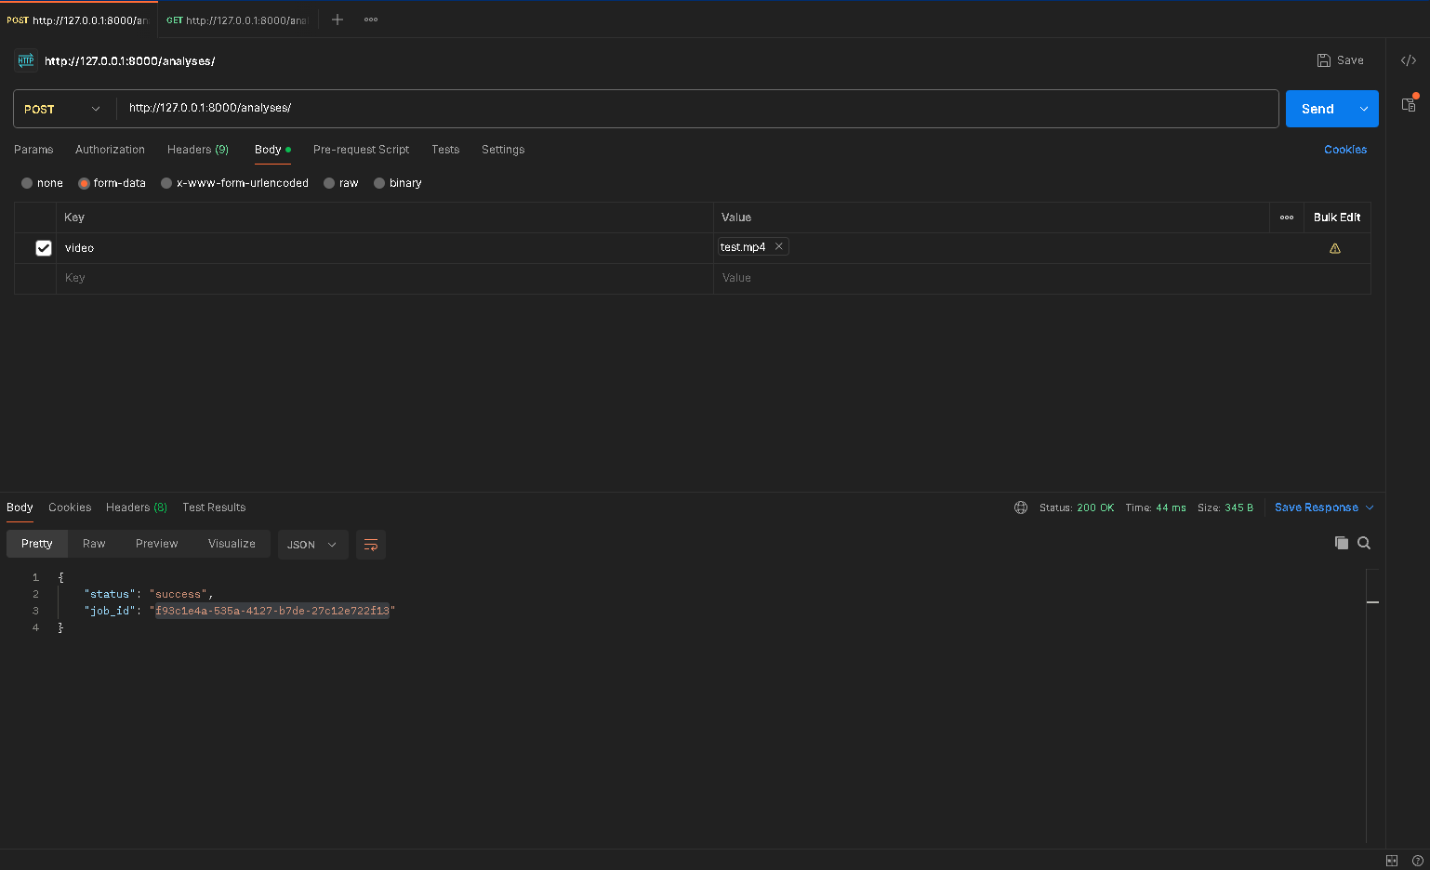

**GET API:**

**URL:** http://127.0.0.1:8000/analyses/status/?job_id={id}

**Example:** http://127.0.0.1:8000/analyses/status/?job_id=f93c1e4a-535a-4127-b7de-27c12e722f13

**Response when Process is still running:**

{

    "status": "success",

    "job_id": "f93c1e4a-535a-4127-b7de-27c12e722f13",

    "analysis_status": "pending",

    "results": null

}

**API Demo on POSTMAN:**

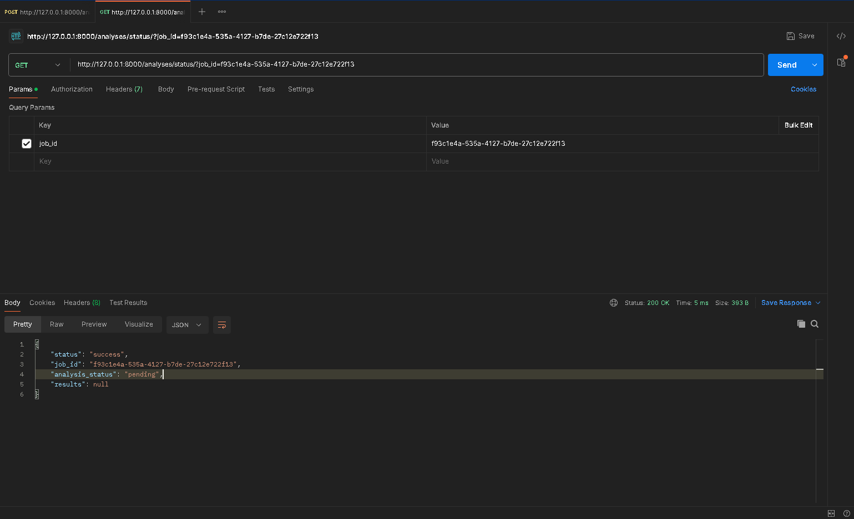

**Response when Process is Complete:**

{

    "status": "success",

    "job_id": "f93c1e4a-535a-4127-b7de-27c12e722f13",

    "analysis_status": "completed",

    "results": {

        "1": {

            "Distance Covered": "25.729 Meters",

            "Average Speed": "12.996 Miles per Hour",

            "Peak Speed": "19.899 Miles per Hour",

            "Net Dominance": "41.89 %"

        },

        "2": {

            "Distance Covered": "21.457 Meters",

            "Average Speed": "7.351 Miles per Hour",

            "Peak Speed": "10.629 Miles per Hour",

            "Net Dominance": "53.92 %"

        },

        "3": {

            "Distance Covered": "23.787 Meters",

            "Average Speed": "13.781 Miles per Hour",

            "Peak Speed": "19.907 Miles per Hour",

            "Net Dominance": "28.88 %"

        },

        "4": {

            "Distance Covered": "26.348 Meters",

            "Average Speed": "14.252 Miles per Hour",

            "Peak Speed": "23.754 Miles per Hour",

            "Net Dominance": "15.54 %"

        }

    }

}

**API Demo on POSTMAN:**

