CAPABILITY DEVELOPMENT FUNDING AGREEMENT

The eLearning XML Editor (eXe) Project (eCDF 203)

The University of Auckland
Report for the Period 1 November till 31 December 2004
Report Date: 31 January 2005

1. Narrative description of progress implementing the project

The eXe project is developing an open source, web-based tool that will enable teachers and academics to create professional-looking web content specifically designed for online learning without needing any knowledge of HTML or XML mark-up technologies. The philosophy underlying the elearning XML editor (eXe) project is that pedagogy needs to drive the development of educational technology. Therefore the eXe project is directed by submissions from the educational community to define the specifications for the development of instructional devices that will be incorporated into the development of the eXe. As eXtensible Markup Language (XML) is a structured tagging notation, it provides educators with unique opportunities to author structured learning content for the Web with the added advantage of manipulating the form and presenting the content with relative ease.

The eXe project is established with the core development team now in place. The project continues to attract both national and international interest as evidenced by the growing number of visits to the project website hosted at Eduforge. On average, there are 1,360 visits to the eXe project home page per month, with a cumulative total of 8164 visits for the six months ending 31 December 2004.

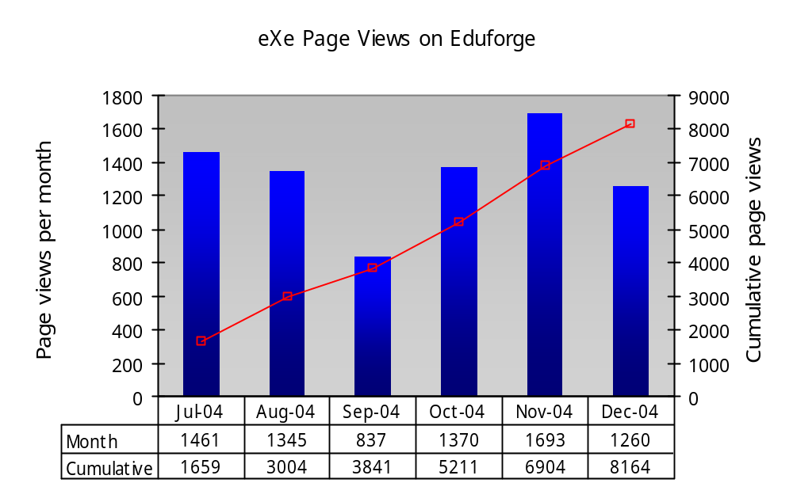

The recruitment of skilled Python software developers has taken longer than we could reasonably have anticipated, particularly given the high employment rates in the New Zealand economy at this time. Consequently, we have lost five month’s worth of code development with our lead developer only joining the project late in November 2004.

Notwithstanding these initial delays, we have completed the architectural design and requirements for the first iteration of eXe. The project is now in a position to implement the open source development philosophy of releasing early and frequently. As a requirement of Milestone 2, the project roadmap has now been recalibrated to cater for a release each month of the project. Code development for the first iteration is well underway with the first release scheduled for mid February 2005 — somewhat earlier than the alpha release planned for April 2005. In this way we hope to promote wider participation from an early developers’ community.

We are confident that this development will achieve the overall aims of the project, taking into account the power of the open source development philosophy. Rapid advances with the implementation of interoperability specifications for content packaging combined with the power of XML technologies we are experiencing in education at this time will contribute to eXe filling a strategic gap in the emerging suite of next generation e-learning technologies.

1.1 Notable achievements for the period of review

- Appointment and induction of core eXe development staff. The following staff have been recruited and appointed to the project:

  - David Moore, lead code developer (Start date: 22 November 2004). The project is fortunate to have recruited the calibre of experience demonstrated by David on the project thus far. Deserving particular mention is his experience and commitment to open source technologies.
  - Jenny Lin, programmer (Start date: 8 November 2004). Jenny has proved her skills as a fast learner and able programmer, particularly with regard to learning Python.
  - Brent Simpson, Web developer (seconded full-time to eXe project from CFDL from 1 November 2004). The eXe project is privileged to have Brent seconded full-time from CFDL on this project. He has a proven track record in CFDL for implementing avant-garde solutions and he will no doubt perform the wizardry we require on the front-end of eXe. Moreover he is an experienced hacker.
  - Doreen Christie, 0.3 FTE Project Manager (Start date: January 2005). Doreen has extensive experience in Business Analysis and Project Management in the IT industry. In addition, she has a passion for finding effective technology solutions for Education,
  - The Director of CFDL at the University of Auckland continues to lead the project with additional guidance and support from CFDL technical staff.

During the start-up period of the eXe project, Wen-Chen Hol (system administrator at CFDL ) provided invaluable work in developing the proof-of-concept. His coding approach is novel, enabling us to find innovative solutions to the challenges we face with the eXe project. Wen-Chen continues to inspire the development with creative solutions for the requirements we must implement.

The eXe project team has developed a shared understanding of the vision for the project and have acquired the tacit knowledge necessary for a successful development. We are searching for another senior Python developer and a dedicated learning designer will be joining the eXe team to support the development of pedagogically robust instructional devices and user documentation for the project.

- Completion of a proof-of-concept for packaging the eXe code base using a localhost web-server. Our desktop research during Milestone 1 indicated the theoretical potential of this approach. As reported earlier, this signalled a change in our original architectural design and the skills requirements for the project. We have successfully packaged a web-server with a small set of eXe test code thus proving that the solution will work (see Packtest example on Eduforge at: http://eduforge.org/frs/shownotes.php?group_id=20&release_id=18). This was a critical path decision for the project and we can now move forward with confidence using this architectural approach.

This is a novel architectural approach which has leveraged a number of strategic advantages for the project:

  - eXe will function as an offline desktop application enabling teachers and academics in New Zealand (and elsewhere) to author interactive web content without the need for Internet connectivity. Moreover, with recent advances in the implementation of interoperability specifications for content packaging, users will be able to import eXe content into SCORM compliant LMS technologies;
  - eXe can publish learning content as self-contained web pages so that learners with bandwidth constraints can experience rich multimedia and interactive web content without the need for connectivity. This means that teachers, schools and small community-based institutions that are unable to maintain sophisticated LMS installations will still be able to benefit from the advantages of interactive web content;
  - As users will be authoring in a native web environment, eXe is able to preview content as it would display in a browser. In this way, eXe is able to mimic wysiwyg functionality of desktop publishing associated with contemporary word processing software. This means that authors will have immediate visual feedback of their work thus promoting the development of learning content that is appropriate for the medium.

- We have successfully imported eXe content generated by the proof-of-concept into Moodle and WebCT using their SCORM import facilities. This demonstrates that interoperability for eXe content will be achieved;
- The Director of CFDL presented a workshop session on the eXe project while attending a recent seminar organised by UNESCO IITE in Moscow. This has promoted the international exposure of the project (see: http://www.iite.ru/iite/events/events?id=96);
- The eXe concept was demonstrated at the recent NZ interoperability workshop held at Lincoln University thus promoting the technology within the tertiary sector (see presentation at: http://eduforge.org/docman/?group_id=20).
- Early concepts for the user interface were developed inviting feedback from potential users (see Step 4 at: http://eduforge.org/wiki/wiki/exe/?pagename=HomePage). We have concluded from feedback that the interface inspired by TiddlyWiki (http://www.tiddlywiki.com/) will offer the most intuitive authoring interface with the added benefits of authoring within an embedded wysiwyg environment;
- We have developed a proof-of-concept for an interactive iDevice using the requirements associated with the functionality of a multiple choice question. This demonstrates that eXe will be able to include an environment for authoring interactive iDevices. These interactive iDevices can be packaged as standalone web content that will operate on a desktop browser without Internet connectivity. This means that students with bandwidth limitations or connectivity problems will be able to experience interactive learning content.

2. Achievement of project milestones and deliverables

This reporting period covers the specifications and architecture design for the eXe project. In particular, we have completed the following specified deliverables:

- Specifications and corresponding priorities for the first release of eXe have been completed in consultation with the user group for the project. The requirements for the first iteration of eXe are published on Eduforge. (see: http://eduforge.org/wiki/wiki/exe/wiki?pagename=FirstIterationRequirements.
- The architectural design for eXe has been completed ensuring a modular design that is adaptable and scaleable. (see design diagram hosted on the internal development wiki: http://exe.cfdl.auckland.ac.nz/wiki/Architecture). However, we recognise that the development and refinement of the architecture is reiterative and the project will continue to refine and improve the design through repeated “plan-do-reflect” cycles.
- Core developers’ and user group meetings were held to prioritise and specify the requirements for the first release of eXe. The core developers and user groups have sanctioned the requirements for the first release.

Project Milestones | Outcomes and deliverables | Achievement Date
Milestone 1  Set-up, desktop research & international best practice evaluation (Oct 04) | Subtask 1: Setup and recruitment of project staff  - Written terms of reference for the management team  - Location of core developer staff in Auckland  - Location of core developer staff in Wellington | 31 January 2005  22 November 2004  Relocated to the core eXe development
 | Subtask 2: Installation of systems and desktop research  - Installation of development hardware  - Setting up collaboration website  - Desktop research report  - Proof-of-concept  - Project website | Yes (30 November 2004)  30 November 2004  7 August 2004  31 October 2004  18 October 2004  26 November 2004
 | Subtask 3: International best practice evaluation  Evaluation of current state of the art regarding Educational Modelling Languages, XML and the semantic web. | No  Deferred to May/June 2005 in consultation with the TEC.
Milestone 2  Specifications and architecture design | NZ Core developers meetings  User group meetings  Meetings with CSIR developers  Architecture design and specifications  Recalibration of project roadmap (see 2.1 below) | Yes (23 December 2004)  20 December 2004  14 December 2004  Virtual communications  14 December 2004  23 December 2004

Based on the outcomes and deliverables listed above, the 2nd Milestone for the project has been achieved. In our initial planning for Milestone 2, we indicated the requirement for recalibrating the project roadmap. The next iteration of the project roadmap is discussed in the following subsections.

2.1 Recalibration of the project roadmap

The eXe project was originally planned according to a classical software development. Three definitive releases were planned:

- Proof-of-concept prototype — 31 October 2004
- Alpha release — 30 April 2005
- Beta release — 31 July 2005
- Final release — 31 January 2006

Our experience gained from developing the proof-of-concept, combined with recent developments with the implementation of interoperability specifications for content packaging have necessitated the recalibration of the project roadmap. The following factors need to be considered:

- Our test packaging of eXe code with a localhost web server has enabled the project to be developed as an offline desktop application. This has significant strategic advantages for eXe as we now have the capability of implementing web technologies on a local desktop without the need for a centralised server model. The project was originally conceived as a development based on a centralised server model. Our novel solution for an easy download and installation of a localhost web server has necessitated the recalibration of the project roadmap. We now have the means to package an easy install for any teacher in the world to download and experience the features of eXe thus creating an environment for users to shape the development according to local educational needs;
- The eXe project is contractually committed to be delivered in a manner that links and is consistent with the NZOSVLE project lead by the Open Polytechnic of New Zealand. When the eXe project was planned, the outcome of the evaluation and selection of an open source LMS was unknown. Consequently, in the original roadmap for the eXe project we planned for the code development that would be necessary for the integration of eXe content with this initiative. The selection of Moodle by the NZOSVLE project has resulted in significant gains for the eXe project. First, Moodle’s modular object design enables sophisticated interfacing between eXe content and the LMS, because eXe will be able to save content in the file format of a Moodle course using an XML structure. This will enable users of Moodle to author selected web content offline with eXe as a content authoring environment. Second, a recent release of Moodle has incorporated a SCORM import utility. Using outputs from the eXe proof-of-concept, we have successfully imported eXe content into Moodle thus proving the power of evolving interoperability specifications. These notable developments will enable eXe to achieve more than we could reasonably have anticipated and the project plan must be reconfigured to capitalise on these advantages.
- We have created an online environment for any teacher or academic to submit ideas for instructional devices (iDevices) they would like to be incorporated into the eXe development (see: http://cfdl.auckland.ac.nz/idevice_interest/introduction.html). iDevices are discrete objects that make teaching content unique and this differentiates eXe from other authoring environments. They include things like reading activities, case studies, and a range of different learning activities that can be signalled visually on the display with the potential for embedding learner-content interaction features. However, in the absence of a working example of eXe, practitioners are experiencing difficulty in understanding this abstract concept. Therefore, it is not wise to delay the first release of the technology until the end of April 2005. The project needs to provide a practical example of the eXe concept early in the process. While the features for the first iteration will be extremely limited, we believe that an early release will benefit the project tremendously. In this way teachers and academics will be able to see a practical example of an instructional device.

Taking these factors into account, combined with the open source development philosophy of releasing early and frequently, the project will be recalibrated to provide a release on the 10th of every month, except for the month when the core development team will be offshore for the international best practice evaluation and international promotion of the eXe project.

2.2 Categorising releases and key project tasks

The dynamic nature of an open source development means that it is difficult to predict how the development community will evolve and potentially contribute to the project. However, this is not an excuse for ignoring sound project management. Mechanisms for managing this dynamic complexity must be implemented.

The eXe project will achieve this by identifying a high-level roadmap whereby a fixed monthly release is predetermined, in this case the 10th of every month. The requirements of each release will be more dynamic but the project will plot an envisaged path describing the intended release objective of four subsequent releases. Every two months, the requirements are prioritised and agreed by the user group for the next two releases. Every month the eXe development team will post ideas for the target of the fourth consecutive release from the current monthly release. While the scope of a particular release may not utilise full coding capacity, or as coding capacity for the project increases through a growing developers’ community, a mechanism must be found to establish a pool of small but discrete coding projects. This will be achieved by building a pool of minor development requests, for example a submission for the development of an iDevice.

A minor development request is a discrete coding task, but should not be misinterpreted as a trivial piece of code development. The nature of interactive iDevices will require innovative code development. Within the project management framework, minor development tasks should be seen as a reservoir of small projects that can fill up the capacity gaps of the monthly eXe releases, or as small projects to be tackled by the development community. Examples of minor development requests include:

- The code set for authoring and delivering multiple choice items as an eXe iDevice;
- The QTI interoperability specifications for objective assessment items, for example, multiple choice, true-false and matching;
- Sophisticated interactive iDevices that provide for learner-content interaction and smart implementation of multi-media, for example “drag and drop” activities, dynamic flow charts, and interactive image maps;
- Conditional page presentation sequences;
- Translations of the eXe interface for multiple language packs;
- Mini pedagogical templates which comprise a number of dedicated iDevices, for instance an authoring template to embed public domain java applets in different subject areas. Alternatively, a pedagogical template to embed 3-dimesional, virtual reality objects in web pages. In this way eXe becomes an authoring tool for contextualising learning objects for local teaching situations thus enhancing the potential for reusability of media-rich learning objects.
- Development of different cascading style sheets to increase the range of presentation and publishing alternatives for eXe content;
- The development of XML-based export alternatives so that eXe can be used as an authoring tool for different delivery technologies, for example iPods and PDAs;
- The development of presentation templates and their dependent iDevices that will be required of institutional specific website designs;

In addition to the code development for the core eXe engine undertaken by the development team at the University of Auckland, we envisage a number of parallel developments in which the developers’ community might participate, over and above the code enhancements and debugging of the core eXe engine. This would include:

- Dedicated modules that can be used in conjunction with eXe. For example, a translation module to assist translators when translating eXe content from one language to another;
- Selected developments from the minor developments’ reservoir;
- Specifying XML file structures for eXe exports into different LMSs. This will enable offline authoring of learning content for different LMSs. We believe that this approach can provide for a richer LMS import functionality than is currently possible with interoperability specifications, for example, the ability to deep-link discussion forums from within the web content to the discussion forum engines of different LMSs.

Figure 1 below illustrates the project management flowchart for eXe. The international education community submit requests for iDevices they would like to see developed for eXe and these are included in the “minor developments’ reservoir. On the 10th of every month a release is scheduled for eXe. This is directed by the key objective for that release. The eXe development team put forward ideas for the key objective for the next four consecutive releases. However, the priorities and user requirements for individual releases are determined in consultation with the user group meetings every two months. At the same time the developers’ community may select minor requests for development, or tackle the parallel development of modules that are not scheduled for coding by the University of Auckland development team.

Consequently the development roadmap is fixed for a two month period for the core eXe development team, but at the same time the project is flexible enough to accommodate the iterative dynamic associated with an open source development. The developers’ community may choose to prioritise other specifications in minor developments’ reservoir, or may commence with parallel modules. These will be incorporated with the respective releases as they unfold during the project.

Developers’ Community
Minor developments’
Reservoir
Release 1
Release 2
Release 3
Release 7
Release 6
Release 5
Release 4
Key objective for each monthly release
eXe Development Team
User group meetings
Submissions
for
iDevices
Parallel eXe modules
(Eg. Translation module, VR object integration module)
International Open Source Software
Development Community
Core eXe Development Team
(Funded by the Tertiary Education Commission of New Zealand)
International Education community
Figure 1: The project management flowchart for eXe

2.3 Anticipated objectives for the next 5 releases

A user group meeting was convened during December 2004, where the user requirements for the first release were discussed and prioritised. For this reason five instead of four key objectives are documented in this report. There is no release scheduled for June due to the rescheduled international best practice and eXe promotion visit. The release objectives for releases 6 to 10 are yet to be defined.

- eXe Release 1 (First Iteration — Due mid February 2005)

The first iteration will feature the basic functionality of eXe so that the community can gain a better understanding of what the technology is. Only a few elementary iDevices will be included with this release. The purpose of this release is to provide a working example of eXe so that the education community can submit further ideas for iDevices.

A summary of the requirements for the first iteration prioritised in consultation with the user group follow:

  - iDevice templates

The inclusion of two basic types of iDevice namely: Free text consisting of a free area field; and Generic consisting of a graphic icon to represent the iDevice plus text field sub elements for the Idevice concerned (eg Reading activity, objectives). It will not be possible to delete the supplied iDevice templates in this iteration or modify existing iDevice templates. This is planned for Release 3. However, users will be able to add, delete and move iDevices assuming the content is filled in, within the taxonomy below.

  - Package properties

A content package or resource is a collection of content. The size of a content package is determined by the user and may, for example, be a learning resource for a unit of study or the content for an entire course. A package will have the properties: Title, Author, Description as well as the functionality to input the preferred nomenclature for the content taxonomy, for example: module, section and study unit; or semester, week, and day. Users will be able to add or delete levels from the hierarchy, promote or demote hierarchical levels and move sub elements and their respective children within the taxonomy. Each element in the taxonomy can be edited to use a content specific label.

  - User interface

The user interface shall render in Mozilla Firefox and consist of: a general editing and preview area; a tree for viewing the content structure and a tool box containing the available iDevices. A content object (iDevice template with content filled in) can be viewed in editing or preview mode. When the user clicks “done” the content object will be displayed in preview mode according to the style sheet selected.

  - Runtime behaviour

eXe will run on a computer with no network connection — in other words, an offline authoring tool. eXe will render in a browser. Once installed the editor will be launched from a single command in a standard Windows XP environment, and will therefore not require any services to be set up.

  - Exports

The first iteration will provide two export alternatives:

      - Self-contained website consisting of well formed (X)HTML, CSS, media and Javascript. It will run independently on the client side (without the requirement for connectivity) and will render in Firefox 1.0 and Internet Explorer 6.
      - IMS/SCORM content packaging, containing the IMSmanifest.XML plus zipped assets. The export will be able to be imported into Moodle and other SCORM compliant LMSs. Users will be able to import this export into the Reload Editor.

  - Packaging

The complete eXe editing system will be made available as a self-installing executable which will run on Windows XP — no other files will be required. An RPM for Linux may also be made available.

- eXe Release 2 (“Minor developments” Release — Due 10 March 2005)

This release will be dedicated entirely to the development of selected iDevices in order to demonstrate a range of representative iDevices that will hopefully trigger ideas for more submissions from the educational community. For example, we expect that the multiple choice iDevice will receive a high priority rating as this will demonstrate the capabilities of an interactive iDevice, but at the same time provide the code engine for managing other forms of interactive assessment. This iDevice could also facilitate the management of limited logical sequencing of page displays in the (X)HTML content pages that are exported by eXe.

However, the priorities and requirements for this release must still be assigned in consultation with the user group. The user group will meet shortly after the first release to agree on user requirements and priorities for Release 2 and 3.

- eXe Release 3 (iDevice Editor Release — Due 10 April 2005)

The eXe project team recommend that this release is dedicated to the development of the iDevice editor module that will enable users to create or modify their own iDevices and construct their own pedagogical templates.

- eXe Release 4 (Image Management Release — Due 10 May 2005)

There are a number of architectural issues relating to the management of images within the technology. For example, should the images used for each instance of an iDevice be replicated, or should all iDevices of the same type share a single copy of the image? When a user changes the icon image for an iDevice, should it automatically change all instances of the same iDevice? How should the image folder be managed?

- eXe Release 5 (Undo/Redo Release — Due 10 July 2005).

The eXe development team are keen to provide users with the functionality of being able to undo and/or redo recent actions. The implications of how best to implement this functionality within the eXe must still be explored.

We envisage that as the project develops the priorities for these releases might change. In so far as the coding carried out by the core eXe development team is concerned, these priorities will be determined in consultation with the user group. The developers’ community, taking into account the dynamic of an open source project may well prioritise other requirements and these will be reflected through the releases as the project evolves.

2.5 Ongoing tasks

There are a number of project tasks that continue for the duration of the project, feeding in to individual releases. These include:

- Submission of iDevices: The national and international education community continue to submit requests for the development of iDevices. The specifications and requirements for individual iDevices are submitted online at http://cfdl.auckland.ac.nz/idevice_interest/introduction.html . Submissions are stored in the small development’s reservoir (see Figure 1). In consultation with the eXe user group, priorities for iDevice development by the core eXe development team are established. The open source development community also assist with the development of iDevices from the small development’s reservoir. A learning designer will be joining the core eXe development team to assist with the submission of iDevices.
- Researching technical alternatives: This is an ongoing process for the team to keep abreast of contemporary developments. Moreover, specific desktop research relating to implementation alternatives is necessary to inform the key objectives for monthly releases. For example, the implementation alternatives for incorporating a spell checker into eXe.
- Development of user documentation: User documentation will be developed from a pedagogical bias of how to use eXe to promote best practice in e-learning. User guides will be published in HTML using eXe to author the materials. The learning designer joining the eXe team will take the lead in developing these resources.
- National and international promotion: The eXe development team will continue to promote the technology among the education community. This will include the development of fliers, brochures and packaged demonstration versions of eXe. In addition eXe will provide presentations at conferences, submit papers for publication and make regular contributions in appropriate electronic news forums.

A high-level summary of the recalibrated project plan is provided in Annexure 1.

3. Achievement of project performance indicators

The performance indicators specified for the project are being met. The achievements are summarised in the table below.

Performance Indicator | Achievement of Indicator
1. All milestones are met as measured by the successful completion of the outputs specified in the Capability Funding Agreement. | - The deliverables for Milestone 2 have been met.  - Subtask 3 of Milestone 1 regarding international best practice evaluation was rescheduled for later in the project (May/June 2005) in consultation with the TEC. Early desktop research indicated that the eXe would not need to be based on XML schemas for education given significant progress in the implementation of the IMS specification for content packaging.
2. eXe Project promotes the establishment of a stable core development community (national and international). | The project is managed in a way that will facilitate the establishment of a stable core development community. For example:  - All aspects relating to the project are published on the Eduforge site. The project charter, outcomes of our desktop research, formulation of requirements, ideas concerning technology choices and inputs concerning the user interface have been developed in consultation with the wider community.  - An open website for the submission of iDevices has been established.
3. The usability and intuitiveness of the editing interface – monitored by feedback from the target user audience. | The first iteration will be released during February, and we will monitor feedback from the target audience. In the interim, the user group was consulted regarding decisions on the editing interface for the first iteration.
4. The extent that the technology interfaces with existing institutional LMS technologies. | We have demonstrated with successful imports in WebCT and Moodle that eXe interfaces with existing LMS technologies using the interoperability specifications for content packing.

4. Other issues arising in the delivery of the project

The eXe project is an innovative development aimed at developing tools for next generation e-learning. The project is dynamic and iterative and shows huge potential for building pan sector capability in e-learning for New Zealand. Consequently, the project must explore ways to promote wide scale adoption across the sector to include both the primary and secondary education sectors. We therefore enquire whether the TEC can assist and facilitate some discussion of alternatives to promote wider involvement of these sectors in New Zealand, including appropriate stakeholders such as the Ministry of Education.

Report prepared by:

Associate Professor Wayne Mackintosh
eXe Project Leader
Centre for Flexible and Distance Learning
University of Auckland

Date: 31 January 2005

 | Agreed  Project  Budget  [inc GST] | Budget  For  Reporting  Period | Actual  Expenditure  For  Reporting  Period | Cumulative  Budget to  Date | Cumulative  Actual  Expenditure  To Date | Cumulative  Variance
ESTABLISHMENT
EXPENDITURE

Capital
expenditure
Database and web  Server hardware | $40,000 | Nil | Nil | $40,000 | Nil | $40,000
Office equipment  And furniture | $18,500 | Nil | $12,698 | $18,500 | $12,698 | $5,802
Operational Costs

Advertising &  Recruitment | $9,000 | Nil | Nil | $9,000 | Nil | $9,000
ONGOING
PROJECT
EXPENDITURE
Direct operational
Costs
Staff costs | $461,300 | $51,000 | $24,270 | $153,000 | $24,270 | $128,730
Travel &  Accommodation | $72,000 | $15,600 | $1,961 | $45,200 | $1,961 | $43,239
ACC levy &  Superannuation | $33,050 | $3,653 | $1,738 | $10,961 | $1,738 | $9,223
Indirect
Operational costs
Overhead costs | $558,174 | $61,710 | $29,367 | $185,130 | $29,367 | $155,763
Administration &  Office supplies | $27,680 | $3,060 | $1,537 | $9,180 | $1,537 | $7,643
TOTAL | $1,222,504 | $135,023 | $71,571 | $470,971 | $71,571 | $399,400

Annexure 1
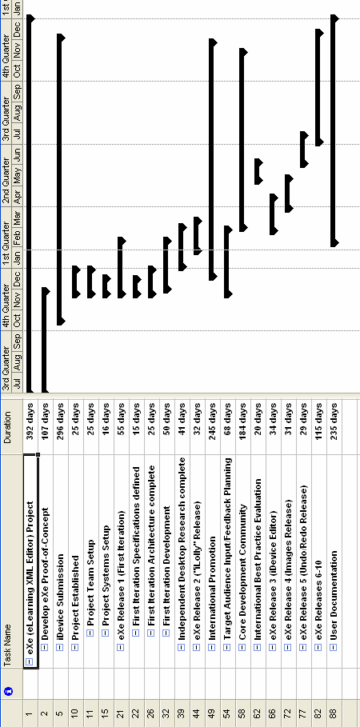
Recalibrated project plan to accommodate a Monthly eXe Release

This report expands on the interim report submitted during December 2004 to the TEC in support of the request for extending the submission date for this reporting period due to submission date falling within the summer vacation period.
SCORM import functionality now available in Moodle has obviated the need for eXe code development at the Open Polytechnic as originally anticipated for the integration of eXe content with the NZOSVLE project.
Installation of central web server now deferred until iDevice repository is required.
No meetings have taken place with CSIR developers. However the Director of CFDL will be in South Africa for a personal visit and will be meetings with representatives from the CSIR.
We have not yet purchased and installed web server and database hardware. The shift to a localhost architecture for eXe has obviated the need for a central webserver at the startup of the project. However, soon after the first release when the community begins to share iDevices for eXe, this hardware will be required.
The large variance on staff costs relates to early delays in recruiting staff for the project. However, as of February 2005, the staff costs will be 85% of the budgeted monthly amount. We are currently searching for an additional senior Python programmer.

