# Get the server installed and running

Install Uniform Server

Install composer

Point composer to the php70 folder in Uniform/core

Test composer by running the command composer

Run Uniform and configure as follows:

Put some MySQL root password

Change the root folder for apache and ssl to the app’s public folder

Enable SSL

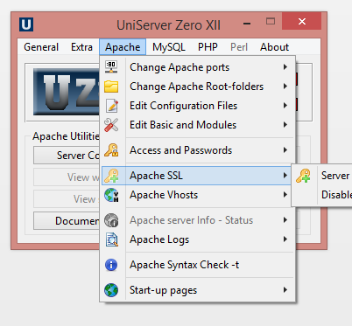

Switch to dev on PHP

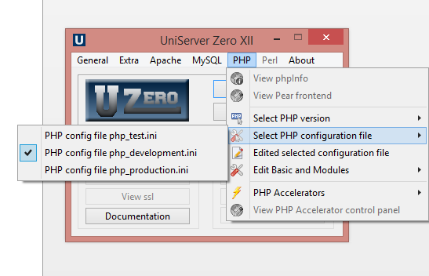

Enable file info and open ssl

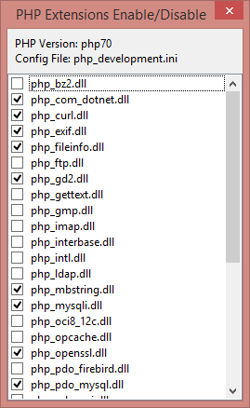

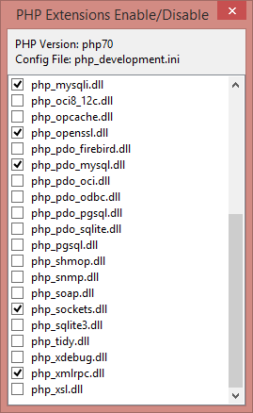

Make sure that

* PHP >= 5.5.9
* OpenSSL PHP Extension
* PDO PHP Extension
* Mbstring PHP Extension

(According to <https://lumen.laravel.com/docs/5.2>)

Add to the php.ini cli version in php-cli.ini (\UniServerZ\core\php70\php-cli.ini)

extension=php_fileinfo.dll

Go to the app’s root folder and run

composer install

# Get the app running

php artisan migrate

If you get an error:

$ php artisan migrate

[Illuminate\Database\QueryException]

SQLSTATE[42S02]: Base table or view not found: 1146 Table 'stinjee.users' doesn't exist (SQL: alter table `users` add `id` int unsigned not null auto_increment primary key, add `email` varchar(255) not null, add `name` varchar(

255) not null, add `password` varchar(255) not null, add `remember_token` varchar(255) not null, add `created_at` timestamp default 0 not null, add `updated_at` timestamp default 0 not null)

[PDOException]

SQLSTATE[42S02]: Base table or view not found: 1146 Table 'stinjee.users' doesn't exist

Then:

Changed the “table” to “create” in:

\stin-jee\database\migrations\2015_09_09_081535_create_users_table.php

Schema::table('users', function (Blueprint $table) {

To

Schema::create('users', function (Blueprint $table) {