Date: Augst 12, 2024

Instructor: Richard Krasso

Student: Exenreco Bell

Course: WEB 231

# Weekly Folders

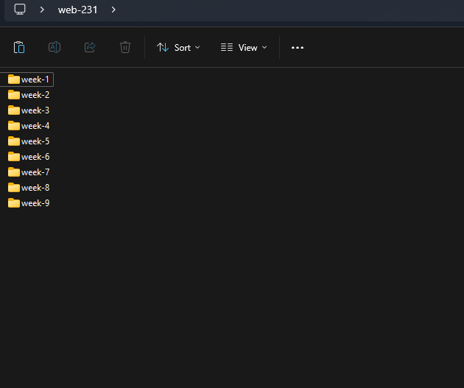

Weekly Folder Structure GUI

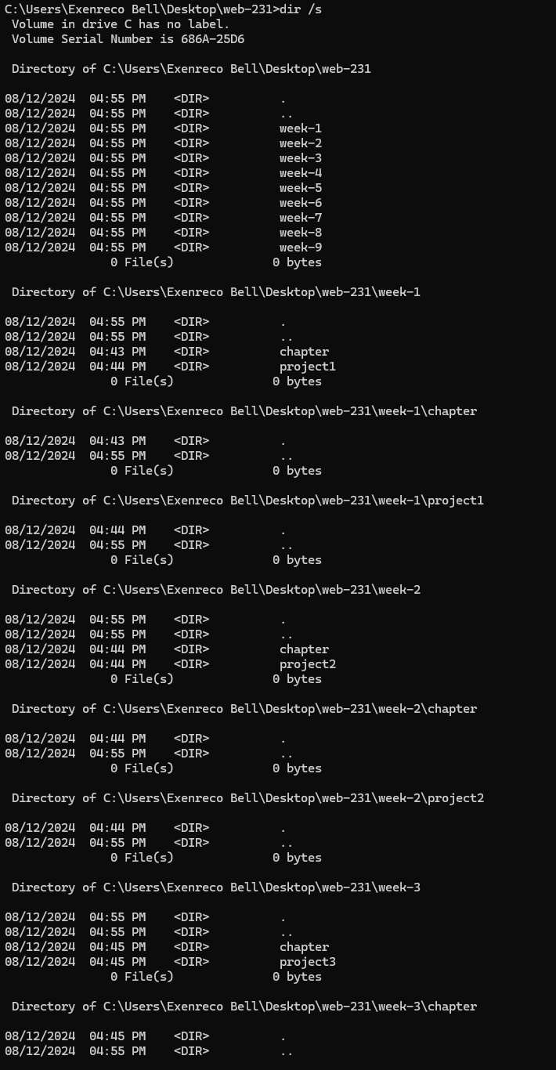

Weekly Folder structure CMD

# GitHub Setup

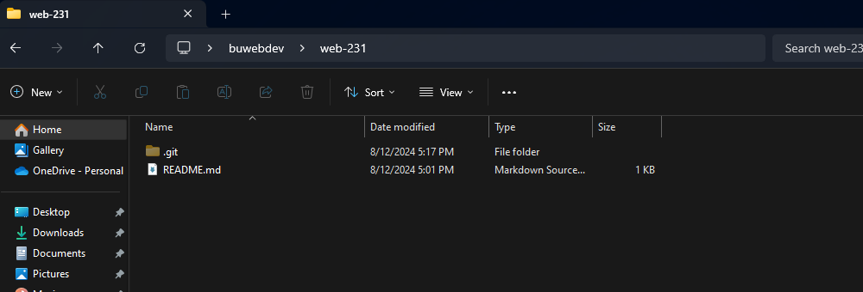

Git folder structure – GUI local

Git Repo