Literature Review of Live Sphincter Segmentation for Predicting Post-ERCP Pancreatitis

1.1 Kim et al. (2021) — AI-Assisted Ampulla Detection and Cannulation Difficulty Classification
This study aimed to assist endoscopists performing ERCP through automatic detection of the ampulla of Vater (AOV) and identification of cannulation difficulty using CNNs, using ERCP data from 531 and 451 patients respectively across two Korean tertiary centers.

Key Innovation: Soft Mask Output
Rather than predicting a hard bounding box, the model transforms bbox annotations into pixel-wise soft masks using a bivariate normal distribution centered on the bbox centroid justified by the AOV's inherently ambiguous boundary. This achieved mIoU 0.641, precision 0.762, recall 0.784, centroid distance 0.021, with a 91.4% success rate at IoU ≥0.3 — on par with expert annotation.
During evaluation, the predicted mask is normalized to peak value 1.0, then thresholded at 0.6 to recover a bounding box. This design creates a systematic vulnerability in live video: without a raw confidence floor prior to normalization, frames without a visible papilla will still produce a false-positive bounding box around the highest-probability region in the frame.

Architecture
Detection: U-Net with VGGNet-based encoder-decoder and skip connections, pretrained on ImageNet. Difficulty classification: ResNet-50 achieved best binary performance (recall 71.9% easy, 61.1% difficult; AUC 0.680) over VGG19+BN and DenseNet161. Five-fold cross-validation used throughout. No PEP outcome is predicted.
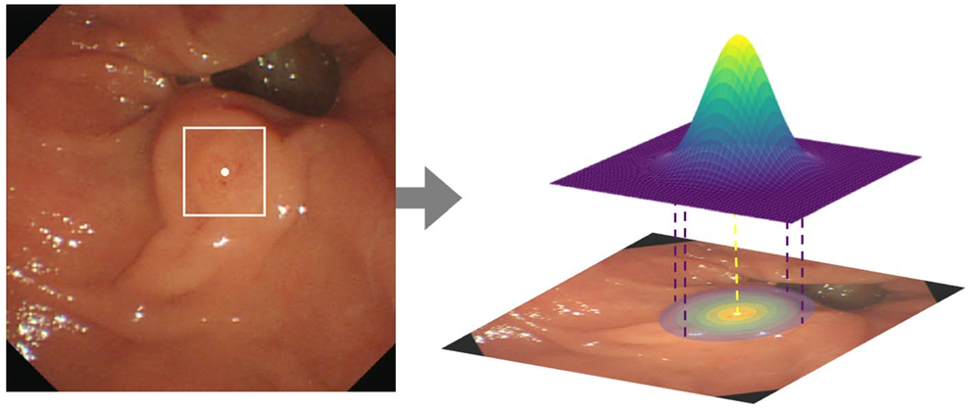
Soft mask detection results from Kim et al. (2021).

1.2 Chen et al. (2024) Papilla Radiomics-Based PEP Prediction
Chen K et al. Duodenal papilla radiomics-based prediction model for post-ERCP pancreatitis using machine learning. Gastrointestinal Endoscopy 2024;100(4):691-702.
This study investigated the association between papilla morphology and PEP by developing a radiomic score (R-score) from deep learning analysis of endoscopic papilla images, using 2,038 patients from two Chinese centers (January 2019 to June 2022), with 486 post-PSM cases in the derivation cohort and 334 in external validation.

Key Innovation: R-Score as the Dominant PEP Predictor
MDP images were manually segmented into three regions (entire image, papilla, orifice). Images were cropped to a square bounding box, resized to 224×224, and contrast-normalized on the central chroma region. ResNet-50 was trained as a binary PEP/non-PEP classifier. The R-score — averaged across images per patient, was the single strongest predictor in all three ML algorithms (LASSO, RF, XGBoost): OR 7.79 (95% CI 4.48–13.55) in logistic regression, outranking cannulation attempts (OR 3.49), and papilla type.
The final 6-variable logistic regression model (age, WBC, small papilla, cannulation attempts, IDUS, R-score) achieved AUC 0.825–0.857 across cohorts.
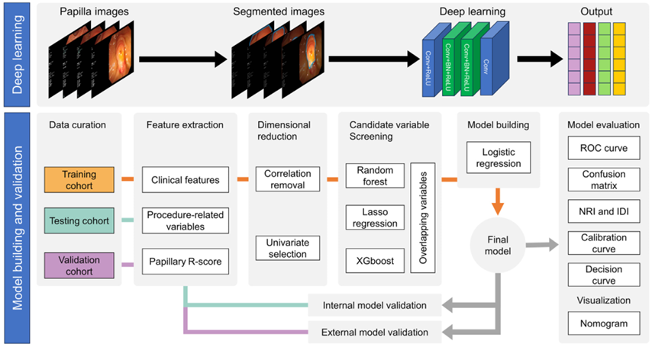
Pipeline in Chen et al.

1.3 Xu et al. (2024) Multimodal PEP Prediction: MDP Images + EHR
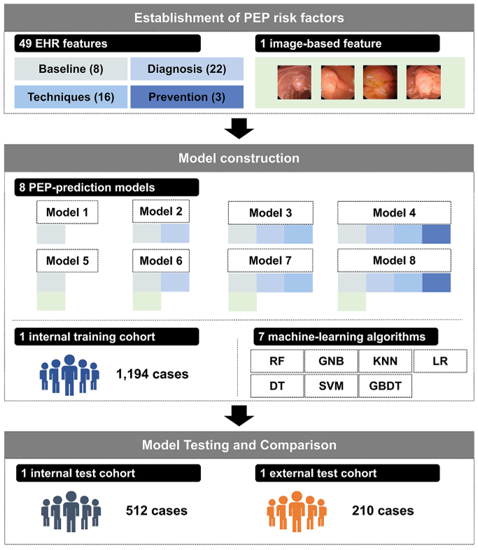
Pipeline in Xu et al.
This study comprehensively investigated PEP risk factors by constructing and validating models incorporating multimodal data; 49 EHR features and one image-based feature.

Key Innovation: Incremental Feature Category Architecture
Eight models were built sequentially, adding EHR feature categories (baseline → diagnosis → technique → prevention strategies), then the image feature. This design quantified each category's marginal contribution. Technique features (difficult cannulation, NKS, endoscopist experience) improved sensitivity from 63.9% to 77.8% over baseline+diagnosis alone. Adding the image-based factor (same ResNet-50/chroma-normalization pipeline as Chen et al.) produced the largest single improvement: AUC 0.96 vs 0.88 in internal validation, with image score ranked highest in feature weight across all fusion models. Random Forest outperformed all six other algorithms at 50-feature scale (AUC 0.96 vs LR 0.87).
The pre-procedure decision model (Model 6: image + baseline + diagnosis features only) achieved AUC 0.88 using only variables known before cannulation begins, unlike models incorporating technique or prevention features that emerge mid- or post-procedure.

1.4 Arabpour et al. (2026)
This study aimed to build and evaluate ML models to predict PEP probability via CatBoost and XGBoost, with SHAP-based feature importance analysis, using a prospective registry of 1,190 ERCP patients with naïve papilla at a single Iranian tertiary center (March 2022 to October 2024).

1.5 Liu et al. (2025) 4STDH Real-Time Papilla and Cannula Detection
This study aimed to address the challenges of detecting the small duodenal papillary orifice and surgical cannula in live ERCP video by proposing 4STDH — a four Swin Transformer decoupled heads detection framework — and a real-time guidance GUI, validated on the first publicly available ERCP cannulation dataset (DPAC: 1,840 annotated images from 12 patients).

Key Innovation: Multi-Scale Real-Time Detection with GUI
The 4STDH architecture uses four prediction heads at different spatial scales (160×160, 80×80, 40×40, 20×20), decoupled classification/regression branches, and a Swin Transformer module in the neck for long-range attention — designed specifically for the ERCP challenge of large object size disparity and high papilla-background similarity. The guidance GUI displays real-time papilla and cannula positions, their planar distance and direction, with color-coded readiness warnings: green (<100 px), yellow (100–300 px), red (>300 px). No PEP outcome is predicted.
The DPAC dataset, while small (12 patients), is the first publicly available ERCP video dataset with annotated papilla and cannula positions — a critical resource for future training of live segmentation models. However, all frames require both papilla and cannula to be simultaneously visible, limiting applicability to pre-cannulation or early cannulation frames only.

2. Comparison of Model Architectures

2.1 Logistic Regression (Chen et al.)
Despite using deep learning for image feature extraction, Chen et al.'s final prediction model is multivariate logistic regression chosen for clinical interpretability (odds ratios, nomogram), ease of bedside implementation, and regulatory acceptability. The six-variable model is presented as a nomogram enabling manual risk calculation. Logistic regression is appropriate for a static pre-procedure tool, but cannot capture interactions between variables, addressed by the Random Forest.

2.2 Random Forest (Xu et al)
Both Xu et al. and Takahashi et al. identify Random Forest as best-performing in their settings. Random Forest handles nonlinear relationships and variable interactions. Random Forest also has the advantage of fast inference (milliseconds per case), making it compatible with real-time video processing pipelines.

3. In Live Papilla Segmentation for Real-Time PEP Prediction
The central finding of this review is that MDP image content is the strongest individual PEP predictor (Chen et al., Xu et al.) yet no current system extracts this signal in real time from live ERCP video. Both image-based prediction studies required manual pre-framing by an experienced endoscopist before cannulation began, making their pipelines inherently static. A live system requires automating three sequential steps: (1) papilla detection and pixel-level segmentation from raw video frames, (2) standardized crop and contrast normalization of the papilla region, and (3) dynamic R-score generation fused with concurrent clinical variables.
Kim et al.'s U-Net with VGGNet encoder and skip connections is the appropriate foundation for papilla segmentation. Liu et al.'s four prediction heads at four spatial scales should be incorporated to handle the large size disparity between papilla and cannula. Two critical additions for live deployment are absent from both studies:
Raw confidence floor before normalization: Kim et al.'s design always produces a normalized peak of 1.0 regardless of model confidence, generating false-positive bounding boxes in frames without a visible papilla. A minimum raw probability floor (e.g., raw peak < 0.3 = no papilla detected) must be applied before normalization.
Both image-based PEP prediction studies used identical preprocessing: square crop to the papilla bounding box, central chroma region isolation, contrast normalization, then ResNet-50 inference. For live video, the segmentation model's output bounding box directly replaces the manual annotation, and contrast normalization must be applied per-frame rather than per-patient. Chen et al. demonstrated that the papilla region is most predictive (ResNet-50 papilla AUC 0.759 vs entire image AUC 0.539), prioritizing accurate papilla boundary delineation over orifice-only crops. Separate segmentation of papilla and orifice regions, as used in Chen et al., should be retained in any live architecture.

Dynamic Features Not Captured by Current Models:
The most significant opportunity for a live system lies in dynamic intraoperative signals impossible to extract from static pre-cannulation images:
Cannulation attempts count and contact duration, inadvertent PD wire passage, automated papilla morphology (Arabpour et al)

3.5 Proposed Pipeline for Live PEP Prediction
Stage 1 — Papilla presence detection: Lightweight binary classifier (MobileNet or ResNet50 or equivalent) at 30 fps. Only proceed when papilla confirmed present across N consecutive frames.
Stage 2 — Papilla segmentation: U-Net with ResNet/VGGNet encoder, skip connections, Raw confidence floor applied before normalization. Separate masks for papilla region and orifice.
Stage 3 — Cannula tracking: 4STDH-style simultaneous detection of cannula position relative to papilla orifice, counting contact events, duration, and approach angle in real time.
Stage 4 — Dynamic R-score extraction: Preprocessed papilla crop (Chen et al. pipeline, automated) through pretrained ResNet-50, updated after each cannulation contact event or at fixed intervals.
Stage 5 — Risk output: Running PEP risk probability updated in real time, displayed to the endoscopist with escalating alerts at predefined thresholds. The Brenner et al. GBM model provides the clinical decision framework onto which the live image-based risk score is layered as an add-on feature, enabling prophylaxis selection recommendations.

References
1. Kim T, Kim J, Choi HS, et al. Artificial intelligence-assisted analysis of ERCP images for identifying ampulla and difficulty of selective cannulation. Sci Rep 2021;11:8381.
2. Takahashi H, Ohno E, Furukawa T, et al. Artificial intelligence in a prediction model for postendoscopic retrograde cholangiopancreatography pancreatitis. Dig Endosc 2024;36(4):463-472.
3. Chen K, Lin H, Zhang F, et al. Duodenal papilla radiomics-based prediction model for post-ERCP pancreatitis using machine learning. Gastrointest Endosc 2024;100(4):691-702.
4. Xu Y, Dong Z, Huang L, et al. Multistep validation of a post-ERCP pancreatitis prediction system integrating multimodal data. Gastrointest Endosc 2024;100(3):464-472.
5. Arabpour E, Sadeghi A, Rastegar R, et al. Predicting post-ERCP pancreatitis using machine learning: risk stratification and feature importance analysis. J Hepatobiliary Pancreat Sci 2026;0:1-13.
6. Brenner T, Kuo A, Sperna Weiland CJ, et al. Development and validation of a machine learning-based, point-of-care risk calculator for post-ERCP pancreatitis and prophylaxis selection. Gastrointest Endosc 2025;101(1):129-138.
7. Liu Y, Chen X, Zuo S. A deep learning-driven method for safe and effective ERCP cannulation. Int J Comput Assist Radiol Surg 2025;20:913-922.

