ropfec: a tested, reproducible implementation of reaction-order-constrained flux-exponent control for staged bioconversion, with a built-in falsification of structural priors
Lei Zhou
2026-06-22
Abstract
Reaction-order-polytope (ROP) geometry and flux-exponent control (FEC) claim that the dynamics of a metabolic network can be regulated from binding structure, and predicted without full kinetic-parameter identification — an attractive but, as we show below, only partly supported idea for controlling staged bioconversion, and one that has existed as theory and a model-predictive-control concept without an open, tested implementation. We present ropfec, a small, test-anchored Python package that makes the framework runnable and testable: H-representation construction of the ROP, ROP-constrained FEC as a CasADi/IPOPT optimal-control problem, interval/robust and multicellular extensions, a data-driven order-uncertainty module, test-anchored re-implementations of two published glycolytic oscillators (Sel’kov; Wolf–Heinrich), and a modular closed-loop reference architecture. The software ships 44 automated tests and a one-command reproduction of every data figure and number reported here (the architecture is a separate schematic). Beyond the artifact, the package encodes two honest results as first-class, re-runnable claims: a clarifying identity — the exponents FEC controls are exactly the elasticity coefficients of metabolic control analysis (MCA) — and a built-in falsification: tested against a count-matched random-facet null, the binding-derived ROP does not improve data-driven estimation of reaction orders. The transferable thesis is that reaction-order structure is a control-admissibility set, not an estimation prior. ropfec is intended as the computational control layer for the staged “Biological Operating System” whose wet-lab decoupling result is reported separately; all demonstrations here are in-silico with reference components and published or synthetic ground truth.
Keywords: reproducible software; flux exponent control; reaction order polytope; metabolic control analysis; optimal control; staged bioconversion; falsification
Code metadata.
Code metadata description | Value
C1 Current code version | v1.0
C2 Permanent link to code/repository | to be finalized at posting (GitHub)
C3 Permanent link to reproducible capsule | to be finalized at posting (Zenodo DOI)
C4 Legal code license | MIT
C5 Code versioning system used | git
C6 Software languages, tools, services | Python 3.9+, NumPy, SciPy, CasADi/IPOPT, Matplotlib, pytest
C7 Compilation/runtime requirements & dependencies | Python $≥$3.9; NumPy, SciPy, Matplotlib; CasADi+IPOPT optional (SciPy projection fallback otherwise)
C8 Developer documentation/manual | repository README + module docstrings
C9 Support email | exergyleizhou@gmail.com

Motivation and significance
Predicting and controlling the dynamics of metabolism from network structure sits between two established extremes. Flux balance analysis (FBA) predicts steady-state fluxes from stoichiometry and an optimality principle with no kinetic parameters, but is static [1,2]; mechanistic kinetic models capture dynamics but require many poorly identifiable parameters [3]. Approximate middle-ground frameworks include dynamic FBA [4], lin-log kinetics [5,6], and ensemble methods [7,8]. Xiao, Li and Doyle proposed another [9,10]: in a power-law description the reaction-order exponents are constrained by binding stoichiometry to a polytope, the reaction order polytope (ROP), whose continuous analogue is the log-derivative of the rate; flux exponent control (FEC) casts dynamic regulation as an optimal-control problem over the ROP, tractable by model predictive control [11]. Because the admissible exponents come from structure, FEC is proposed to predict dynamics — glycolytic oscillations being the motivating example — without full parameter identification.
This is a natural candidate control layer for staged bioconversion, where a process is deliberately decomposed into a deconstruction stage, a standardizing kernel, and a recovery stage linked by a declared chemical handover — the “Biological Operating System” (BOS) pattern whose wet-lab resource-recovery result is reported separately [12]. To be used, built upon, and trusted in that setting, the framework needs two things it did not have: (i) an open, tested implementation, and (ii) an honest account of where its structural prior actually helps. ropfec supplies both. No novel scientific result is claimed: ROP, FEC and the log-derivative geometry are the prior work of Xiao and colleagues; the contribution is the open, tested, reproducible implementation and the honest map around it, not a new method: and we are deliberately conservative about novelty. Concretely the package provides:
- a tested reference implementation of ROP construction and ROP-constrained FEC, with robust/interval, multicellular, and data-driven-uncertainty modules, and a one-command reproduction (Section 2);
- the MCA-elasticity identity as a design contract that keeps the control variable physically interpretable: the controlled exponents are exactly metabolic-control- analysis elasticities (Section 2);
- a built-in falsification: a test that compares the binding-derived ROP against a count-matched random-facet null and finds it confers no advantage for data-driven order estimation (Section 3). Self-skepticism is shipped as a re-runnable feature, so the framework’s scope is auditable rather than asserted.
All demonstrations are in-silico, on synthetic or published-model ground truth, with the loop’s estimation/robustness/governance blocks supplied as clearly-labelled reference components; no wet-lab data are introduced here (those live in [12]). For a software contribution this scope is the point, not a limitation.

Software description

Software architecture
ropfec is a small Python package (NumPy/SciPy, with optional CasADi/IPOPT) organized around the constructs below; Figure 1 shows the closed-loop reference architecture and its mapping onto the three BOS stages. For a chemical reaction network with species $x∈R_{≥0}^{n}$, stoichiometric matrix $N$, and power-law rates [13,14],
$$v_{r}(x)=k_{r}\prod_{i=1}^{n}{x_{i}^{α_{r,i}}}, \dot{x}=N v(x,α), ROP≜\{α∣Aα≤b, α≥0\}, \frac{∂logv_{r}}{∂logx_{i}}=α_{r,i}.$$
Dynamic regulation is the optimal-control problem $\min_{α(⋅)}\int_{0}^{T}{ℓ}(x,f,α) dt$ subject to $\dot{x}=Nv(x,α)$, $α(t)∈ROP$, $f=v(x,α)$.

MCA-elasticity identity (a design invariant).
The log-derivative in that FEC controls is the elasticity coefficient of metabolic control analysis, $ε_{x_{i}}^{v_{r}}=(∂v_{r}/∂x_{i})(x_{i}/v_{r})=∂lnv_{r}/∂lnx_{i}$ [15–17]. The package therefore exposes the log-derivative matrix as a first-class object and treats “the control variable is an elasticity” as a unit-checkable contract across modules. We are careful with vocabulary: $α$ is a local, single-reaction elasticity, not a systemic flux-control coefficient; the identity is textbook MCA, and making it the basis of FEC’s control variable is the small clarifying point, not a theorem.

Software functionalities
- rop_polyhedron.py — builds the H-representation $Aα≤b$ from binding stoichiometry (optionally augmented with data-driven bounds from log-linear regression of measured rates), and exposes feasibility, Euclidean projection $Π_{ROP}$, and the log-derivative matrix.
- fec_solver.py — transcribes the FEC optimal-control problem into an NLP (dynamics integrated over a horizon, ROP membership imposed as the linear constraint $Aα≤b$, objective tracking a reference flux), built with CasADi [18] and solved with IPOPT [19]; a SciPy projection fallback runs when IPOPT is absent.
- robust_extension.py — an interval ROP and a sampled min–max scenario robust FEC over a digital-twin uncertainty set, using standard robust/scenario MPC machinery [20–25].
- multicell_agent.py — scales the loop to a consortium coupled by a quorum signal with a population-level resource policy.
- order_uncertainty.py — from noisy $(x,v)$ data builds the bounded-error data-consistent order polytope, intersects it with the ROP or with a random facet set, and measures the worst-case spread of any linear functional; this drives the falsification in Section 3.
- bos_integration.py — narrow interfaces (estimation, robustness, governance, durable workflow, digital twin) with shipped reference implementations so the loop runs end to end; these are deliberately swappable, not a production deployment.
- case_studies/ — validated re-implementations of the two-variable Sel’kov model [26] and the single-cell core of the Wolf–Heinrich yeast model [27], in pure NumPy/SciPy with tests asserting the known limit-cycle behaviour; reusable testbeds for the FEC pipeline.
ropfec runs on Python 3.9+ with fixed seeds for randomized components. A suite of 44 automated tests (33 engine + 11 case-study) covers ROP construction/projection, the FEC solver (CasADi path and fallback), the robust and multicellular extensions, the order-uncertainty machinery, numerical stability, the end-to-end loop invariants, and the case-study oscillations; a single command reruns the tests and regenerates every data figure and number below. Installation and reproduction are environment-agnostic:
pip install -e . # NumPy/SciPy/Matplotlib/pytest (+CasADi)
PYTHONPATH=. pytest -q # 44 tests
PYTHONPATH=. python3 paper/make_softwarex_figs.py # regenerate the data figures + numbers
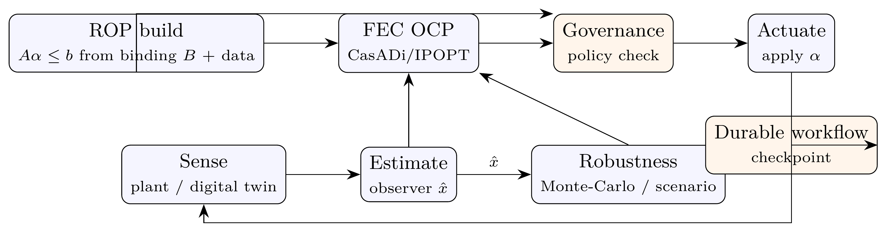
Figure 1. Closed-loop reference architecture implemented by ropfec. The ROP is built once from binding stoichiometry and data and supplies hard constraints to the FEC optimal-control problem and the governance check; the estimation, robustness, governance and workflow blocks are reference implementations, not a production platform. The loop is intended to supervise a staged-bioconversion process (deconstruction $→$ kernel/handover $→$ recovery; the BOS pattern [12]), for which the ROP supplies the admissible exponent geometry.

Illustrative examples
All examples run on synthetic or published-model ground truth, with every number traceable to a script in the repository.

(1) The ROP constraint matters for control (mechanism illustration).
On a $3$-species, $4$-reaction glycolysis-like toy network (the Xiao running example) with a six-facet binding-derived ROP, an exponent placed outside the polytope gives a mean trajectory error of $9.9\%$; the same exponent projected onto the ROP reduces it to $3.1\%$ (Figure 2), and the FEC solver, tracking a target flux, converges to an in-ROP exponent that reproduces the prescribed ground-truth exponent to within $∼2\%$ (a round-trip check that the transcription and solver are correct, not an identification result). On the same network the FEC solution yields a final-state tracking cost no worse than in-ROP FBA- and MM-derived exponent policies across 50 seeds ($1.01$ vs $1.28$ and $1.09$; all three respect the polytope), and a scenario-robust variant bounds the worst case at near-nominal cost — internal sanity checks on synthetic ground truth, not a performance benchmark. This is a mechanism illustration, not a benchmark: the ground truth is synthetic and the out-of-polytope baseline is, by construction, out of the polytope, so the example demonstrates that respecting the binding constraint lowers the synthetic-trajectory error, not empirical accuracy on biological data.
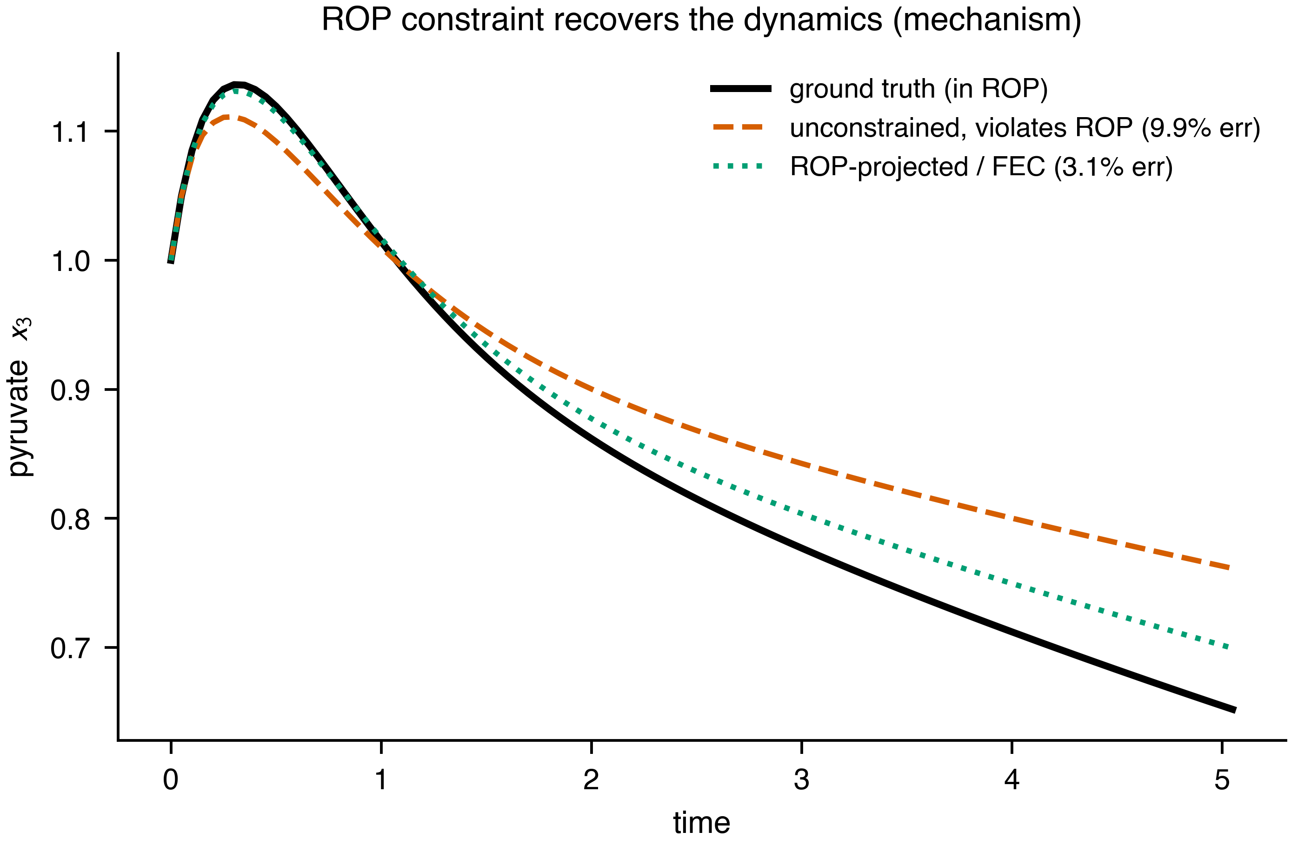
Figure 2. Mechanism illustration (in-silico): a state trajectory under the ground-truth exponent, an unconstrained exponent that violates the ROP, and the ROP-projected/FEC exponent. Respecting the binding-derived polytope lowers the synthetic-trajectory error (mean $3.1\%$ vs $9.9\%$). Synthetic ground truth; not a biological benchmark.

(2) Validated oscillator testbeds.
The Sel’kov and Wolf–Heinrich re-implementations reproduce the published qualitative behaviour (Figure 3): Sel’kov settles onto a stable limit cycle inside its Hopf window and to a fixed point outside it, and the Wolf–Heinrich single-cell core sustains glycolytic oscillations. Both are asserted by tests and serve as reusable, citable testbeds for the FEC pipeline beyond the toy network.
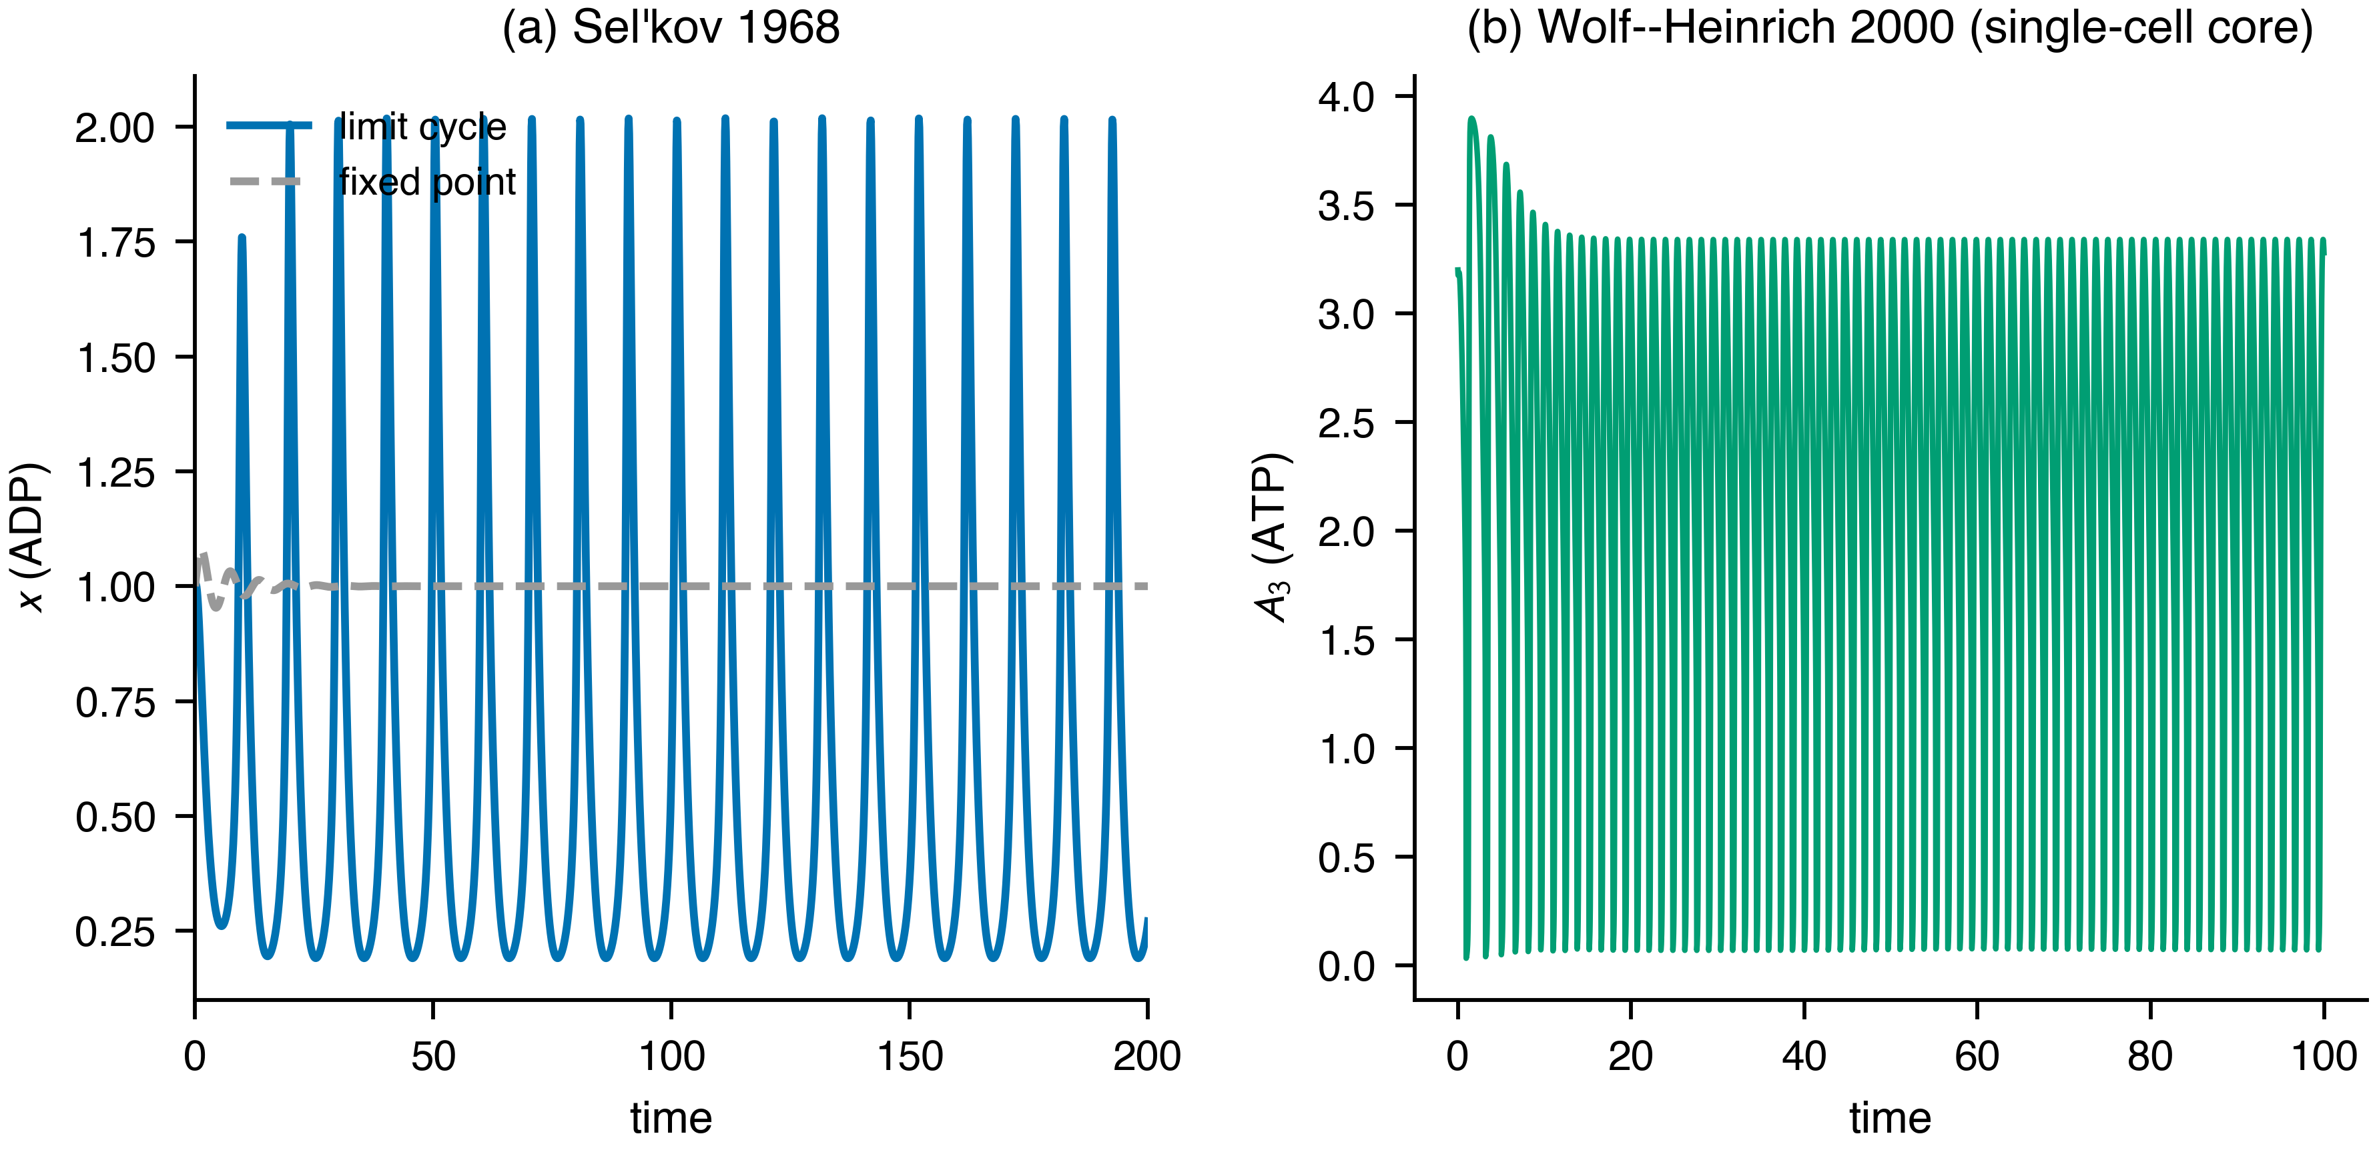
Figure 3. Validated re-implementations of two published glycolytic oscillators: (a) Sel’kov 1968 (limit cycle vs. damped fixed point); (b) Wolf–Heinrich 2000 single-cell core (sustained oscillation of an ATP-like cofactor). Tested against the published dynamics.

(3) Built-in falsification: structure does not aid identification.
The central honest result, shipped as a test rather than buried as a caveat. A natural hope is that the binding-derived ROP, used as a prior, tightens data-driven estimation of reaction orders. We test this against the right null. From noisy rate data we build the bounded-error order set and compare three feasible sets: the data set alone, the data set intersected with the ROP, and the data set intersected with a count-matched random facet set calibrated to still contain the true orders — a control for “more facets” versus “the right facets” [28]. We measure total reaction-order uncertainty in an informative regime and a data-poor regime (Figure 4).
The result is negative. When data are informative the ROP is inactive: the data, data$∩$ROP, and data$∩$random sets have identical order uncertainty ($≈0.048$) — the data already constrain the orders more tightly than the ROP does, and its facets never bind. When data are scarce the ROP tightens the set only modestly ($2.80​→​2.34$) and no more than the count-matched random set ($2.42$); across trials neither beats the other consistently. The interpretation is clarifying rather than discouraging, and it is the package’s transferable thesis: the value of ROP/FEC is as a structural control-admissibility set — the geometry the controller must respect (example 1) — not as a statistical regulariser for identification. Structure constrains what the controller may do; it does not, by itself, tell you more about the plant than the data already do. Running the full reference loop, every structural invariant holds: the applied exponent is in the ROP at every step, the published polytope matches the constructed one, governance violations are detected and counted, and the reference multicellular policy rejects every over-capacity configuration in the test suite by its admission threshold.
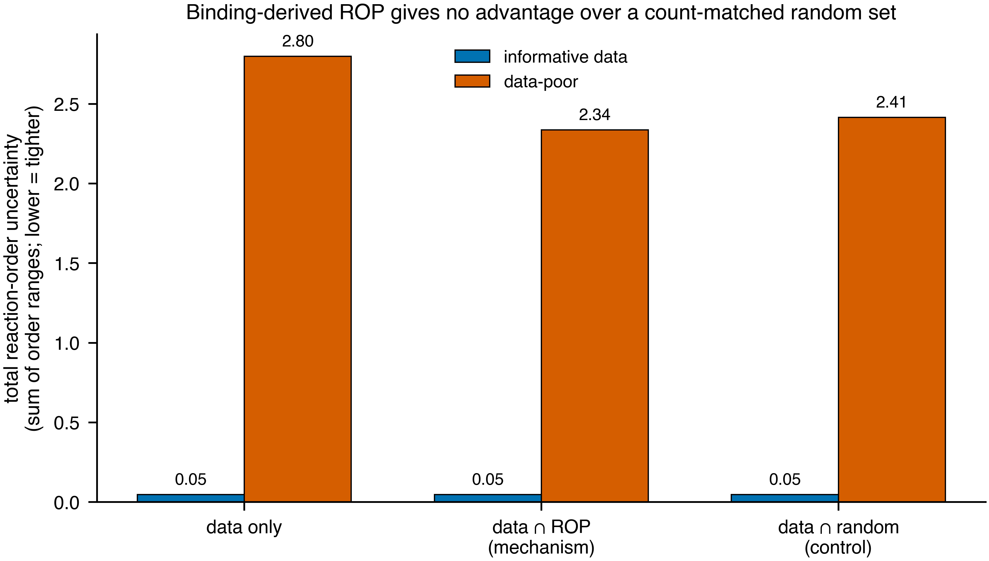
Figure 4. Built-in falsification (the package’s central result). Total reaction-order uncertainty for the data-only set, data$∩$ROP, and data$∩$random (count-matched, truth-covering) sets, in an informative and a data-poor regime. The binding-derived ROP confers no advantage over a random set of equal size: when data are informative it is inactive; when data are scarce it is no better than chance. Shipped as a re-runnable test.

Impact
ropfec provides an open, tested, citable implementation of a control framework previously available mainly as theory and a model-predictive-control concept, with three concrete uses. As infrastructure, it is a reproducible substrate for staged-bioconversion control research: the ROP/FEC core, the robust and multicellular extensions, and the swappable reference loop let others prototype controllers without re-deriving the geometry, and the two validated oscillators are ready-made testbeds. As pedagogy and grounding, the explicit MCA-elasticity identity places FEC inside a classical formalism that is familiar to the systems-biology and process-control communities, making the control variable interpretable and unit-checkable. As a methodological caution, the built-in falsification — with its count-matched random-facet null — is a transferable template: it shows how to ask whether a structural prior adds information beyond a generic constraint of equal size, and reports the honest answer for this case (it does not). By shipping self-skepticism as a test, the package makes the scope of the framework auditable, which we regard as the responsible default for software that operationalizes an attractive but unproven idea. Within the broader BOS software ecosystem [12], ropfec provides the candidate control-geometry layer; the empirical resource-recovery results and the boundary-matched accounting are reported and reproduced separately.

Conclusions
We presented ropfec, an open, tested, one-command-reproducible implementation of reaction-order-polytope-constrained flux-exponent control for staged bioconversion. Beyond the artifact, the package encodes two honest, re-runnable results: the clarifying identity that FEC exponents are MCA elasticities, and a built-in falsification showing that the binding-derived structure aids control but not data-driven identification. The work is offered as a reproducible reference and an honest map of where the framework adds value, not as an overclaimed method; its scope is explicitly in-silico, with the wet-lab system reported separately [12].

Declarations

Code and data availability.
The ropfec source, the 44 tests, and the script that regenerates every figure and number will be released under the MIT license and archived with a DOI on Zenodo upon posting (Table 1).

Use of generative AI.
Generative-AI tools assisted code and text drafting; the author reviewed, verified, and is solely responsible for all content, including every quantitative claim and citation, and reproduced all reported numbers from the released code.

Competing interests.
The author declares no competing interests.

Funding.
This research received no specific grant from funding agencies in the public, commercial, or not-for-profit sectors.

Acknowledgements
This work implements and builds upon the reaction order polytope and flux exponent control framework of Fangzhou Xiao, Jing Shuang Li, and John C. Doyle.

References
[1] Orth, J. D., Thiele, I., and Palsson, B. Ø. What is flux balance analysis? Nature Biotechnology, 2010;28:245–248. doi:10.1038/nbt.1614
[2] Varma, A., and Palsson, B. Ø. Stoichiometric flux balance models quantitatively predict growth and metabolic by-product secretion in wild-type Escherichia coli W3110. Applied and Environmental Microbiology, 1994;60:3724–3731. doi:10.1128/aem.60.10.3724-3731.1994
[3] Saa, P. A., and Nielsen, L. K. Formulation, construction and analysis of kinetic models of metabolism: A review of modelling frameworks. Biotechnology Advances, 2017;35:981–1003. doi:10.1016/j.biotechadv.2017.09.005
[4] Mahadevan, R., Edwards, J. S., and Doyle, F. J. Dynamic flux balance analysis of diauxic growth in Escherichia coli. Biophysical Journal, 2002;83:1331–1340. doi:10.1016/S0006-3495(02)73903-9
[5] Hatzimanikatis, V., and Bailey, J. E. Effects of spatiotemporal variations on metabolic control: Approximate analysis using (log)linear kinetic models. Biotechnology and Bioengineering, 1997;54:91–104. doi:10.1002/(SICI)1097-0290(19970420)54:2<91::AID-BIT1>3.0.CO;2-Q
[6] Visser, D., and Heijnen, J. J. Dynamic simulation and metabolic re-design of a branched pathway using linlog kinetics. Metabolic Engineering, 2003;5:164–176. doi:10.1016/S1096-7176(03)00025-9
[7] Miskovic, L., and Hatzimanikatis, V. Production of biofuels and biochemicals: In need of an ORACLE. Trends in Biotechnology, 2010;28:391–397. doi:10.1016/j.tibtech.2010.05.003
[8] Smallbone, K., Simeonidis, E., Broomhead, D. S., and Kell, D. B. Something from nothing: Bridging the gap between constraint-based and kinetic modelling. The FEBS Journal, 2007;274:5576–5585. doi:10.1111/j.1742-4658.2007.06076.x
[9] Xiao, F., Li, J. S., and Doyle, J. C. Flux exponent control predicts metabolic dynamics from network structure. 2023 american control conference (ACC), 2023;1189–1194. doi:10.23919/ACC55779.2023.10156281
[10] Xiao, F. Biocontrol of biomolecular systems: Polyhedral constraints on binding’s regulation of catalysis from biocircuits to metabolism. California Institute of Technology, 2022. doi:10.7907/rtwq-v497
[11] Rawlings, J. B., Mayne, D. Q., and Diehl, M. M. Model predictive control: Theory, computation, and design. Nob Hill Publishing, Madison, WI, 2017.
[12] Zhou, L., Deng, Q., Li, X., Huang, X., and Chen, G. Decoupling waste deconstruction from nutrient recovery: A staged insect biological operating system for circular valorization of agro-industrial waste. Journal of Cleaner Production (under review), 2026.
[13] Feinberg, M. Foundations of chemical reaction network theory. Springer, Cham, Switzerland, 2019. doi:10.1007/978-3-030-03858-8
[14] Alon, U. An introduction to systems biology: Design principles of biological circuits. CRC Press, Boca Raton, FL, 2019.
[15] Kacser, H., and Burns, J. A. The control of flux. Rate control of biological processes (symposia of the society for experimental biology, vol. 27), 1973;65–104.
[16] Heinrich, R., and Rapoport, T. A. A linear steady-state treatment of enzymatic chains: General properties, control and effector strength. European Journal of Biochemistry, 1974;42:89–95. doi:10.1111/j.1432-1033.1974.tb03318.x
[17] Fell, D. Understanding the control of metabolism. Portland Press, London, 1997.
[18] Andersson, J. A. E., Gillis, J., Horn, G., Rawlings, J. B., and Diehl, M. CasADi – a software framework for nonlinear optimization and optimal control. Mathematical Programming Computation, 2019;11:1–36. doi:10.1007/s12532-018-0139-4
[19] Wächter, A., and Biegler, L. T. On the implementation of an interior-point filter line-search algorithm for large-scale nonlinear programming. Mathematical Programming, 2006;106:25–57. doi:10.1007/s10107-004-0559-y
[20] Kothare, M. V., Balakrishnan, V., and Morari, M. Robust constrained model predictive control using linear matrix inequalities. Automatica, 1996;32:1361–1379. doi:10.1016/0005-1098(96)00063-5
[21] Scokaert, P. O. M., and Mayne, D. Q. Min-max feedback model predictive control for constrained linear systems. IEEE Transactions on Automatic Control, 1998;43:1136–1142. doi:10.1109/9.704989
[22] Mayne, D. Q., Seron, M. M., and Raković, S. V. Robust model predictive control of constrained linear systems with bounded disturbances. Automatica, 2005;41:219–224. doi:10.1016/j.automatica.2004.08.019
[23] Calafiore, G. C., and Campi, M. C. The scenario approach to robust control design. IEEE Transactions on Automatic Control, 2006;51:742–753. doi:10.1109/TAC.2006.875041
[24] Campi, M. C., and Garatti, S. The exact feasibility of randomized solutions of uncertain convex programs. SIAM Journal on Optimization, 2008;19:1211–1230. doi:10.1137/07069821X
[25] Bertsimas, D., Brown, D. B., and Caramanis, C. Theory and applications of robust optimization. SIAM Review, 2011;53:464–501. doi:10.1137/080734510
[26] Sel’kov, E. E. Self-oscillations in glycolysis. 1. A simple kinetic model. European Journal of Biochemistry, 1968;4:79–86. doi:10.1111/j.1432-1033.1968.tb00175.x
[27] Wolf, J., and Heinrich, R. Effect of cellular interaction on glycolytic oscillations in yeast: A theoretical investigation. Biochemical Journal, 2000;345:321–334. doi:10.1042/bj3450321
[28] Ben-Tal, A., and Nemirovski, A. Robust convex optimization. Mathematics of Operations Research, 1998;23:769–805. doi:10.1287/moor.23.4.769

State Key Laboratory of Subtropical Silviculture, Zhejiang A&F University, Hangzhou, China. exergyleizhou@gmail.com; ORCID 0009-0000-9073-1349.

