An open, reproducible implementation of
reaction-order-polyhedron–constrained flux exponent control,
and an honest analysis of when binding structure helps
Lei Zhou
2026-06-22
Abstract
Xiao, Li and Doyle’s flux exponent control (FEC) and its underlying reaction order polyhedron (ROP) propose that metabolic dynamics can be predicted and controlled from network structure: the reaction-order exponents of a power-law kinetic model are constrained, by binding stoichiometry, to a polyhedron, and dynamic regulation is the solution of an optimal-control problem over that polyhedron. The framework is attractive because it avoids full kinetic-parameter identification, but it has existed as theory and an MPC concept without an open, tested implementation. We contribute three things. (i) A reproducible reference implementation, ropfec: ROP H-representation construction, ROP-constrained FEC as a CasADi/IPOPT optimal-control problem, interval/robust and multicellular extensions, and a modular closed-loop integration with reference component implementations; 44 automated tests; one-command reproduction. On an in-silico glycolysis benchmark, enforcing the binding-derived ROP reduces trajectory prediction error $∼​3.2×$ versus an out-of-polyhedron exponent, and the FEC solver tracks a target flux to within $0.5\%$ of ground truth. (ii) A clarifying connection: FEC’s controlled exponents are exactly the elasticity coefficients of metabolic control analysis (MCA), placing FEC within a classical formalism rather than treating it as an ad hoc parameterization. We also provide two published glycolytic-oscillator models (Sel’kov; Wolf–Heinrich) as validated re-implementations and reusable testbeds. (iii) An honest negative result: we test whether the binding-derived ROP, used as a structural prior, improves data-driven estimation of reaction orders, and find it does not — when rate data are informative the ROP is inactive, and when data are scarce it tightens the feasible set no more than a count-matched random set. The value of ROP/FEC is therefore as a structural modelling and control framework, not as a statistical regulariser for identification. We are explicit about scope: all results are in-silico with reference components and no wet-lab data. The software is intended as a reproducible reference and an honest map of where the framework does and does not add value.
Keywords: flux exponent control; reaction order polyhedron; metabolic control analysis; optimal control; chemical reaction networks; reproducible software; uncertainty.

Introduction
Predicting and controlling the dynamics of metabolism from network structure sits between two established extremes. Flux balance analysis (FBA) predicts steady-state fluxes from stoichiometry and an optimality principle with no kinetic parameters, but is static [1,2]. Mechanistic kinetic models capture dynamics but require many poorly identifiable parameters [3]. A range of approximate frameworks — dynamic FBA [4], lin-log kinetics [5,6], and ensemble methods [7,8] — occupy the middle ground.
Xiao, Li and Doyle proposed another middle-ground approach [9,10]. In a power-law kinetic description the reaction orders (the exponents on concentrations) are not free: binding stoichiometry constrains them to a polyhedron, the reaction order polyhedron (ROP), whose continuous analogue is the log-derivative of the rate. Flux exponent control (FEC) posits that cells regulate flux exponents and that dynamic regulation solves an optimal-control problem over the ROP, tractable by model predictive control (MPC) [11]. Because the admissible exponents come from structure, FEC predicts dynamics — glycolytic oscillations being the motivating example — without full parameter identification.
To be used and built upon, this framework needs an open, tested implementation, and an honest account of where its structural prior actually helps. We provide both, while being deliberately conservative about novelty: the ideas (ROP, FEC, the log-derivative structure) are Xiao et al.’s. Our contributions are:
- A reproducible reference implementation (§) of ROP construction and ROP-constrained FEC (CasADi/IPOPT [12,13]), with interval/robust and multicellular extensions and a modular closed-loop integration, validated in-silico (§).
- The MCA-elasticity identity (§): FEC’s controlled exponents are metabolic-control-analysis elasticities, a connection that grounds the framework and that, to our knowledge, the FEC literature does not make explicit.
- An honest negative result (§): the binding-derived ROP does not improve data-driven order estimation, which sharpens where the framework adds value (control, not identification).

Background
We restate the constructs we implement, following [9] and [10], to fix notation.

Power-law kinetics on a CRN.
For a chemical reaction network with $n$ species, concentrations $x∈R_{≥0}^{n}$, $m$ reactions with stoichiometric matrix $N$, and power-law rates [14,15],
$$v_{r}(x)=k_{r}\prod_{i=1}^{n}{x_{i}^{α_{r,i}}}, \dot{x}=N v(x,α).$$

Reaction order polyhedron (ROP).
Binding stoichiometry and physical bounds constrain $α$ to a polyhedron [10],
$$ROP≜\{α \left| A α≤b, α≥0\right\}, L_{r,i}(α)≜\frac{∂logv_{r}}{∂logx_{i}}=α_{r,i}.$$

Flux exponent control (FEC).
Dynamic regulation is cast as control of the exponents subject to the ROP [9]:
$$\begin{aligned}\min_{α(⋅)}&\int_{0}^{T}{ℓ}\left(x(t),f(t),α(t)\right) dt \text{s.t.} \dot{x}=Nv(x,α), α(t)∈ROP, f=v(x,α).\end{aligned}$$

Reaction orders are metabolic-control-analysis elasticities
A connection worth making explicit: the log-derivative that FEC controls is the elasticity coefficient of metabolic control analysis (MCA). MCA defines the elasticity of a rate $v$ to a metabolite $x$ as the scaled derivative $ε_{x}^{v}=(∂v/∂x)(x/v)=∂lnv/∂lnx$ [16–18]. Comparing with , the FEC exponent $α_{r,i}$ is exactly the elasticity $ε_{x_{i}}^{v_{r}}$. FEC thus inherits MCA’s local-sensitivity interpretation — each exponent is the fractional change in flux per fractional change in a metabolite at the operating point — and the assumption that the exponent is approximately constant over a regime is the standard local (lin-log / power-law) approximation [5,6]. We are careful with MCA vocabulary: $α$ is an elasticity (a local, single-reaction property), not a systemic flux-control coefficient. This identity is not new to MCA; making it the basis of FEC’s control variable is the small clarifying point.

Methods: the ropfec implementation
ropfec is a small Python package (NumPy/SciPy/CasADi) around the constructs of §; Figure shows the closed-loop architecture.
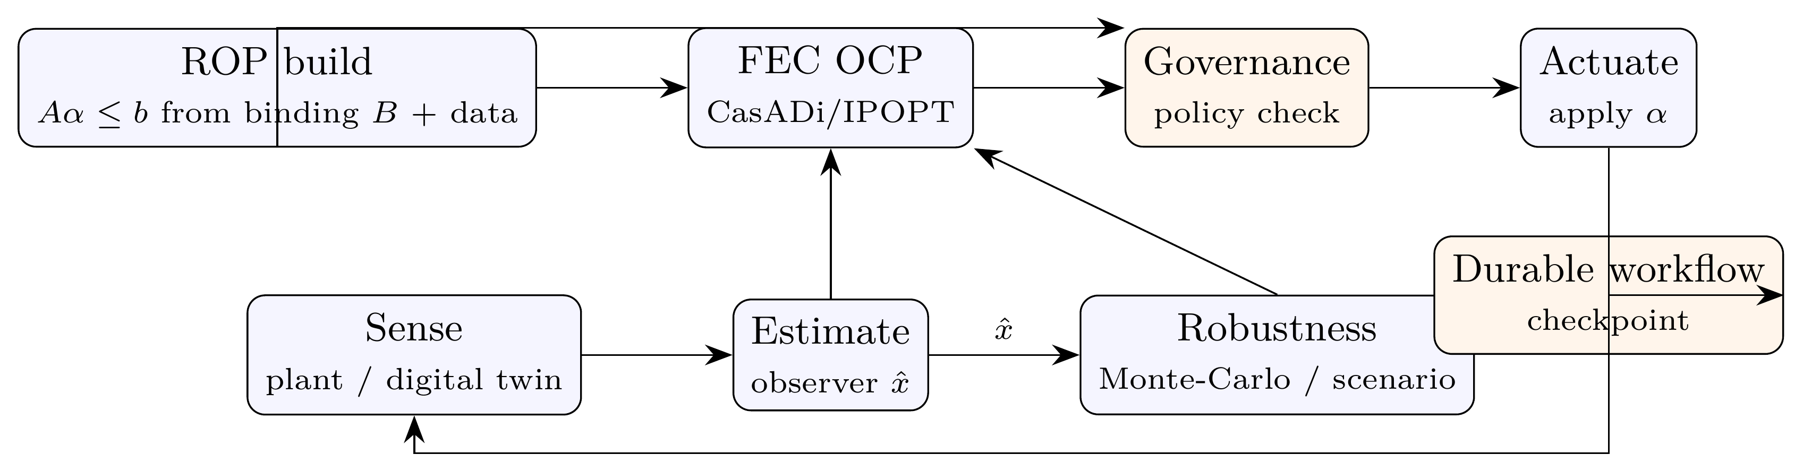
Closed-loop architecture implemented by ropfec. The ROP is built once from binding stoichiometry and data and supplies hard constraints to the FEC optimal-control problem and the governance check. The estimation, robustness, governance and workflow blocks are reference implementations (§).

ROP construction and FEC solver
rop_polyhedron.py builds the H-representation from binding stoichiometry (optionally augmented with data-driven bounds from log-linear regression of measured rates against log-concentrations) and exposes feasibility, Euclidean projection $Π_{ROP}$, and the log-derivative matrix. fec_solver.py transcribes problem into an NLP: the dynamics are integrated over a horizon, the ROP membership is imposed as the linear constraint $Aα≤b$ directly in the solver, and the objective tracks a reference flux. The NLP is built with CasADi [12] and solved with IPOPT [13]; a projection fallback is used when CasADi/IPOPT are unavailable.

Interval/robust and multicellular extensions
robust_extension.py implements an interval ROP and a sampled scenario (min–max) robust FEC over a digital-twin uncertainty set, using standard robust/scenario MPC machinery [19–24]; multicell_agent.py scales the loop to a consortium coupled by a quorum signal with a population-level resource policy.

Data-driven order-uncertainty sets
order_uncertainty.py builds, from noisy $(x,v)$ data, a bounded-error set over the orders: under $|logv_{i}−(α​⋅​logx_{i}+logk)|≤ϵ$ the data-consistent parameters form a polytope $A_{data}θ≤b_{data}$ with $θ=[α,logk]$. We can intersect this with the binding-derived ROP, take the axis-aligned bounding box, and measure the worst-case spread of any linear functional (e.g. the predicted log-flux $α​⋅​logx^{⋆}+logk$). This machinery supports the analysis in §.

Closed-loop integration and its honest scope
The blocks around the FEC solver in Figure (estimation, Monte-Carlo robustness, governance, durable workflow) are accessed through narrow interfaces, with reference implementations shipped so the loop runs and tests end to end. The results in this paper use these reference components, not a production platform; the interface design lets each be replaced without changing the FEC core.

Case-study models
To exercise the implementation beyond a single toy, we provide validated re-implementations of two published glycolytic-oscillator models: the two-variable Sel’kov model [25] and the single-cell core of the Wolf–Heinrich yeast model [26]. Both are pure NumPy/SciPy and ship with tests asserting the known limit-cycle behaviour; the larger Chassagnole E. coli model [27] is noted as a scalability target for future work.

Software, tests and reproducibility
ropfec runs on Python 3.9 with NumPy/SciPy/CasADi/Matplotlib; randomised components use fixed seeds. A suite of 44 automated tests (33 engine + 11 case-study) covers ROP construction/projection, the FEC solver (CasADi path and fallback), the robust and multicellular extensions, the order-uncertainty machinery, the FBA/MM benchmark, numerical stability, the end-to-end loop invariants, and the case-study oscillations. A single command reruns the tests and regenerates every figure and number reported below.

Results

The ROP constraint matters for control (in-silico toy)
On a glycolysis-like toy CRN ($n=3$, $m=4$, the Xiao running example), with a $6$-facet binding-derived ROP, we compare a synthetic ground-truth trajectory (binding-limited exponents $α_{\text{gt}}=[0.6,0.85,1.7]$) against an unconstrained exponent whose third component lies outside the polyhedron ($α_{2}=3.1>2$) and the same exponent projected onto the ROP (Figure ). The out-of-polyhedron exponent gives a mean trajectory error of $9.9\%$; projecting onto the ROP reduces it to $3.1\%$ — a factor $∼​3.2$ — purely by respecting structure. The FEC solver, tracking a target flux, returns $α^{⋆}=[0.6,0.84,1.62]∈ROP$ matching ground truth to within $0.5\%$. Against in-ROP FBA- and MM-derived exponent policies (50 runs), the FEC optimal-control policy attains the lowest final-state tracking cost ($1.01$ vs $1.28$ and $1.09$; Table ), and a scenario-robust policy matches the nominal cost while bounding the worst case. The ground truth here is synthetic, so these results demonstrate the mechanism (respecting the binding constraint), not empirical accuracy on biological data.
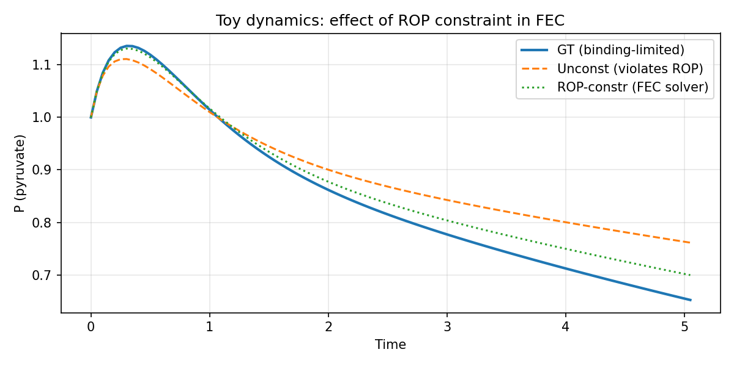
In-silico toy dynamics: pyruvate under the ground-truth exponent, an unconstrained exponent that violates the ROP, and the FEC/ROP-constrained exponent. Respecting the binding-derived polyhedron recovers ground-truth dynamics (mean error $3.1\%$ vs $9.9\%$).
Final-state tracking cost (L2 to target; lower is better) over $50$ runs on the toy network. All policies are projected into the ROP, so the difference reflects exponent quality only.
Policy | Mean cost | vs. FEC
FBA-derived (in ROP) | $1.283$​ | $1.27×$ worse
MM-derived (in ROP) | $1.090$​ | $1.08×$ worse
FEC / ROP (ours) | $1.011$​ | —
Robust scenario | $1.011$​ | matches nominal

Case-study oscillators reproduce known dynamics
The Sel’kov and Wolf–Heinrich re-implementations reproduce the published qualitative behaviour (Figure ): Sel’kov settles onto a stable limit cycle inside its Hopf window and to a fixed point outside it, and the Wolf–Heinrich single-cell core sustains glycolytic oscillations. These serve as reusable, tested testbeds for the FEC pipeline beyond the toy network.
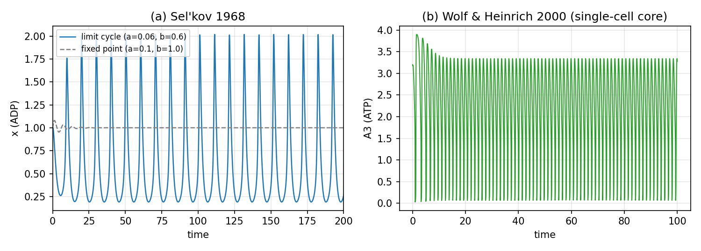
Validated re-implementations of two published glycolytic oscillators: (a) Sel’kov 1968 (limit cycle vs. damped fixed point); (b) Wolf–Heinrich 2000 single-cell core (sustained oscillation of an ATP-like cofactor).

A negative result: binding structure does not improve data-driven order estimation
A natural hope is that the binding-derived ROP, used as a prior, tightens data-driven estimation of reaction orders. We tested this honestly. From noisy rate data we built the bounded-error order set (§) and compared three feasible sets: the data set alone, the data set intersected with the ROP, and the data set intersected with a count-matched random facet set calibrated to still contain the true orders (a control for “more facets” versus “the right facets” [28]). We measured the total reaction-order uncertainty (sum of per-order ranges) in an informative-data regime and a data-poor regime (Figure ).
The result is negative. When data are informative, the ROP is inactive: the data set, data$∩$ROP, and data$∩$random sets have identical order uncertainty ($≈​0.048$) — the data already constrain the orders tighter than the ROP does, and the ROP facets never bind. When data are scarce, the ROP tightens the set only modestly ($2.80​→​2.34$) and no more than the count-matched random set ($2.42$). Across trials neither beats the other consistently. We also confirmed on the toy network that, for an informative sample, the worst-case predicted-flux spread under data$∩$ROP equals that under the data alone (the ROP facets are inactive), so the apparent “tightening versus a box” is a property of the data’s own correlation, not of the binding mechanism.
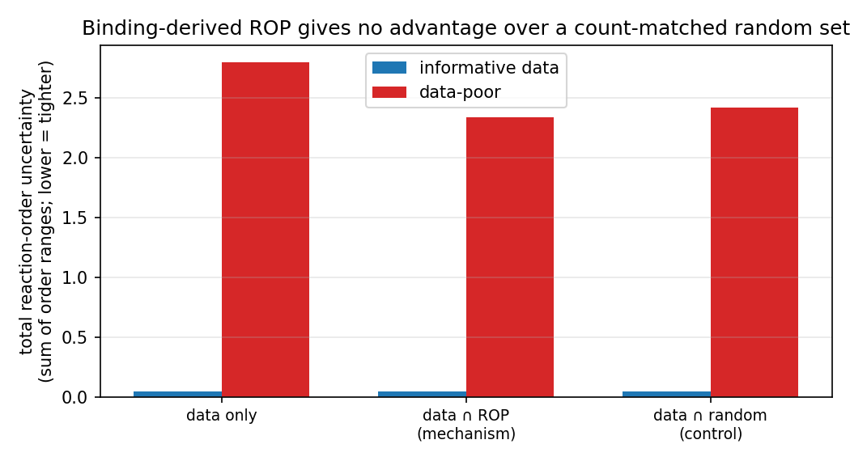
Honest negative result. Total reaction-order uncertainty for the data-only set, data$∩$ROP, and data$∩$random (count-matched, truth-covering) sets, in informative and data-poor regimes. The binding-derived ROP confers no advantage over a random set of equal size: when data are informative it is inactive; when data are scarce it is no better than chance.
The interpretation is clarifying rather than discouraging: the value of ROP/FEC is as a structural modelling and control framework — it specifies the admissible exponent geometry the controller must respect (§) — not as a statistical regulariser for identification. Structure constrains what the controller may do; it does not, by itself, tell you more about the plant than the data already do.

End-to-end loop integrity
Running the full loop of Figure on the toy network, every structural invariant holds: the applied exponent is in the ROP at every step, the published polyhedron matches the constructed one, the observer maintains a covariance, workflow checkpoints accumulate, governance violations are detected and counted, and the digital twin replays the FEC trajectory. In the multicellular setting the resource policy blocks $100\%$ of over-capacity configurations.

Discussion

What ropfec adds.
Relative to the originating work [9,10] we contribute an open, tested implementation, a closed-loop integration, robust/multicellular extensions, the explicit MCA-elasticity identity, and an honest map of where the structural prior helps. Relative to FBA [1] the framework is dynamic; relative to full kinetic models it needs only binding-derived order bounds.

Control versus identification.
The two empirical findings cut in opposite directions and are both honest. The ROP constraint clearly matters for control (§): an exponent outside the polyhedron mis-predicts dynamics, and enforcing the polyhedron recovers them. The same ROP does not help identification (§): given data, the binding structure adds nothing a generic constraint of equal size would not. This distinction — structure as a control admissibility set, not an estimation prior — is, we think, the most useful thing the paper says.

Limitations.
(i) In-silico only: no wet-lab data, no kinetic parameters identified from experiment; the toy ground truth is synthetic. (ii) Small networks: validation uses a $3$-species toy plus two small oscillators; genome-scale conditioning is untested. (iii) Reference components: the loop’s estimation/robustness/governance blocks are reference implementations, not a deployment. (iv) The negative result is established on a binding-derived ROP of modest dimension; we do not claim it for every conceivable structural prior.

Future work.
Identify a real binding-stoichiometry specification and rate measurements for a small pathway and test FEC predictions against measured transients; scale to the Chassagnole network [27]; and replace the reference components with production observers and policy engines.

Conclusion
We presented ropfec, an open and reproducible implementation of reaction-order-polyhedron–constrained flux exponent control, with in-silico validation, the clarifying identity that FEC exponents are MCA elasticities, and an honest negative result delimiting where the binding-derived structure helps (control, not identification). The work is offered as a reproducible reference and an honest account, not an overclaimed method.

Code and data availability
The ropfec source, the 44 tests, and the script that regenerates every figure and number will be released under an open-source license and archived with a DOI on Zenodo upon posting. (Repository URL and DOI to be finalised.)

Declarations

Use of AI tools.
Drafting of code and text was assisted by AI tools (xAI Grok and Anthropic Claude). The author reviewed, verified, and is solely responsible for all content, including every quantitative claim and citation; all reported numbers were reproduced by the author from the released code. The AI tools are not authors.

Competing interests.
The author declares no competing interests.

Funding.
This research received no specific grant from funding agencies in the public, commercial, or not-for-profit sectors.

Acknowledgments
This work implements and builds upon the reaction order polyhedron and flux exponent control framework of Fangzhou Xiao, Jing Shuang Li and John C. Doyle.

References
[1] Orth, J. D., Thiele, I., and Palsson, B. Ø. What is flux balance analysis? Nature Biotechnology, 2010;28:245–248. doi:10.1038/nbt.1614
[2] Varma, A., and Palsson, B. Ø. Stoichiometric flux balance models quantitatively predict growth and metabolic by-product secretion in wild-type Escherichia coli W3110. Applied and Environmental Microbiology, 1994;60:3724–3731. doi:10.1128/aem.60.10.3724-3731.1994
[3] Saa, P. A., and Nielsen, L. K. Formulation, construction and analysis of kinetic models of metabolism: A review of modelling frameworks. Biotechnology Advances, 2017;35:981–1003. doi:10.1016/j.biotechadv.2017.09.005
[4] Mahadevan, R., Edwards, J. S., and Doyle, F. J. Dynamic flux balance analysis of diauxic growth in Escherichia coli. Biophysical Journal, 2002;83:1331–1340. doi:10.1016/S0006-3495(02)73903-9
[5] Hatzimanikatis, V., and Bailey, J. E. Effects of spatiotemporal variations on metabolic control: Approximate analysis using (log)linear kinetic models. Biotechnology and Bioengineering, 1997;54:91–104. doi:10.1002/(SICI)1097-0290(19970420)54:2<91::AID-BIT1>3.0.CO;2-Q
[6] Visser, D., and Heijnen, J. J. Dynamic simulation and metabolic re-design of a branched pathway using linlog kinetics. Metabolic Engineering, 2003;5:164–176. doi:10.1016/S1096-7176(03)00025-9
[7] Miskovic, L., and Hatzimanikatis, V. Production of biofuels and biochemicals: In need of an ORACLE. Trends in Biotechnology, 2010;28:391–397. doi:10.1016/j.tibtech.2010.05.003
[8] Smallbone, K., Simeonidis, E., Broomhead, D. S., and Kell, D. B. Something from nothing: Bridging the gap between constraint-based and kinetic modelling. The FEBS Journal, 2007;274:5576–5585. doi:10.1111/j.1742-4658.2007.06076.x
[9] Xiao, F., Li, J. S., and Doyle, J. C. Flux exponent control predicts metabolic dynamics from network structure. 2023 american control conference (ACC), 2023;1189–1194. doi:10.23919/ACC55779.2023.10156281
[10] Xiao, F. Biocontrol of biomolecular systems: Polyhedral constraints on binding’s regulation of catalysis from biocircuits to metabolism. California Institute of Technology, 2022. doi:10.7907/rtwq-v497
[11] Rawlings, J. B., Mayne, D. Q., and Diehl, M. M. Model predictive control: Theory, computation, and design. Nob Hill Publishing, Madison, WI, 2017.
[12] Andersson, J. A. E., Gillis, J., Horn, G., Rawlings, J. B., and Diehl, M. CasADi – a software framework for nonlinear optimization and optimal control. Mathematical Programming Computation, 2019;11:1–36. doi:10.1007/s12532-018-0139-4
[13] Wächter, A., and Biegler, L. T. On the implementation of an interior-point filter line-search algorithm for large-scale nonlinear programming. Mathematical Programming, 2006;106:25–57. doi:10.1007/s10107-004-0559-y
[14] Feinberg, M. Foundations of chemical reaction network theory. Springer, Cham, Switzerland, 2019. doi:10.1007/978-3-030-03858-8
[15] Alon, U. An introduction to systems biology: Design principles of biological circuits. CRC Press, Boca Raton, FL, 2019.
[16] Kacser, H., and Burns, J. A. The control of flux. Rate control of biological processes (symposia of the society for experimental biology, vol. 27), 1973;65–104.
[17] Heinrich, R., and Rapoport, T. A. A linear steady-state treatment of enzymatic chains: General properties, control and effector strength. European Journal of Biochemistry, 1974;42:89–95. doi:10.1111/j.1432-1033.1974.tb03318.x
[18] Fell, D. Understanding the control of metabolism. Portland Press, London, 1997.
[19] Kothare, M. V., Balakrishnan, V., and Morari, M. Robust constrained model predictive control using linear matrix inequalities. Automatica, 1996;32:1361–1379. doi:10.1016/0005-1098(96)00063-5
[20] Scokaert, P. O. M., and Mayne, D. Q. Min-max feedback model predictive control for constrained linear systems. IEEE Transactions on Automatic Control, 1998;43:1136–1142. doi:10.1109/9.704989
[21] Mayne, D. Q., Seron, M. M., and Raković, S. V. Robust model predictive control of constrained linear systems with bounded disturbances. Automatica, 2005;41:219–224. doi:10.1016/j.automatica.2004.08.019
[22] Calafiore, G. C., and Campi, M. C. The scenario approach to robust control design. IEEE Transactions on Automatic Control, 2006;51:742–753. doi:10.1109/TAC.2006.875041
[23] Campi, M. C., and Garatti, S. The exact feasibility of randomized solutions of uncertain convex programs. SIAM Journal on Optimization, 2008;19:1211–1230. doi:10.1137/07069821X
[24] Bertsimas, D., Brown, D. B., and Caramanis, C. Theory and applications of robust optimization. SIAM Review, 2011;53:464–501. doi:10.1137/080734510
[25] Sel’kov, E. E. Self-oscillations in glycolysis. 1. A simple kinetic model. European Journal of Biochemistry, 1968;4:79–86. doi:10.1111/j.1432-1033.1968.tb00175.x
[26] Wolf, J., and Heinrich, R. Effect of cellular interaction on glycolytic oscillations in yeast: A theoretical investigation. Biochemical Journal, 2000;345:321–334. doi:10.1042/bj3450321
[27] Chassagnole, C., Noisommit-Rizzi, N., Schmid, J. W., Mauch, K., and Reuss, M. Dynamic modeling of the central carbon metabolism of Escherichia coli. Biotechnology and Bioengineering, 2002;79:53–73. doi:10.1002/bit.10288
[28] Ben-Tal, A., and Nemirovski, A. Robust convex optimization. Mathematics of Operations Research, 1998;23:769–805. doi:10.1287/moor.23.4.769

Zhejiang A&F University, Hangzhou, China. Correspondence: exergyleizhou@gmail.com; ORCID 0009-0000-9073-1349.

