

**Supporting Information for**

**Evidence for microbially-mediated tradeoffs between growth and defense throughout coral evolution**

Hannah E. Epstein1, Tanya Brown2, Ayọmikun O. Akinrinade2,3, Ryan McMinds1,4, F. Joseph Pollock5,6, Dylan Sonett7, Styles Smith5, David G. Bourne8,9, Carolina S. Carpenter10,11, Rob Knight11-14, Bette L. Willis8,15, Mónica Medina5, Joleah B. Lamb3, Rebecca Vega Thurber1, Jesse R. Zaneveld2*

*1Department of Microbiology, Oregon State University, 226 Nash Hall, Corvallis, OR 97331, USA*

*2School of Science, Technology, Engineering, and Mathematics, Division of Biological Sciences, University of Washington Bothell, UWBB-277, Bothell, WA 98011, USA*

*3Department of Ecology and Evolutionary Biology, University of California, Irvine, CA 92697, USA*

*4Center for Global Health and Infectious Diseases Research, University of South Florida, 13201 Bruce B. Downs Blvd, MDC 56, Tampa, FL 33612, USA*

*5Department of Biology, Pennsylvania State University, 208 Mueller Lab, University Park, PA 16802, USA*

*6Hawai*՛*i & Palmyra Program, The Nature Conservancy, Honolulu, HI, USA*

*7School of Pharmacy, University of Washington, Seattle, WA 98195, USA*

*8College of Science and Engineering, James Cook University, Townsville, Queensland 4811, Australia*

*9Australian Institute of Marine Science, Townsville, Queensland 4810, Australia*

*10Scripps Institution of Oceanography, University of California, San Diego, La Jolla, CA 92093, USA*

*11Center for Microbiome Innovation, University of California, San Diego, La Jolla, CA 92093, USA*

*12Department of Pediatrics, University of California, San Diego, La Jolla, CA 92093, USA*

*13Department of Computer Science & Engineering, University of California, San Diego, La Jolla, CA 92093, USA*

*14Micronoma Inc., San Diego, La Jolla, CA 92121, USA*

*15ARC Centre of Excellence for Coral Reef Studies, James Cook University, Townsville, Queensland 4811, Australia*

*Jesse R. Zaneveld

**Email:**  [zaneveld@uw.edu](mailto:xxxxx@xxxx.xxx)

**This PDF file includes:**

Figures S1 to S4

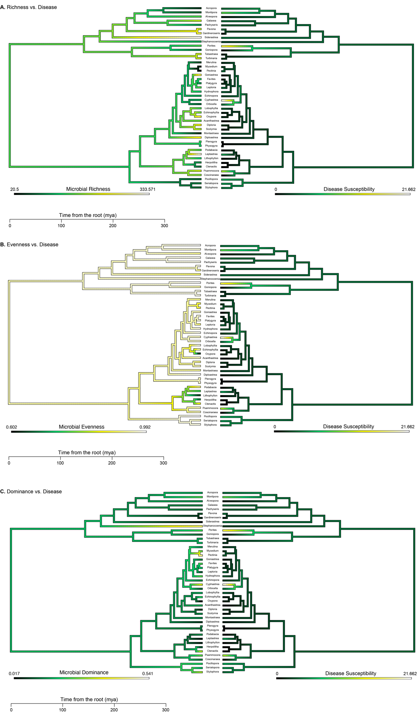

**Fig. S1.** Ancestral state reconstructions mirroring disease susceptibility and microbial alpha diversity metrics, including A) species richness, B) evenness (Gini Index), and C) dominance (Simpson’s Index).

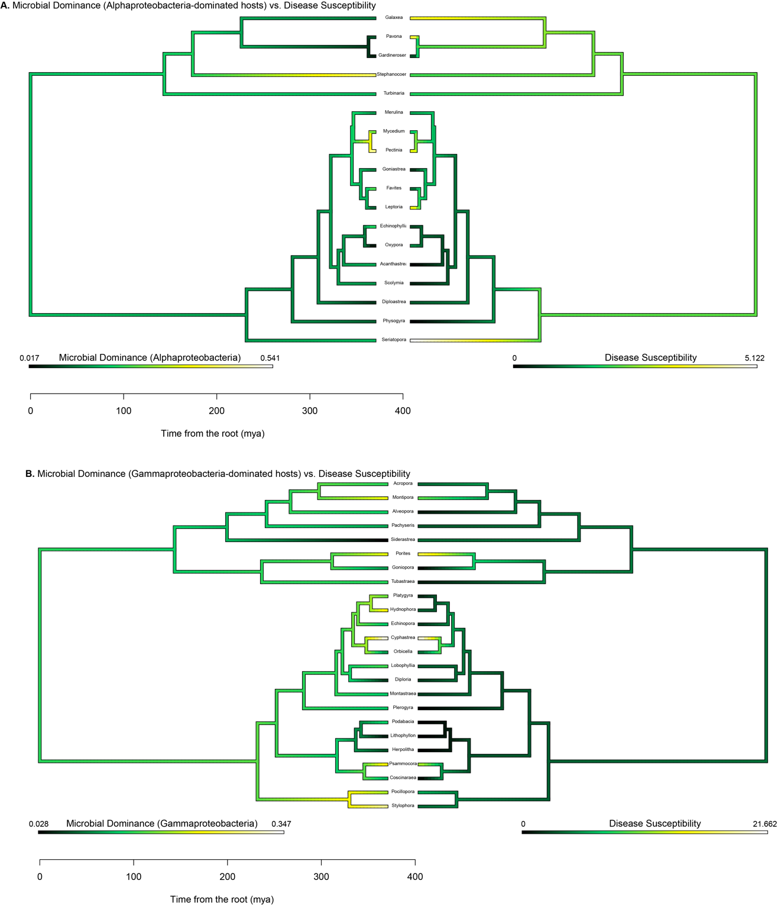

Fig. S2. Ancestral state reconstructions mirroring disease susceptibility and microbial dominance of A) Alphaproteobacteria only and B) Gammaproteobacteria only.

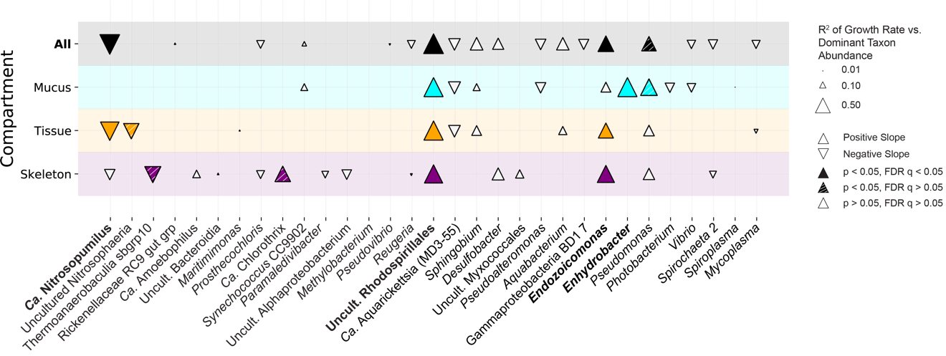Fig. S3. Growth rate vs. dominant taxon abundance (zeros excluded). R2 of the correlations between average coral host growth rate and dominant taxon relative abundance in corals only where each taxon is present (zero counts excluded). Arrow direction indicates a positive or negative correlation, filled arrows refer to significant correlations, striped arrows indicate nominally significant correlations (did not pass multiple comparisons) and open arrows indicate insignificant correlations. Size of the arrow represents R2 value (See Supplementary Data Table 9b for details).

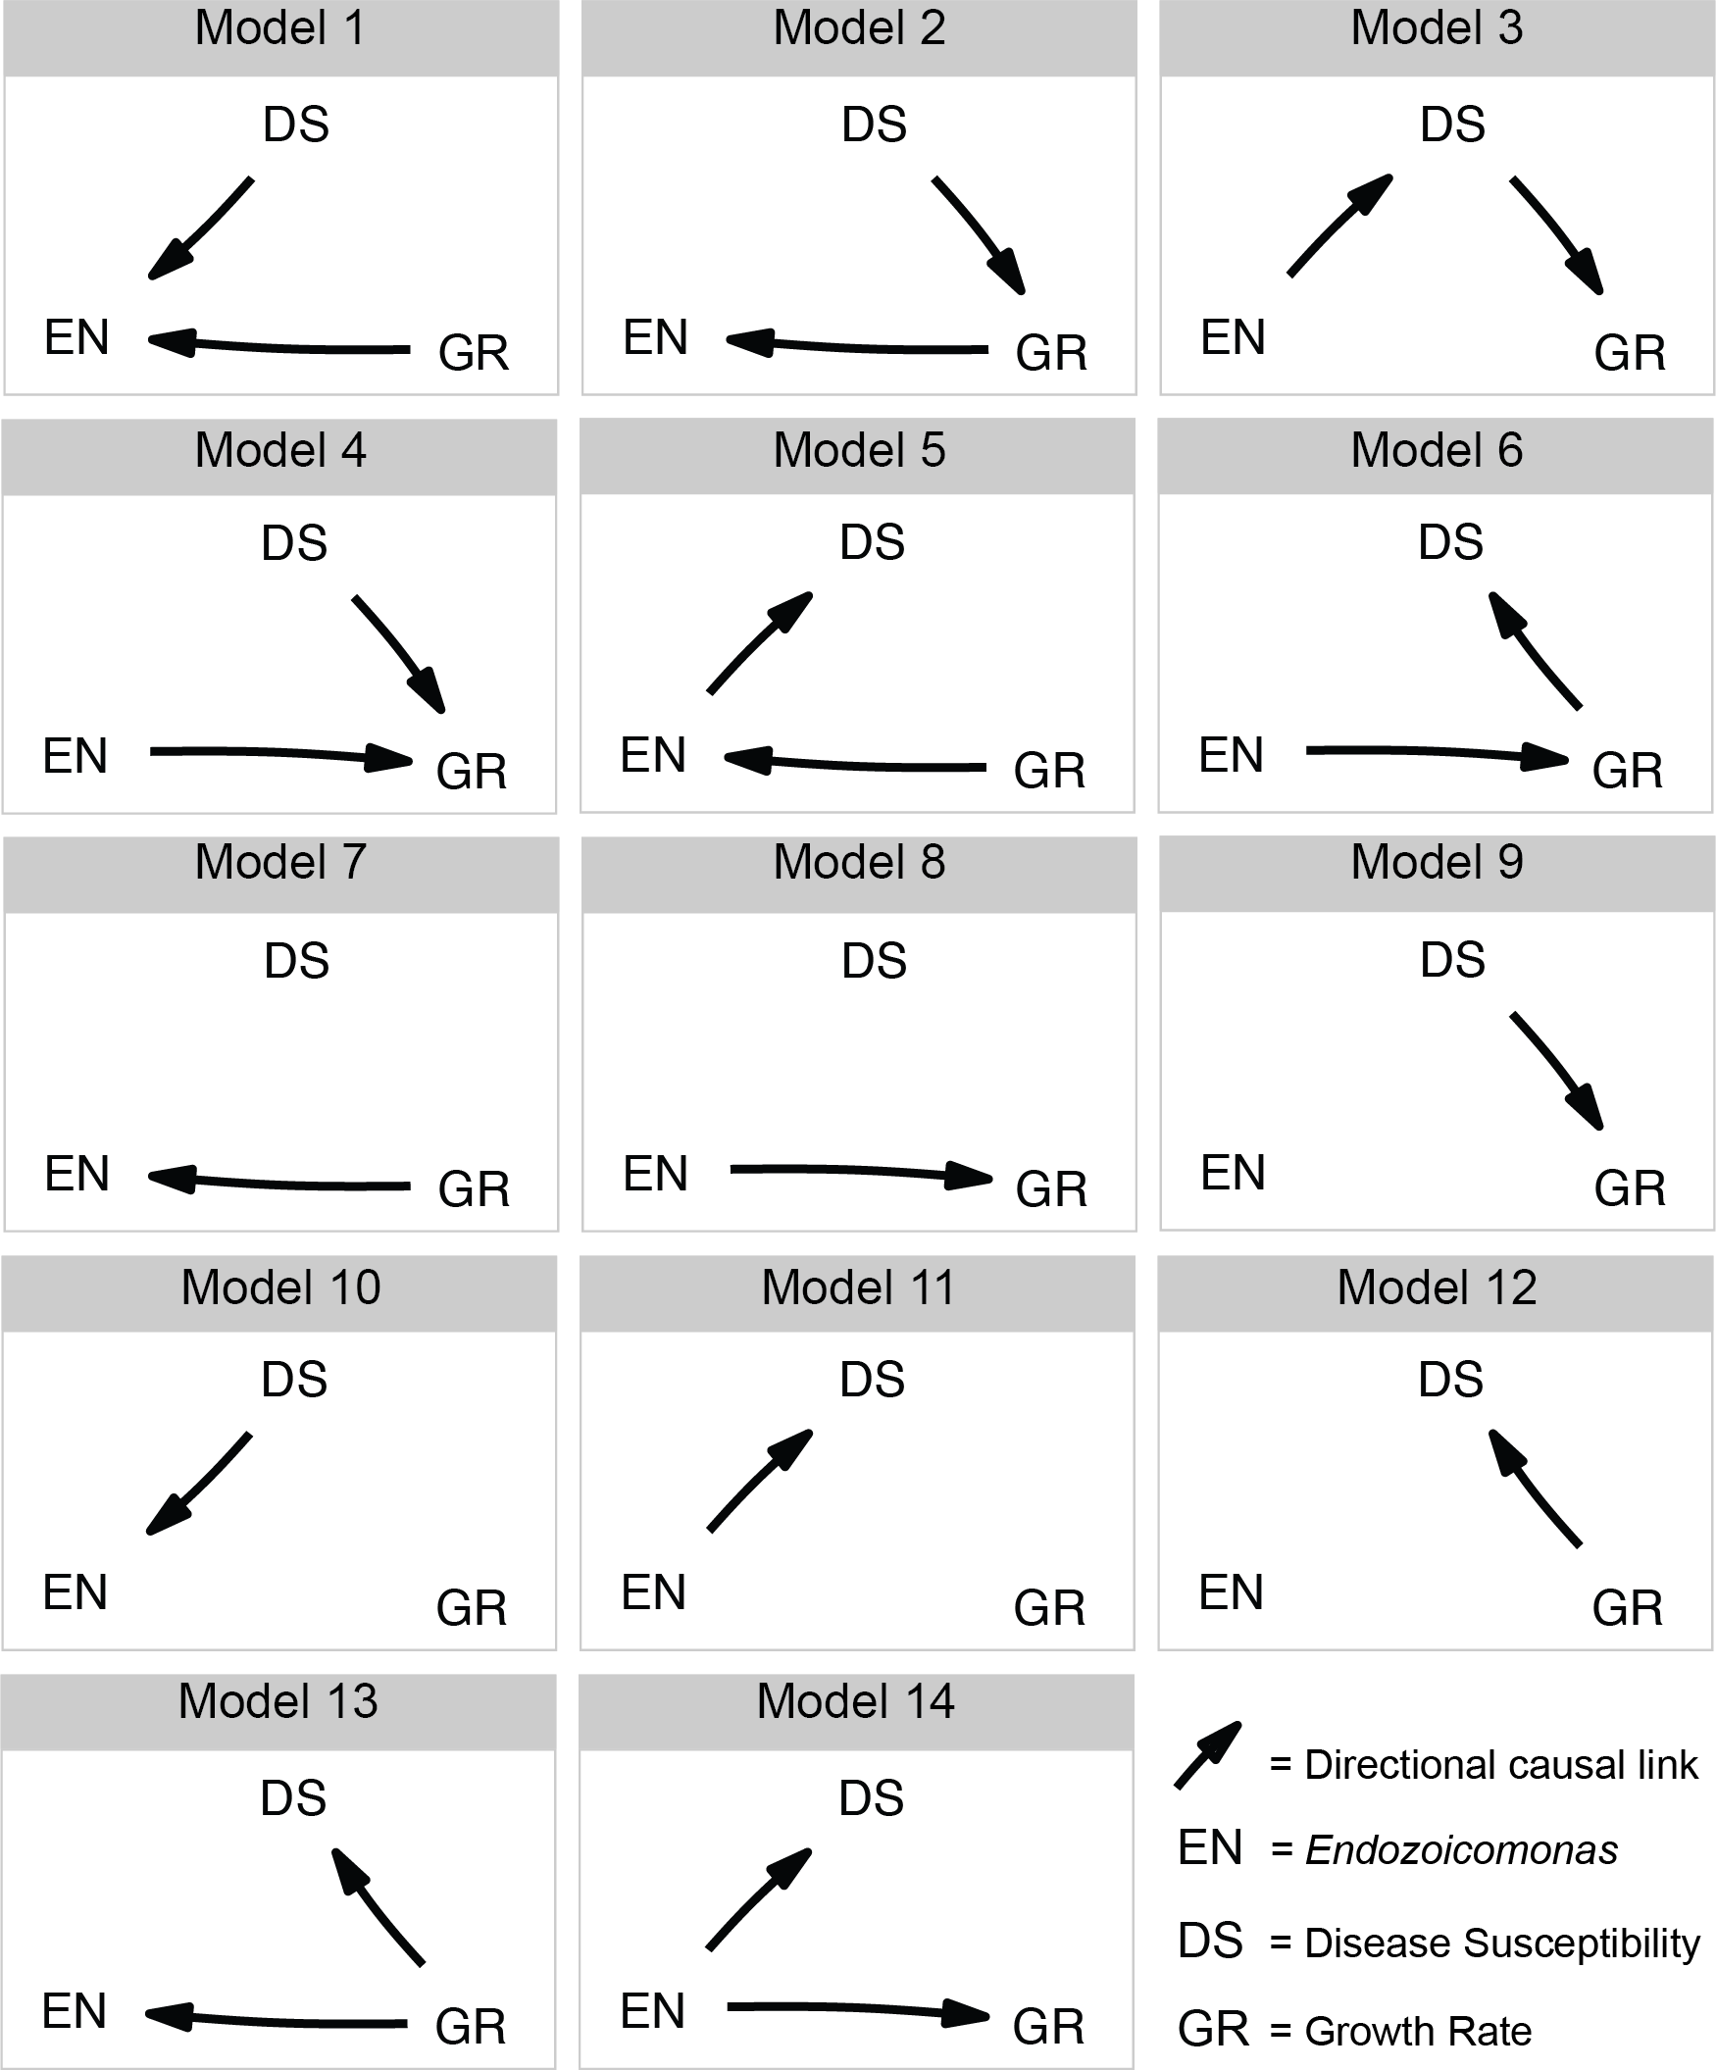

Fig. S4. Model selection for phylogenetic causality analysis. These models represent the fourteen plausible causality pathways that were used in the phylogenetic causality analysis. EN = *Endozoicomonas* relative abundance, DS = coral disease susceptibility, and GR = coral growth rate.