# 数据

## 通用数据-GameData

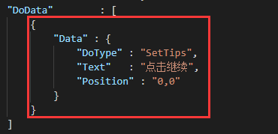

## 引导节点数据-GuideNodeData

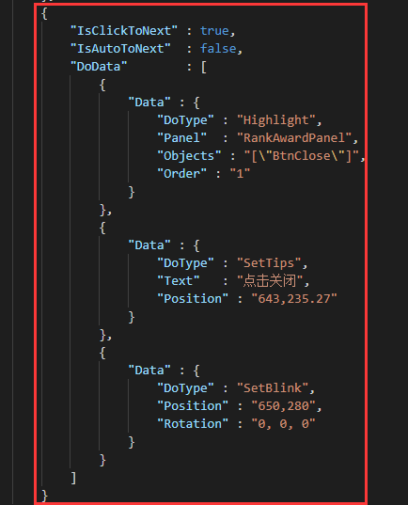

1. IsClickToNext

选中后（true），点击事件会去检测是否满足下个引导节点。满足则执行下一条

1. IsAutoToNext

选中后（true），自动执行下个引导节点

1. DoData

通用数据链表，引导节点要做的事情

## 引导块数据-GuideData

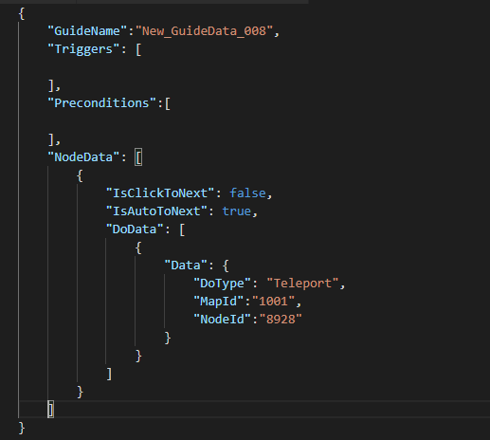

1. GuideName-引导块的名字

引导块的名字

1. Triggers-引导触发方式

通用数据链表，触发方式，可以有多种触发方式

1. Preconditions-引导前置条件

通用数据链表，满足前置条件才会被执行

1. NodeData-执行逻辑

## 条件数据-ConditionData

Update time:2018/11/15

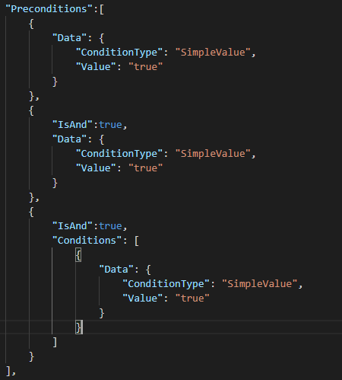

1. IsAnd-与或逻辑

ture时执行与逻辑（&）

false时执行或逻辑（！）

1. Data-通用数据

具体的执行条件

1. Conditions-条件合集

条件块，有这条数据时，不会判断Data的条件是否成立，逻辑判断上与Data是一样的

## 引导辅助数据-GuideHelpData

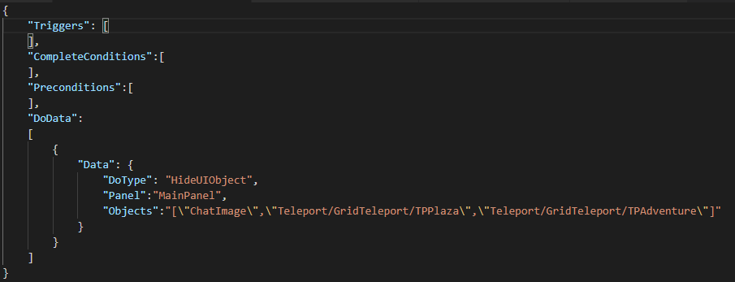

1. Triggers-引导触发方式

通用数据链表，触发方式，可以有多种触发方式

1. Preconditions-引导前置条件

通用数据链表，满足前置条件才会被执行

1. CompleteConditions-完成条件

满足完成条件后，改辅助功能不会被触发

1. DoData-具体的执行逻辑

## 参数数据

### 地图区域-MapAreaParam

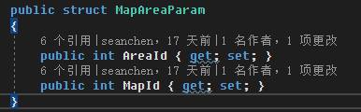

示例：

{

“MapId”:1002,

“AreaId”:2

}

### 地图节点-MapNodeParam

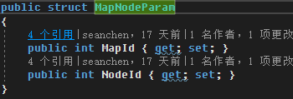

示例：

{

“MapId”:1001,

“NodeId”:9060

}

# 触发器

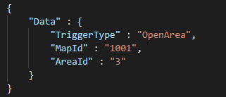

TriggerType：触发器类型

## 打开面板-OpenPanel

在面板被打开后

|  |  |  |  |
| --- | --- | --- | --- |
| TriggerType | 触发器类型 | String | OpenPanel |
| PanelName | 打开的面板名字 | String | RankAwardPanel |

## 展开区域- OpenArea

在区域块被展开后

|  |  |  |  |
| --- | --- | --- | --- |
| TriggerType | 触发器类型 | String | OpenArea |
| MapId | 地图Id | Int | 1001 |
| AreaId | 区域Id | Int | 3 |

## NPC点击- NPCClick

在NPC被点击后

|  |  |  |  |
| --- | --- | --- | --- |
| TriggerType | 触发器类型 | String | NPCClick |
| NPCId | NPCId | Int | 101 |

## 引导完成后- GuideCompleted

Update time:2018/9/22

在某个引导完成后，注意跟条件里完成引导的区别

|  |  |  |  |
| --- | --- | --- | --- |
| TriggerType | 触发器类型 | String |  |
| GuideName | 完成引导的名字 | String | Guide_01 |

## 玩家抵达地图节点- ArrivalNode

Update time:2018/12/3

在玩家抵达指定的地图节点后，执行完节点上所有的事件后触发

|  |  |  |  |
| --- | --- | --- | --- |
| TriggerType | 触发器类型 | String | ArrivalNode |
| Nodes | 指定的地图节点 | List<MapNodeParam> | [{“MapId”:1001,“NodeId”:9060}] |

## 玩家通过地图节点- PassingNode

Update time:2018/12/3

在玩家通过指定的地图节点，在执行节点事件之前触发。触发后玩家移动停止

|  |  |  |  |
| --- | --- | --- | --- |
| TriggerType | 触发器类型 | String | PassingNode |
| Nodes | 指定的地图节点 | List<MapNodeParam> | [{“MapId”:1001,“NodeId”:9060}] |

## 登录成功- LoginSuccess

Update time:2018/12/18

玩家登录成功触发

|  |  |  |  |
| --- | --- | --- | --- |
| TriggerType | 触发器类型 | String | LoginSuccess |

## UI被点击- UIClick

Update time:2019/3/1

UI被点击触发

|  |  |  |  |
| --- | --- | --- | --- |
| TriggerType | 触发器类型 | String | UIClick |
| UIName | 被点击的UI名字 | String | BtnClose |

# 条件

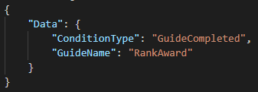

ConditionType：条件类型

## 完成引导- GuideCompleted

需要完成指定的引导

|  |  |  |  |
| --- | --- | --- | --- |
| ConditionType | 条件类型 | String | GuideCompleted |
| GuideName | 完成的引导名字 | String | RankAward |

# 执行效果

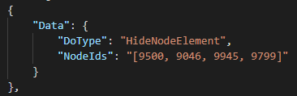

：DoType：执行类型

## 设置提示语- SetTips

设置并显示Tips文本

期望：是否需要指定锚点，以适应自适应的问题

Update time:2019/3/1

|  |  |  |  |
| --- | --- | --- | --- |
| DoType | 执行效果类型 | String | SetTips |
| Text | 文本内容 | String | 你是🐖吗？ |
| Position | 坐标 | Vector2 | 1,2 |
| ShowFrame | 是否显示背景框 | Boolean | True |
| AutoDisappear | 是否自动消失 | Boolean | False |
| Duration | 消失的持续时间 | Float | 2.0 |

## 清除提示语- ClearTips

隐藏Tips文本

|  |  |  |  |
| --- | --- | --- | --- |
| DoType | 执行效果类型 | String | ClearTips |

## 设置提示图标- SetBlink

设置并显示Tips文本

期望：是否需要指定锚点，以适应自适应的问题

|  |  |  |  |
| --- | --- | --- | --- |
| DoType | 执行效果类型 | String | SetBlink |
| Position | 坐标 | Vector2 | 1,2 |
| Rotation | 旋转角度 | Vector3 | 0,0,180 |

## 隐藏遮罩- HideMask

隐藏遮罩，可以点击到遮罩下面的内容

|  |  |  |  |
| --- | --- | --- | --- |
| DoType | 执行效果类型 | String | HideMask |

## 显示遮罩- ShowMask

显示遮罩，只能点到高亮的内容

|  |  |  |  |
| --- | --- | --- | --- |
| DoType | 执行效果类型 | String | ShowMask |

## 设置遮罩透明度- SetMaskAlpha

显示遮罩，只能点到高亮的内容

|  |  |  |  |
| --- | --- | --- | --- |
| DoType | 执行效果类型 | String | SetMaskAlpha |
| Alpha | Alpha值 | Float | 0.5 |

## 高亮UI对象- Highlight

高亮指定UI面板上的对象，可以指定绝对路径或者对象名称，对象可以指定多个

Order高亮对象的排序等级，默认1。值越大层次越高

|  |  |  |  |
| --- | --- | --- | --- |
| DoType | 执行效果类型 | String | Highlight |
| Panel | 面板名字 | String | MainPanel |
| Objects | 对象 | String[] | [“aa/ee”,“bb”,”cc”] |
| Order | 排序等级 | Int | 1 |

## 清楚高亮的UI对象- ClearHighlight.

清楚所有被高亮的UI对象

|  |  |  |  |
| --- | --- | --- | --- |
| DoType | 执行效果类型 | String | ClearHighlight |

## 隐藏UI对象- HideUIObject

隐藏指定面板上的UI对象,可以指定绝对路径或者对象名称，对象可以指定多个

|  |  |  |  |
| --- | --- | --- | --- |
| DoType | 执行效果类型 | String | HideUIObject |
| Panel | 面板名字 | String | MainPanel |
| Objects | 对象 | String[] | [“aa/ee”,“bb”,”cc”] |

## 显示UI对象- ShowUIObject

显示指定面板上的被隐藏的UI对象,可以指定绝对路径或者对象名称，对象可以指定多个

|  |  |  |  |
| --- | --- | --- | --- |
| DoType | 执行效果类型 | String | ShowUIObject |
| Panel | 面板名字 | String | MainPanel |
| Objects | 对象 | String[] | [“aa/ee”,“bb”,”cc”] |

## 清除引导面板- ClearGuidePanel

清空引导面板，提示文本，提示图标，图片浏览，（特效）

|  |  |  |  |
| --- | --- | --- | --- |
| DoType | 执行效果类型 | String | ClearGuidePanel |

## 显示图片- ShowPictures

显示浏览图片

|  |  |  |  |
| --- | --- | --- | --- |
| DoType | 执行效果类型 | String | ShowPictures |
| Paths | 图片路径 | String[] | [“aa/ee”,“bb”,”cc”] |

## 设置被交互对象（名称）- SetInteractableNames

设置被交互对象的名称，直到相应名称的对象被交互后才执行下一个引导节点，

对应的引导节点需要设置：IsClickToNext:true，IsAutoToNext:false

|  |  |  |  |
| --- | --- | --- | --- |
| DoType | 执行效果类型 | String | SetInteractableNames |
| Names | 对象名字 | String[] | [“aa”,“bb”,”cc”] |

## 设置被交互对象- SetInteractable

设置被交互对象，直到相应名称的对象被交互后才执行下一个引导节点，

对应的引导节点需要设置：IsClickToNext:true，IsAutoToNext:false

|  |  |  |  |
| --- | --- | --- | --- |
| DoType | 执行效果类型 | String | SetInteractable |
| Panel | 面板名称 | String | MainPanel |
| Objects | 对象名字 | String[] | [“aa”,“bb”,”cc”] |

## 等到面板被打开- WaitPanelOpen

一直等到指定的面板被打开后才执行下一个引导节点，

|  |  |  |  |
| --- | --- | --- | --- |
| DoType | 执行效果类型 | String | WaitPanelOpen |
| PanelName | 被打开面板的名称 | String | MainPanel |

## 等到面板被打开- WaitPanelClose

Update time:2018/9/22

一直等到指定的面板被关闭后才执行下一个引导节点，

|  |  |  |  |
| --- | --- | --- | --- |
| DoType | 执行效果类型 | String | WaitPanelClose |
| PanelName | 面板的名称 | String | MainPanel |

## 设置地图节点是否可行走- SetCanWalk

设置指定的地图节点是否可以行走（通过），

|  |  |  |  |
| --- | --- | --- | --- |
| DoType | 执行效果类型 | String | WaitPanelOpen |
| NodeIds | 被设置的节点 | Int[] | [9000,9001] |
| CanWalk | 是否可行走 | Boolean | True（False） |

## 设置地图是否被激活- SetMapActive

设置整张地图是否可以被交互，

|  |  |  |  |
| --- | --- | --- | --- |
| DoType | 执行效果类型 | String | SetMapActive |
| Active | 是否激活 | Boolean | True（False） |

## 显示地图节上的元素- ShowNodeElement

显示指定地图节点上的元素，（物件等）

|  |  |  |  |
| --- | --- | --- | --- |
| DoType | 执行效果类型 | String | ShowNodeElement |
| NodeIds | 被设置的节点 | Int[] | [9000,9001] |

## 隐藏地图节上的元素- HideNodeElement

隐藏指定地图节点上的元素，（物件等），需原节点上有元素

|  |  |  |  |
| --- | --- | --- | --- |
| DoType | 执行效果类型 | String | HideNodeElement |
| NodeIds | 被设置的节点 | Int[] | [9000,9001] |

## 启用地图节上的事件- EnableNodeEvent

开启指定地图节点上的事件，需节点上被设置过事件

|  |  |  |  |
| --- | --- | --- | --- |
| DoType | 执行效果类型 | String | EnableNodeEvent |
| NodeIds | 被设置的节点 | Int[] | [9000,9001] |

## 禁用地图节上的事件- DisableNodeEvent

禁用指定地图节点上的事件

|  |  |  |  |
| --- | --- | --- | --- |
| DoType | 执行效果类型 | String | DisableNodeEvent |
| NodeIds | 被设置的节点 | Int[] | [9000,9001] |

## 加载NPC-LoadNpc

加载指定的NPC，不可重复加载同Id的NPC

|  |  |  |  |
| --- | --- | --- | --- |
| DoType | 执行效果类型 | String | LoadNpc |
| NPCInfo | NPC信息 | NpcData | 见下方具体说明 |

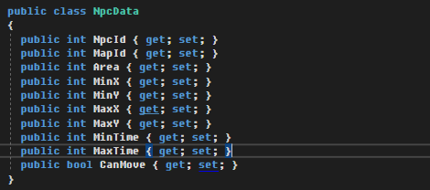

{\"NpcId\":102, \"MapId\":1001, \"Area\":3, \"MinX\":63, \"MaxX\":63, \"MinY\":44, \"MaxY\":44, \"CanMove\":false}

MinX，MaxX，MinY，MaxY：NPC活动区域

CanMove：NPC是否可以移动

MinTime，MaxTime：NPC下一次活动的时间区间

## 销毁NPC- DestroyNPC

销毁指定的NPC

|  |  |  |  |
| --- | --- | --- | --- |
| DoType | 执行效果类型 | String | DestroyNPC |
| NPCId | NPCId | Int | 102 |

## 播放AVG- PlayAVG

Update time:2019/04/15

播放一段AVG剧情，可以指定是否停止当前背景音乐，在剧情结束后继续播放当前背景音乐

|  |  |  |  |
| --- | --- | --- | --- |
| DoType | 执行效果类型 | String | PlayAVG |
| Name | AVG文件名 | String | Aaa |
| StopBgm | 是否停止背景音乐 | Boolean | False |

## 进入表世界冒险- EnterAdventure

进入表世界

|  |  |  |  |
| --- | --- | --- | --- |
| DoType | 执行效果类型 | String | EnterAdventure |
| AreaId | 区域Id | Int | 20101 |
| SectionId | 章ID | Int | 1 |

## 等待固定时间- Await

等待一段时间

|  |  |  |  |
| --- | --- | --- | --- |
| DoType | 执行效果类型 | String | Await |
| WaitTime | 等待的时间 | Float | 1.5 |

## 打开UI面板- OpenUIPanel

打开一个指定面板

|  |  |  |  |
| --- | --- | --- | --- |
| DoType | 执行效果类型 | String | OpenUIPanel |
| PanelName | 面板名称 | String | Dialog |

## 打开UI面板- CloseUIPanel

关闭一个指定面板，必须是当前打开的面板。（弹出层有限制，如果是需要点返回的面板，智能关闭最上层的面板）

|  |  |  |  |
| --- | --- | --- | --- |
| DoType | 执行效果类型 | String | CloseUIPanel |
| PanelName | 面板名称 | String | Dialog |

## 地图传送 - Teleport

Update time:2018/9/22

传送到地图上指定的地点

|  |  |  |  |
| --- | --- | --- | --- |
| DoType | 执行效果类型 | String | Teleport |
| MapId | 地图ID | Int | 1001 |
| NodeId | 节点ID | Int | 9894 |

## 等待面板打开 - Complete

Update time:2018/11/15

主动完成当前引导

|  |  |  |  |
| --- | --- | --- | --- |
| DoType | 执行效果类型 | String | Complete |
| PanelName | 面板名称 | String | MainPanel |

## 等待区域打开 - WaitAreaOpen

Update time:2018/11/15

等待地图区域被打开

|  |  |  |  |
| --- | --- | --- | --- |
| DoType | 执行效果类型 | String | WaitAreaOpen |
| MapId | 地图Id | Int | MapId |
| NodeId | 区域Id | Int | AreaId |

## 等待区域打开 - WaitAreaClose

Update time:2018/11/15

等待地图区域被关闭

|  |  |  |  |
| --- | --- | --- | --- |
| DoType | 执行效果类型 | String | WaitAreaClose |
| MapId | 地图Id | Int | MapId |
| NodeId | 区域Id | Int | AreaId |

## 等待角色移动到 - WaitMoveTo

Update time:2018/12/3

等待主控角色移动的地图节点，可指定多地图块，

经过点，经过时会触发，触发后停止移动。

到达点，角色达到后触发了节点所有事件后会触发。

|  |  |  |  |
| --- | --- | --- | --- |
| DoType | 执行效果类型 | String | WaitMoveTo |
| PassingNodes | 经过点 | List<MapNodeParam> | [{“MapId”:1001,“NodeId”:9060}] |
| ArrivalNodes | 到达点 | List<MapNodeParam> | [{“MapId”:1001,“NodeId”:9060}] |

## 解锁模块 - UnlockModule

Update time:2018/11/26

解锁对应的模块，Module详见6.2

|  |  |  |  |
| --- | --- | --- | --- |
| DoType | 执行效果类型 | String | UnlockModule |
| Module | 模块名字 | String | Role |

## 显示单一特效- ShowSingleEffect

Update time:2018/12/3

显示指定的特效

重载元素：目前只支持文本重载，

{

"TxtTips":"haha",

"TxtPlayerName":"lizhua"

}

把名字为“TxtTips“的文本重载为“haha”, 把名字为“TxtTips“的文本重载为“haha”

|  |  |  |  |
| --- | --- | --- | --- |
| DoType | 执行效果类型 | String | ShowSingleEffect |
| EffectName | 特效名字 | String | FeatureUnlocked |
| OverridElements | 重载元素 | T | {  "TxtTips":"haha",  "TxtPlayerName":"lizhua"  } |

## 进入游戏-EnterGame

Update time:2018/12/18

进入游戏主界面，一般登录成功后使用，

|  |  |  |  |
| --- | --- | --- | --- |
| DoType | 执行效果类型 | String | EnterGame |

## 加载节点元素- LoadElement

Update time:2019/01/03

在当前地图指定的节点，加载指定的元素，并设置元素的相对坐标，相对角度，相对缩放

|  |  |  |  |
| --- | --- | --- | --- |
| DoType | 执行效果类型 | String | LoadElement |
| NodeId | 地图节点Id名字 | Int | 9896 |
| ElementKey | 加载的元素 | String | Aa |
| Position | 元素坐标 | Vector3 | 0,0,0 |
| EulerAngles | 元素角度 | Vector3 | 0,0,0 |
| Scale | 元素缩放 | Vector3 | 1,1,1 |

## 显示已经解锁的传送按钮- DefaultTeleport

Update time:2019/01/16

在主界面下方显示在当前引导进度所有已经解锁的传送按钮

|  |  |  |  |
| --- | --- | --- | --- |
| DoType | 执行效果类型 | String | DefaultTeleport |
| TeleportTag | 传送按钮标签 | List<string> | [“Plaza”,”Cards”] |

## 解锁新的传送按钮- UnlockNewTeleport

Update time:2019/01/16

在主界面下方显示新解锁的传送按钮,不包含已有的按钮标签

|  |  |  |  |
| --- | --- | --- | --- |
| DoType | 执行效果类型 | String | UnlockNewTeleport |
| TeleportTag | 传送按钮标签 | List<string> | [”Adventure”] |

## 解锁新的传送按钮- UnlockNewTeleport

Update time:2019/01/16

在主界面下方显示新解锁的传送按钮,不包含已有的按钮标签

|  |  |  |  |
| --- | --- | --- | --- |
| DoType | 执行效果类型 | String | UnlockNewTeleport |
| TeleportTag | 传送按钮标签 | List<string> | [”Adventure”] |

## 添加地图节点事件- AddMapEvent

Update time:2019/03/1

给指定的地图节点添加事件，地图需要已被加载

|  |  |  |  |
| --- | --- | --- | --- |
| DoType | 执行效果类型 | String | AddMapEvent |
| NodeId | 传送按钮标签 | Int | 90056 |
| Data | 事件数据 | NodeEventData | {}具体问呵呵 |

## 清除地图节点事件- ClearMapEvent

Update time:2019/03/1

清除指定的地图节点事件，地图需要已被加载

|  |  |  |  |
| --- | --- | --- | --- |
| DoType | 执行效果类型 | String | ClearMapEvent |
| NodeId | 传送按钮标签 | Int | 90056 |

## 播放视频- PlayVideo

Update time:2019/04/15

播放视频，视频放在Sound工程的Media/Video文件夹下面

注意需要填写文件后缀

|  |  |  |  |
| --- | --- | --- | --- |
| DoType | 执行效果类型 | String | PlayVideo |
| ClipPath | 视频路径 | String | Aa/ss.mp4 |
| CanSkip | 是否可以跳过 | Boolean | False |

## 播放背景音乐- PlayBgm

Update time:2019/04/15

播放指定的背景音乐，

如果BgmName留空（不填），则继续播放之前的音乐，留空配合暂停音乐使用

如果指定音乐是播放中的音乐并且需要重新播放，需要设置Replay为True。

|  |  |  |  |
| --- | --- | --- | --- |
| DoType | 执行效果类型 | String | PlayBgm |
| BgmName | bgm名字 | String | Aa/ss |
| Replay | 是否重新播放 | Boolean | False |

## 暂停背景音乐- PauseBgm

Update time:2019/04/15

暂停播放背景音乐

|  |  |  |  |
| --- | --- | --- | --- |
| DoType | 执行效果类型 | String | PauseBgm |

## 切换角色- ChangeHero

Update time:2019/04/15

切换指定的角色，直接指定皮肤Id

|  |  |  |  |
| --- | --- | --- | --- |
| DoType | 执行效果类型 | String | ChangeHero |
| SkinId | 皮肤Id | Int | 101001 |

## 锁定&解锁皮肤- LockSkin&UnlockSkin

Update time:2019/06/27

锁定指定的皮肤,对上锁的皮肤解除锁定

|  |  |  |  |
| --- | --- | --- | --- |
| DoType | 执行效果类型 | String | LockSkin |
| HeroSkinIds | 皮肤Id链表 | List<int> | [101001,102001] |
| DoType | 执行效果类型 | String | UnlockSkin |
| HeroSkinIds | 皮肤Id链表 | List<int> | [101001,102001] |

## 锁定&解锁卡包- LockCardPackage&UnlockCardPackage

Update time:2019/06/27

锁定指定的卡包,对上锁的卡包解除锁定

|  |  |  |  |
| --- | --- | --- | --- |
| DoType | 执行效果类型 | String | LockCardPackage |
| CardPackages | 卡包Id链表 | List<int> | [1,2] |
| DoType | 执行效果类型 | String | UnlockCardPackage |
| CardPackages | 卡包Id链表 | List<int> | [1,2] |

## 等待事件完成- WaitEventCompleted

Update time:2019/07/08

等待指定地图上指定节点时间完成

|  |  |  |  |
| --- | --- | --- | --- |
| DoType | 执行效果类型 | String | WaitEventCompleted |
| NodeIds | 指定的节点Id | List<int> | [1001,1002] |

## 设置元素角度- SetElementAngle

Update time:2019/07/15

设置指定元素的旋转角度，

Duration：持续时间，可选项，默认0，当值为0时，直接设置角度，不进行旋转！

|  |  |  |  |
| --- | --- | --- | --- |
| DoType | 执行效果类型 | String | SetElementAngle |
| NodeId | 指定的节点Id | int | 1001 |
| Angle | 旋转角度 | Vector3 | 180,0,0 |
| Duration | 持续时间（可选） | Float | 0 |

# 示例

## 天梯奖励面板

{

"GuideName" : "RankAward",

"Triggers" : [

{

"Data" : {

"TriggerType" : "OpenPanel",

"PanelName" : "RankAwardPanel"

}

}

],

"NodeData" : [

{

"IsClickToNext" : true,

"IsAutoToNext" : false,

"DoData" : [

{

"Data" : {

"DoType" : "SetTips",

"Text" : "点击继续",

"Position" : "0,0"

}

}

]

},

{

"IsClickToNext" : true,

"IsAutoToNext" : false,

"DoData" : [

{

"Data" : {

"DoType" : "Highlight",

"Panel" : "RankAwardPanel",

"Objects" : "[\"TogSeasonAward\"]",

"Order" : "1"

}

},

{

"Data" : {

"DoType" : "SetTips",

"Text" : "点击进入赛季奖励界面",

"Position" : "-489,10"

}

},

{

"Data" : {

"DoType" : "SetBlink",

"Position" : "-489,66",

"Rotation" : "0, 0, 0"

}

}

]

},

{

"IsClickToNext" : false,

"IsAutoToNext" : true,

"DoData" : [

{

"Data" : {

"DoType" : "ClearHighlight"

}

}

]

},

{

"IsClickToNext" : true,

"IsAutoToNext" : false,

"DoData" : [

{

"Data" : {

"DoType" : "Highlight",

"Panel" : "RankAwardPanel",

"Objects" : "[\"SeasonAwardPage/BtnLevelAward\"]",

"Order" : "1"

}

},

{

"Data" : {

"DoType" : "SetTips",

"Text" : "点击查看段位对应的奖励",

"Position" : "500,-100"

}

},

{

"Data" : {

"DoType" : "SetBlink",

"Position" : "564,-205",

"Rotation" : "0, 0, 180"

}

}

]

},{

"IsClickToNext" : false,

"IsAutoToNext" : true,

"DoData" : [

{

"Data" : {

"DoType" : "ClearHighlight"

}

},

{

"Data" : {

"DoType" : "ClearGuidePanel"

}

}

]

},

{

"IsClickToNext" : false,

"IsAutoToNext" : false,

"DoData" : [

{

"Data" : {

"DoType" : "ShowPictures",

"Paths" : "[\"aa\", \"bb\"]"

}

}

]

},

{

"IsClickToNext" : true,

"IsAutoToNext" : false,

"DoData" : [

{

"Data" : {

"DoType" : "Highlight",

"Panel" : "RankLevelAwardPanel",

"Objects" : "[\"RankLevelAwardPanel\"]",

"Order" : "1"

}

},

{

"Data" : {

"DoType" : "SetInteractable",

"Panel" : "RankLevelAwardPanel",

"Objects" : "[\"BtnClose\"]"

}

},

{

"Data" : {

"DoType" : "SetTips",

"Text" : "点击关闭",

"Position" : "323,309"

}

},

{

"Data" : {

"DoType" : "SetBlink",

"Position" : "334,253",

"Rotation" : "0,0,180"

}

}

]

},

{

"IsClickToNext" : true,

"IsAutoToNext" : false,

"DoData" : [

{

"Data" : {

"DoType" : "Highlight",

"Panel" : "RankAwardPanel",

"Objects" : "[\"BtnClose\"]",

"Order" : "1"

}

},

{

"Data" : {

"DoType" : "SetTips",

"Text" : "点击关闭",

"Position" : "643,235.27"

}

},

{

"Data" : {

"DoType" : "SetBlink",

"Position" : "650,280",

"Rotation" : "0, 0, 0"

}

}

]

}

]

}

## 换英雄引导

{

    "GuideName":"ChangeHero",

    "Triggers" : [

{

"Data" : {

"TriggerType" : "OpenArea",

                "MapId" : "1001",

                "AreaId" : "3"

}

}

],

    "Precondition":[

        {

            "Data": {

                "ConditionType": "GuideCompleted",

                "GuideName": "RankAward"

            }

        }

    ],

    "NodeData": [

        {

            "IsClickToNext": false,

            "IsAutoToNext": false,

            "DoData": [

                {

                    "Data": {

                        "DoType": "HideNodeElement",

                        "NodeIds": "[9500, 9046, 9945, 9799]"

                    }

                },

                {

                    "Data": {

                        "DoType": "DisableNodeEvent",

                        "NodeIds": "[9350, 9500, 9650, 9046, 9945, 9799]"

                    }

                },

                {

                    "Data": {

                        "DoType": "LoadNpc",

                        "NPCInfo": "{\"NpcId\":102, \"MapId\":1001, \"Area\":3, \"MinX\":63, \"MaxX\":63, \"MinY\":44, \"MaxY\":44, \"CanMove\":false}"

                    }

                },

{

"Data" : {

"DoType" : "SetTips",

"Text" : "快戳我",

"Position" : "500,-100"

}

},

{

"Data" : {

"DoType" : "SetBlink",

"Position" : "564,-205",

"Rotation" : "0, 0, 180"

}

},

                {

                    "Data": {

                        "DoType": "HideMask"

                    }

                },

                {

                    "Data": {

                        "DoType": "WaitPanelOpen",

                        "PanelName" : "MainSelectHeroPanel"

                    }

                }

            ]

        },

        {

            "IsClickToNext": true,

            "IsAutoToNext": false,

            "DoData": [

                {

                    "Data": {

                        "DoType": "ShowMask"

                    }

                },

                {

                    "Data": {

                        "DoType": "Highlight",

                        "Panel" : "MainSelectHeroPanel",

"Objects" : "[\"BtnChange\"]",

"Order" : "1"

                    }

                }]

        },{

            "IsClickToNext": false,

            "IsAutoToNext": true,

            "DoData": [

                {

                    "Data": {

                        "DoType": "ShowNodeElement",

                        "NodeIds": "[9500, 9046, 9945, 9799]"

                    }

                },

                {

                    "Data": {

                        "DoType": "EnableNodeEvent",

                        "NodeIds": "[9350, 9500, 9650, 9046, 9945, 9799]"

                    }

                },

                {

                    "Data": {

                        "DoType": "LoadNpc",

                        "NPCInfo": "{\"NpcId\":101, \"MapId\":1001, \"Area\":3, \"MinX\":63, \"MaxX\":63, \"MinY\":44, \"MaxY\":44, \"CanMove\":false}"

                    }

                }

            ]

        }

    ]

}

# 参数

## 面板名称

AudioSettingPanel = "AudioSetting"; 声音设置面板

MatchPanel = "Match"; 匹配面板

CutscenesPanel = "CutscenesPanel"; 过渡面板，有Tips的

DialogPanel = "Dialog"; 对话框面板

InputPanel = "InputPanel"; 输入面板

CardDetail = "CardDetailPanel"; 卡牌详情面板

PlayerProperty = "PlayerPropertyPanel"; 忽略

GuidePanel = "GuidePanel"; 引导面板

CardsPanel = "CardsPanel"; 卡牌面板

StorePanel = "StorePanel"; 商店面板（黑市）

RankAwardPanel = "RankAwardPanel"; 天梯奖励面板

RankLevelPanel = "RankLevelPanel"; 天梯等级面板

RankEnterPanel = "RankEnterPanel"; 天梯入口面板

RankLevelAwardPanel = "RankLevelAwardPanel"; 天梯等级奖励面板  
RankLeaderboard = "RankLeaderboard"; 天梯排行榜面板

HandBookPanel = "HandBookPanel"; 手册面板

ReliqueDetailPanel= "ReliqueDetailPanel"; 遗物详情面板

MailDetailPanel= "MailDetailPanel"; 邮件详情面板

RechargePanel = "RechargePanel"; 充值面板

FateCardPanel = "FateCardPanel"; 命运卡面板

LoginPanel = "LoginPanel"; 登陆面板

LoadingPanel = "LoadingPanel"; 加载中面板（转圈）

TipsPanel = "TipsPanel"; 小提示面板

CheckPanel = "CheckPanel"; 游戏检测面板（版本、资源）

ChallengePanel = "AreaPanel"; 挑战面板

RoleSystemPanel = "RoleSystemPanel"; 忽略

CommonAwardedPanel = "RewardPanel"; 通用奖励面板

MainPanel = "MainPanel"; 主面板

CharacterInfoPanel= " CharacterInfoPanel"; 玩家信息面板

MainSelectHeroPanel = "MainSelectHeroPanel"; 切换英雄面板

EquipPanel = "EquipPanel"; 十字娘面板

DeckPanel = "DeckPanel"; 卡组面板

BattlePanel = "BattlePanel"; 战斗面板

RankPreparationPanel = "RankPreparationPanel"; 天梯备战面板

ChallengePreparationPanel = "ChallengePreparationPanel"; 挑战备战面板

AdventurePreparationPanel = "AdventurePreparationPanel"; 冒险备战面板

ArenaPreparationPanel= " ArenaPreparationPanel"; 竞技场备战面板

HeroSkinInfoPanel= " HeroSkinInfoPanel"; 英雄皮肤面板

ShopPanel = "ShopPanel"; 忽略

HeroEvolutionPanel = "HeroEvolutionPanel"; 英雄进阶面板

CommonUpgradePanel = "UpgradePrompt"; 忽略

PlayerLevelAwardPanel = "PlayerLevelAwardPanel"; 玩家等级奖励面板

EducationHeroeMaterialPanel = "HeroEducationPanel"; 英雄材料养成面板

StoryViewPanel = "StoryViewPanel"; 忽略

EducationLotteryPanel = "EducationLotteryPanel"; 抽蛋面板

CardLotteryPanel = "CardLotteryPanel"; 抽卡面板

ChangeHeroPanel = "ChangeHeroPanel"; 忽略

CommonItemDescriptionPanel = "DescriptionFrame"; 材料介绍面板

CompoundMaterialPanel = "CompoundMaterialPanel"; 合成材料面板

GameMoneyConversionPanel = "GameMoneyConversionPanel"; 点金面板

AdventurePanel = "AdventurePanel"; 冒险面板

AdventuringPanel = "AdventuringPanel"; 冒险中的面板

AdventuringDeckPanel = "AdventuringDeckPanel"; 冒险中卡牌背包

AdventuringGetCardPackPanel = "AdventuringGetCardPackPanel";

冒险中战斗结束获得卡包

AdventuringCardPackPanel = "AdventuringCardPackPanel"; 好像没用了

AdventuringTestPanel = "AdventuringTestPanel"; 测试的

AdventuringOpenUIPanel = "AdventuringOpenUIPanel"; 冒险中UI对话

AdventuringShopPanel = "AdventuringShopPanel"; 冒险中商店

AdventuringMercenaryPanel = "AdventuringMercenaryPanel"; 冒险中佣兵

AdventureAreaPanel = "AdventureAreaPanel"; 里世界冒险选关

AdventureSweepingPanel= " AdventureSweepingPanel"; 扫荡面板

AdventuringClosingPanel = "AdventuringClosingPanel"; 冒险结算

AdventuringMatchingPanel= " AdventuringMatchingPanel"; 竞技场匹配面板

StoneworkPanel= " StoneworkPanel"; 石方

ExternalAdventurePanel = "ExternalAdventurePanel"; 表世界选章节

ExternalAdventureAreaPanel = "ExternalAdventureAreaPanel"; 表世界选关

ExternalAdventureUnlockPanel = "ExternalAdventureUnlockPanel";

表世界解锁信息

ExternalAdventureAwardPanel = "ExternalAdventureAwardPanel";

表世界领取奖励

ExternalAdventureAwardListPanel= " ExternalAdventureAwardListPanel";

表世界领取奖励弹窗

ArenaPanel= " ArenaPanel"; 竞技场面板

ArenaSelectPanel= " ArenaSelectPanel"; 竞技场选择（卡，角色）面板

ArenaTopPanel= " ArenaTopPanel"; 竞技场状态面板

RenamePanel= "RenamePanel"; 重命名界面

AvgPanel= " AvgPanel"; Avg面板

PlayerLevelUpPanel= " PlayerLevelUpPanel"; 等级提升面板

BattleModeChoosePanel= " BattleModeChoosePanel"; 天梯竞技场选择面板

PlayerBackpackPanel= " PlayerBackpackPanel"; 背包面板

AdventuringCharacterInfoPanel= " AdventuringCharacterInfoPanel"; 冒险玩家信息面板

GetNewCardPanel= "GetNewCardPanel"; 获得新卡面板

## 模块类型

Adventure =冒险,

AdventureSp = 冒险体力,

Arena = 竞技场,

Bag = 背包,

CardPack = 卡组,

Challenge = 挑战,

CharacterProperty = 玩家属性,

ComposeMaterial = 材料合成,

DrawCard = 抽卡,

Equip = 武器（十字娘）,

ExternalAdventure = 外部冒险,

GoldPointing = 点金,

MonthCard = 月卡,

Mineral = 挂机,

Rank = 天梯,

RankMatch = 天梯匹配,

Recharge = 充值,

RoleEgg = 角色养成,

Role = 角色,

Shop = 商城,

FreeStore = 自由商店

AdventureStore = 冒险商店,

RankStore = 天梯商店,

ArenaStore = 竞技场商店,