**How to run Virtual Advisor on Mac**

1. Download “git “ for desktop. Online link [https://github.com/exitudio/virtualAdvisor](https://github.com/exitudio/virtualAdvisor" \t "_blank)



2. Log in to git. Then, click on “virtualAdvisor” folder then click the last doted circle and sync the application,

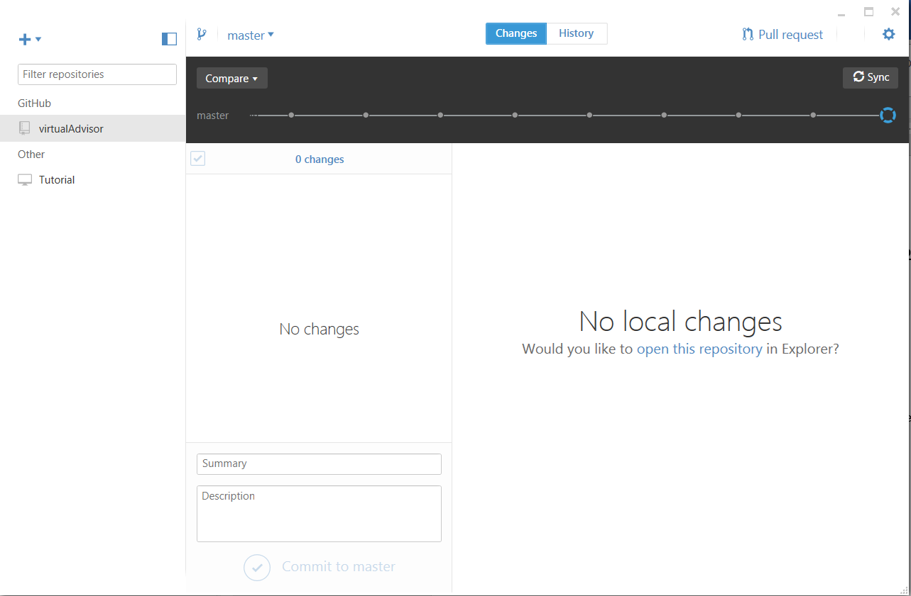

3.After successful sync, right click on virtualAdvisor folder and select “open in Finder”.

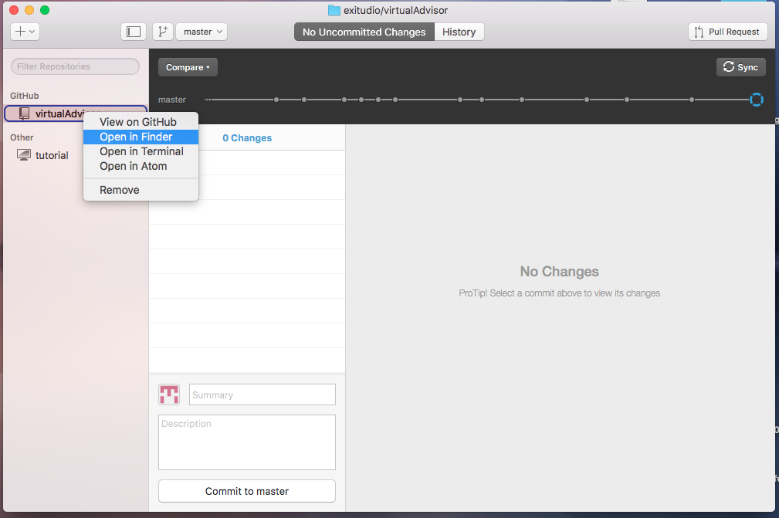

4. Step 3 will lead you to following pop up.

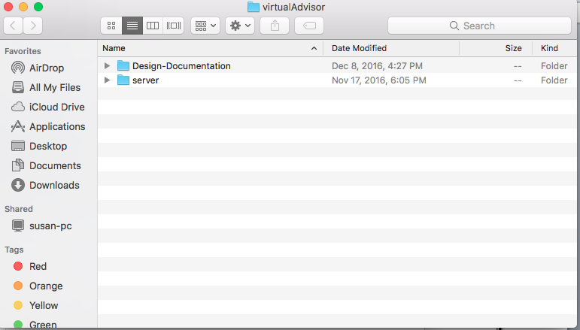

5. Click on “server” folder

6. Open up your terminal command prompt for mac and navigate to proper file.

7.After that open chrome and download “node.js” using <https://nodejs.org/en/> (note: download recommended version)

8..After step 7, go back to terminal and type “install npm” and hit enter. This will install all node.js packages.

9..Once step 8 has been completed, type “npm start” in the same command prompt.

10. Open preference of web browser and type “localhost:3000”

