**How to run Virtual Advisor on Windows**

1. Download “git” for desktop.



1. Log in to git. Then, click on “virtualAdvisor” folder then click the last doted circle and sync the application,

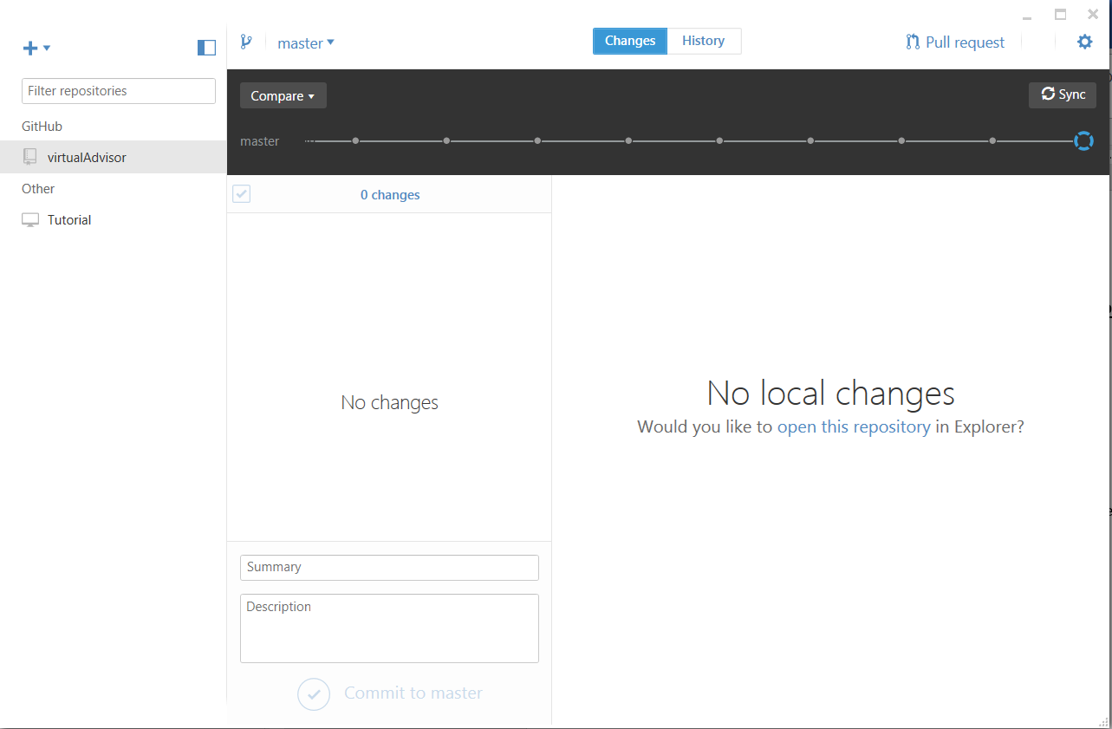

1. After successful sync, right click on virtualAdvisor folder and select “open in explorer”.

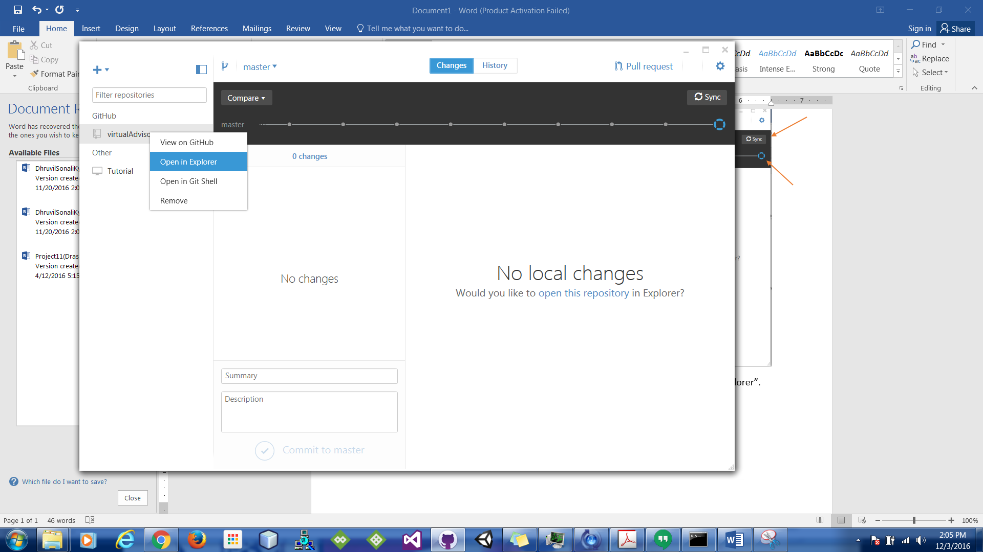

1. Step 3 will lead you to following pop up.

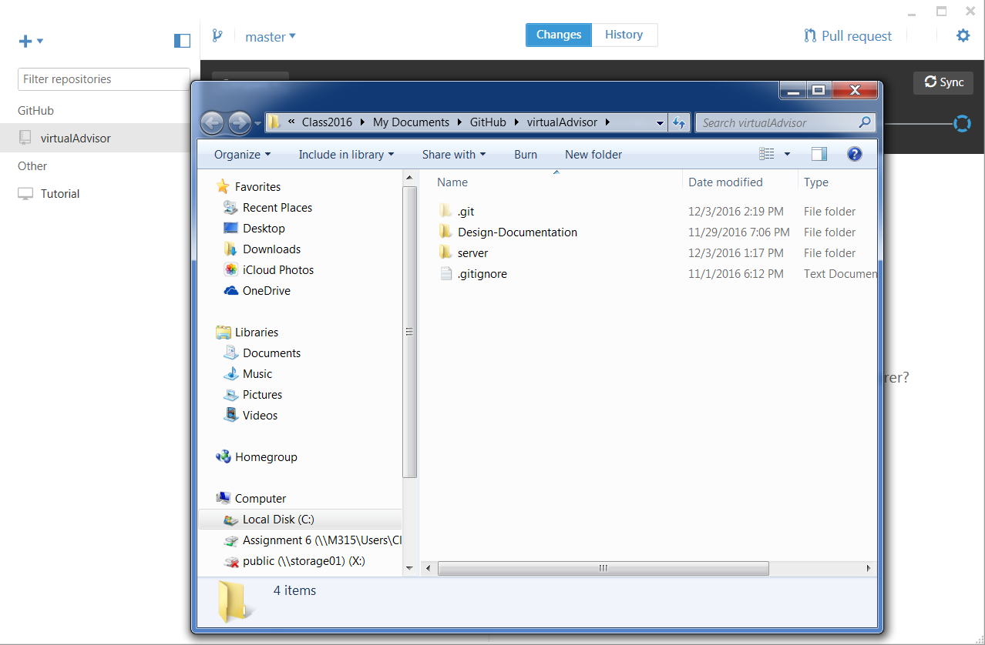

1. Click on “server” folder and then on path location type “cmd” and hit enter.

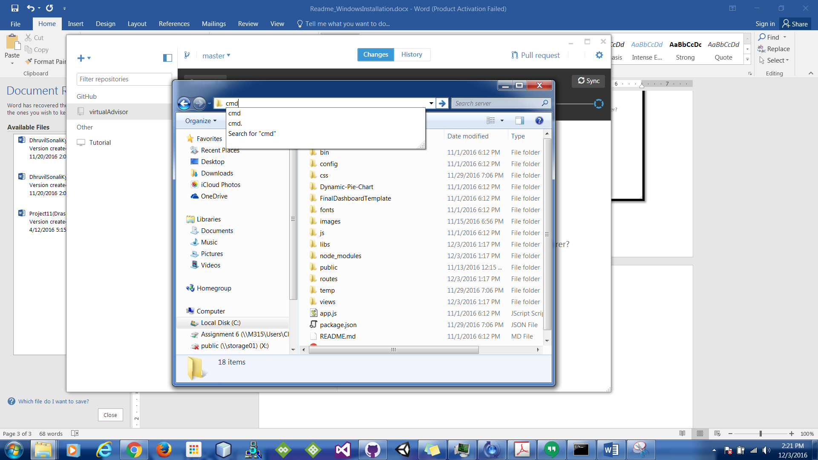

1. Step 5 will lead to command prompt.
2. After that open chrome and download “node.js” using <https://nodejs.org/en/> (note: download recommended version)
3. After step 7, go back to command prompt and type “install npm” and hit enter. This will install all node.js packages.
4. Once step 8 has been completed, type “npm start” in the same command prompt.

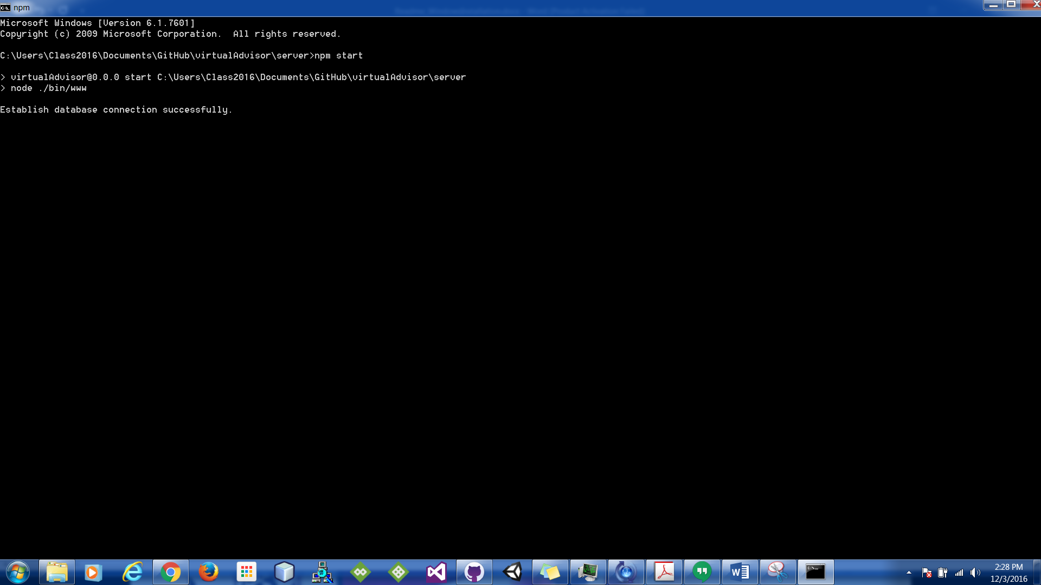

1. Open web browser and type “localhost:3000”

