Project Design Documentation
I. Project Overview
Our project will be a multiplayer game of blackjack. It consists in players being clients, and the dealer being our server. The maximum number of clients we will allow is six. We'll respect all rules of Blackjack except for the "split" action. When accessing the game for the first time, each player will have to register and will get a certain amount of money on his bank account. When he bets, this money will be debited from this account.

I.2 Project Overview
While all of the rules for Blackjack have been enforced, the Split was, as stated before, not included in development. The users will still have to register for the game and add money at the start, but no longer is there a need for the user to connect with six other players.
II. Detailed Architecture
The following picture shows the architecture of our project.

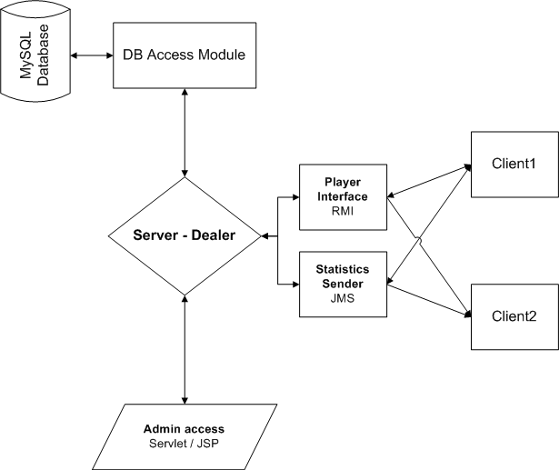

The server will be using a MySQL database in order to store client login names, as well as the money they have earned. We will implement this by including a Database Access Module (or Data Extraction Module) which the server will use to receive information from the database, instead of directly accessing the database.

The server will also use RMI so clients can access methods (and access the database) within the Blackjack server. The methods we will use will consist of round actions - deal, hit, stand, double, and high stakes. A more detailed overview of the database design and handling of data is explained in Section III.

Players will be using GUI clients from which they can request actions such as deal the cards, hit, stand, double. Players will also be able to send "e-mails" to each other, using JMS. Section IV.1 describes the user interface for clients.

Although the server won't have any GUI and will have to be ran as a command line application, we plan to implement a Web interface for the server using Servlets and JSP technologies. This interface will provide management access to the server for the administrator and is described in Section IV.2.

III. Data Design
Persistent data will be in the form of MySQL integration. We will require the client to log in to our system and then we will give that user an initial set of playable money which he/she will use to make bets during games. Every time a user wishes to log out, their ending amount of money will be stored in the database under their name. Therefore, next time the user logs into our system, he/she will be able to play with the money they acquired last time. Users will be allowed to save credit card information on their blackjack account, enabling them to make withdraws in order to keep playing. The option to "Quick Add Money" will also be added; if the user enables this, it will automatically charge the user's credit card in the event of bankrupting their account.
A UML diagram has been constructed below, documenting the design of the database we wish to implement.
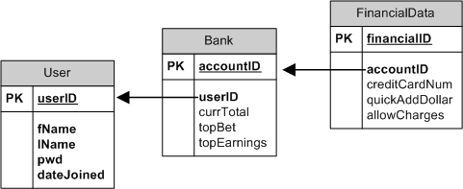

V.2 Database
The updated database diagram is show below -- complete with relationships (something not included before).

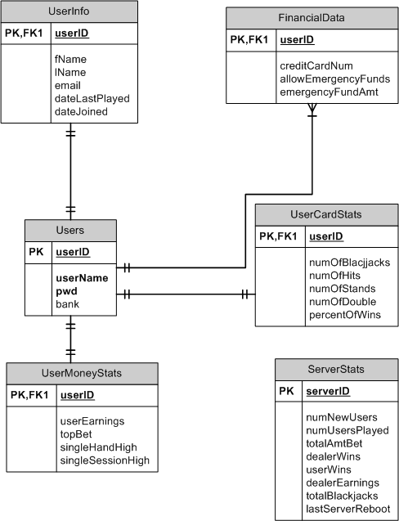

We have centered the database around the Users table; this is because primarily the server will be most interested in the user (currently playing or not) before updating the various other tables. Three statistic tables have been inserted in order to better understand the nature of our blackjack players. UserMoneyStats is to record the user's monetary statistics -- this should not be confused with FinancialData. FinancialData holds the critical data regarding the user's funds and their credit information. Another statistics table is the UserCardStats which acts like a "fun" data-gathering table. Information inserted here can then be relayed to the user's for their own personal amusement. The last statistics table is the ServerStats and will primarily be used to monitor the server's behavior. Data gathered from this table by administrators will mostly be used to determine whether the server is being exploited (IE very high user wins and low dealer wins) or the success of the Blackjack game with new/old users.
Another change is indexes have been added to the FinancialData on the Bank column. This is because of the constant need for the server to access and update the user's monetary pool.

V.3 Database
The emergency funds idea has been removed from this version of the database. Based on time constraints of implementation, we decided that the user would be better off without addressing a concept such as emergency funds.
Along with this the "Quick Add Money" - which ties in with the emergency funds concept - has been removed. Users will have to manually add money vis-a-vi an "Add Money" button, now located in the top-left corner. Money added will immediate be put into play and added to the user's bank in the database.
Relations
Users will be the center of most (excluding ServerStats) tables and will direct the queries to the appropriate tables. Users has a one-to-one relation with UserMoneyStats, UserCardStats, and FinancialData. It has been discussed whether or not to allow Users to have a one-to-many relationship with FinancialData because a user may wish to have multiple lines of credit. This concept is reflected in the above diagram but may get revised.

Using this database design, a data extraction class will be created with all the SQL queries necessary to extrapolate the data. Once retrieved, another class will then gather the values and store them in local variables that can be accessed through the blackjack application. This concept is illustrated below.

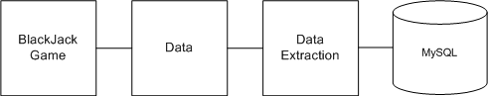
This concept is to restrict SQL commands by the developer, so data access can't be corrupted and encourages cleaner coding practice as no SQL commands will be visible in the application code. It also promotes tidier and simpler code since we are breaking up the tasks through various classes.
Summary - All methods in the Data Extraction class will have the necessary SQL queries to retrieve the data; the data will then be available via accessors. Data from these accessors will be stored in the Data class in local variables. So, when the game application requires certain information, it only needs to review the variables located in the Data class.
V.2 Data Methods
Data methods have been added to fully use the UserCardStats, ServerStats and the UserMoneyStats. Previous versions has little or no support for this as the game development did not require use of it. Methods will update the user primarily for statistical reasons and for administrative purposes.
Administrative reasons for having user and server stats primarily hinge on the administrators hindsight and his or her interpretation of the data. Suppose countless hours begins to be logged in gameplay, the numbers will show possible trends regarding user/dealer wins. If too many dealer hands are winning, then users will stop playing. If too many users are winning hands, then the dealer (company) will go broke. This is mostly for detecting coding logic issues that may be missed on small-scale testing.
Users with high hands or total earnings being in the "top" will earn a place on the Blackjack game board for all other playing users to see. This will encourage competition without users actually getting to see players face to face.

IV. JMS
JMS will be used between the server and the client to communicate statistics. Every hour, the server will fetch information from the database, build the top players list and send it to each client who will display it on the screen. We will use the publish method and have asynchronous subscribers.
We will implement this using 4 classes:
- JMSLayer: Abstract class which can create a connection to Glassfish in order to get a topic.
- JMSPublisher: Class that extends JMSLayer, and provides a publish() method to send messages.
- JMSAsyncSubscriber: Class that extends JMSLayer and registers a MessageListener to the topic.
- ClientTextListener: Listener that extends MessageListener and displays the messages it receives on the GUI screen.
For deliverable 3, we only provide a test client and server to illustrate how messages are sent and received.

V.2 Server Messages
Using the JMS feature we were able to successfully retrieve from the database the top five Blackjack players and display them in real-time on the game board. This nifty little message use enables users to see how they rank against the other players of the game, thus encouraging friendly competition.
Further development of this aspect could see users pairing up their own stats against the world players. Filters could be implemented to show the top players from a specific region or country. Further customization could have the users showing advanced statistics based on their own play style (ie, percentage of Hits taken when game strategy states to Stand, and of those, percentage won).

V. User Interface
V.1 Client Interface
The initial user interface will be a full-screen window with a button to connect to the server. Once the user has connected to the server, they will be asked to enter their login information or register, and enter a game if there is room (maximum of 6 players can be connected). When a minimum of one person has connected, server will wait an additional 30 seconds to allow more people to join; if no other players join, start a game. Buttons will consist of Hit, Stand, Double, Bet, and "High-Stakes"; two cards will be shown face-up for each client, and one face-up card for the dealer and one face-down card for the dealer. When every client has stopped "hitting" the dealer will turn his face-down card over and hit until he reaches 17 or over. Other parts of the user interface will include buttons to decide what your current bet will be, and a display of the total amount of money the client has to play with. Here is a first draft of this user interface.
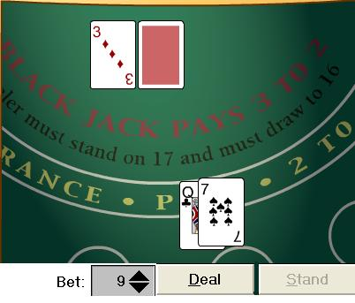

We will also include the possibility to send "e-mails" (text messages) to the other players. We will include buttons and windows for checking and sending e-mails.

V.1.5 Client Interface
Major changes have been implemented regarding the user and how they can play. Firstly, the user connects to the server and will be playing against the dealer only - not against other players as originally planned. This is to address the issue of creating and managing "groups" and hopefully void the need for a user to wait for at least one more user to join.

Also removed is the ability to "e-mail" other users. Since the group function was removed, there is really no need to have an email system set up to contact other players.

V.2 Server Interface

As we said, the server interface will consist of servlets so will be presented as a web page. It will display the uptime, a game log, the list of current users and elapsed connection time. The administrator will be able to use commands to interact with players: send them e-mails, give them money, kick/ban them...

V.2.5 Server Interface
The server interface has been successfully implemented using JSPs, and gives an admin the ability to display all players and their current numbers (bank). The JSPs give the admin the ability to kick or ban a user, as well as increase or decrease their monetary stats. This was done to ensure a non-database requiring format to change the money value, should any discrepancies arise (ie, the user doesn't carry credit cards and chooses to mail a check to the admin to add money to their account). This web interface also shows the server log as well as recorded statistics.

VIII. Tools
These are the tools we plan to use to help us in this project.
VIII.1 Subversion (SVN) and Google Code
SVN is a version control system. Open Source and free software, it is the successor of CVS and is supposed to be more flexible and powerful. Our project will be hosted on Google Code, as an Open Source licensed over GPL v2. Anyone can read the code but only the team members can modify it. Instructions are available on the following web page: http://code.google.com/p/rit-database-project/source/checkout

VIII.2 Netbeans
We will use Netbeans to help us design the client interface, since this IDE provides GUI design features. This is a free and cross-platform software. We don't know which version of Netbeans we will be using yet, however, it will certainly be the latest (currently being 6.5).

IX. Revision History
- v1.0
- v1.1 - Eric Kisner / Tyler Schindel
  - Added database design
  - Described database / application relational model
  - Rules of Blackjack
- v1.2 - Emilien Girault
  - Detailed architecture schema, description of each module
  - Split section IV in 2 parts: client and server architectures
  - Section VII: tools

- v1.3 - Emilien Girault / Tyler Schindel
  - Added the JMS section
  - Added updated database model

- v1.4 - Tyler Schindel / Eric Kisner / Emilien Girault
  - Covered database changes
  - Added server methods for game stats
  - Updated JMS use
  - Covered client interface changes
  - Covered server interface changes
  - Updated design
  - Updated servlets and JSPs

