**Game Specification**

**The Version of Unity:** 2020.3.29f1c1

1. **Game Setup：Set the Scenes Order in File-->Build Settings.**

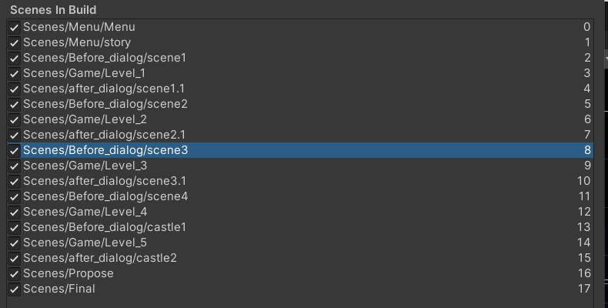

1. **Game Play：**

|  |  |
| --- | --- |
|  | Name Game |
| S key | enter the game's scene dialogue. |
| Right arrow | Moves Space Fighter towards the right side |
| Left arrow | Moves Space Fighter towards the left side |
| Up arrow | Moves Space Fighter upwards. |
| Down arrow | Moves Space Fighter downwards. |
| R key | Have a dialogue with the NPC. |
| Spacebar | Pause/resumes the entire game. |

|  |  |  |  |
| --- | --- | --- | --- |
| Level | Name Game | Game Task | Limited Time |
| Level 1 | Push Carrots | The player needs to clear the surrounding box obstacles, and finally push the carrot into the cave (at the red flag), which is the success of the level. | 60 seconds |
| Level2 | Graphic Reasoning | The player is required to find the rule according to the given figure and finally infer the correct figure to pass the level. | 45 seconds |
| Level 3 | Logic Reasoning | Two out of three NPCs are wrong in their statements, and the player should find the correct NPC to get through the level. | 45 seconds |
| Level 4 | Find The Maze Exit | Find the intersection to the castle in the maze. | 90 seconds |
| Level 5 | Mathematical  Calculation | The player needs to calculate the solution of the final specified equation according to the given equation set. | 45 seconds |